Yggdrasil
The Art of Eidonomy in Mechanism

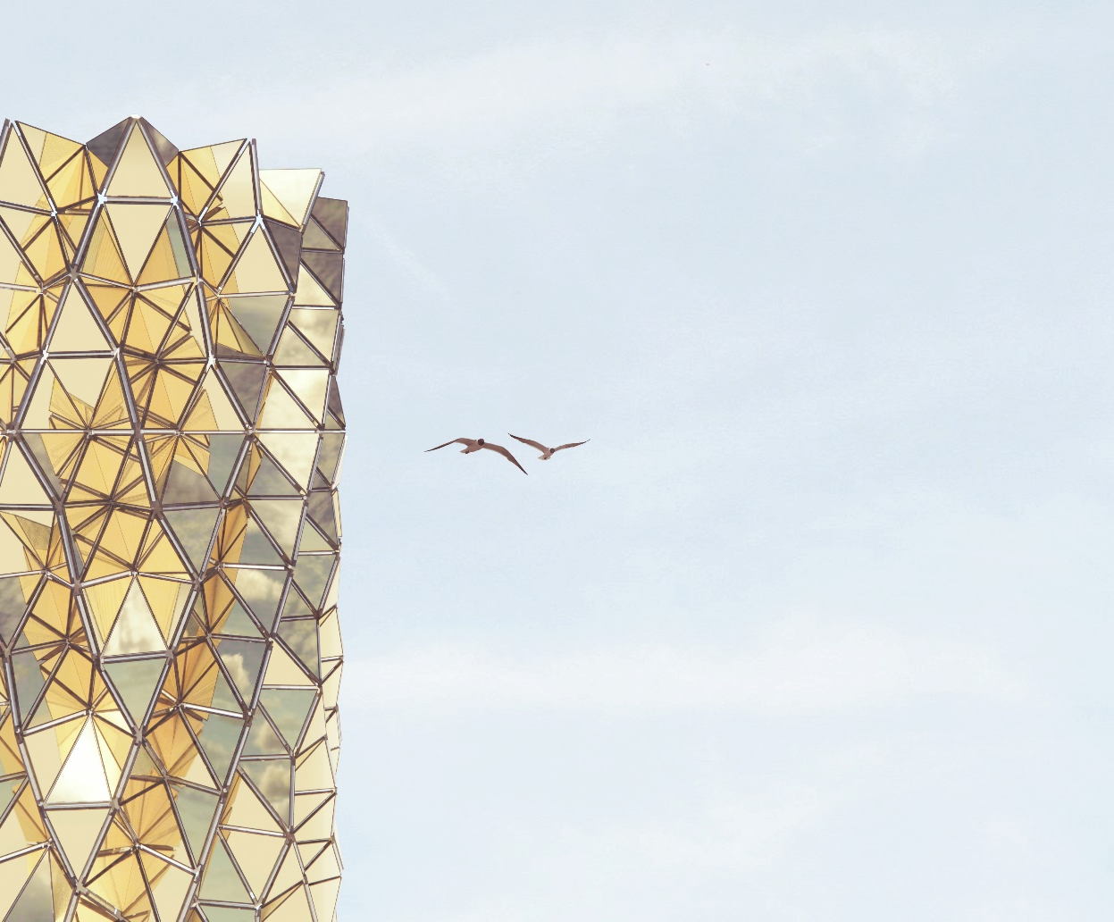

LAGI 2022 Mannheim
Beautiful Forms of Energy

Project Statement
Redraw the Beauty of Natural Morphology

As one of the latest federal garden biennale in Europe, Bundesgartenschau (BUGA) showcases joys and pleasures from the beauty of artificial landscapes in a vast stretch of green belt in the Spinelli Park, Mannheim. Not only is this major event to share ideas of natural harmony by craftsmanship, but it also be a forum to issue visions of sustainable development with aesthetics upon the age of interchange between post-industrialization and artificial intelligence. What is the definition of natural beauty? Is it possible to draw natural beauty from innovation of technology? How to sustainably adopt new methods into a creation? Yggdrasil is our answers in reply.

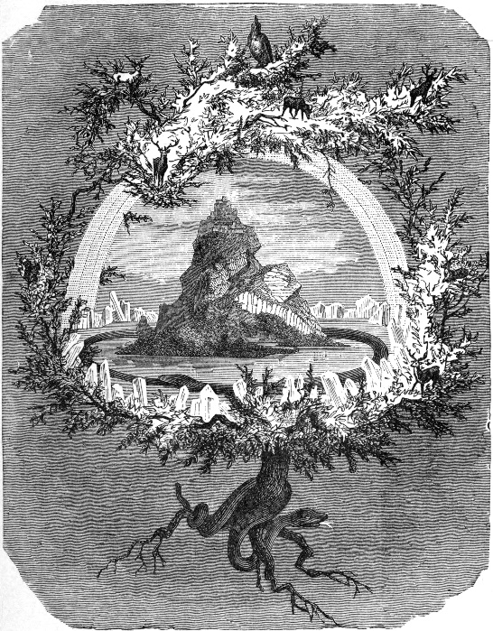
Yggdrasil, titled from a name of an immense sacred tree in Germanic mythology, is an installation, with a function of clock tower, settling at the centre of the venue, in order to celebrate a new era of post-mechanical productions, and to present new interpretation of renewable energy technologies. The form is inspired from plants’ anatomy and morphology that we use morphological variations of plant lifecycle as a concept to perform flow of time within a day. In accordance with the design principle, the outlook will gradually be expanded and shrunk from day to night, by domination of an integrated mechanical system at the core, as similar as a stem. The envelope will be enclosed by a number of triangular photo-voltaic (PV) modules, as petals, to shape the form of Yggdrasil.

Apart from solar energy, electro-magnetic technology is also adopted into the proposal of Yggdrasil. A circular square with a diameter of 20 metres will be fully covered by the triangular floor tiles with electro-magnetic generators in the bottom.
The downward force from pedestrians’ footsteps will activate machine to generate electricity at the result. The energy from both electro-magnetisms and photovoltaics are not only for self-sufficiency for manual operation of the installation, but the outputs can also benefit to the electrical demand in the surrounding.

With the mission of supporting United Nations Sustainable Development Goals issued in 2015, Yggdrasil is proposed for joys and pleasures formed by the performance of human ingenuities. Besides, more importantly, it summarises our intent of sharing and equality within the concept of the design.

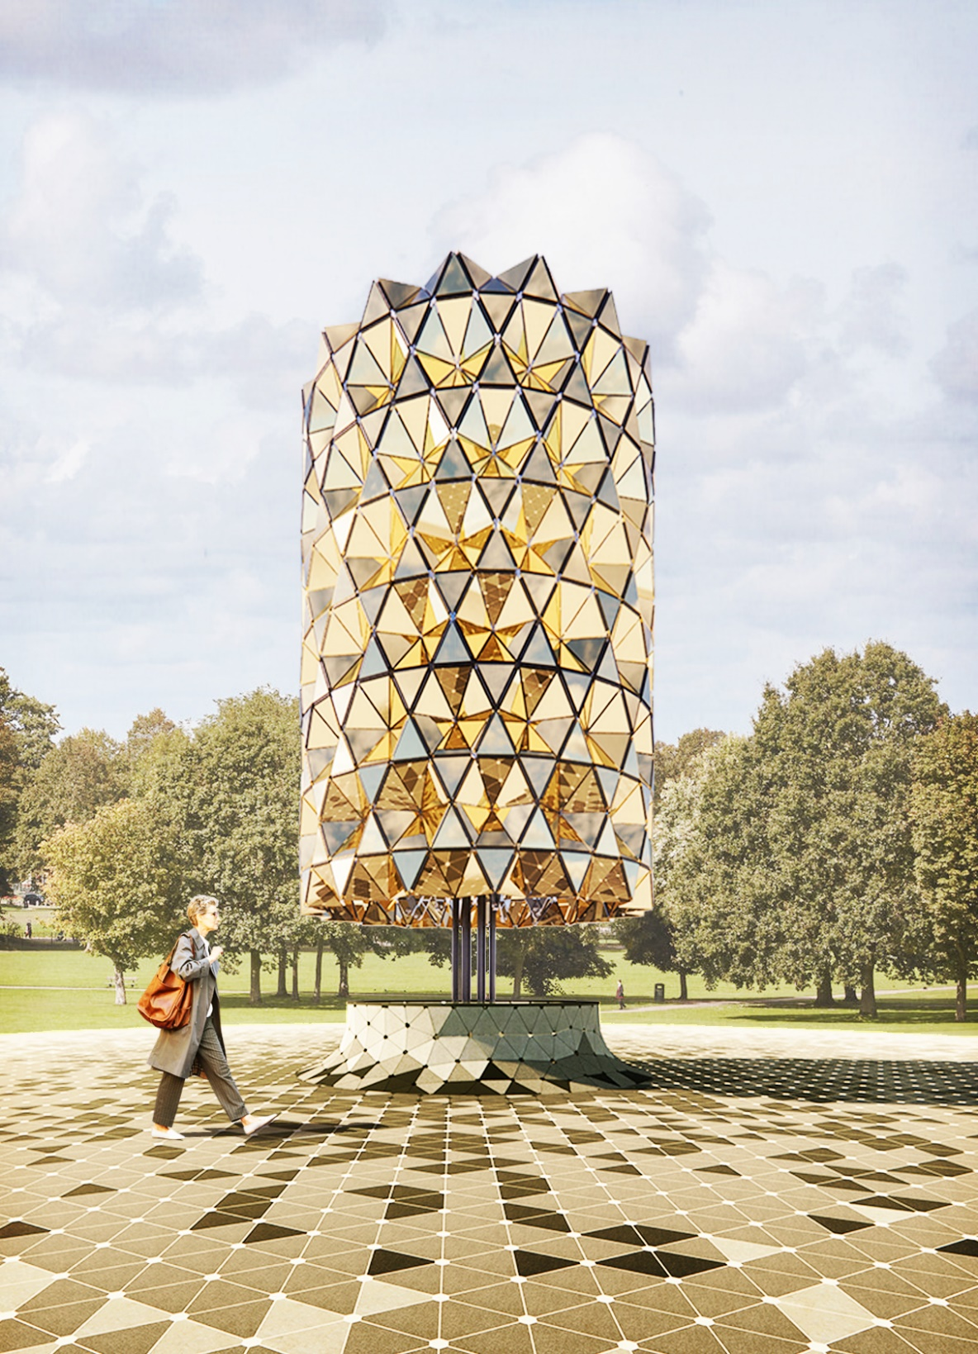
The centre of the field
Site and Function
To Signify Importance in Central Axis

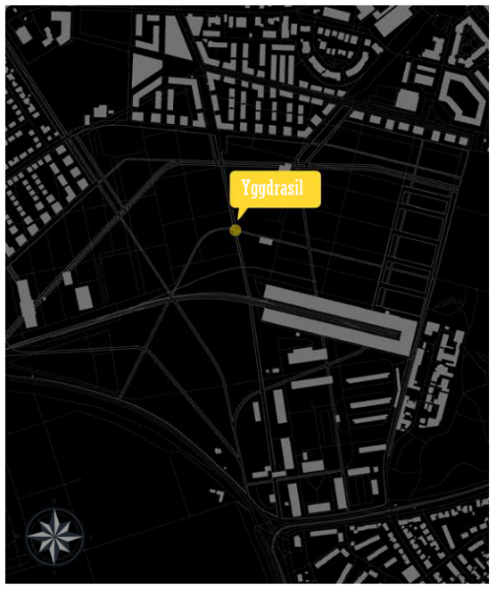
Yggdrasil is settled in the centre of the land field, which also in the place of inter-crossing between the pedestrian paths. The site selection comes from the intent of its function as clock tower.

The change of forms represents the time flow. Its characteristic enlightens us to consider its potential of being a clock tower, to serve the visitors during the period of festival. When we started to draft our ideas and did research at the same time, we find an interesting thing about the history of clock-making.

Clock towers were first erected at fairs during the industrial age in the late 19th century. On the battlefields of rivalries between nations, clock-making once was a symbol of artistic and horological excellence. Therefore, the clock itself has an important significance in human history.

The history of clocks inspires us to contemplate the design of Yggdrasil by examining how it functions. Alteration of the form thus has a particular meaning to express wonder of craftsmanship in the new age of interchange between post-industrialization and artificial intelligence

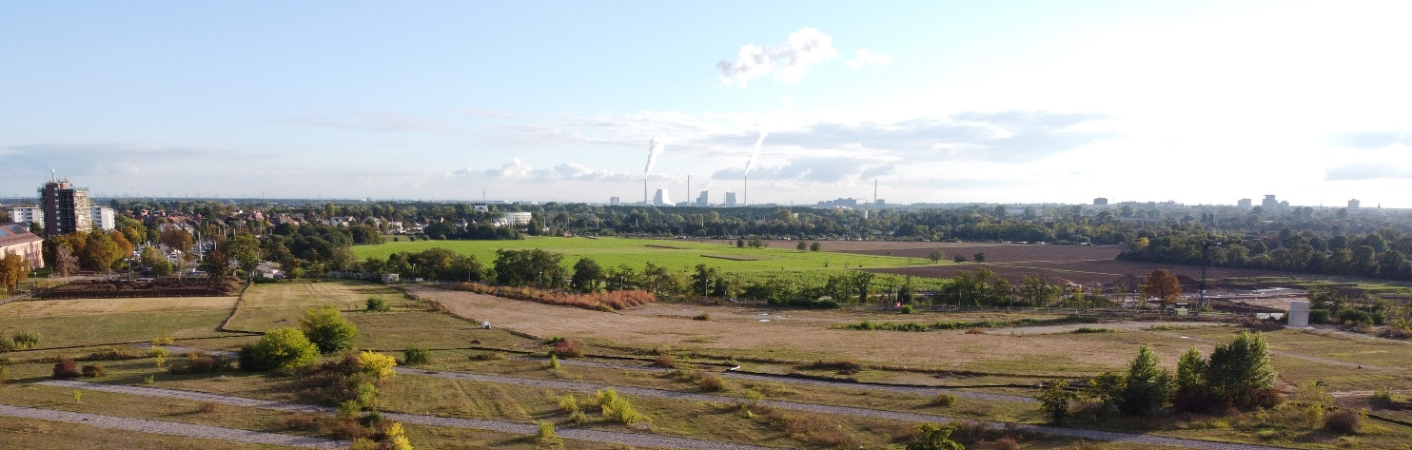

Structural System
Mechanical Integration to Draw Beauty

The structure of Yggdrasil was inspired by the natural form of tree and clock tower. Starting from a column as trunk from the ground, the structure was connected to a skeleton, as brunches of the tree, and then the triangulated façade as leaves. On top of column is the clock which represent time. The movable structure combined radical, linear, and folding movement to create the whole folding effect.

Located on top of the column, the clock hand was connected to the motor inside the column which gives initial radical kinetic movement to drive the folding of skeletons.

The beauty of mechanical system inspired from plants’ morphology

The body compose of 6 stacking levels of radial formed skeleton. Each level of skeleton consists of two layers of diamond shaped movable structure. The inner layer composes series of module of four identical steel members with hinge joint on both ends. 8 modules connected the outer layer from the column, allows linear outward movement from the centre driven by the clock and transform wind load to compression applied to the column.

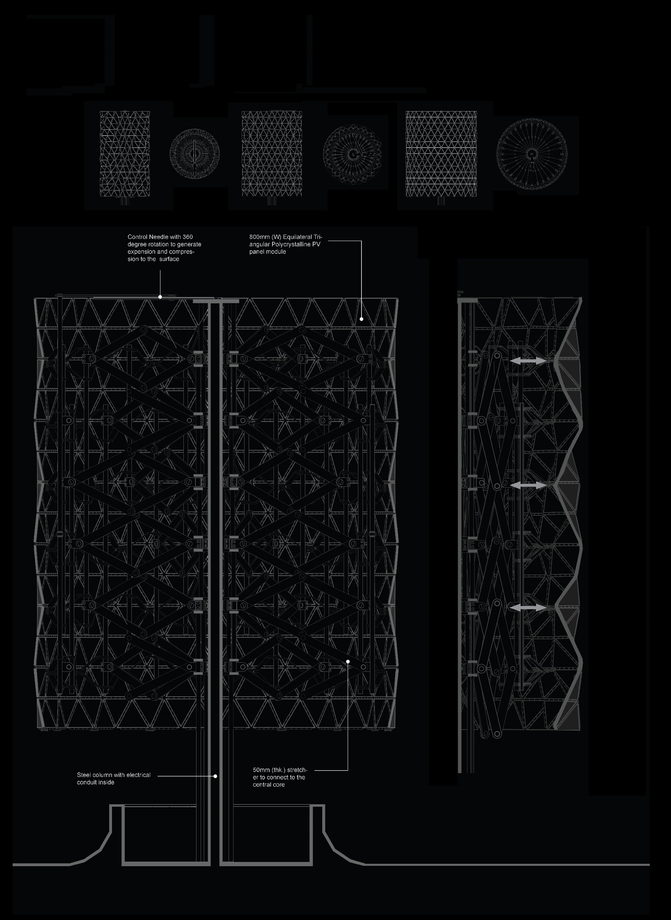

The outer layer was connected the inner layer and the facade. Having similar diamond shaped connection with the inner layer, the module of outer layer consists of a pair of steel members and a pair of hinge joint from the outermost layer of PV panels. The 16 modules connected to in a ring form outside the first layer.

With the metal rod chained the skeleton of all levels, the structure transforms the rotation of clock hand to consistent and evenly distributed folding movement along the origami-like façade, echoing the movement of the sun.

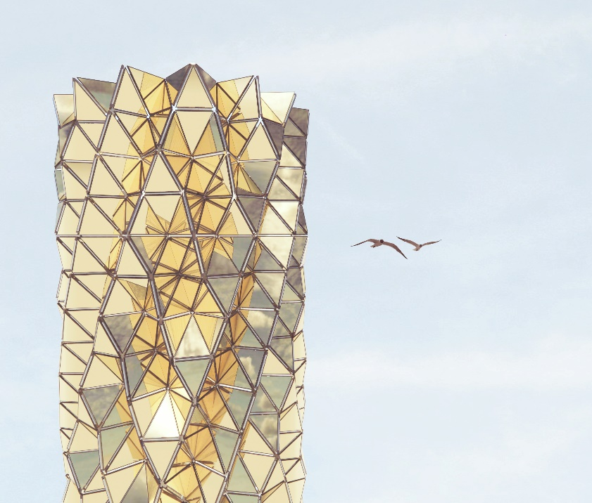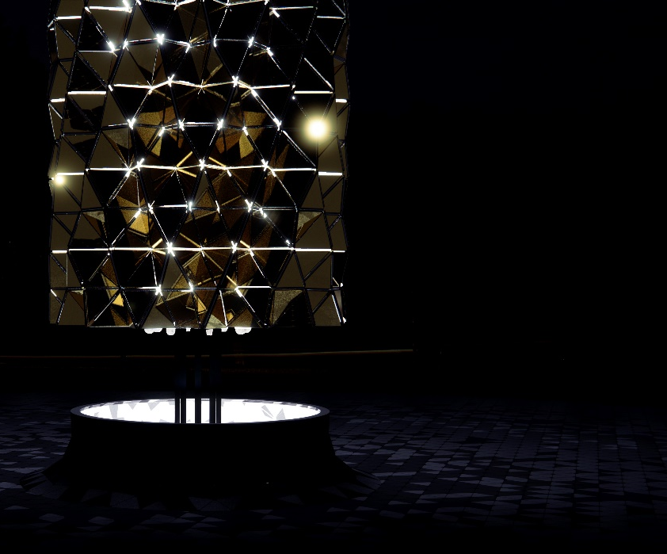

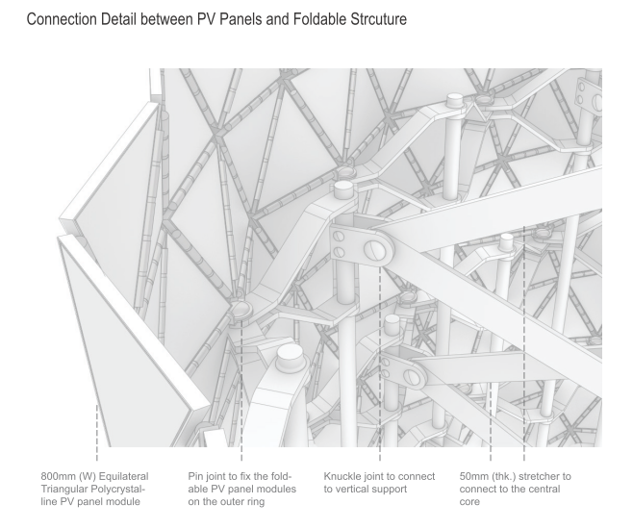

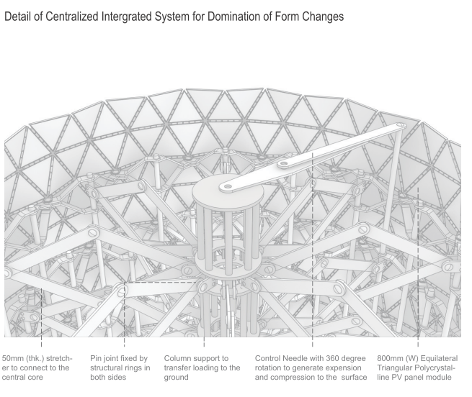

Renewable Energy
Innovation of Solar Energy

There is another mechanism to form changes in photovoltaic module installations in order to achieve the beauty of alteration and movement. A foldable system, as similar as origami, integrates the modules of PV panels instead of knuckle connections to the stretchers. Four equilateral triangles by 800mm (W) are grouped together as one module. Each module is connected to the stretchers. Additionally, each panel is hinged at the butt. The whole surface will deform when there is tension or compression by the forces. Such alteration actually be our design intent for Yggdrasil.

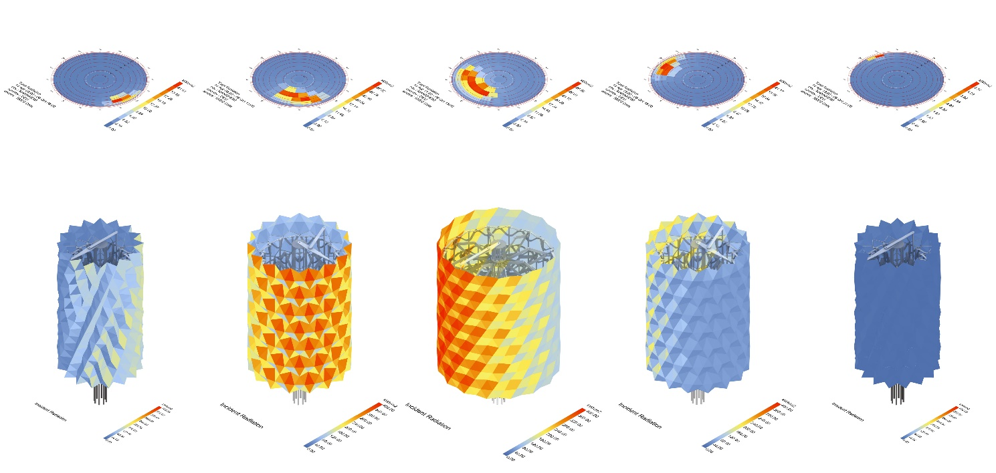
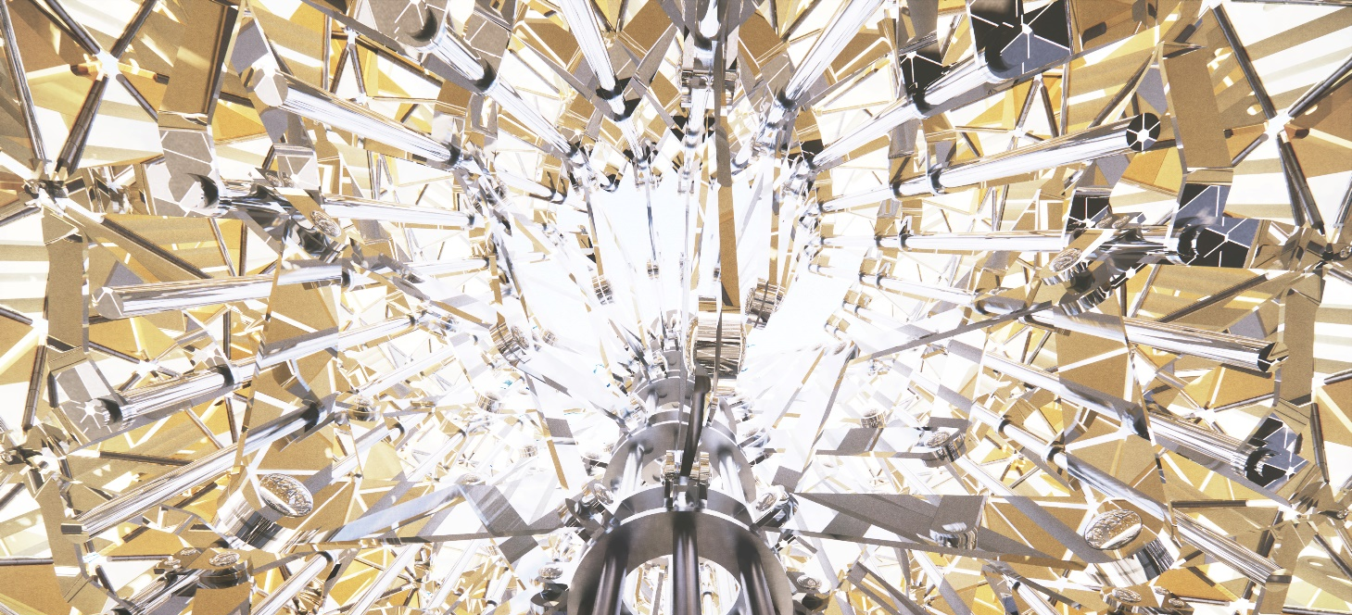

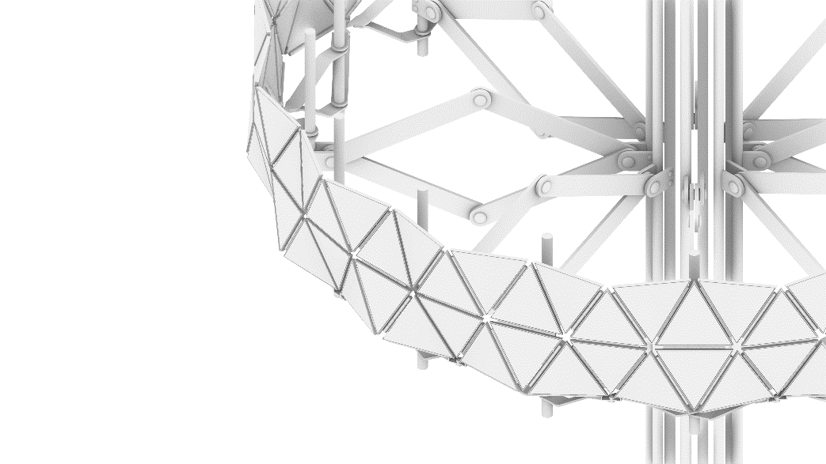
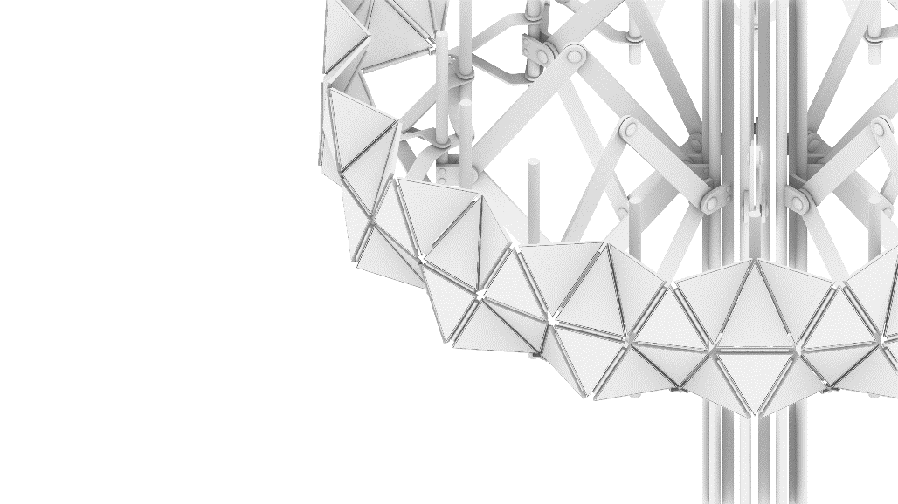
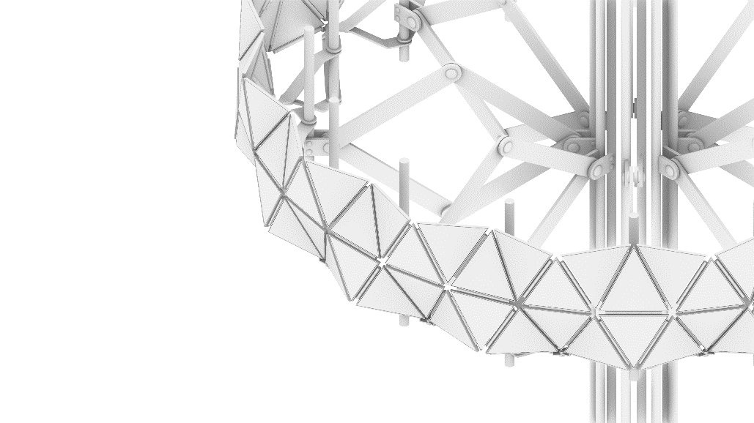
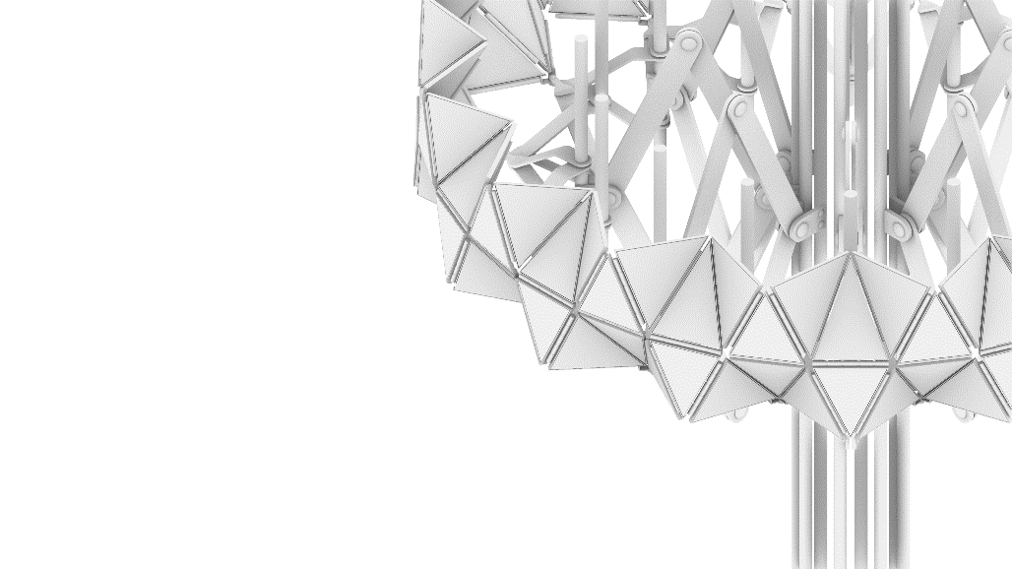
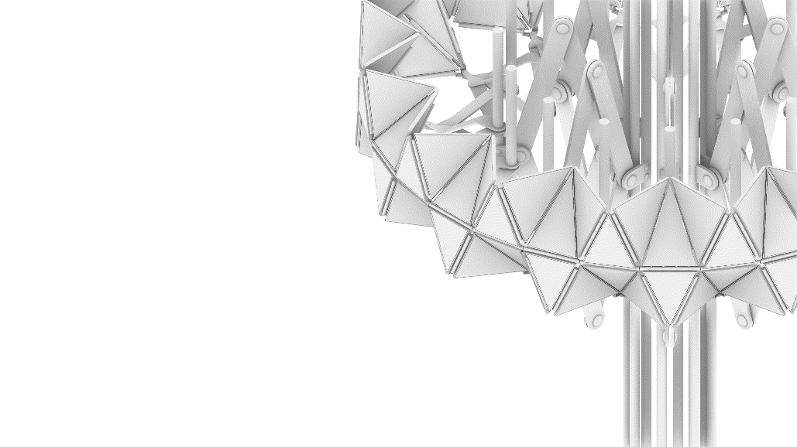
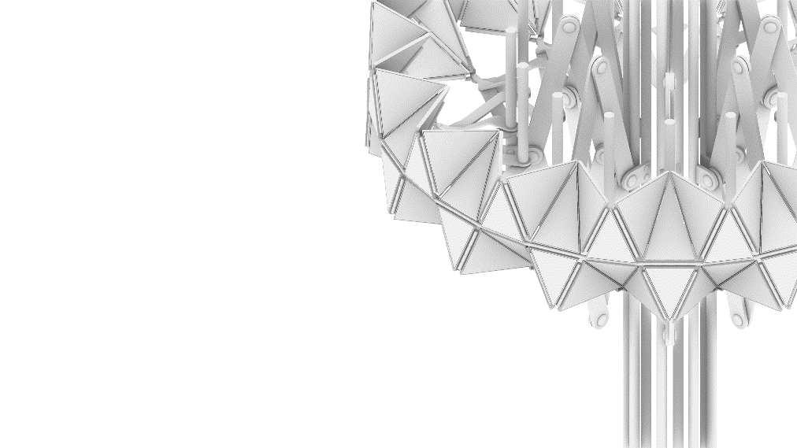

Renewable Energy
Application of Electromagnetic Triboelectric Hybrid

We also consider to apply electromagnetic triboelectric hybrid into our design in order to provide one more options for renewable energy adoption. We refer to specification of one proprietary product at the market to draft our idea. The floor paving is composed by equilateral triangular floor tiles on ground. The product can be beard 9Kn point loading in the record. Its maximum power output can be up to 5W per footstep.

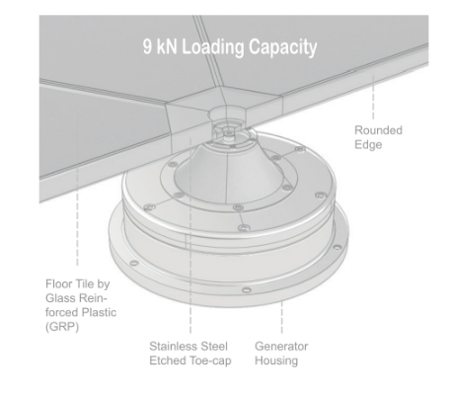
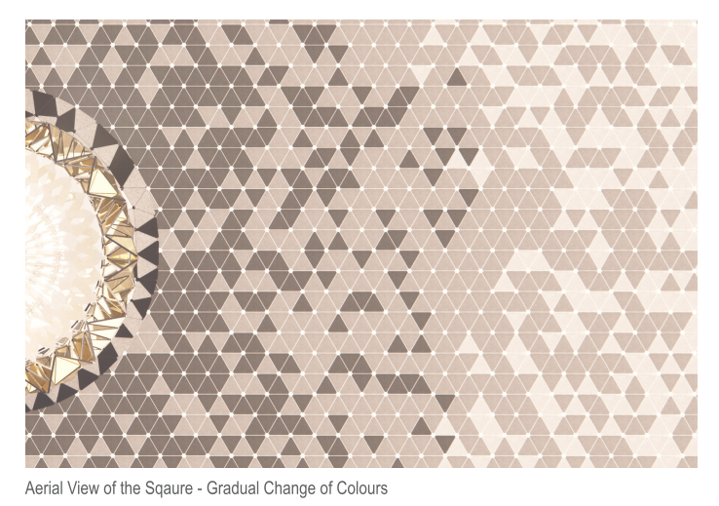
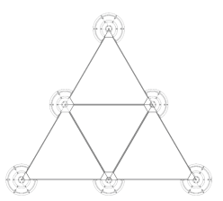

Energy Output Estimation

We have roughly estimated the energy output from our proposal. The counting has been followed in below:

Total Area of Polycrystalline Solar Panel:
=0.277 m2 (Area of a 800 width equilateral triangle) x 896 (number of panels)
=248.3 m2
Surface PV Area:
=248.3 m2 x 1000
= 2483000 W
x 23% Efficiency Assumed Based On LAGI Field Guide Renewable Energy, Crystalline Silicon:
= 571 kW
Annual kWh (kilowatt-hours) of Energy Expected:
= 248.3 m2 (Total panel Area) x 23% (Efficiency) x 5.2(Pea Sun Hours) x 75% (Effective Output % After Deducting Losses) x 365(day per year)
= 81,295 kWh/ year

Steps required to pass through the circular paving zone per person:
60m (1.5 times of diameter)/ 1.4 (steps/metre)
=43 steps/ person

Total energy generated in the area:
43 (steps/ person) x 300,000 (number of visitor in German Garden ’BIOTOPIA – Growing Community’ Floriade Expo 2022, 14 April to 9 October) x 5W (Energy generated per steps)
= 64.5 MW

Cost Estimation

Cost control is also one of our concern during the design process. Here is the cost estimation followed in below:

Polycrystalline Solar panel (800mm wide equilateral triangle)
Surface Area: 248.3 m2
Cost: $112,000
Steel Work with labour cost (including columns, folding skeleton and hinge joint on façade)
Cost: $ 5000
LED Light strip (Warm white):
Cost: $300
Electro-magnetic pavement
Area: 1000 sqm.
Cost: $200,000
Lump sum in the construction: 317,300

Environmental Impact Summary
Reduction and Encouragement

In order to minimise impacts to the environment during construction process, our proposal of Yggdrasil will fully reach the standard of Energy Performance of Buildings Directive (EPBD) in the aim of achieving net zero emissions and sustainable construction.

Firstly, we propose to use sustainable steel for the main structure. The materials should be manufactured under the scrap-based electric arc furnaces (EAF) production in order to reduce emissions. According to relevant research from EY Analysis, reduction of carbon dioxide can be up to 80% during production compared to the traditional blast furnaces (BFs). Also, the materials should be procured nearby the region, in order to reduce environmental impacts arising from transportation.
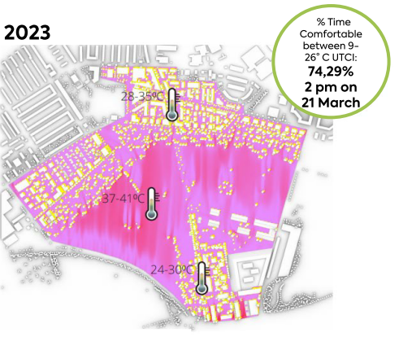
Furthermore, control of material colours is also our consideration. In summer, the land field of the Spinelli Park can be raised to 40 °C by a count of universal thermal comfort index (UTCI). Minimising absorption of heat radiation within the construction site is then a major concern in the proposal. Therefore, selection of light colour for materials is a basic design principle so that the infrared heat can efficiently be reflected to limit the solar heat gain on the ground surface.

Finally, our proposal is an experiment to firstly apply electromagnetic triboelectric hybrid technology into the open spaces in Mannheim. The latest researches was found that if the hybrid floor-tile to integrate with sufficient device and bridge rectifier, the maximum power output can be up to 5W per footstep. If this application is successful in this project, it will be a good example to encourage wide range of uses within the communities. It can reduce dependence on power supply from non-renewable energy.

