Building Game
A sustainable built environment made fun and accessible

Everyone is an Architect
- Claudia W. Otten

Our contribution to the LAGI 2022 focuses on bringing a sustainable built environment to the masses. We developed a new, three dimensional interlocking brick made out of Adobe material. This interlocking turns a building project into a building puzzle which we aid users in solving through the usage of Augmented Reality and Virtual Reality, empowering them to express their creativity in the built environment.

Site
The building site at the spinelli barracks area hosting the BUGA 2023, is located in Mannheim in southern Germany. This region is historically one of the warmest and driest in Germany and we analyzed that with the recent climatic changes, this trend continues further. On site we propose a participative and educative building sculpture which aims to educate visitors on sustainable building materials and techniques. We teach visitors about a traditional building material, adobe and how it empowers the creation of sustainable building blocks through regenerative energy sources. Visitors can source, create and use our building blocks to participate in the creation and modification of a landscape sculpture at the Bundesgartenschau. Our system is inherently designed to allow for big and complex structures as well as small-scale and practical applications in a home garden context.

Adobe

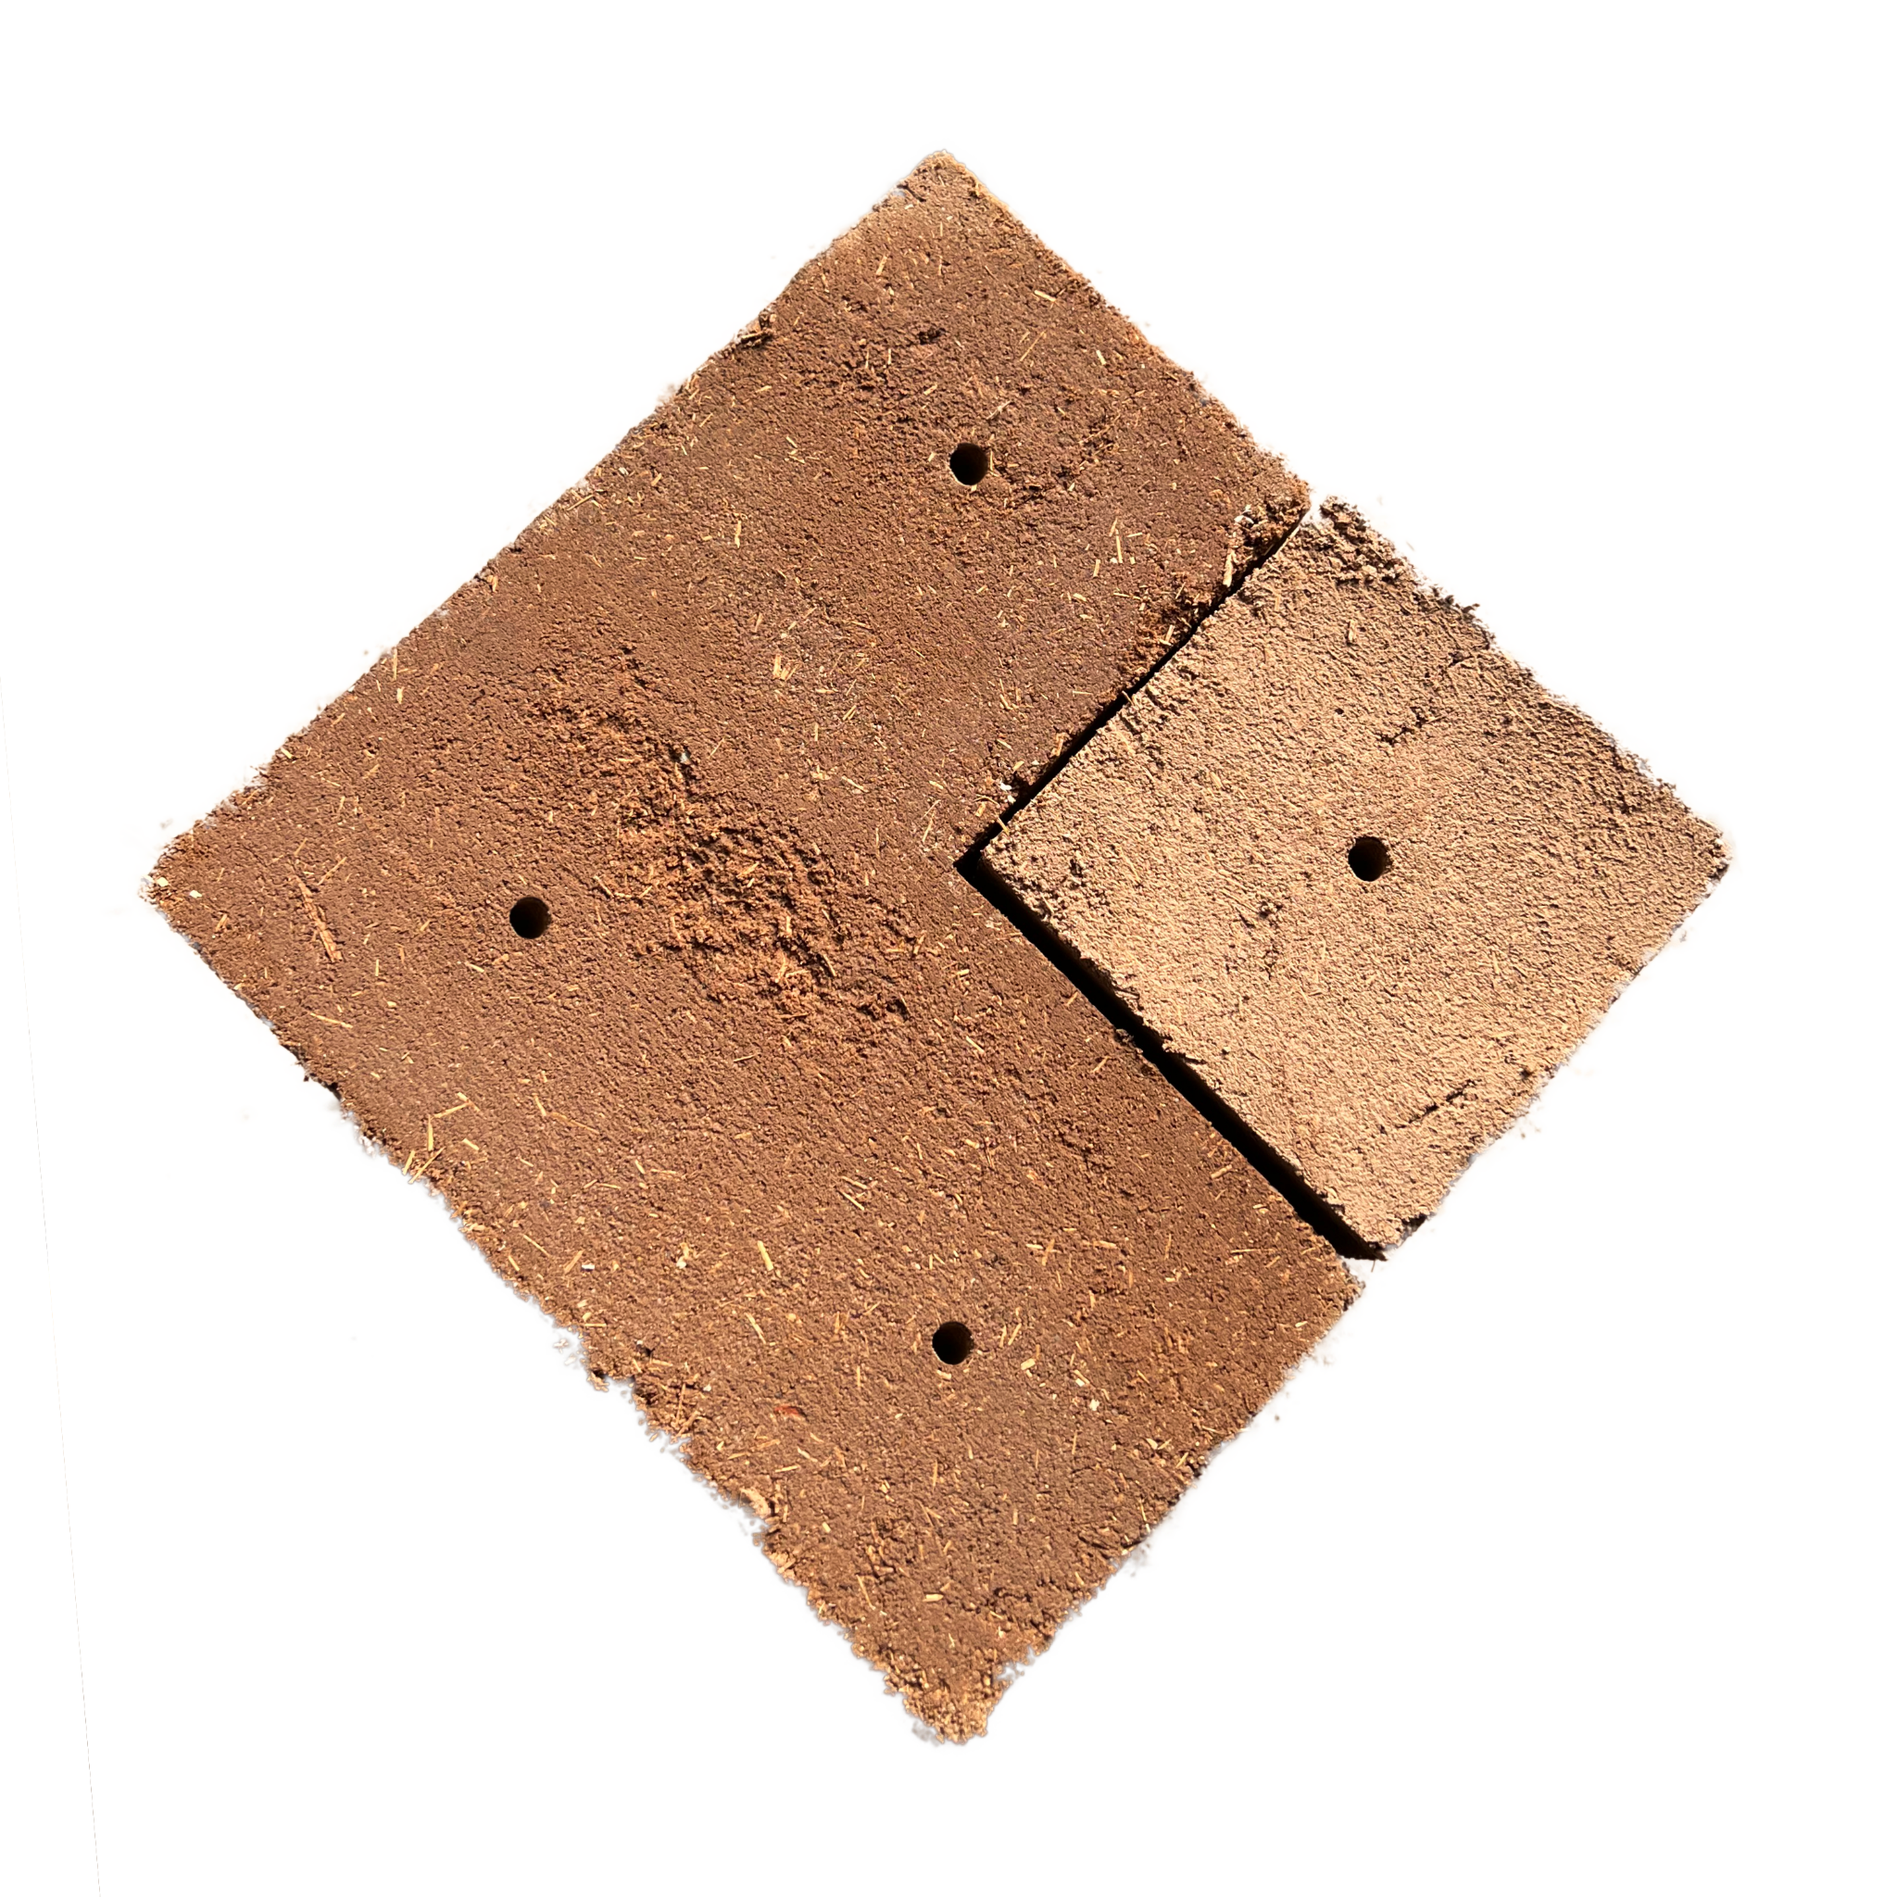

The material for our novel bricks, Adobe, is a building material with a rich history of being used in building projects across cultures and ages all over the world. It is inherently sustainable, being made out of Clay, Water, Straw and Manure. Traditionally it is acquired by mixing the components, forming the mixture into bricks using molds and drying it in direct sunlight.
The whole process takes at least 2 weeks, depending on the humidity, temperature and sun hours of the site. The times for the individual steps are as follows:

- Formation mixing the material and pressing it into the mold: 30 minutes
- Pre-drying letting the brick solidify enough to be moved: 2 days
- Drying move the brick away from ground and let fully dry: 2-6 weeks

After sourcing and transporting the raw materials to the building site, the fabrication of our bricks only uses human labor, solar and wind energy.

Bricks

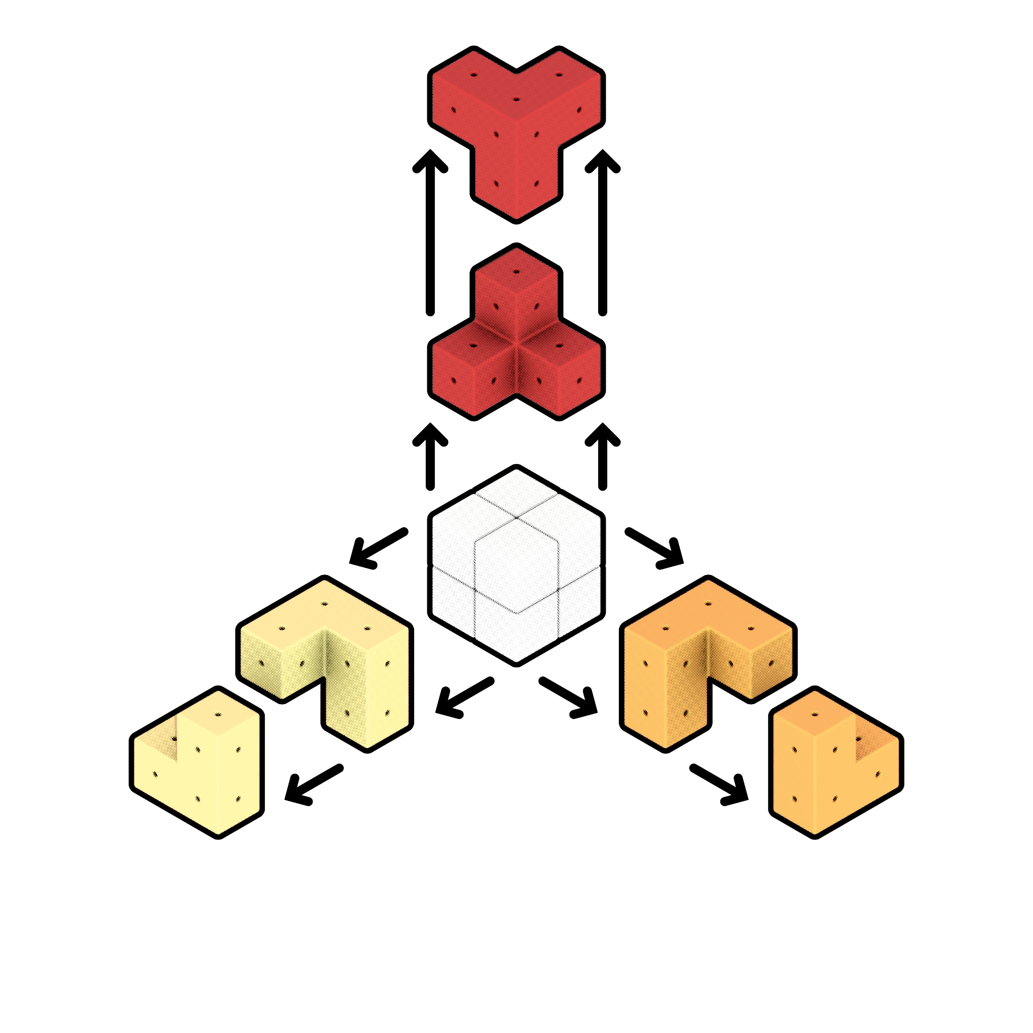

Our interlocking bricks are conceptually cut from the 2 by 2 unit cube. Contrary to traditional brick shapes which are mostly extruded from a base shape, our bricks extend in all 3 dimensions. We developed 3 unique shapes, as well as multiple designs possible to be created from combining those shapes.

Technology

While our system can be fun and rewarding towards participants wanting to challenge their imagination, we also want it to be inclusive and lower the barrier of entry for all visitors. For this we supply the possibility to be guided through the building process by an algorithm which can either run on the visitor's smartphone visualized in Augmented Reality, or through Virtual Reality glasses on site. Participants can choose from a library of simple architectural parts, as well as sketch shapes in the digital space. The algorithm then proposes ways of achieving the shapes the users requested and is flexible enough to react to changes users might introduce while building. For this we developed a custom implementation of the wave function collapse algorithm extended in the third dimension. While designing with the system ourselves we found it to be very flexible and achieving promising results in almost realtime for reasonable structure sizes.

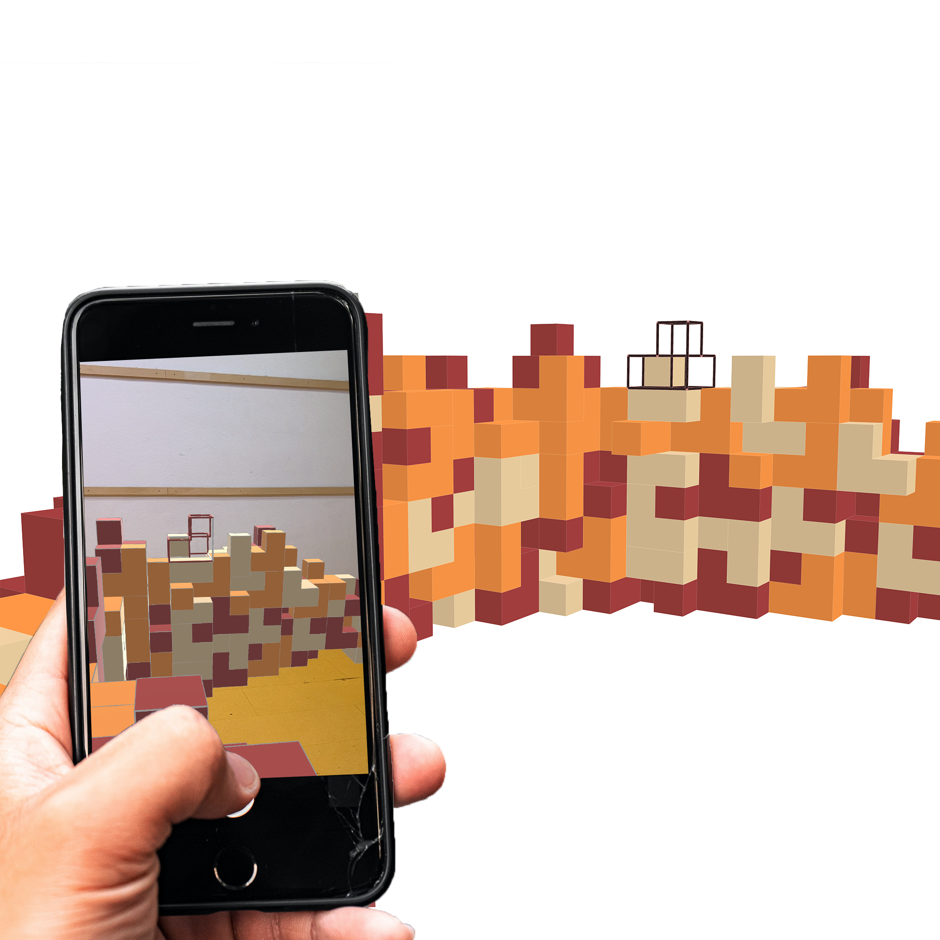

Building Game

In our building game we focus on the fun aspects of participation, teamwork and creativity. Visitors get the chance to participate in the whole process of sourcing and making our bricks, as well as placing them either towards some community goal or for individual creative pleasure. We expect most daily visitors to only shortly participate, so to reduce the barrier of entry we have a stock of ready-made bricks on site, as well as algorithmic helpers available through AR, and VR. We gamify the experience of sourcing building materials and being part of a team building towards a bigger structure. Through this we want to educate visitors on sustainable building techniques they can also use in the small scale context of their home garden.
We also offer special workshops on the weekend on a second, temporary site, which can be used as team-building exercises and generally span multiple hours or days, working towards self-found or pre-existent sculptural goals. Participants can learn to contribute towards a complex real-world project as well as to express their creativity in the built environment.

Energy

We envision the future of sustainable energy as an act of restoration and human active participation, we tried to show a novel way of sustainable thinking by restoration of different kinds of energy into our brick system, starting this cycle from our visitor’s participation to building the bricks, going through all the stages needed to get a fully shaped element, until we reach the moment where we address maximizing the usage of sun energy by exploring new ways of benefiting from it.

This cycle is building a bridge between traditional techniques and modern conceptual approaches towards a new sustainable world, and brings to the table that everyone can actively participate through millions of simple steps in creating a better environment for all.

Cost estimate

For our composite we need to buy clay, straw, manure and water, as well as wood for the molds.

We assume 10000 bricks being built during the BUGA, which gives the following material quantities needed:

Material | Quantity | Cost per ton | Total Cost
Water | 11.2m³ | 3.01€ | 33.71€
Straw | 16.8t | 100€ | 1680.00€
Clay-sand mixture | 28t | 40€ | 1120.00€
 |  |  | 2833.71€

Energy Calculation

The materials used for our Adobe bricks can be locally sourced from the Mannheim region, which makes energy usage for transport negligible in the overall energetic context of our building material. Mixing and compressing is achieved through human labor which we also consider a renewable energy source. Our brick composite is moist and soft and we harvest the energy needed for drying directly from the sun.

The monthly average temperature in Mannheim during the summer is around 20°C and we know that the energy needed to evaporate one gram of water at this temperature is 585 calories.

Our composite has a water content of 20%, from this and the weight of our bricks being 5.6kg each we can deduct the amount of water per brick being 1120gram.

From this follows for the energy gain per brick:

$1120g × 585\frac{cal}{g} =655.2kcal$

Which equates to 0,000761488MWh per brick.

Our goal for the timespan of the exhibition would be the creation of around 10000 bricks. If successful this would equate to a total of 7,61488MWh energy gained.

