ENERGY CIRCUS
SEED (Socio-Ecological Energizing Device) of Mannheim
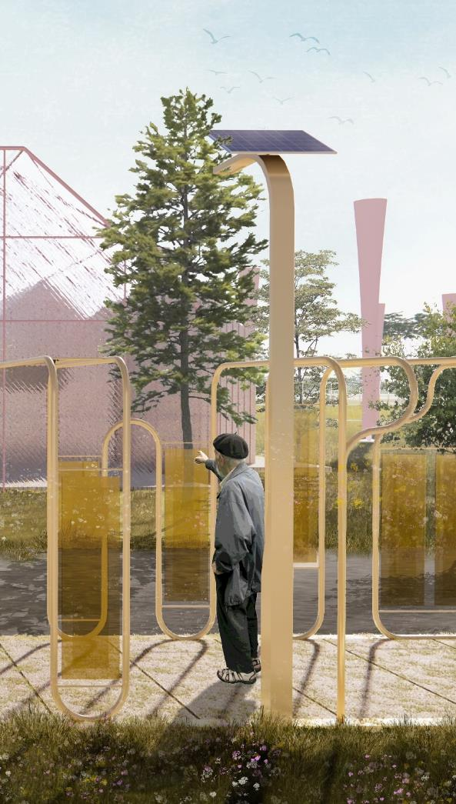

CONTENT

Prologue: Project Statement …3
Energy Circus: SEED (Socio-Ecological Energizing Device) of Mannheim

Chapter 1: Blueprint of Energy Circus …6
Contextual Inquiries & Strategic Planning
Programmatic Framework & Ecosystem

Chapter 2: SEED (Socio-Ecological Energizing Device) Inventory …13
Food: Productive Landscape
Civic: Collective Participation
Technology: Operative Implementation
Ecology: Environmental Stewardship

Chapter 3: Renewable Construction & Material Ecology …19
Obsolescence of Our Built Environment
Closed-Loop Resources Cycle
Design for Disassembly
Architecture: The Constructive Imageability

Epilogue: Conclusive Remarks …24
Environmental Impact Summary
Energy Generation Brief Calculation
References

PROLOGUE
Project Statement

Energy Circus: SEED (Socio-Ecological Energizing Device) of Mannheim

Alongside with the BUGA 23 horticultural show, the former Spinelli Barracks site is expected to be transformed into a public park- filled with lush greens, rich biodiversity, and active participation of communities. Such transition inspires us to forwardly express our imagination upon the future of the park: What will be the ideal relationship between people, the landscape, its wildlife, and the energy/ resources which cycles within? How would this cycle be emerged and prevailed to its community in a tactile and theatrical experience? And what could be the possible meaning of this park to Mannheim?

Responding to these initial propositions, the project Energy Circus align itself to the theme of the festive atmosphere of BUGA 23, envisioning a public park driven by flow of energy and native resources that are staged analogously to a circus. Energy Circus shall become a collective ground to cultivate intimate relationship between its community, landscape, and wildlife through a bespoke cycle of shared ecosystem. While offering an educational, participative yet playful experience, the public park is left to be embellished and grow with natural human activities and organic changes over time.

In this sense, architecture is perceived as temporary guest here without override the pre-existed environment. Energy Circus is designed with an inventory of SEEDs (Socio-Ecological Energizing Devices) to support the holistic ecosystem. These lightweight and transient structures are acting as series of energy or resources apparatus to support the 4 significant domains in the masterplan- food, civic, ecology, technology, and ecology. They are the vessels to channel and revamp the energy or natural resources, where a palpable close-loop cycle could be witnessed, celebrated, observed, and learned when navigating through the park.

Reflecting on the 4 domains stated, the programmatic framework of Energy Circus is shaped for combination of sustainable and resilient purposes- [1] food: cultivation of productive landscapes; [2] civic: fostering collective participation; [3] technology: efficient operative implementation; and [4] ecology: initiating environmental stewardships. Energy Circus is thus, a resonance of vivid biosphere and visible circulation of energy flows, natural resources, people’s movements, and wild livings- almost akin to an ‘energy amusement park’.

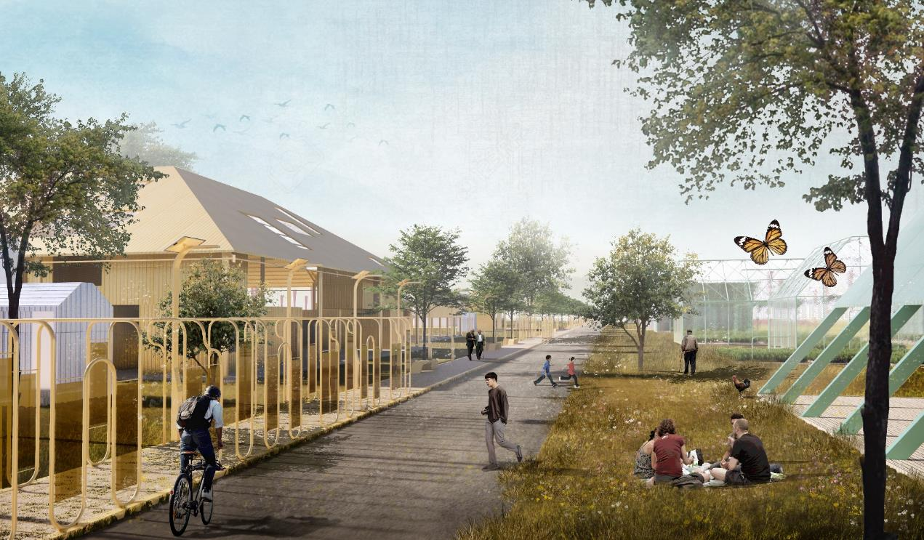
The focus area of Energy Circus is tagged along to an axial nave by transforming it to be a sensorial journey allow its visitors to observe, experience, and participate in the flow of energy and resources- where a circular cycle is never complete without its receptors or audiences.

CHAPTER 01
Blueprint of Energy Circus
Contextual Inquiries & Strategic Planning
The overall blueprint revolves around the intersectional area between the prominent green corridors, forming a nave that becomes the focused area as pilot project. It encapsulates the proposed designs of temporary energy/ resources apparatus that are scalable and replicable within or beyond the Spinelli Park.
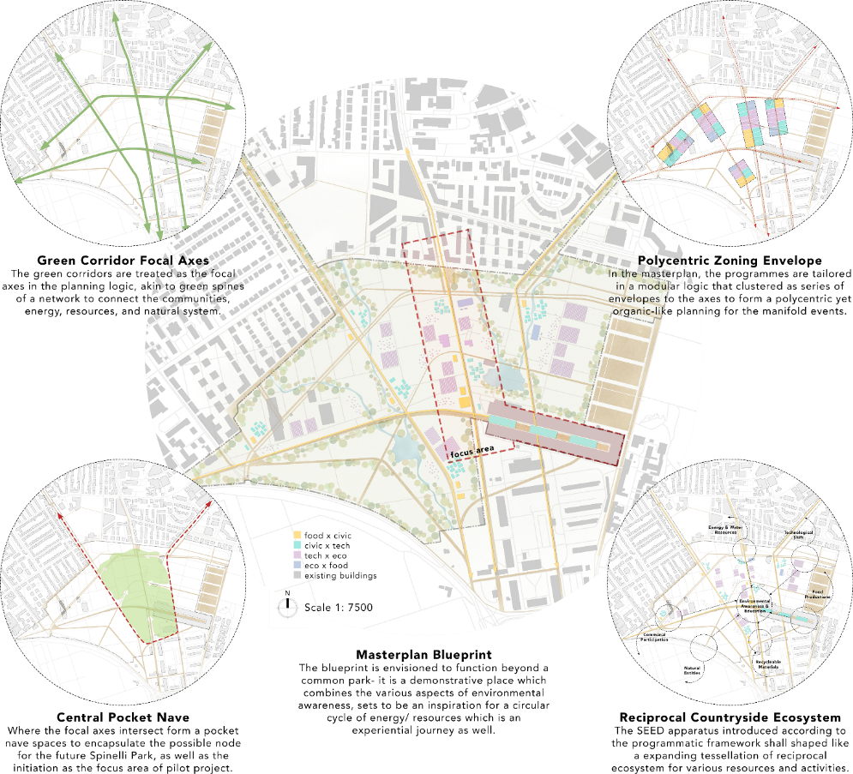
Sits on a relatively suburban setting, the notion of master planning is first informed by the axes of the green corridors, then emerges a central pocket area which we anticipate rendezvous of manifold activities. Zoning layers are organically envelopes the central area, with programmatic infill to the 4 pillar domains- food, civic, technology, and ecology. The relations of this domains are later materialized into energy/ resources apparatus which complement a greater and perceptible energy cycle in motion.
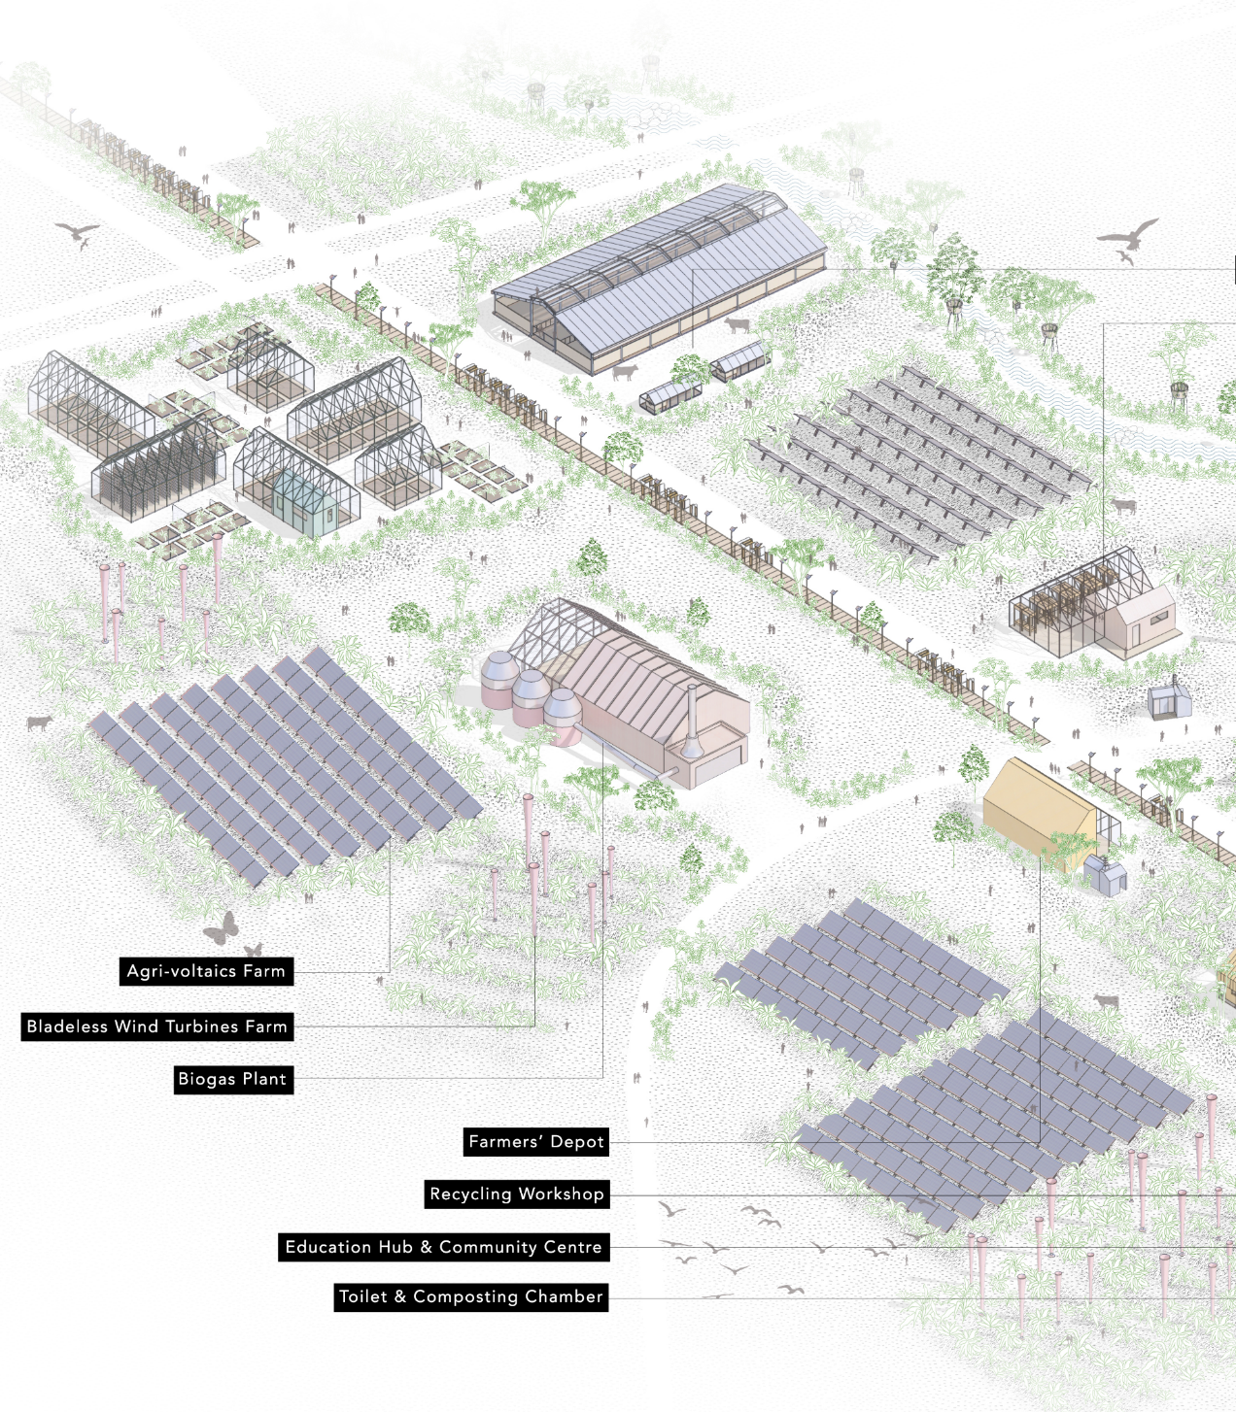
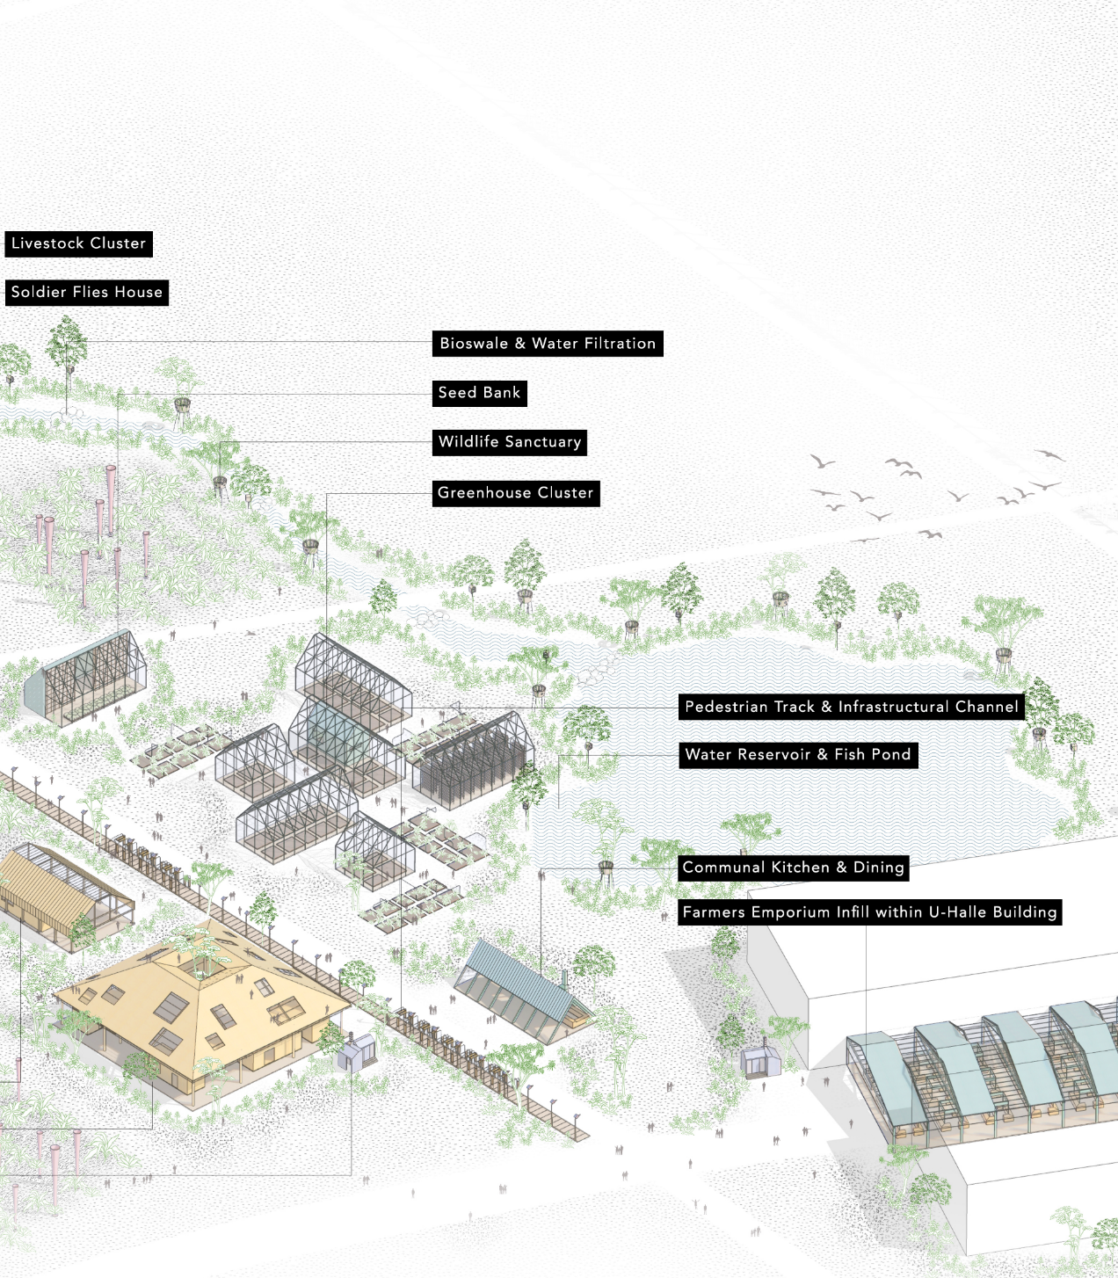
Programmatic Framework & Ecosystem
The blueprint of energy circus is introduced as a programmatic framework and ecosystem instead of a stringent planning to allow room for bottom-up process and flexibility for changes. Analogous to an energy carousel, the logic of the framework is rooted within the circulation of the manifold aspects of food, civic, technology, and ecology. The conjunctions of these aspects branch into the energy/ resources apparatus responding to their functions as a vessel to complement the energy/ resources cycle in a self-regenerative loop.

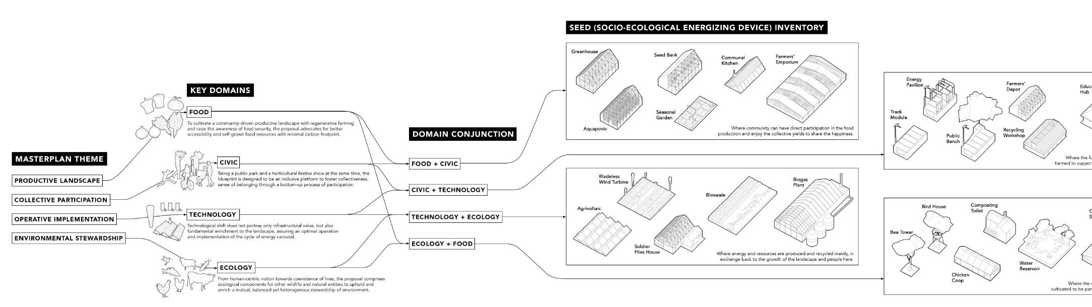

These seemingly independent and distinct apparatus does not function alone but instead, reciprocate to shape a circular system and exchanges within and beyond the park. They are not merely functional parts, but interpreted their meanings relatively to one another to encapsulate a broader totality in harmony and rhythm. Orchestrated under such framework, new lifelines are drawn upon the public park and a multilayered ecosystem arises naturally- seeding the park and its surrounding context for a sustainable, resilient, and reciprocal future.

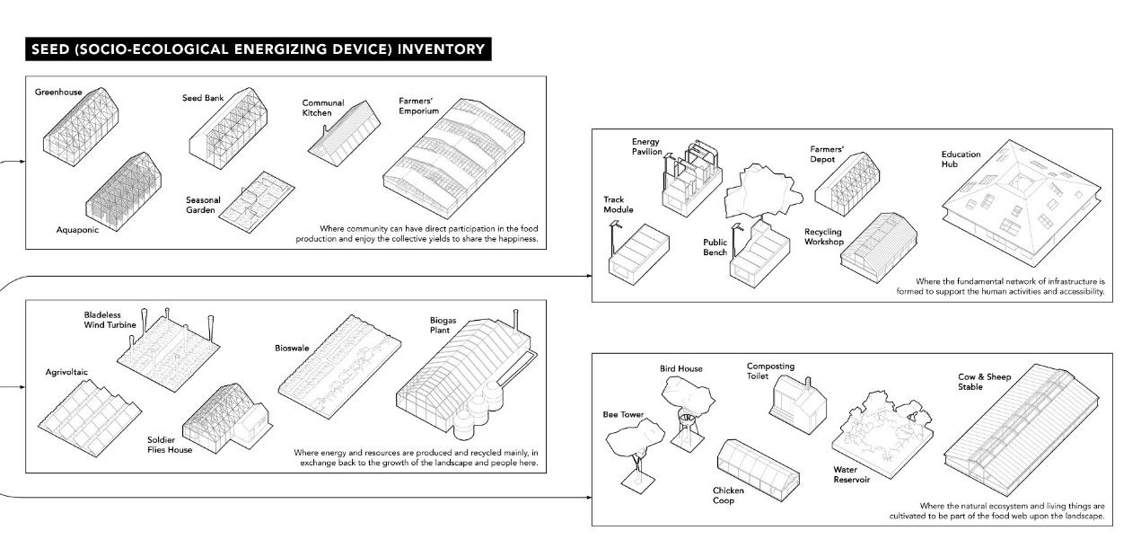

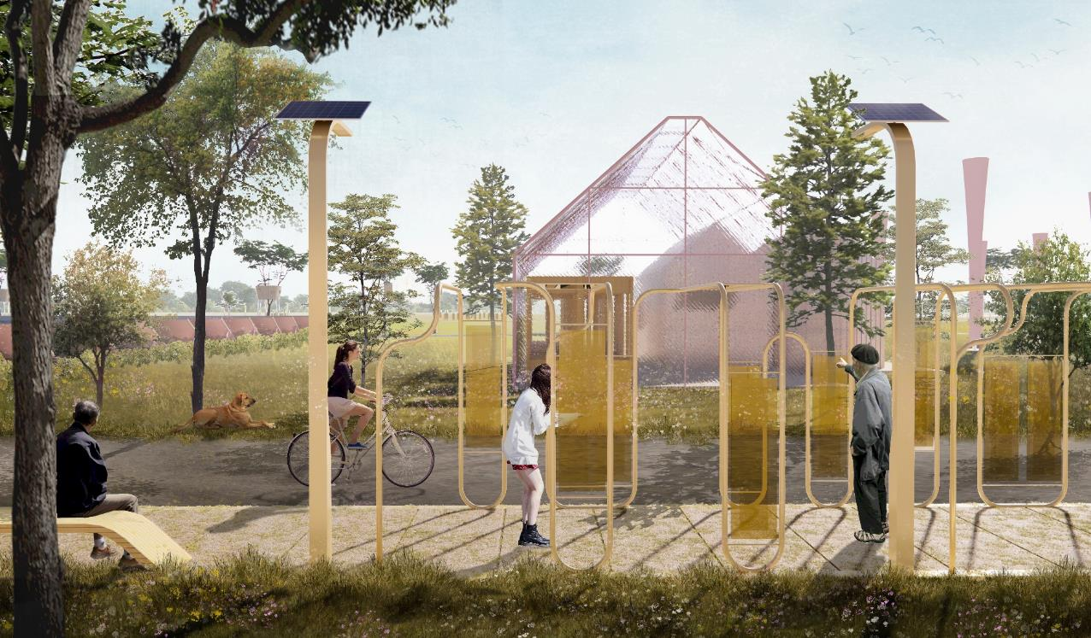
The energy pavilion along the trail provides an interactive segment with piezoelectric films that generates energy through touching, subconsciously leading the visitors to play and participate in such environment.

CHAPTER 02
SEED (Socio-Ecological Energizing Device) Inventory
Food: Productive Landscape
To cultivate a community-driven productive landscape with regenerative farming and raise the awareness of food security, the proposal advocates for better accessibility and self-grown food resources with minimal carbon footprint.

Civic: Collective Participation
Being a public park and a horticultural festive show at the same time, the blueprint is designed to be an inclusive platform to foster collectiveness, sense of belonging through a bottom-up process of participation.

Technology: Operative Implementation
Technological shift does not portray only infrastructural value, but also fundamental enrichment to the landscape, assuring an optimal operation and implementation of the cycle of energy carousel.

Ecology: Environmental Stewardship
From human-centric notion towards coexistence of lives, the proposal comprises ecological components for other wildlife and natural entities to uphold and enrich a mutual, balanced yet heterogenous stewardship of environment.

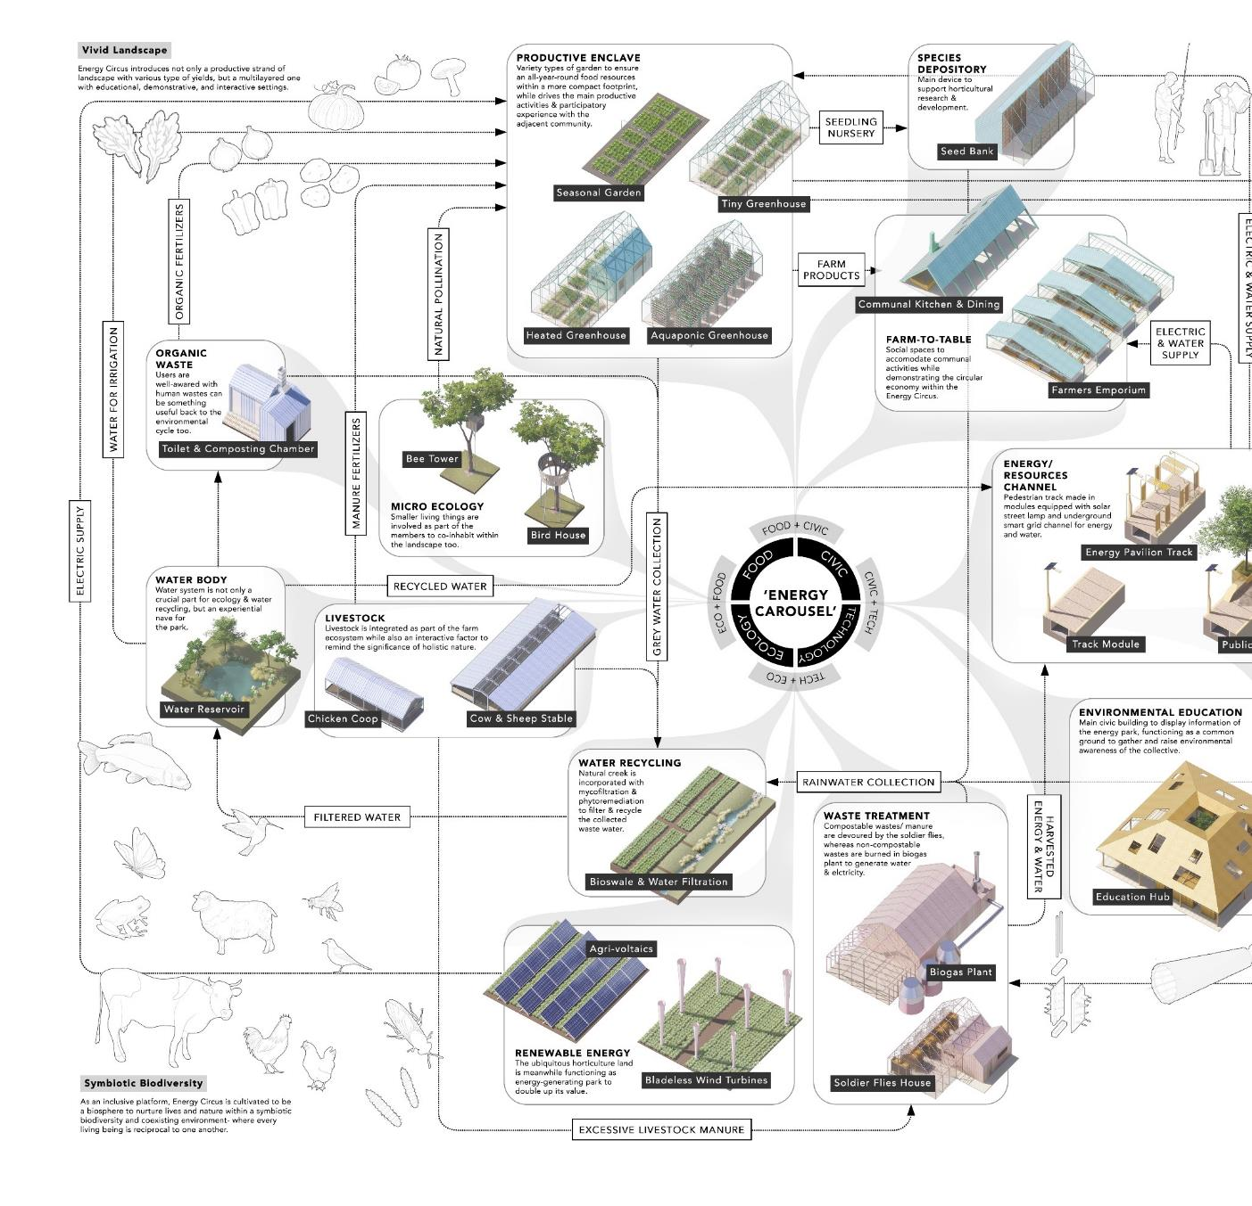
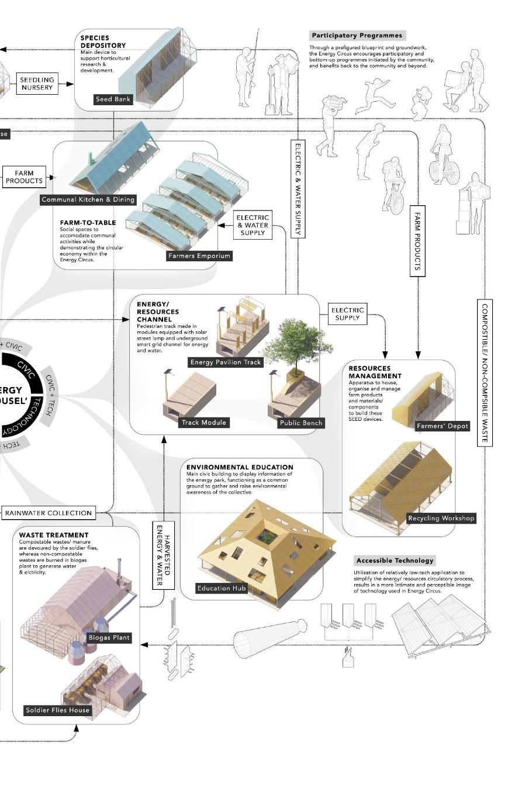
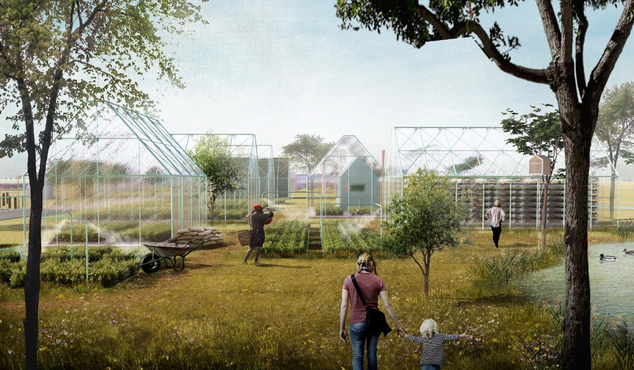
A productive landscape is pioneered naturally through the communal horticultural activities, with a tactile experience where the moisturizing mist comes from the recycle tubes and sunlight diffused through the polycarbonate panels
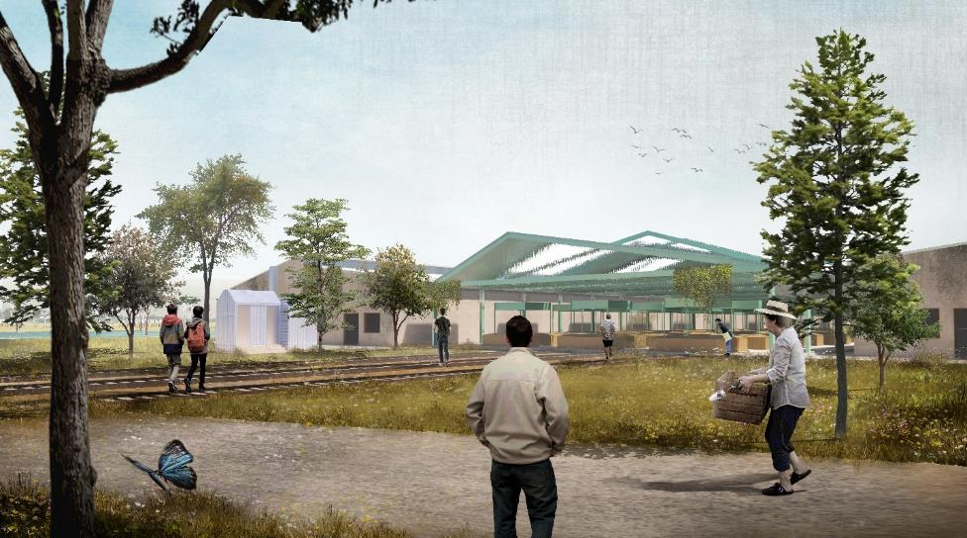
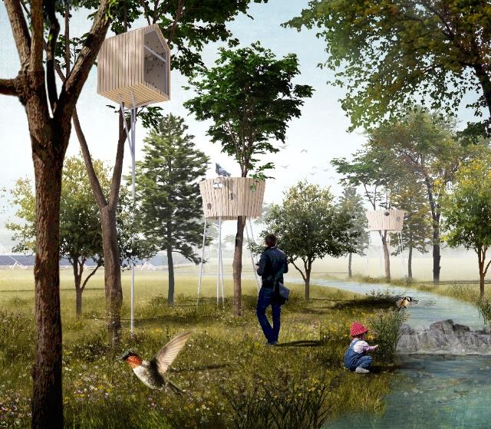
Infill of Farmers’ Emporium within the U-Halle building gives a second life as a community-centric place populated by socioeconomic activities, encouraging the conscious to inhabit again on even ruined buildings.
The bioswale is not only a filtration channel for water resources, but also becomes a wildlife sanctuary with the birdhouses and bee towers which helps pollinate the biodiversity of plants.

CHAPTER 03
Renewable Construction & Material Ecology
Obsolescence of Our Built Environment
Studies have shown that demolition processes account largely for the negative environmental impact of buildings. The main problem is the fact that the assembled materials nowadays have very low or no potential for reuse or recycle. During the last decades, while architects have been mainly dealing with reducing the energy consumption of buildings, the use life cycles of buildings has gradually shortened due to the use requirements and the needs of people and society have been changing at a faster pace.
Conversely, the technical life cycle has increased and building structures have been designed to last for 50 to 100 years. This led to an unbalanced system where buildings are designed to last longer than their actual need. Furthermore, the extensive use of non-renewable material in the building industry is leading to a faster depletion of the available resources and to an increase in carbon emissions and energy consumption due to manufacturing processes.
Therefore, it is time for a new design approach which considers the possibility of reusing components and elements or entire products and buildings extending the material life cycles. It is also important to maximise the use of natural and renewable materials to slow down the depletion process and minimise the environmental footprint of materials in the built environment.
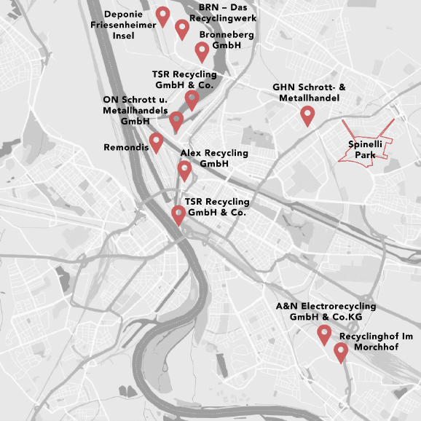
Recycling Centers in Mannheim
The tessellation of resources and industrial waste recycling could be a supportive network to Energy Circus, proposing better and mature practice for localized resources recycling.

Closed-Loop Resources Cycle
Carbon footprint of buildings are embodied carbon accounts for all the processes involved in extracting, producing, installing, and transporting materials for the purposes of construction. The proposal innovates a material ecology for a low-carbon footprint design that incorporates several integrated cycles to minimize the carbon emission during the construction process, while able to recover the energy embodied in materials. Shaped under the vision for a renewable construction and material ecology, the closed-loop resources cycle is not only responds for an ever-changing adaptation and inhabitation over the existing landscape, but also raises a wider concern on the ecological perspective in our built environment.
With the computational-aided design and localized sourcing of salvaged building materials, construction waste is minimized hence a lower embodied carbon. The materials used are component-based design which are able to be disassembled and then retrieved when the buildings are decommissioned. As the lifespan of these materials extended, they can be circulated within this resources cycle and being reassembled again for another round of new inhabitation even at a new site. On the other hand, incremental components of renewable energy harnessing are introduced as detachable modules to counterbalance the operative carbon and regular energy consumption.
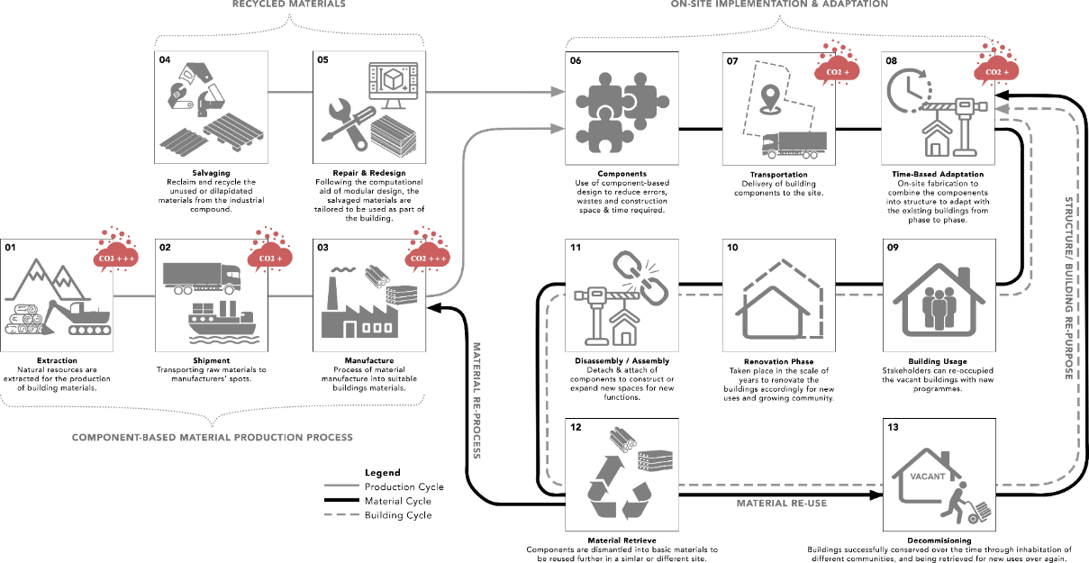

Design for Disassembly
Architecture in this proposal is interpreted as non-static and ever-changing, primarily revolves on the idea of metabolism across an existing landscape. Adopting the concept of S. Brand’s Typical Shearing Layers of Buildings, the architecture is being anatomized into series of layers, which is replaceable, renewable, and retrievable. The design for disassembly could implement the similar notion to incorporate recycled materials, M&E system and more complex functions on top of the structural frame. It is originated on the belief that our built environment should evolve into a more adaptive and flexible framework, transforms accordingly to the growing community, different events, and time without compromising the essence of its environment.
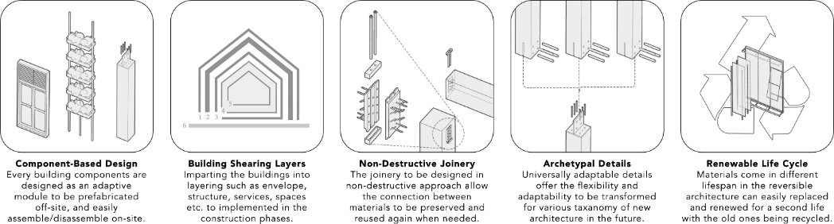
The designs are primarily made with the lightweight combination of engineered timbers, steels, polycarbonate sheets, and many salvaged industrial materials. By adopting a combination of fleeting and transient materiality, the architecture touches the landscape lightly with low environmental impact.

Architecture: The Constructive Imageability
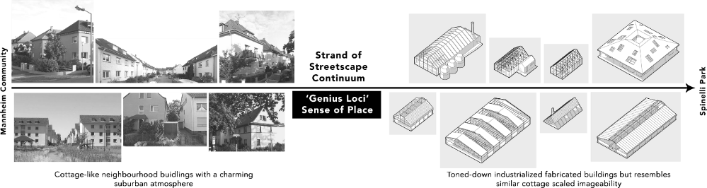
Located within a countryside setting complementing a horticultural theme, the architecture in the Energy Circus is traced from the cottage typology which is easily found within the nearby context. From a larger picture, the cottage-like modules shall construct an intimate imageability without disrupting the environment, remained in a more humane-scaled and naturally textured iteration.

The recycle hub with an opened plan houses the various salvaged materials and showcase the process to recover them as part of the buildings within the park.
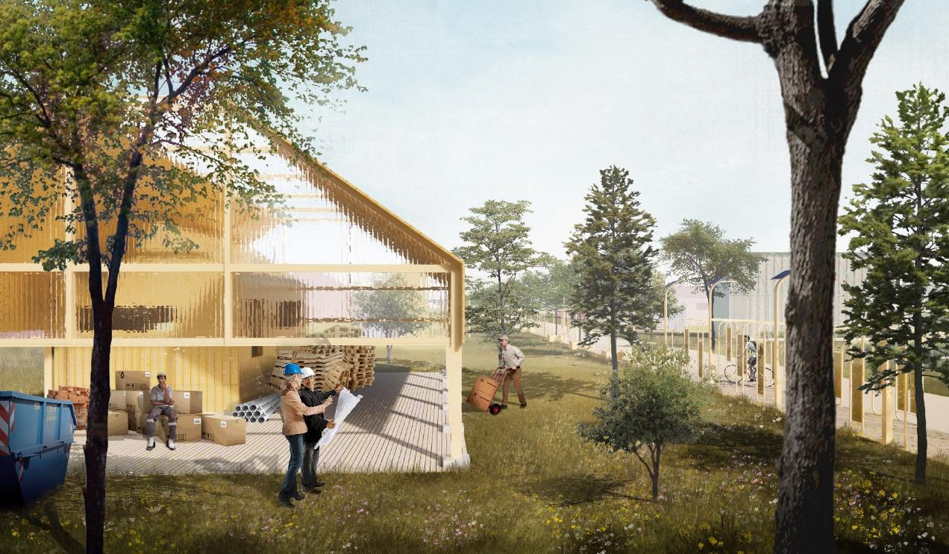

EPILOGUE
Conclusive Remarks
Environmental Impact Summary
The design proposal of Energy Circus revolves around the key notion to fabricate a renewable cycle of energy/ resources that is well-rooted within its environment, context, and community. The cycle is thus supported by various aspects including natural resources, materiality, construction ecology, and supplementary infrastructures.
At the very fundamental level, primary program like horticulture comes with the composting, irrigating, waste decomposing is integrated with relatively organic method based with natural resources. These include mycofiltration and phytoremediation water recycling system, bee and bird houses, composting toilet, and soldier flies chamber. They are low-tech, low energy and low maintenance to leave minimal impact to the environment but enriching it instead.
Besides the horticultural activities, the park involved with civic participation requires other build-ups. Anchoring to the cottage typology and human-scale design, these structures are fabricated from salvaged industrial materials that can be sourced from the nearby recycle centers around Mannheim. The lightweight and easily maintained materials such as mild steel members, cross laminated timbers, wooden pallets, polycarbonate sheets, metal decks- would fits suitably for component-based design which is capable for disassembly after a timespan when the buildings are decommissioned.
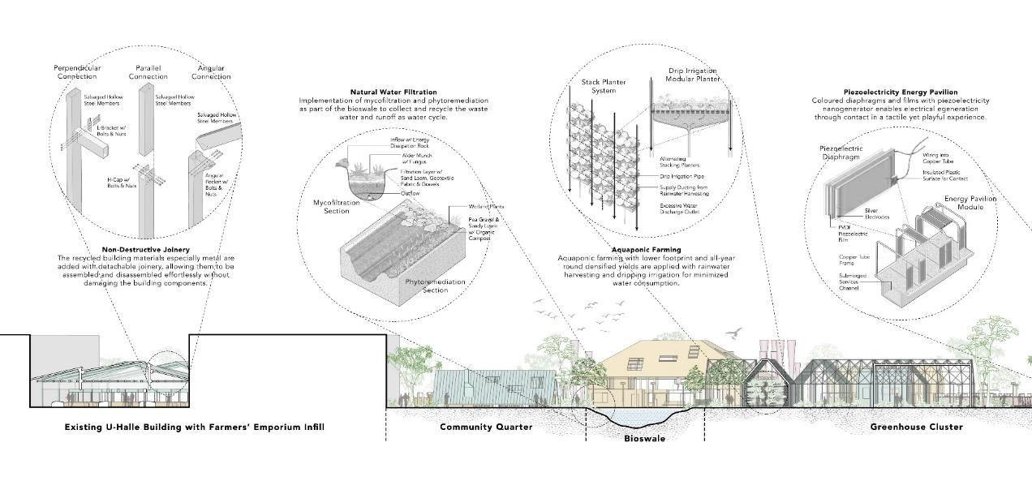
On the scale of construction ecology, these structures are considered just temporary inhabitation over the landscape, which are expected to contribute back into the renewable material cycle when disassembled. This gesture reduces the embodied energy/ carbon in the building components and projects a high recyclability of materials lifespan within a moderately framed usability of these buildings.
Some technological infrastructures are adopted to complement the daily operation of the future park too, such as agrivoltaics, bladeless wind turbine, piezoelectric energy pavilion, and biogas facilities. Within a compact footprint, they are all implemented not solely as additional parts, but integral bodies to double up the farmlands, either as a sensorial channel or a participatory medium.
Conclusively, the project combining affordable, accessible, sustainable, and inclusive methodology to comprehend a total circle of energy/ resources flows, addressing the net zero consumption in energy, water, and waste. Above all, aligning to the theme of BUGA 2023, Energy Circus transcends not just as an energy park, but a civic platform to raise broader environment awareness- where many elements we often neglected can also aid as part of how our environment process in a whole cycle, a circle of life.

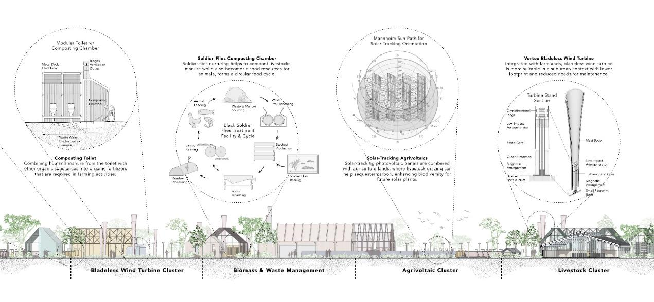
Energy Generation Brief Calculation
Energy Type |  | Area (m2) | Energy Generated (MWh)
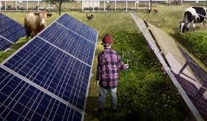 | Agrivoltaics | 5180 m2 | 12.69 MWh
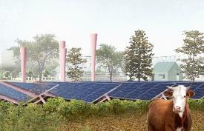 | Bladeless Wind Turbines | 500 m2 | 0.06 MWh
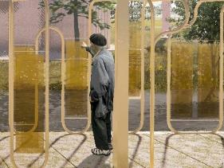 | Piezoelectric Films | 165 m2 | 0.003 MWh
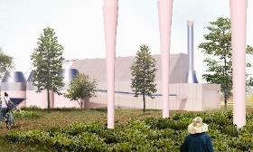 | Biogas Plant | 285 m2 | 4.5 MWh
Energy Type |  |  | 17.253 MWh

Total Land Size for Focus Area (m2) | 55000 m2
Energy Generated per m2 (Wh/m2) | 314 Wh/m2

Estimated Energy Consumption for Focus Area (MWh) | 0.682 MWh
Energy Efficiency (%) | 2530%

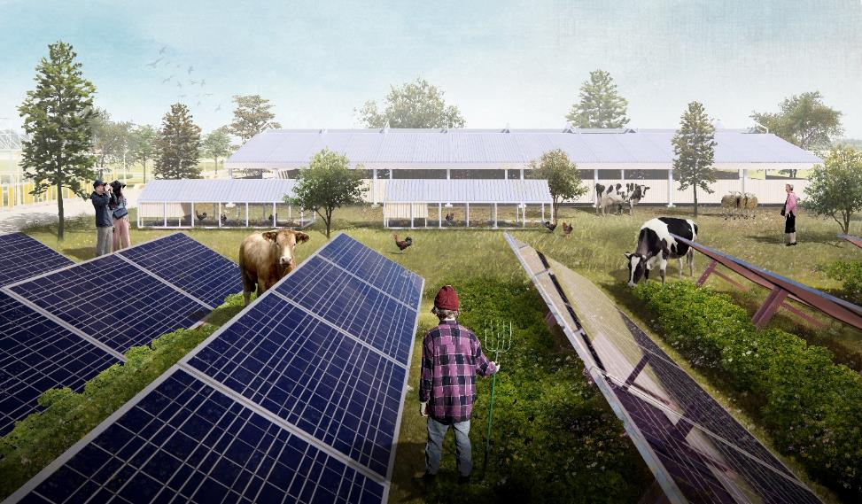
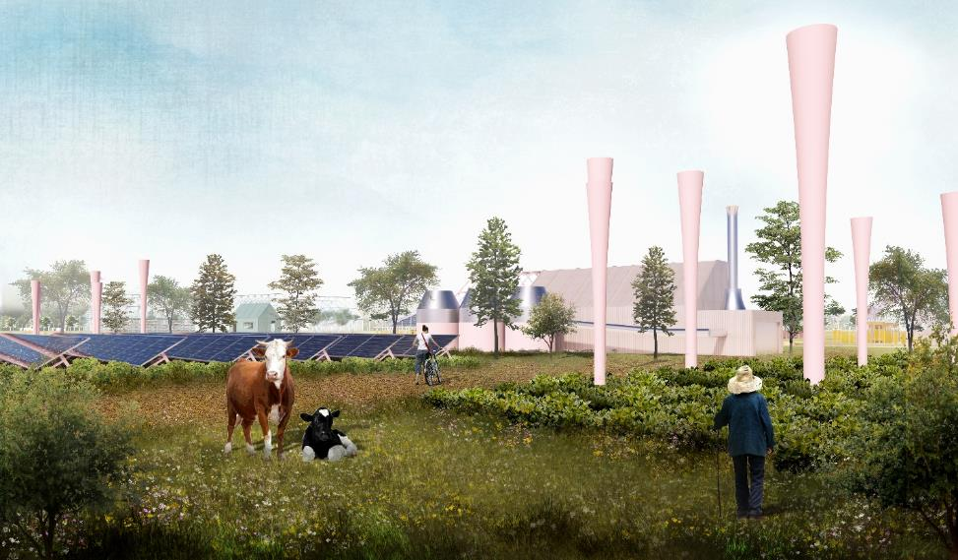
Housed under the stable and chicken coop, livestock grazing could help with sequester carbon, maintain the farmland, and enhance the totality of biodiversity in future power plants.
The farmlands are doubled up as an energy farm integrated with agrivoltaics and bladeless wind turbines to generate clean energy, meanwhile softening the notion of energy infrastructures as part of the park.
References
- Brand, S. (1994). How Buildings Learn. New York: Viking.
- Christophi C. (2011). Ecological research & Macro Algae monitoring facility, North Arsenale, Venice. RIBA Presidents’ Medal.
- Enzio Pozzi, L. (2020). Design for Change: An adaptable housing complex which deals with the impermanence of architecture. TU Delft Architecture and the Built Environment.
- Graves R. et al (2019). A Social-Ecological Approach to Architecture and Planning, Journal of Architecture and Construction, 2(4), pp. 33-44.
- Moffatt S., Kohler N. (2008). Conceptualizing the built environment as a social–ecological system, Building Research &amp; Information, 36:3, 248-268
- O'Neill, R. V., DeAngelis, D. L., Waide, J. B., & Allen, T. F. H. (1986). A Hierarchical Concept of Ecosystems. Princeton: Princeton University Press.
- Oxman N. (2015). Design at the Intersection of Technology and Biology. TED Talk

