THE HYPERBOLIC GARDEN
Can we bridge the gap between naturally grown ecosystems and human made structures? Can we combine our ingenuity with nature’s wisdom to build a symbiotic relationship in which we design and nature builds? How can we merge our necessities with those of our surrounding environment?
The Hyperbolic Garden proposes a new kind of land and climate stewardship, one in which nature and humans become partners in a quest to restore balance and sustainability to our built environment. Can we harvest the products of the land to build sustainably, and in the process create a new kind of art, one in which we provide the creativity and nature delivers the sculptural means? Can nature and humanity coauthor the next land art masterpiece?
Our proposal is rooted in Mannheim’s local tradition and history while sustainably harvesting domestically available natural resources to have nature build the infrastructure the city needs to reach its sustainability goals going forward. We propose shifting the building industry paradigm to one in which humanity does the designing and nature not only provides the building materials and techniques, but also the energy required to build and maintain new structures.
The Hyperbolic Garden is born from the idea of tackling multiple climate issues in a holistic and symbiotic way, responding to societal and environmental requirements through an artistic solution. The design combines the innovations of vertical farming and agrivoltaics with biomimicry and revolutionary materials and building techniques.
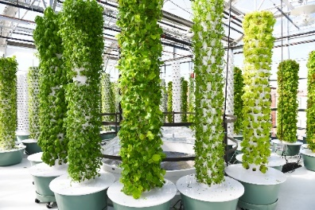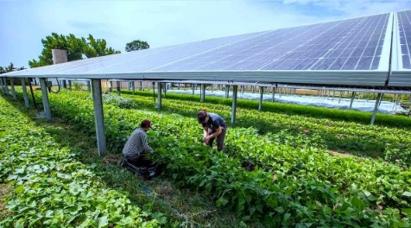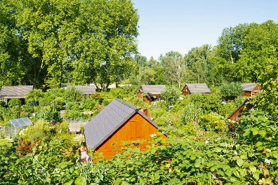
From left to right: Vertical Farming with tower gardens by True Garden, Agrivoltaics, and the Schrebergarten.
Inspired by the German Schrebergarten, the project produces sustainably, locally and naturally grown food through a 34m tall vertical farm built out of mycelium bricks. Unlike traditional vertical farms that take the shape of modular cylinders, our concept takes the shape of a hyperboloid that by design protects fragile crops from excessive solar heat while maximizing sun exposure for those crops with higher sunlight requirements. The result is an elegant silhouette constructed out of naturally grown mycelium bricks. The bricks are laid out leaving a small gap between one another where the crops are placed with their roots hanging freely inside the core, just like in traditional cylindrical vertical farms. The roots are in direct contact with air, maximizing the oxygen absorbed by the crops, and are watered from inside the mycelium core through a series of sprinkler rings that spray water from different heights, maintaining a constant and homogenous water supply to every crop. The natural qualities of the mycelium bricks make it an excellent option for constructing the core of the vertical farm since they have phenomenal hydrophobic and fire-resistant properties, and work fantastically under compression efforts. Because the bricks are made from the root structure of fungus and a natural substrate like agricultural waste or sawdust, they can be recycled, shredded and used as fertilizer to continue to grow crops. During the production of the mycelium bricks, the fungus absorbs CO2 as it expands through the substrate, binding every particle and fiber to create any shape desired. This means that the production process of the main material used in the vertical farm absorbs CO2 from the environment rather than expel it, unlike concrete or other industrialized construction materials.
Mycelium is a fantastic material that has only began to be experimented with over the last decade. Researchers from the Netherlands and the UK have developed a way to 3d print the material into furniture and artifacts like lamps and sculptures, and designers in the US and Korea have used the material to build selfsustained structures like pavilions and treelike columns.
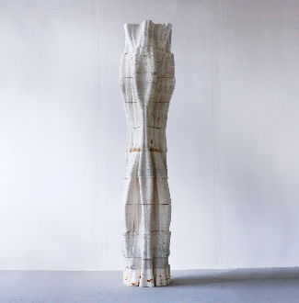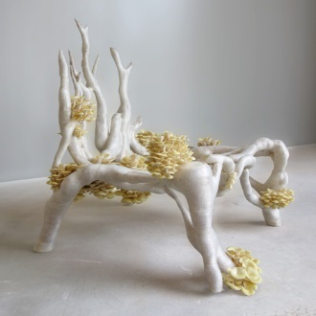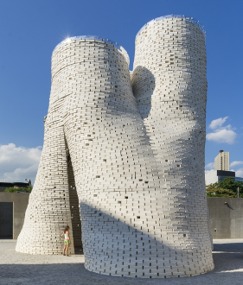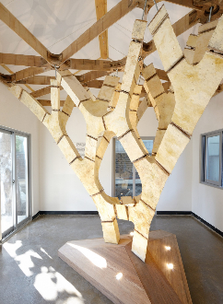
From left to right: The Tree Column by London based Blast Studio, The Mycelium Chair by Dutch designer Eric Klarenbeek, the MoMA PS1 Gallery Pavilion by New York based The Living, and the Mycelium Tree, by Swiss Architect Dirk Hebel, and Swiss engineer Philippe Block. (Even though we have no relation with any of these designers, we got inspired by their research).
The mycelium brick core is reinforced from the inside by a locally harvested Cross Laminated Timber (CLT) sub-structure, making the entire construction 100% sustainable.
The second layer of the Hyperbolic Garden consists of a constant pitch spiraling CLT ramp that wraps around the mycelium core, providing access to visitors and stewards of the vertical Schrebergarten to plant and harvest the crops. This sculptural ramp also makes a fantastic observation platform for the newly developed Spinelli Park with phenomenal views all the way across the Neckar River. The ramp is supported by a Digital Timber Construction exo-structure that builds on the research conducted by the Institute for Computational Design and Construction (ICD) and the Institute for Building Structures and Structural Design (ITKE) at the University of Stuttgart. We have no relation to these institutions, but we draw inspiration from their work with the 2019 BUGA Wood pavilion, which is based on the shell structure of sea urchins. As part of their research into biomimicry, they have developed a robotic manufacturing platform for the automated assembly and milling of the pavilion’s 376 bespoke hollow wood segments. This fabrication process ensures that all segments fit together with sub-millimeter precision like a big, three-dimensional puzzle. The pavilion builds on the biomimetic principle of using “less material” by having “more form”. We based the design of our timber exo-structure on these principles, using as little material as possible by designing a triangulated hyperbolic shape composed of 304 modules of 10 different sizes and proportions that maximizes the structural performance of the timber. The result is a beautiful, naturally harvested structure that pays tribute to the works of previous generations of artists like Frei Otto, Carlfried Mutschler and Ove Arup, who designed the magnificent Multihalle for the 1975 Bundesgartenschau that also took place in Mannheim.
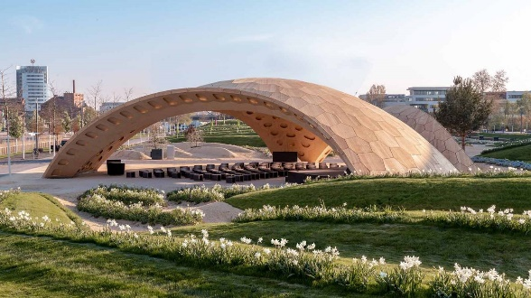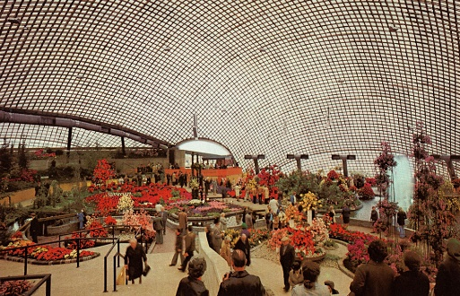
From left to right: The BUGA Wood Pavilion by the Institute for Computational Design and Construction (ICD) and the Institute for Building Structures and Structural Design (ITKE) at the University of Stuttgart, and Frei Otto’s 1975 Multihalle. (We took reference from the research conducted at these institutions, but we have no relation to them, nor to Frei Otto).
Because the resulting structure is permeable and porous, the air coming in from Green Corridor Northeast gets cooled as it goes through the core with minimal resistance. This is of particular importance given that Mannheim is one of the warmest cities in Germany. The sprinkler system inside the core and the cool microclimate created by the crops in and around the structure helps bring down the temperature of the air while contribute to the goals of the Green Corridor.
The Hyperbolic Garden is accompanied by an elevated CLT walkway that connects the old railroad that runs through Spinelli Park to the new structure, and ultimately goes around the entire perimeter of the park. This walkway, which is divided into two sections, The Shorter and The Longer timelines, plays a symbolic and educational role in the overall masterplan. The turns in the Shorter Timeline that ends at the Hyperbolic Garden represent the 8 UN Sustainability Goals directly addressed by our design. The turns in the Longer Timeline represent the 9 remaining UN Sustainability Goals not directly addressed by our design but nonetheless equally relevant. The walkway is constructed using Cross Laminated Timber because the Longer Timeline is conceived as a temporary structure. Once decommissioned, the material can be processed to be used as substrate for the creation of thousands of Mycelium Bricks than can then be given away to the residents of Mannheim to build their own Hyperbolic Gardens at home or at their own Schrebergarten.
Because the design of the hyperbolic garden is entirely modular, the concept can easily be scaled to adapt to both urban and domestic settings. We have designed a prototype for domestic use built on the same principles of its urban-scale counterpart. A cross laminated timber (CLT) inner structure is wrapped by mycelium bricks that provide the growing canvas for the vertical farming crops. A photovoltaic array on top of the structure harvests enough energy to run the water pump that keeps the crops irrigated and light the hosting home.
The structural components can be standardized, and the bricks can be grown domestically by the users themselves, thus reducing costs and incentivizing the widespread adoption of vertical farming.
Environmental impact Summary:
The Hyperbolic Garden addresses the environmental issues facing three of the productive sectors that constitute the main CO2 contributors to the environment: Construction, Energy Generation and Agricultural activities. By tackling these three sectors simultaneously and providing a sustainable and environmentally friendly way to obtain the same, if not better, resources through new and innovative solutions, the design not only produces zero CO2 emissions, but it actually absorbs CO2 from the environment from the production process of one of the main building materials used to build the structure. Every material used in the construction of the structure is locally harvested, from the timber of the DTC exo-structure to the mycelium bricks that build the core of the vertical farm. This reduces transportation emissions to a minimum while maximizing social participation and conscientization about the potential of locally harvested construction materials and the possibilities of producing those materials out of usually overlooked means.
The photovoltaic array at the top of the structure is composed of 125 Mono-Crystalline PV modules. We calculated the power output of the array using Königsbrunn based AE Solar’s AE ME-T150BD 485W-510W Third-Cut Cells panels (We have no relation to the company). Each 120-cell panel has an average power output of 495W with a range between 510W and 485W. That nets us a total of 61,875 watts, or a 61.8KW solar panel system. Estimating an average of 5 hours of direct sunlight a day, we calculate the array could produce up to 309KWh of electricity per day or 112,8MWh per year. That is more than enough electricity to power the pump required to water the crops and the entire Spinelli Park.

