Whirling wheels park
LAGI 2022 Manheim

Project Narrative

Index:
- Introduction
- Walking and cycling paths
- Farmlands
- Multifunctional park
- Whirling vertical farms
- The lake
- The north jungle
- The U-hall
- Technology and materials and output per year
Introduction
Climate change and environment destruction are the most important challenges for human being these days. Governments and people have recently found out that producing food and other principal subjects should be driven in another safe and not destructive processes.
Harvesting sunlight and wind as sustainable energies can lead us to a way out of this crucial disaster.
In LAGI 2022, we have taken the advantages of embracing various shapes of sustainable and green energies, we have used photovoltaic panels, and also some special objects which can catch the wind energy and change it to electrical power by Piezo technology. Using wind turbines was also a prominent way of producing electricity in our project. Our design aims to integrate existing technologies in novel ways.

Walking & cycling paths
Because of existing a vast site, a big opportunity for execution photovoltaic and piezo electric panels all over the intended locations was provided. We tried to equip the main walking and cycling paths by photovoltaics and piezo technology equipped objects as a multifunctional ceiling which also could protect the visitors against the hot sunshine of summers. Just imagine you are riding your e-bicycle or your wheelchair on these paths, a pleasant cool tour on a green land covered by woods and local plants and a huge lake, with multiple scenes of sky and earth, created by the mixture of pure green technology structures and nature, on each time you blink. Natural forms of plants inspired us for designing this curvy structure.

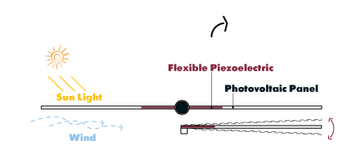

We also construct some electrical charging stations, relaxing spots, and tiny stores by the paths, to provide welfare services. We extend our designing to the streets of neighborhood in order to link the site and the city.
Farmlands
On the zone farmlands, north of the U-hall, it seemed reasonable to erect some Agri-voltaic panels. These Agri-voltaic panels are special. They can also be productive when the wind is blowing. These linear panels simultaneously are agrivoltaic and piezoelectric equipment.

An important challenge in maintaining agricultural crops is always protecting them in heavy rains and hailstones. We have designed a kind of folding umbrella located in the tubular leg of panels, which can blossom in case of extra rain. Revers umbrellas can gather and guide the water to reserve water tanks in addition to taking care of farmlands.

Multifunctional park
On the other part of the site plan, we have designed a hill-shaped multi-age park. On the top of hills, we have located photovoltaic panels in order to produce electricity for the site and the around residential blocks. This park is multifunctional. People can freely walk, sit, lay down, play, do physical and mental exercise, seed and plant local plant species, being learned about the environment and clean energies, and do co-operating social activities like charity or artistic events.
Creating collaboration and assistance spirit among all people and being respectful to nature have been the main purposes of our designing process.
This is inevitable that having a happy vivid society is the consequence of assuming all the people of the world as our family. When it comes to reinforcing such senses, we as architects should play our roles, but how can we help with this subject? We have designed some trampolines for kids and placed a great number of springs under the play membrane. When the children are happily playing on these play tools the springs produce electrical energy by piezoelectric technology, this electrical current charges the batteries of e-wheelchairs of old and disabled people.
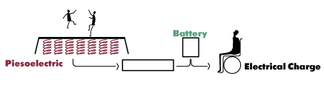
We have informed this procedure to children and other people by written and pictorial signs and boards. This method contains a very important message and lesson for kids,” you are a very effective person for your society, you can support who they need your help, and others count on you”. This also can help old and disabled men to be hopeful and feel not alone.
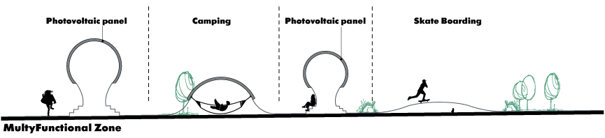

Whirling vertical farms
Architecture is an adaptive human response to the threats of the environment, some things as rain, snow, and freezing, and hot weather; where on the next level it combines with art and makes an intoxicating complex. We have designed and located four circular high-rise buildings on our site as vertical farmlands. We have persuaded dominant goals in our result of architecture. This type of architecture may be a suitable sample for constructing vertical farmlands in narrow sites among compressed building blocks in crowded cities all over the world and a way to solve food shortage issues and bring green zones to polluted artificial environments.
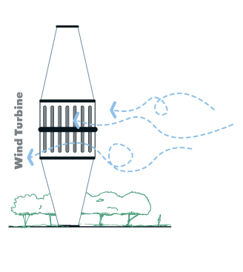

Secondly, this vertical farm has mobile caps. When it starts to rain the caps open and the water drains into a pipe and gathers in a tanker located under the building so the farmers can irrigate their garden with the water gifted them. Thirdly, a wind turbine has been set exactly in the center of the building which can produce the required energy of the complex, and at last, these whirling-shaped high-rise structures create a big chance for visitors to enjoy attractive views of the park and the city.
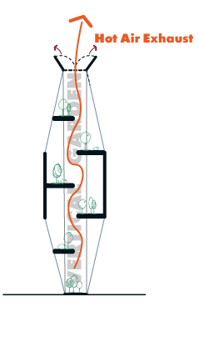
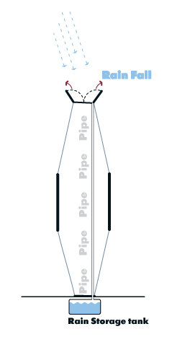
The lake
Heavy rains can be very destructive if you do not consider about them. As we know Mannheim always faces with this problem so we have found a way to manage the over plus water of the rain.
A vast lake could be a reasonable response. The lake can gather the water and save it for the farmers; in addition, this lake plays a big role in cooling the air of the neighborhood in hot summers. Visitors would have fun by swimming and watching the natural views of the lake and eventually, the animals of the park can use and drink water.
Two main underground pipes connect the lake to the river, when the rain is too heavy and the flood threats the site, the safety valves open and discharge the extra water into the river.
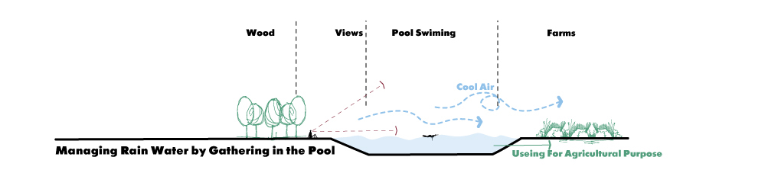

The north jungle
On the north side of the site and by the residential blocks, we have planted local trees to create a wood. This jungle would be a main source of oxygen and fresh cool air for the neighborhood. A good area for people to inhale pure oxygen and do camping. This is also a place where animals can live and a strong motivation for visitors to know the plants and animals.
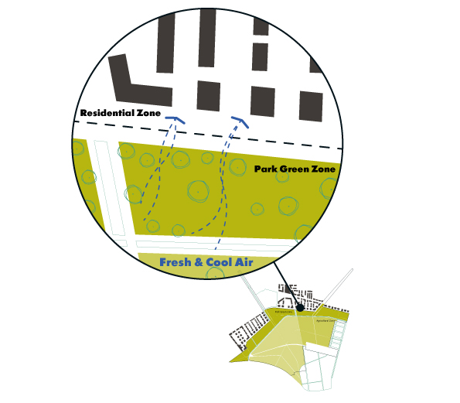

The U-hall
we respected to the U-hall and did not manipulate it at all. The only change we have made in it was equipping the covered parts of roof by photovoltaic panels.
Technology
storage technology
Energy storage systems (ESS) provide a means for improving the efficiency of electrical systems when there are imbalances between supply and demand. Additionally, they are a key element for improving the stability and quality of electrical networks. They add flexibility into the electrical system by mitigating the supply intermittency, recently made worse by an increased penetration of renewable generation. One energy storage technology now arousing great interest is a zero carbon method the flywheel energy storage systems (FESS), since this technology can offer many advantages as an energy storage solution over the alternatives. Flywheels have attributes of a high cycle life, long operational life, high round-trip efficiency, high power density, low environmental impact, and can store mega joule (MJ) levels of energy with no upper limit when configured in banks.
(https://www.mdpi.com/2076-3417/7/3/286)
(FESS) works by accelerating a rotor (flywheel) to a very high speed and maintaining the energy in the system as rotational energy. When energy is extracted from the system, the flywheel's rotational speed is reduced as a consequence of the principle of conservation of energy; adding energy to the system correspondingly results in an increase in the speed of the flywheel.
Most FESS systems use electricity to accelerate and decelerate the flywheel, but devices that directly use mechanical energy are being developed.
Advanced FESS systems have rotors made of high strength carbon-fiber composites, suspended by magnetic bearings, and spinning at speeds from 20,000 to over 50,000 rpm in a vacuum enclosure. Such flywheels can come up to speed in a matter of minutes – reaching their energy capacity much more quickly than some other forms of storage.
(https://en.wikipedia.org/wiki/Flywheel_energy_storage)

We have buried (FESS) underground for safety.
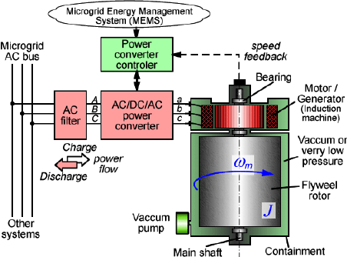
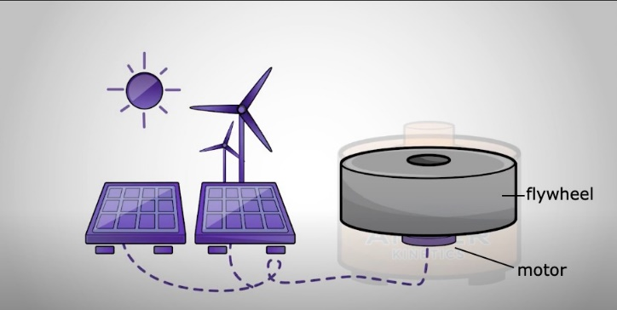

Production technology

PI Ceramic – Piezo Technology + photovoltaics panels, and wind turbine.

Note: the panels are simultaneously photovoltaics and Piezo technology equipped.

PI Ceramic – Piezo Technology
- Unlimited Resolution
Piezo actuators convert electrical energy directly into mechanical energy and vice versa and allow for motions in the sub nanometer range. There are no friction elements that limit resolution.
- Stiffness, Load Capacity, Force Generation
To a first approximation, a piezo actuator is a spring-and-mass system. The stiffness of the actuator depends on the elasticity module of the ceramic (approx. 25% of that of steel), the cross section and length of the active material, and other nonlinear parameters. Typical actuators have stiffness between 1 and 2,000 N/μm and compressive limits between 10 and 100,000 N. For tensile stresses, a casing with integrated preload or an external preload spring is required. Adequate measures must be taken to protect the piezo ceramic from shear and bending forces and from torque.
- No Wear and Tear
A piezo actuator has no moving parts, like gears or bearings. Its displacement is based on crystalline solid-state dynamics and shows no wear and tear.
- Operation at Cryogenic Temperatures
The piezo effect continues to operate even at very low temperatures close to 0 Kelvin.
- Vacuum and Clean Room Compatible
Piezo actuators neither cause abrasion nor do they require lubrications. The all-ceramic insulated PICMA® actuators have no polymer coating and are thus ideal for ultrahigh vacuum applications.
- Operating Voltage
Two types of piezo actuators have become established:
Monolithic-sintered PICMA® multilayer actuators (low-voltage actuators) Classical high-voltage actuators (PICA high-power actuators)
- Low Energy Consumption
Static operation, even holding heavy loads for long periods, consumes virtually no power. A piezo actuator behaves very much like an electrical capacitor.
- Rapid Response
Piezo actuators allow response times of a few microseconds. Acceleration rates of more than 10,000 g can be obtained.
- High Force Generation
High-load piezo actuators capable of moving loads of several tons are available. They can cover travel ranges to 300 μm with resolutions in the sub nanometer range.
- Position Resolution
The piezo ceramic itself works free of friction and theoretically has unlimited resolution. In practice, the resolution actually attainable is limited by electrical and mechanical factors:
a) Sensor and servo-control electronics, amplifiers: Amplifier noise and sensitivity to electromagnetic interferences (EMI) affect positional stability.
b) Mechanical parameters: Design and mounting precision issues concerning the actuator, preload and sensor can induce microscopic friction which limits resolution and accuracy. Piezo actuators reach sub nanometer resolution and stability.
- No Magnetic Fields
The piezoelectric effect is related to electric fields, piezo actuators do not produce magnetic fields nor are they affected by them.

Travel Range
The travel ranges of piezo actuators are typically in between a few 10 to a few 100 μm for linear actuators. Bending actuators can achieve a few millimeters.

(https://www.piceramic.com/en/expertise/piezo-technology/properties-piezo-actuators/displacement-modes/)

Output: 8000 MWh generated per year

