Super Pot.

The Bauhaus is the before and after of the architecture, is the step of this:

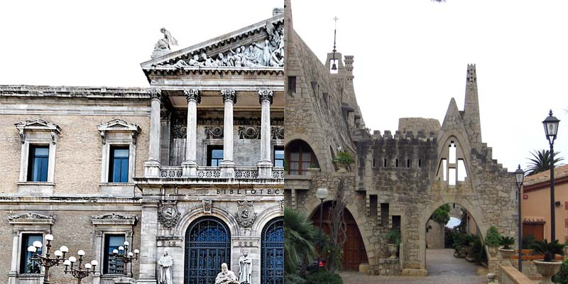

Of this:

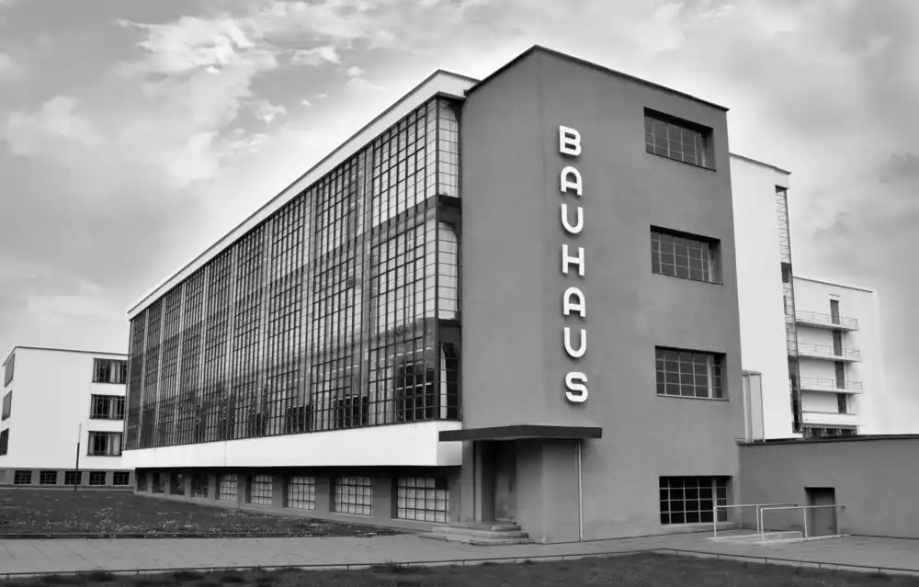
Its simplicity, functionality and beauty are immense. It is time for the Bauhaus to resurface to eliminate the coldness in renewable energies and give them a more functional and aesthetic direction, this through its wonderful geometry. Plants are the most beautiful thing in nature, from the most humble house to the most luxurious mansion in the world has a plant. By putting together the bauhaus+plants… the result will be spectacular:

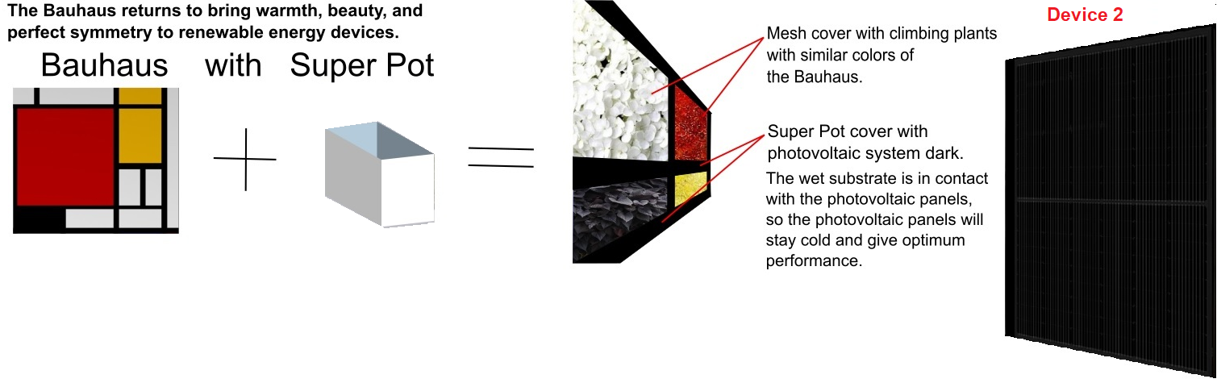
Super Pot:

The pots must be made with recycled plastics and the structure to support the "Super Pot" must be made of renewable materials such as bamboo. The latter preferably from developing countries where bamboo is common.

The pots already in their place of installation and with their energy generating devices, will be filled with ground preferably from the site (savings in transfers) mixed with fertilizer. Then seeds or plants will be placed. All this as indicated by the designer and the botanist.
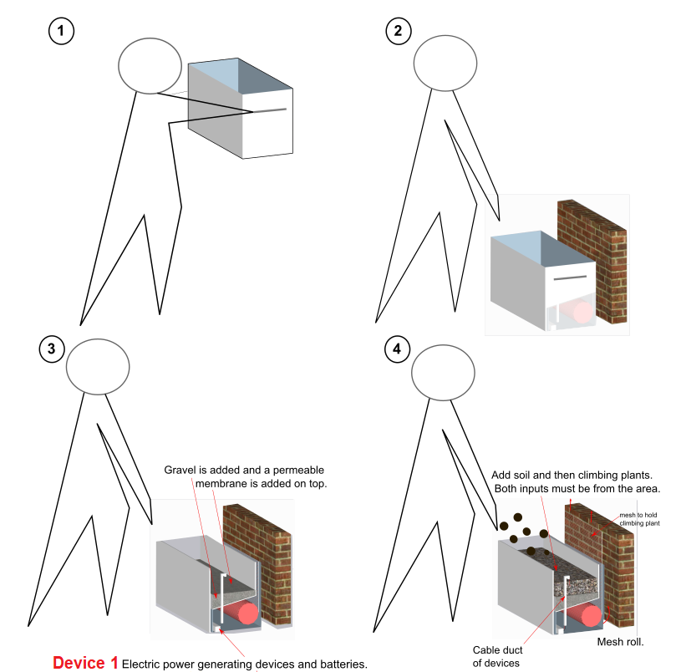

When the plants germinate, the mesh is unrolled so that the climbing plants can ascend. This mesh is fixed to a facade, so the climbing plants will grow and cover the mesh with the desired colors.

Super Pot will be easily modulated, from a "Super Pot" for an apartment, to the union of thousands of Super Pot for a park, university, mall, industry, etc.

My proposal for the public park uses two types of renewable energy devices.

Technology used in my design:

Device 1: generates electricity from plants and microorganisms. This device is integrated into the "Super Pot"

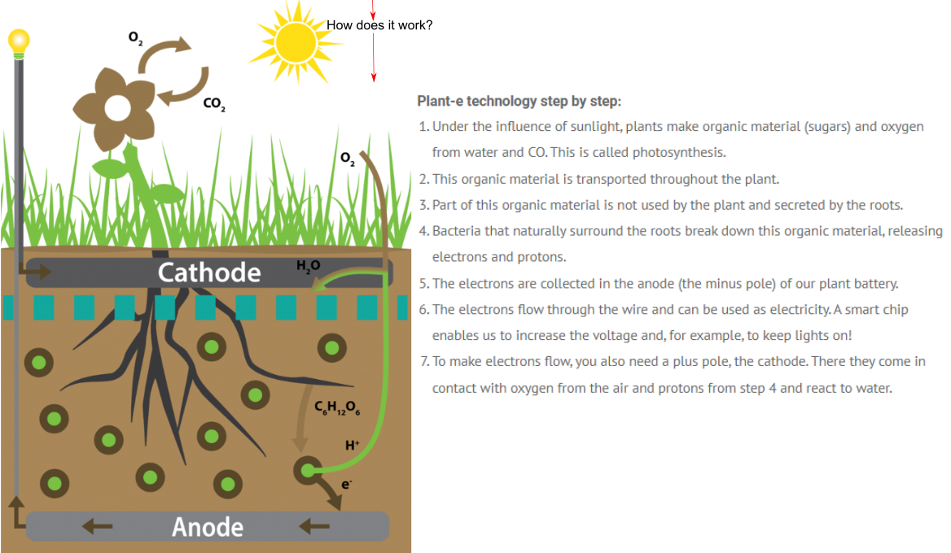

Device 2: Photovoltaic system. Which will cool down with the moist soil of the pots, thus they will have a much more optimal energy production.

Environmental Evaluation..

The prevailing winds come from the east, which will pass through the meshes with climbing plants and at the same time through the irrigation-spray system. Which will increase the freshness and humidity of the wind, which will pass freely from side to side of the park.

Support for the objectives of the Green Corridor (Klimopass)

*For the reduction of CO2: the parking lot will give priority to electric cars with exclusive spaces for them. The roof will be with a photovoltaic system.
*Regarding the construction of sustainable spaces: priority will be given to bamboo structures to replace structural steel in sculptural elements or Bauhaus-walls.
* Photovoltaic energy: The shapes of the sculptural modules or Bauhaus-walls are cubic to be easily covered with high performance solar panels.

Description of public activities and social co-benefits my design would support:

People will gain knowledge related to the botany of their country and learn more about the Bauhaus. You will see the union of the beautiful nature with renewable energy.

Support UN sustainable development goals:

“7.1” By providing public electrical sockets, whose electricity comes from renewable energies.

“7.a” By proposing renewable and foreign technology for investment in the infrastructure of a public park.

MWh per Year:
Photovoltaic System Devices
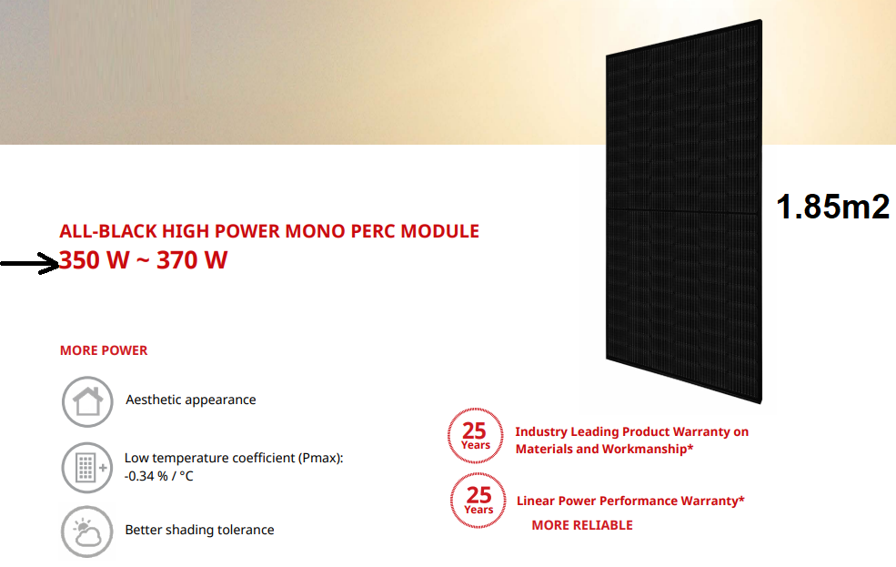

360 Watts=0.36 Kilovatios (Kw)

0.36 kw x 3.00= 1,296 Kwh = 1.296MWh

1.296MWh X 8760 = 11,353MWh per Year (1.85m2)

Total m² photovoltaic devices= 18,000

TOTAL= 110481081 Mwh per year.

MWh per Year:
Biological energy Device of plants and microorganisms.

1m2 of soil= 3 Wh

Total m² of soil on the public park in “Super Pot”=21 000

3x21 000= 63 000Wh

63000Wh / 1000000 = 0, 063MWh

x 1 year (31.536.000 )

TOTAL 1,986,768MWh per year.

