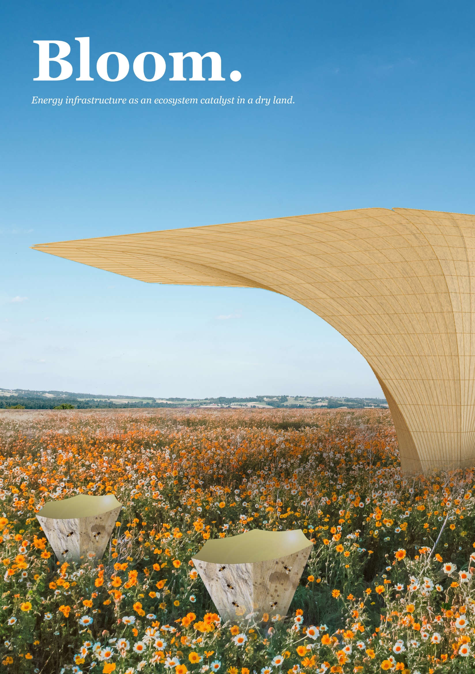

Content

Chapter 1.
Ecosystem catalyst energy infrastructure………………………………3

Chapter 2.
Design system: Canopy unit & mobile unit……………………………6

Chapter 3.
Enhancing micro-climate & improving city air circulation……13

Chapter 4.
Environmental impact assessment………….…………………………14

Chapter 1
Ecosystem-catalyst energy infrastructure.

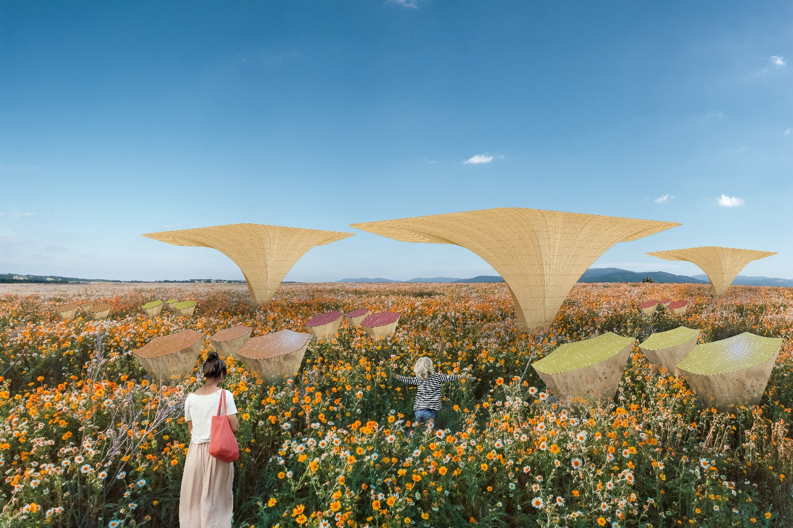

1.1 Main concept
The proposal’s main idea is to bring the concept of a hydro pphotovoltaic panel that combined photovoltaic cells with hygroscopic material to catch vaporization from hot air turned into a water source. The idea aims to provide a water source from the air integrated into the energy infrastructure which not only generates electrical power but also thrives and flourishing the surrounding living organism-environment during the drought season. Thus, the future of infrastructure has become a major rule in playing the role of an ecosystem catalyst in a city.

1.2 Challenges to opportunities
To achieve the goal that fulfilled the needs of not only humans but also animals and plants on site, the proposal analyzed challenges and opportunities specific to the site. The mapping of challenges aims to find the opportunities for creating inter-collaborative opportunities between energy infrastructure, humans, and living organisms.
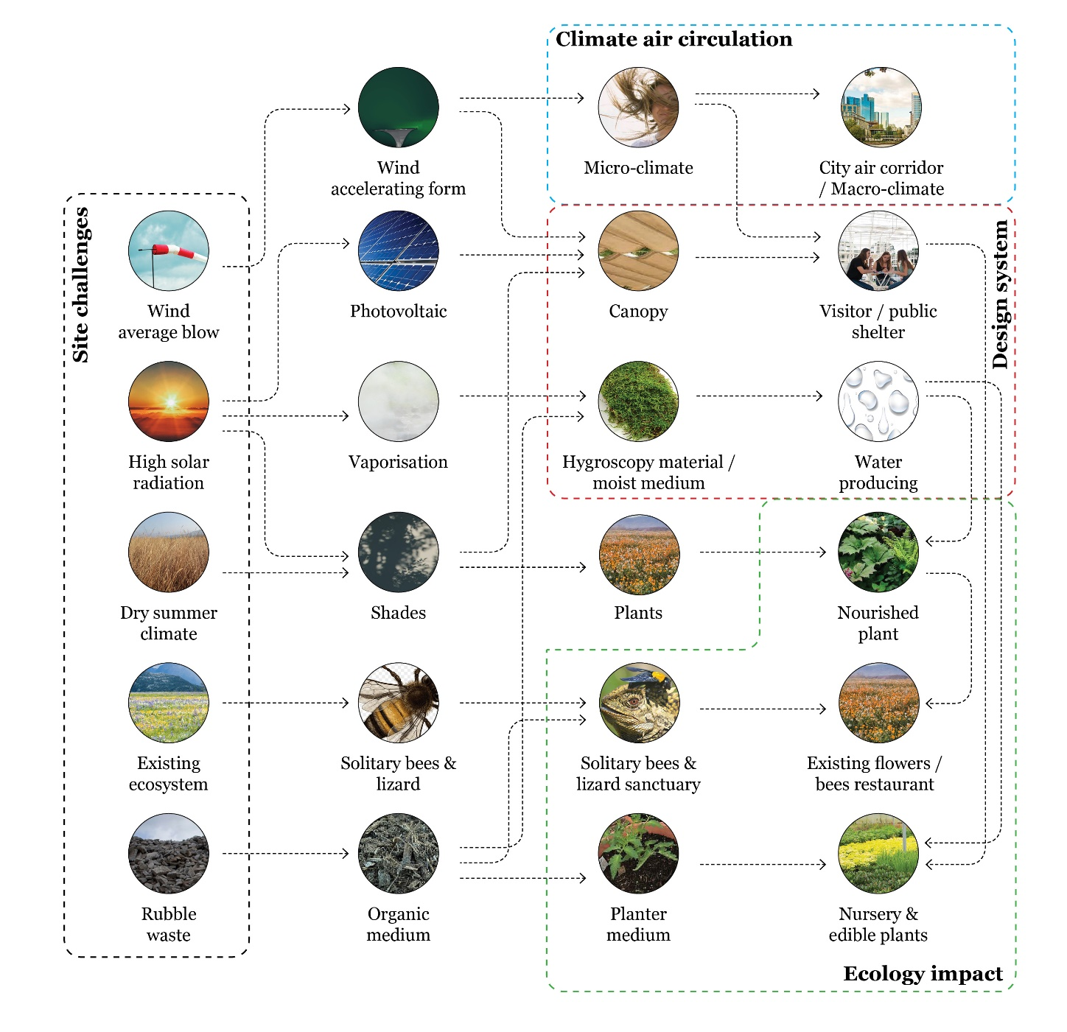

Firstly, by looking at the challenges of high solar radiation and the lack of water sources surrounding the site during summer, the proposal brings the opportunity to turn the hot air into water by vaporization. Blooms will provide the integration of energy and water source that can be mobile and easily placed in the garden which has drought problem. So that the plants, living organism and crops can still live and thriving during the drought season.
Secondly, the proposal elevates existing ecology, plants, and living organism to thrive and sustain in the drought season, especially during dry summer climate. Blooms provide a concept of ecosystem catalyst infrastructure, which can provide existing living organisms such as flowers, plants, bees and lizard surrounding the devices protection from direct heat radiation during summer and thriving live spans.
Thirdly, by looking at the tons of building construction wastes on-site due to the demolition and dismantling of the former military base, the proposal will be utilizing rubbles, and deconstruction construction waste achieving net zero as a circular material scheme and organic moist medium. Using the re-used material not only reduces construction waste but also facilitates decayed organic sourced materials to become an organic medium for water absorption and nest for insects.
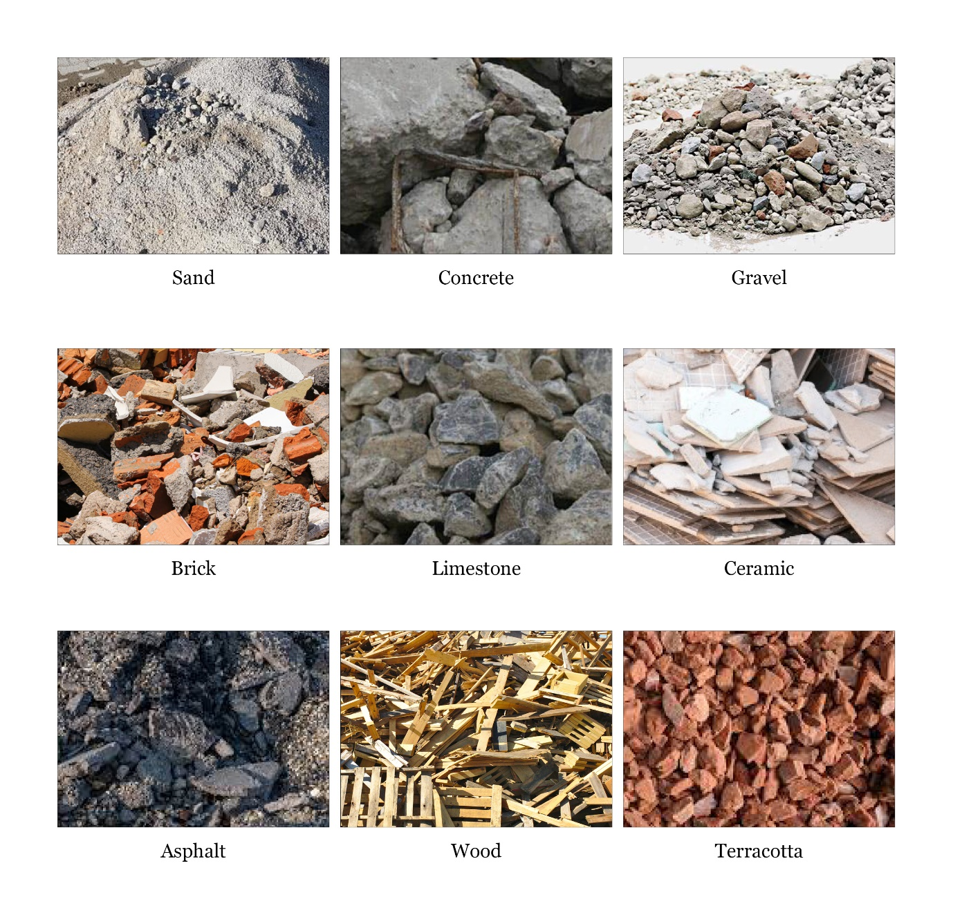

Lastly, the humid and hot temperature on the site during summer has become a challenge for BUGA 23 visitors, and the need of shelters indispensable to be built during the BUGA event which gives shade and sun radiation protection as well as maintain micro-climate. The canopy will open the broader possibilities for social co-presence and interaction, especially related to nature-related activities. Education such as a field school, Montessori kindergarten, shelter for farmers, and nursery area for productive plants are examples of suitable functions to designed beneath the canopy.
Chapter 2
Design system: Blooms canopy unit and mobile small unit.

Blooms will bring integrated hydro panel into a broad modular possibility with two variants, canopy-based form as the main unit and mobile small unit. For all variants, the idea of form is based on a six-sided polygonal shape found on the bee’s wax. With the six-sided polygonal shape, the unit can be integrated into each other in the convenient chain and save spaces while connected with each other in the garden.
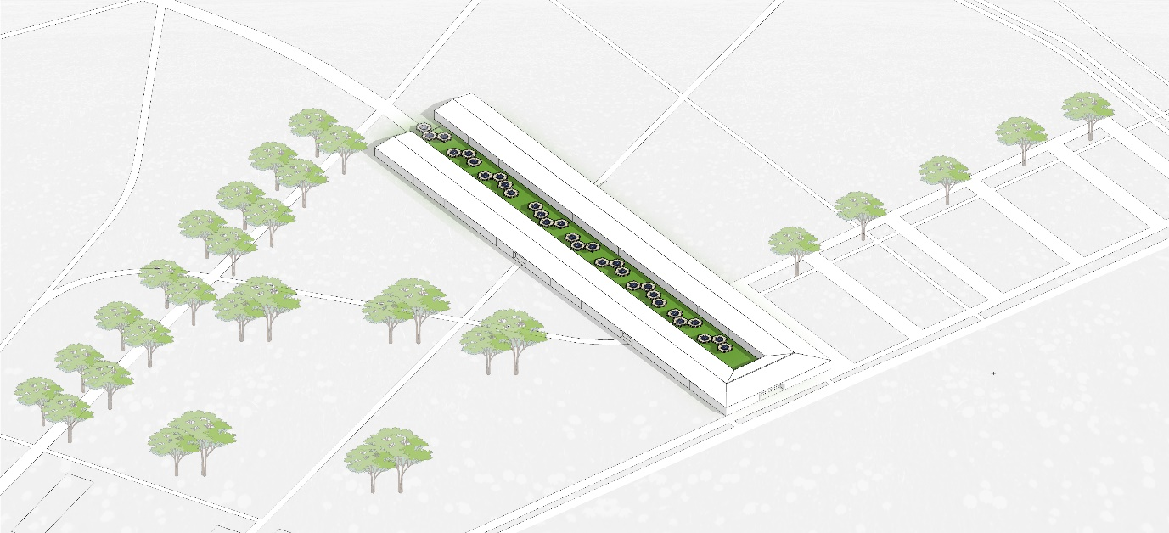
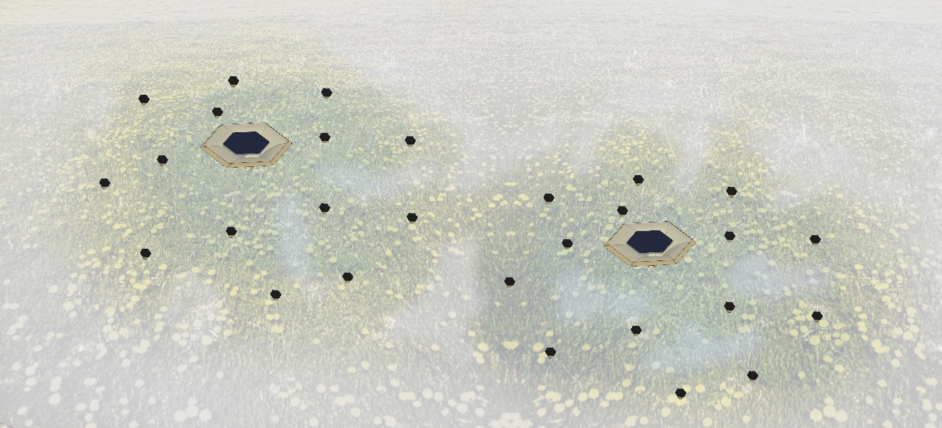

2.1 Hydro panel: turn air into water.
The basic system of hydro panel is utilizing solar heat to turn air into water while capturing solar radiation. The solar panel system allows air to enter the vaporization chamber underneath the photovoltaic and blows by a solar-powered fan into the hygroscopic material which absorb water particle in the air and turn it into water drops.
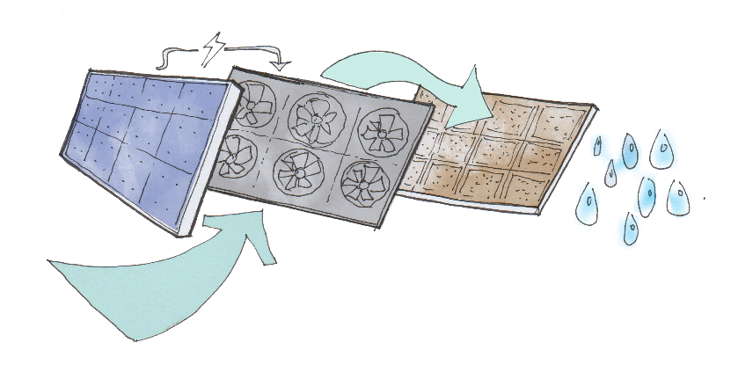
The difference between the single-unit hydro panel on the market and the implementation in the Bloom device is the water that generates from hydro panel will enter a moist chamber made from organic decomposed construction waste instead of flowing into the water tank sources.

2.2 Moist chamber.
Moist chamber is a chamber aims to keep water drops from Hygropanel and maintain moisture in the air. While the outside air moisture is dry, the moist chamber has an ability to keep the moisture air and prevent water vaporization. The chamber is located on the inside of the tabular form and enclosed by wooden structure. In the centre of the chamber placed moist medium, consist of organic decomposing construction waste such as wood chunk, bricks, stone, soil and organic waste from plants which keeps water and enhance moist organism. This process will allow water naturally absorbed by the environment itself. Besides, by mimicking the process of the natural spring, the water will naturally be filtered by soil and becomes groundwater which supplies existing flowers and plants in the surrounding.
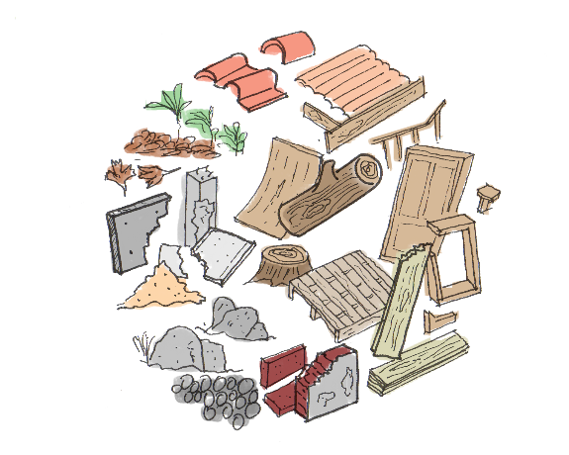
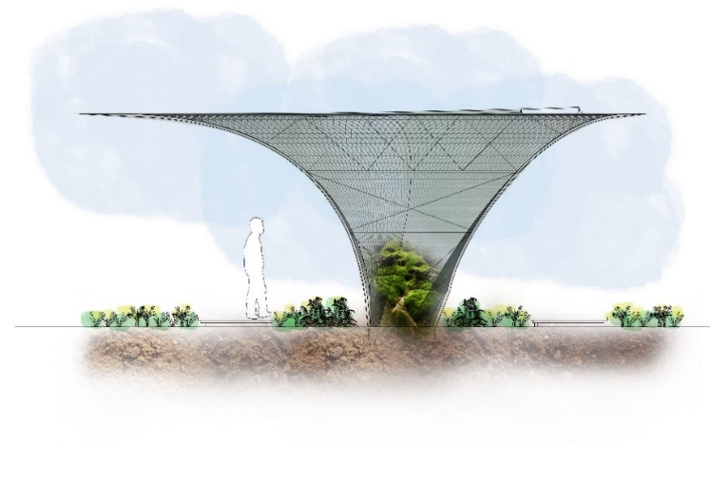

2.3 Canopy-based form main unit.

2.3.1 Energy system
With the implementation of Hygropanel PV and piezoelectric PV on the 12m2 flat surface on top of the canopy, the main unit has the ability to generate 111 kWh of electricity. Besides the electricity, the main unit can produce 10L of water per day during the hot summer climate. The calculation is based on the Hygropanels market sale Source brand, with the calculation for one single panel that can produce a maximum of 1L water per day.
Device | Area / Capacity | Energy generating
Hydro panel Photovoltaic | 17,2 m² (1 Canopy) | 2632 kWh annually
Translucent Organic Photovoltaic | 46,1 m² (1 Canopy) | 7053 kWh annually
Hydro panel water drops | 6 PV devices in 1 Canopy  (2,5 L per PV device per day) | 15 L per day
energy harvesting for 1 canopy | Hydro panel PV + Translucent Organic PV | 9685 kWh annually
Application for 10 Ha  land cover | 10 Ha = 690 canopies | 6682.65 MWh annually

2.3.2 Structures & Season modes
The canopy-based form arose from a hexagonal form twisted from below to the upper surface. The structure consists of main waffle structures, plywood claddings, and bracing cables. The waffle structure has been chosen following its ability to shape a single structural form without a supporting column and make a rigid share wall. 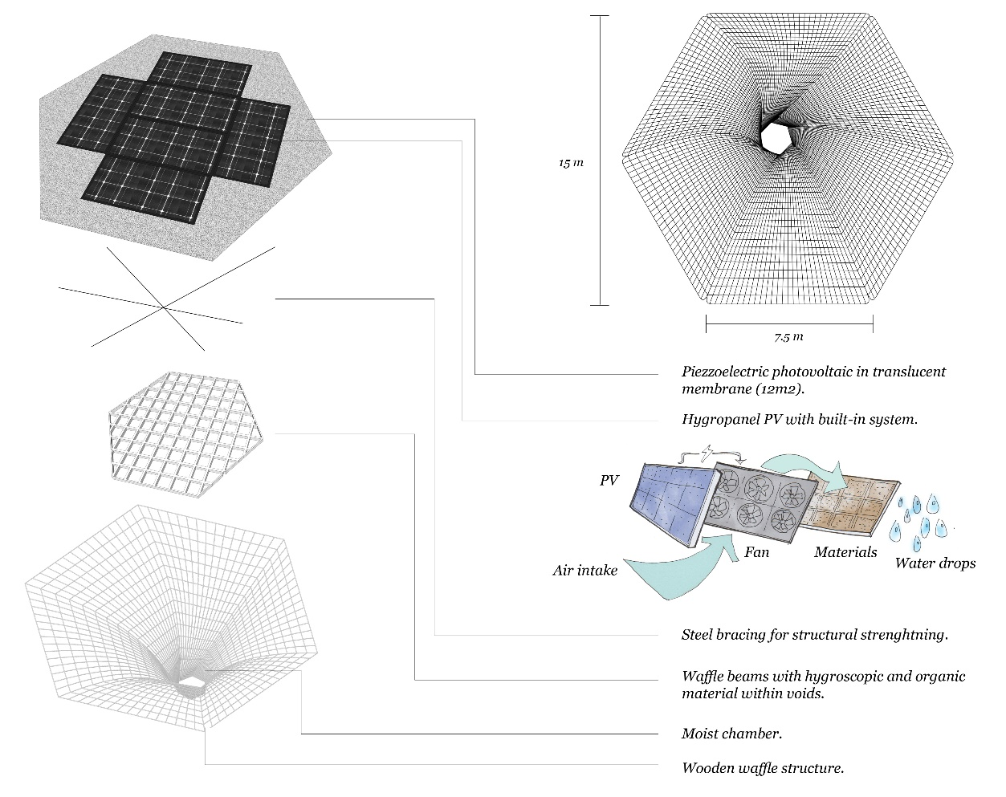
Structure | Material | Volume / Quantity
Vertical waffle structure | Environment-certified  Wood / reused material | 20,5 m³
Horizontal waffle structure | Environment-certified  Wood / reused material | 10 m³
Plywood cladding | Environment-certified  Wood / reused material | 82 m²
Foundation | Reused building concrete or boulders | 25 m³
Cable Bracing for membrane structure | Reused steel cable from industries | 25 m
Hinge key & L-key  For waffle structure | Reused metal from industries / construction | 1200 joints
Bolts | Reused bolts from industries | 2400 pieces
The main canopy unit has two seasonal usages features that can adapt during seasonal changes. In the summer, the main unit will become a canopy and moist chamber for water production, while in the winter, the plywood cladding can be deinstalled and translucent curtains installed on the eaves of the canopy turning the area inside into a greenhouse. By turning into the greenhouse, the design will be expanding the possibility to using the canopy during winter to grow plants and crops, especially in the small garden. This is one of the solutions in achieving UN sustainable goals in food security during the year and in the drought and cold season.
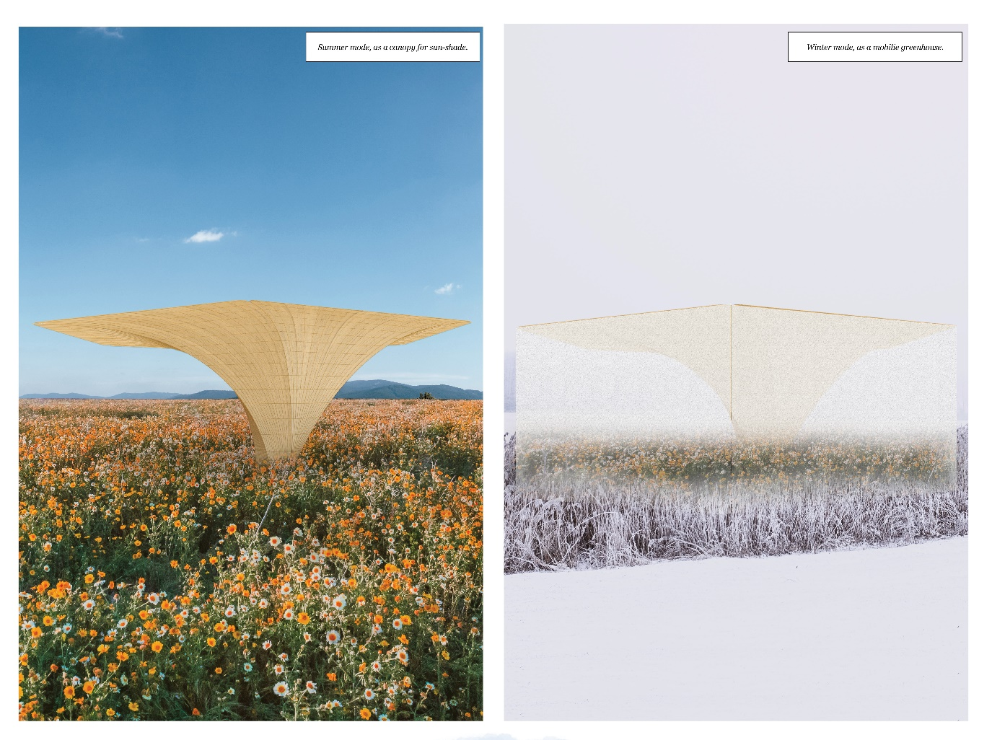

2.4 Small-mobile unit.
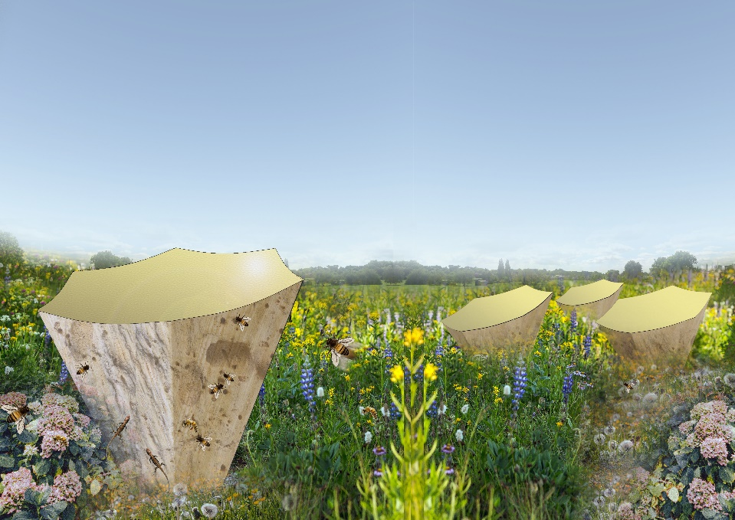

2.4.1 Energy system
The design principle for small-mobile unit adopting the principal of hydro panel system with hygroscopic material embedded in the design without hydro panel market device. It has hygroscopic material placed on the waffle structure with solar-generating fan blows air from air intake into the materials. The moist chamber underneath hygroscopic materials keep water drops and naturally absorbing water to the ground.

Device | Area / Capacity | Energy generating
Organic photovoltaic in colored translucent membrane | 1 m² | 1,2 MWh annually
Hygroscopic material |  | 1 litre per day
Application for 10 Ha  land cover | 10 Ha = 2100 devices | 2520 MWh annually

2.4.2 Structures & Modular scheme.
With the height range between 80 cm until 1.3 meter, the device will have simple structure made from reused wood material from construction site. The photovoltaic made from tensile membrane with colors translucent and photovoltaic embedded and supporting by reused fishing nets.

Structure | Material | Volume / Quantity
Wall | Reused wood material from construction | 2 m²
Horizontal waffle structure | Reused wood material from construction | 1 m²
Membrane supporting structure | Reused fishing net | 1 m²
Hinge key & L-key | Reused metal from industries / construction | 40 pieces
Bolts | Reused bolts from industries | 80 pieces

Chapter 3
Enhancing micro-climate and improving city air circulation.

By looking into Mannheim city policy of fresh air circulation corridor, the proposal aims to enhance the policy by shaping wind accelerating form that helps air velocity flows into the city. Using computational analysis to shape evidence-based design strategy, the proposal analyses the design 3-dimensional form that helps air flow and maintaining not only micro-climate but helps air velocity accelerate to the city centre.
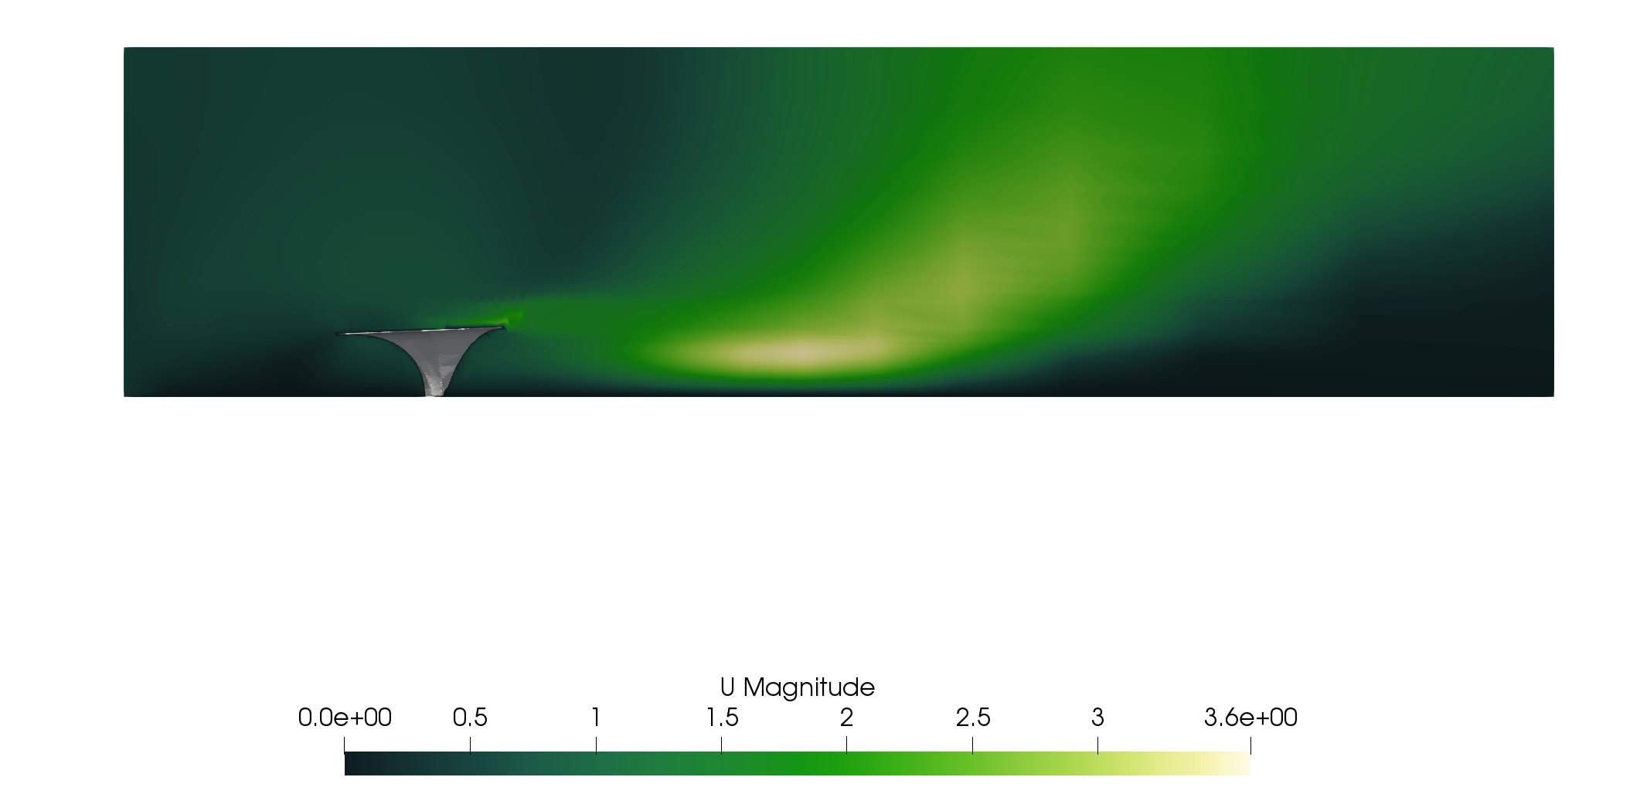

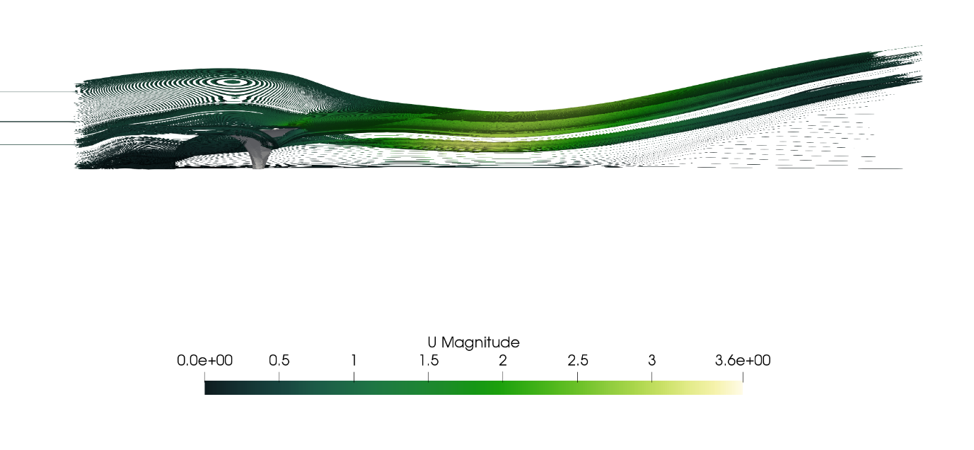
Chapter 4
Environmental impact summary.

In this chapter 4, the report will describe the Environmental impact summary including environmental impact in the construction process. There are three environmental principles that considering in the Bloom proposal, edible and thriving ecosystem landscape, renewable energy and water generating, and air circulation to the city. In daily usage, the Bloom proposal has a low impact on the environment and encourage thriving living organism especially bees and lizard in the surrounding Spinelli Park area. The three principles can be seen in the diagram below.
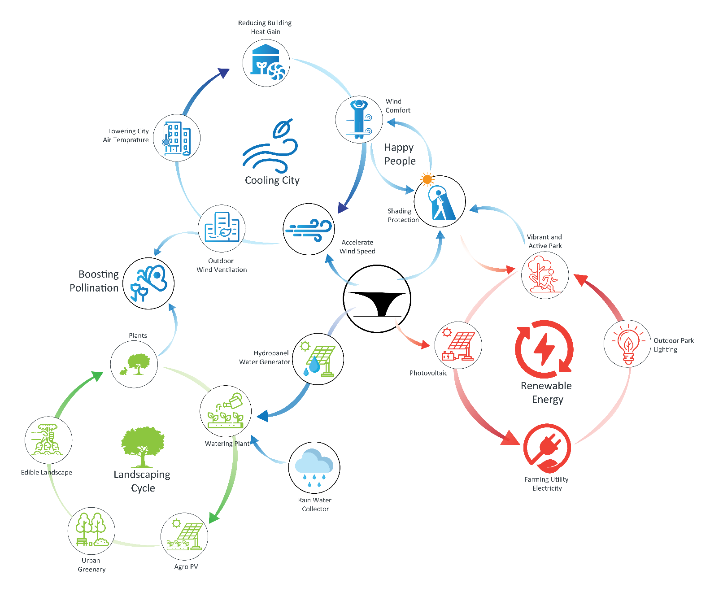

The tables below investigate the cumulative impact and residual impact in the environmental impact assessment of Bloom's proposal from the construction phase until the de-mobilization of the devices.
Canopy main unit
Project phase | Activity | Description of impact | Cumulative impact | Mitigation measures | Residual impact
Site choosing | - Land surveying | - Anticipated existing plants destruction by survey activities. | Low | - Survey activities need to adapt environmental awareness strategies.  - Mapping the existing ecosystem to prevent high destruction on existing land while survey. | Low
Mobilization of construction materials | - Materials transportations | - Imported materials have possibilities in carbon embodied by transport-  ation process.  - Fossil fuels in materials transportation (trucks and heavy-duty construction vehicle).  - Dust and loud sound from heavy-duty transportation. | High | - Materials need to collected from local sources or local neighborhood, especially collected from construction waste and organic waste in the area.  - Prevent imported materials from another city or greater that Mannheim.  - Imported materials or materials from outside the location neighborhood should not achieve 10% from overall construction materials.  - Prevent using non-organic (plastic, steel and polyester) material exceed 15% from the overall construction materials. | Medium
Pre-Installation | - Project site plan and construction flows.  - Construction management plan.  - Construction materials placement | - Construction materials placement have possibility to obstruct land and existing plants. | Low | - Provide areas which existing ecosystem not exist in the area for materials placement, for example existing road, concrete pavement, etc.  - Bringing the construction materials by pre-cast solution and with foot to the center of site (without heavy-duty vehicle). Materials installed in site always considering existing ecosystem plants and animals. | Low
Installation / On-site Construction | - Construction process.  - Workflow management. | - Installation process have a possibility to destruct plants surrounding site.  - Installation tools have a possibility to impact existing ecosystem. | Medium | - Installation process needs to adapt environmental project construction methods which considering existing ecosystem surrounding chosen site.  - Limit the installation workers to maximum 3 people to prevent influx of human impact to the surrounding ecosystem.  - Project management and workflow needs to adapt environmental approach to the impact from construction tools. | Low
De-mobilization | - Clearing from construction waste and non-organic construction tools. | - Decluttering project site. | Low | - Clearing both construction site and materials placement location with rigorous flow plan considering surrounding environment. | Low
Daily usage | - Self-generated electricity from Photovoltaic.  - Self-generated water from hygroscopic materials | - Sound from fan activity. | Low | - Installed acoustic barrier inside the moist chamber made from organic materials such as dried leaves, dried straws, etc. | Low

Small mobile-unit
Project phase | Activity | Description of impact | Cumulative impact | Mitigation measures | Residual impact
Installation and construction  (Out-site construction) | - Construction workshop | - Construction workshop impact surrounding neighborhood in terms of loud and dust. | medium | - Implemented sustainable energy strategies in workshop building.  - Placed surrounding barrier in order to prevent loud sound and dust to neighborhood. | Low
Mobilization | - Transportation from workshop to the site. | - Fossil fuels for transportation (trucks) | Medium | - Adapt efficiency strategy in arranging the load in truck to achieve efficiency transportation.  - Using bicycle cargo transporting as an alternative to transport the devices if the scale of the site is smaller than 2 Ha. | Low
De-mobilization | - Clearing from waste and non-organic waste (cables, etc.) | - Decluttering site. | Low | - Clearing both construction site and materials placement location with rigorous flow plan considering surrounding environment. | Low
Daily usage | - Self-generated electricity from Photovoltaic.  - Self-generated water from hygroscopic materials | - Sound from fan activity. | Low | - Installed acoustic barrier inside the moist chamber made from organic materials such as dried leaves, dried straws, etc. | Low

