Room to Breathe

Submission for the LAGI competition 2022

windbelts as energy generators
The green path provides an air corridor from which wind pushes from the countryside into the city. However, the wind speed is very low, so many of the technologies for generating wind energy power are not suitable or would work very inefficiently. Therefore, we decided to use the technology of "windbelts". This has the advantage that they work well at low wind speeds. The construction of the generators is simple. A thin stretched membrane is hit by the wind so that it can flow past it at the top and bottom. This causes the membrane to vibrate. At the two ends of the membrane, magnets are located on both sides of the faces directly under the copper coils. The vibration of the membrane causes the magnets to move up and down through the coil.

The generator makes use of what is known as Lenz's law and self-induction. A current-carrying coil builds up a magnetic field around itself. As soon as the energy is switched off, however, current continues to flow. The energy comes from the magnetic field as it decays. The "windbelt" technology use this by generating this magnetic field artificially, externally with the magnets. However, the current flow in the coil follows the same rules as described in the physical law. Thus, it is possible to convert the kinetic energy of the wind into usable electrical energy.
The vibration causes the upper or lower magnet to move alternately through the coil. By having a negative pole on one and a positive pole on the other side, this results in an alternating current. This is important because our power supply system is also based on this type of current and not on direct current. Thus, the generated electricity can be used directly.

general concept
The basic idea was quite simple, to design a wind generator that not only has a high aesthetic appeal, but also works well at low wind speeds. Particularly important is the gentle intervention in the side. Therefore, the exterior appearance is reminiscent of a green hill and thus fits into the existing green belt from the city center to the countryside. The type of construction is not massive at all, on the contrary, the structure is designed in such a way that it is partly hard to see. Like a Fata Morgana, it blurs with its surroundings. Despite the light construction method, this creates a certain curiosity on the viewer. It is highlighted by a colorful shimmer from the inside of the hill once again. However, the design goes beyond a mere visual observation. Rather, it should make the wind as an element experienceable with all senses. The visual is of course important. In this way, the visitor sees the moving windbelt inside the structure and the moving light fields on the floor and the structure. But listening is also stimulated. Like any vibrating body, the membranes emit a sound which is perceived by the visitor and which accompanies him during his discoveries. In the center of the pavilion there are additional zones that play with that sound. There are also areas to stay and experience. For example, hammocks where you can feel the wind on your skin in the semi-shade. This creates a place that, on the one hand, can unconsciously power the near environment and, on the other, has an educational and enlightening function. All that is summarized in a unique place of resting.

Structure and Construction
The complete structure consists essentially of three elements. The supporting structure consists of metal columns. These stand in a square grid and are trimmed in height from the desired shape. Between the supports are thin metal tubes. On the one hand, these serve as suspension for the membranes, on the other hand, they also provide the necessary space to hide the technical components and cables of the generators. This gives the construction a slimmer and more playful appearance.
The second element is the generator. It is the heart of the system, as this is where the energy is produced. The coils are also attached to thin metal tubes, which are connected to the cross pipes. Finally, there are the membranes, which consist of thin strips. They are the key element of the whole pavilion. The materiality makes it look light, diffuse and gives it a certain softness. To sum up, the result is a rather simple construction, but one that makes it possible to create a large volume with an enormous spatial quality.

concept Surround view
To create the shadowy design, and despite its lightness, to create the largest possible eye-catcher, the appearance changes depending on the point of view to the pavilion. This is achieved by two different aspects. The first is due to perspective distortion. The supports move optically as closer to each other as steeper the angle to the viewed surface becomes. The surface closes and appears almost massive. If you stand in front of it, the effect is nearly the opposite, the surface is barely hidden. This creates an exciting interplay between visible and invisible, between massive and light. The second aspect is the density. By playing with the different types of alignment of the membranes and the combination of different modules, dense and less dense areas can be created. This is further enhanced by the transparency of the membrane material, as the layering becomes visible here. This also results in a strong variation in the views.

light and sound - a user education experience
The pavilion is not only meant to be a place for visiting. Rather, it is a place to experience. This experience appeals to several senses and thus brings the power and energy of the wind closer to the visitor. The sensory stimuli are produced directly by the "windbelts" themselves and thus contribute to the experience this renewable energy. Visually, the structure plays with light. The different overlays and translucent membranes create a cluster of different light and shadow plays inside, which can be experienced by visitors walking through. The color change at the outer layers for different shades of green to a colorful inside in the center. This serves as a kind of guide that leads the visitor into the interior and arouses curiosity to explore the structure. But the generators not only create a visually beautiful image, the vibration of the membrane also creates a sound. A kind of humming, which once again emphasizes the function of the wind. The frequency of the sound changes with the length of the membrane, there is also a change in the sound in the cylinders, since here the strips are shorter. The visitor can experience that by standing inside or walking around them. Thus, the generation of electricity by wind becomes an audio-visual experience.

Energy usage as a part of education
The production of the energy is not visible to the visitor at first. In order to complete the experience with the wind and the associated energy generation, a small part of the energy is consumed directly on site. There are on the one hand changing ports for mobile devices that invite the visitor to rest for a longer time and enjoy the experience. On the other hand, the most important energy consumer is the lighting, which is switched on at night and gives the structure a new look.

UN sustainable development goals
The "UN sustainable development goals" are a good indicator for evaluating how sustainable, climate-friendly, and thus future-oriented a project is. The project clearly tries to fulfill as much as possible of these points and combines them with a high quality of design. Since the structure consists only of wind generators, it is a local supplier of clean green energy. The “windbelt” technology offers the advantage that it works at lower wind speeds and can be installed in small systems directly at the consumer. In this way, the cities of the future will not only be a consumer of energy and resources, but they will also produce them themselves. Based on this, cycles and a kind of artificial ecosystems can be formed, which are particularly sustainable. However, the design developed offers even further advantages both for the environment and for production. The low-tech approach of the used technology makes repairs easy and the absence of composite materials facilitates both production and possible recycling at a later stage. The method of construction offers the possibility of mass production that saves resources. In addition, the modular design allows quick adaptation to change in conditions and surroundings, as well as the possibilities of easy disassembly and relocation. All in all, despite its sculptural appearance, the design has a high demand for sustainability.

Material and sustainability -
environmental impact summary
The protection of the environment and the preservation of nature is the central theme of our time, which is why the buildings of the future should also have this as their supreme guiding principle. The construction we have developed is particularly sustainable despite its high level of technology. This is due to several factors. The whole structure consists of several levels of modules. These are easier to produce and save energy and resources due to the possibility of mass production. In addition, the modular structure offers the chance of adaptation to a wide variety of applications, locations and sizes. Thus, the construction method offers the possibilities of an energy-producing shading element in the home garden but also offers the possibility of a landscape architecture in an open area. Also, a simple dismantling of the modules is part of the lastingness, which they can be stored so after their use simply or be rebuilt directly at another place. The materials also play a major role in sustainability. For the construction we have therefore ensured that all materials are as easy to separate as possible and preferably in their pure form. This makes later recycling much easier and more rewarding. The lightweight construction also saves a lot of material. Another point when it comes to buildings and sustainability is the use of land and the interaction with the environment. Although the design is in the size of a landscape architecture, it does little damage to the environment, both visually and physically. This is mainly due to the fact that the construction is very filigree and so is perceived but without the presence of a massive building. In addition, it has only a small footprint, which means that only a small area is sealed and that there is little damage to nature. The design thus offers a great representative impression with minimal damage to the environment and the immediate environment.

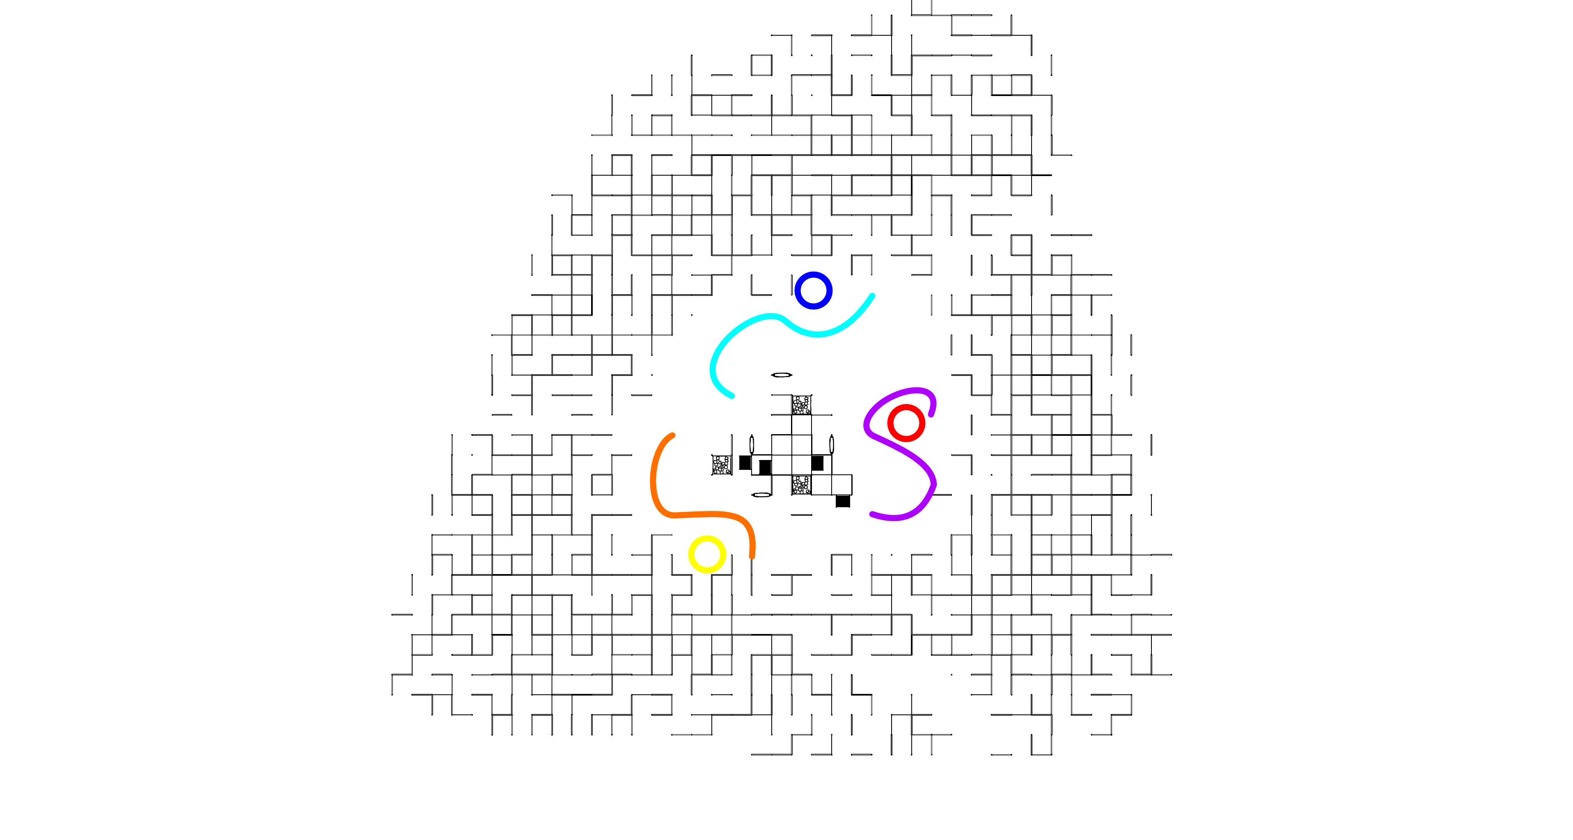
Calculation – annual capacity

Outer membranes
(length 1,50m)
P (in watts) = I (in ampere) * U (in volt)
I = 2 [ampere] U = 9.011 [V]
P = 2 * 9.011
P = 18.022 [watts]
annual capacity =
P * hours per day * day of the year
annual capacity = 18.022 * 24 * 365
annual capacity = 157870.627 [Wh]
number of generators n = 43503
total annual capacity [MWh] =
(annual capacity/1000000)*n
total annual capacity [MWh] =
6867.846 [MWh]
Cylinder - red
(length 1,30m)
P (in watts) = I (in ampere) * U (in volt)
I = 2 [ampere] U = 10.413 [V]
P = 2 * 10.413
P = 20.825 [watts]
annual capacity =
P * hours per day * day of the year
annual capacity = 20.825 * 24 * 365
annual capacity = 182428.280 [Wh]
number of generators n = 200
total annual capacity [MWh] =
(annual capacity/1000000)*n
total annual capacity [MWh] =
36.486 [MWh]
Cylinder - yellow
(length 1.125 m)
P (in watts) = I (in ampere) * U (in volt)
I = 2 [ampere] U = 7.509 [V]
P = 2 * 7.509
P = 15.018 [watts]
annual capacity =
P * hours per day * day of the year
annual capacity = 15.018 * 24 * 365
annual capacity = 131558.856 [Wh]
number of generators n = 252
total annual capacity [MWh] =
(annual capacity/1000000)*n
total annual capacity [MWh] =
33.153 [MWh]
Cylinder - Blue
(length 0.95 m)
P (in watts) = I (in ampere) * U (in volt)
I = 2 [ampere] U = 5.188 [V]
P = 2 * 5.188
P = 10.376 [watts]
annual capacity =
P * hours per day * day of the year
annual capacity = 10.376 * 24 * 365
annual capacity = 90895.210 [Wh]
number of generators n = 302
total annual capacity [MWh] =
(annual capacity/1000000)*n
total annual capacity [MWh] =
27.450 [MWh]
Wall - Violet
(length 1,50 m)
P (in watts) = I (in ampere) * U (in volt)
I = 2 [ampere] U = 9.011 [V]
P = 2 * 9.011
P = 18.022 [watts]
annual capacity =
P * hours per day * day of the year
annual capacity = 18.022 * 24 * 365
annual capacity = 157870.627 [Wh]
number of generators n = 588
total annual capacity [MWh] =
(annual capacity/1000000)*n
total annual capacity [MWh] =
92.828 [MWh]
Wall - Orange
(length 1,125 m)
P (in watts) = I (in ampere) * U (in volt)
I = 2 [ampere] U = 7.509 [V]
P = 2 * 7.5090
P = 15.018 [watts]
annual capacity =
P * hours per day * day of the year
annual capacity = 5.018 * 24 * 365
annual capacity = 131558.856 [Wh]
number of generators n = 596
total annual capacity [MWh] =
(annual capacity/1000000)*n
total annual capacity [MWh] =
78.409 [MWh]

Wall – light blue
(length 0,90 m)
P (in watts) = I (in ampere) * U (in volt)
I = 2 [ampere] U = 4.915[V]
P = 2 * 4.915
P = 9.830 [watts]
annual capacity =
P * hours per day * day of the year
annual capacity = 9.830 * 24 * 365
annual capacity = 86111.251 [Wh]
number of generators n = 860
total annual capacity [MWh] = (
annual capacity/1000000)*n
total annual capacity [MWh] =
74.056 [MWh]
inner core
(length 1,50m)
P (in watts) = I (in ampere) * U (in volt)
I = 2 [ampere] U = 14.317 [V]
P = 2 * 14.317
P = 28.635 [watts]
annual capacity =
P * hours per day * day of the year
annual capacity = 28.635 * 24 * 365
annual capacity = 250838.885 [Wh]
number of generators n = 357
total annual capacity [MWh] =
(annual capacity/1000000)*n
total annual capacity [MWh] =
89.549 [MWh]
capacity of the hole structure
6867.846 + 36.486 +
33.153 + 27.450 + 92.828 +
78.409 + 74.056 + 89.549
= 7299.777 [MWh]
The total capacity of the hole structure is 7299.777 [MWh] per year.

