CORRIDOR OF LIFE

“The wisdom of nature is such that it produces nothing superfluous or useless”

Nicolaus Copernicus

INTRODUCTION

The project design takes inspiration and direction from the flows of nature, as a permeable artistic sculpture, modelled and engraved by the forces of the natural elements. The direction and force of the winds are channeled and accelerated to create energy, as is the energy of the sun that is captured through “solar wings” installations. The addition of bodies of water such as wetlands and ponds, as well as forests and green areas, will serve as stopover sites for migratory bird, along with paths and walkways for the public. All of these contribute to the creation of an energy generation landscape, where the sculptural beauty of the designed and natural elements, all sustainable and renewable, can coexist in harmony on multiple scales. Just like single primordial self-sufficient cells can merge into a multiform body, beauty of the energy then becomes a body for the joy and pleasure of the communities.

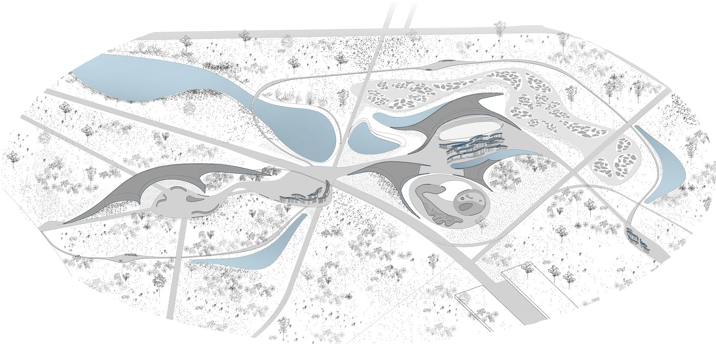

CONTENT

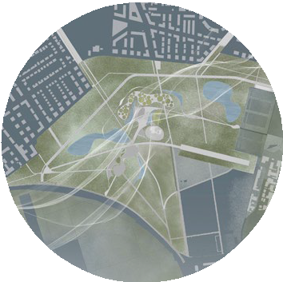
CHAPTER 1 : THE WIND

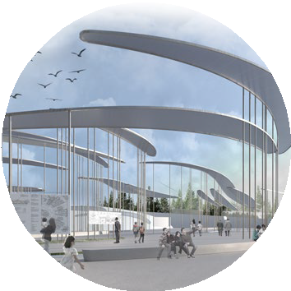
CHAPTER 2 : THE SUN

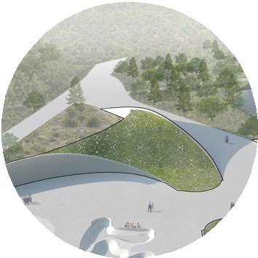
CHAPTER 3 : THE GREEN
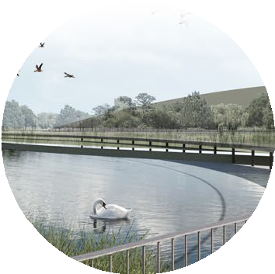
CHAPTER 4 : THE WATER

ENVIRONMENTAL IMPACT CONCLUSION

CHAPTER 1.
THE WIND

Within the given project area, we have studied the zones and directions where the wind is the strongest, and we are proposing to create structures called “architecture of wind”. These structures are integrated with the natural landscape, by passing over the paths or going underground, while forming public areas.

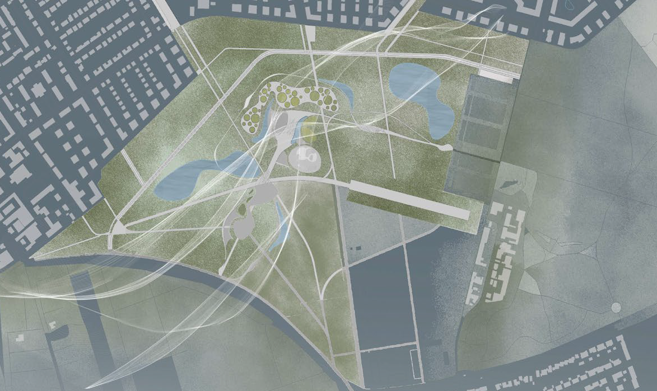
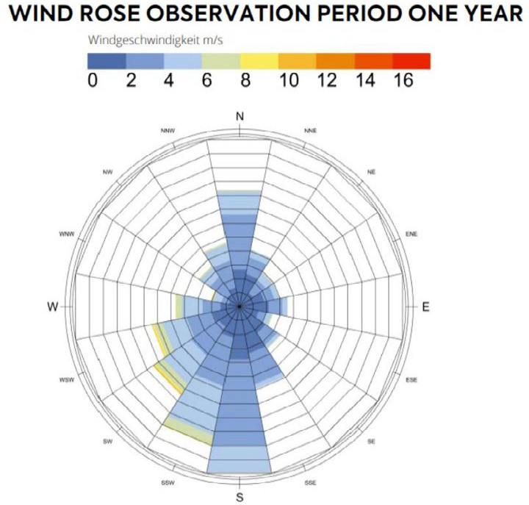

The main principle of the “wind concentrators” is based on the Venturi effect. By decreasing the sections of the ducts in the central parts, the air flow is channeled and then accelerated, creating a “concentrated wind”. This effect can accelerate the wind speed by 2-3 times and consequently the power output
by 4-8 times. By studying scientific articles, we have utilized the optimal proportions for these “wind concentrators”.

Based on the technology chosen, the “wind concentrators” can even work with low-speed wind. Turbines are then positioned in the narrow part of the concentrator, in order to harvest the strongest wind.

These structures will not represent a risk for animals, people and local fauna, as the entrance and exit are closed by grills, and isolated by distancing public activities and used green areas.

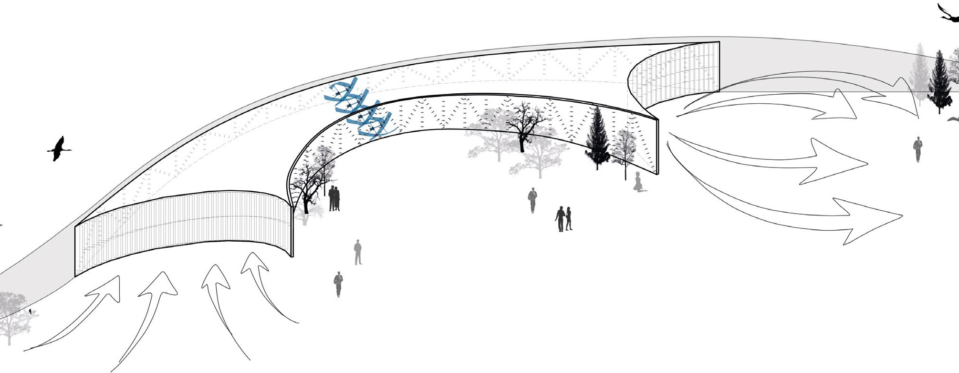

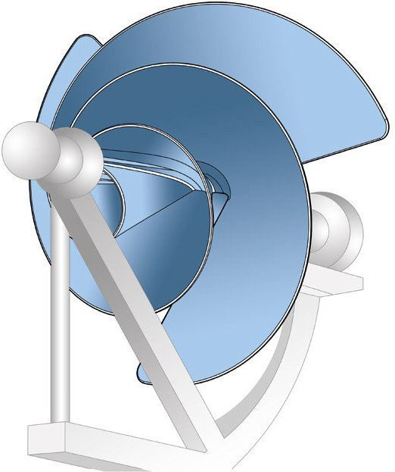
We have selected silent turbines respecting the surrounding environment and public activities.

We propose a new type of wind turbine comprising three circular blades which are wrapped around one another and then expanded. The special design ensures that wind is drawn into the turbine. The average yield is many times higher compared to a normal urban windmill propeller.

We will be using 200 turbines of this type in our project (calculated according to the cross section of the “wind concentrators”) of 1000W. We have taken yearly average wind speed of 3m/s in Mannheim and assumed that the Venturi effect will increase the wind speed to an average of 8m/s. Therefore the total energy produced by wind is 960kWh per day.

The annual total energy produced will be approximately 350MWh.

The “wind concentrators” are scalable, meaning, they can be made in smaller dimensions while keeping the optimal proportions for efficiency. They can be installed in private areas, giving them additional functions (urban furniture, seating, areas for aggregation of groups, islands of socialization).
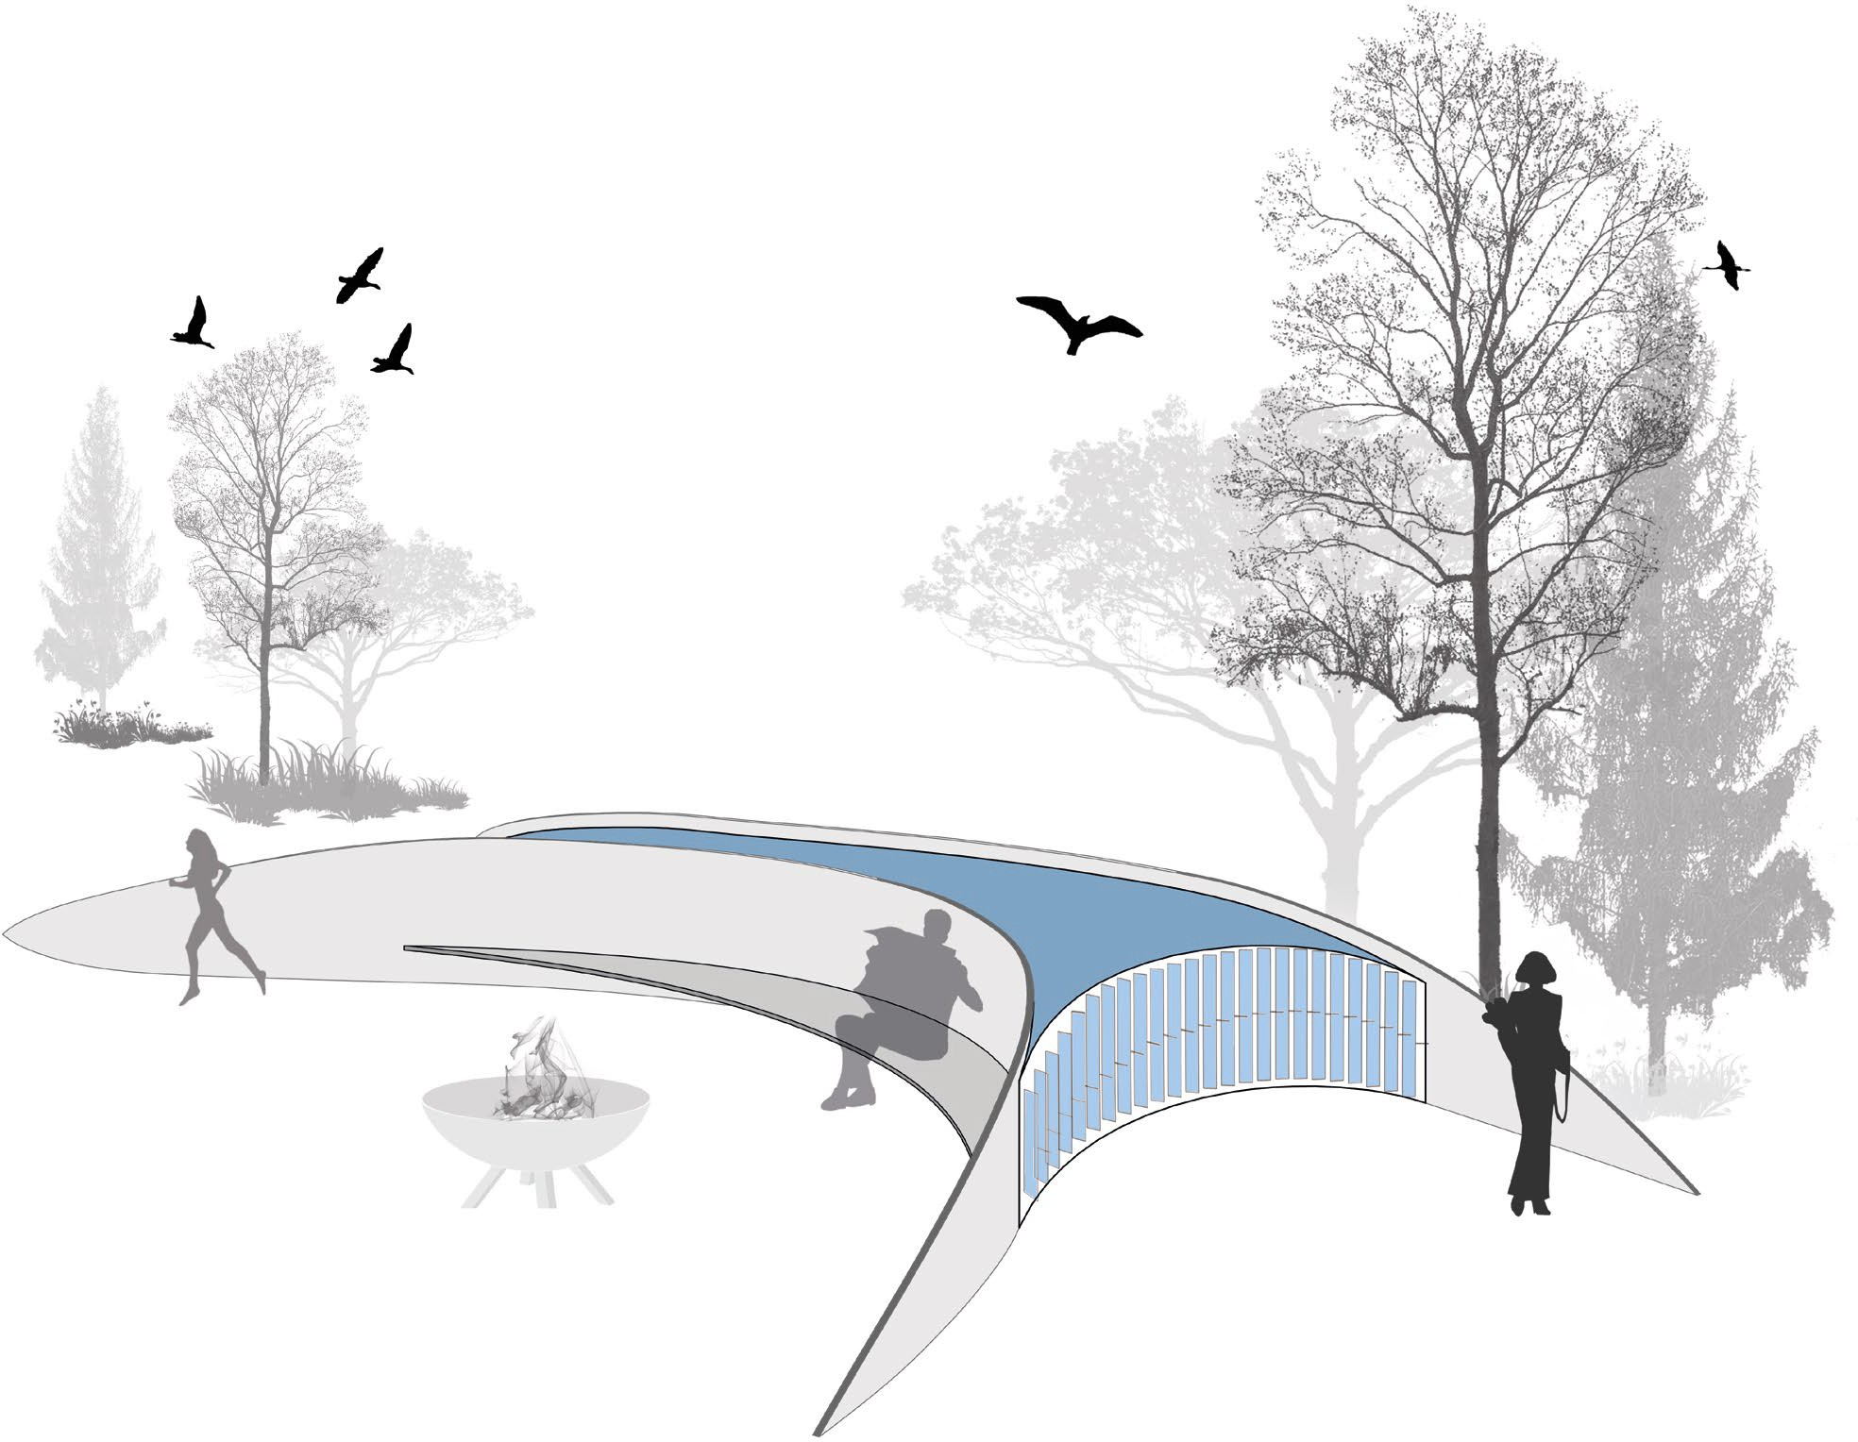

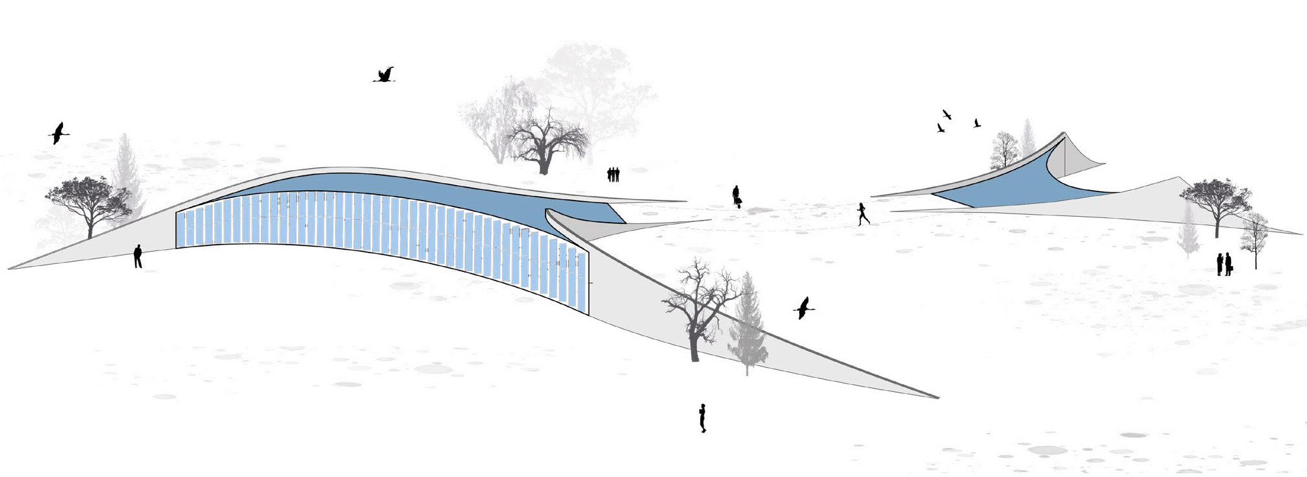

In the central area of our project, the “wind concentrators” frame spaces for public use, such as the amphitheater for large events, which is powered by the energy produced. In another area, the “wind concentrators” generate spaces intended for sports and leisure activities for children and adults (skateboarding, climbing, cycle path etc.). An additional area forms a large space for exhibitions with different purposes (artistic, educational, sustainable living...)

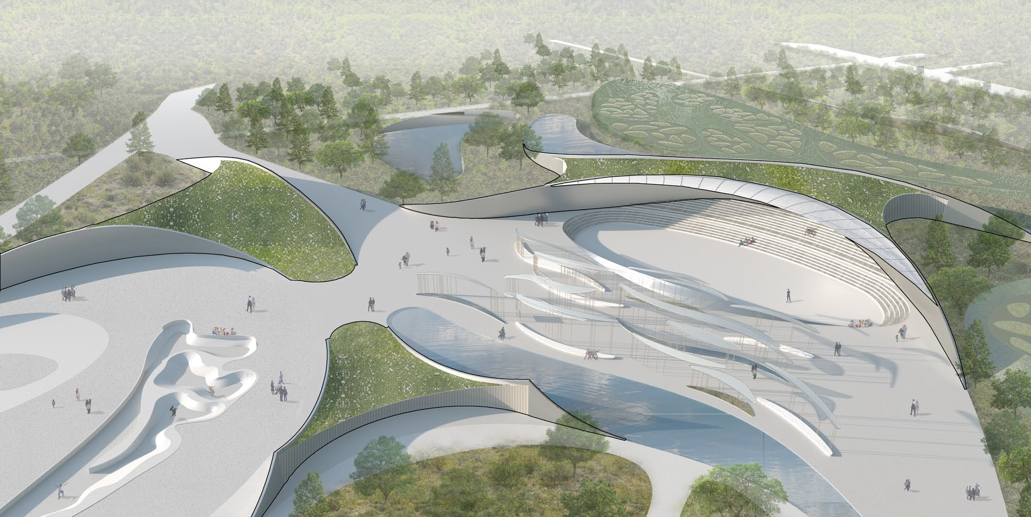

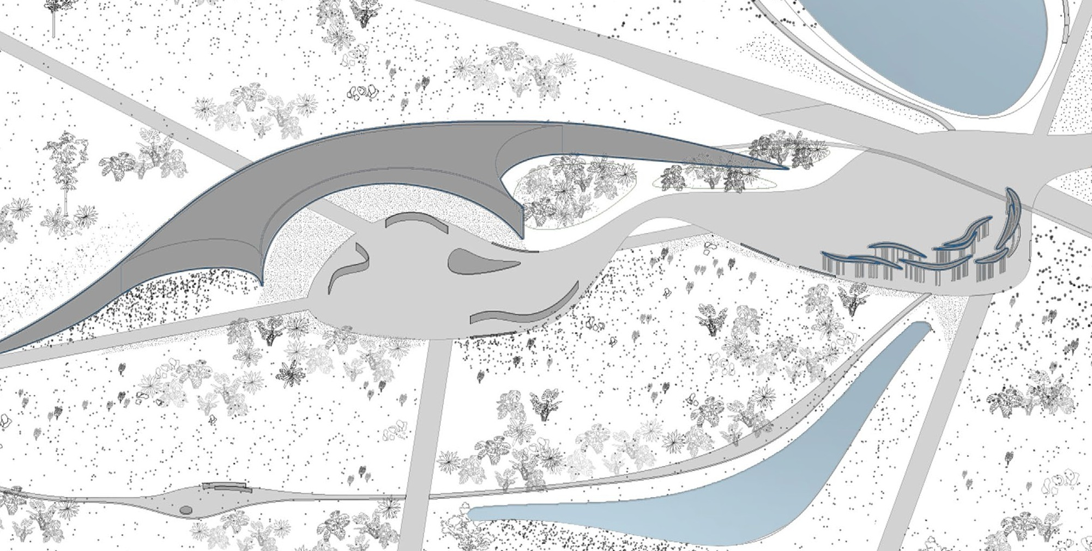

CHAPTER 2.
THE SUN
Another important part of the project is the design of the solar energy elements called “Solar Wings”. These elements are located in the central part of the project and follow the physical and energetic paths of the sun. Their height is about 5-7 meters, providing shade and creating a diverse and multifunctional space underneath. The addition of elements of urban furniture (benches, rest areas, recreational areas, exhibition areas) to the structures, allowing for a multitude of functional uses, as well as looking like artistic aerial sculptures that are similar to kites or large wings, imitating the passage and migration of birds that occurs above them.

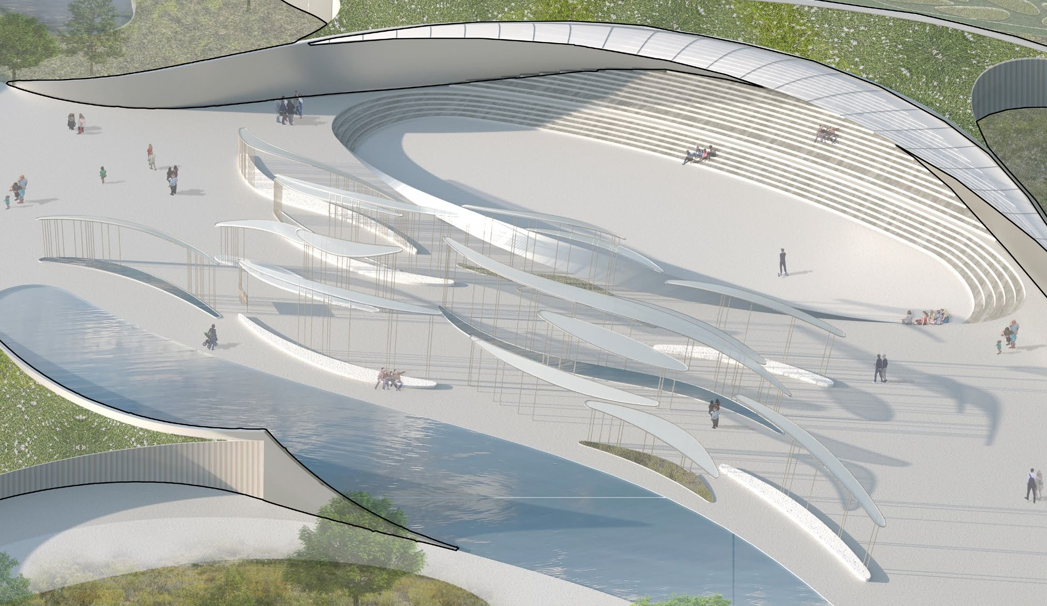

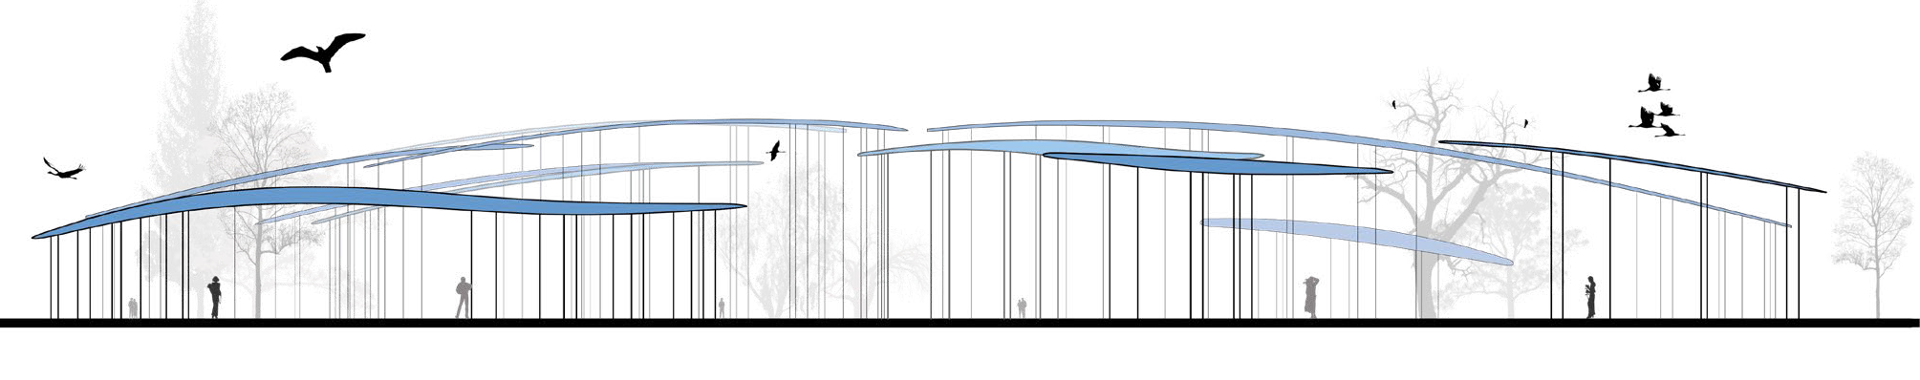

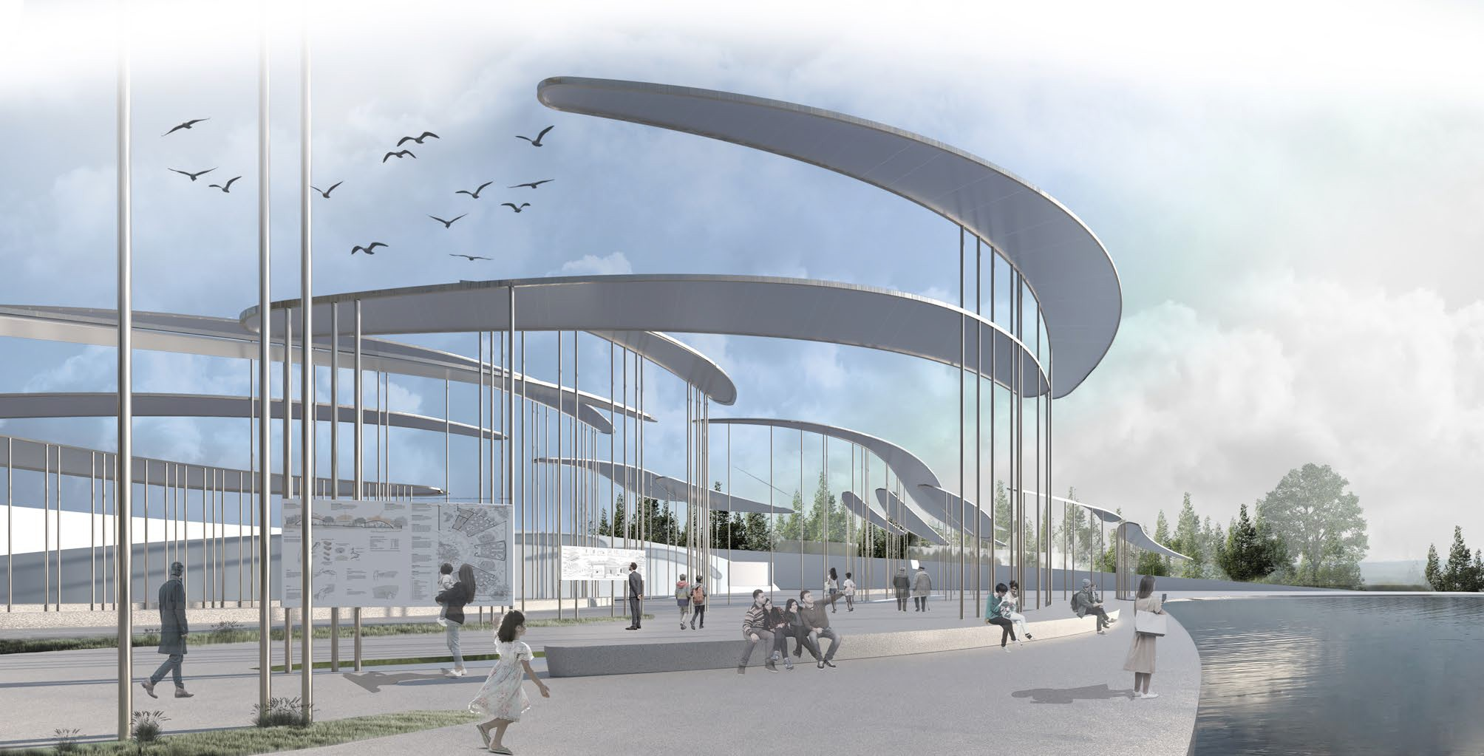

These organic forms can be combined in infinite ways. They can also be scaled down for smaller or more limited spaces (public or private), all while maintaining their attributes and performance.

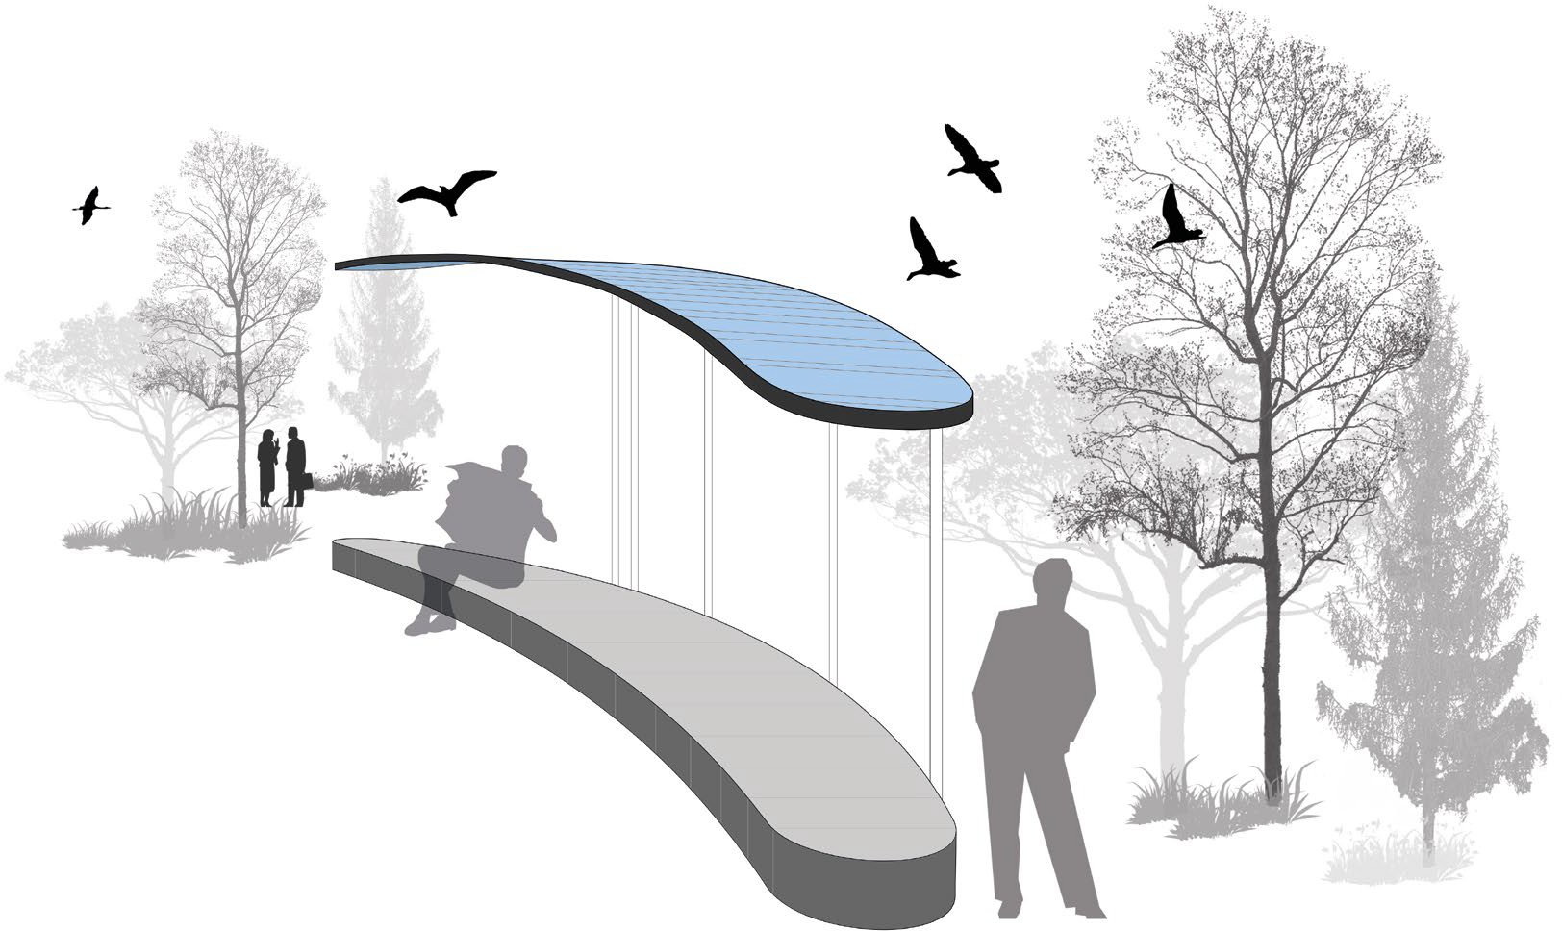

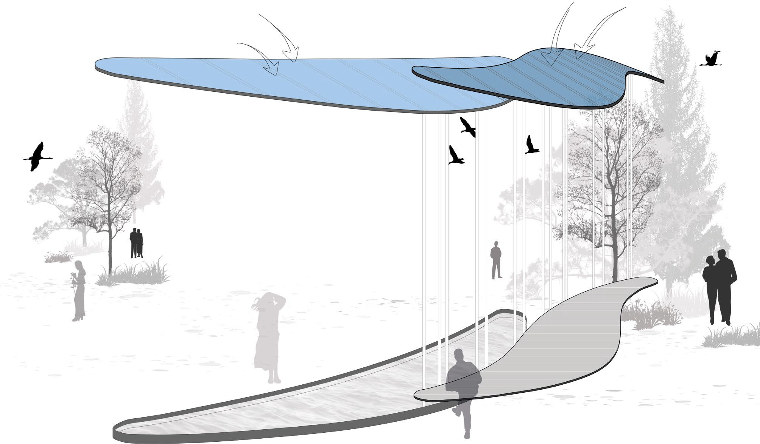Recycled concrete seating
Semi-transparent
Dye-sensitized solar cells
Recycled aluminium structure

In our project the “solar wings” are made out of recycled aluminum structure, recycled concrete and can include water or greenery. The roof is made with semi-transparent dye-sensitized solar cells, with an
advantage of their flexibility, durability and low cost. They also function comparatively better than other PV technologies in low light levels and indirect light.

These “solar wings” are located in major public spaces of the project as well as within urban farms as agrivoltaics. We have a total surface area of DSSC of 7000 sqm.

Considering the efficiency and the average yearly sunshine hours, the total solar energy output is 647MWh.

CHAPTER 3.
THE GREEN

We wanted to reinforce the idea of the green corridor by addressing the arising problem of migratory birds. With industrialization and increasing human population migratory, birds have fewer stopover sites that are vital to them for the recovery during their exhausting journey.

Therefore we decided to concentrate our design in the central part of the area and create a natural environment comprising of several wetlands that will become stopover sites for the birds. A walking / cycling pathway goes through these areas, elevated from the ground in order to provide minimal influence and leave these areas as private as possible.

The project involves the creation of two large wetlands, which we believe to be essential ecosystem services that can regulate hydrological flows, water purification, soil erosion control, climate change mitigation (through the absorption of CO2 present in the atmosphere), and the protection of biodiversity.

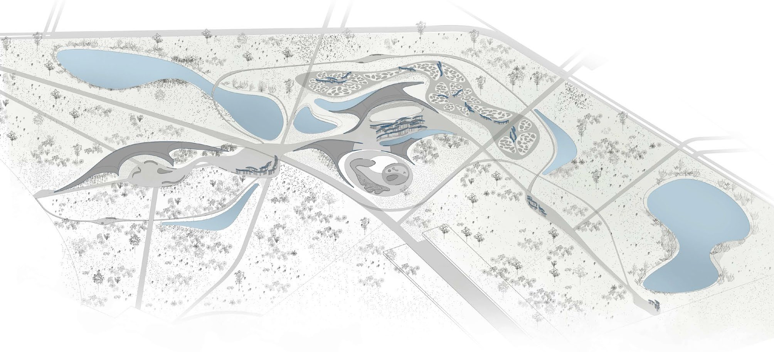

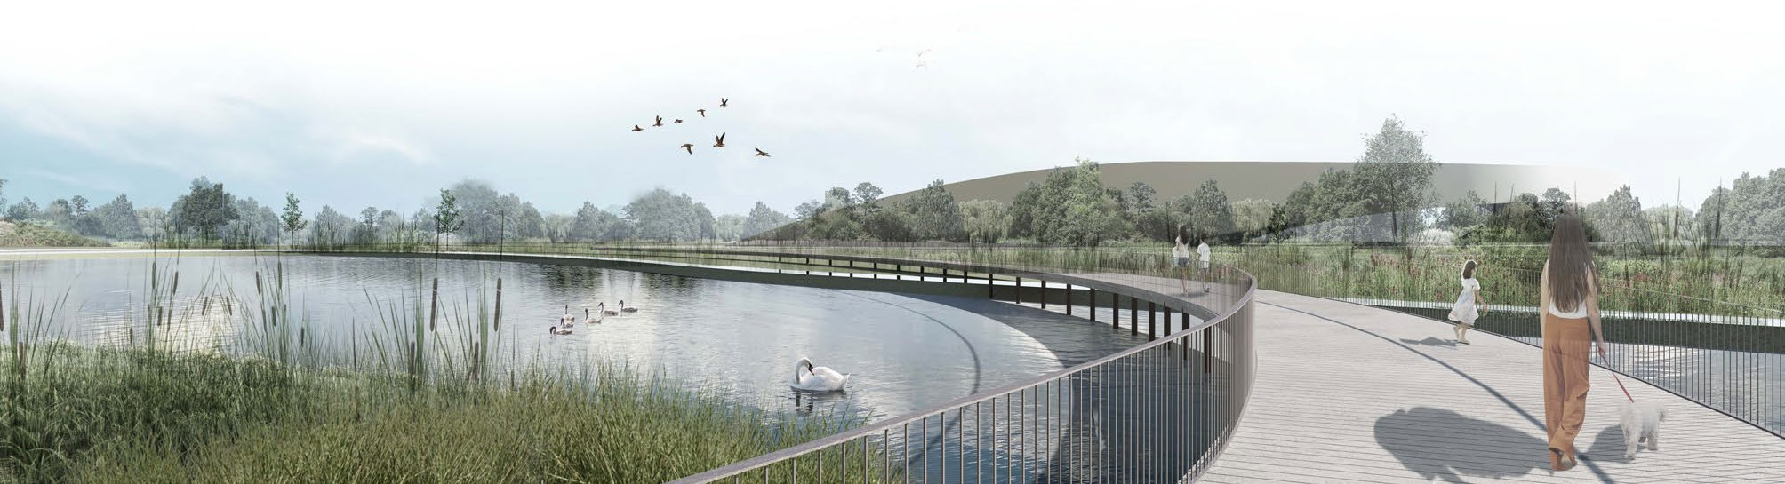

Another topic we wanted to address in this project is urban farming. Urban agriculture represents first and foremost, a solution to redevelop degraded areas in cities. It moreover protects agricultural biodiversity, favoring the short supply chain and reducing emissions. Urban gardens tend to develop strong social inclusion, creates employment, reduces the cost of food, enhances the territory and rediscovery of social ties between people, all while improving the surrounding micro-climate.

CHAPTER 4.
THE WATER
Our project includes three types of bodies of water: 2 ponds to support the wetlands;
rainwater collection tanks which use Phyto depuration systems, which represent a renewable and local source of irrigating lawns, plants and vegetable gardens; and finally, connections and water passages that act as a hinge between the project structures, the lakes and the water collection tanks. Those passages follow a path that ideally starts from the northern area of the urban gardens and flows into the lake foreseen in the bordering East area, thus creating a continuum between projects, territories and energy corridors.

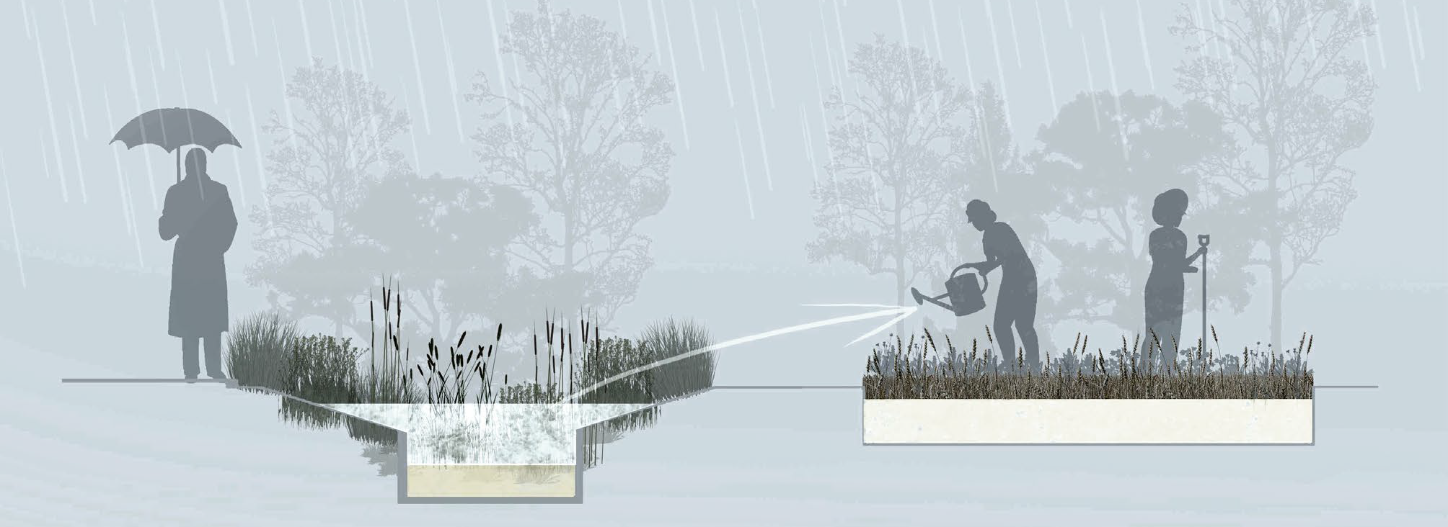

ENVIRONMENTAL IMPACT

Our project facilitates the pathways of the energies of the area (micro and macro-area) (wind direction and speed, migratory corridors, sun, water flows,) without preventing in any way the interruption, including visual connections; the whole project is like a permeable artistic sculpture modelled and engraved by the
same forces of nature and acts as a hinge for the green corridors of the surrounding areas in harmony with each other.

Consistently with a systemic and dynamic vision, the landscape surrounding the project is investigated through the relationships established over time between the natural and built components.

We have analyzed the connections with the environmental, productive and cultural reality of the territory. The choice of focus on the creation of urban gardens, green areas and artistic sculptures that capture renewable energy, wind and sun, is placed in this perspective as a preferential point of view to analyze the landscape and as a field of experimentation to build enhancement strategies, landscape and local identity management.

The internal routes and the many activities present in our project are interpreted not only as an infrastructure but as a human resource for the entire garrison, allowing the local population to have better air, a closed cycle of zero energy consumption, energy efficiency, use of renewables, abatement of pollutants, biodiversity, sustainable mobility, the possibility of managing the excess energy produced by giving it to the surrounding areas, the development of social inclusion and a transformation of the territory that returns to its natural origins with the return of native flora and fauna.

CONCLUSION

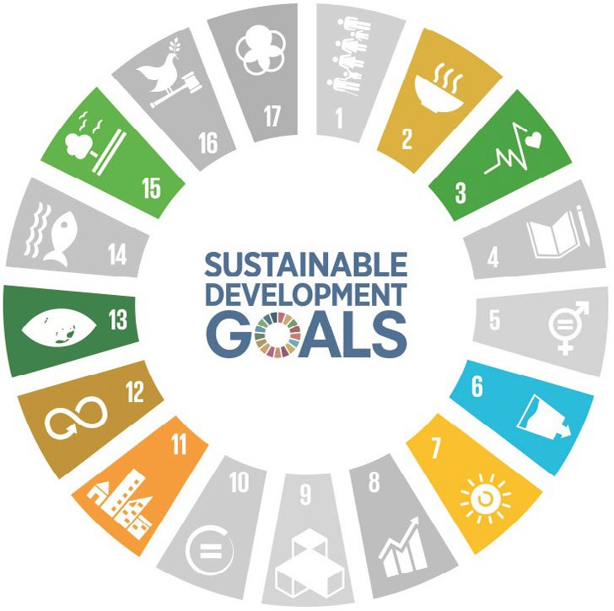Redevelopment of degraded areas and enhancement of biodiversity

The mitigation of climate change (through the absorption of CO2 present in the atmosphere)

Zero km consumption, zero CO2 emissions, reduced food costs

Development of sociability and aggregation, social inclusion

Urban farms, agrivoltaics

Parks, urban farming, rediscovery of social bonds between people

Rainwater collection, Phyto depuration

Renewable energy present in the project

The activities designed and present in our project, all scalable, are many: urban agriculture (urban gardens) as places of socializing and aggregation; education and teaching; playful and recreational activities; large play areas and learning spaces for children, teenagers and schools; recreational activities ; permanent and traveling exhibitions; energy security, opportunities for economic growth and development; responsible recovery of the territory also recreating the fundamentals of nature, with wetlands and renewable energies, which generate an abundant capacity for generating public-private energy with zero emissions of greenhouse gases.

Our design will produce in total an estimated annual energy of 997 MWh, clean and renewable (wind energy, solar energy, piezoelectric walkway). This energy can be stored and feed all activities present within the project and the surplus can be shared with the surrounding community.

The heart of our project is to try to show the beauty of renewable energies that take shape through the creation of artistic and sculptural forms inspired by nature and thus bring a message of active hope for the post-carbon future of humanity.

All this leads us to share the history of the site and the surrounding areas of the project, convincing us to support, with our proposal, the objectives of the green corridor (Klimopass) in the union of neighboring contexts and areas in harmony, beauty and usefulness.

In this way we have tried to make many united nations sustainable development goals in which we deeply believe and which we want to announce and disseminate for a new safe, happy and sustainable future of our next generations.

