THE FLOURISHING NEST
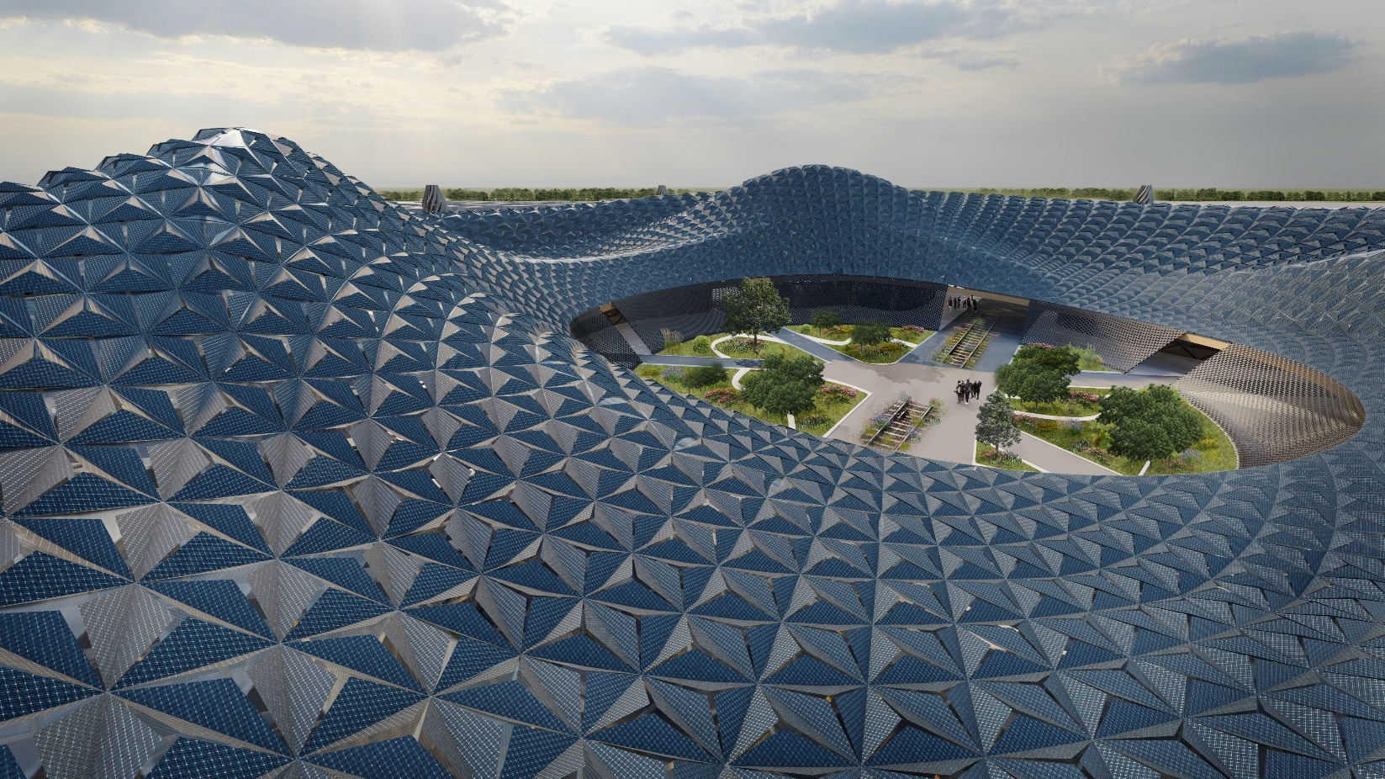

NEST:
Is a place that artfully built, where acts like learning and singing together happens, and everyone knows survive means togetherness, where is safe and warm.

Project Description
The Public's view of renewable energies is changing!
In this project, renewable energy enters the lives of citizens and tourists of this region with an interactive process and then exits leisurely from this region using the applied technique to be used in various spaces. These spaces include yards, schools, hospitals, roof gardens, and any open space of various sizes. Boundaries between technology and humans are eliminated, and harmony is created, leading humans to a brighter future. This is not a school, museum, or park project, but it executes their role. It teaches today's humans a lesson about using renewable energies in an attractive, interactive setting mixed with nature. Hence, this project puts emphasis on the UN's sustainable development goals, especially goals 4, 7, and 11. The design was started considering the direction of routes and by creating a proper center within the site that will attract the attention of audiences from various parts of the site. The design was formed commensurate with climatic conditions taking the green corridor into consideration for the future flowers to grow and flourish in this center, creating the main form. The project consists of a neat and aerodynamic design covered with a state-of-the-art system of panels. Various activities are conducted in different sections, helping humans understand the importance and methods used in the energies. This will help create a dynamic community. A circle spreads from the center of lines covering the site, and the intersection of lines forms the main surface of the landscape. The centers are utilized for establishing turbines with modern designs and unique functions, acting as a viewpoint to enjoy the harmony created between humans, nature, technology and energy.

Technology Used in Design
Existing and newly developed green technologies were reviewed at the start of the design, and the need for another energy source in this design was felt. This is because the project is conducted within a region where rainy and cloudy hours were abundant, causing the efficiency of solar panels to decrease during these hours. Ultimately, chosen technologies for energy generation were divided into two groups:
- The technology used in the pavilion
This system can be used on various scales, such as large communal spaces, and a small pavilion was also used for the backyard of a personal house. This system consists of photovoltaic cells (PV of any kind) in triangular panels capable of opening/closing and droplet-based energy generators (DEGs) under PVs that consists of PTFE layers with a transparent surface capable of light emitting. On a smaller scale, this structure can be designed without the capability to open/close, and panels are placed in an open manner, helping both photovoltaic cells and DEGs to function at any time.
- Technologies used in various park sections using wind energy
The technology used here consists of vertical-axis wind turbines (VAWTs) mixed with social activity (at a large scale) and another application, i.e., creating illumination (on a small scale). These turbine towers within the site can generate energy and make it possible for people to visit the tower, which can act as a viewpoint for the site. Additionally, a connection between humans and this energy generation system can be created by showing the audience how the system works.

The following technologies are also used in the design:
- Water harvesting and storing system between the pillars and cellar and garden plants are irrigated using pumps within the plan.
- The structure consists of wooden beams, and there was no damage done to nature in the production process, which is the promise of green construction for the designer.
Public Activities and Social Co-Benefits
A new space called the Garden of Life is located in the center of the form. The garden is a symbol of the relationship between the four components creating the design, i.e., human, nature, technology, and energy, and its growth requires coordination and harmony between the four components. It symbolizes today's society whose growth depends exactly on these factors. As it is evident, the energy in the form of solar light plays a role in the garden. The required water, collected from rainwater by the form and stored in underground reservoirs, is used smartly by the technology to irrigate the garden when needed. The growth of plants and the presence of this space positively impact the human spirit. Here, the human prunes and grows plants, as once known as the distorter of the world's harmony, who is now the constructor of the design and creator of the harmony. This whole reminds the human of the harmony between the four elements, indicating that the survival of this order is a condition for the survival of humanity.
In addition to the garden, a structure made up of six different sections for public activities and social co-benefits is considered below the shell. A library for the Public, a specialized reservoir for new energy resources, a study hall, a book store, conference halls, play spaces for children, an interactive fair for the connection of the human and energy, beverage and food, a recreational space, and the lines used for the design in the site plan create surfaces with different areas in the landscape, in which green spaces and multi-purpose activities are formed, creating various experiences in the human. The wind turbine towers, located at the intersection of these lines, are also used as a landscape.

UN Sustainable Development Goals
The present design seeks the following goals, in addition to the points mentioned:
1. Goal 4: Learning with experience and through observation, along with the design of spaces to improve the scientific level and introduce affairs associated with renewable energy and environmental preservation, such as the library, conference hall, and interactive fair on the site.
2. Goal 7: The advanced hybrid solar and rain panels, along with the wind turbines used in the design, provide the green energy required for the individuals in the region throughout the year. The simplicity of the techniques used in the design, along with the buildability, elegance, and scalability of the system, make it available for the whole people. This is a step forward in helping society achieve the seventh goal of the UN.
3. Goal 11: The type of design used here can attract experts' attention to use advanced technology and sustainable buildings so that they would design spaces based on this idea in the future, improving the resilience and stability of the human residence.
MWh Generated per Year

1.Pv Capacity in kWp

- Surface PV Area: 44,825 m² 8,965 kW
- x 19.5% Efficiency Assumed Based On LAGI Field Guide Document, 3D Solar Cell 1,748 kW(p)

Annual mWh (Megawatt-hours) of Energy Expected

Annual kWh: 1748 kW x 0.195 (Efficiency) x 1750 (Average hours of sunshine per year) x 0.75 (Effective Output % After Deducting Losses) = 2,294,250 kWh/year
Annual mWh = 2,294.25 mWh/year

2. Droplet-Based Energy Generator (DEGs) Capacity in kWp

- Surface PV Area: 4034 m²
- 4034 m² x 50.1 W/m² (DEG power density) = 202 kW

Annual kWh: 202 kW x 1920 (Rainy hours per year) = 387,840 kWh/year
Annual mWh = 387.8 mWh/year

3. Wind Turbins Capacity in kWp

- Each VAWT Turbin: A(Sweep Area)=15.6 m (Diameter) x 25.5 m (Height)=397.8
- P_{wind} = 0.5 x 1.225 kg/m³ (Air Density) x (10.49)³ (Wind Speed) x 397.8(sweep Area)=281.25 kW
- Output Power= 281.25 kW x 0.3(30% efficiency)- 5%(losses)= 75.1 kW

Annual mWh (Megawatt-hours) of Energy Expected

Annual kWh: 75.1 kW x 16 (Number of Turbins) x 365 x 9.6(Peak Windy Hours) = 4,210,406‌kWh/year
Annual mWh = 4,210 mWh/year

4.Whole system Annual mWh (Megawatt-hours) of Energy Expected

Solar+Wind+Rain= 6,891 mWh/year

Environmental Impact Summary
The materials used in this project have been selected based on their returnability to nature, with out any waste. The wooden structure, one of the main materials both for the main pavilion and the turbines, is known as a green material and has less harm to the nature, also glass which can be recycled endlessly.
One of the main considerations of this design is the city green corridor and with the help of aerodynamic shape of the form the impact of it will be diminished, and by using the circle grid system the spaces between wind turbines are designed in a way that there is no obstacle to the airflow through the city.
The beauty ingrained in the design combined with a touch of nature and curved lines will attract people to the site, touch their soul and show them how society’s thriving depends on technology which should be in a harmony with nature for better future. The public spaces under the pavilion provide a place for cultural and scientific interactions that are an important part of a society's development, and one of its goals is to influence children who are the future builders of any society.
The main pavilion and the turbines can be used in different scales, either civic or in a private garden, which can distribute energy collectors throughout the city. This can lead to decentralization and make the cities more resilient and sustainable.

