Vorfreude
Description
Vorfreude is a Garden Pavilion and Observation Tower located in the Themed Garden Spinelli Park area, Mannheim, Germany. This facility consists of an observation area, and an educational area related to plant care, agricultural technology development and ecological awareness. This design is made for a long time with a shape that adapts to the Spinelli park flower garden area without having a bad impact on the Spinelli park flower garden ecosystem.
The name “Vorfreude” is taken from German language which is mean “the anticipation of a pleasure yet to come: it is the enjoying of a dream and expectation that we have”. We hope that this design can provide a pleasant and enthusiastic feeling to learn and explore the Spinelli park flower garden site further. Visitors are expected to enjoy the beauty of the Spinelli park flower garden and increase awareness of the importance of maintaining and caring for the Spinelli park flower garden ecosystem in the future.
Vorfreude is located in an area with a high variety of vegetation, in Themed Garden Spinelli Park, Mennheim, Germany. In addition, this position allows Vorfreude to be on the pedestrian path from the BUGA festival to UHalle which will become the Exhibition Center. This allows Vorfreuda to be one of the main routes for visitors to reach Uhalle. Visitors can enjoy the flower garden and pavilion garden before reaching Uhalle. This experience is expected to leave a good impression in the minds of visitors and a deep awareness of the importance of preserving the natural ecosystems around us.
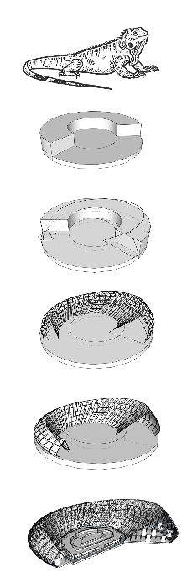
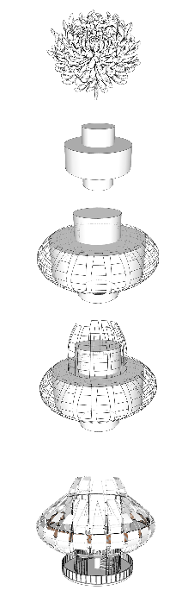
Transformation form

The shape of the Garden Pavilion is inspired by the shape of the Iguana which is one of the inhabitants of the Spinelli park habitat. This form is made of two-way circulation with different sizes on both sides. This aims to provide a mysterious space experience and trigger the curiosity of visitors to go deeper. In addition, the curved facade area is covered by photovoltaics cells that can store electricity reserves of up to 4960 MWh. The inner circumference is made of glass material to maximize natural lighting.
The shape of the Observation Tower is inspired by the shape of Chrysanthemum flower to represents the Spinelli park flower garden area. This tower has a height of about 5.3 meters from the ground. The shape of the faade is inspired by flower petals which are embodied with FRP Composite and alumunium Tube. In addition, the circular shape allows visitors to enjoy the beauty of Spinelli park 360 degrees.
These two forms were taken with the aim of representing the site ecosystem around Spinelli park. This design is designed for the long term and is independent in terms of energy requirement.
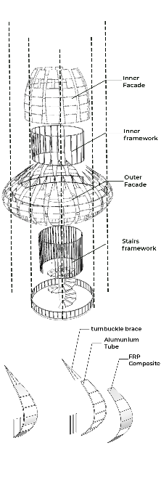
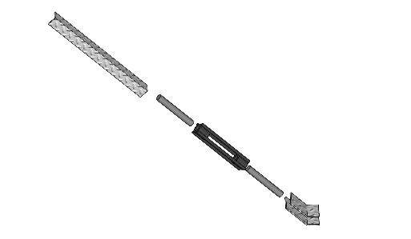
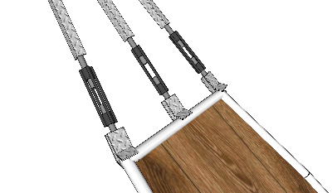
Construction Concept and detail

The construction of the Observation Tower is supported by a concrete column with a diameter of 80cm, and a concrete plate for the 2nd floor. The facade frame uses a 2-inch diameter aluminum tube which is connected by welding technique, then a plate of FRP Composite is attached. The faade is also connected by a Post brace connection at the top. FRP Composite is one of the environmentally friendly construction materials and has begun to be widely used in construction, especially for the manufacture of facades, because this material is quite flexible.
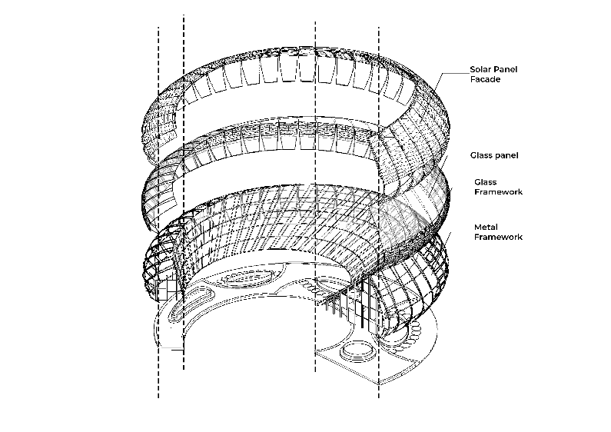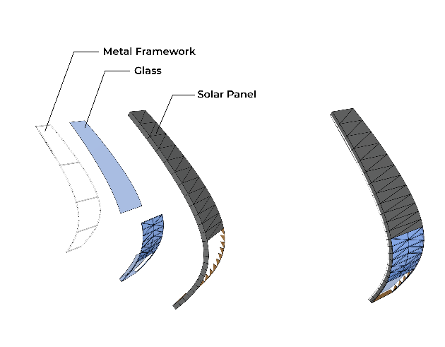
The construction of the Garden Pavilion uses a wide span truss system. This pavilion uses a metal framework for the outer and inner circles. The outer ring is added with a layer of glass at the bottom and then a solar panel at the top to capture sunlight. Then the outer ring is completely covered with glass to maximize natural lighting.
Technology Concept and details
Photovoltaic
Photovoltaic (solar panels) is a technology that converts energy from sunlight into electrical energy. potential for this type of power generation industry is being developed by the German government so that it can become one of the main producers of electrical energy in the future.
- Application on site
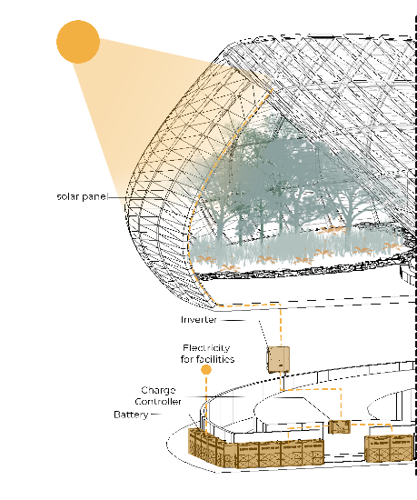
Solar panels are installed on the facade to maximize the absorption of sunlight. This light is then processed into electrical energy and stored in batteries to be distributed to all areas in need. Photovoltaics is equipped with applications that can monitor and control energy requirements.
Photovoltaics system
- Light is absorbed by solar panels installed on the façade
- The light that has been absorbed is channeled to the inverter to be converted into electrical energy
- The energy is then channeled to the charge controller which is a medium that distributes electrical energy so that it can be stored in the battery
- Energy that has passed through the charge controller is channeled to the battery to be stored or distributed to areas that require electrical energy.
MWh Per year
AE Solar
Germany, Messerschmittring 54, 86343 Königsbrunn
FLEX-03W-460W-490W - From $1.75 / Wp = 460 ~ 490 Wp
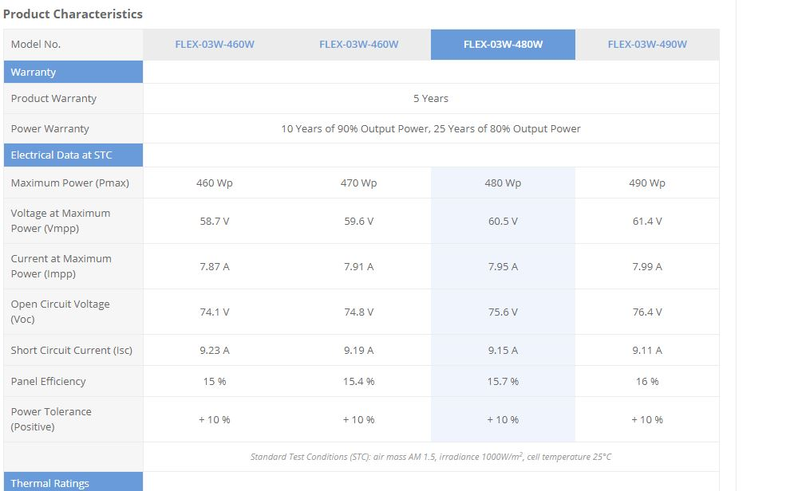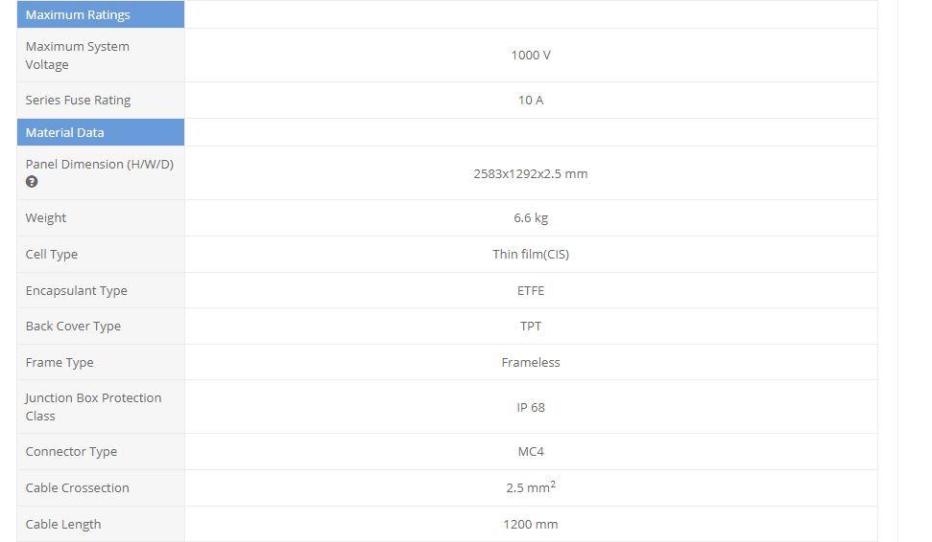
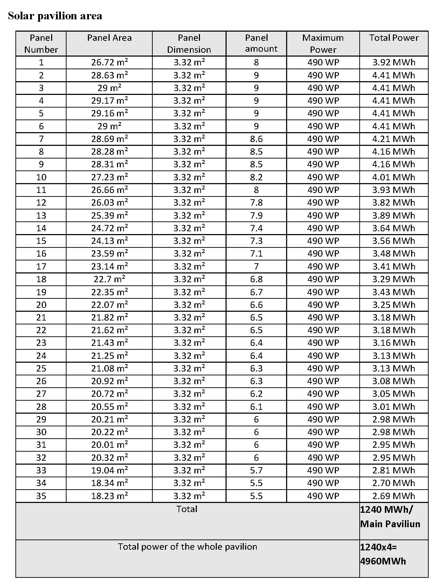

Rainwater harvesting
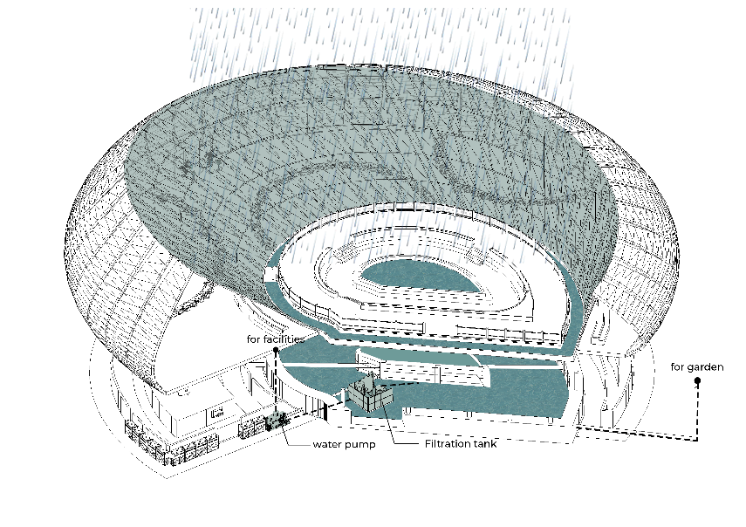
Rainwater that falls through the facade of the inner ring will be channeled into the outer pool, after which it will be channeled into the middle pool to fill the middle pool. The water collected in the pond can be used to water the plants around Vorfruede after going through the filter and pump. excess drains will be channeled to the environment according to local regulations.
Rainwater harvesting system
- Rainwater will flow down through the biling field of the inner ring façade
- Rainwater will collect in the outdoor pool and then be channeled to the inner pool to be stored as well as fill the inner pool
- The water that has been collected will go through the filtration stage by the filter when it is needed
- After passing through the filtration stage, the water will be channeled to the pump to then be used to water the plants.

Calculation of water storage capacity
Pool Volume= Surface Area x depth
V= 443.56m2 x 2m = 887.12m3 = 887120 L

Cost Estimation and strategy
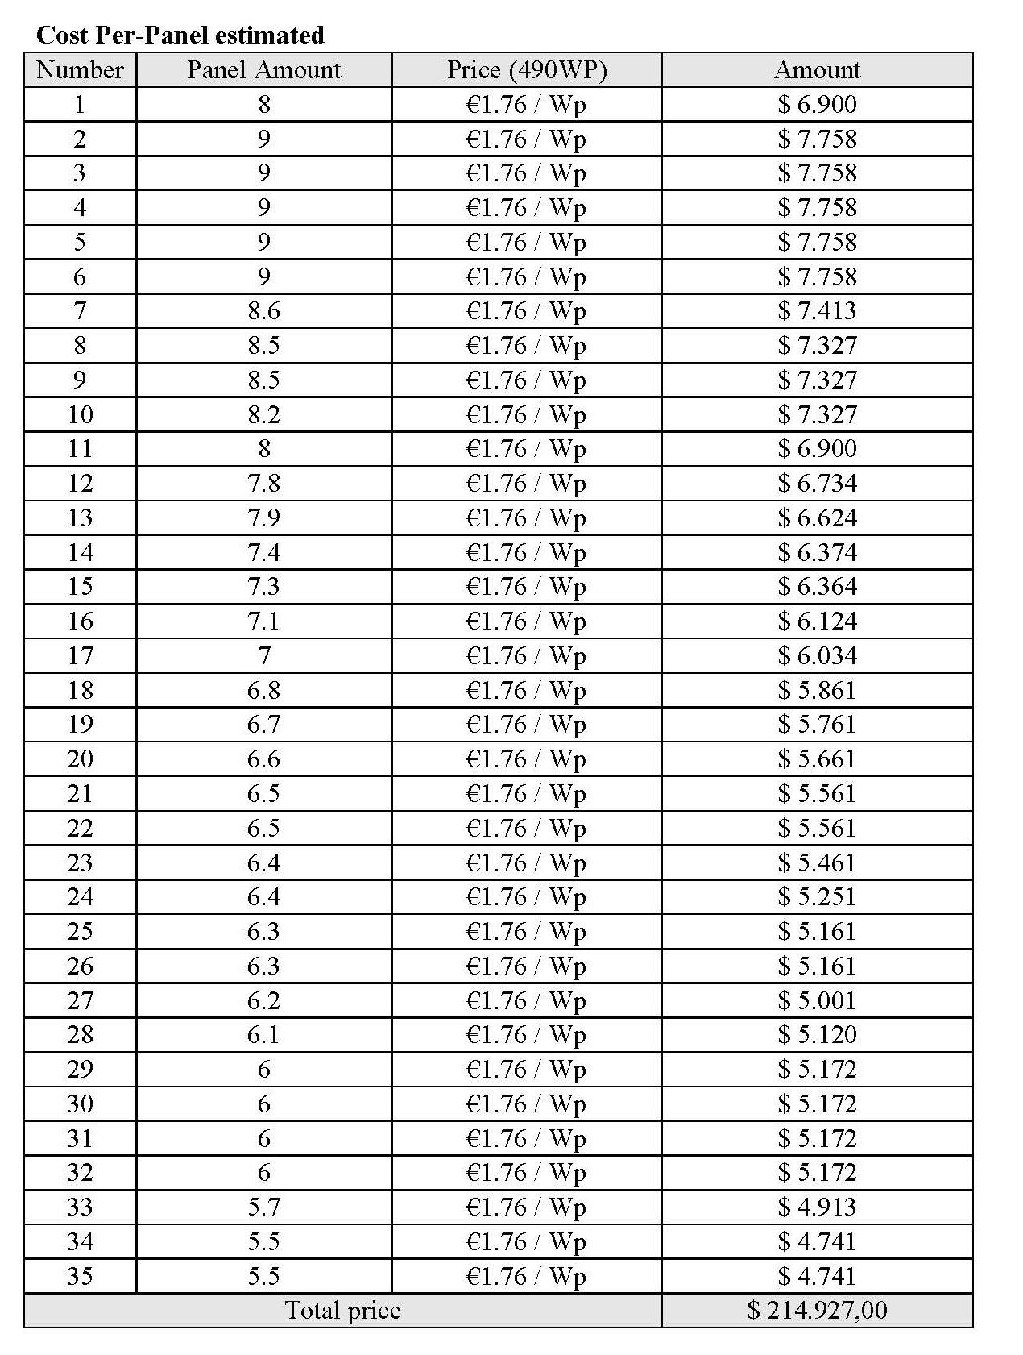
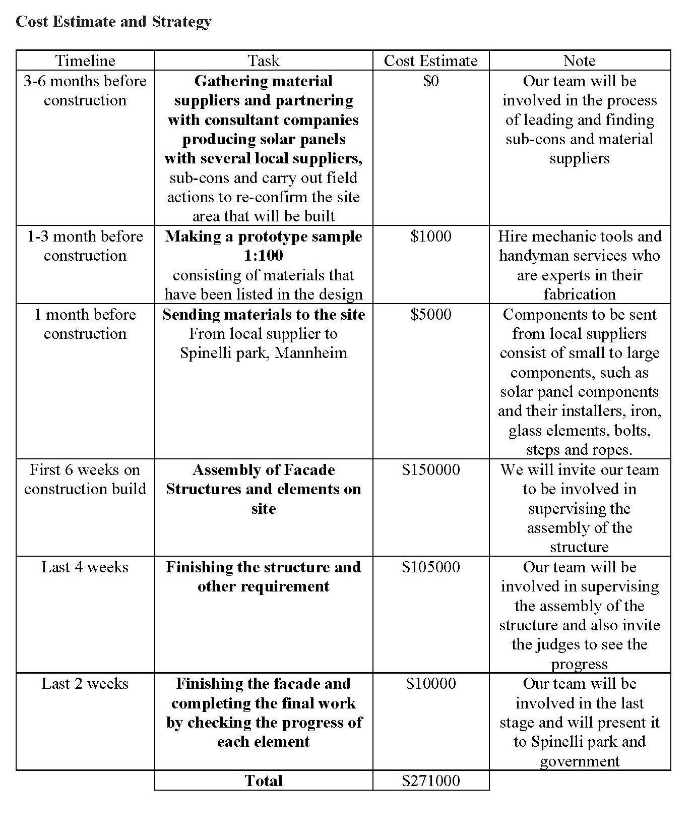
Public Activity
Vorfreude is a facility that made to support Educational and recreational purposes, these facilities are concist of Garden Pavilion and Observation Tower. Observation activities from the observation tower can provide further understanding of the plants in the Spinelli Park flower garden. Visitors can enjoy the beauty of the Spinelli Park flower garden to the maximum from the top of the tower.
In the center there are 4 pavilions with different themes. In this pavilion, visitors will be presented with garden landscapes and vegetation exhibitions as well as learn more about plant care, types of plants and flowers, and innovations in developing vegetation for food.
Visitors can also get involved by trying to apply technology and experience firsthand the ways to care for plants.
How does it support United Nation Sustainable Goals (UNSDG) ?
Vorfreude is try to help developing 2 of 17 United Nation Sustainable Goals the Affordable and Clean Energy point from UNSDG number 7, this point refers to energy sustainability that is able to support energy needs independently and is environmentally friendly. The use of photovoltaic technology and rain water harvesting can help around 80% of flower garden maintenance and observation facilities from time to time.
In addition, the points that are also developed are Living on Earth number 15 from the UNSDG. Points refer to the conservation and sustainability of the habitats of other living things. This design supports the development of sustainable habitat in the Spinelli Park flower garden by creating a distance between the theme garden and humans, thereby reducing the risk of damage to the ecosystem by humans. In addition, in the pavilion area there is education related to plant care that can help visitors understand the importance of maintaining and caring for the ecosystem around the site.
Environmental Impact
Vorfreude uses environmentally friendly materials that do not produce a lot of emissions. In addition, the distance between visitors and the flower garden is limited to prevent possible destruction of the habitat around the flower garden. Vorfreude not only created for observation facilities, but there is also a garden facility in the middle which can increase the understanding and awareness of visitors regarding the need to protect the environment around Spinelli Park and how to care for it. It is hoped that in the future there will be a community that cares about the ecosystem and is able to attract visitors' interest related to these issues.
The facade of the main pavilion, is designed with solar panels that are able to store electrical energy needs up to 4960MWh. This electric current is used as a power source for the Spinelli park theme park area. This power source is sufficient to assist the maintenance, lighting and maintenance of this facility independently, in addition, the existence of a pool that also functions as a rainwater reservoir saves Spinelli Park water expenditure for the theme park area. Both sunlight and rain are environmentally friendly energy potentials that are easy to apply but have a big impact on the sustainability of flower garden care.

