TETRAVOLTAICS

Modular Tetrahedron Framework for Energy and Food Production

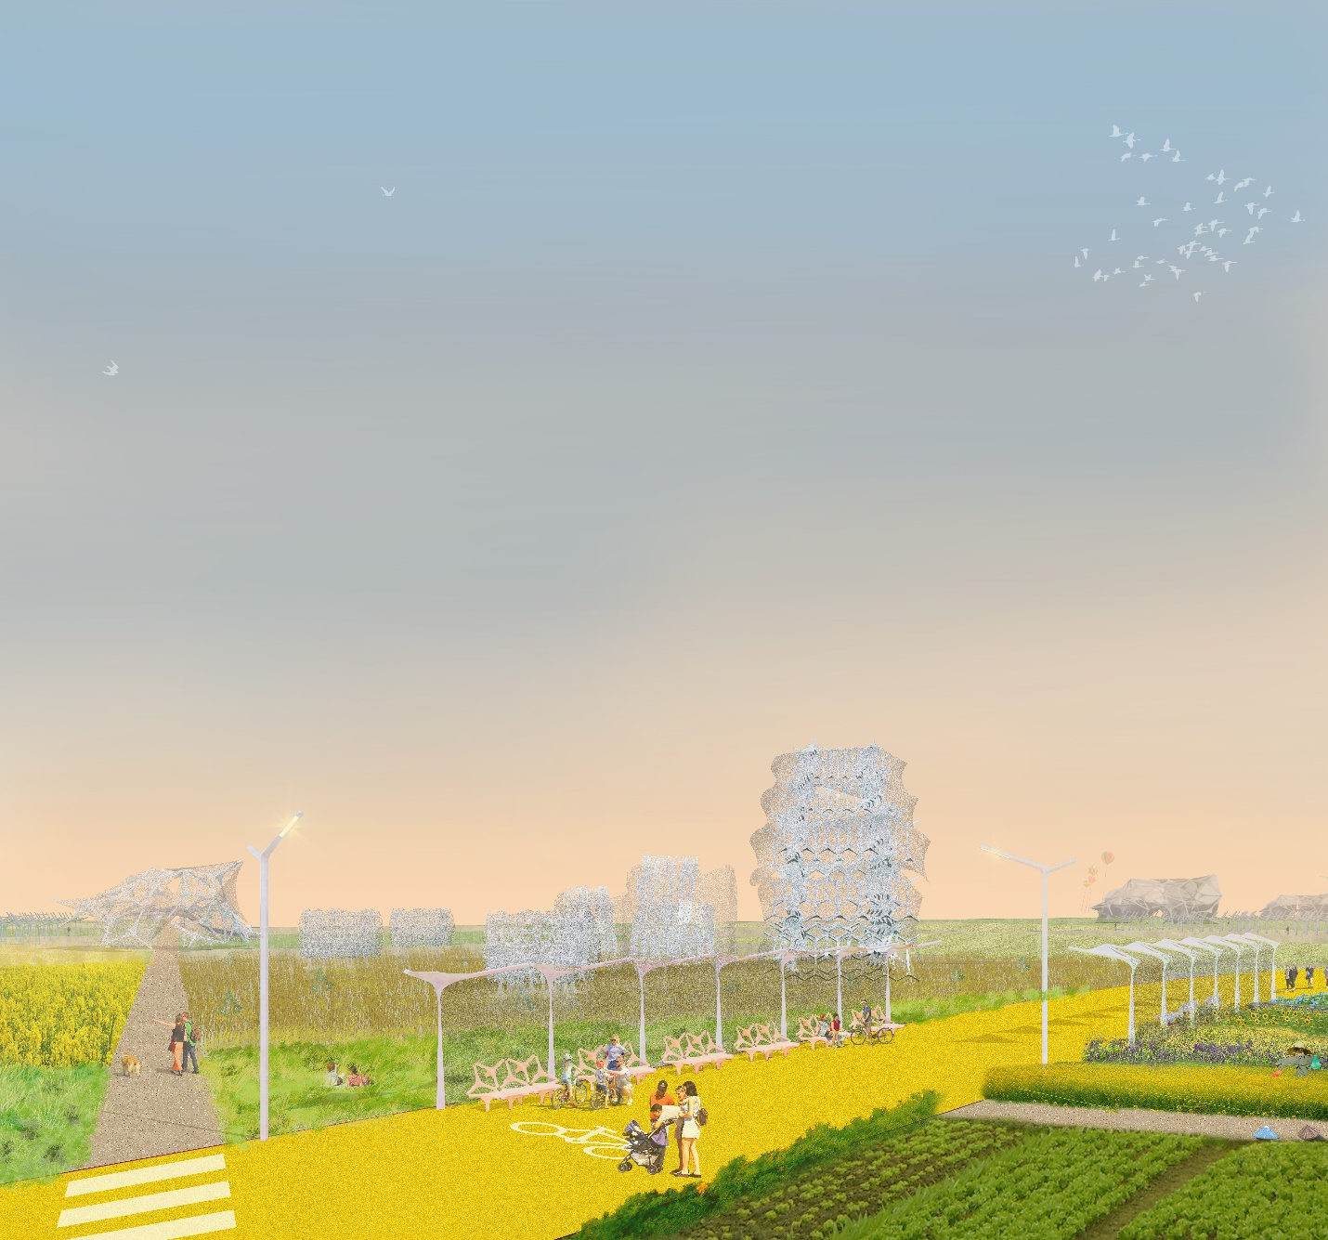

CONTENTS
1. Project Description ………………………………………………………………………………………………………………….. | 02
2. Public Activities and Social Co-Benefits ……………………………………………………………………………………. | 03
3. UN Sustainable Development Goals …………………………………………………………………………………………. | 04
4. Technologies ……………………………………………………………………………………………………………………………. | 05
5. Environmental Impact Summary ……………………………………………………………………………………………… | 09

1. PROJECT DESCRIPTION
Situated near the city center of Mannheim, our site needs to serve as a gateway to the Rhein-Neckar Green Corridor. We envision the public park as a collection of three distinctive smaller parks: the Community Park, the Garden Park, and the Solar Park. These parks engage with the ecological landscape on the site's southern edge and the residential and commercial neighborhood on the northern edge.
The Community Park serves the local community's needs, providing amenities to live active lives, spend time with family, and enjoy art. The Garden Park consists of productive gardens where the infrastructure for farming becomes the landscape design elements. The Solar Park acts as a civic outdoor space and a source of solar energy and water that fuels the community and beyond.
In a sense, Tetravoltaics is an homage to Mannheim's legacies, particularly related to experimentation in urban design and innovations in mobility (bicycle, tractor, and automobile). Inspired by the grid-patterned city center of Mannheim, our master plan embodies three autonomous grid systems. Each grid system forms the layout of the three smaller parks, and the network of bicycle and pedestrian paths links to the existing circulation infrastructure.
The tetrahedron lattice modules can be assembled into various configurations, forms, and scales. As a modular design system, the application can range from furniture scale (bench, planter, streetlight) to architecture/ landscape scale (lookout, greenhouse, aeroponic tower, rest pavilion, playground, irrigation system, bridges). The structures are made of sustainable materials and are designed and manufactured using computational design and digital fabrication techniques.
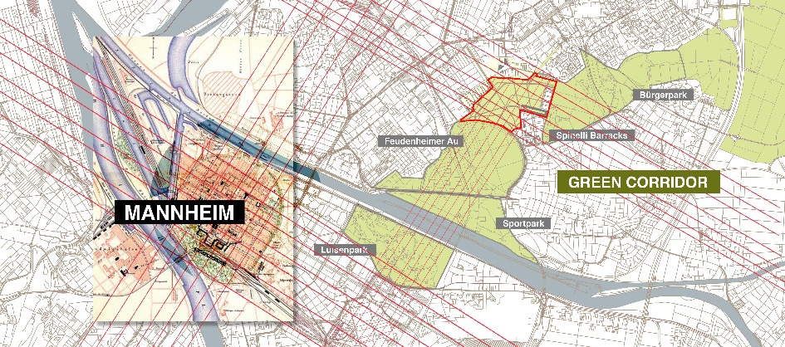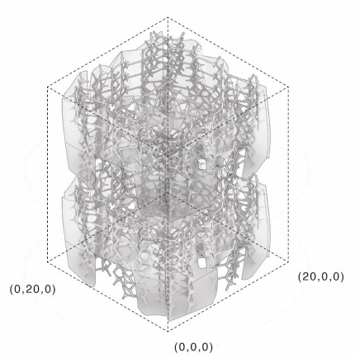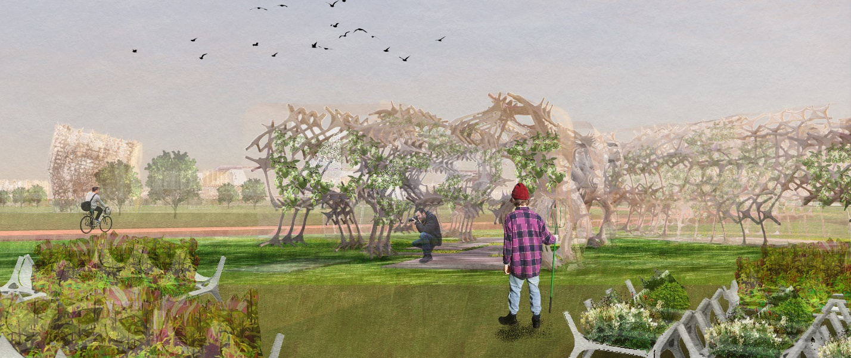

2. PUBLIC ACTIVITIES AND SOCIAL CO-BENEFITS
Tetravoltaics proposes three distinctive public parks that are themed as Community Park, Garden Park, and Solar Park. The bike paths and walkways that stitch together the three parks provide pedestrians, joggers, and bicyclists with a plethora of experiences. We also deploy modular tetrahedron lattice structures throughout the park to activate the spaces and provide amenities to visitors.
The Community Park provides amenities, including playgrounds, sports and recreation spaces, rest stations, and art installations to the surrounding communities. The facilities support both individual visitors and families of all ages.
The Garden Park utilizes a productive landscape design that integrates food production with the public park. Vegetables, herbs, and flowers are grown using various methods, such as raised beds, greenhouses, and aeroponic towers.
The Solar Park consists of large open areas and lawns for the neighborhoods. We allocate a large park area to deploy a field of sail structures that harvest solar energy, collect rainwater, and provide shade to visitors.
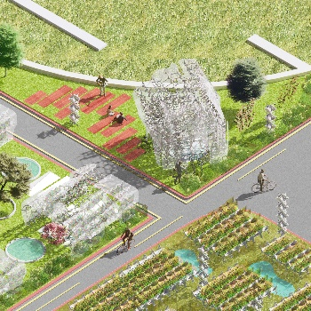 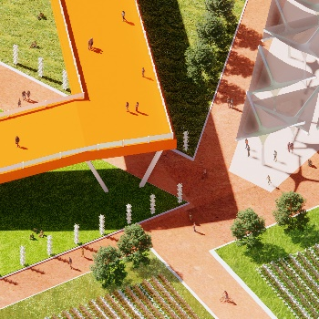 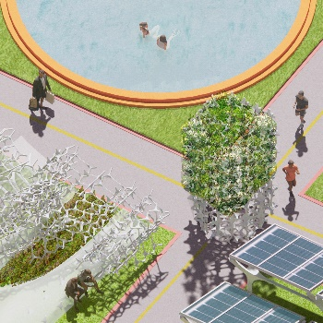 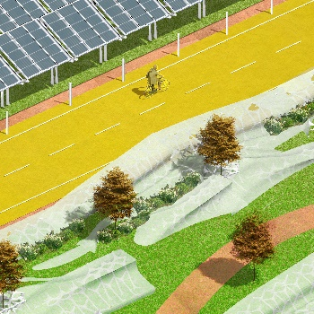 Micro Farming Elevated Walkway Community Park Bicycle Path
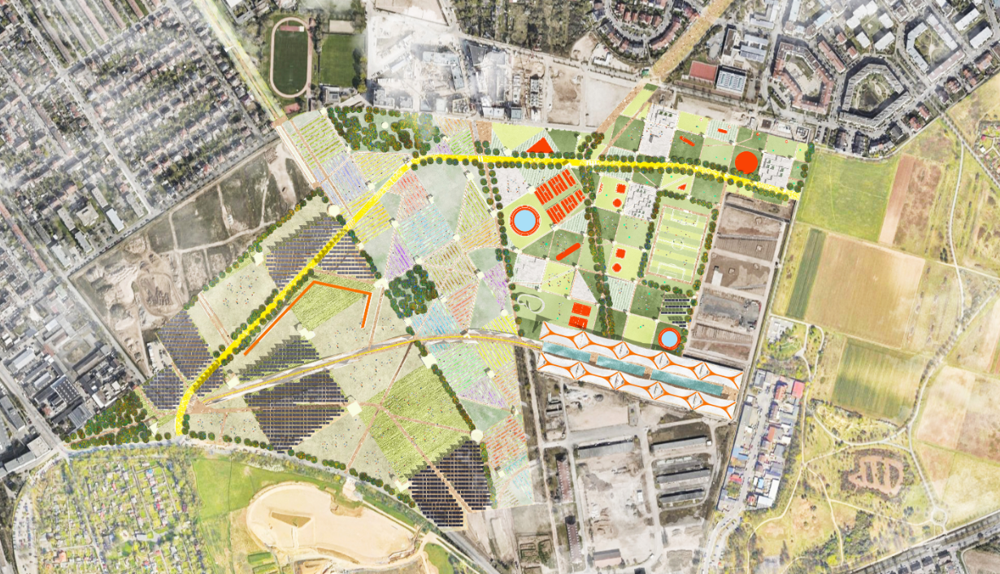

3. UN SUSTAINABLE DEVELOPMENT GOALS (SDG)
The proposed Community Park support the neighborhood residents and foster an active and family-centered lifestyle (SDG 3. Good Health and Well-being & SDG 11 Sustainable Cities and Communities). The Garden Park integrates various modes of food production, promoting sustainable agriculture and healthy living (SDG 2. Zero Hunger). The Solar Park merges the public park with large-scale energy production (photovoltaic membranes) and rainwater management (SDG 6. Clean Water and Sanitation & SDG 7. Affordable and Clean Energy). Furthermore, Tetravoltaics modules are constructed using sustainable fabrication processes and materials (SDG 9. Industry Innovation and Infrastructure & SDG 12. Responsible Consumption and Production).

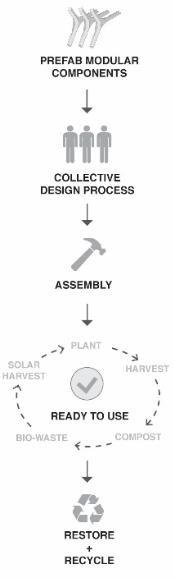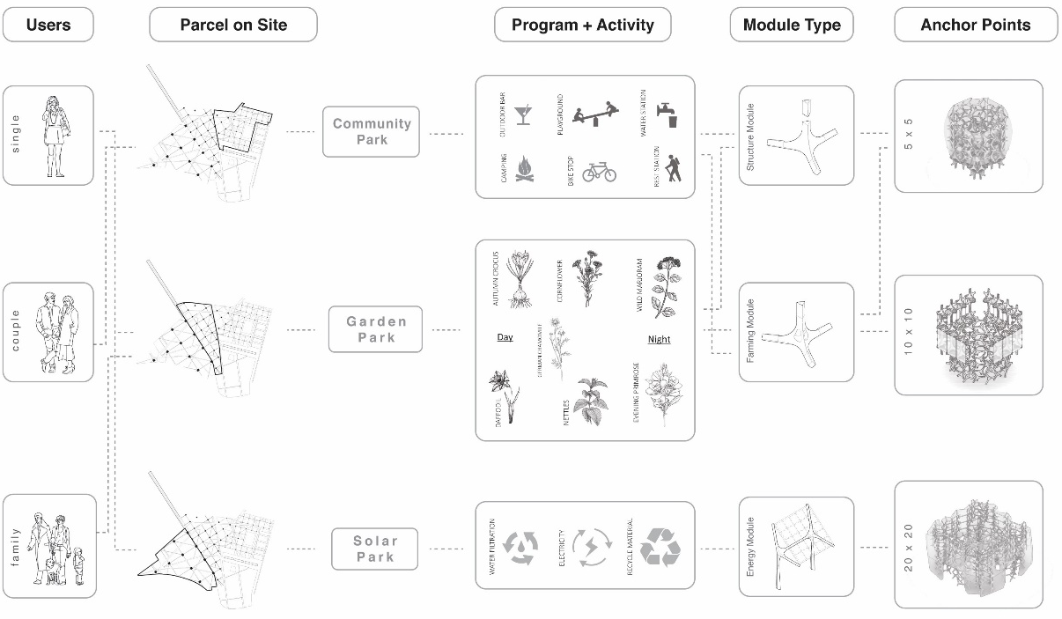
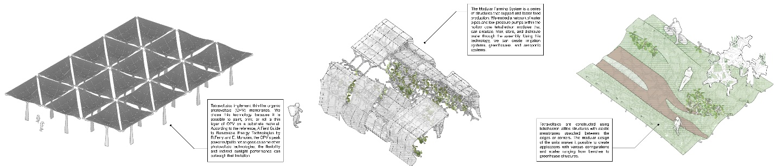
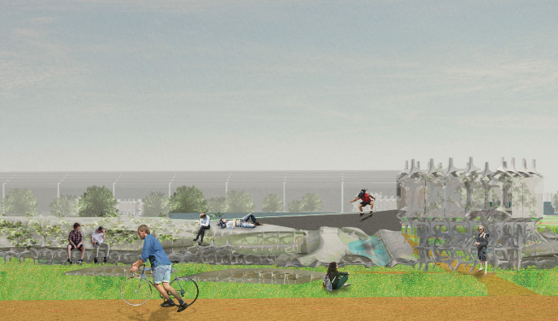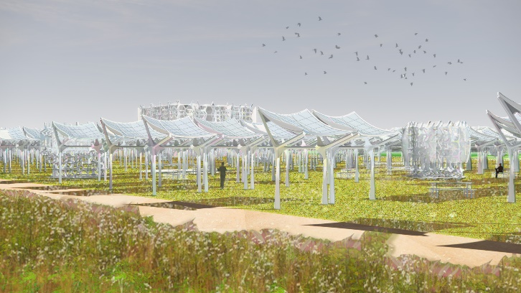

4. TECHNOLOGIES

4.1 Modular tetrahedron lattice structure and membrane
Tetravoltaics are constructed using tetrahedron lattice structures with elastic membranes stretched between the edges or corners. The modular design of the units makes it possible to create applications with various configurations and scales ranging from benches to greenhouse structures.
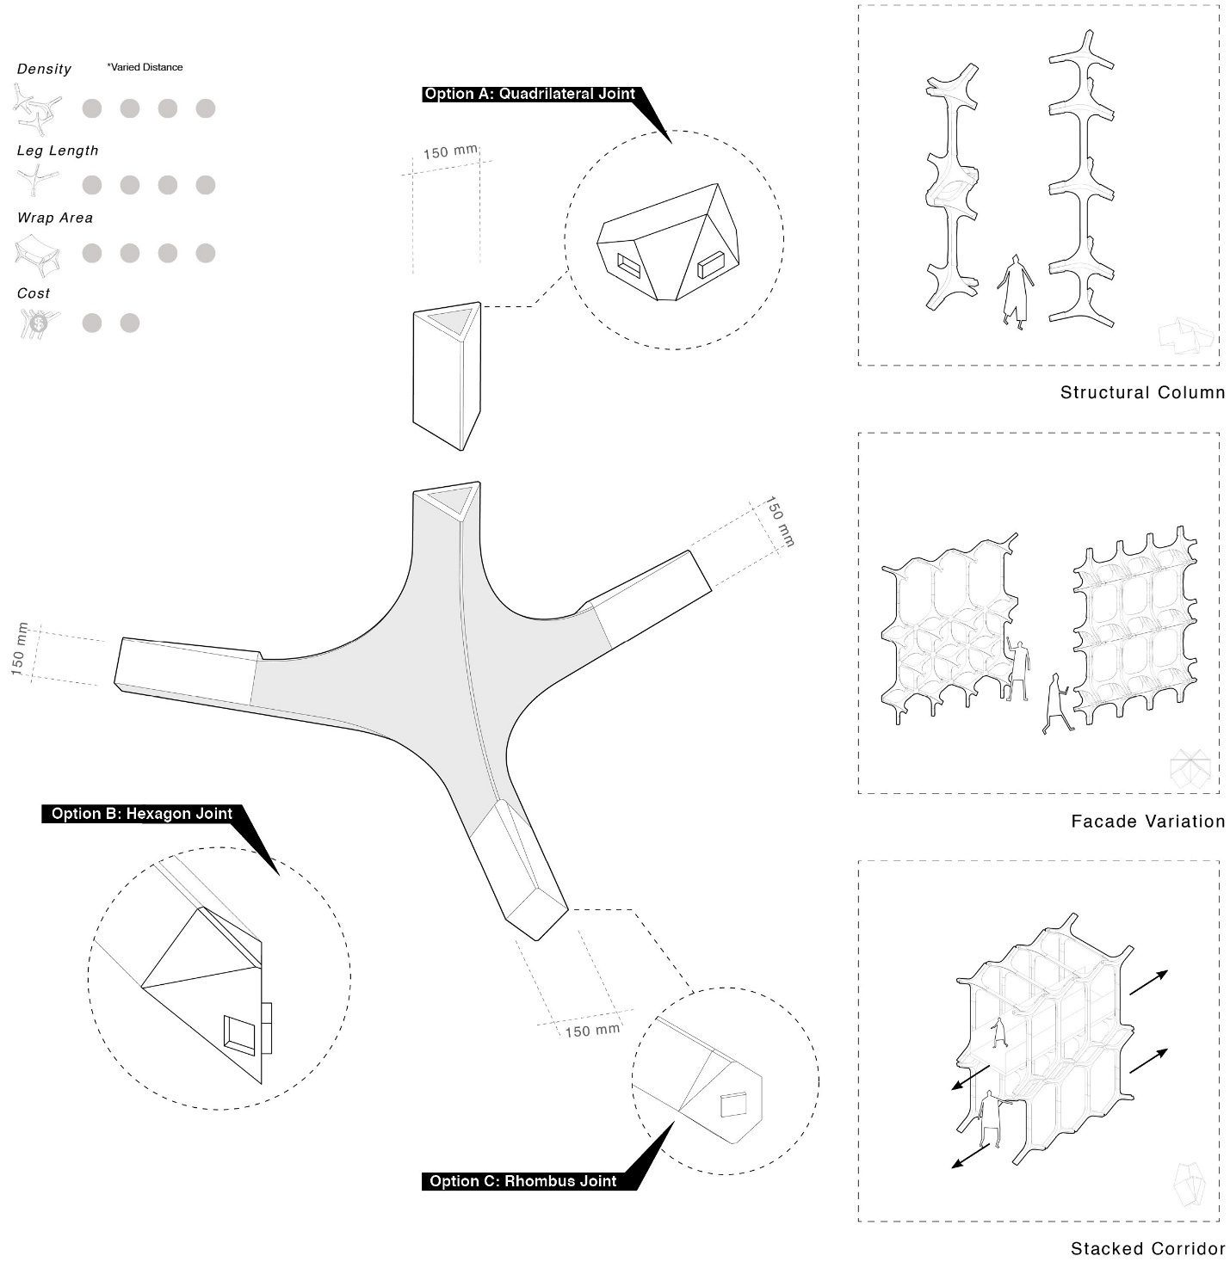
We use computational design and digital fabrication techniques to configure, optimize, and fabricate the structures. The material selection for the structures and membranes depends on the mechanical and functional requirements of the application. All materials are recyclable (e.g., aluminum, stainless steel, plastics) or renewable materials (e.g., bamboo, mass timber).
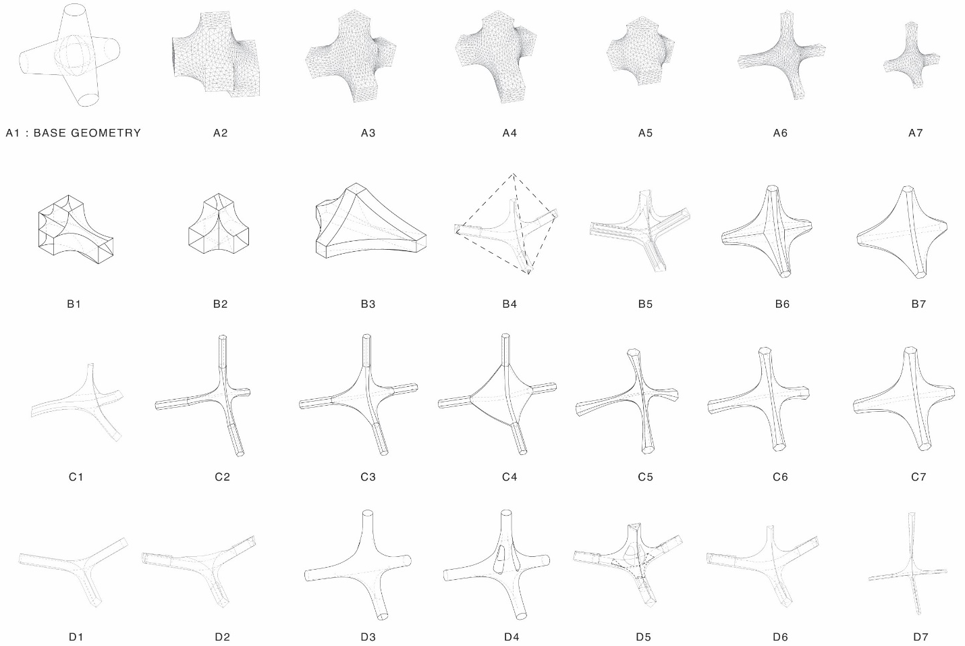Tetravoltaics Module Design Iterations

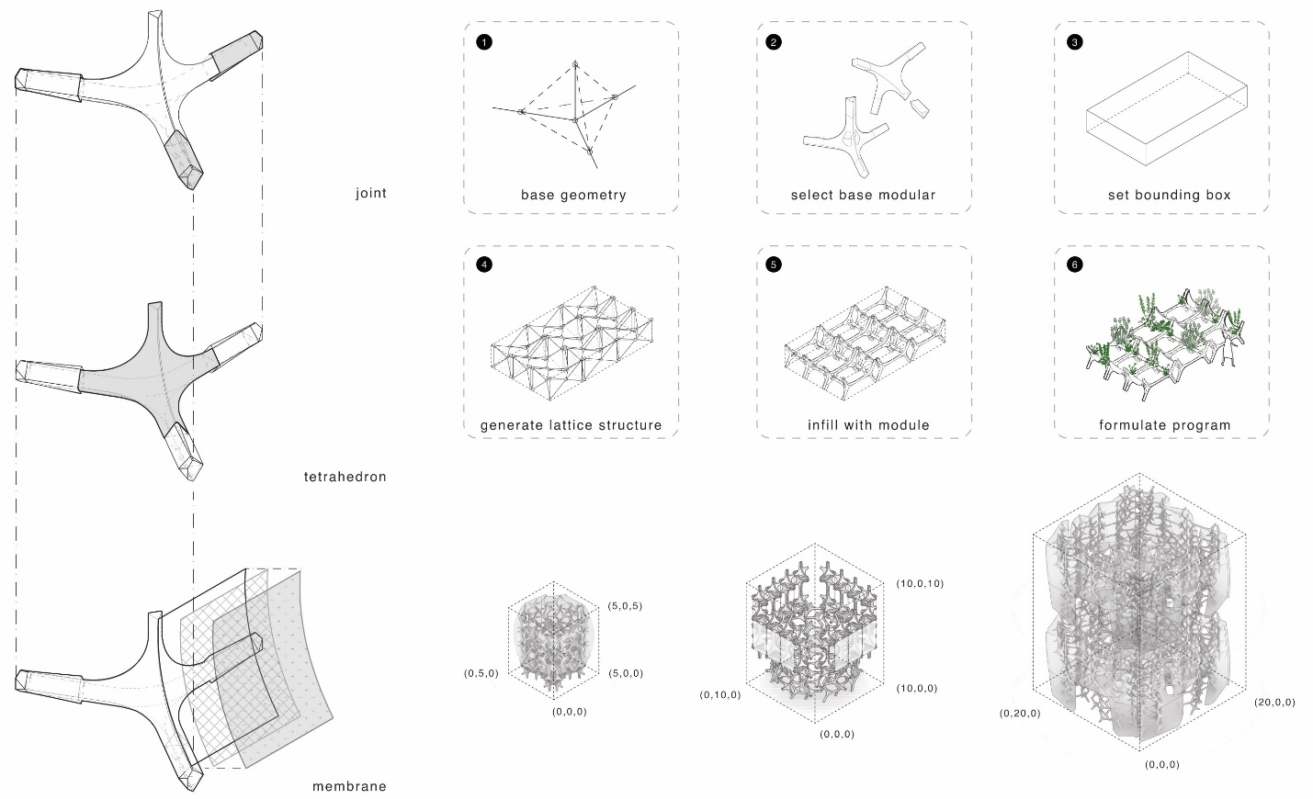Design and Fabrication Workflow

4.2 Organic photovoltaic and MWh Generated Per Year
Tetravoltaics implement thin-film organic photovoltaic (OPV) membranes. We chose this technology because it is possible to paint, print, or roll a thin layer of OPV on a substrate material. According to the reference, A Field Guide to Renewable Energy Technologies by R.Ferry and E. Monoian, the OPV's peak power output is not as good as some other photovoltaic technologies; the flexibility and indirect sunlight performance can outweigh that limitation. Based on the total solar area of 51,586 square meters at a conversion efficiency of 16%, Tetravoltaics can generate up to 18,615 MWh per year.

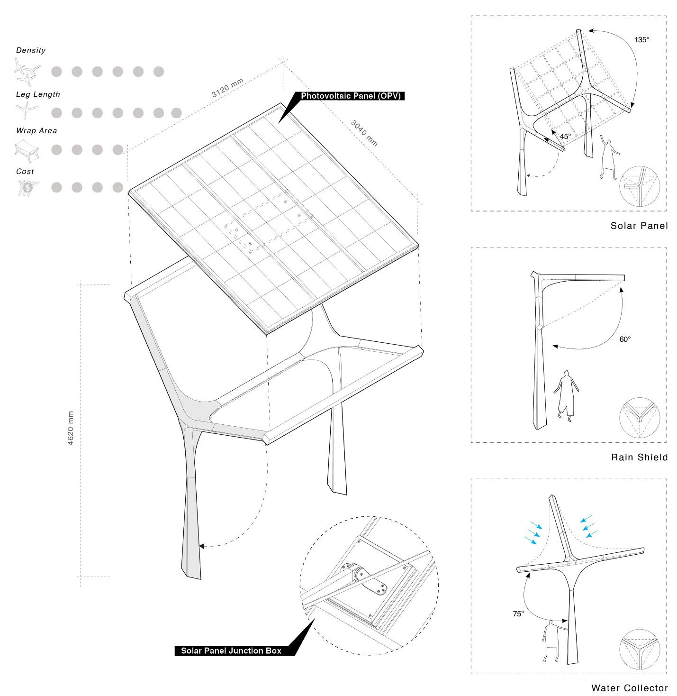

4.3 Aeroponics and Rainwater Management
The Modular Farming System a series of structures that support and foster food production. We embed a network of water pipes and low-pressure pumps within the hollow core tetrahedron modules that can circulate, filter, store, and distribute water through the assembly. Using this technology, we can create irrigation systems, greenhouses, and aeroponic* systems.

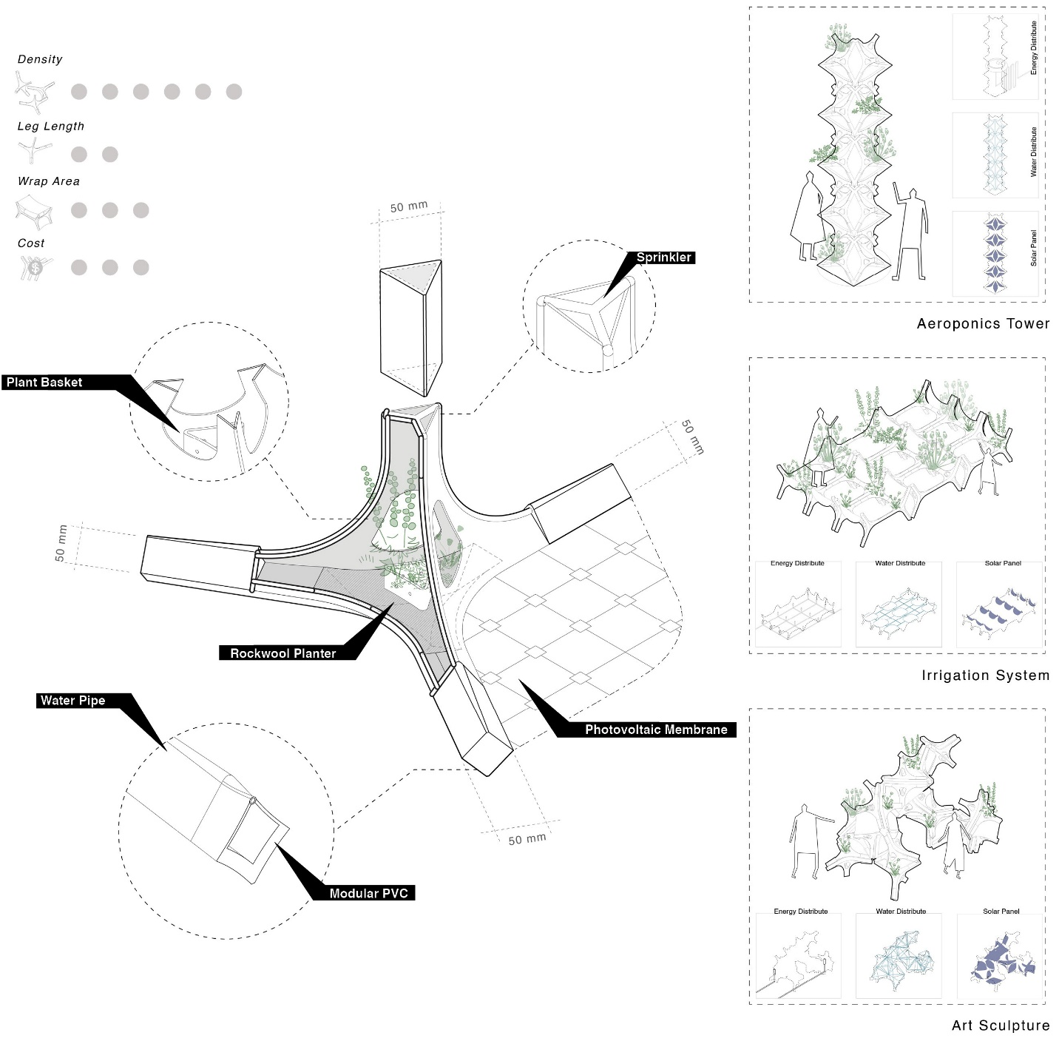

*Aeroponics is a soil-less plant growing process using water or mist to provide nutrients (type of hydroponics). This method significantly reduces water, fertilizer, and pesticide compared to open field agriculture while maximizing the crop yields.

5. ENVIRONMENTAL IMPACT SUMMARY
The Tetravoltaics aims to create a public park that fosters sustainable and healthy communities.
The community spaces, including playgrounds, sports and recreation spaces, rest stations, and art installations, foster a healthy lifestyle for visitors of all ages. The bicycle and pedestrian walkways network extend from these spaces throughout the site and beyond, further encouraging active living.
The raised bed gardens, greenhouses, and aeroponic towers form a productive landscape that provides fresh produce to the community and fosters food self-sufficiency. The community and visitors can learn and actively participate in growing food and maintaining the gardens.
The solar sail structure can collect and distribute clean energy to the entire park and adjacent communities. Furthermore, the sail surfaces can also collect and store rainwater and use it for irrigation. As another added benefit, the sails can provide shade to visitors on hot summer days.
The proposed tetrahedron modules can create lattice structures that are lightweight, efficient, and versatile. The membrane that covers the structures is also thin, flexible, and light. This design can create large volumes using minimum materials, conserving valuable resources. As a result, the Tetravoltaic systems will sit softly on the landscape as ephemeral intervention. With the change of season and time, these ephemeral structures can be reconfigured, relocated, or recycled, providing unique experiences without intruding on or permanently altering the natural landscape.
