Vibranergy
Energy turned into vibrancy

The link between beauty and mesmerizing movement is expressed by many natural events, like the wind pushing the branches of a tree, the zigzagging dance of a falling leaf in autumn or the rhythm of a wave unleashed by the wind. These magical moments, which are the primary aesthetic experience of all humans, were the inspiration to create a sculptural and functional piece that ​​represents the vibrancy of life and humankind: VIBRANERGY. The design combines the key role that Mannheim played in the development of the music worldwide with the idea of a fire as the original manifestation of human gatherings and inventiveness.

VIBRANERGY revives the musical roots of Mannheim to create a set of hot spots that foster community gatherings and ensure energy and food security. It is aimed to engage citizens in an immersive orchestral experience capable of generating clean electricity and pleasant frequencies aimed to elevate human vibes and foster healthy plant growth. This happens through a set of sculptures in the public space that integrate the latest advances in bladeless wind power technologies, electromagnetism, piezoelectric sensors, and crop-booster methods. This artwork proposed is inspired by various wind and string instruments historically played by the Mannheim school since the latest half of the 18th century. These musical devices were reinterpreted as a series of urban hotspots for social interaction, which can generate 25% (1125 households) of the electrical energy demand of the future housing developments expected in the urban design area. VIBRANERGY spots also transform wind and movement into frequencies that optimize and boost different types of crops, making federal garden show BUGA23 more cheerful and vibrant.

VIBRANERGY is composed of a hollow core turbine surrounded by 4 irregular fins and sails that were abstracted from the most musical universal symbol: the treble clef. When assembled, these elements operate in a synergy that maximizes the potential of air flow to generate constant vibrations to produce clean electricity. VIBRANERGY is easily scalable since the basic concept module can vary in size and settings. It can be grouped in countless ways to meet different urban design conditions. The grouping pattern proposed for the design site is based on the 1.5 string quartets proportional ratio, which is key in musical pieces of orchestral nature. This is applied in 4 urban scales:

- Intimate scale – Violin – Sculpture and urban furniture infrastructure
- Site scale – Viola – Scup – Multi-purpose hotspot
- Neighborhood scale – Cello – Gathering space
- Metropolitan scale - Double Bass – Urban landmark

A given layout and scale setting responds to the nature of each community interaction and the related activities. A key design premise was the versatility to adapt to diverse environments. Variations in size, accents, hierarchy, and layout strengthen the functional character of the sculptures, but always resembles the orchestral nature of the Mannheim school.
The modules will be located at specific strategic spots, responding to the activities that emerge from the social interaction of each neighborhood, and taking advantage of the enhanced air flow that results from interventions on the ground shape to create pressure differentials.
The character of every sculpture and hotspot is defined by its use. A 24-hour operation scheme is applied to three different characters:

- Vibranergy as a piece of sculptural contemplation.
- Vibranergy as an interactive device, which engages citizens.
- Vibranergy as a place and container that provides room for a great variety of activities.

In addition to the power generation sculptures, the design team proposed modifications to the ground to manipulate and control air flow so that it is directed and enhanced at the locations proposed. Mounts, sloped terrain, tree canopies and urban furniture are shaped and set to cause a Venturi Effect.

Other variables were considered to maximize the power generation outcomes:

- Analysis of natural wind flows
- Use of magnets to generate repellency between the pieces
- Waterproof membranes in the curvatures of the fins to produce wind resistance on a larger surface.

To maximize the vibration, sculptures are made from low-density materials, such as carbon fiber and light weight waterproof membranes. The footings incorporate elastomers that mitigate the rigidity of the structure, allowing its oscillation, vibration, and continuous motion. The structure is hollow to withstand load bearing stress while reducing weight and embedded energy. Openings on these structural elements contribute to reducing weight while creating whistles and ambient sounds that vary according to the intensity, speed, and quantity of wind. This makes VIBRANERGY a piece of art that can be enjoyed visually but also acts as a soundscape that can promote positive emotions through music.

Electrical Power Generation

VIBRANERGY has two main power generating mechanisms. First, the central hollow mast, which functions as a bladeless wind turbine supported on an elastic rod embedded in the ground. This core remains in constant motion in a wide range of wind speeds, generating electromagnetic fields via magnets, which then transform the mechanical energy into electricity.
For a 10,2 m bladeless turbine, it is estimated that 1kW can be generated at 3m/s wind speed. During the periods of low wind speed, the strategies described above are applied to cause acceleration. Under this improved scenario, the main bladeless core can produce up to 8640kWh/year, in the scale of a Double Bass module (10,12mts).

The second energy generation mechanism are the four fins and sails that surround the hollow core. Instead of magnets, these elements transmit motion to the base in the form of pressure applied to piezoelectric micro generators. To estimate power generation, we studied similar successful mechanisms previously applied (NAVY II, by Channel Industries INC). After cost-benefit analysis, the design team determined twelve piezoelectric sensors is the best number to be installed at the base of each fin:

To determine the amount of energy generated by the piezoelectric generators, we grouped the results according to the 4 scales proposed.
The figure below highlights the value of VA: 0.4632 V/N of the reference technology analyzed. This was used to determine the amount of voltage generated by each piezoelectric according to the mass of every single element of VIBRANERGY.
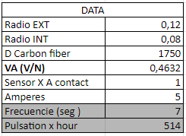
The power generated by the piezoelectric system is estimated for every proposed scale, according to the variation of weight and height of each fin:

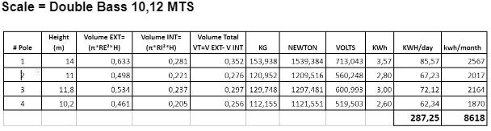
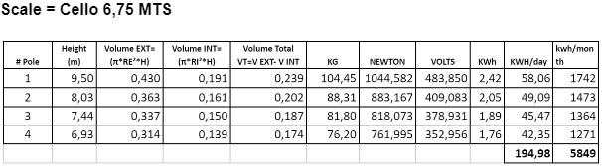
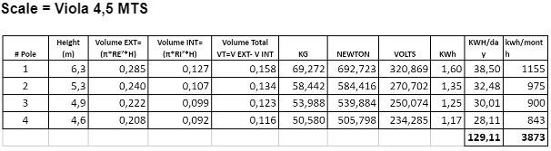
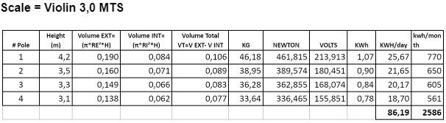
The footing system developed is capable of generating energy but also producing sounds through human interaction via press steps activated by foot. In this case, the calculation considered the average weight per person to activate the mechanism (Pascal’s principle):

Interaction for power generation

Finally, we obtained the following overall results:
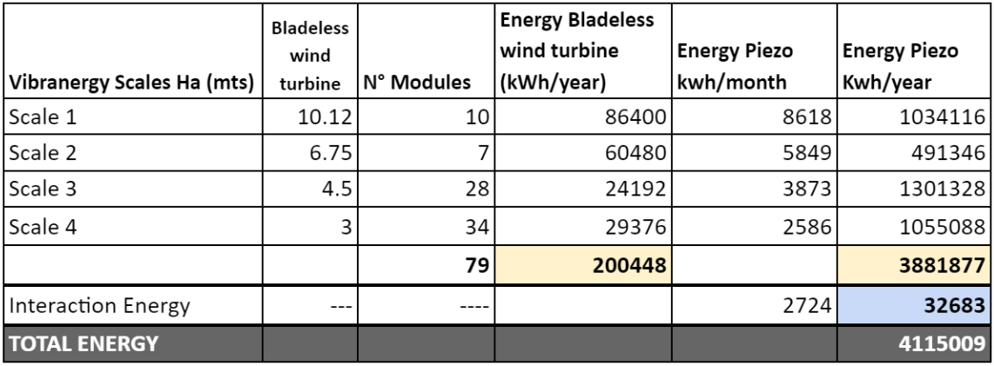
Energy Supply for New Households
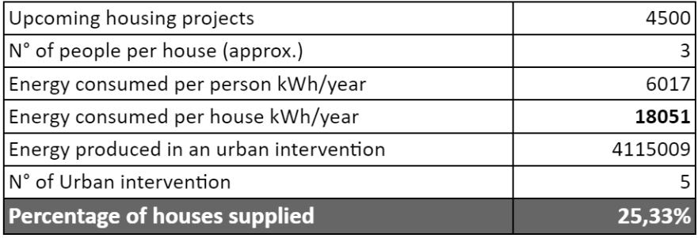
* The proposed urban intervention occupies 5 Ha (79 Modules) of land, which equals to 10% of the total master plan.
#Houses Per Module: 6
#Vibranergy Modules Needed: 734
Only 10% of the masterplan is used to incorporate 79 VIBRANERGY hotspots which blaze at night and generate power 7/24 for1120 new homes of the overall electrical energy demand in the future residential development expected in the urban design area. The amount of electricity generated will also be used for gardening irrigation purposes, feeding the public lighting network, and delivering free charging stations for electronic devices.

VIBRANERGY invites the community to participate in various diverse activities during the day and at night.
Integration with the horticultural show

VIBRANERGY modules will benefit the gardens and crops planned for BUGA23. The proposed system has the capacity to load the water of the irrigation system with acoustic frequencies based on the crop-booster effect (optimization technology in plant growth). The system generates electromagnetic waves resulting from the water friction through the metal pipes. These strategies optimize and positively stimulate the photosynthesis process and reduce the use of fertilizers to increase the production by at least 25%.

SDG

The proposal is aimed to generate affordable power through non-polluting processes, making significant contributions to the development of cities that are less harmful for the planet through technologies that help mitigate climate change and provide community spaces for interaction that foster human well-being.
Targeted SDG:
- GOAL 2: Zero Hunger. The crop-boosting system contributes to food security in urban areas.
- GOAL 3: Good Health and Well-being. The urban environments proposed elevate human emotional health and community integration.
- GOAL 5: Gender Equality. The proposed hotspots are age and gender inclusive.
- GOAL 7: Affordable and Clean Energy. The power generated is low-cost as it relies on a constant natural source of energy: wind.
- GOAL 9: Industry, Innovation, and Infrastructure. The system proposed incorporates the latest innovations and advancement on wind generation technologies and crop-boosting methods via frequency transfer.
- GOAL 11: Sustainable Cities and Communities. The overall site is converted into amusement parks that promote sustainable living and community integration.
- GOAL 13: Climate Action: The modules mitigate global warming, by minimizing CO2 emission and replacing power generation technologies that rely on fossil fuels.

Environmental Impact Summary

VIBRANERGY was conceived as a contribution to environmental awareness. It takes wind power generation alternatives a step forward, avoiding the use of mechanical systems that demand high maintenance. Bladeless mechanisms don't make loud noises and are bird friendly. To prevent the negative impacts of batteries, the design team relied on capacitors and interaction with the public power grid. The emission of CO2 related to the manufacturing process and the embedded energy is significantly reduced by making elements hollow and replacing mass by smart section design. In terms of positive environmental impacts, the system brings benefits for vegetation via innovative frequency transferring techniques applied to the substrates and plants via irrigation water.

VA: Apparent Power

