Introduction
The world is in need of innovation and leadership to demonstrate how sustainability can be achieved. Poverty, sustainable agriculture, health and well-being, education, water management, climate change, and biodiversity are a few goals the United Nations have put in place. The world is pessimistic in the ability to achieve this, but the way to achieve these goals is through leadership and demonstrating what innovation can do. The Trichterpark has the initiative to demonstrate how we can make progress in the United Nations goals.
This proposal is about community and energy generating initiatives. Our goal is to create a green corridor that acts as a people driven area for education and community while generating enough energy to have surplus to the community. This park will impact the environment by not only decreasing the heat island effect in the community but generating power for the park to be self efficient. With such beauty and initiative this park will draw people from all over the world to learn and be inspired. This park will be a destination for education, well-being, and health.
Every feature that is designed in this park is done with thought and productivity to the community that lives here and the inspiration that it will bring to others. This park addition will include many United Nation initiatives. End poverty; end hunger, achieve food security and improved nutrition and promote sustainable agriculture; ensure healthy lives and promote well-being for all at all ages; ensure inclusive and equitable quality education and promote lifelong learning opportunities for all; ensure availability and sustainable management of water and sanitation for all; ensure access to affordable, reliable, sustainable and modern energy for all; build resilient infrastructure, promote inclusive and sustainable industrialization and foster innovation; make cities and human settlements inclusive, safe, resilient and sustainable; ensure sustainable consumption and production patterns; take urgent action to combat climate change and its impacts.
Activities and Energy
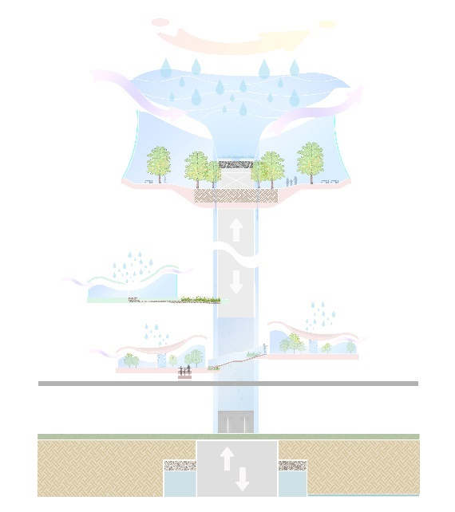
The main focal point as seen in Figure 1 is a futuristic energy generating unit that has beauty that will bring people from all parts to witness. Each pod acts as a biosphere with the top having the shape of a set of contour lines. The top biosphere has incredible 360 views over the city. It will have a relaxed seating for people to enjoy the environment and views. People will be able to explore and wonder through the different biospheres branching off the main spine. Each sphere will have a different theme educating people on biodiversity with some to include native plant species, tropical plants, and edible plants. Other spheres will educate people on pollinators with themes of bees and butterflies. The top of each biosphere is covered in photovoltaic solar cells to generate and capture energy. They are uniquely shaped to also act as a basin for rainwater catchment as displayed in Figure 2. Rainwater catchment will fall down the main spine creating the illusion of a waterfall. The rainwater catched in the branching smaller pods will be funneled to the main spine all being collected to the same location. The water will be stored in a main water tank underground that will allow water to flow freely once it reaches a certain level. The water will be filtered by natural materials as needed and used for park amenities such as drinking fountains, bathrooms, fire hydrants, and watering the park vegetation. The main spine will include an elevator, with the theory of generating and storing energy using gravity. This elevator will bring people to the 360 biosphere.
Figure 1: Trichterpark Biosphere
Figure 2: Rainwater Catchment
The majority of the park is green open space and the elevated path help achieve this. The elevated paths will make people feel as though they are walking through a tree walk. The elevated paths will be made with kinetic pavers that generate energy for the lights along the path. As people wonder through the park, they will see tree sized flowers that are also design like the biospheres. These flowers are shown in Figure 3. The water will be transferred underground to the main water tank. They will also see the vortex induced vibration resonant wind generator as seen in the LAGI Glasgow competition. These solar and water catchment flowers and wind generators will be artistically and thoughtfully placed throughout the park for maximum catchment and beauty.
Figure 3: Flower
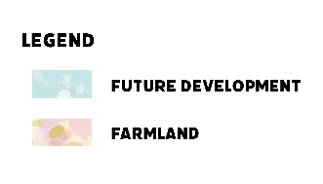
In the northeast corridor as shown in Figure 4 will have a food driven farm dedicated to community. This farm will be established based on permaculture principles. These principles are observe and interact, catch and store energy, obtain a yield, apply self-regulation and accept feedback, use and value renewable resources and services, produce no waste, design from patterns and details, integrate rather than segregate, use small and slow solutions, use and value diversity, use edges and value the marginal, and creatively use and respond to change. These principles are what drove this design; with a strong community there will be a strong inspiration to others. The farm will supply food to the community through a farmers’ market and will include an education centre for teaching other about the value and permaculture.
Figure 4: Farmland and Future Development
There is an area that is designated to development as shown in Figure 4. This development will include an innovation health centre. It will provide innovative solutions to health care with its technology and delivery, helping people of the community and being a destination centre for specific health specialties. There will also be a sufficient amount of space designated to residential development.
The park will be achieved through phase plan. The fist phase will be to establish the main path connections. Second will be the addition of the solar and water catchment flowers and wind tower generators. Next will be the main biosphere focal point. Lastly, the permaculture farm, residential development, and innovation health centre.
Calculations
The total number of flowers within the park is 50, with there being 1 large biosphere and 13 branching spheres. This will give an area of solar panels is 7,046 square meters. A 20% efficient solar panel will have a 200 W capacity per square meter as stated in the Photovoltaic Solar Cell description found in the LAGi Field Guide to Renewable Energy (R. Ferry and E. Monoian). At this rate Environmental factors such as surface dust, orientation, shading can contribute to a lower capacity factor (R. Ferry and E. Monoian). At the 20% rate the solar panels will generate roughly 1.4MW per day.
The water system will not necessarily generate energy, but it will not use energy to bring in or use water from other areas of town. The water will be filtered by natural materials as needed and used for park amenities and watering the park vegetation.
There will be 50 vortex induced vibration resonant wind generators within the park. This design will call for a 5.5-meter-tall wind generator. At a capacity of 100 watts per 2.75-meter-tall generator these turbines will produce approximately 0.01MW per day (R. Ferry and E. Monoian).
The idea of creating an elevator that uses gravity to produce and store energy came from Gravitricity. Gravitricity established in 2011 is a new patented technology that is based on the principle of raising and lowering a heavy weight to store and release energy (Gravitricity, 2022). Currently, Gravitricity is only applied to deep underground shafts but why not create an energy elevator? The concept is simple electricity is stored in the form of potential energy by raising weight (the elevator) and power is then generated by lowering the weights to turn a generator (Gravitricity, 2022). As this elevator concept is a theory, we do not have an estimated number for energy produced. With that said Gravitricity states their units can be configured to produce between 1 and 20MW peak power, with output duration from 15 minutes to 8 hours. They also state a 20MWp system could power 63,000 homes for every hour that it discharges. The information found for Gravitricity was found on their website in 2022.
The kinetic pavers generate power with every step. Land8: Landscape Architects Network wrote an article called Pavegen: Using the Pavement to Generate Energy on June 9, 2014. It states that when the Pavegen pavers are placed on a busy street, each slab generates 2.1 watts per hour (Land8: Landscape Architects Network, 2014). The energy can be used to power lighting along the paths or be stored.

Environmental Impact
The Trichterpark will be an excellent inspiration to combat climate change.
In a natural environment, landforms are not simply a flat land. This design has basin like contours and sloped landscape where it maximizes the usable green space which people will have the ability to access from different parts of the park and from every corner in the community. The kinetic paths will cause people to have the ability to contribute energy to the community while they are on daily commutes.
The planting areas within the area are divided into tree major types which are meadow, permaculture, and biospheres. Meadows are located along the major bike path and around the center area of the park, this is where the most noticeable areas are. As such, native plant species will be planted, as to mitigate the chances of having invasive species to the place. Pollinator plants will also be selected to help mitigate the pollinator crisis. The trees will also be creating habitat for birds. A two-year rotation for perennials planting is recommended as this will ensure healthy soil nutrition.
Permaculture area is recommended to be owned by three major groups who are government, small business owners and education sectors. The government will take the role to promote self-sustain agriculture, health and well being. It could also take an overview of the promotion and monitoring. Small business owners will supply to the microbar at the top biosphere or anything at the farmers market where could promote “local organic grown and supply”, “Farm to Table”. Finally, the education sectors will demonstrate permaculture & sustainability for current and future generations through tours and programs. It can also be an attraction to people country wide or even internationally.
The branched biospheres are elevated to lower the impact of human activity acting on natural environments and habitats where could possibly increase numbers of animals to be within the area. The biospheres would also be in different themes aiming to create a micro-climate for the eco-system to be developed in the and inter-connected to each other.
References
Ferry, R. and Monoian, E. (2019, November). A field guide to renewable energy technologies (2nd ed.) Detroit Publishing Company Collection and the Library of Congress. http://www.landartgenerator.org/LAGI-FieldGuideRenewableEnergy-ed2.pdf
Gravitricity. (2022). Technology. https://gravitricity.com/technology/
Land8: Landscape Architects Network. (2014, June 9). Pavengen: using the pavement to generate energy. https://land8.com/pavegen-using-the-pavement-to-generate-energy/

