H H
E A
L L
I L
O
S
T
A
T

Content
Design scenario
Responding to energy
United Nations Goals
Energy produced
Vegetation and wildlife
Design Documents

Design scenario
According to the needs determined for the design as well as the needs that the design group considered necessary for the design, various steps have been carried out in the design. First, knowing the location of the project and its conditions, we tried to stay loyal to the environment and context of the site and the city, climatic factors and weather conditions. We introduced a network of urban divisions into the site, just like the division in the city center, in order to pay more attention to the design environment. After that, according to the principles and advances that are taking place today in various discussions and meetings all over the world, it was decided to avoid excessive construction as much as possible and to use the existing buildings and conditions. Therefore, construction was not done vertically as much as possible, except for the central element of the site, and all the existing lines, raised from the ground, are designed in a completely fluid manner, and it has been tried to move soil and empty places and fill different positions. The site, external factors required for construction, do not enter the plan.
Also, we maintained the only building on the site, which we know as U HALLE, which has been used as a warehouse before, and with a few changes, we added the necessary uses to it in order to do this as well. We have helped to build less and create less pollution and environmental problems.
Urban agricultural lands and private gardens, which were part of the plan's needs, were also placed in the outer layer of the site and in an area of more than 60% of the area of the designated lines. In addition to creating entertainment for the elderly or other audiences, this urban agriculture will also help to create a food security and health in the society (Principle No. 2, 3 of the United Nations) and by considering spaces to create local markets to sell

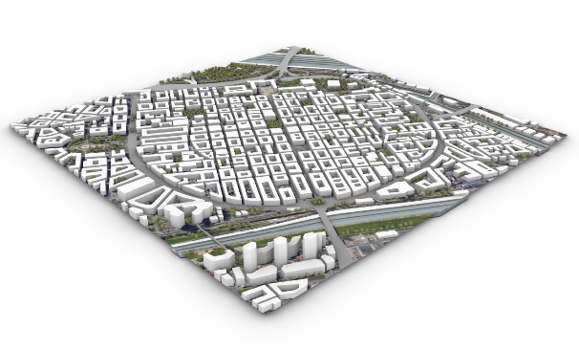

Mannheim city center:
showing the grid (Quadrate)

Design area and context:
Connections and buildings

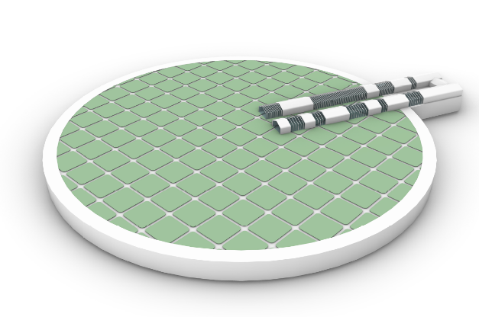
the same products, the economy of the audience and, as a result, the urban economy have also been thought about.
The houses and resorts that were used in these agricultural lands and private gardens were built almost like other common houses and cottages, where the use of materials, construction and production of pollutants were to a large extent. The solution of the plan is to design modular houses that can be opened and closed and also provide the possibility of easy relocation, less pollution is produced and the construction is done in a prefabricated way to reduce the defects of the old and common construction.
Also, these houses are self-sufficient in energy production and storage, and will supply the energy needed by their residents through photovoltaic panels placed in different directions on their roofs.
The existence of several green strips and so-called small-scale forest parks located in the middle of the site and agricultural lands will also help to create animal habitats and also bring natural ecosystems into the site and its urban environment. These green strips with dense planting in the middle of the site will be the habitat of animals in the area that are endangered by the excessive expansion of cities, which will help in future developments in other areas, the existence of these dense green parts.
In the middle of the site and in its central part, there is a high-ranking element that will play different roles. This central element is primarily an energy absorber with a central energy production system, and secondly, the presence of this element will help to create an exhibition viewpoint and also serve as a landmark and urban sign that can be addressed and created, It will give an index location to the middle of the site.
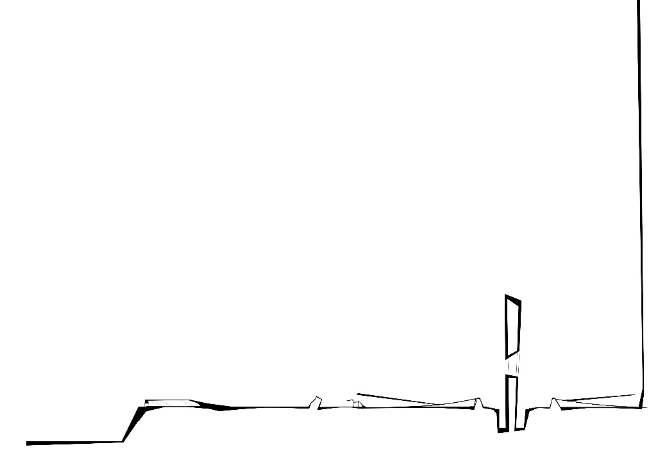
Around and on the side of this central element, there is a shell of rotating mirrors that, with different orientations in the days and seasons of the year, will focus the sunlight towards the center and upper floors of the middle tower to help generate energy. also on sunny days, they will help to create gathering spaces under them with shading. In the night view, the presence of light sources under this support network will help to create a live and urban hybrid space.
The presence of a small-scale lake right at the location of the central tower, which is created from the water collected on the surface of the site during the rainy days of the year, in addition to creating a

1st level:
Implementation of the grid and identification of the existing situation

2nd level:
Create a vertical axis to create a landmark
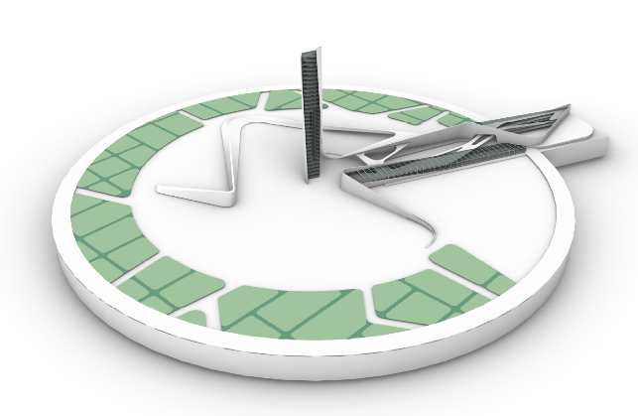

3rd level:
Changing form and creating fluid shells
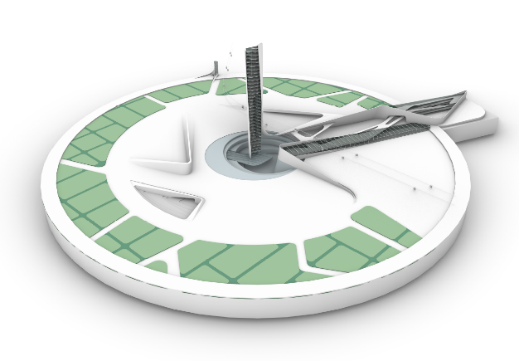
different feeling in the central parts by reflecting the image of the tower and the sides It will help the energy production system in the central tower and this water can be stored for different uses.
The intended uses and other parts of the plan are also located in the main building of U HALLE, which was also tried to be used. Greenhouses for planting and maintaining plants that do not have the conditions to be kept in the open space, a space for holding cultural or sports events, or a seed bank that will also help in the development and future of the project.
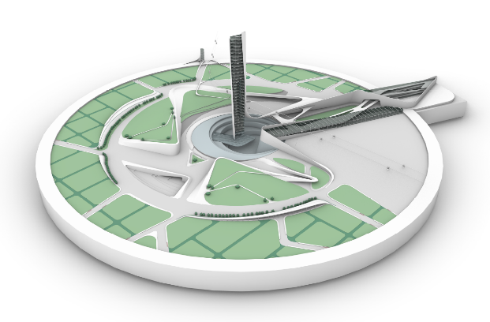
In terms of communication and access to the site, the extension of the cable car line, which started from Lewisen Park and crossed the river, will penetrate into the site as well, which, considering the three main stations in the site, the possibility of entering and The exit to the location will be provided through this way and this path will continue until the end of the urban green corridor.

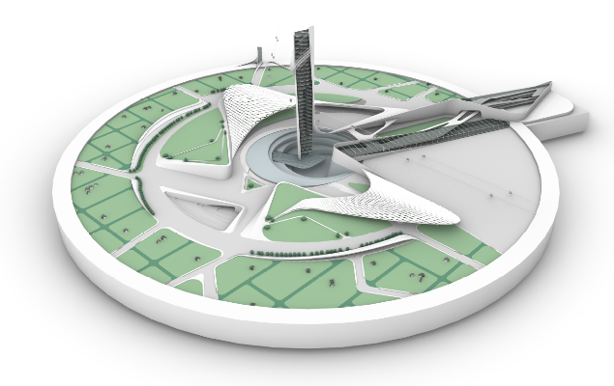

1st Transportation of modular houses 2nd placing the modular houses
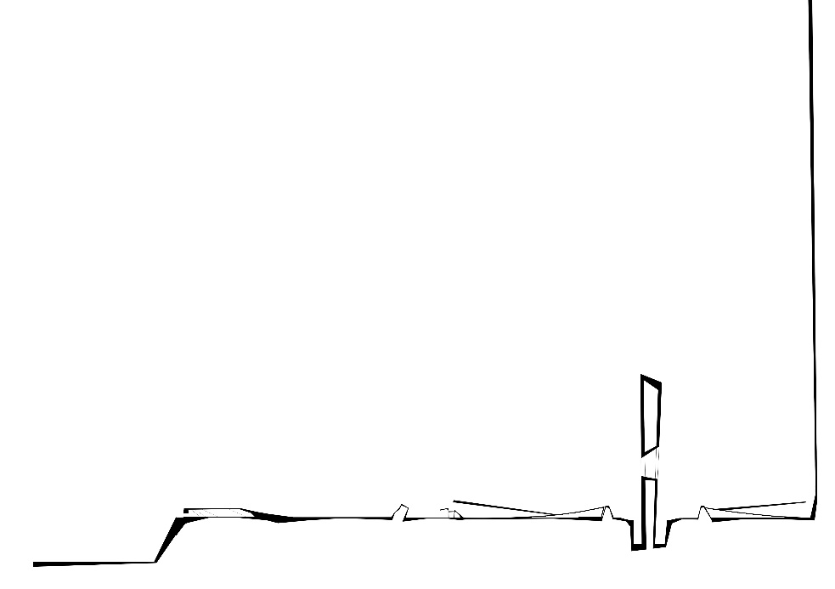

3rd Participation in its establishment 4th Efficiency of modular houses

4th level:
Creation of movement axes and depressions of the site

5th level:
Creating site bumps and other movement paths in it

6th level:
The emergence of energy-reflecting shells at the foot of the central tower
Responding to energy production and storage needs
As mentioned earlier, two main energy production and storage systems have been considered in the site, the first system is a central system that has mirrors and reflectors in different directions and positions in the site. They are placed to reflect the sunlight to a concentrated part in the middle of the site and at a height as high as a tower, to raise the temperature of the desired point and generate energy through a reciprocating system.
The components of this system include:
• Radiant absorbing tower elements in the center (light absorbing panels that will help with heating.)
• Light reflecting mirrors that can change direction and reflect light towards the center.
• Water transfer system in the central vertical axis of the tower (heating liquid circulation)
• A source for converting heat into steam
• Energy production turbine (rotation by steam pressure)
• Power transmission system
• Cooling tank
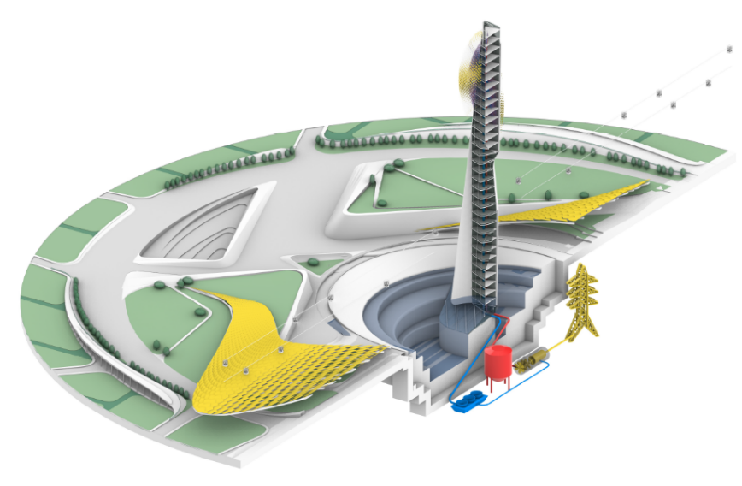
The second energy production system that has become common nowadays is the system of photovoltaic panels that are placed on the upper surfaces of modular houses and their roofs. This system will help by absorbing sunlight and converting it into electrical energy.
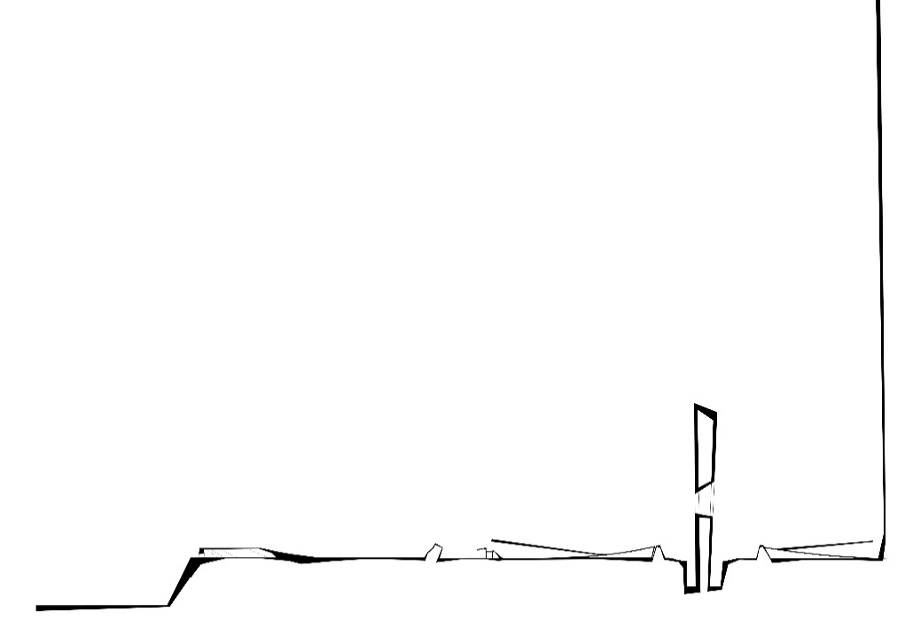

Design of energy system in central zone
UNITED NATIONS
Principles of the United Nations that were tried to be mentioned in the design:
P.02 zero hunger
By urban farming
P.03 good health and wellbeing
By Healthy and organic agricultural products
P.07 affordable and clean energy
by clean energy production and storage systems
P.08 decent work and economic growth
By Considering the area of supply of products and agriculture
P.11 sustainable cities and communities
By observing the principles of urban sustainability and paying attention to reducing the production of pollutants
P.15 Life on land
By Considering the animal habitats on the site
P.17 partnership for goals
By Cooperation of contacts in agriculture and modular houses
Calculate the amount of energy produced:
The 1st system: according to similar examples of energy production systems in the form of reflectors and central absorbers, the energy production calculations in this section will be as follows:
A similar sample under investigation:
two solar farms located in Spain (ps10, ps20)
The amount of energy produced per square meter of reflectors (mirrors) during a year:
about 0.31 MWh

Considering that the German climate is slightly different from Spain and has more non-sunny days, a factor of 60% will be added to this amount of energy production, so:
0.31 x 60%= 0.19 megawatt hours per square meter per year
Total amount of reflectors in square meters:
about 20,000 square meters
Result: 20000x0.19=3800 megawatt hours per year

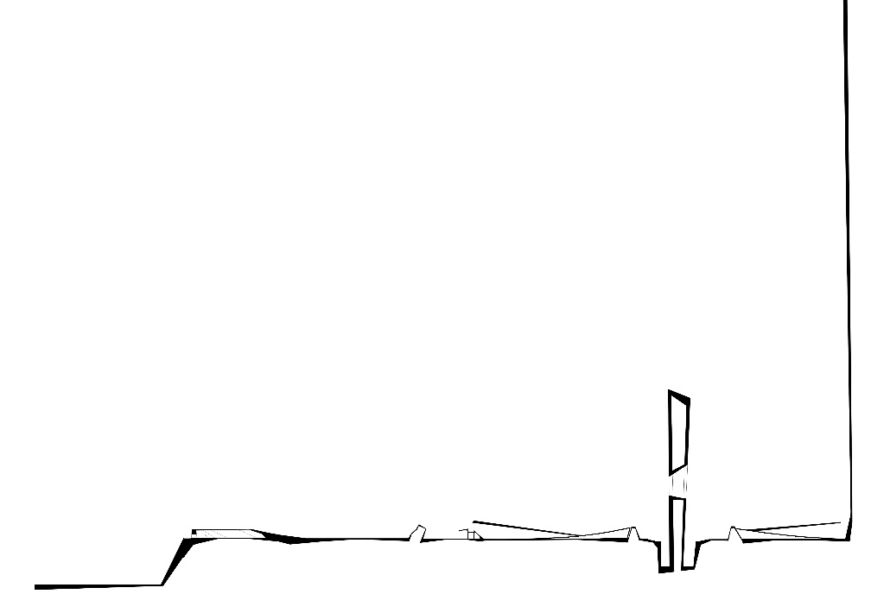
The 2nd system: using photovoltaic panels on the roof of modular houses:
Each house has about 30 square meters of photovoltaic panels on its roof, and the number of modular houses is at least 95 according to the land grid. Therefore, there are about 2850 square meters of photovoltaic panels on the roof of modular houses. On average, about 3.5 kilowatt hours of energy will be produced per square meter in the city of Mannheim.

Central tower perspective

Modular houses photovoltaeic panels
Vegetation and wildlife
One of the main goals of the plan and the grand goals in Manheim's urban development is to create a middle green strip in the almost north-south axis in the city. Therefore, as much as possible, this decision should remain in the plan. Vegetation in the site and plan is divided into four sections and main zones;
• Agricultural lands and private gardens
• The central location of the exhibition
• Small-scale forest parks
• The central greenhouse of the site
In the outer layer of the site, which occupies a larger area, agricultural green lands and private gardens are considered, which are intended for planting and urban agriculture, economic self-sufficiency of the audience and selling products, creating a green belt and green space in The heart of the city will help create food security (principle number 2 of the United Nations) as well as create rest spaces and a quiet space for the elderly and other contacts.
The central location of the exhibition, by emerging from the heart of the site and creating a gentle bulge in the center of the site, has created a space for displaying all kinds of flowers and plants for temporary and permanent exhibitions. This space has created a park and an urban landscape, which also has a space for different and cumulative uses. After the exhibition, this space can be used for ceremonies, exhibitions and as a green space and urban park.
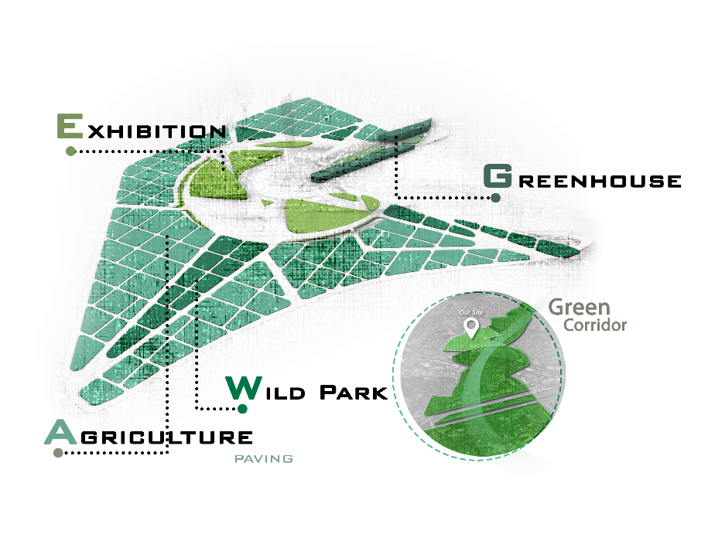
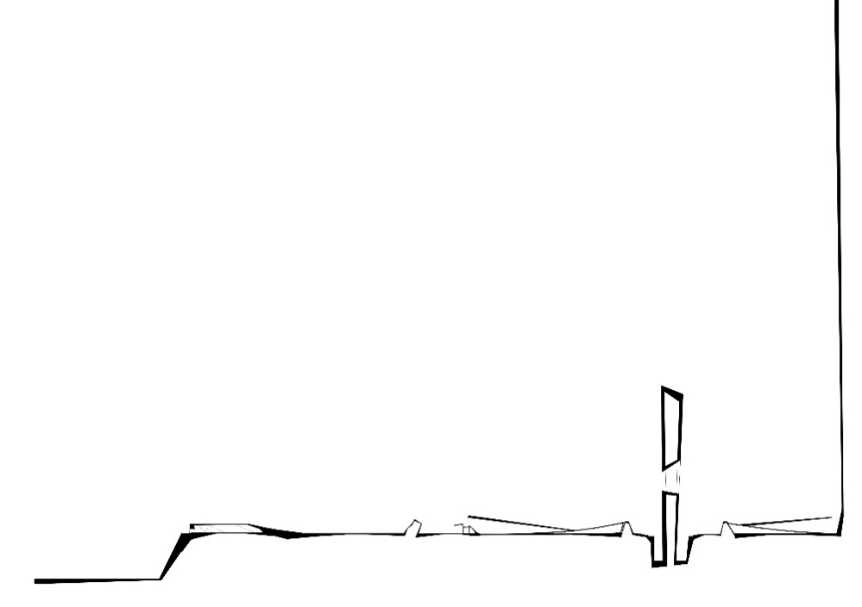

small-scale forest parks in different parts of the site in the middle of agricultural land, where trees and plants are planted and maintained are denser, which will help to create an ecosystem and the habitat of different animals in the heart of the city. This place can provide a suitable place for the life and seasonal migrations of animals and birds and bring life and feeling to the heart of the site.
The central greenhouse of the site, in a part of the existing U HALLE building, which was decided to be used, a glass space called the greenhouse was created so that plants and trees that cannot be planted in this climate and open space can be planted there. to be planted and maintained, also a centralized section under the title of seed and plant seed bank was considered in this building to point to a future perspective and the importance of vegetation.

Design Documents
Final design
After going through all the design stages, we reached a final design in which we tried to remain stable to all the principles and elements that were mentioned. Documents in the form of outputs from the site plan, human perspectives, bird's eye perspectives, existing designed details, explanatory diagrams and sections, etc. are given below, which will provide explanations on the plan.

- Diagrams of uses and spaces in design:

1st diagram: central tower and U-halle
2nd diagram: modular houses in urban farming
3rd diagram: Agricultural products market
4th diagram: exhibition and central park

- Opening and closing stages of modular houses:

3D layout of reflectors

3D layout of reflectors
Heliostats

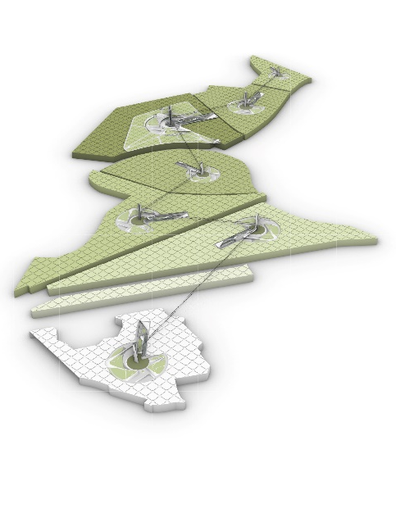
Design development and future vision of design in Mannheim green corrido

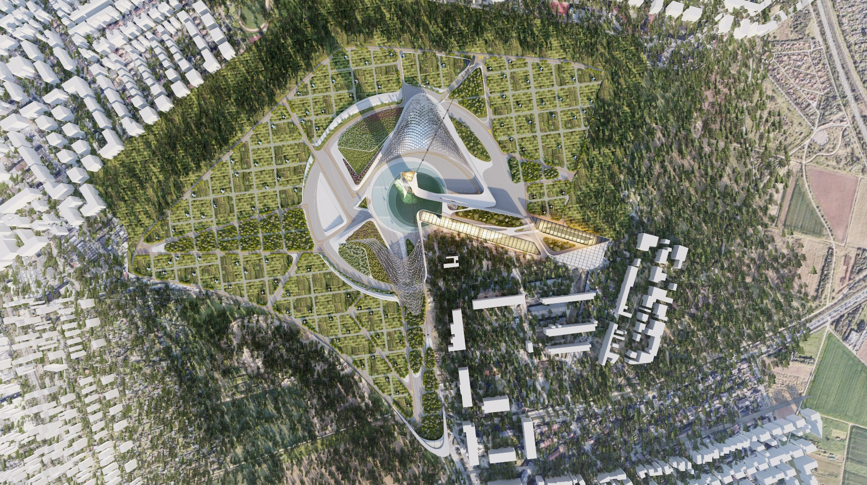

- Human perspectives

Site view
Human perspective ꟾ central zone
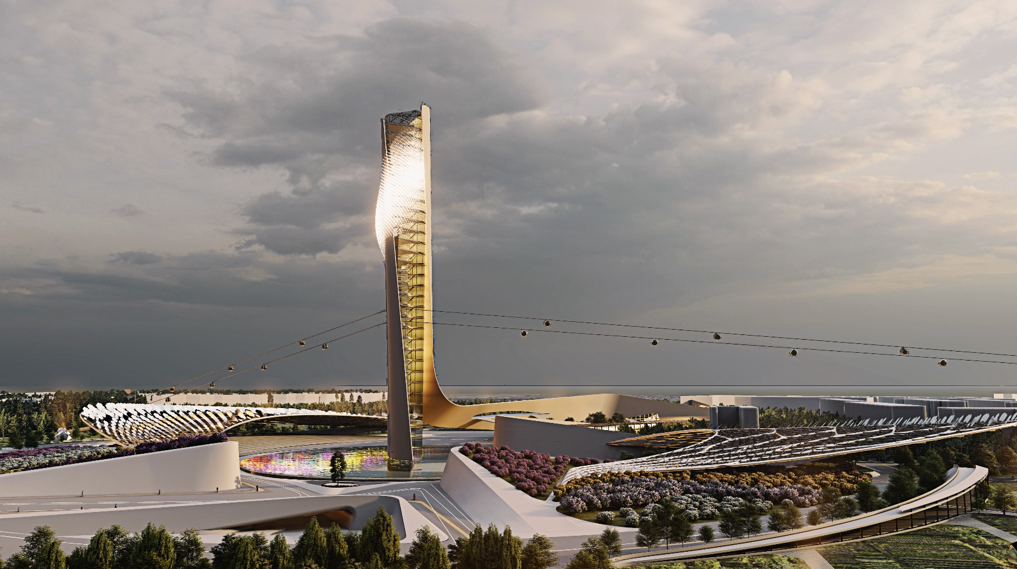

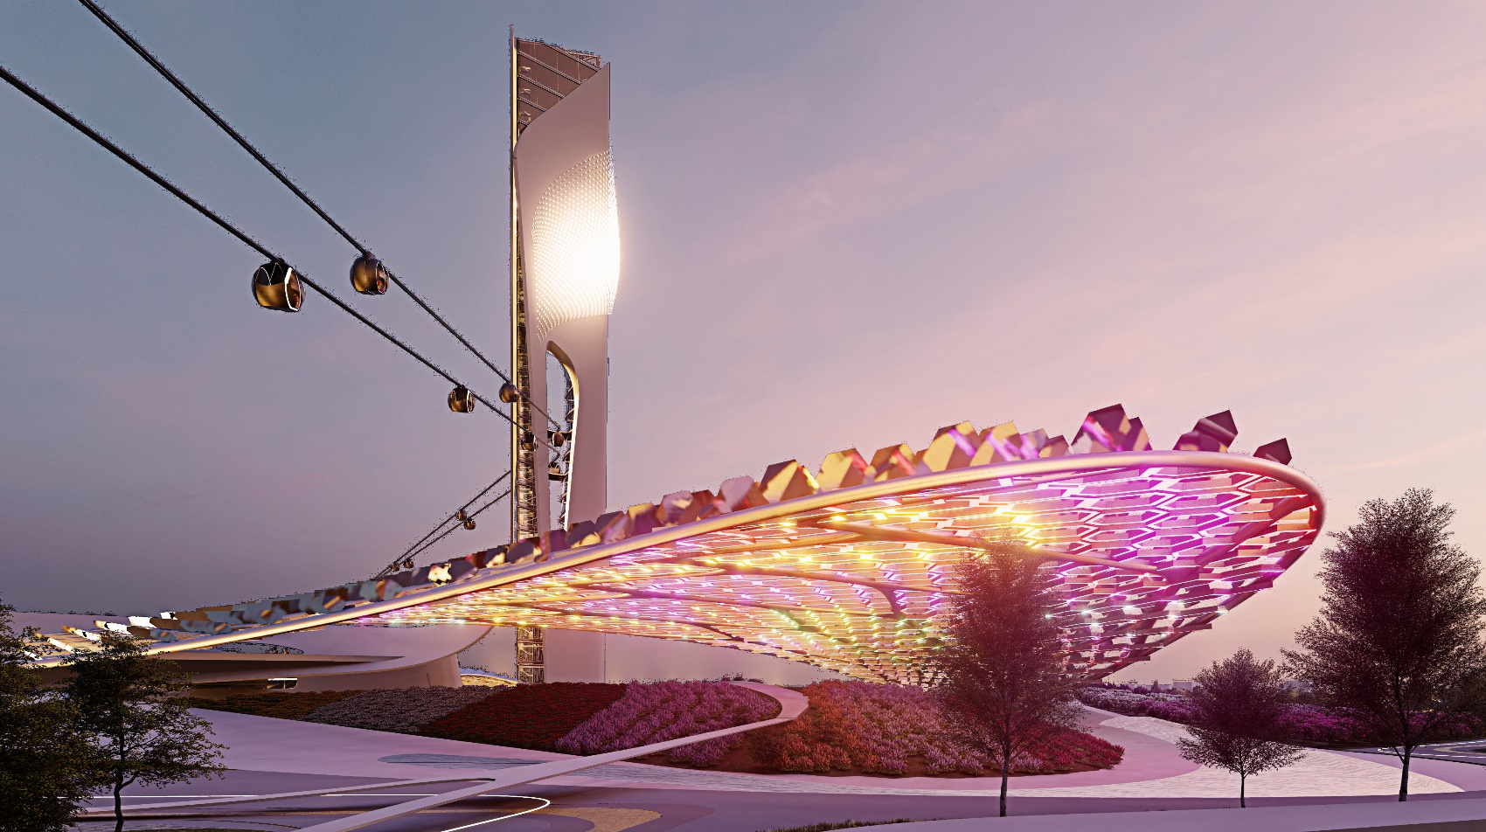

Human perspective ꟾ lights below the reflectors (central zone and tower)
Human perspective ꟾ modular houses
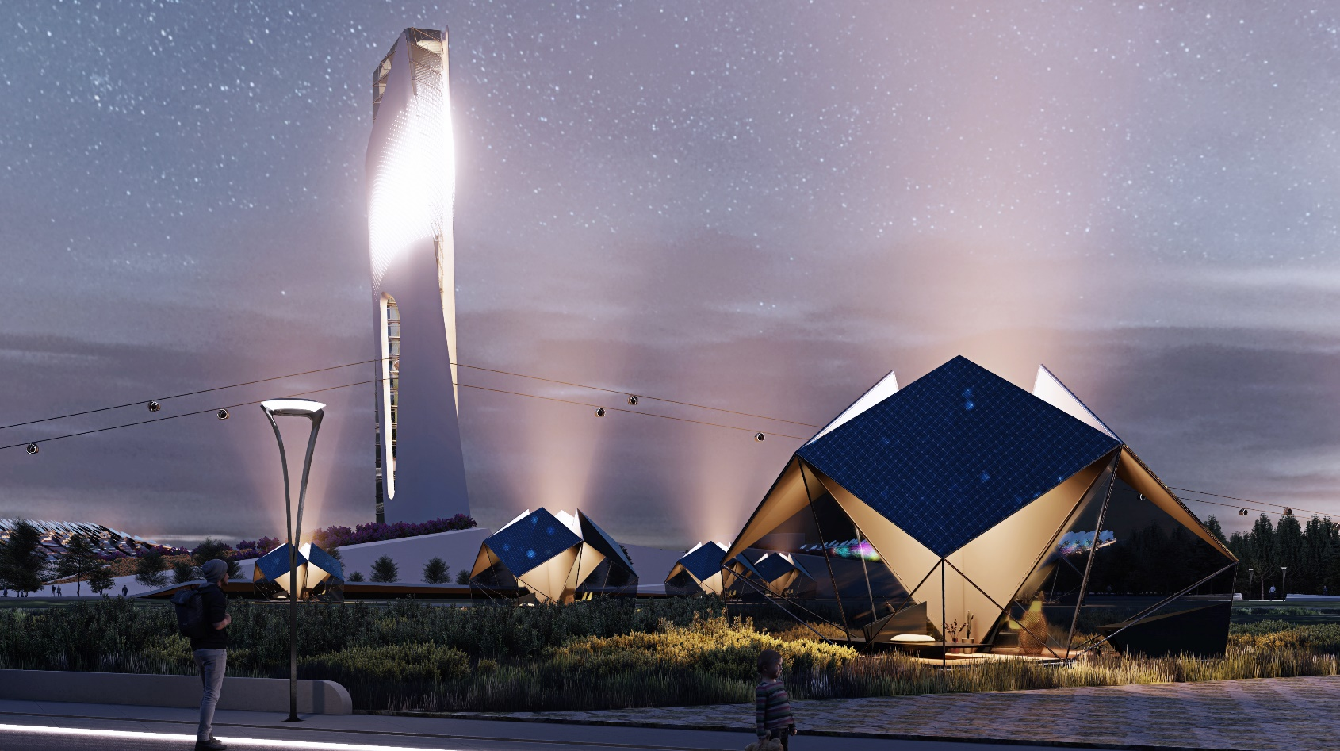

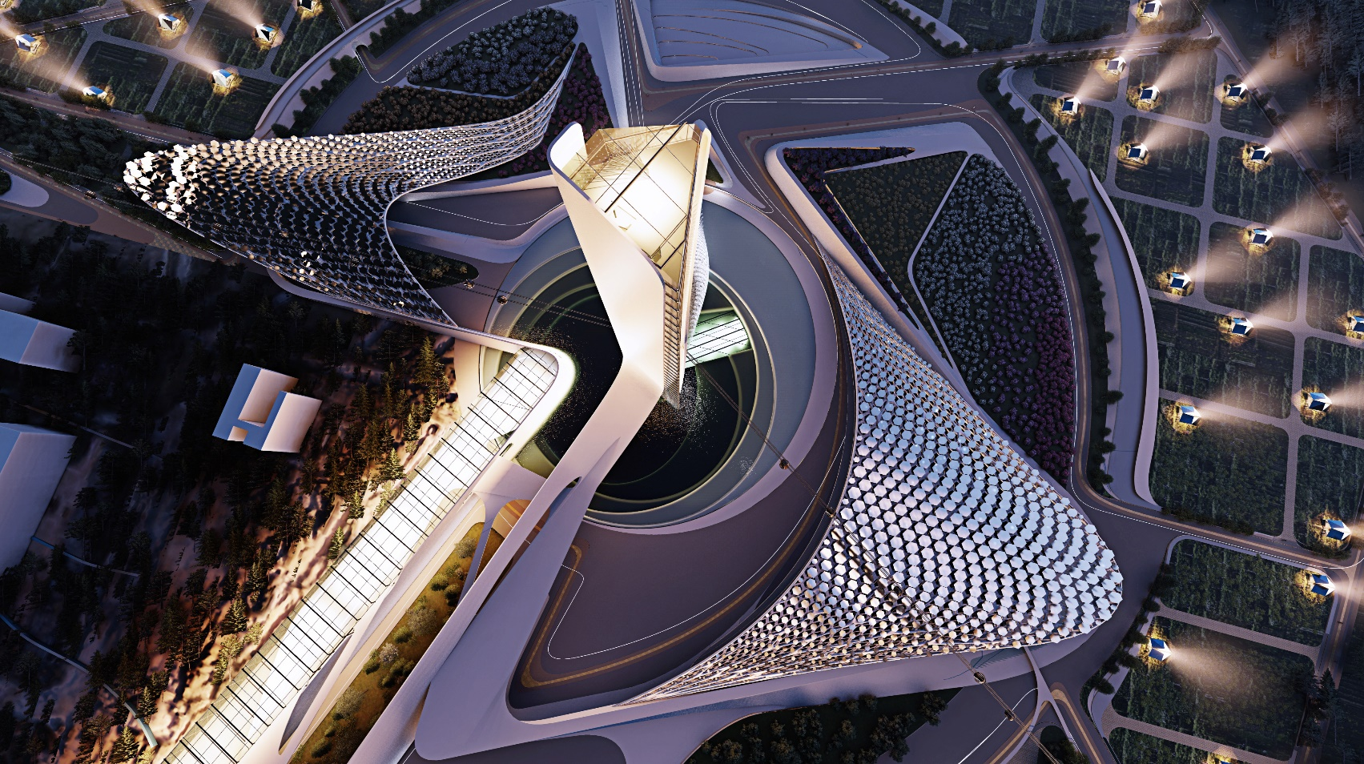

Birds view perspective ꟾ central zone from top (reflectors and tower)
Birds view perspective ꟾ U-halle building
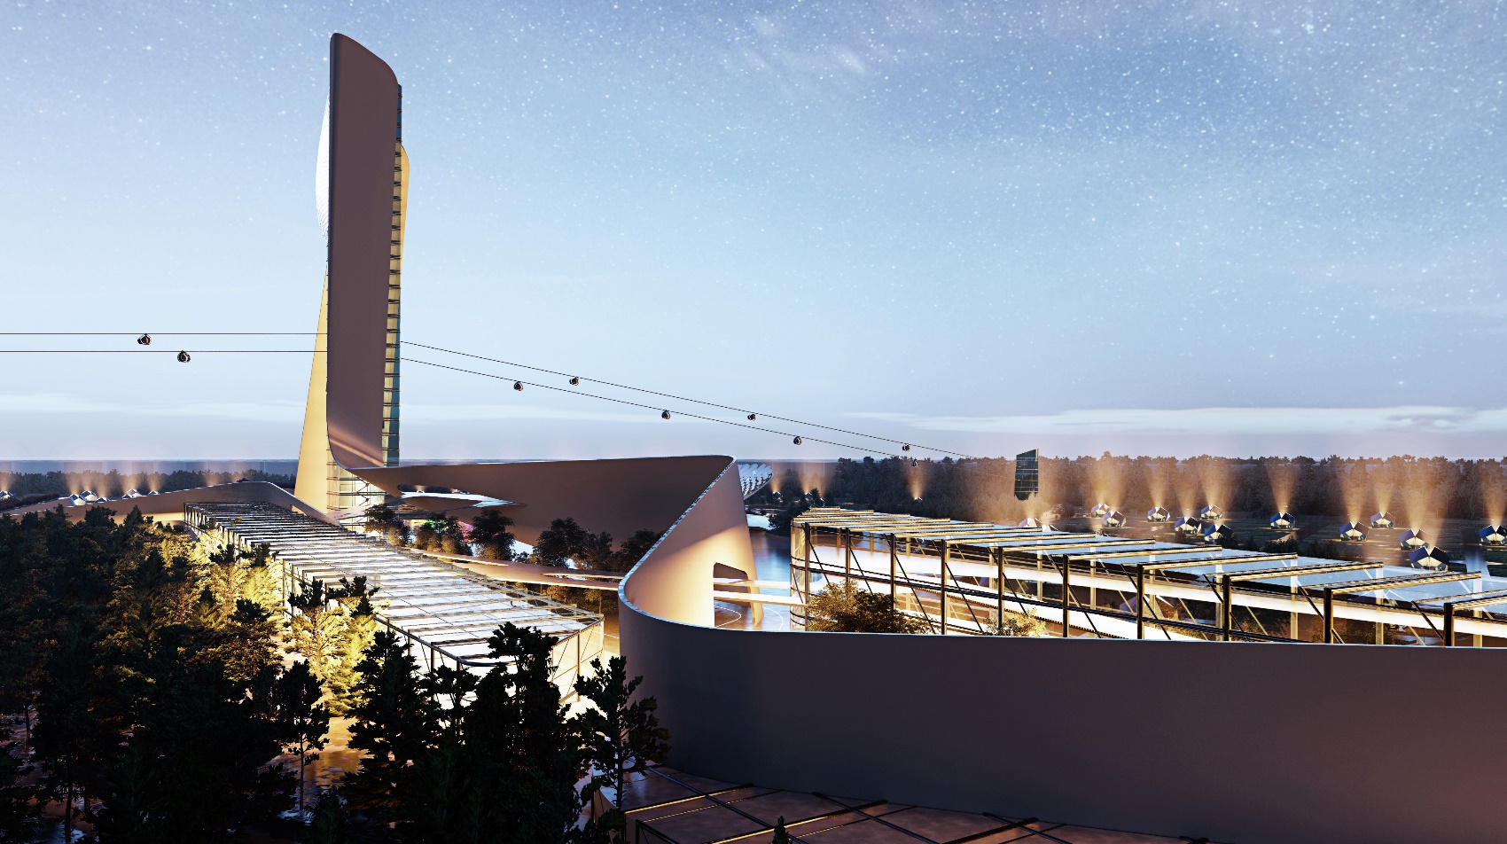

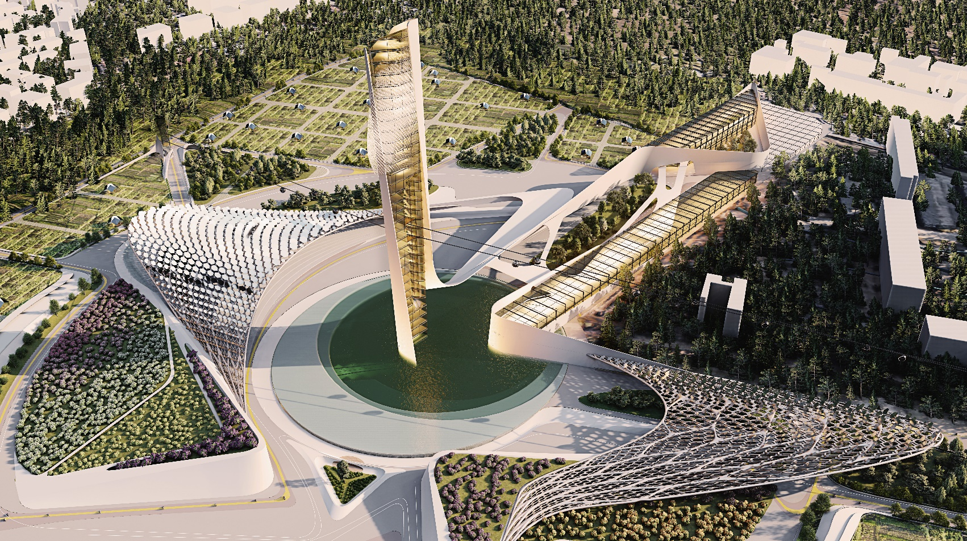

Birds view perspective ꟾ central zone from top (reflectors and tower + U-halle)
Birds view perspective ꟾ modular houses arrangement in site
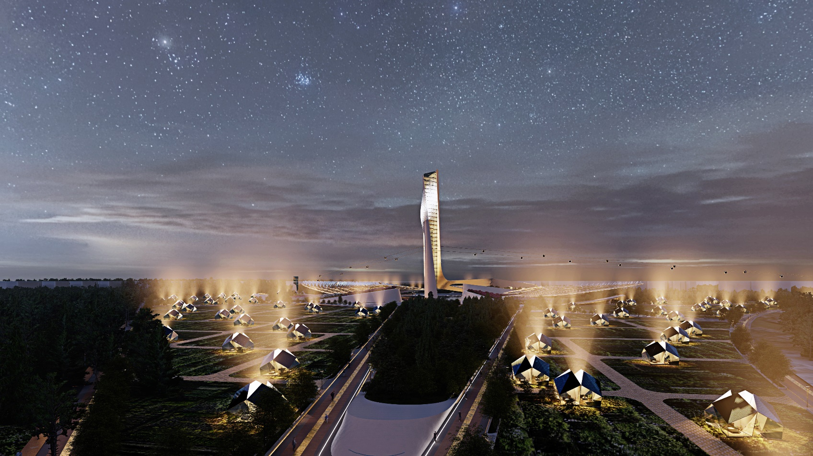

SUMMER 2022

