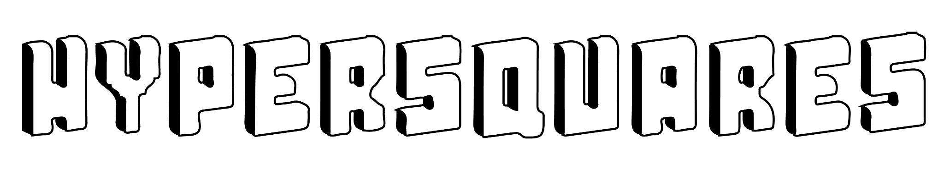
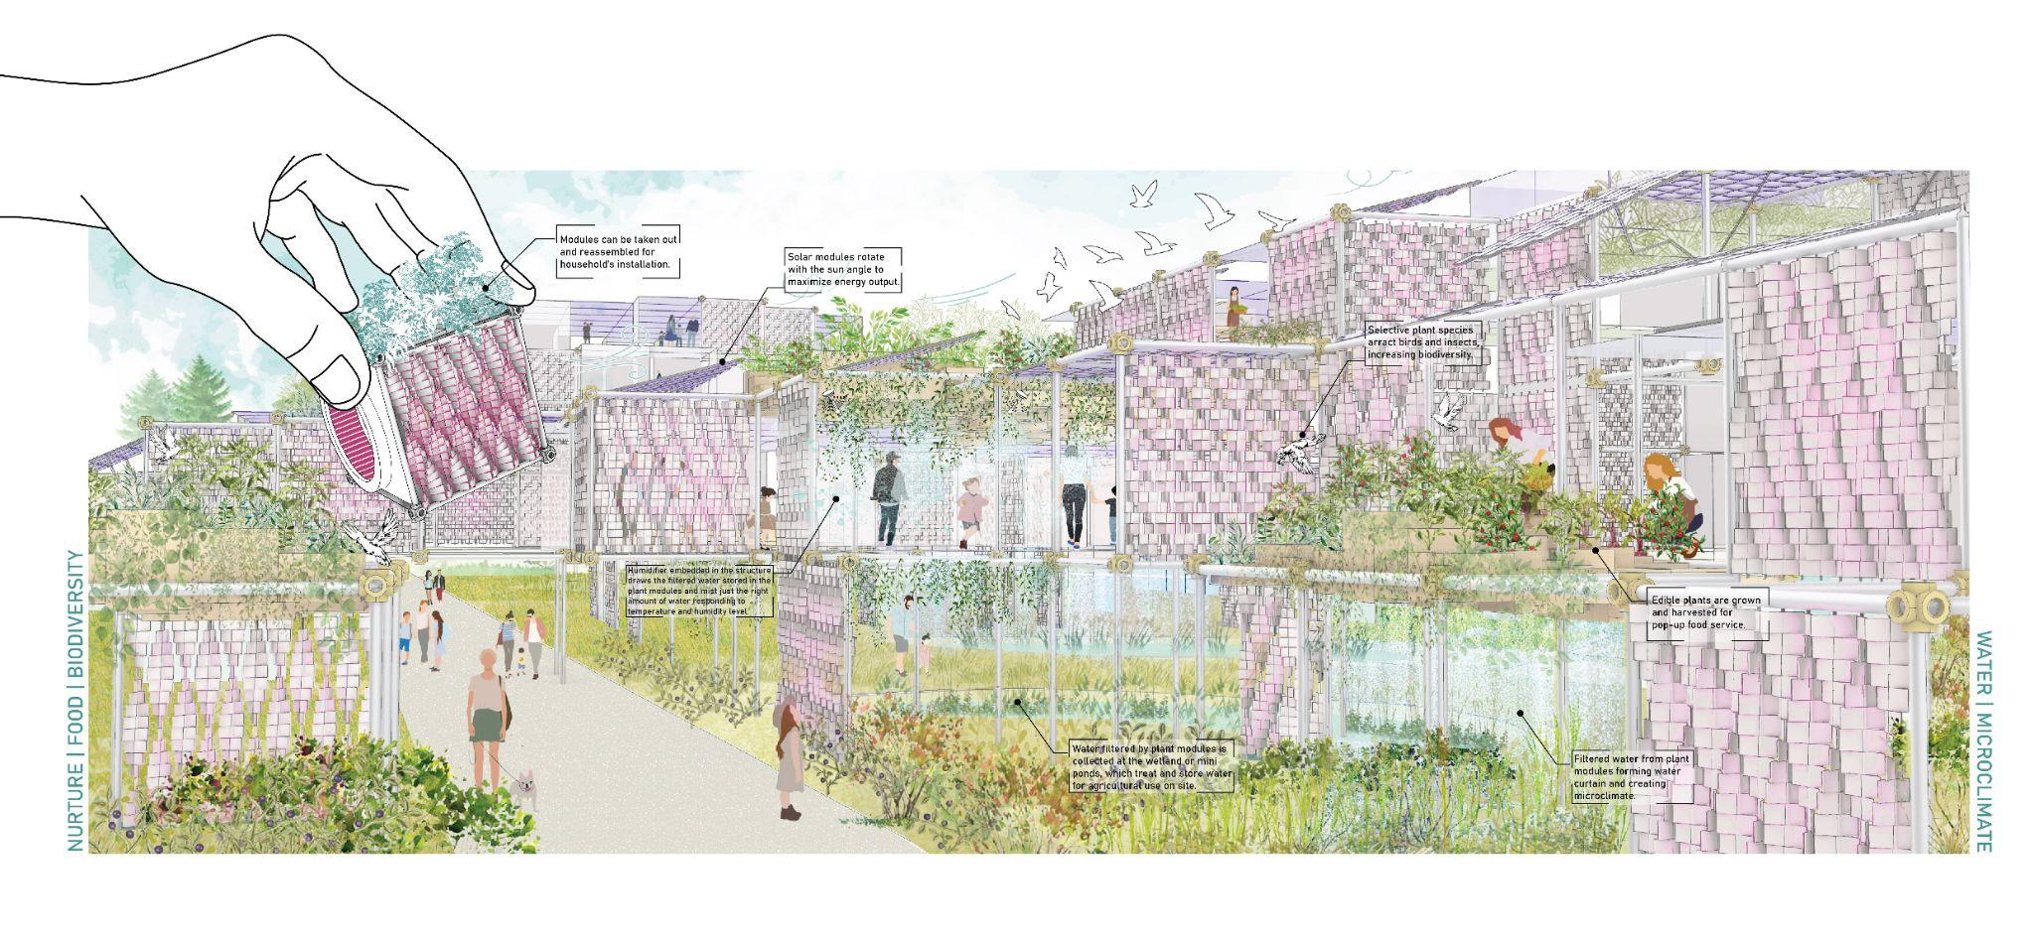
Annual Capacity: 6432 - 7843 MWh

- Project Statement
HyperSquares seeks to stimulate the imagination of Mannheim's post-carbon future while remaining firmly rooted in the city's "square" history. The installation design reflects the intersection of Mannheim's past and future, nature and culture, art and technology. Eschewing homogenized large-scale energy harvesting machines, HyperSquares redefines the energy production landscape, allowing for playful, dynamic, interactive program spaces with diverse combinations and flexible scaling.

Our solution integrates solar, wind, plant microbial fuel cell, and kinetic energy harvesting technologies to provide energy with multiple side benefits on both civic and residential scales. In response to BUGA23's theme, HyperSquares provides visitors with a multi-dimensional experience while they explore topics related to climate change, green energy, and urban farming. Beyond renewable energy production, HyperSquares enriches people's lives socially, recreationally, and educationally, confirming the city's slogan that life is lived to the fullest – or “life squared”.

- The Civic Park Scale (Spinelli Barracks)

Nicknamed Quadratestadt, the city of Mannheim is built in a grid pattern, making it unique among other German cities. From the primitive natural geography of the dunes to the man-made construction of military bases, the Spinelli site has gone through a long past, yet it is ready to embrace a promising future. The city is located in Germany’s warmest summer region and the Spinelli Barracks site receives ample sunlight hours all year round. As the gateway to the Rhein-Neckar Green Corridor, the site will serve as a vital node for wind flow from the west to the city center. Inspired by the latticework of urban construction and the natural historical geological features of the site, a cluster of installations emerges out of the landscape, in the form of dunes stacked by cubes. The orientation of each dune is designed to concentrate the wind flow which then maximizes on-site energy production. The solar hour analysis and wind flow simulation help to determine the location and quantity of solar and wind panel modules respectively.

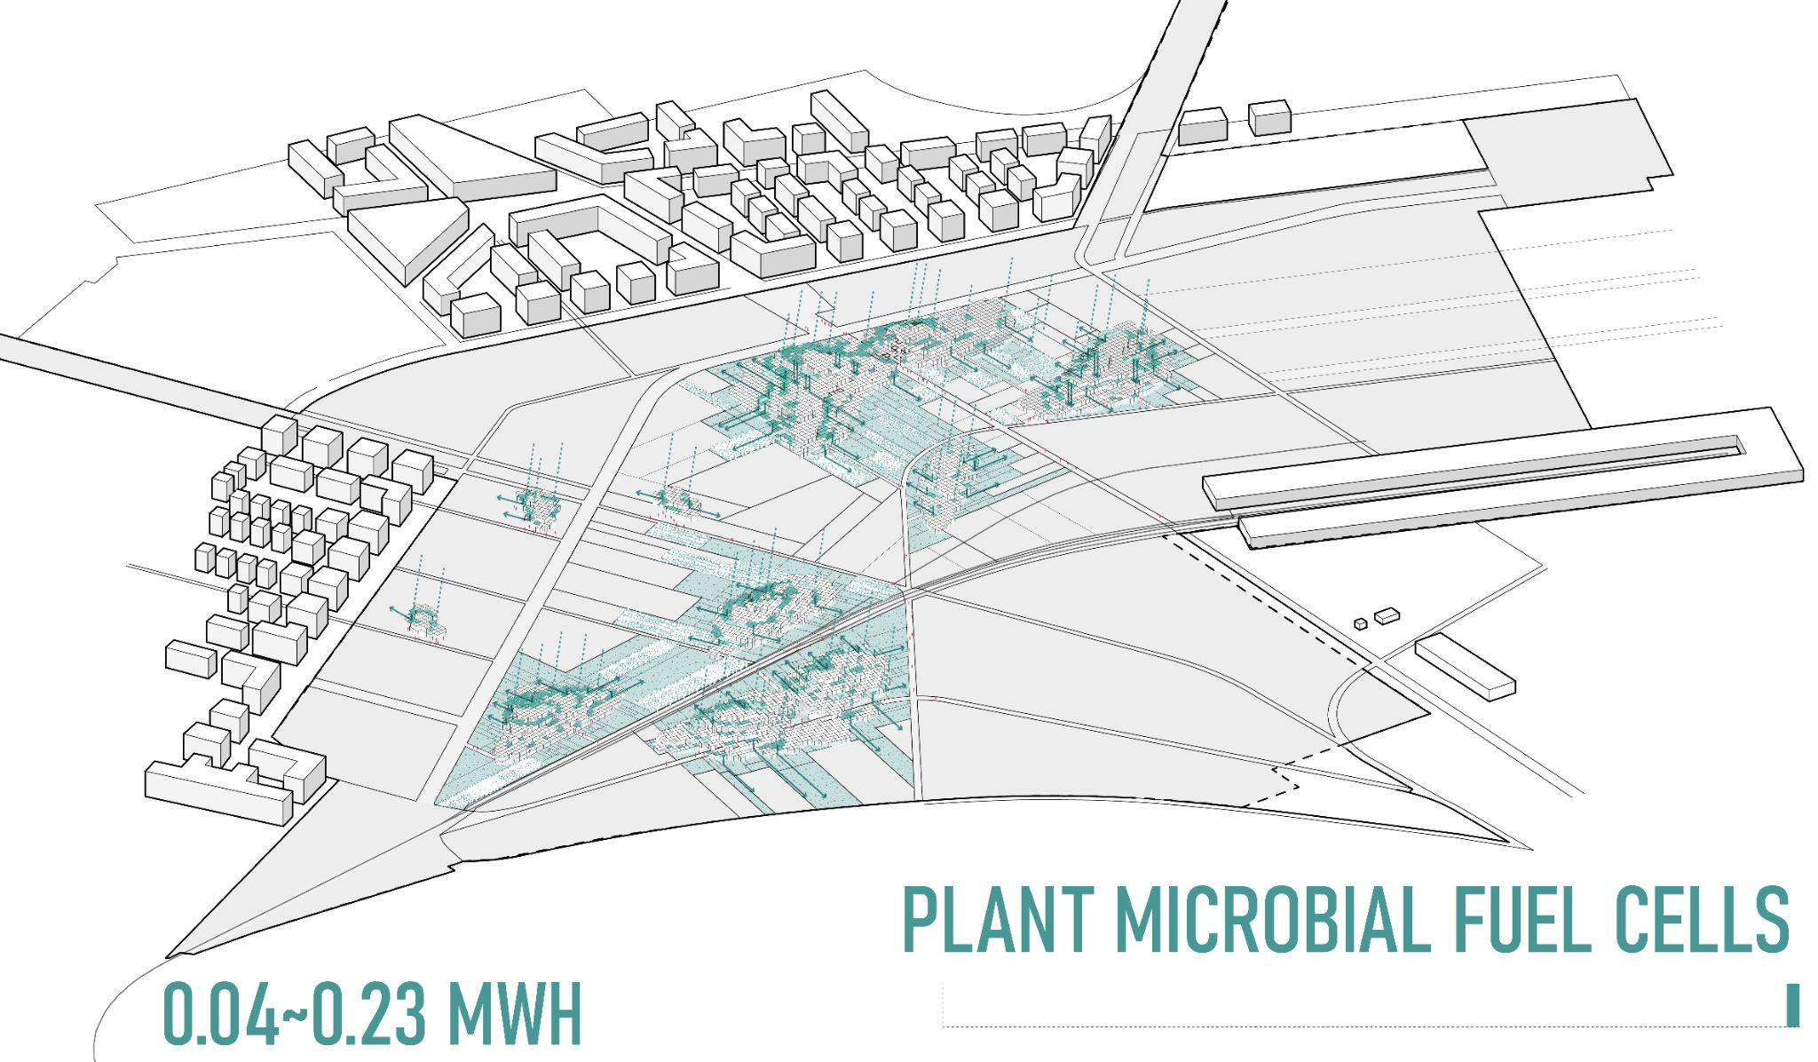
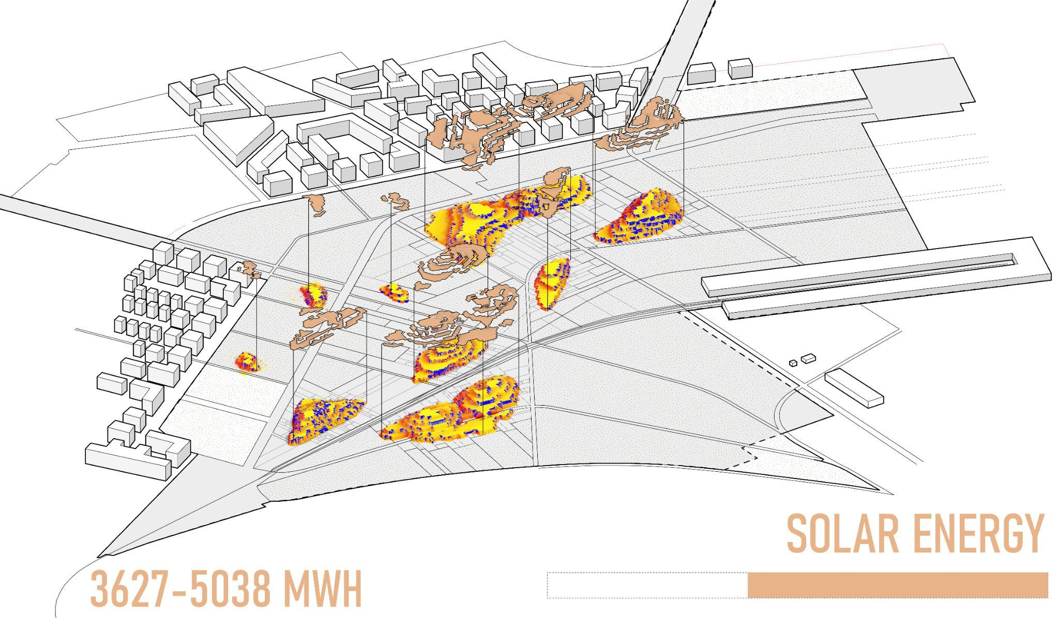
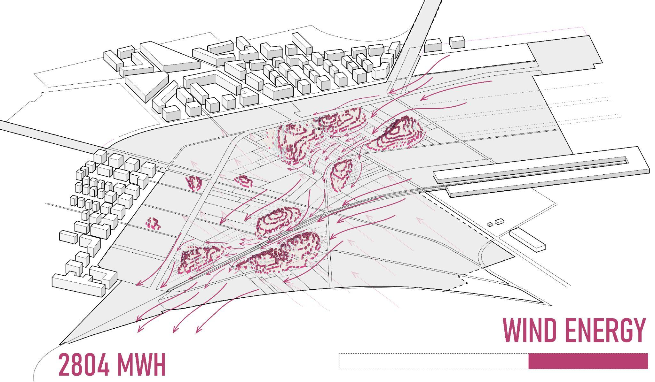
The assemblage of HyperSquares will take place in phases and create new job opportunities during each phase. Dunes on the major axis will be built first, with periphery dunes coming in the later phases.
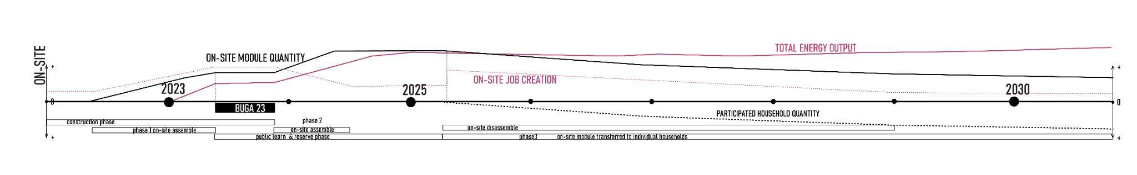
The topography piled up on the open site creates three-dimensional multifunctional spaces that serve as large-scale art installations and energy machines, infused with interactive play, overlooking terraces, and biodiverse habitats, to reflect three major themes about art & culture, nature & water, play & education. During BUGA 23, visitors will have a chance to visit and interact with a portion of this energy landscape to learn about how the system functions and reserve a spot for “PLUG-IN”- the module adoption program for their garden.

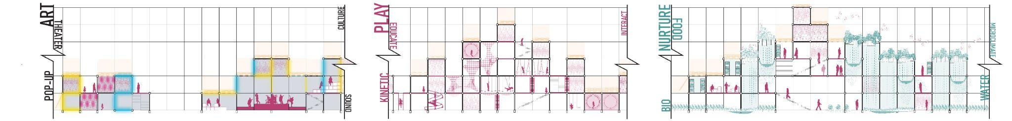

- Hypersquare Module Information

The HyperSquares installation is designed with different scales of application in mind, assembled in 3x3x3m sized HyperSquare modules. The module includes 3 types of components: faces, frame+joint, and add-ons. Faces integrate green technologies to harvest renewable energy, which are connected by frame+joints with internal circuits for transporting electricity. The frame is wrapped with a LED shell that produces different lighting effects in response to energy harvest data collected. Finally, add-on programs within HyperSquare cater to the needs of different groups of people.

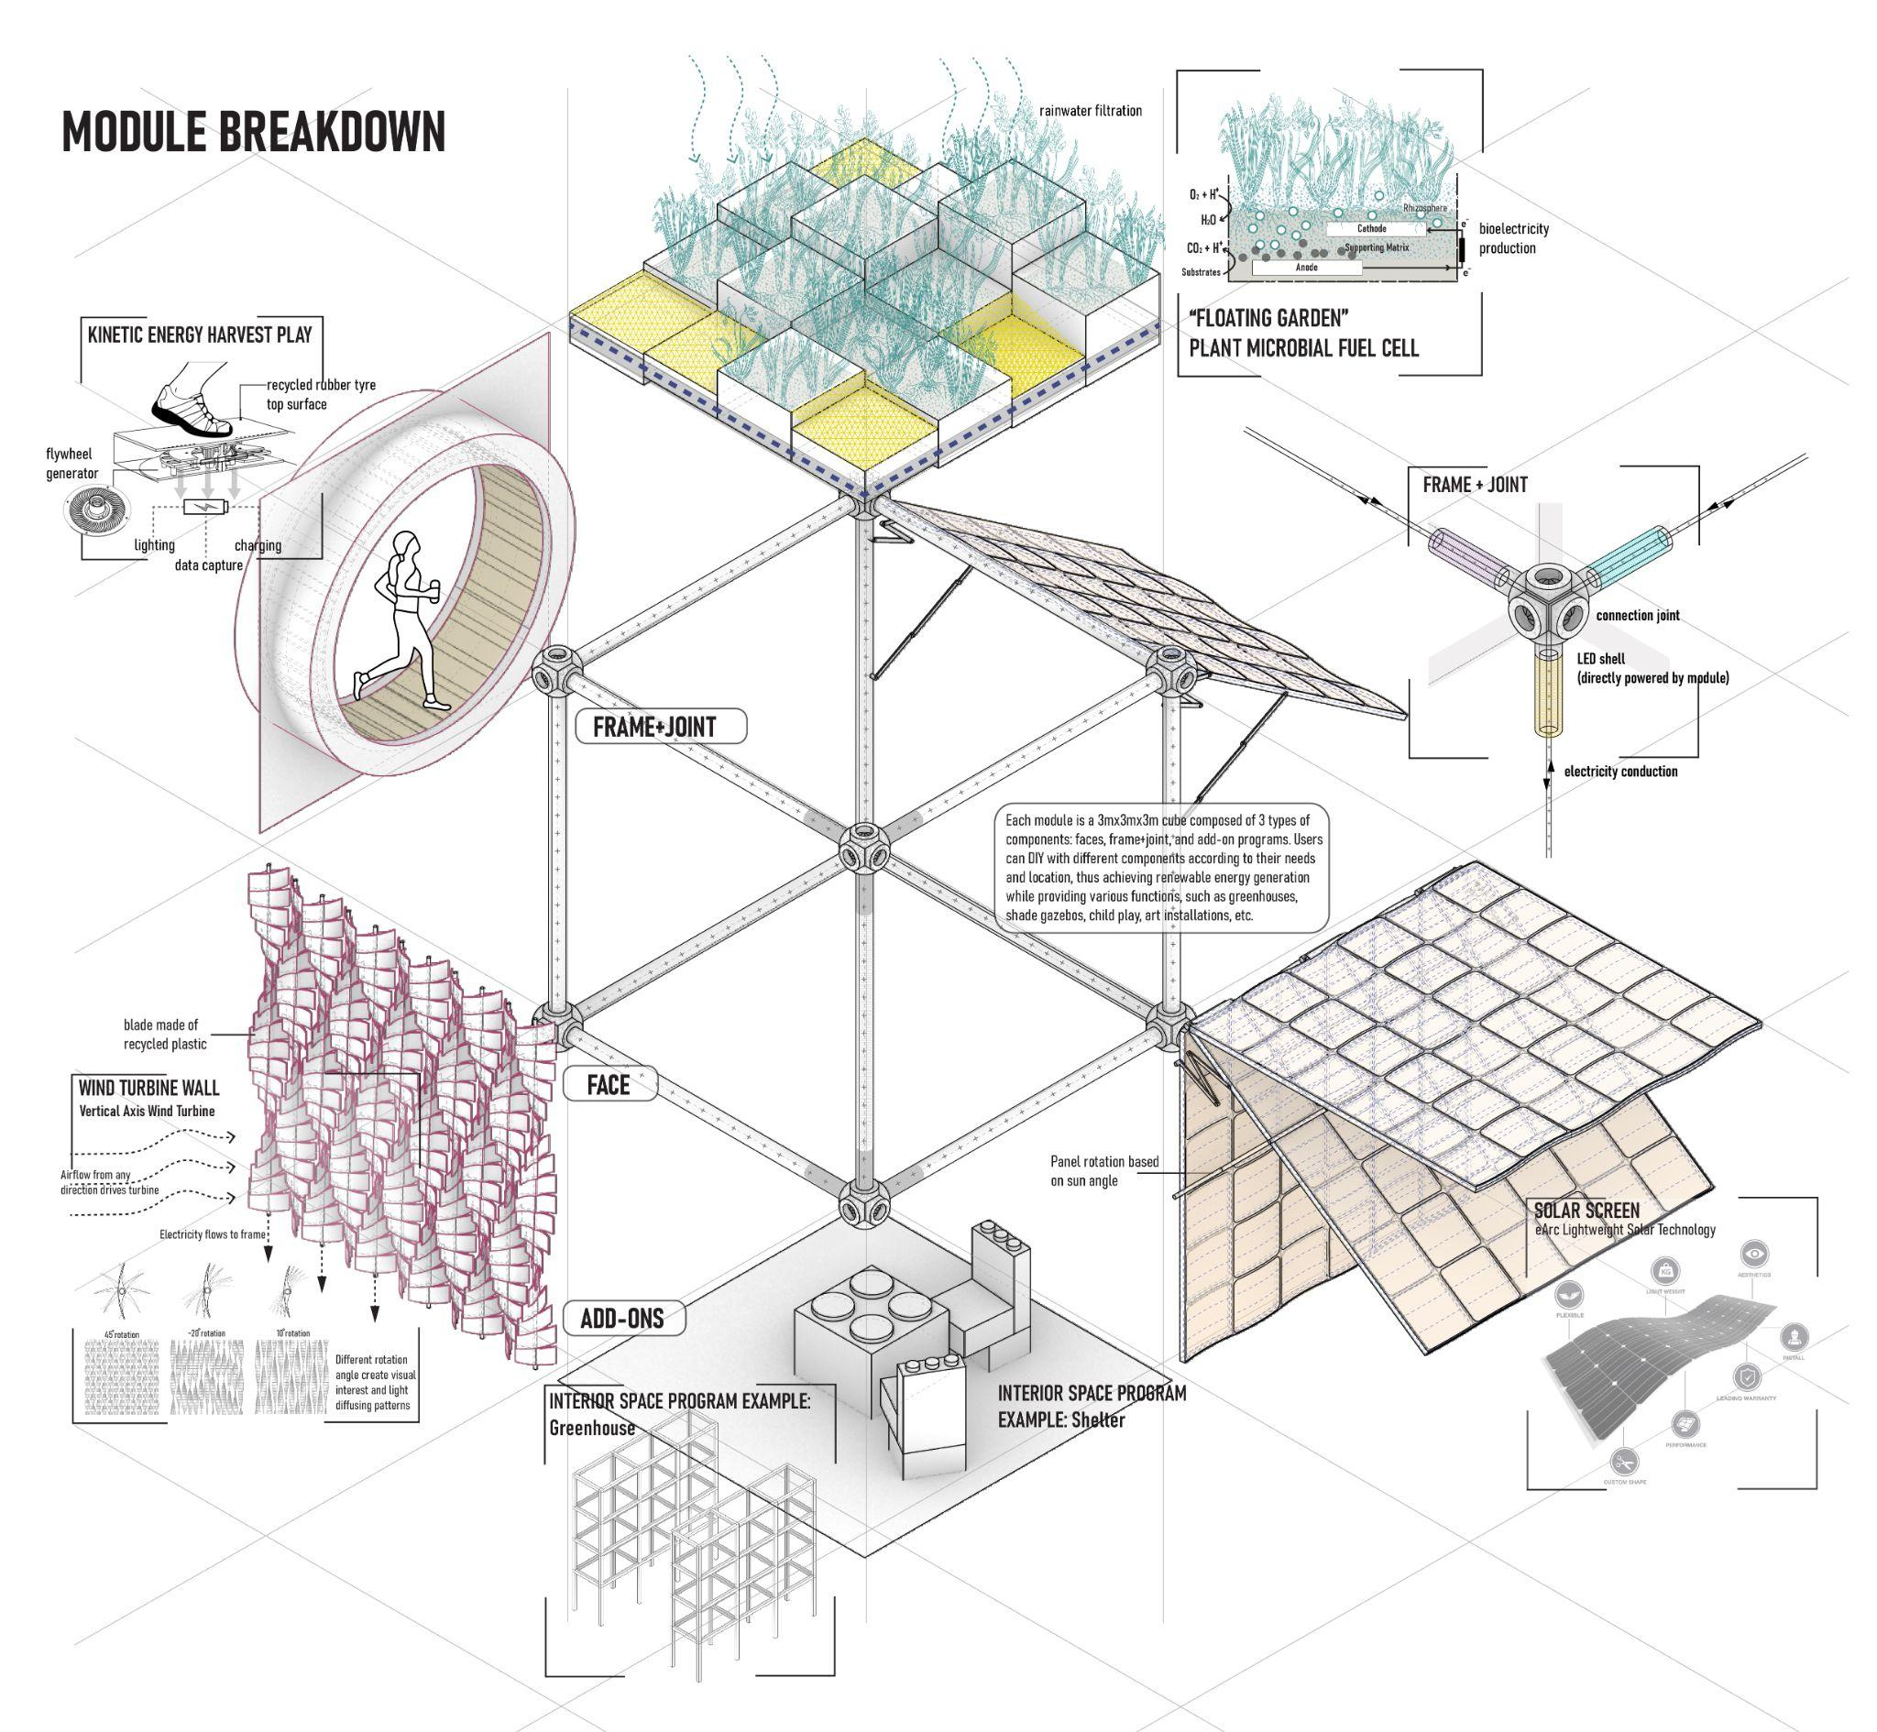
1 HYPERSQUARE TOTAL ENERGY PRODUCTION (2solar+1wind+1MFC):
5530 kwh/year = enough to support one household’s annual consumption
HYPERSQUARES INSTALLATION TOTAL ENERGY PRODUCTION:
6432 - 7843 MWh / year

“Faces” Technologies:
- Solar
Total number of 3x3 units: 2488
Total Solar Panel Area: 22392 sqm
Total Solar Energy Harvested Per Annum: 3627.5-5038.2 MWh (based on site’s available solar energy 900-1250kwh/sqm)
The proposal integrates Sunman’s eARC solar panel due to its lightweight, flexibility, and durability. The product applies Crystalline silicon cell technology and contains no glass and metal to achieve lightweight and durability while less lightening risk. The panel can rotate responding to sun angle for maximum radiation collection.

- Wind
Total number of 3x3 units: 1895
Total Wind Panel Area: 17055 sqm
Total Wind Energy Harvested Per Annum: 2804.6 MWh (based on the main wind speed of 3m/s)
The wind turbine wall applies the vertical axis wind turbine technology. Integrating the Airiva wind turbine wall and the Alpha 311 vertical axis turbine technologies, the system can harness wind everywhere, generate almost no sound, and produce changing aesthetical effects. The main material made up of the rotary blade is recycled plastic, which is cheaper and locally available. Each 3mx3m wind turbine wall can generate approximately 1480kwh/year at 30% efficiency.

- Floating Garden- Plant Microbial Fuel Cell
Total number of 3x3 units: 968
Total MFC Area: 8712 sqm
Total MFC Energy Harvested Per Annum: 42 - 230 kWh (Dependent on plant species)
The floating garden uses the Plant Microbial Fuel Cell, which is a greener technology for bioelectricity production, wastewater treatment, and greenhouse gas mitigation. Although less efficient in producing electricity, the system can generate enough energy to sustain wireless sensors, which can monitor the surrounding flora and vegetable health in a private garden. The components of PMFC include electrodes, membranes, conductors, and bioreactors. They are inert and not perishable, making this technology inexpensive as compared to conventional MFCs.

- Kinetic Energy
The module integrates Pavegen tile and interactive play structures to allow visitors to interact with the modules playfully. The kinetic energy harvesting strategy is considered as an additional energy input that requires visitor participation, so it is not included in the total energy output calculation. As people step on the module surface, their weight causes generators underneath the tiles to rotate, generating power via electromagnetic induction. Additionally, Bluetooth beacons embedded in the tiles connect with the mobile app to allow visitors to learn about how much energy they generate.

- The Schrebergarten Scale (Scalable solution)
The Hypersquare installations can be recycled and reassembled into modules that can be plugged into small gardens on the other end of the scale spectrum. The flexibility and diversity of Hypersquare modules allow community residents to fully participate in the design. Through a digital platform, users can select different functional surfaces to assemble their modules which can replace the existing structures on-site. The new DIY modules not only will achieve sustainable energy production but also meet the needs of different households. Those can function as greenhouses, shade gazebos, child play, art installations, etc. Meanwhile, residents can monitor their energy savings on phones to help contribute to a post-carbon community. In addition to being placed in private gardens, the HyperSquare can be plugged into any corner of the city. For example, it can become a new type of EV charging station that collects renewable energy through its facades, as well as wildlife roosting spots and fun rest stops in urban areas. 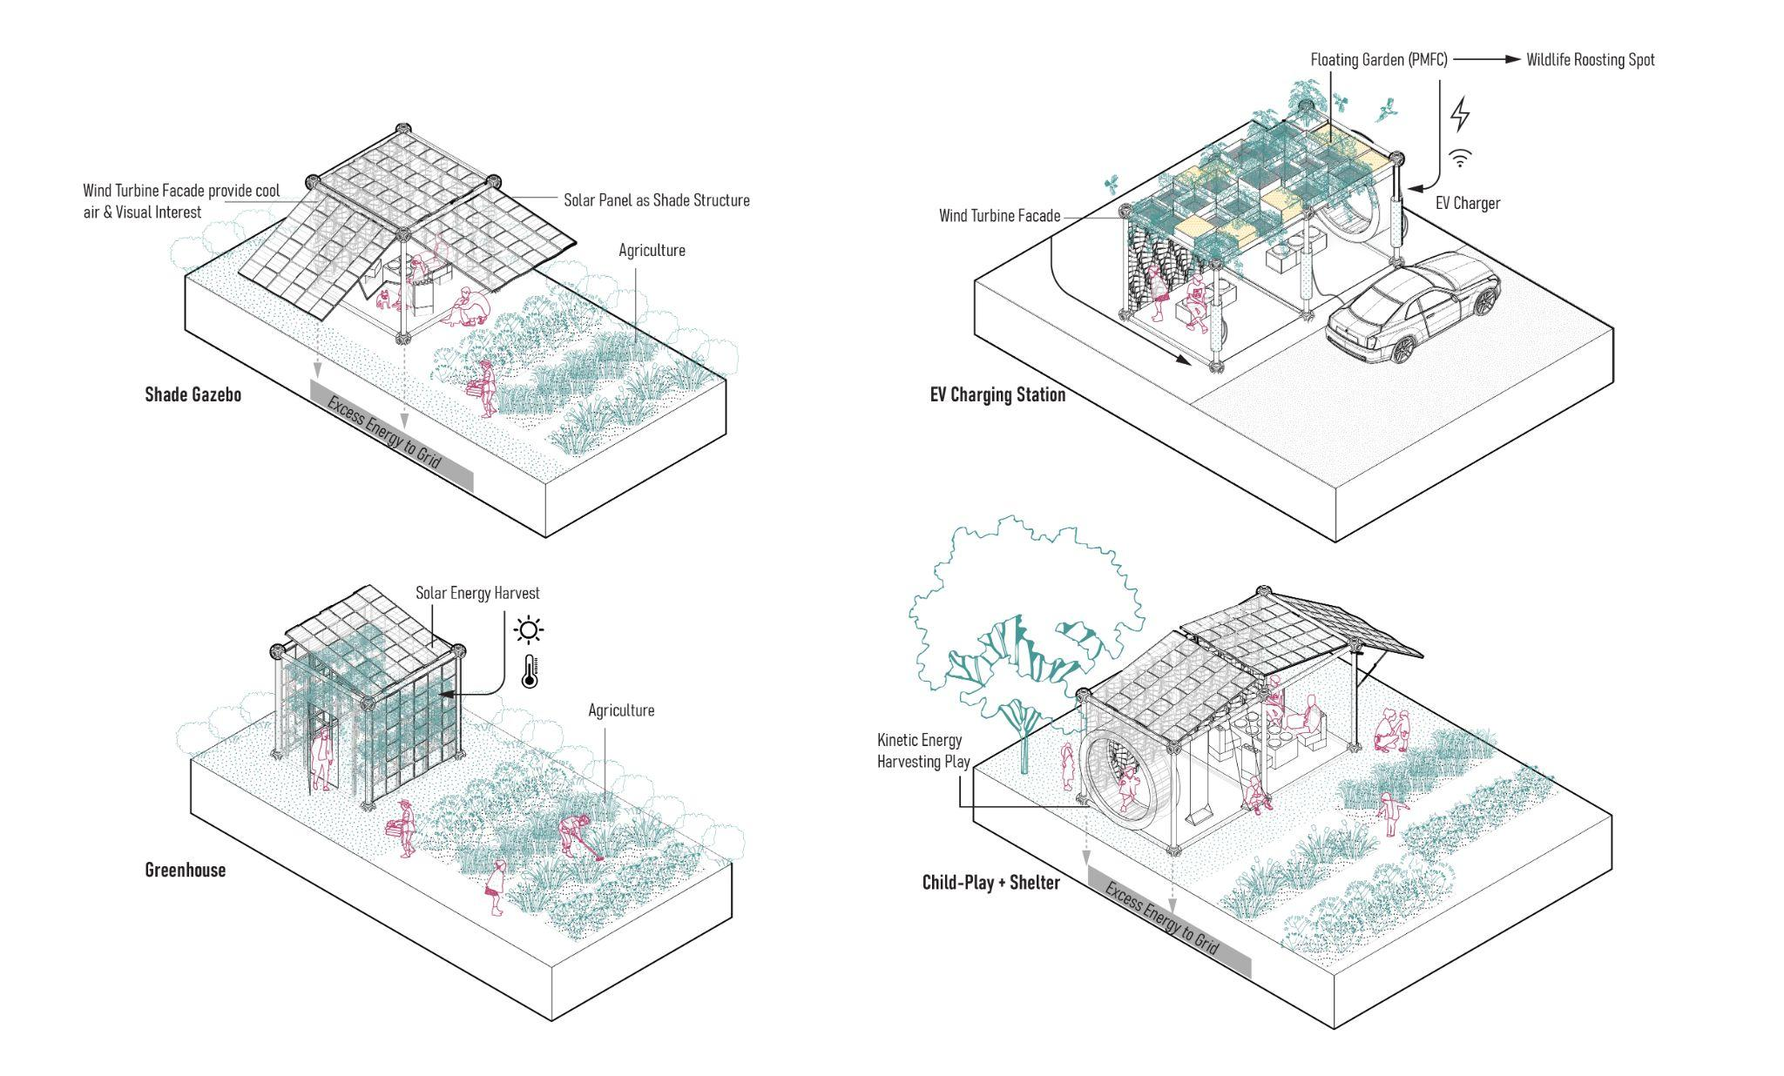
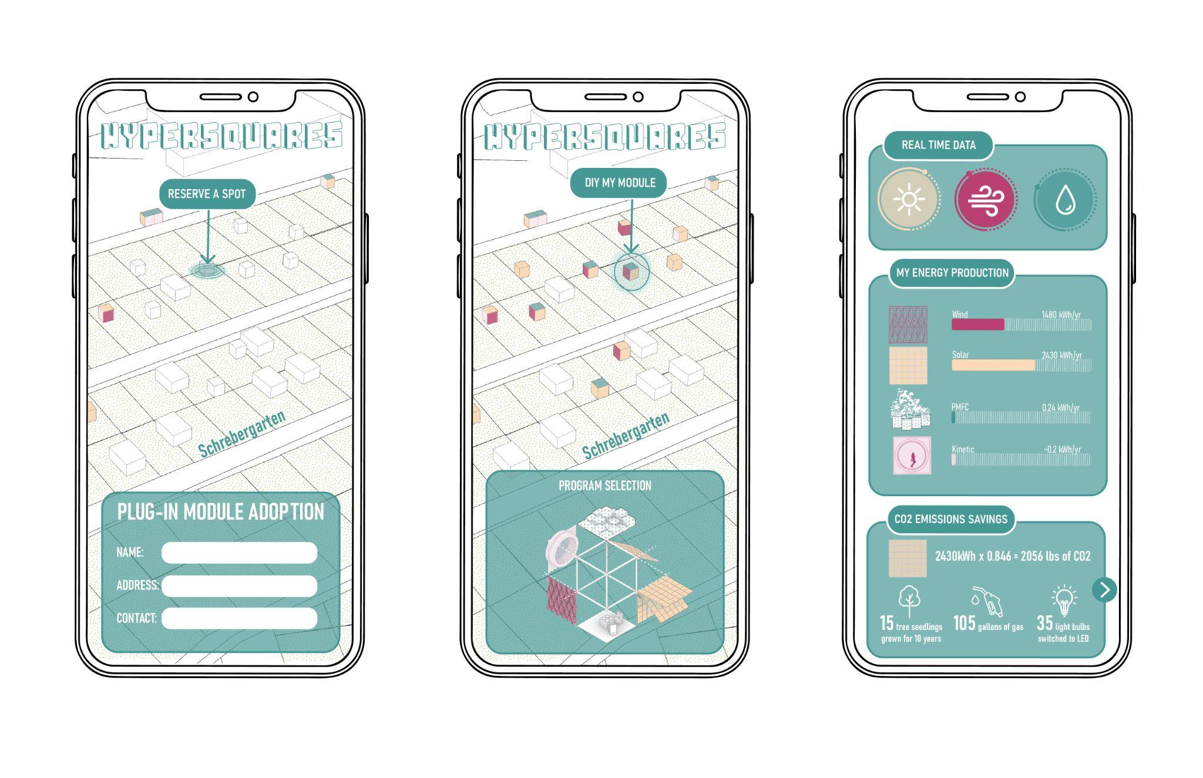
Image: “PLUG-IN” APP interface

- Supporting UN Sustainable Development Goals

The design aims to address multiple UN Sustainable Development goals:
Goal 2: As part of the extension of the installation, agricultural patches spread out from each HyperSquares dune, irrigated by the water collected through the structures. Also, selective edible plants grown at plant modules provide on-site harvesting and tasting experience.
Goal 3: HyperSquares encourages healthy lifestyle after the pandemic by providing playful interaction programs outdoors for people of all ages.
Goal 7: The modular design allows everyone to choose and DIY his/her HyperSquare to harvest renewable energy in the city. The technologies chosen are easy to install and affordable.
Goal 11: The modules not just supply green electricity and food for human communities, but also help create habitats for non-human species. Planting cells collect and purify stormwater, and absorb pollution while providing roosting spots for wildlife in urban areas.
Goal 12: The material applied in the installation modules is mostly local and recyclable, which produces no waste or pollution. Renewable energy production on-site not only supports cleaner energy resources but also raises people’s awareness of shifting toward a more sustainable lifestyle.

- Environmental Assessment

- To reduce the impact of construction, the project proposes recycled lightweight steel as the frame structure, which will be assembled on-site by the local workforce without the requirement for heavy excavation and transportation work. Meanwhile, it will help create new job opportunities and foster economic growth.
- All the modules assembled on-site can be reassembled in different forms for individual household usage, which maximize the flexibility of installation processes and produce no waste.
- The plant modules help collect and filter stormwater for reuse such as irrigation and interactive waterscape.
- Selective plant species help attract insects and bird species, thus promoting biodiversity in urban areas.
- Agriculture patches produce food on-site for nearby consumption thus reducing carbon emissions due to transportation.
- Power generated by the modules will sustain on-site program uses and provide excess energy to serve nearby communities.

Kabutey et al., “An Overview of Plant Microbial Fuel Cells (PMFCs).”

