The Terminus of beginning
Regarding the historic terminus building and historic railway track line in Mannheim, this piece of land art proposed it to play a main role as an art piece. Very prominent in the historic area and period of steam engines, industrial revolutionary building revival to the present time onward to the future of energy.
Scenario outline
The existing railway track at the West boundary is marked as the beginning (or ending as a loop) of the pathway. There is also a small pond of algae at the starting point, which both pathway and pond flanking along the tracks lead visitors to the u-shape layout of the former barracks building. While at the mid-way of the tracks in the site, there will be the algae pond and berm as a junction to the pedestrian. Then they will lead to the reviving barracks building that seems like the giant grain shape of parabolic troughs levitating like a wave over it.
These are related and tribute to the historical urban site and the new masterplan of Spinelli Park that provides pedestrians as a part connecting to the city green corridor. Accordingly, this land art proposed the pond blending to it and initiated the movement via the linkage loop of existing rail tracks by handcar. This vehicle invite visitors to operate and take a pleasure journey through the trail whilst producing the kinetic energy as well.
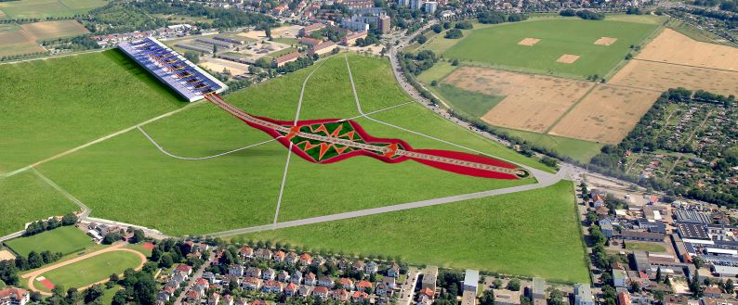
The Energy Composing
Appearance in the glimpse, there are 2 compositions. First at the barracks u-shape building, there are the parabolic troughs that sit on the ridges & reinforce roof structure of existing buildings. Secondly, there will be an algae pond with a berm at the center of the existing railway tracks.
However, there are 4 components in term of activities and energy resources to generate.

1. Historical building from steam engine revolutionary period to New era of Solar energy production: 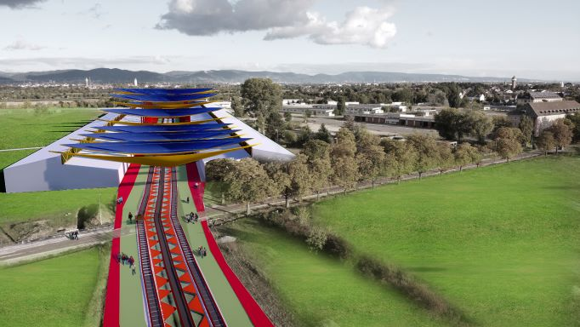
The sunlight creates solar thermal with the parabolic trough. The previous u shape layout former barracks building adapted to be part of the support to the parabolic trough that oriented in the North and the South. The trough faces the sun light from both the East and the West and turns the solar to be energy and collects inside the buildings. The designed distances and positions between the curvature rows to avoid the impact of shadows. These make it as big grains float above the roof.
Energy produce: 2,760 MWh annually

2. Inviting people to enjoy and playing in vehicle on historical railtrack and turn to be energy:
This kinetic energy by the movement of handcar in the existing railway tracks. The land art welcomes visitors to be part of the project by turning their travel & play on site to be energy by pushing the arm of the handcar while they ride, it will create kinetic energy as well. At daytime the kinetic energy stored in the batteries inside the berm for automatic run at nighttime. The nighttime run will keep circulating the algae in the tube to give an effect of the luminous flow. Although this looks like it creates a small amount of energy, it would show the interactive how humans are involved with the power energy and let the visitors enjoy more activities on site.
Energy produce : 0.02 MWh annually
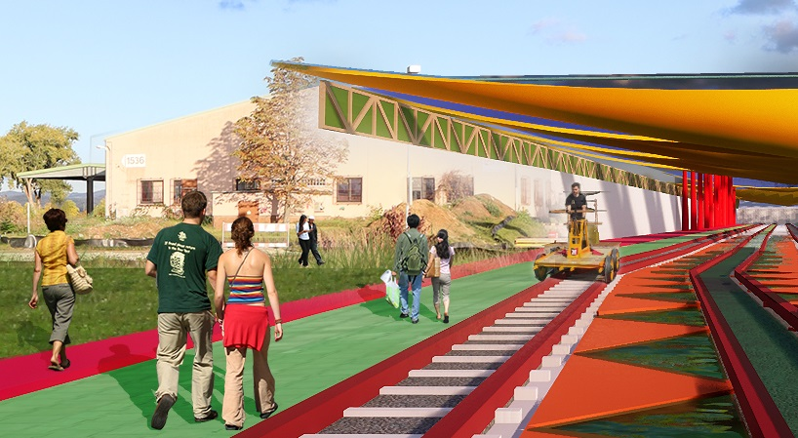
3. Leisure walk while generating energy: The pathway along the rail track finished by EPDM rubber flooring and PZT (lead zirconate titanate), the material plate of piezoelectric effect. The pathway along the tracks and ponds engage visitors to enjoy the promenade while the compressing of their weight to the surface will produce electricity.
Energy produce: 320.5 MWh annually
4 Bioluminescent light and biofuel production from algae pond : the algae which produce both biofuel and lighting. There are algae cultivated in transparent tubes along the edge of berm and track, which will react chemically with water, sunlight and carbon dioxide. Then it turns into a bioluminescent light. (This luminous refers to the very good research of Richard Beckett @UCL Bioluminescent light from algae tube to light wrap around the facade and the remarkable product design by Mike Thompson which initiates the lamp by the algae.) In addition, biofuel from algae might be a new resource to use as heat transfer fluid for the parabolic trough too.
Energy produce : 824.7 MWh annually

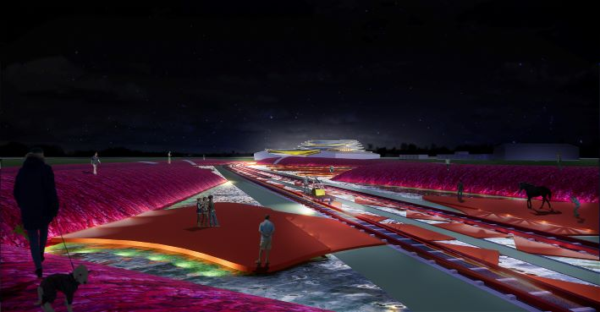

In the total amount of Energy composting, all the components are generates 3,905.22 MWh annually.

The Art Composing
It is understandable that some might say art is subjective, on the other hand science is tangible and calculable. However, one aim of the competition is to search for the beauty of renewable energy with creative implementation. Therefore, this project carefully considers the composition and rational allegory of the shape, form and color merging into the technologies.
The algae’s pond shape represents the freeform transfer to the bioenergy and let it luminous through the red berm and pathway.
The red color berm & pathway of EPDM rubber flooring allowed in the green field, resemble the energy merge into nature.
The golden grain shaped parabolic trough on the terminus reminds the audience how important agriculture and the transportations were in the steam engine industrial revolution., which was the beginning of the Modern movement until now, the importance of re-new energy in the present time.
The parabolic trough gets energy from the sun above while on the ground gets energy from algae then the kinetic energy to circulate the biofuel to the trough, these like parallel travelling energy loops.
In conclusion, these overall compositions in the project manifested to the audience that both energy and the old railway and terminal may be not obsolete but it can be resurrected in the new language and dimension to the people.

Environmental impact assessment:
Structural; The footprint of parabolic troughs are combined with the existing layout of the u-shape building by reinforcing the structure of the ridges, adding the structural trusses and only some few poles as necessaries at 12 of them which look like levitating undulate over the roof.
The algae pond and berm positioned as elevated ponds on the ground with the light weight structural berm to avoid the deep ground digging.
Vista of the project ; As mentioned earlier that the historical railway track and terminus are considered part of the project so this land art project is mostly covered in the horizontal with the elevated pond and berm cover to preserve the existing landscape ground and soil. Then the accent is vertical by the rows of grain shape of parabolic troughs, which lay on the space like a floating wave at the terminus act like a harmonious blending to the historic part.
The grain shape of parabolic trough, although it functions for collecting the solar thermal but the location which is higher above the roof. In addition, the space, like the courtyard of u-shape building under it, will act like ventilation tunnel. Therefore, it would not expand the heat to lower area or the visitor. Each location of the trough are overlapping and alternating to face the East and the West, not only to collect each side of sunlight but also to avoid the unforeseen eyesore from the glare.
The savings of co2 footprint: Furthermore, the advantage of the proposed land art generator has parallel to its importance for climate protection measure. As refer to the International Journal of Renewable Energy,Vol.6, No.2 Jan 2012 the parameters of 1kWh electric equals 1.00 g co2 and 1kwh thermal equal 300 g co2. The co2 savings are 33.8 tco2/a (or0.18t Co2/a)for thermal and 16.9t co2/a(or0.09t co2/a) for electrical, respectively. Therefore, this will reduce 3905 kg of Co2 or equivalents to at least 5 households co2 emit per years.
Inspired and Adaptable to the private garden, these could be the example (prototype) of how to adapt the urban energy from the macro to micro scale, (biofuel, kinetic, sun and motion stress) to the household use in schrebergarten.

