Description

The objective of the LAGI 2022 competition was the design of an agricultural park in the city of Mannheim in Germany, involving an area of ​​approximately 53 hectares near the Spinelli barracks. The destination of the area could have been residential through the design of a neighborhood and a green park would have been a good economic investment through the sale of apartments, large size capable of generating excellent profit margins so that it represents a convenient economic investment for the area to replace the residential district. Agriculture in Europe in Germany and in Italy has always been the subject of public funding promotional campaigns so that it can be preferred to other economic activities, but the fundamental limit of agriculture is profitability or from agricultural activities there are no great economic gains. and this is taught by the history of agriculture in Italy and around the world. In Italy it represented the only economic activity in the last century in the 1930s, especially in areas with a low number of inhabitants. My father, a railway worker himself, worked as a farmer as a second job and as a hobby. The work to be carried out in agriculture in the absence of agricultural machinery was very tiring to collect a few quintals of potatoes, they had to be sown in May, treated in the intermediate phase also by irrigation and hoed in September by collecting them and putting them in bags; at the end of this work she was taken to the greengrocer who paid her a few euros and the work carried out was useless. The enhancement of agriculture passes through the economic balance sheets of farms and we see that animal husbandry or the breeding of cows, pastoralism, sheep breeding, pig and chicken breeding represent good forms of investment. The mistake that most farmers made was the emphasis on the agricultural machine very often they went into debt to buy the tractor with the most power or the biggest combine instead of looking at the dairy production at the number of cattle almost that the social status of a farmer such as Ferrari today is revealed through the power or the number of horsepower of his tractor.
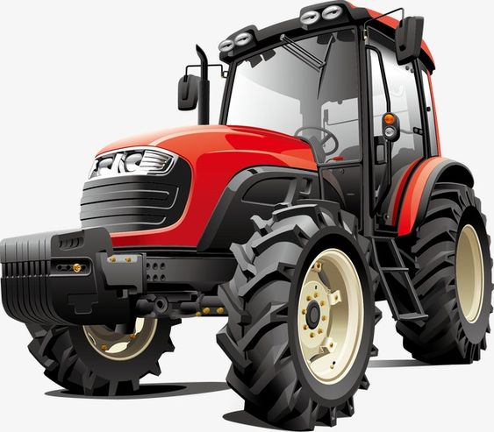

The size and social and economic status of a farmer is represented by the number of cattle and how many liters of milk his cows can produce. The emphasis on the agricultural machine was not a negativity for agriculture personally, but for the robotization and the elimination of all those forms of labor exploitation that take place in fields such as the harvesting of tomatoes and potatoes which represent unacceptable working conditions for any human being.
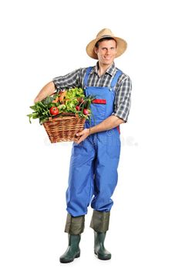
The project presented consists of an energy park with photovoltaic panels, stables for sheep, cattle and horses, photovoltaic greenhouses, homes for farmers, electrical substations, and a green bar-restaurant where agricultural products can be consumed; most of the 53 hectares have been destined pasture with green grass for the collection of forage in the form of hay bales and rolls, we did not resort to intensive agriculture but to greenhouses where it is possible to cultivate quality agricultural products even genetically modified typical products of the Mediterranean areas that with the climate of Germany they would not even sprout. Clearly we are talking about vegetables such as peppers, tomatoes, potatoes, beans, chickpeas, courgettes, melons, strawberries, fruit trees, mushrooms, truffles, snails, salads, vegetables, ect a high quality production. Today, energy self-sufficiency becomes fundamental for a community, every common city must be able on its own to meet the energy demands for heating and lighting its inhabitants. In this perspective, the energy park built with simple photovoltaic structures fits perfectly where in the city of Mannheim in the Land of Baden-Wurttemberg in Germany 1 Kwp of photovoltaic system power is able to produce about 1100 Kwh per year of electricity corresponding to three photovoltaic modules with dimensions 1.50x1.00 m; the intervention involves the installation of numerous photovoltaic panels engaging 30% of the surface which corresponds to about 16 ha of photovoltaic surface for a total power of the agricultural park of about 35500 KWp and an annual production of electricity equal to 39,000,000 KWh keeping considering the cost of energy 3cc / KWh in a year, about 1,200,000 euros are obtained from the photovoltaic system alone. Photovoltaic installations are very expensive, if twenty-year mortgages are stipulated with credit institutions, the gain deriving from energy production covers the mortgage payments for which it provides economic income after 10-20 years; It is therefore advisable to reduce the installment by stipulating mortgages for 50 years so that from the moment of installation they represent a source of income for the farm. The advantage, above all in current times of war, is that of energy self-sufficiency, that is to say, towns, cities, neighborhoods, heated and illuminated with locally produced energy that must not be imported.
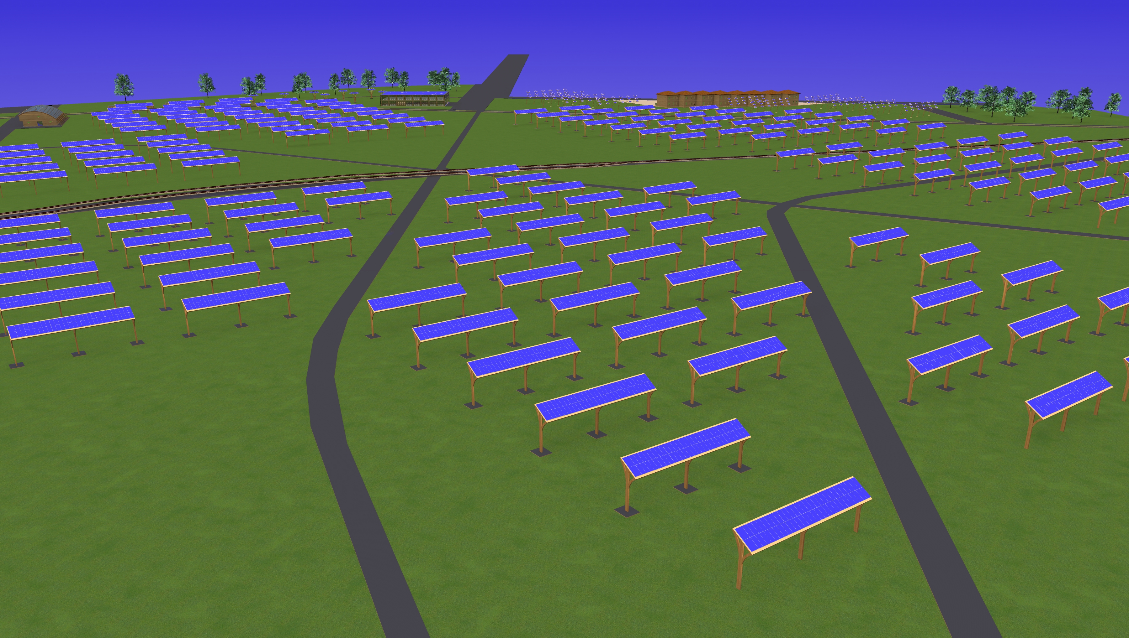
Next to the agricultural park there is the cattle farm which consists of about 80 heads, 60 cows and 20 calves, and a sheep farm of about 200 heads, 100 sheep and 100 goats.
The animals are in the wild grazing in the park where the shading of the photovoltaic installations does not affect the growth of grass and the collection of forage such as hay and corn for the winter periods.
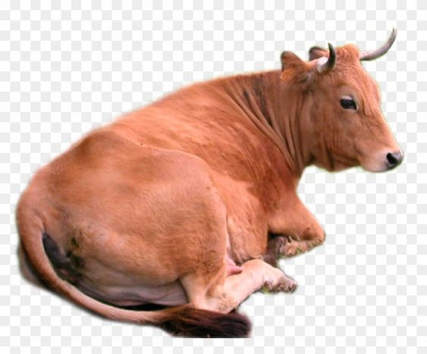
Dairy cows are able to produce around 30 liters of milk in one day, while goats and sheep around 2 liters of milk per day, but higher values ​​can also be reached. The total annual milk production for cows is about 657,000 liters, while for sheep 146,000 liters of milk; alongside the milk products there is the meat deriving from the slaughter of calves (40 / year), lambs-kids (300 / year) and head of cattle over the years: it can be said that the annual revenue of this livestock farm is about € 500,000 deriving from the sale of milk alone, while around € 50,000 for meat.
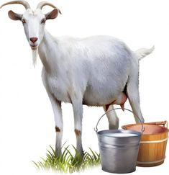

The photovoltaic greenhouses are used for the production of quality vegetables and fruit with traditional organic and genetically modified methods in order to enhance the product of the earth, a necessary condition since the market prices of vegetables are negligible and would nullify the entire economic activity. The manure of the animals and therefore the manure is used as fertilizer for the agricultural products of the greenhouses. Houses have been provided for agricultural workers to be employed on the farm, they are two-storey wooden terraced houses that integrate perfectly in the natural environment intended for 16 families; each modular plan has an area of ​​about 96 square meters are clearly leased or purchased by farmers through a mortgage and deducted from their salary.
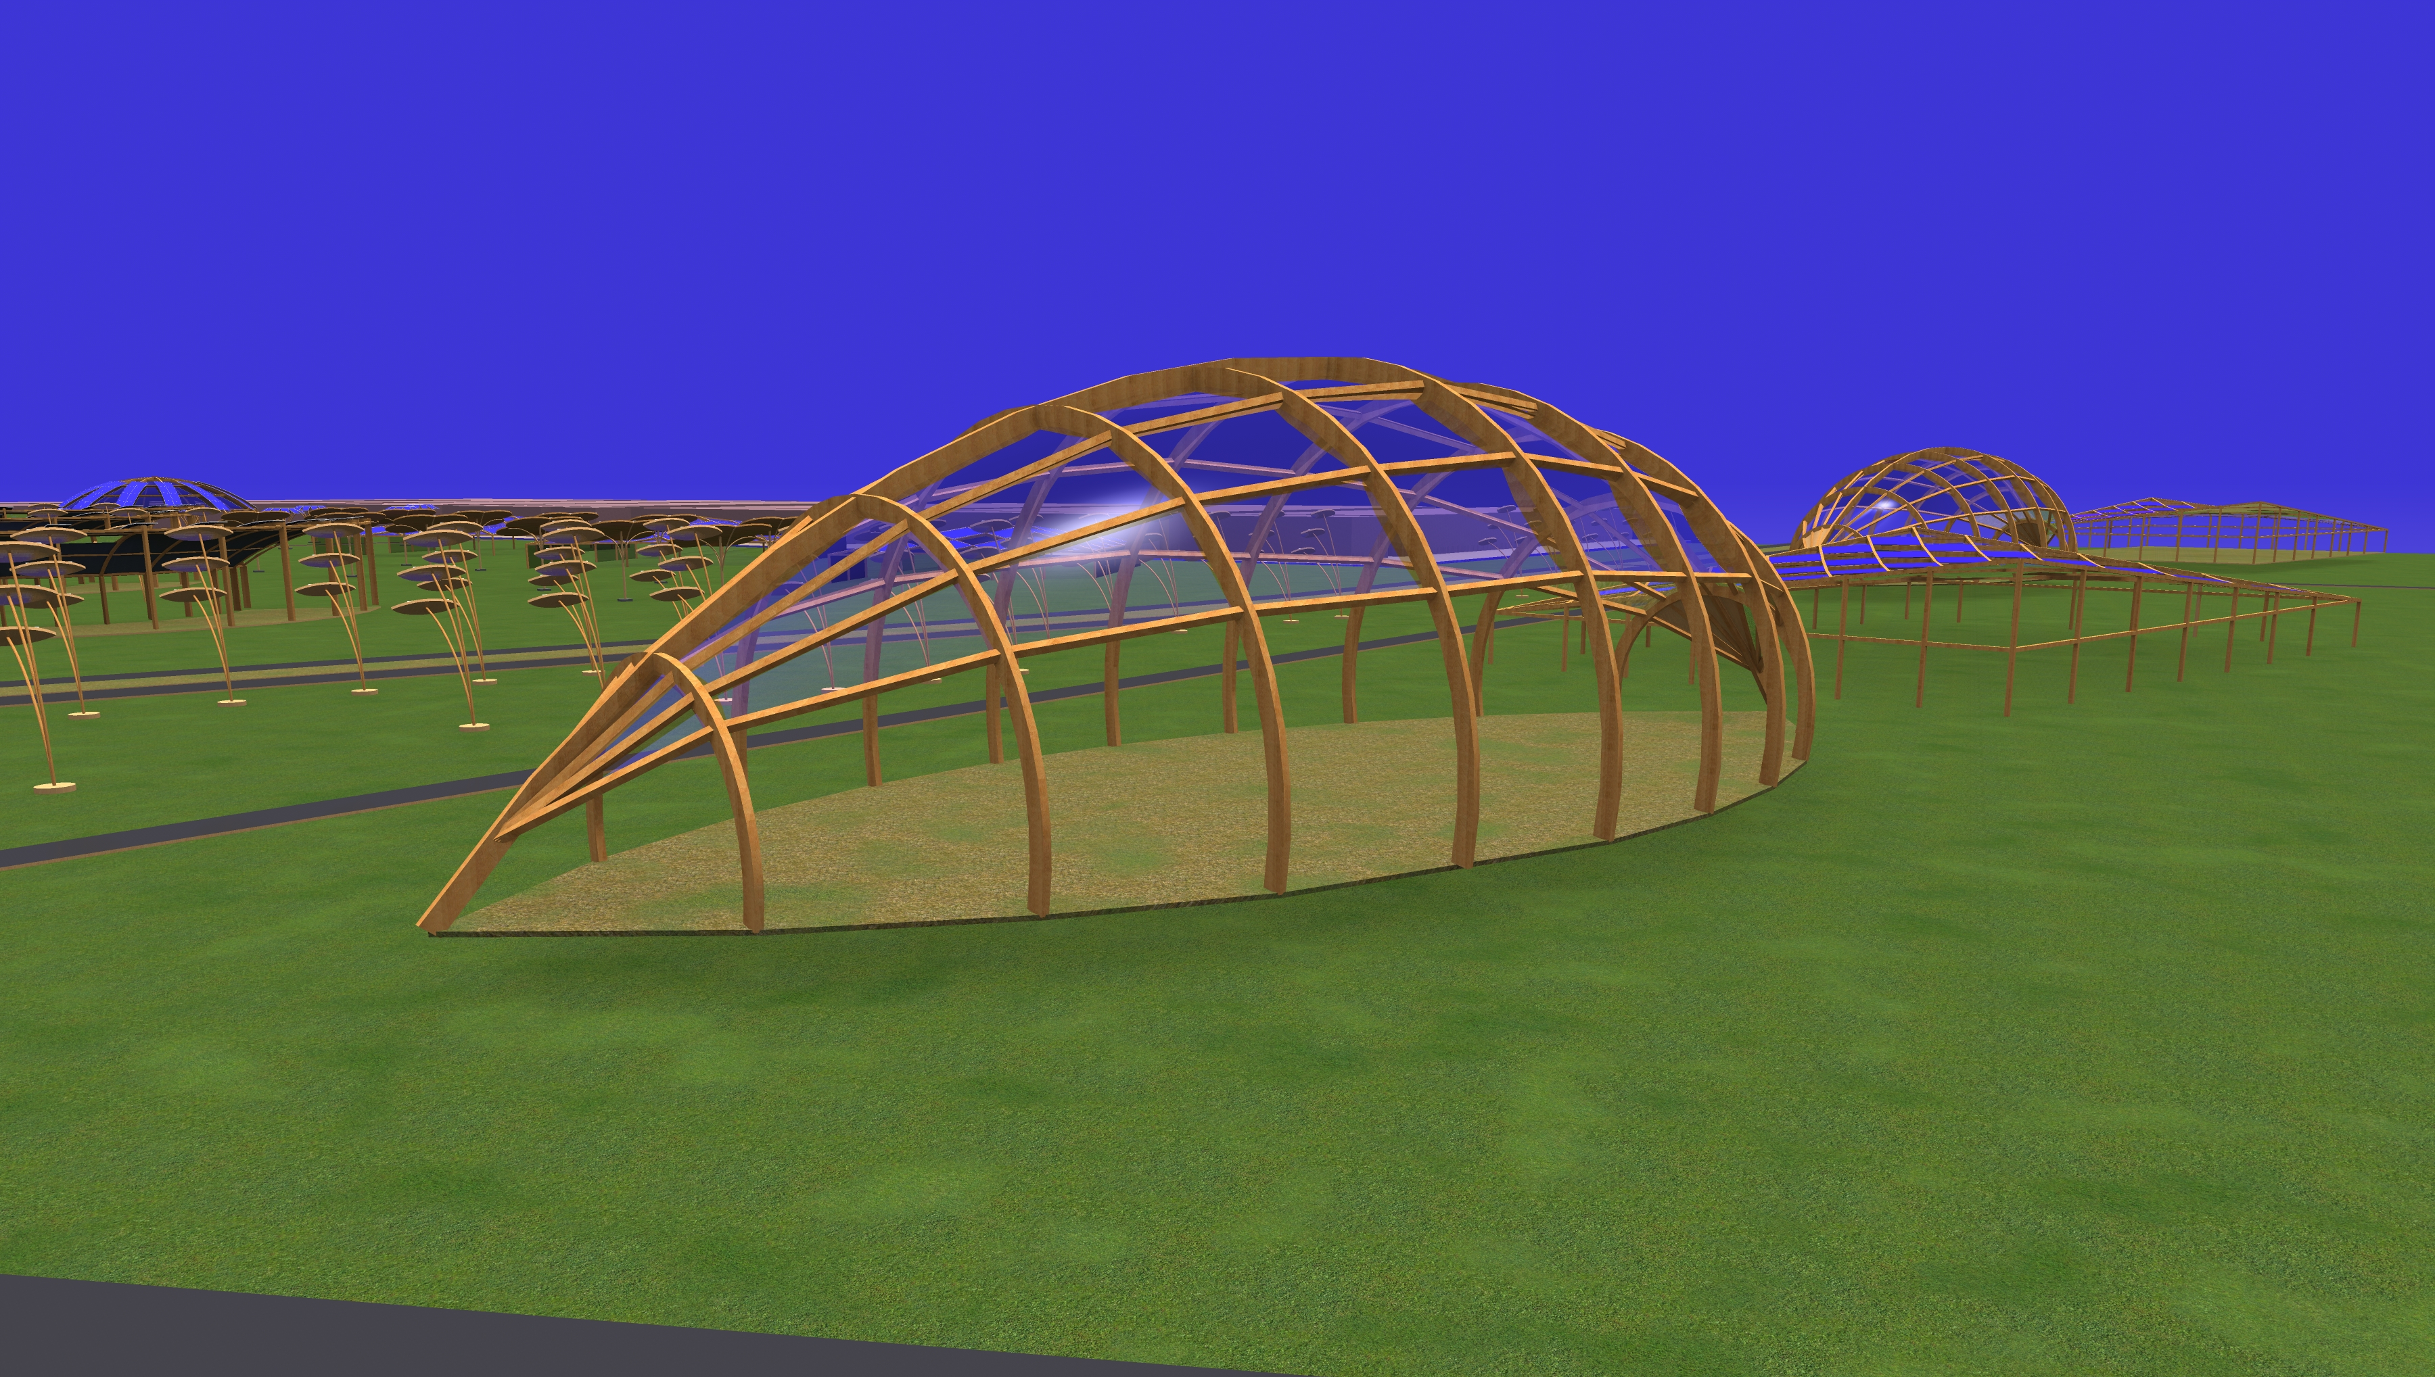
A green building has been planned whose ground floor is used as a bar and restaurant where you can taste agricultural products in a modern farmhouse while ornamental plants are grown on the upper floor. From what has been said, the agrivoltaic intervention is economically convenient with revenues ranging around 2 million euros, it is clear that there are costs related to the construction of the entire structure and its management that can be amortized over a period of more or less 50 years; it must be borne in mind that it is a company that produces revenues every year, so we can believe that it is economically convenient on a par with the construction of a neighborhood. In this description I focused mainly on the economic aspect, but an agrivoltaic park is a green area where you can ride a bicycle, joccing, go horseback riding, a place of integration and socialization as well as a place to breathe and transmit pure air to the city. without problems of environmental impact due to buildings. The animals, the cows, the sheep, the goats make the environment a particularly pleasant destination for visitors and tourists, not only inhabitants of the city of Mannheim, but also tourists from other areas of Germany. The photovoltaic forms are the typical ones such as trees and flowers, as
well as the photovoltaic greenhouses with the most imaginative geometry; the materials used are glass or plexiglass, aluminum painted with wood paint was used for the structures: the consumption of wood and therefore the cutting of trees would have been prohibitive. The agrivoltaico represents a new way of doing agriculture by combining agricultural and livestock production with energy production, a way to relaunch agriculture by also engaging young people in the form of cooperatives since you can make money unlike what happened in the last century where the farmer belonged to the lower social class for economic reasons: today the farmer is an entrepreneur like industrial and construction artisanal enterprises, he is placed in a middle-upper social class far from ancient social legacies that saw the farmer as a sharecropper who hoes the land with mental distress and poor cultural preparation.-

ENVIRONMENTAL IMPACT

An agricultural park integrates perfectly into the natural environment, especially if integrated with farms and therefore the presence of livestock. Furthermore, the photovoltaic technology that produces clean energy directly from the sun without noise pollution has a low environmental impact. The structures that support the photovoltaic panels are made of recyclable aluminum material painted with wood paint so that they integrate into the green landscape and no trees are cut down for their construction since one of the greatest environmental damage after fires is represented by deforestation if the trees are not replanted. The designed park is close to the city of Mannheim so it is revealed as a green play area for the social integration of Pet-Therapy sports activities and can only have a positive impact on the overall municipal area. The environmental damage that characterizes photovoltaic power plants is not the architecture of the panels, their arrangement but the excessive consumption of land or using 53 hectares of land to build an agrivoltaic park similar to speculative building with 2 or 3-storey buildings where the the same volume could be achieved through a vertical development involving reduced portions of the territory. Obviously, engaging large areas for the construction of agricultural parks is not harmful to the environment since the soil is not consumed but used for agricultural activity for cultivation of pastures in general green area is as if the urban destination of the area is not energy but agricultural saving environment, the soil becomes productive, a sports playground for horseback riding by bicycle, for socialization and integration: a place to spend free time and relax

-UN SUSTAINABLE DEVELOPMENT GOALS
The project idea effectively supports many of the United Nations Sustainable Development Goals, not only with regard to access to reliable and affordable energy systems, but also fosters lasting and sustainable economic growth in a broader perspective according to which all human beings must have the right to the food and energy necessary for the health of humanity. It is evident that the quality of life in the city of Mannheim is such that no citizen needs food and energy or that the resources of the city are such as to guarantee a high standard of living for everyone, but the agrivoltaic park increases inclusiveness and safety and the sustainability of the city also helps to limit climate change. The main objective that satisfies the project is that of promoting health and well-being for all by acting as a green park, an area for socialization and sporting activities, but above all the mental health of the farmer who becomes an agricultural manager, whose personality for reasons of duties working has always revealed forms of hardship, ranging from poverty to poor culture.

