Lagi

Lagi city
  - LAGI MANNHEIM FLOWER GARDEN CIVIC & PUBLIC PARK
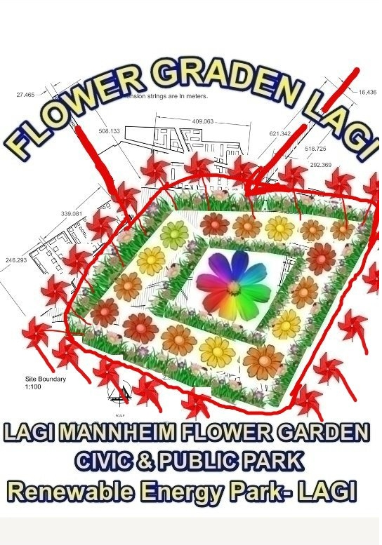
1.2- AERIAL VIEW OF THE LAGI MANNHEIM FLOWER GARDEN CIVIC & PUBLIC PARK PROJECT PLANNING IN SOLAR ENERGY CELL PANELS RENEWABLE PLANT AND WINDWILL RENEWABLE ENERGY PLANT PRODUCING 30 MW to 3000 MW OF POWER TO THE CITY

  - INTRODUCTION -The Renewable Energy park developed in Solar Plant and Wind Will plant project in Lagi city at Mannhein and in rest of the world is a source of clean energy and environment safe project for the future when large quantity of energy required can be supplied from these similar project on land and water . This kind of project in renewable energy can overcome the power shortage crisis in a city in future by developing a energy plant in a the heart of the city like building roof tops , in & over water, public park where the trees , plants , building roof can be developed and made on photo voltaic cells and public park can be a place for visitors , guests and for many use like sports ,community program , family program , people programs .The photo voltaic energy is formed as a sun rays passing via the photo voltaic cells breaks the electrons and a electric current is formed as the electron passes by the electric circuits .
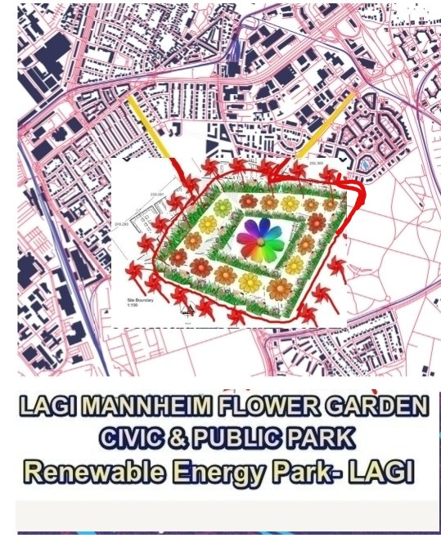
1.4- BRIEFING THE LAGI PARK DESIGN GIVEN ABOVE - The Lagi Park renewable energy plant is made of solar cells panels in flower designs shapes where the flowers are the roof building , structure and flowers roof shapes are made of solar cells pants . In the picture designed consisting of a flower in the center surrounded by many flowers and the drawing design is divided to inner circle of park and outer circle of park and many such solar cells are jointed to make flower petals in different colors for the center flower in inner circle and also for many flowers in outer circles making many building and solar roof and this petal solar frames is supplying power of 22 MW and remaining power of 8 MW from wind mill placed and rest from the roof solar of old building surrounding the park can produce a electricity fro 30 Mw to 300 Mw capacity depending on the fusion and fission take place in the solar cells panel and wind mill debicex
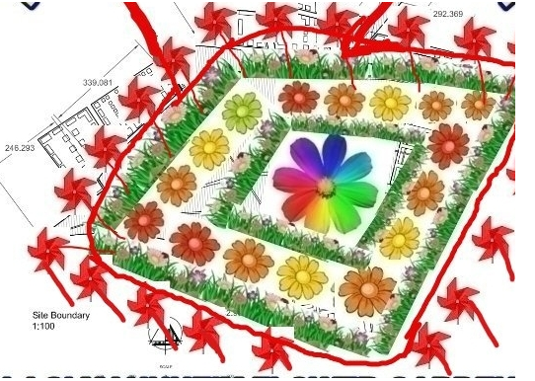
1.4a- INNER CIRCLE OF THE PARK The Aerial view of the park picture submitted shows that the park is with big shape flower in the inner circle center and lower area of solar flowers can be used as a public patk . The elevated Solar panels in shape of flower can produce energy from both side of glass as light is incident from both side produce more energy than building roof top solar panel with one side open to sunlight . The inner circle with a wider flower made of solar cells is Surrounded with green shrubs with flowers made of second layers of solar as the inner circle is with two layers as petals of flowers as one layers and shrubs the other layer as inner circle consist of center flower and green shrubs with flowers
1.4b- THE OUTER CIRCLE OF THE PARK The outer circle consist of many small flowers of 16 no or more made of solar cells where the lower area of the solar flowers space can be for public park . The outer flowers is Surrounded by green shrubs with flowers and trees
1.4c- The ROAD NETWORK TO THE PARK - The Red line is the roads to the park and the red circles the public park area and elevated roads are made above this red road so that people can view the flower photovoltaic cells in the park by the elevated road above the red road
1.4d- WIND WILL - The Wind Will machines are places behind the green shrubs in the outer and inner circles. The wind will can be placed in water bodies in inner and outer circles .
1.4f- THE SURROUNDING OLD BUILDING AROUND THE PARK PROJECTS –
The Surrounding old building can modernized with solar roofing so that the power can be multiplied from this park projects from the houses solar roof energy produced as there are large number of houses around the park and on either side of road to the park and also near to the park land area
1.4g- CONSTRUCTION OF BOUNDARY WALL WITH FENCED SOLAR WALL PANEL
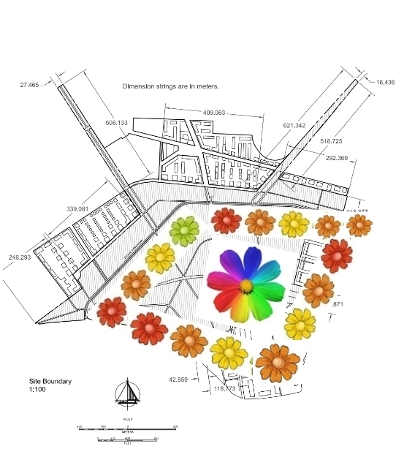
Solar boundary wall -Boundary wall for the 53 hectares civic and public park can be constructed with solar power wall

1.4h- OUTER DRAINAGE CANAL AROUND THE PARK -The outer canal is constructed so that the flood water flowing by the waterways should not flow into the park when the river or canal overflows
1.4i- PARKING SPACE BENEATH THE SOLAR PANEL - Large packing space ground can be made below the elevated Solar panel flower shapes that will reducing the traffic problems
1.4k-BIG SHOPPING MALL CONSTRUCTION- Big shopping malls need to ve constructed near the parks so that people can use the renewal park space and park facilities while shopping in mall and also park the vehicles in the parking ground beneath the elevated solar panels in the renewal park adjacent to mall , hospital , theater in the shopping complex near the park
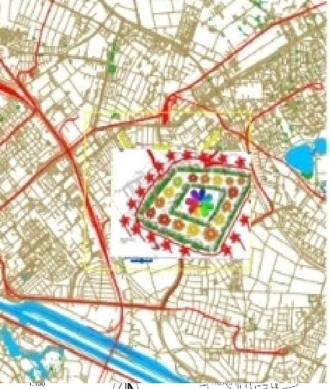

1.5 THE PICTURE PRESENTATION IN BRIEF
The Picture of flower designed is using online image editor software like Imageeditor and photoeditor
The Images of solar glass flowers plates , solar glass boundary wall & wind mill are over layed and merged over the images of Lagi city maps and the sketch of the lagi city renewable park landscape giving the aerial view after merging the flowers and wind will as given in the three images attached
I used tool like lines in the online photoeditor and makes roads in red in this way
The Technology used is Elevated flower shaped Solar Panels that generate electricity when light rays passing the solar front and back side free electrons resulting a hole in the solar glass and the electron moving via the electric circuit and wire emits electricity and after passing via the wire this election will join with vacant hole , this kind of thousand electrons is released and thousand of holes are formed as light rays passing the solar panel at a same time placed in flowers design one after the other in 53 hectares of land. this electricity produced can use to power generator or invertor to convert DC to A.C current and transmitted and distributed in power limes to the lagi city reducing transmission losses not like power supply from dams that is km away not in city area from the renewable energy park
The total energy produced from solar panel flowers from 53 Hectares space and the roof solar panels of houses can be distributed to the city with no transmission losses can be a new technology implemented that will beautify the park and on other side give electricity to the lagi city
Along with the solar panel , the Large number of Wind mill placed in 1000 no in 53 hectares can produce electricity by static energy by rotor and stator and the rotating blade will rotate the rotar placed inside the stator and there by cut the electro magnetic field produce electricity . This electricity when work a generator or invertor will convert the electricity developed from D.C to A.C and distributed to lagi city by power lines
Along with elevated solar panels , building roof solar panels , the boundary wall can be made with solar panel also giving power will make this park eco friendly
The quantity of water required to clean the solar panel can be saved by using or recycling this water to flow to flower garden , fountain , vegetable gardens etc . vegetable garden beneath the solar panels give food to the city is giving more benefit the lagi city
The list of the primary materials used in the design are the images of solar panels in form of flowers and wind mill like the space galaxy and in between flowers it is possible to make several other statues like birds , flies a , insect
The cost of the project for 53 hectares of land renewal park producing 30 Mw to 300Mw can vary from 500 crores of rupees to 20,000 crore .
The short summary for prototype renewable patk development is on fund provided and the material availability as i can pass this to project work to leading solar plant construction company in Kerala and India.
1.6 THE BENEFITS OF RENEWAL SOLAR PARK
1. This park give electricity from 30 MW to 300 MW to lagi city
2. This park can give open space for people by the Civic and public park
3. This park give parking space beneath the elevate solar panels to lot of car other than people coming to park like for cars to near by town ship , mega mall and conference centers
4. As this solar panel is elevated over the park., more power of electricity can be produced by two sides of the solar glass as sun light reach both sides not like roof solar panels
5. This park give food to the lagi city from the vegetable garden beneath the solar glasses
1.7 ENVIROMENTAL IMPACTS SUMMARY IN 500 WORDS
The construction of renewal park in 53 hectares of land will be affected by floods water , heavy rains as it is open surface and heavy wind . In order to protect the solar renewal park from flood , proper drainage had to be connect that connect with outer boundary canals and there after to river . if proper drainages are not build , the water rises very fast and recede very slow when flood water can isolate the park if the water cannot recede faster if the drainages , canals are blocked by debris and other waste as the lagi city waste can also block the water ways connected to the park . A proper drainage is to be constructed as this park is located in the city area and not in a remote places not surrounded by building .
The second impacts is waste water following to park from debris collected near by the park from building and shops inside the park and the the waste water should be diverted from entering the park area
The third is birds and Animals passing via should not pollute the park . The Animal waste can harm the park , so all animals roaming in the 53 Hectares land had to be relocated
The Polluted air and Smoke from Factories should not circulate this place beauty , the renewable park should be not in a place very near to quarry or factories
Vehicle parking centers had to be provided . A large packing center beneath the Solar panels can reduce traffic jams and blocks in city

1.8 CONCLUSION - The Details are given as per the size of the land area in 53 hectares that can generate clean energy up to 30 MW capacity to 300 Mw . Thw Urban planning and Architecture design for sustainable development can bring many such projects that is environmental friendly .
I conclude by submitting that Parks are normally with flowers and building flower solar panels in the park will be a major attraction as this park can be named flower garden and the lower area of flower panels can ve used as public park with gardens , vegetable parks , sports etc and so many flowers surrounding a center flowers is like planets around the center sun and such project of flower solar park is having many advantages like beautiful flowers in the beautiful nature of Lagi Mannheim city of Germany .
I had made a inner circle with a big flowers like sun and outer circle with many small flowers as planets and in between spaces is with green shrubs and water bodies and the outer road and elevated roads make people to enjoy the beautiful solar flowers cells from sky aerial photo or from the elevated roads
The Aerial view beauty of the park is made attractive by designing a park with flower cells and many wind will . the wind will can light the park with aerial lights fixed in the wind will structure.
This is my projects for Lagi renewable energy park and as i am not using AutoCAD for urban planning , forwarding the image file with brief explanation of project in words for this competition 2022 in lagi Mannheim.
In Kerala state , the festival of flowers is Onam and people celebrate Onam as a traditional festival with Flowers design and colored flowers called Atham in every house welcoming Mahabali king who ruled kerala years before . Thos kind of flower design Solar glass and wind mill plants will welcome many tourist to the places as they can see these flowers from the height of a plane or helicopter flying above as this flowers are bigger and visible from very fat distances , a open space park for local community in the heart of the town and at the same produce renewable energy of 30 MW to the city is a solution to the future fire shortage problems
thank you
Georgie s cherian
Karimpanoor house ,Pannivizha East, Adoor kerala state India, Pathanamthitta district 691623 Mobile – 7560805137
email - gscadoor@gmail.com
1.9 Appendix-
  - Lagi mannheim flower garden civic & public park
1.2- Aerial view of the lagi mannheim flower garden civic & public park project planning in solar energy cell panels renewable plant and windwill renewable energy plant producing 30 mw to 3000 mw of power to the city
1.3- Introduction
1.4- Briefing the lagi park design given above
1.4a- Inner circle of the park
1.4b- The outer circle of the park
1.4c- The road network to the park
1.4d- Wind will
1.4f- The Surrounding Old building around the park projects
1.4g- Construction of boundary wall with fenced solar wall panel
1.4h- Outer drainage canal around the park
1.4i- Parking space beneath the solar panel
1.4k-Big shopping mall construction
1.5 The Picture presentation in Brief
1.6 The benefits of renewal solar park
1.7 Enviromental impacts Summary in 500 words
1.8 Conclusion
1.9 Appendix
1.10 Reference-
1.10 Reference-
kerala flood
https://www.google.com/amp/s/www.bbc.com/news/world-asia-india-58940880.amp

