puppy gallery
Raise the sloping solar panel by 2 meters, and the back of the solar panel becomes the perfect display panel for displaying children's paintings. The Organizing Committee can organize a global children's painting competition with the theme of "Achieving the UN Sustainable Development Goals", and print the winning works on the back of the solar panels.
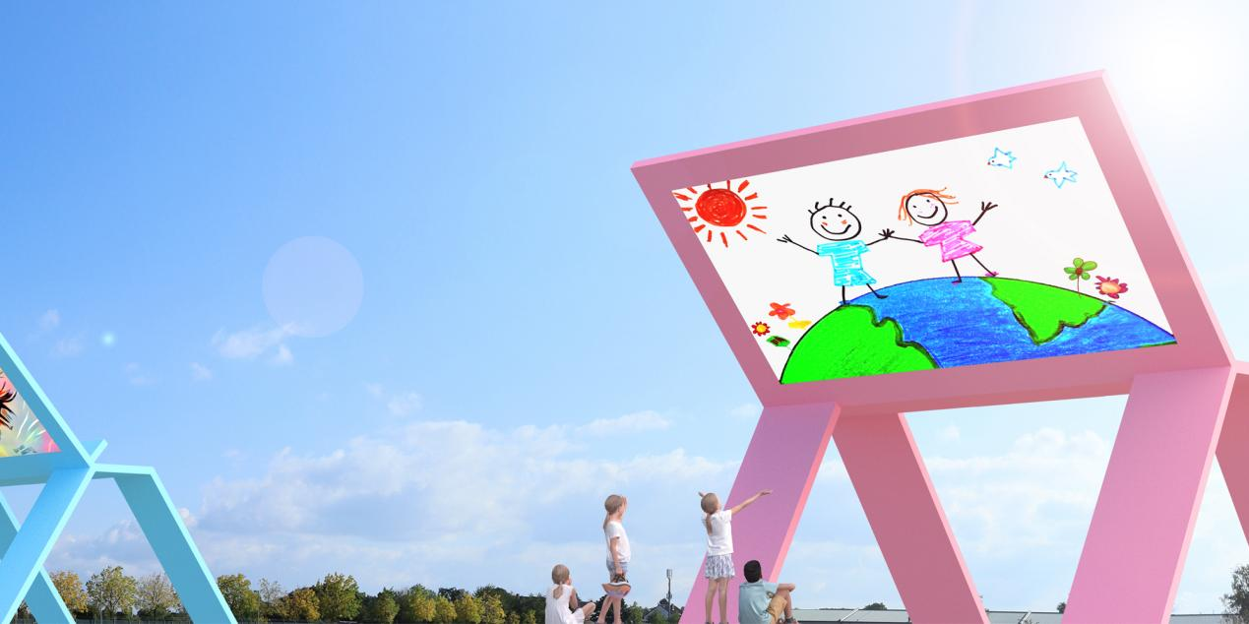
20 puppy-shaped solar panels form a colourful gallery along the bike path. When visitors appreciate the paintings, they can also feel the urgency of realizing the UN Sustainable Development Goals and caring for our shared earth.
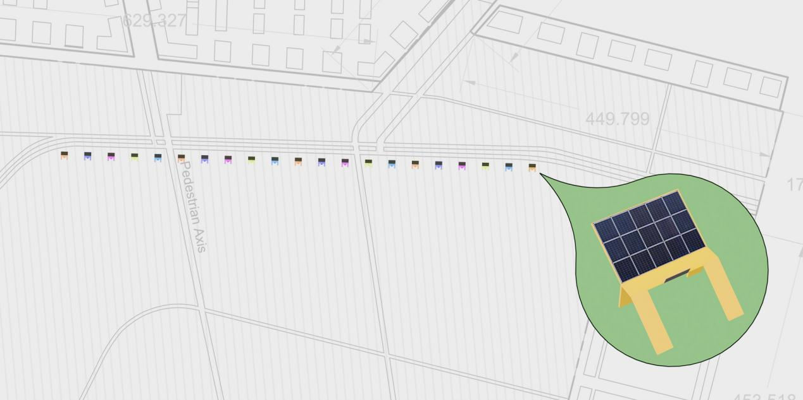
Each puppy easel can be installed with 10.25 square meters of monocrystalline silicon solar panels, and 20 solar panels with a total of 205 square meters can produce 30.75 MWh of electricity per year.

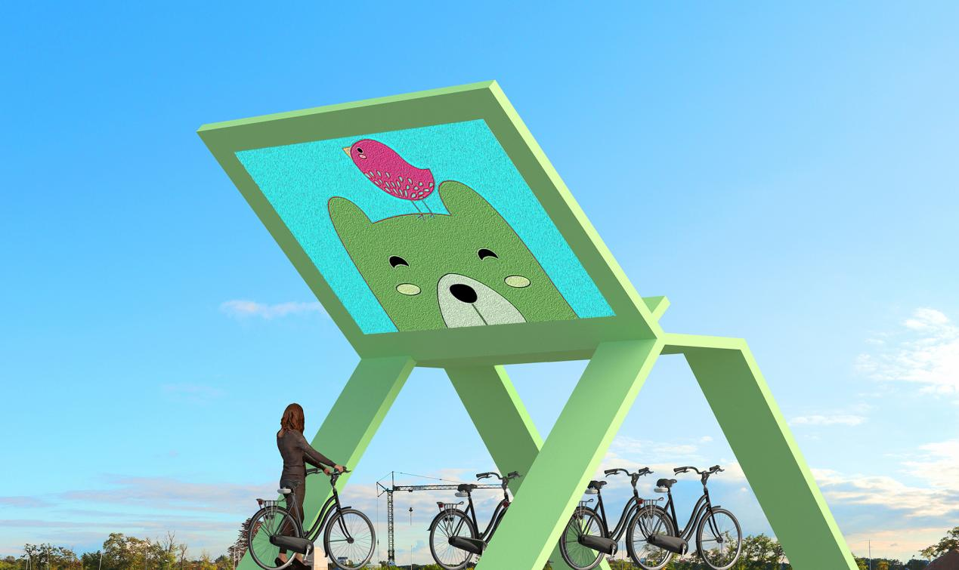
The puppy gallery can be used as a parking place for bicycles and a place for tourists to rest, as well as a temporary market for selling agricultural products.

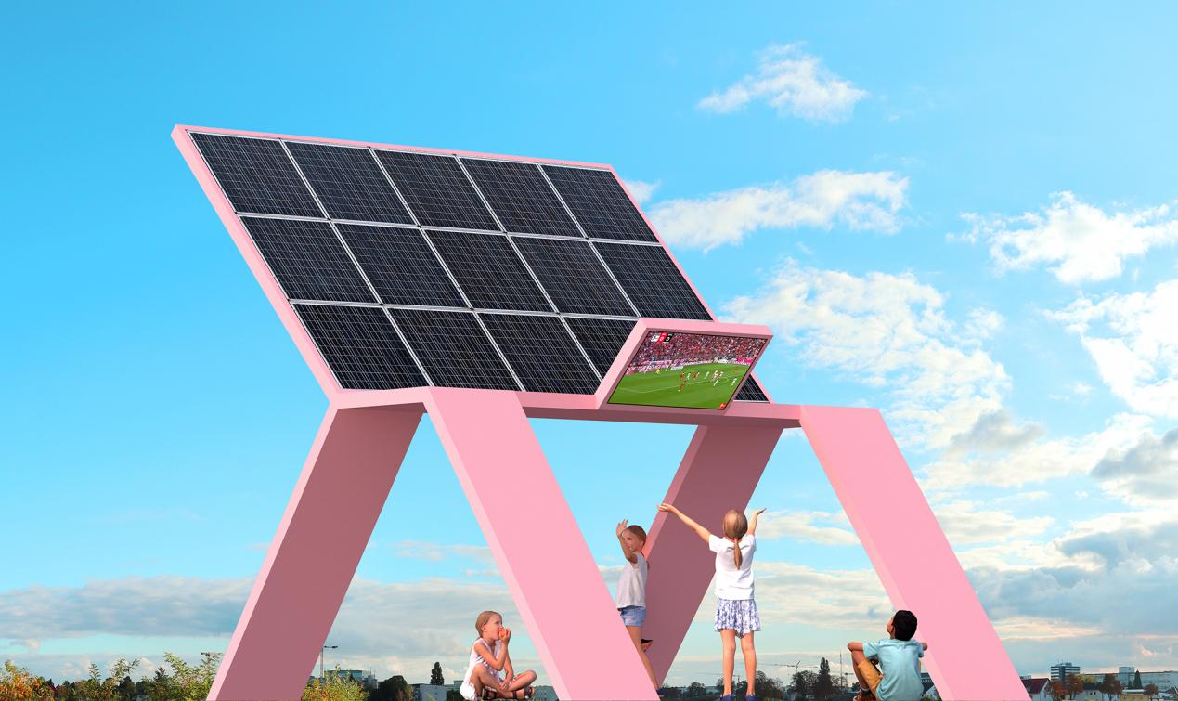

The modular frame made of recycled aluminium is easy to install and remove, and can be resized to suit your needs. The overhead structure at the bottom of the puppy panels and the 16-meter spacing between each panel ensures that the puppy gallery does not obstruct the air circulation of the surrounding environment.

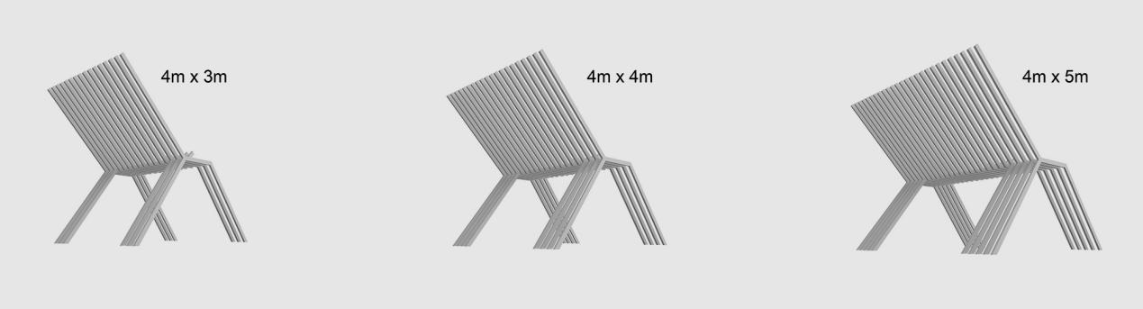

Businesses can buy puppy and place them in their neighborhoods and streets, and by providing the community with free green energy, businesses gain access to these billboards.

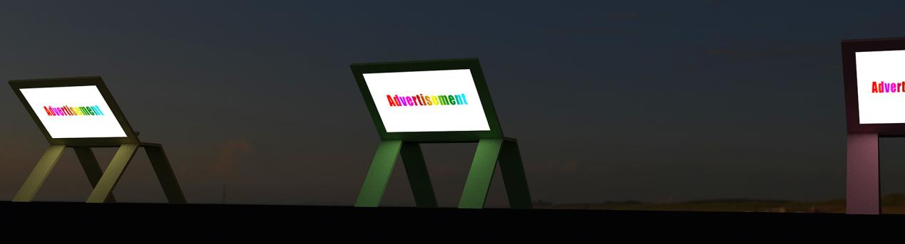

The mass production cost of each puppy is around $3500, and I was able to make a 1:4 scaled prototype for $1200.

