THE BARRACKS
Spinelli Ecological Intersection
BUGA23 X Future Recreational Park
PROLOGUE
The military has shaped Mannheim particulary and in many different ways. For war purposes, a large number of barracks were built during World War II. The design area is the former Spinelli Barracks built by Wehrmacht in 1938 and served as pioneer barracks. After World War II, the US Army took over all military sectors and gradually developed them to suit their needs. The barracks were then named after American presidents and deceased troops, including Spinelli Barracks.
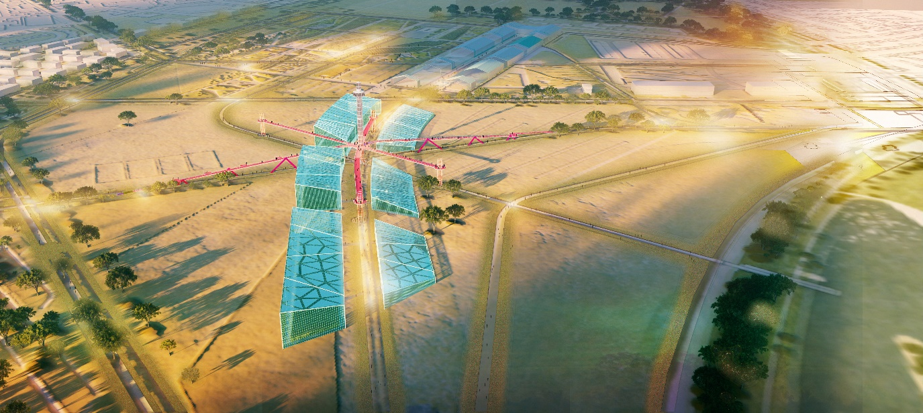
THE BARRACKS seek to recall the old design that was strongly associated with the memories of the local community and respond to one of the key objects remaining from the historical overview.
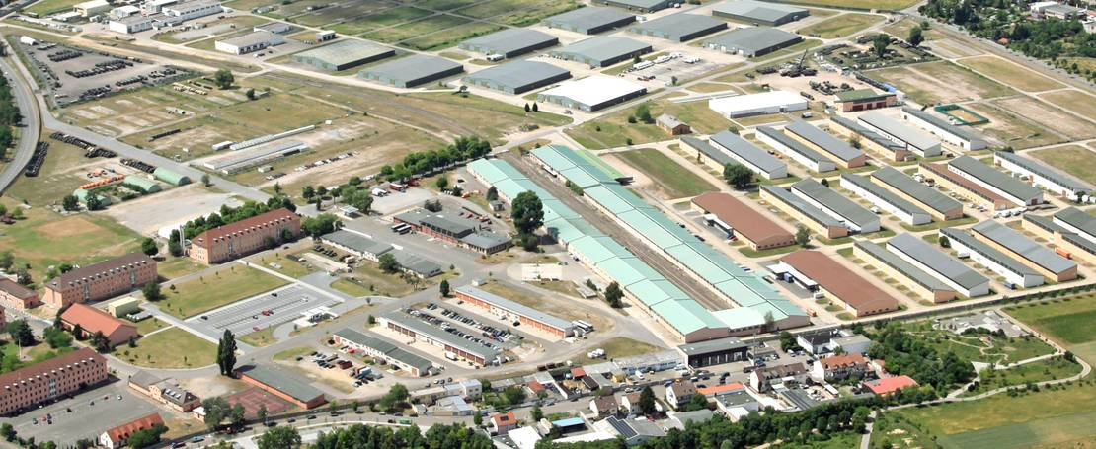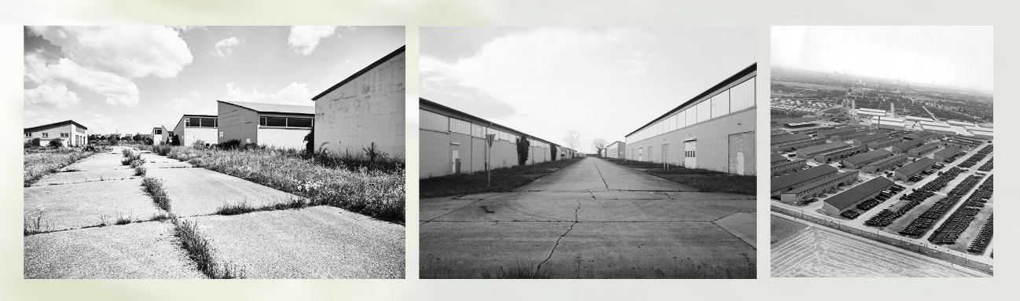
The series of mass compositions are inspired by the barracks’ regular designs adjusted in a line with the U-hall and expanding the building’s existing courtyard as one of the axis paths in the latest layout of Spinelli Park for BUGA23. This object is designed for agrivoltaic systems.
The barracks’ mass compositions also integrate a skywalk and hybrid panoramic lift to strengthen the intersection point of the new layout of the park landscape. These integrated objects are designed to provide individuals of all ages and groups with the best possible experience in every condition while taking in the beauty of Spinelli Park.
This historical composition in a series of well-designed public artworks offers sustainability in the form of energy, ecological infrastructure, and agriculture, as well as encourages major innovation without disrupting the ecological composition and the flow of fresh air in the area's green corridor (Klimopass). In some places of the climate park, the object indeed improves the ecological environment by multiplying the percentage of green elements vertically and by being arranged following the corridor system.
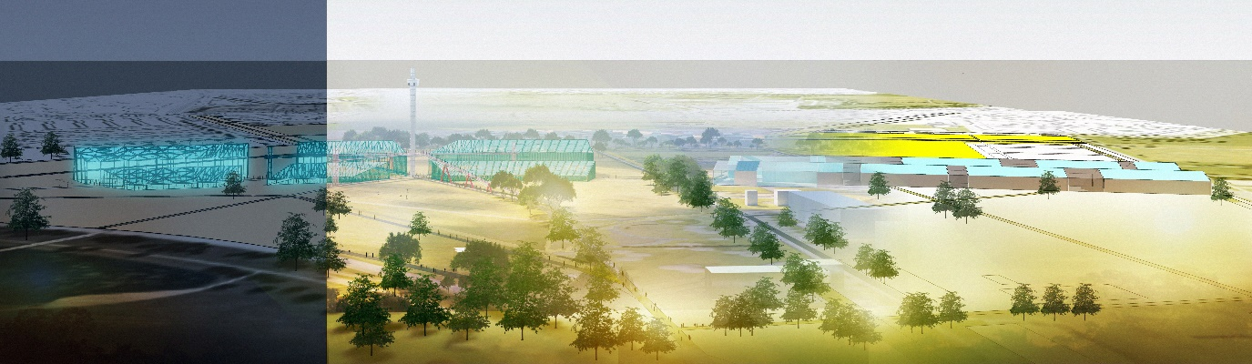
In addition, THE BARRACKS design is also deep-rooted and closely integrated with the environment and landscape plans, responds to the urban context at macro and micro levels, as well as supports several points of the UN Sustainable Development Goals.
The energy generated by THE BARRACKS will then be used to power Spinelli Park, public facilities, nearby buildings and housing, while the agricultural crops will supply the local community with food.
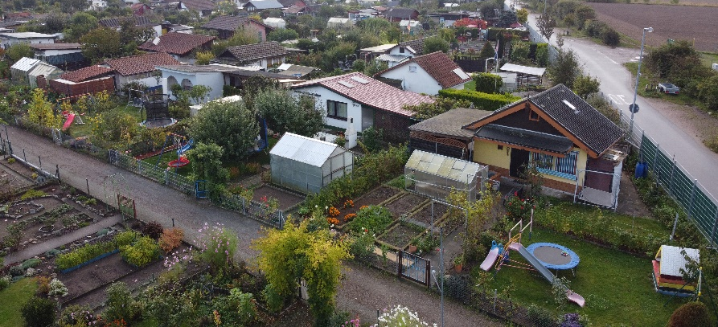
(Schrebergarten as design consideration)
It is engaging to see each plot of Schrebergarten in more detail, park elements with simple iron structures combined with greenery and prolific plants that are visible around the cottage or garden shed. The installation of solar energy panels on some of the houses’ roofs also gives more value to the arrangement. This combination is taken into consideration in the design of stunning and productive public artwork and is intended to be more alluring, iconic, and attractive.

DESIGNS
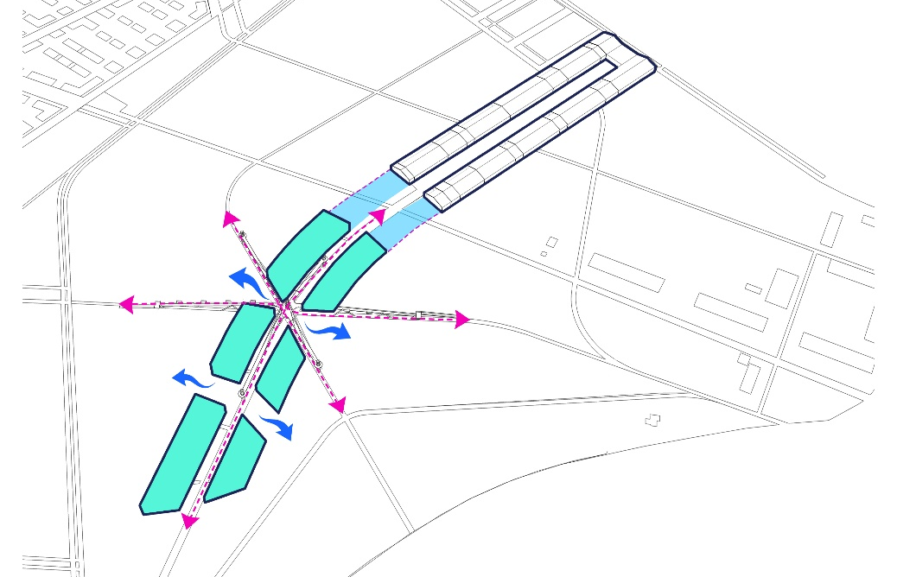
Object A (mass concept and its components)
- Mass extension of U-Hall (history)
- Buffer space between masses (airflow)
- Inter-building intersection adjusting to park circulation plan (suitability)
- Designed for agrivoltaics
- Supported with microbial energy
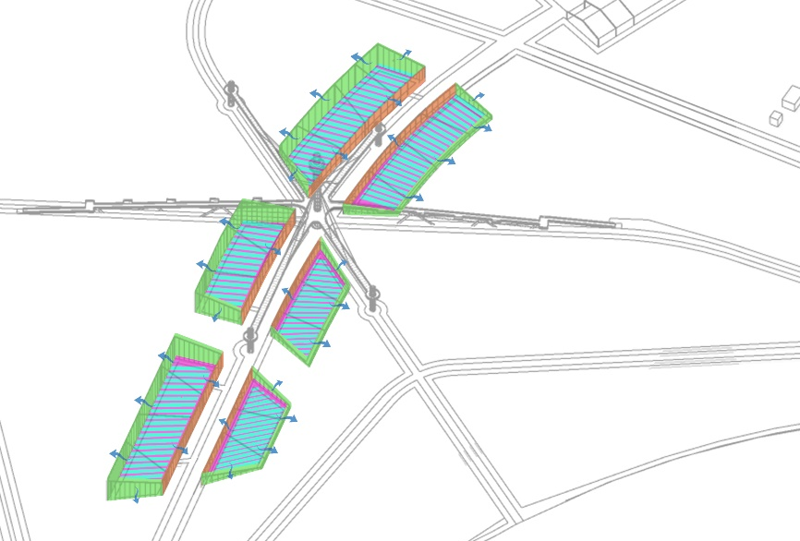
Object A (agriculture and vertical farming)
- 15,244 m² area of landed farming
- 16,425 m² vertical farming media
- 8,187 m² microbial energy turf
- 9,796 m² microbial energy wall
- Vertical farming and microbial energy wall are arranged and latticed for maximum airflow
- Four green components reinforcing the fresh air in the climate park area

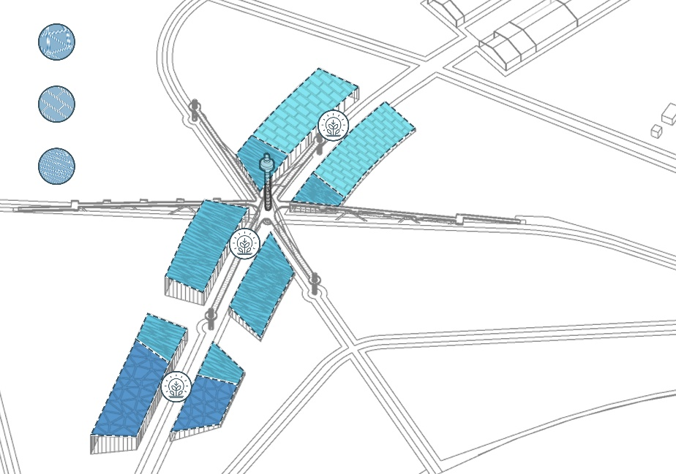

Object A (transparent solar panel and night photosynthesis)
- 13,994 transparent solar panels
- Three different modules on a transparent solar panel to enrich the Spinelli park layout pattern
- Night photosynthesis to accelerate harvest season with maximum yield per year
- More frequent harvest times
- Optimizing the quality and quantity of plant food production by up to 25%-40%.

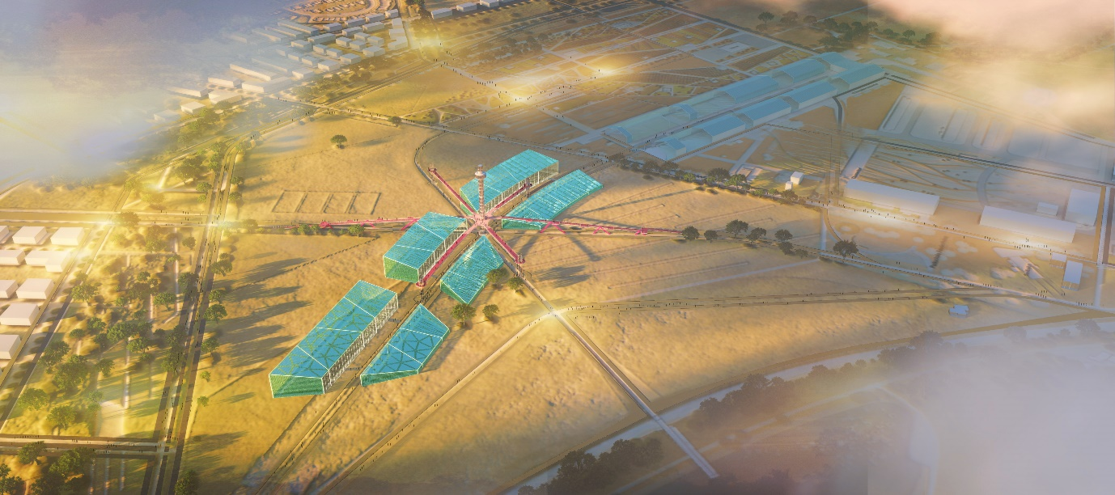
Variety of Motives
(An attractive park serves a variety of purposes). The varied motives and patterns of Spinelli's park layout plans are further enhanced by presenting three new patterns of solar panels covering the top of the barracks to provide varied shades of shadow and light from each segment.
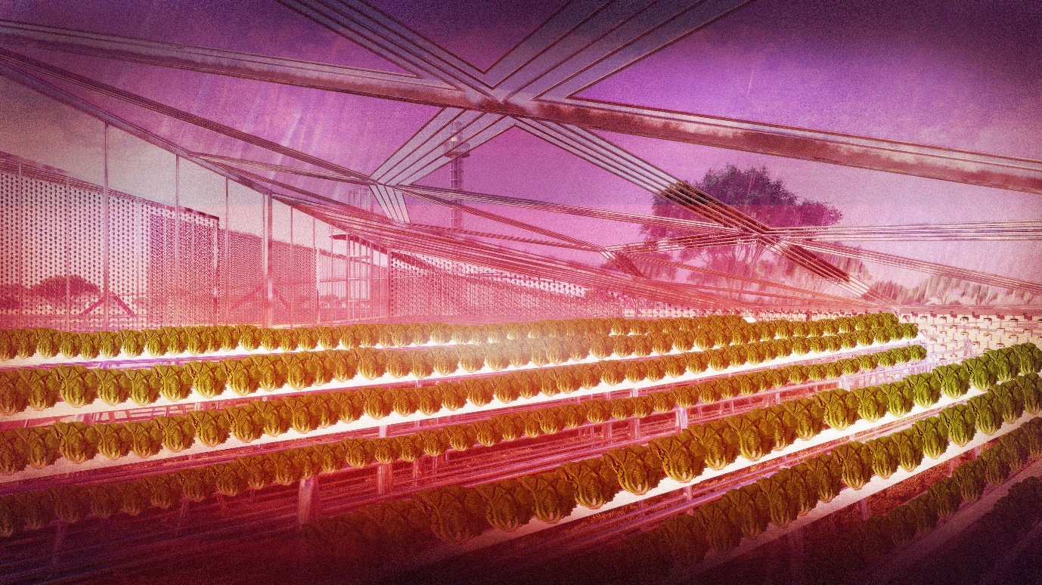
Night Photosynthesis
Encourage innovation - with regard to agrivoltaics, night photosynthesis is an additional feature to speed up harvest times, and maximize quality and quantity at each harvest season, encouraging more yields in a year. combines the original light spectrum and the red spectrum to replace ultraviolet light at night.

DESIGNS
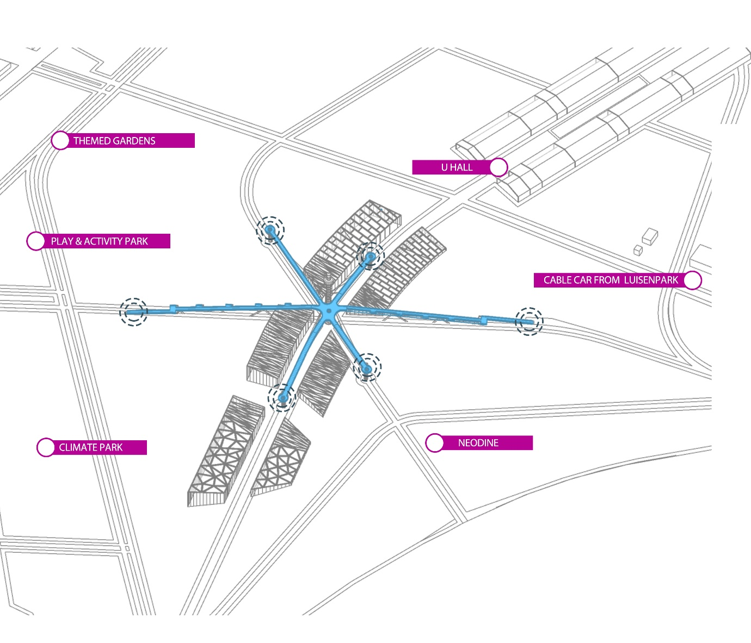
Object B (skywalk and urban connection)
- The presence of a skywalk for more enjoyable experiences
- Responding to six directions of the pathway intersections

Object B (panoramic walk and viewing deck)
- 1 spot of the skywalk circulation ramp, responding to arrivals from the north corridor as well as play and activity spots
- 1 spot of the skywalk circulation ramp, responding to the arrivals from the south area and cable car stop point from Luisenpark
- 1 deck view spot on the north side to relish themed gardens
- 1 deck view spot on the south side to enjoy Neodine and water body
- 1 deck view spot on the east side to enjoy the U-Hall and the Barrack rooftops
- 1 deck view spot on the west side to enjoy the climate park and the Barrack roof panels

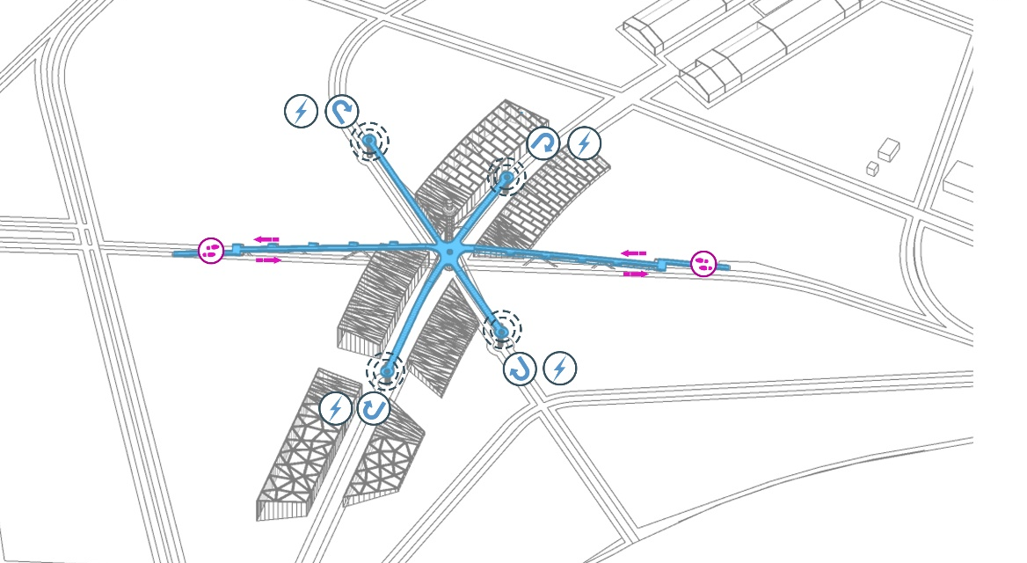
The Potentials of Recreational Park X Public Festivals
Considering the increasing number of visitors to Luisenpark boosted by numerous attractions and facilities at BUGA 1975, we are optimistic about the future of Spinelli Park and the launch of BUGA23 because we can turn the potential visitors into an opportunity for sustainability by collecting energy through footstep energy.
Object B (footstep energy)
To ensure that each deck view path receives maximum footsteps and is as energy-efficient as possible, the skywalk route with each deck view is aesthetically designed, ends on one side, and directs visitors to return through the same track to go to another deck view.
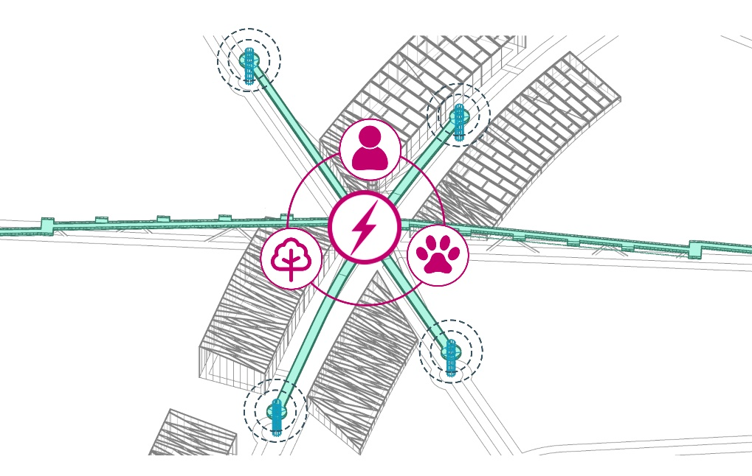
Object B (column x aviary)
The ecological column serves as a power source for lifts, accommodates attraction functions at the ground and skywalk levels, and provides indoor and outdoor bird habitats to reunify people with nature and animals.

Object B (ecological column)
- Supporting attractions from each deck view
- Serving as bird aviary on the inside
- Completed with a microbial cell pot on the structure
- Bird-attracting plant
- Bird and feeding stations on the outside

Objek c - visioning (more experiences to enjoy the park arrangement)
It is surely an enjoyable moment when we can feel the nature vibes, stroll among the exquisitely placed plants, and sit closer to the lovely greenery. The beauty of the park design and layout, however, is what lies behind it all, composed of art and science considerations about the plant itself, and presenting unique patterns that tie the ground where it is placed.
Hybrid panoramic lifts and observation decks offer visitors more experiences to collectively enjoy the elegance of garden art design and appreciate a great masterpiece as the result of an individual or group thought process.

Object C (Innovation for the better experiences)
THE BARRACKS strive to encourage innovation to provide attractive sites for all groups in various conditions, presenting a hybrid panoramic lift connected to the observation deck at the top, activated by the energy of the elements attached, including footstep energy, wind belt energy, and microbial energy pot. The lift operation and movement activate thousands of rollers connected to the dynamo at the top of the lift tower which produces energy for operation.

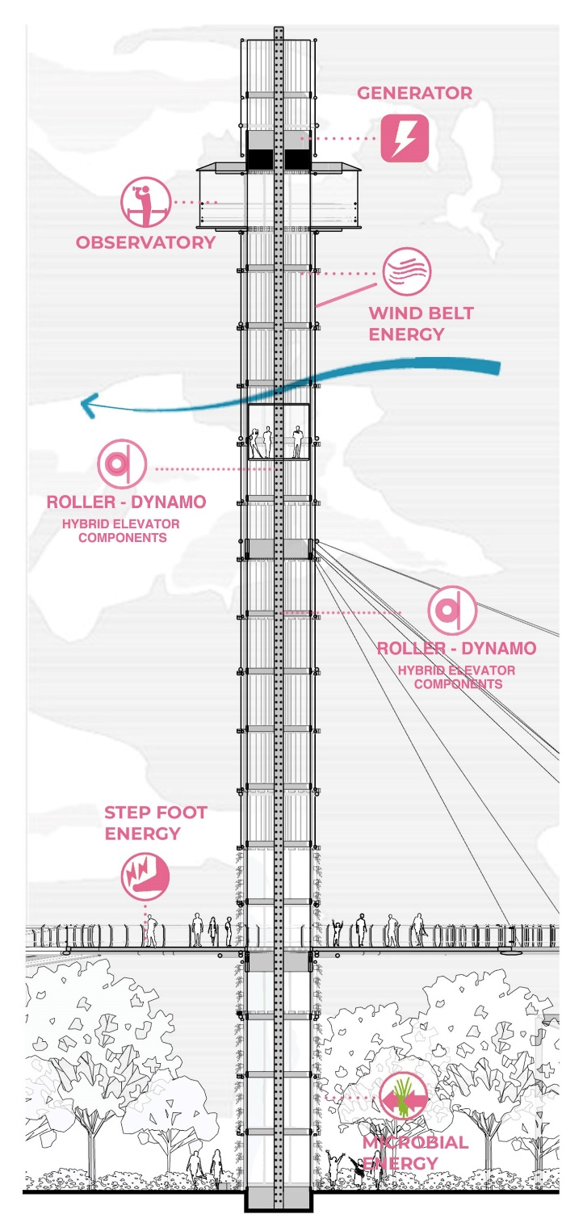

Object C (hybrid panoramic lift)
- Observation deck
- 50-meter-high lift tower
- 1600 unit of rollers
- 300 wind belt energy generators
- 770 microbial energy pots
- A vertical connection from the ground to the skywalk level and ends at the observation deck

Energy Resume :
1) Monocrystalline silicon photovoltaic
Solar panel energy production per square meter: 5 kWh / day
Total solar panel area: 13.994 m 2
- Total energy output per day: 69.970 kWh / day atau 69.9 mWh / day
- Total energy output per year : 25.513,5 mWh
- 15 % for night photosynthesis – 85 % channeled to the surrounding houses

2) Windbelt
Windbelt output per linear meter: 0.2 kWh / day
Total linear meters of windbelt: 300 meter
- Total energy output: 60 kWh / day
- Total energy output per year : 21.900 mWh
- 25 % to help elevator activation – 75 % channeled to the Spinelli park facilities

3a) turf microbial energy
output per linear meter: 3.9 kWh / day
Total meter square of microbial energy: 8187 m2
- Total energy output: 31.9 mWh / day
- Total energy output per year : 11.643 mWh
- 100 % channeled to the Building around

3b) Wall - Pot microbial energy
output per linear meter: 3.9 kWh / day
Total square meters of microbial energy: 9796 m2
- Total energy output: 38.2 mWh / day
- Total energy output per year : 13.943 mWh
- 100 % channeled to the Building around

4) Footstep energy
output per meter square : 1 kWh / day
Total square meters of of step floor: 2398 m2
- Total energy output: 15.8 mWh / day (with an estimated average number of park visitors)
- Total energy output per year : 5.767 mWh
- 100 % to help elevator activation.

5) Roller – Dynamo (Hybrid components)
output per linear meter: 1 kWh / day
Total of Rollers : 1600 units
- Total energy output: 0.7 mWh / 1 lift movement – up & down
- Estimated to move 8 times per day
- Total energy output per year : 2044 mWh
- 25 % for next elevator operation – 75 % channeled to the surrounding houses.

6) vegetable and fruit plants production
Planting Area : 15.244 m2 + 16.425 m2 = 31.669 m2
- estimated yield increase with additional night photosynthesis 25% – 40%

- List of the primary materials used in your design and major dimensions

• Building column type
1. Column type 1
Length: 18.7 meters
Quantity: 18 pieces
Material: Hollow iron with a size of 30 cm x 30 cm

2. Column type 2
Length: 12.5 meters
Quantity: 18 pieces
Material: Hollow iron with a size of 30 cm x 30 cm

3. Column type 3
Length: 8.8 meters
Quantity: 14 pieces
Material: Hollow iron with a size of 20 cm x 20 cm

4. Column type 4
Length: 3 meters
Quantity: 14 pieces
Material: Hollow iron with a size of 20 cm x 20 cm

• Type of Building Filling Column
1. Filling Column 1
Length: 12.5 meters
Quantity: 85 pieces
Material: Hollow iron with a size of 10 cm x 10 cm

2. Filling Column 2
Length: 8.8 meters
Quantity: 69 pieces
Material: Hollow iron with a size of 10 cm x 10 cm

• Circle Skywalk Column
Length: 18.8 meters
Quantity: 48 pieces
Material: Black Steel Pipe
Size: Diameter 5 Inch

• Elevator Tower Column
Length: 60 meters
Quantity: 10 pieces
Material: Black Steel Pipe
Size: Diameter 8 Inch

- Order-of-magnitude conceptual cost estimate : USD 22.500

- strategy for on-site prototype development in the event.

The project will be divided into several important parts to represent the planned elements, 2 small scale barracks modules, as agrivoltaic around the circulation junction, 1 skywalk ramp leading to the arrival corridor on the north side, 1 skywalk ramp leading to the south side, and 1 ecological column with the aviary inside at the midpoint of the skywalk.

- Environmental Impact and Sustainable Statement
THE BARRACKS design is very concerned about the ecological side in the context of the site and the surrounding environment, 4 kinds of green elements that strengthen the fresh air in the green corridor scheme of the area, also become a good air filter. several ecological elements are also important features in the design, all of which are oriented towards the environment, sustainable energy, human and animal food production, in other words this project also represents sustainability on a more complex scale (planetary scale). besides that the project also answered some of the points of the UN Sustainable Development Goals.
THE BARRACKS represents 10 out of the 17 UN Sustainable Development Goals as follows:
- Erase Hunger
- Establish Good Health and Well-Being
- Provide Quality Education
- Enforce Gender Equality
- Grow Affordable and Clean Energy
- Create Decent Work and Economic Growth
- Increase Industry, Innovation, and Infrastructure
- Mobilize Sustainable Cities and Communities
- Influence Responsible Consumption and Production
- Organize Climate Action

