Unfold
Inspiration
Being well-known for its inventions, including the automobile, the bicycle, as well as the tractor, Mannheim is often called the "city of inventions". The civic symbol "Mannheim Water Tower" tells a particular story of water to this city. Inspired by these unique characters, we designed the unfolding artwork to harvest solar energy and water which not only satisfies the irrigation of plantations in different situations but weaves renewable energy and agriculture into urban lives.

Technology
Energy Harvesting
The installation is designed to harvest solar energy and water for two reasons. Firstly, solar energy was the only system to experience a significant, positive relationship in power density over time among different renewable energies (Figure01, the power density of electricity production is the electrical power produced per horizontal m² of surface area which shows how much space will be occupied to produce electricity). Geologically, Mannheim owns a relatively high annual solar radiation which is about 1200kwh/m²/year (Figure02). The global radiation value runs from 200kwh/m²/year (Norway) to 2600kwh/m²/year (Saudi Arabia).
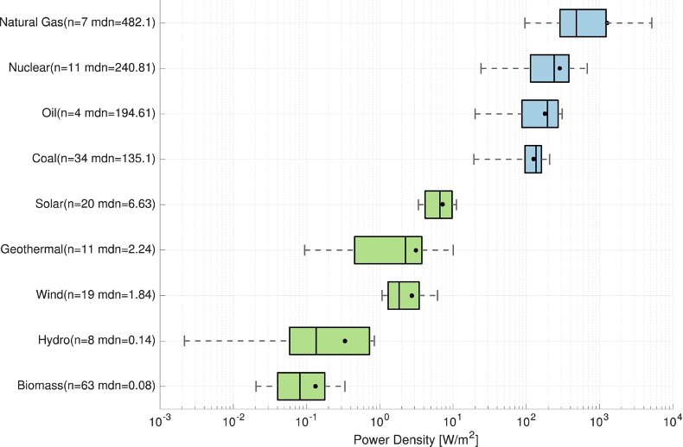
Figure01 Box plots of power densities for all energy types visualized on a log scale. The annotations n and mdn give the number of values found for each energy type, and the median power density respectively.
Secondly, water is a unique element to Mannheim because of the history of the Mannheim Water Tower. In addition, the average annual percentage of humidity in Mannheim is more than 77% which is a great premise for harvesting water (Figure03). More importantly, harvesting water has practical benefits to the city which includes irrigation, drinking, as well as recreation.
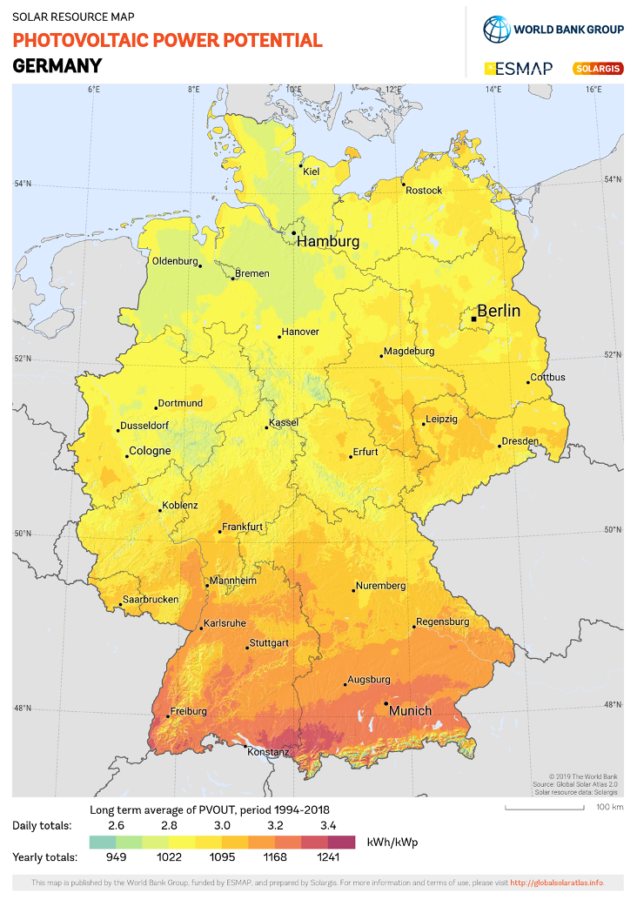
Figure02 Photovoltaic Power Potential in Germany

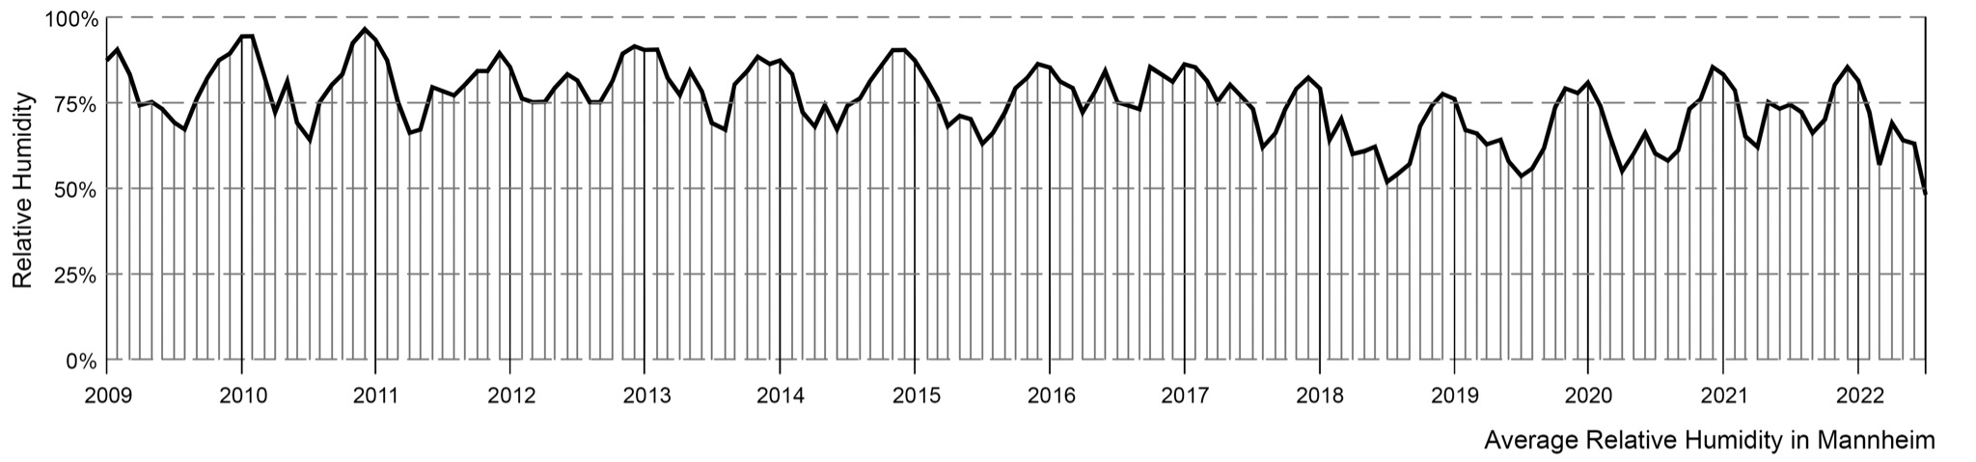
Figure03 Average Humidity in Mannheim

Components
The installation is composed of the OPV (organic photovoltaic) skin, solar-driven hygroscopic water harvesting device, as well as a bladeless drone (figure04).

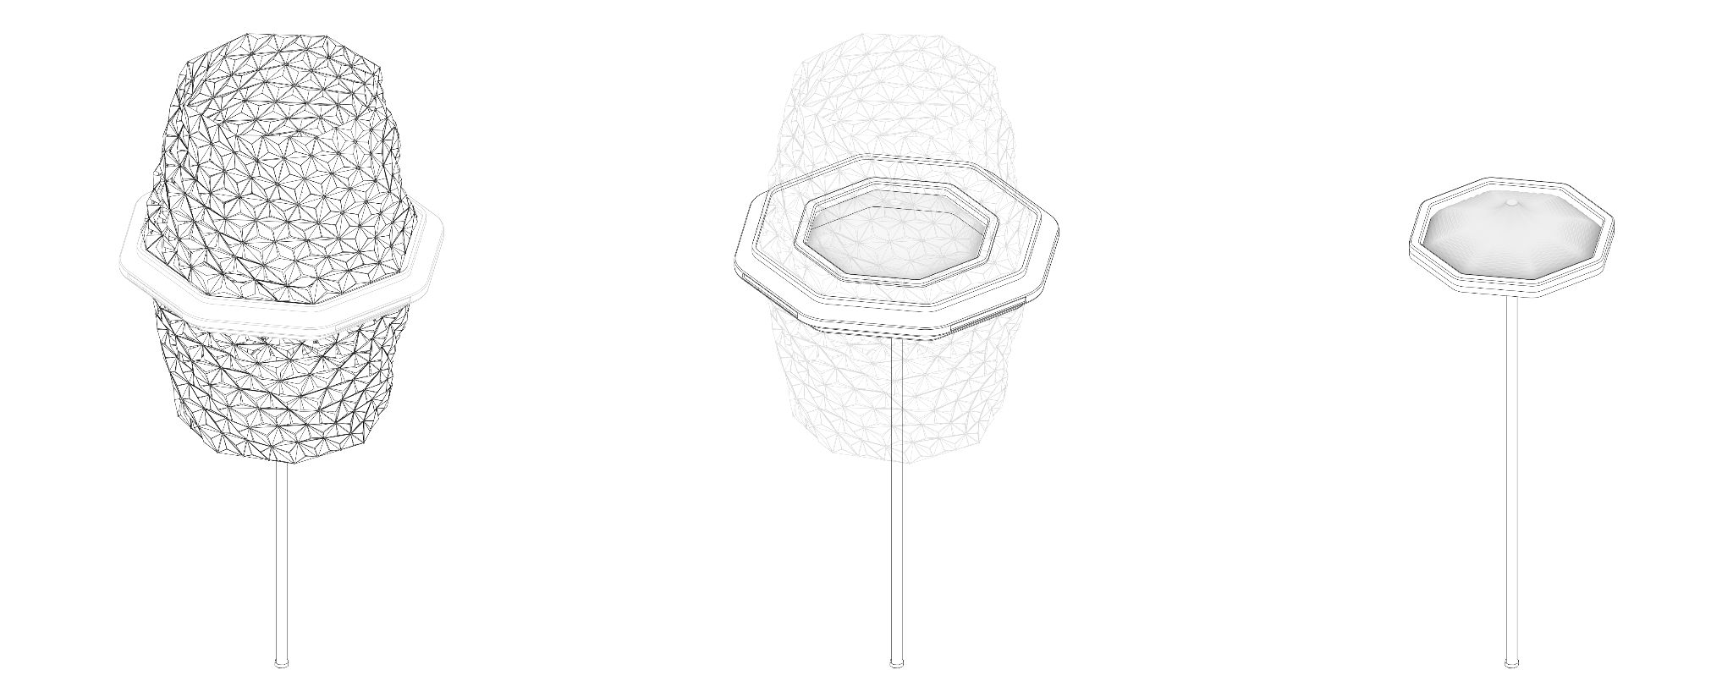
OPV Skin Bladeless Drone Water Harvesting Device
Figure04 Installation components

+Structure
The structure is the skeleton of the installation which connects the OPV skin and the pole. It is retractable vertically based on the water harvesting process.
+OPV Skin
The OPV skin collects solar energy during the day and is retractable in vertical direction which enables it to fly with the bladeless drone. Besides, the OPV skin is composed of triangle pieces whose angles are adjustable based on two factors. The first one is the perfect angle for harvesting maximum solar energy. The second one is the amount of sunlight penetrating into the water collecting device. These two factors need an automatic adjustment to reach a balance.
+Water Harvesting Device
The solar-driven hygroscopic water harvesting device is made of semi-transparent material surrounded by the OPV skin. The device harvests water from air through an ancient method. During the harvesting process, the sorbent in the device captures water molecules by physical adsorption from the air in the night, and then the water molecules in the sorbent are desorbed under the heating of sunlight during the day. The water vapor generated in this part will be recondensed, liquefied, and collected. The heated sorbents are re-cooled during the night for the next water vapor capture (figure05).
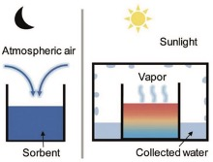
Figure05 Schematic of solar-driven hygroscopic water harvesting.

+Bladeless Drone
Inspired by Dyson products, we designed the bladeless drone which is composed mainly of impellers, loops, battery, as well as water tank (figure06). In order to make the drone look decent,
all those components are designed inside which means they cannot be seen during the flying.

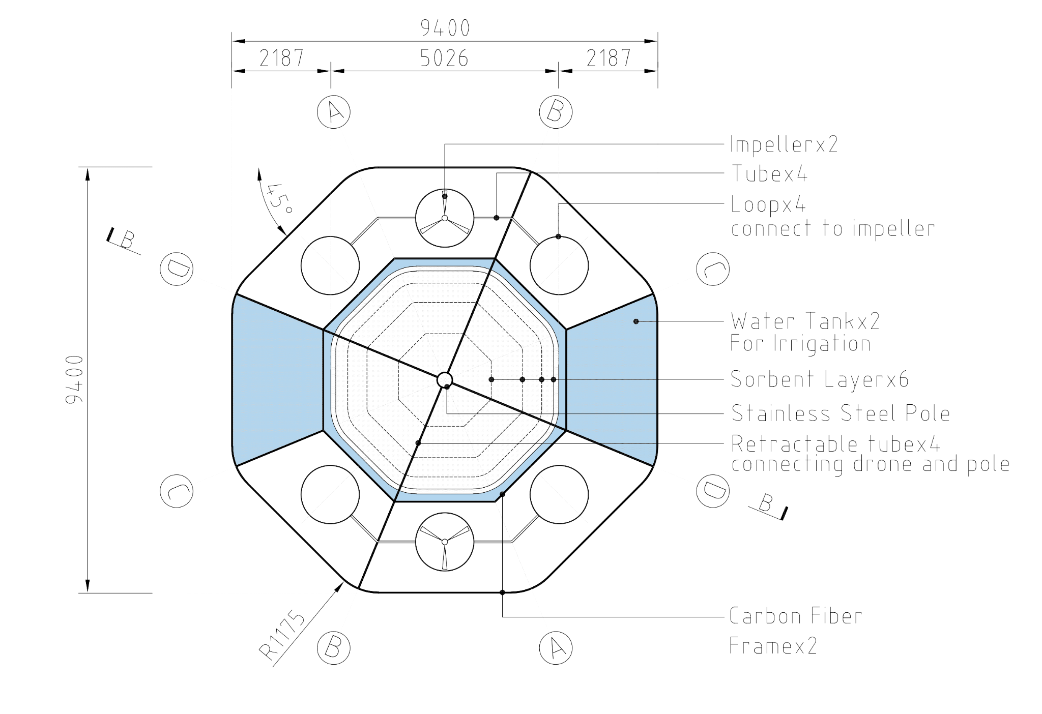
Figure06 Bladeless Drone Schematic

Mechanism
When the sun rises, the OPV skin is at its longest status which means it is harvesting solar energy. Meanwhile, the sunlight penetrates the OPV skin to reach the water harvesting device which indicates the process of water harvesting. The OPV triangle pieces on the skin can be adjusted to adapt the Sun’s rotation to reach the best energy harvesting status, including harvesting electricity and water. The retraction of OPV skin and the water harvesting process are designed to be synchronized. When the water collection reaches its biggest volume, the OPV skin will retract to the minimum status which gives a signal to the drone to take off. So, the drone will fly to irrigate crops or other plantations in the park. When the irrigation process finishes, the drone will return back to its original place to charge the battery, the OPV skin will return back to the longest status, waiting for the next day’s sunrise.

Public Activities and Social Benefits
New Model of Harvesting and Distributing Energy
The old model of large-scale power plants located far from city centers has numerous disadvantages which include huge loss in energy transportation, destroying natural landscape, as well as pollution. However, harvesting solar energy and water via this installation is a new model that brings energy production closer to where energy is used. This new model contributes to saving capital, conserving nature landscape, reducing need for transmission lines, as well as delivering more reliable, resilient energy. For example, the installation can be designed near the lights or water feature in the park which means the electricity generated by this installation can be used to power the lights or pump water feature in the park. The water harvested by this installation can be used to irrigate plants in the park which not only saves water but reduces the municipal pipe network. The water and electricity can be saved for every family when it is installed in the private garden.

Mitigating the Conflict Between Land Usage and Energy Producing
The traditional energy producing methods such as fossil fuel power plant or solar power plant need a lot of land for buildings or infrastructures which cause conflicts with existing rural uses such as agriculture, recreation, visual resources stewardship, land conservation, forest preservation, as well as biodiversity. However, this installation can be installed at a wide range of areas which include rural areas, urban settings and private gardens without any conflicts with the existing conditions. For example, this installation can be arranged at the farmland to supply electricity and drinking water with little impact on the crops or animals. It can also be a part of a civic park, a natural park or a private garden without any negative impacts on the species or the land usage.

Inspiring People
All the dynamic processes, including retraction of the OPV skin, adjustment of OPV triangle pieces, water desorption, drone irrigation, as well as mist spaying visualize the energy harvesting and energy distribution which gives people a lot of inspiration and different experiences. For instance, when people see the bladeless drone irrigate the crops, when they enjoy the cool mist spraying from the installation during the hot days, when they see the installation helps harvest water and irrigate vegetables in their private gardens, they might think about that there are so many creative ways for us to integrate sustainable infrastructure into the cultural fabric of our cities. The installation does weave renewable energy and agriculture into our lives which inspires people to be mindful of our relationship with nature.

Energy Calculation
Water Harvesting
The formula to estimate the water generated output of the solar-driven hygroscopic water harvesting device is:
Q=E*A*365
Q=how much water the installation can produce per year (kg/year)
E=water production per square meter of sorbent per day (kg/m²/day)
A=area of sorbent (m²)

E=2.5kg/m²/day
According to the data from a paper called “Advances in Solar-Driven Hygroscopic Water Harvesting”, a multilayer water harvesting device can achieve a water production of 2.5kg/m²/day.
A=A1+A2+A3+A4+A5+A6=3.14*(2.4²+3.6²+4.2²+4.6²+4.4²+3.8²)=286.74m²
The area of sorbent is 286.74m². The height of the water harvesting device is about 2m, the diameter is about 5.0m. The sorbent area includes 6 diameters: 2.4m, 3.6m, 4.2m, 4.6m, 4.4m, 3.8m(Figure07)
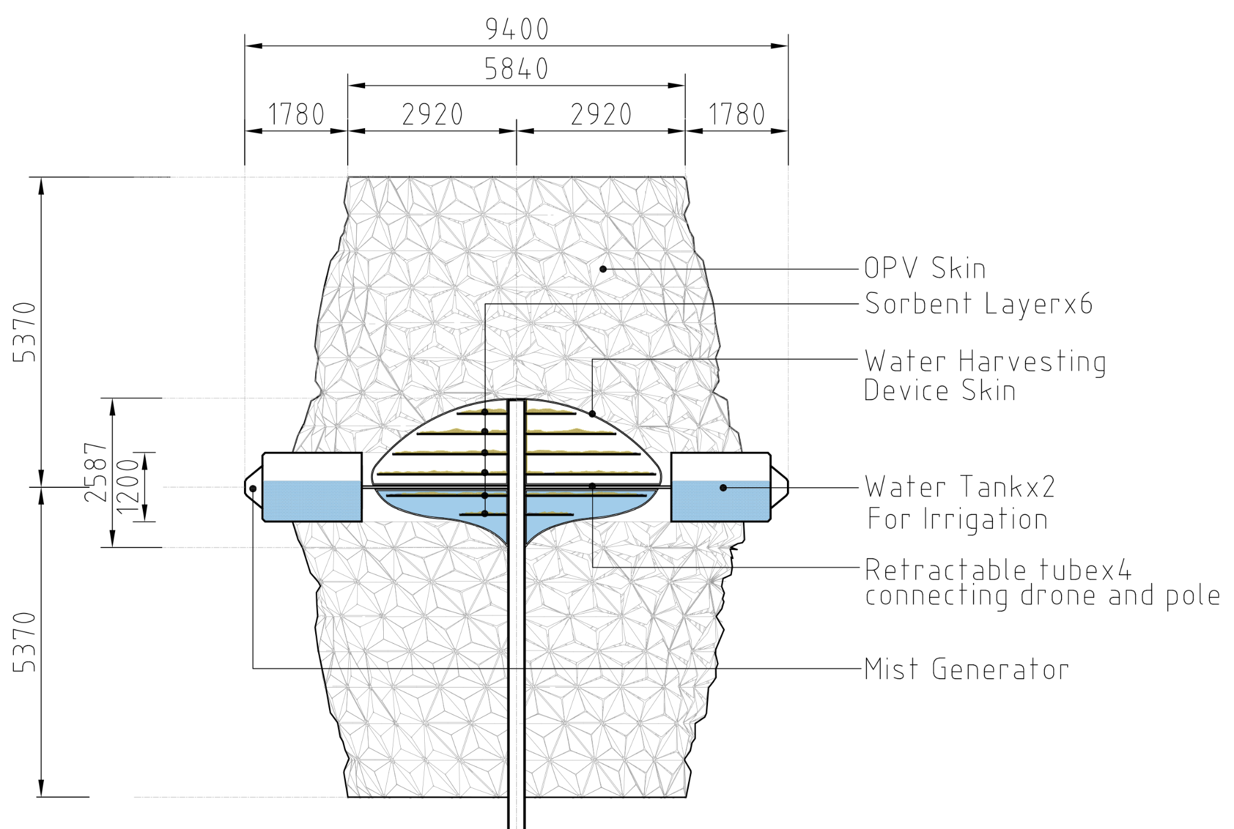
Figure07 Sorbent Layer Section

Q=E*A*365
Q=2.5kg/m²/day*286.74m²*365day=261,654kg=261,654 liters

The installation can harvest 261,654 liters of water per year. This production of water supports common foodstuffs as the chart shows.

Food | Food Quantity (kg) | Water Consumption (liter/kg) | Water Quantity produced by one installation (liter)
Apple | 318.31 | 822 | 261,654
Potatoes | 911.68 | 287
Cabbage | 1104.02 | 237
Tomato | 1222.68 | 214
Food Quantity=Water Quantity produced by one installation/Water Consumption
Water Consumption=how much water is needed to produce 1kg food

Electricity Harvesting
The global formula to estimate the electricity generated in output of a photovoltaic system is:
E=A*R*H*PR
E=How Much Energy the Installation Can Harvest (kwh)
A=Total Solar Panel Area (m²)
R=Solar Panel Yield or Efficiency (%)
H=Annual Average Solar Radiation on Tilted Panels
PR=Performance Ratio, Coefficient for Losses (range between 0.5 to 0.9, default value=0.75)

Our installation will use the OPV (organic photovoltaic) whose efficiency R runs from 8% to 16%.
We will take the average which is R=12%. The annual average solar radiation in Mannheim is about 1200kwh/m²/year (Figure02).
A=13m²*8*2=208m²
R=12%
H=1,200kwh/m²/year
PR=75%
E=A*R*H*PR=208m²*12%*1,200kwh/m²/y*75%=22,464kwh

The electricity produced by this installation will be used for the bladeless drone with an irrigation system. The remaining electricity will be used to power other infrastructures in the civic park such as lighting, water feature, as well as cell phone charging devices.
The electricity will mostly be used to support the irrigation system and outdoor lighting when it comes to the private garden.

Environmental Impact
In order to reduce the environmental impact as much as possible, we have considered multiple factors of the installation which include materials, transportation, producing, installing, as well as maintenance. Meanwhile, we need to make a balance between those factors to achieve the goal of reducing carbon emission, energy saving, as well as environmental protection.

Materials
The installation will be composed of renewable and recycled materials as much as possible and they can be found in local areas with low transit impact. The installation mainly includes four parts: structure, OPV skin, bladeless drone, water harvesting device.
+Structure
The structure is made of carbon fiber or aluminum which helps to reduce weight to save energy when it flies. The pole is made of stainless steel which can be recycled. The structure is the skeleton of OPV skin and connects the pole.
+OPV skin
The OPV skin is made of an equilateral triangle which helps to eliminate leftovers during the cutting process. The OPV has several promising advantages which include lightweight, low cost, 100% recyclable, heat and rain resistant, and has an expected life span of 20-30 years.
+Bladeless drone
The drone is designed to be bladeless which is friendly to birds. In order to save energy, the structure will use carbon fiber which has several advantages including low weight, high stiffness, high temperature tolerance, and a life span of 50 years.
+Water harvesting device
The water harvesting device will use semi-transparent material which should be fit for this installation with some characteristics such as recyclable, transparent, as well as safety. The transparency contributes to absorbing heat from sunlight and also enables people to see the water harvesting process.

Producing and Installing
+Module Components
All the components of the installation will be manufactured in a factory and assembled on site which helps reduce negative impact on the natural environment.Keeping the main energy harvesting devices, the installation is designed to equip other different accessories such as bladeless drones, LED lights, as well as an irrigation system to adapt different settings. This module design also helps to save energy.
+Foundation
The foundation of the installation will use precast concrete which also eliminates the dust and pollution caused by pouring concrete on site.

Maintenance
The installation can be separated into several parts which brings more convenience for maintenance. The main parts of installation are the OPV skin and water harvesting device. The electricity and water harvested from the installation can be distributed to urban lives via different accessories such as bladeless drones and irrigation systems. So, every part can be replaced or repaired without influencing the other operation.

Conclusion
This installation is a pilot of artwork which tries to weave renewable energy and agriculture to urban lives. It is thought-provoking and brings people new ideas about the potential of sustainable energy and agriculture in urban settings in the near future.

Refences
https://www.sciencedirect.com/science/article/pii/S0301421518305512
https://weather-and-climate.com/average-monthly-Humidity-perc,mannheim,Germany
https://onlinelibrary.wiley.com/doi/full/10.1002/gch2.202000085
https://www.youtube.com/watch?v=f2UCK3pCFjk
https://www.theguardian.com/news/datablog/2013/jan/10/how-much-water-food-production-waste#data

