550 Nm
“Nature is our best allied to generate the energy to power our world: we just have to discover the ways it helps us”
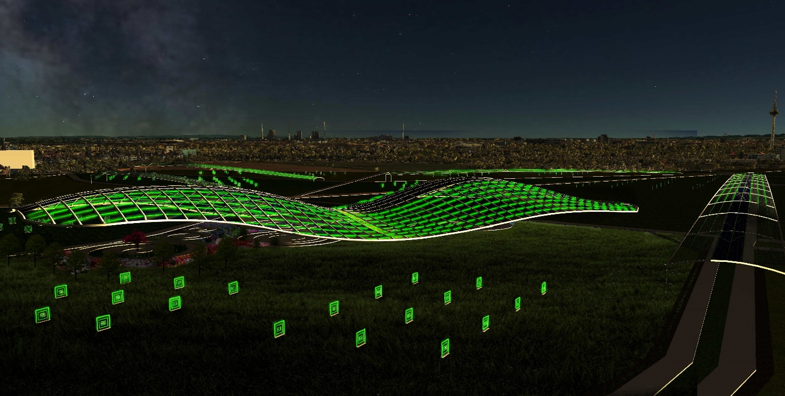
The objective of this project is to create a connection between nature, aesthetic and energy, making people understand and appreciate this unique link. The idea is based on the creation of two main energy paths: a soil-based one, with Microbial Fuel cells powered by the organic wastes from citizens and a solar one that exploits the power of solar radiation for both generating electricity and cultivating crops using thin film photovoltaics and Transparent Luminescent Solar Concentrators (T-LSC) placed even in vertical position. The artwork wants to connect those two paths in a view of a resilient structure that would increase the citizens wellbeing following the SDGs.
LUMINESCENT SOLAR CONCENTRATORS (LSC)
- The LSC surface material separates only the green light (495-570 nm) from the EM spectrum and directs it to the border of the cell where the photovoltaics system converts it into electrical energy. This reflective propriety gives a touch of luminescence to the cell, giving a brilliant aesthetic effect.
- The other wavelengths can go through the cell and activate photosynthesis in all the plants and crops placed under the structure. Green light doesn’t significantly contribute to the photosynthesis, so it can be freely converted into electrical energy
- The NIR-TLSC can also collect the radiation in the near infrared bandwidth (750-1300 nm) and transform it into electricity, the main advantage is that a significant percentage of NIR radiation is thermal and comes from the ground, especially at night. This brings two advantages:
- The LSC cells would work with the absence of sunlight, thus reducing the intermittence problem of RES by powering the grid also at night or in cloudy days, independently from the presence of the sun.
- The cells don’t need to be oriented towards the sun to perform the most; in this artwork the cell structure is vertically placed
MAIN AND SECONDARY STRUCTURES
- The main and secondary stainless steel structures are strategically located so that they face the prevailing wind direction (East-West direction)
- As can be seen from the wind analysis, the structure wouldn’t bring a significant alteration to the natural wind flow in the park, so it would be consistent with the Baden-Württenberg climate adaptation plan and the Klimopass.
- The wind would also run across the structure under the coverage surface, providing a comfortable environment both for people and plants
- The increased wind speed on the top of the surface would decrease the air temperature, increasing the PV efficiency. This can be considered as a clean and useful solution to enhance the performance of the energy system
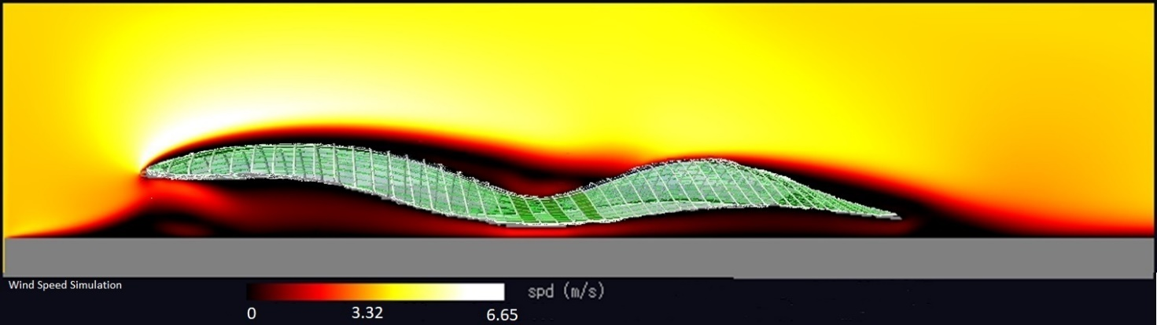
THIN FILM SILICA PV
- The grass in the back of the thin film silica PV has a double affect:
- Aesthetic: makes a green and nature-based connection between the ground and the sky
- Physical: the grass can reduce the air temperature through evotranspiration, thus increasing the PV cell efficiency
- Higher efficiency than the LSC, they provide the energy load to the electrical grid during midday
- Placed on the upper part of the structure where the concave curvature is higher in order to increase the energy harvest and reduce the soil consumption.
VERTICALLY-ORIENTED T-SLC
- Vertically-oriented TLSC cells would bring several advantages:
- Can collect solar radiation from both sides and from multiple directions
- Would greatly reduce soil consumption
- Perform better in the morning and evening hours (7.00-10.00 and 18.00-21.00), so they reduce the traditional effect of an abundance of energy in the midday and a reduction in the morning and afternoon, increasing the flexibility of the energy system towards the electrical grid.
- Can be easily cleaned and get hardly shaded by dirt
MICROBIAL FUEL CELLS
- Soil-based microbial fuel cells (s-MFC) can generate electrical energy exploiting the redox potential of several different types of bacteria placed in the soil. They are really important for the following reasons:
- Can generate free and clean electrical energy
- Have an educational purpose, mainly to raise consciousness on the importance of soil and environmental services as well as the mechanisms of nature to generate electrical energy. All of this would be explained to visitors with boards.
- The substrate of the s-MFC would be the organic waste (ex. Fruit, food or vegetables wastes) collected from the apartments near the park and from the garbage cans inside; this would make people think about the importance of recycling, expressing the fact that even the smellier waste can be a resource.
- The MFC would provide enough energy to power wi-fii routers that can give free internet access to visitors (encouraging people to gather and work in the park); also, the remote connection can drive the smart irrigation system, further reducing the water consumption.
- We can summarize the entire process with the sentence: “Using organic waste to power your phone and to feed the crops”.
SMART IRRIGATION SYSTEM
- The smart irrigation system would use remote sensors connected to the distribution devices in order to feed the crops in an intelligent way avoiding water wastes and increasing efficiency.
- The sensors are driven by wi-fii routers powered by the soil-based MFC placed under the structure, fed by the organic waste provided by the citiziens.
- The distribution devices are placed inside the main and secondary structures and provide water as drip irrigation. For the crops outside, the devices are placed on the structure of the vertical LSC modules.
- The water used to feed the crops is the one collected by the same structure and stored in proper tanks.
SOCIAL FUNCTIONS
- The whole project would bring several benefits to the Mannheim community: people and visitors would walk under the structure surrounded by flowers and crops; there would be working positions with internet connection provided by the MFC, park benches and chessboards. Leisure activities, sports and games would be encouraged; people would gather in the park to study, work, go running or simply to have a rest.
- The edible crops placed under and outside the structures would be cultivated by the citizens as shared gardens/farms. This would provide food and education about the respect of the soil similarly to the german Schrebergarten.
HISTORY INSIDE MODERNITY
- The shape of the structure tries to connect the Mannheim history with the challenge of giving modern touch to the park. In particular, on the main and secondary structures the LSC and thin film PV cells disposition recalls the block-scheme of the Mannheim city center, meanwhile the curved-shape of the upper surface provides a post-modern identity to the artwork.
- Some historical parts of the site would be preserved and visitors encouraged to explore them, they’re the U-Halle building and the railroad. Proper boards with historical information of the past and history of the site would be provided as well.
LED LIGHT AT NIGHT
- Part of the harvested energy is stored and used to power low-energy consuming LED lights that would color with green light all the structure wings. In a philosophical way, this is like an act to return the green light-radiation band to the nature, thus closing the nature-aesthetic and energy bond.
ENERGY GENERATED, MATERIALS AND COSTS
Material | Total Area (m²) | Est. efficiency (%) | Energy production (Mwh/y) | Cost (EUR)
Flexible PV (LSC) | 65964.03 | 0.07 | 6441.39 | 458999.8
Thin film silica PV | 5788.24 | 0.19 | 1534.17 | 260460
Vertical PV (LSC) | 3657.13 | 0.07 | 357.11 | 18322.22
*Considering an irradiance of 1395 KWh/m²
Total energy production: 8332 MWh/y
One LED Light consumption: 34.56 Kwh, approximately the entire system would require 34.5 MWh/y
Approximated Total cost (related to energy production excluding MFC): 737.781 EUR

WATER COLLECTION SYSTEM
Tubes Diameter (cm) | Est. efficiency (%) | Collector area (m²) | Harvested water (m³)/y
20 | 0.95 | 52079 | 39629
*Considering an annual precipitation of 801 l/m2y
MFC
MFC power output: 0.024 kwh/m²
Total area needed for fuel cells*: 2166.7 m²
*Considering an annual energy consumption for a wi-fii router equal to 52 Kwh/y
POSSIBLE PLANTS AND CROPS TO BE CULTIVATED
 | Cultivation for food | Decoration for aesthetic
Shade resistant | Lettuce, cucumber, beets, cauliflower, celery, leeks, rhubarb, scallions, cabbage, beans, herbs | Mint, fagus sylvatica, ostrya carpinifolia, ulmus laevis, prunus avium, sorbus domestica
Sun dependent | Wheat | Salix, betula pendula, quercus robur, salix alba
Shade resistant crops should be placed under the structure (they would have a reduced light intake; sun dependent plants outside under perfect irradiance conditions.

Environmental Impact Assessment
Considering just the GHG as indicator, the estimated total CO2 emissions brought by the energy system are equal to 249 tons. The use and cultivation of plants and crops with the function of carbon capture and storage would reduce the overall emissions to approximately 100 tons.
Considering a total lifetime of PV modules of 30 years, material recycling strategies and processes should be encouraged..
The organic waste recycling in MFC would decrease the overall emissions; further challenges relative to the use of municipal solid waste in MFC should be pursued.
The structure is safe: there’s no direct contact between people and the electrical inverters; the soil consumption is greatly reduced due to the use of the vertical PV and the double function of the LSC cells. The ecological pathway is ensured due to the open spaces outside the structures.

