World Tree

Project Description
In this proposal, we present the sculptural design of a walkway system that acts as the built component of a new green corridor. The centerpiece for this design is an open-air pavilion taking the form of a tree that houses which houses many plants and generates power through photovoltaic panels in the upper level and along the walkways.
For this design, we chose a motif that could work at multiple scales, from the large pavilion, to a raised walkway between buildings or even as an outdoor table/farming system. The design runs along a main axis through the site with the pavilion in the center.

Main Structure
The pavilion structure itself is created through digital fabrication, by 3D printing concrete for the main form. This is scaffolded by a bamboo frame which vine plants can grow along. The walkway is divided into ‘modular’ units which are lined along the main axis. They connect orthogonally, so that they can be assembled sequentially and new modules can be added over time. The design also contains two viewing platforms which run alongside the walkway – these are larger 3D printed structures and the main walkway runs through them.

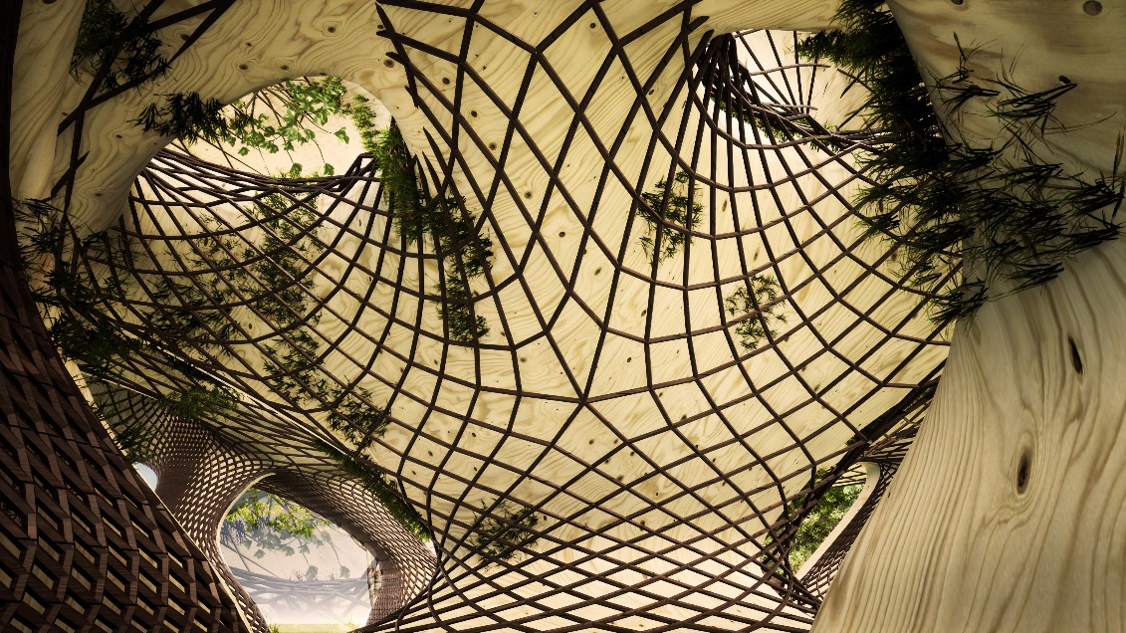

Energy Generation
The walkway and pavilion carry solar panels above rotated for maximum exposure. Their main function is to provide planters to hold vegetation. Water storage collected from the site is stored in underground reservoirs and is pumped using power generated from the site. There is also the opportunity for community farming both in the plants and below the walkway.
Solar power makes up nearly 10 percent of Germany’s energy production and photovoltaics have been well-tested in this environment. The following summary is given for the solar panels.

- Surface PV Area of One Module over the walkway 24 m² 24KW
- x 30% Efficiency Assume 7,200 W(per module)
- Given the modularity of the design, the energy production scales with each added unit – in the axonometric of board 2, 50 modules are present, making the total energy production 360 kW
- Over the course of a year, this is estimated to be 800mWh.

Environmental Impact Statement
The design makes use of 3D printed concrete, which, while having a high embodied energy, also has longevity and by 3D printing, there is no waste used in formwork. It also makes the construction less labor intensive with a large part of the work performed through robotics.
The walkway is built from timber which is a renewable material has the lowest impact on the environment (being a carbon sink).
