SunPath – Modular Arbor
  - With Decorative Solar Tile Canopy
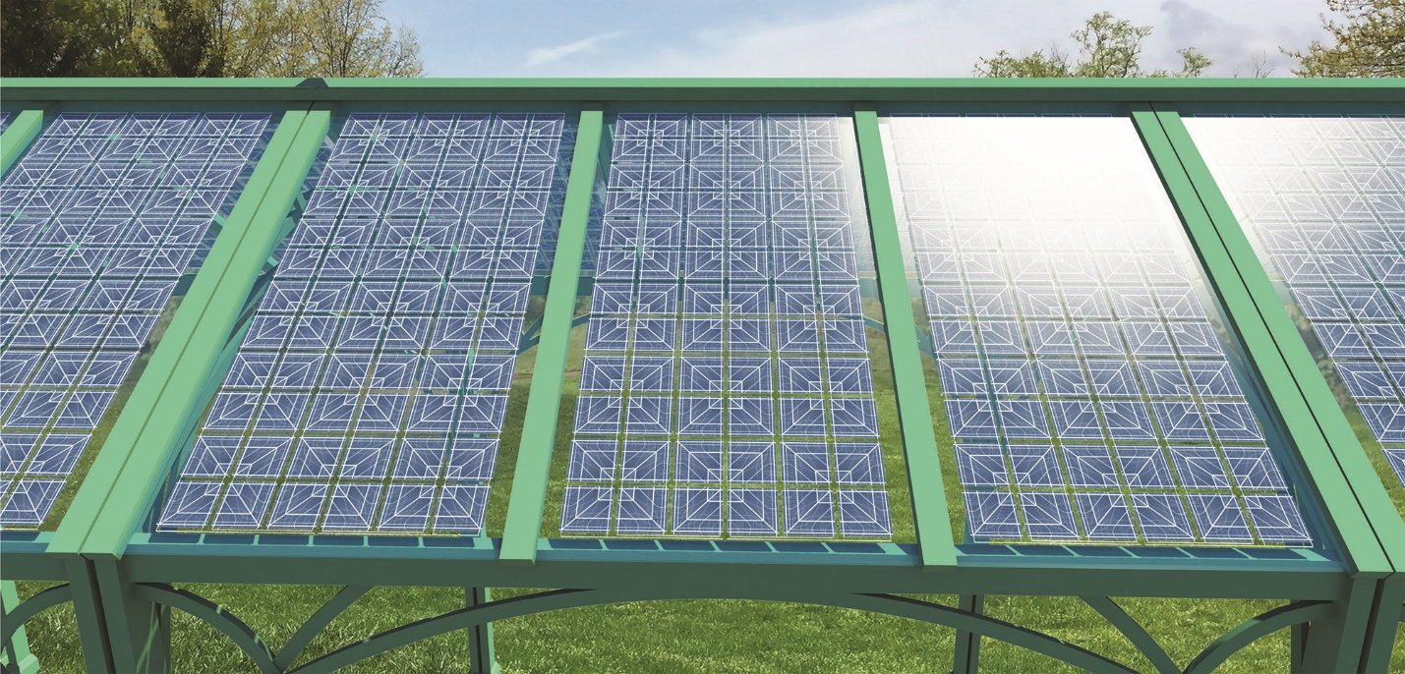

The Path to Solar Energy
SunPath Arbors are not large and iconic, nor complicated in their design. Their purpose is to integrate inconspicuously in outdoor spaces, providing an attractive, inviting shelter or outdoor living space, while also providing a nontrivial source of clean solar energy.
Each SunPath arbor is 3 meters long, 3 meters wide, and about 4 meters high at the peak, supported by four posts, one in each corner.
The arbors can be installed end to end for indefinite distances, providing attractive and comfortable sheltered outdoor space, and producing significant amounts of local clean energy.

Size vs. Power
Solar energy, by necessity, requires large surface areas to be covered in photovoltaic material, such as solar panels, in order to absorb the energy in sunlight. Utility-scale solar installations can cover thousands of acres in utilitarian, industrial solar panels. These massive sites produce impressive amounts of energy, but often face pushback from neighbors who think them unsightly.
Many would agree that covering an entire park with solar panels is counterproductive, and would destroy the other beneficial uses that a park is designed to provide.
However, there is available sunlight, and it can be taken advantage of if the solar installation can take a form factor that doesn’t interfere with—or even improves—the park’s function.

Form vs. Function
SunPath arbors are attractive but not overwhelming. They compliment the landscape through which they weave, providing shelter to pedestrians from harsh sun or cold rain, but maintaining connection with the outdoors through their open sides, not obstructing views of the surroundings, nor the free flow of fresh air through the site.
The structure is simple, with stability provided by sweeping curves of steel that suggest the rising and setting sun.
The tempered glass solar panels are bifacial, meaning that the spaces between the solar cells are transparent; they transmit sunlight through to the space beneath, casting a delicate dappled shade on those below.
The solar cells themselves have a custom decorative pattern, imbuing the otherwise monotonous grid with visual interest by taking advantage of the artistic principles of symmetry, rhythm, and line.
Taken together, SunPath is a thoughtful addition to any space, from the smallest micron-level aesthetic designs on the solar cells, the undulation of the repeating curvilinear forms of the arbor frames, and the architectural effect of the covered walkway winding through kilometers of grass and woodland.
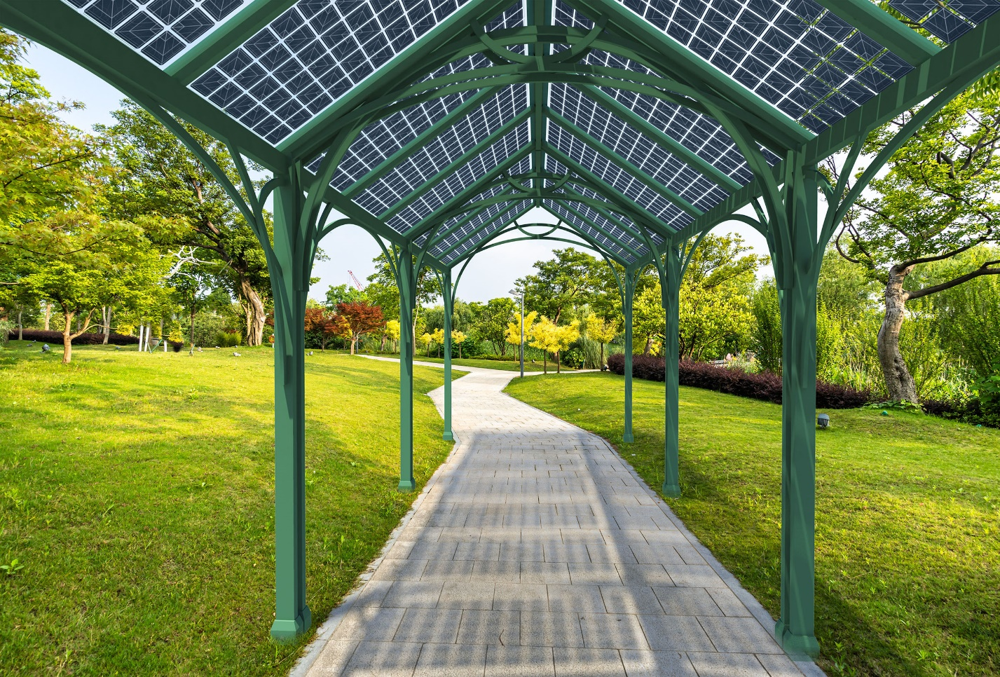

Linear vs. Planar
A standard solar farm fills as much surface area with solar panels as possible in both length and width, creating an imposing planar solar array which monopolizes the use of the land on which it is situated.
SunPath takes a less dense approach, by installing solar panels along linear features such as roads, pathways, and borders. By only using a narrow area that is already delineated by other linear features, SunPath doesn’t interfere with land use.
However, there is still a huge amount of surface area embodied in pathways in a park the size of Spinelli; enough for 800 kilowatts of generation for every kilometer of SunPath. Between two and four kilometers of pathway could easily fit in Spinelli Park without overwhelming the space, which would generate between 1.6 and 3.2 megawatts of clean energy for the surrounding communities.

Technology
The SunPath Modular Arbor is designed from the ground up to use common materials and construction techniques for ease of production.
The steel frame is easily prefabricated and erected on site, composed of readily available square steel tubing which can be powder coated in any color.
The custom bifacial solar panels have unique aesthetic designs, however they can be manufactured on the same production lines, using the same bill of materials, as a standard solar panel. Prototypes have proven that this approach works well, and that artistic designs can function well as a part of a solar cell’s electrical contacts.
The electrical cables for the solar system can be hidden away in the frame, following the ridge cap, then down, inside the supporting legs, through an underground conduit to an enclosure where the power electronics and connection to the electrical grid can be contained.

Primary Materials
SunPath arbor frames are constructed simply from powder coated steel tubing, with only a few modular elements which can easily be prefabricated and erected on site.
The rails that hold the solar panels are extruded aluminum with rubber gaskets for a waterproof seal, and provide additional structural support.
The solar panels are made primarily of glass, thermoplastic, crystalline silicon, copper, and silver.
There is additional copper and other materials in the wiring and power electronics which are not defined here- the SunPath installation is agnostic toward this ‘balance of system’ and is compatible with most off-the-shelf solutions available.

System Inputs
Once installed, the SunPath system does not require any inputs other than sun and regular maintenance at a level similar to other solar generation systems. Solar panels need to be kept clean and free of debris, and should be inspected regularly to be sure the system is operating normally. With regular maintenance, most SunPath arbors and solar panels should last 25 to 30 years.

Rough Cost Estimate
A single SunPath arbor module may cost roughly $1,800 for the solar panels, $1,800 for the weatherproof mounting rails, and $1,200 for the steel, for a total of $4,800 per arbor, or $160,000 per km of SunPath for materials. However, these are retail prices, and costs will be significantly improved when ordering in large quantities. Assuming roughly equal costs for labor, a rough upper estimate would be $350,000 per km of SunPath installed.

Energy Generation
SunPath Arbor modules each have six solar panels, three facing each direction at a 35 degree angle. The position and direction these panels face has an effect on how much power they produce, and at what time of day, so the exact amount of energy generated would require a finalized layout and site study. However, at approximately 300 watts per panel, and 6 panels per arbor, and with an average 6.2 hours of sun over the year, the upper bound would be 11.1 kilowatt hours per year per arbor module. There are 33 arbor modules per kilometer of SunPath covered walkway, yielding about 370 kilowatt hours per km per day, or over 135,000 kilowatt hours per year per kilometer of installed SunPath.
In 2021, Electricity prices in Germany were roughly $0.33 per kWh, so each kilometer of SunPath covered walkway could produce approximately $45,000 worth of electricity per year, breaking even on the cost of the system in as soon as eight years (actual break even time dependent on final system design).

Supported Activities
SunPath arbors are a versatile addition to any outdoor gathering space. Depending on their placement and configuration, they can act as covered walkways, picnic shelters, transit stops, and provide electricity and shelter for information and emergency kiosks.

UN Sustainable Development Goals
SunPath arbors promote several UN Development Goals:

3. Good Health and Well-Being
SunPath provides inviting, comfortable outdoor areas and covered walkways that encourage walking even in weather that is uncomfortable due to heat or precipitation.

7. Affordable and Clean Energy
SunPath generates clean energy in communities by adding another use to existing public property. This reduces the need to acquire single-use land for solar farms, which is a major cost for solar energy. Additionally, the electricity generated by SunPath will likely be much more than a park requires. The extra energy can be sold on the grid, providing a new income stream for the park and offsetting other costs.

11. Sustainable Cities and Communities
SunPath locates solar energy generation in the heart of the city, producing electricity near where it is used.

On-Site Prototype Development
If selected for an honorarium grant to develop a prototype on-site, we would begin by working with the Spinelli Park authorities to finalize the scope of the project, and then get quotes from steel fabricators in the Mannheim area for the cost to fabricate the number of arbor frames required. We would also work with a local solar installation company to provide the grid-tied power electronics and a quote for the ‘balance of system’- the off-the-shelf wiring, inverters, and other standard equipment that will be located in sealed ground-mounted utility boxes nearby.
While these tasks are in motion, we will begin ordering the decorative solar panels with custom symmetrical patterns, with attention paid to the logistics of either shipping them to Mannheim from an international supplier, or working with a German solar panel manufacturer to produce them domestically, which would be preferred.
Once all these have been arranged, the on-site installation of a pilot system would be a straightforward construction project similar in complexity to a group of streetlights or traffic signals, with lightweight steel structures above ground, and some trenching and electrical work underground to integrate with the grid.

Environmental Impact Summary
The SunPath Arbor has very little negative environmental impact aside from the embodied carbon emissions from its manufacture, and disposal at the end of its life, both of which are identical with standard silicon and glass solar panels, and structures fabricated from steel tube. Both solar panels and steel frame structure can be recycled at end of life.

