Kaleidoscopic Dune
LAGI 2022 Mannheim / Complementary information
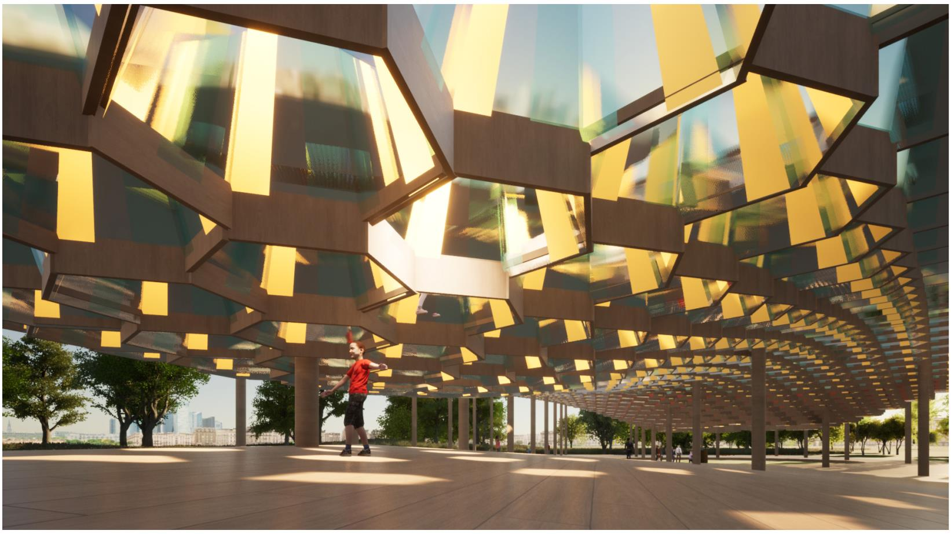

Summary
I. Project statement .................................................................................................................3
II. Modular structures conceived for both inhabitants and public...............................5
III. Conceiving an interactive and ever-changing space.................................................6
IV.Technology...............................................................................................................................7
V. Cost estimate.......................................................................................................................10
VI. Modular system: details...................................................................................................11
Appendix: conception of a prototype model...................................................................18
LAGI 2022
2
Kaleidoscopic Dune

I. Project statement
Our response to inclusion of renewable energy sources:
The Spinelli barracks once used by the German Wehrmacht as a pioneer barracks and by the US
army as a warehouse is to be dismantled and connect them to a continuous green corridor, which
would improve the microclimate and supply fresh air in the surrounding districts in the long run.
The aim of our design is to apply the principles of modularity, scalability with a focus on the renewable
energy generation and sustainable sourcing of materials. Also, the design was based on the idea of
reassembly so that it can be reassembled elsewhere without the need to be fabricated.
Our design was inspired by light and it is evident in the choice of our renewable energy technology,
the inclusion of kaleidoscope and bioluminescent plants.
A concentrating solar collector was chosen as it can give more energy output for the same photo-
voltaic cell area. The energy generated by the photovoltaic cells will be used to power the pavilion
and its equipments namely, light for the concert area, cell phone charging points, musical instru-
ments, electric vehicle charging points. The remaining energy is then sent through the grid to be
used by the city of Mannheim.
A Kaleidoscope is equipped to the wooden construction so that it gives a unique visual eﬀect. Bio lu-
minescent plants have also been included so that less energy for light can be used during the night
time. Our design takes into consideration the location, locality, site history, future expectations so
that a holistic solution can be proposed. Therefore, with the mission to inspire the community about
renewable energy technologies, we propose this design with the technological inclusions.
The yearly AC power output for our main structure is about 84.88 MWh.
Environmental impact summary
LAGI 2022
3
Kaleidoscopic Dune
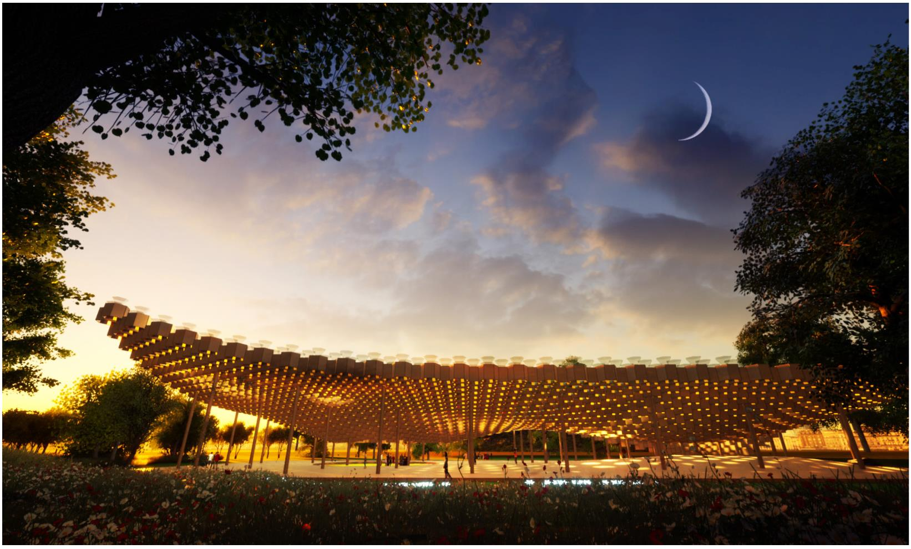

Our design is rooted in the principles of modularity, scalability, innovations of renewable energy ge-
neration and sustainable sourcing of materials. The aim is to generate enough renewable energy
from the sun to power the pavilion, its equipments and pass the remaining energy to the city of
Mannheim through the power grid.
Firstly, renewable, and reclaimed wood is sourced to build the structure. The machine operations are
simple and direct which makes it easier for mass production ensuring that the time is saved. Then
the wooden parts are coupled in a male-female system so that additional elements for ﬁxing of the
parts are eliminated. The intention is to collect the wood on site and from the nearby demolition
areas to reduce the carbon foot in material transportation.
The timber used is light timber so that it is easier to be transported and less energy is consumed
for transportation. For other materials, prefabricated products with low environmental impact will
be used to complement the proposal’s intent. The structure does not require heavy maintenance
and regular checks can ensure that large repair costs can be avoided. The structure has been de-
signed based on the principles of modularity and scalability with a high reassembly potential. This
means that the structure if it is built once can be reassembled elsewhere, without the need to be
fabricated again.
In conclusion, our proposal has low embodied energy in building materials, low energy intensity of
construction methods, high modularity and scalability and excellent reassembly potential.
Our proposal aims to inﬂuence the community about the extraordinary potential of renewable ener-
gy technologies and to encourage future designs to continually include them.
We can conﬁdently say that our project responds to many of the sustainable development goals, in-
cluding «Aﬀordable and clean energy», «Industry, innovation and infrastructure», «sustainable cities
and communities», «responsible consumption and production», as well as «Education» to a certain
extend, as our project as a recreational / learning aspect to it.
LAGI 2022
4
Kaleidoscopic Dune

II. Modular structures conceived for both in-
habitants and public
In terms as of planning, the ﬂexibility of our structure allows us to cater to the needs of both public
and inhabitants, as the system is highly modular. we chose to focus our intervention on an axis that
will be probably very used. We concentrate the more public functions: Concert/ exhibition / Event /
Light Experimentation, as well as siting areas / garden, at the center of the site, at the crossroad of
all the directions. We dedicated smaller, more intimate area for the inhabitants, alongside this same
road with private gardens, playgrounds, and observatory.
We chose to focus our intervention on an axis that will be probably very used, as it deviates from the
main pedestrian axis, linking the «Theme gardens» and «Neo-Dune»
In addition, our project use bioluminescence plants to guide people navigate the area during the
evening, linking the diﬀerent pavilions. Those plants, created by a group of scientists, glow in the
dark. It is originally found in insects, sea creatures, mushrooms. The light of the plants, naturally
A group of scientists created plants that glow in the dark. This phenomenon is Bio Lumines-
cence. It is found in insects, sea creatures, mushrooms. They made it glow by injecting DNA from
glowing mushrooms into them. Their report says that plants injected with the DNA from the glowing
mushrooms glowed continuously throughout their life cycle from seedling to maturity. The light is
formed from a chemical reaction in the body. In the case of animals, the glow is used for diﬀerent rea-
sons including communicating with each other, ﬁnding prey, hiding from or warning oﬀ predators and
aꢀracting a mate. As much as 76 percent of ocean animals are bioluminescent, producing their own
light through a series of chemical reactions or containing bacteria give oﬀ light.
LAGI 2022
5
Kaleidoscopic Dune
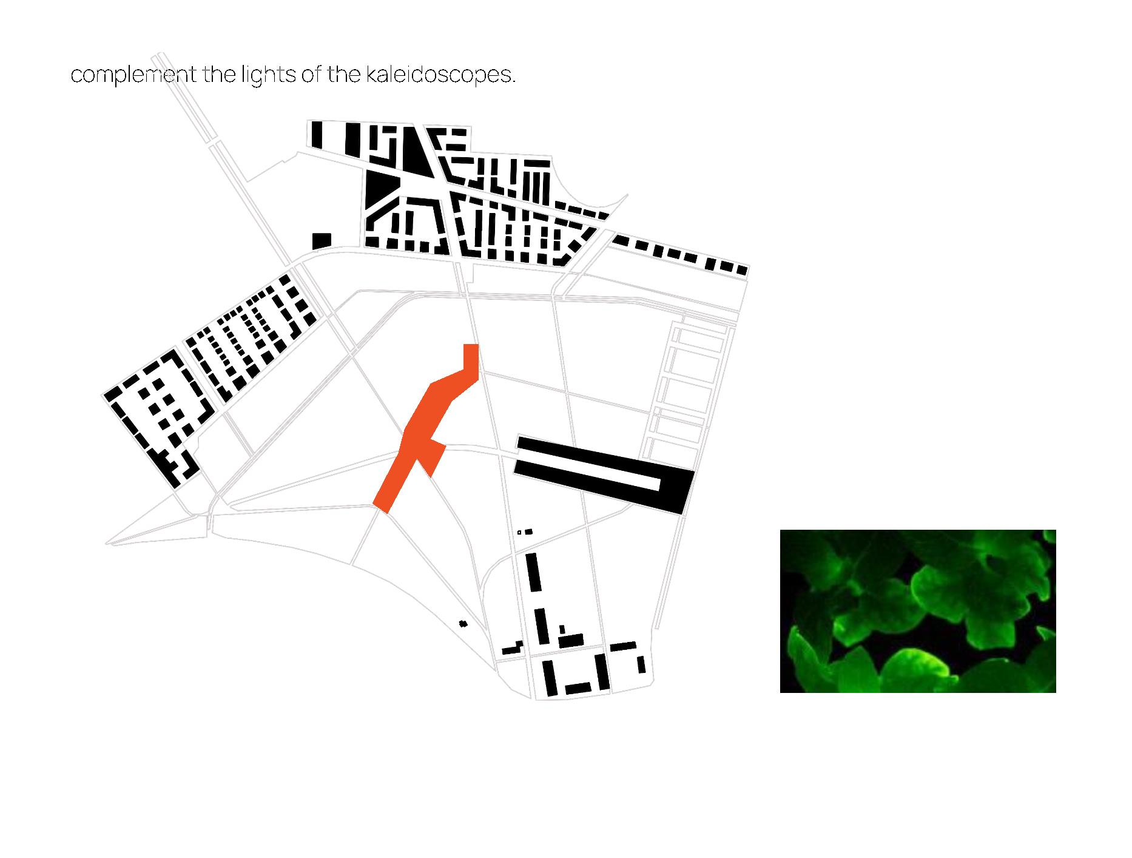

III. Conceiving an interactive and ever-chan-
ging space
Mankind has been living on the earth for a long time. It can’t be denied that in order to live, humans
need many elements from nature, ‘Light’ is one of the main elements that we need for living. We have
been using light for many activities, such as hunting, cooking, celebrating, or even for a funeral. It can
be seen that we can’t live
without ‘light’. Therefore, in this project, we would like to design a project that aims to celebrate the
relationship between humans and light, we would like to present another beautiful aspect of light
and we also would like to present the idea of how can we use the combination between technology,
art, and light to generate electricity in order to provide and inspire an idea of how we could produce
the clean energy and support the sustainable goal of the world.
The idea of this project is to design a modular structure system that can be adjusted to several de-
signs and can be connected to each other in order to create a bigger pavilion. One modular system
consists of more than 70 hexagonal kaleidoscope solar cell module. Inside Each hexagonal module
has a color glass and reﬂective glass which will reﬂect the light and it will create a kaleidoscope
eﬀect in the pavilion where users could experience another aesthetic or light during the daytime
and nighꢀime. On the top of hexagonal modules, we design an automatically rotatable solar system
that will harvest the sun’s energy in order to be used for activities in the pavilion and to be used in
Manheim city.
LAGI 2022
6
Kaleidoscopic Dune
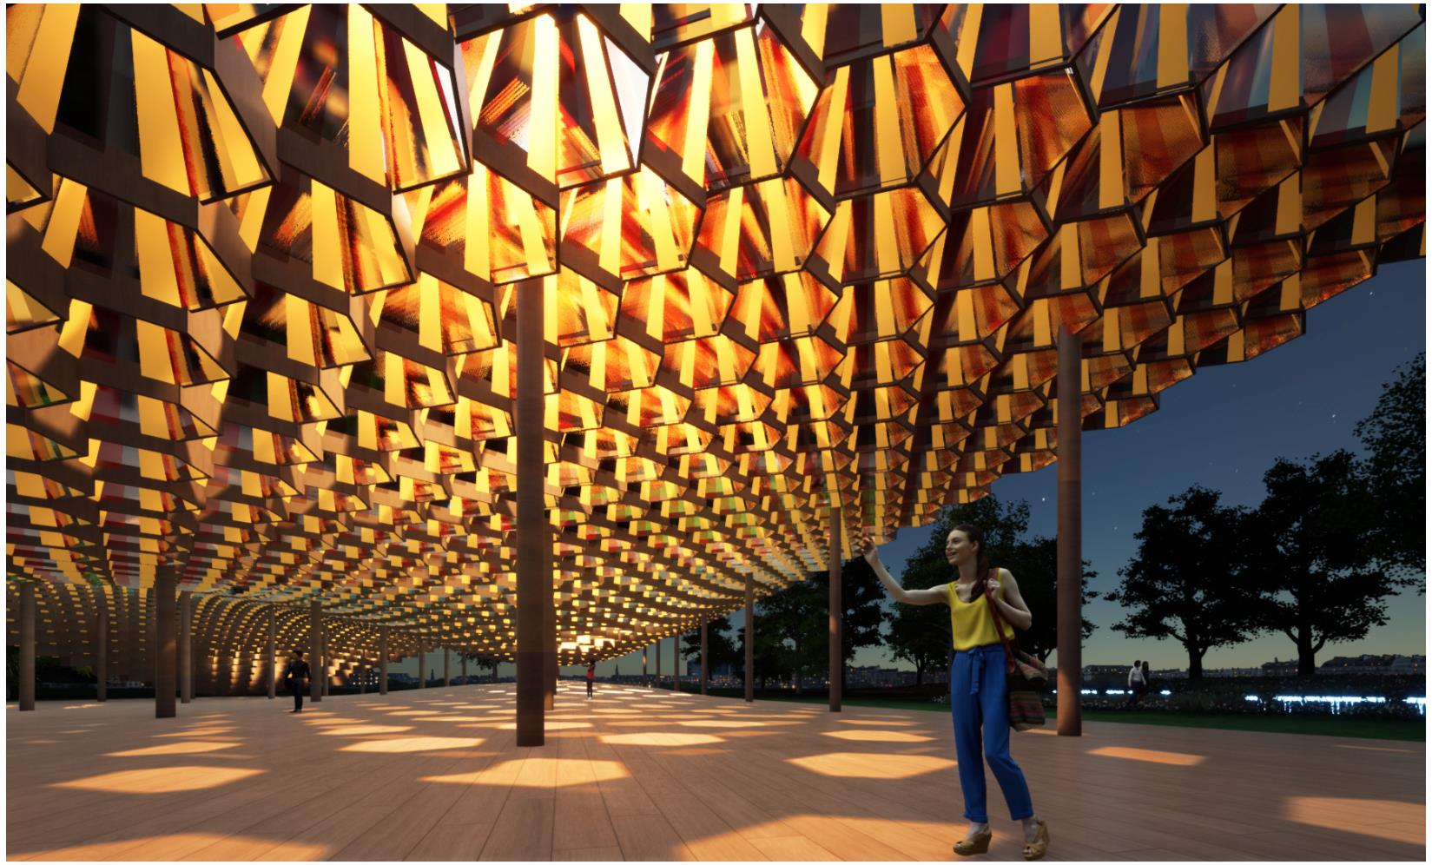

IV. Technology
Tracking system
rotational axis
rotational axis
A responsive facade system based on concentrating solar collectors called the Integrated Concen-
trating Solar Facade (ICSF)
The individual pyramid-shaped suspended glass modules can capture 85% of sunlight by moving
around a pin, rotating around the horizontal and vertical axis to respond to the path of the sun and
maximize the natural lighting. The structure of the pyramidal glass is particularly complex because it
is characterized by a primary (POE) and secondary optical element (SOE), a highly eﬀicient concen-
trator photovoltaic cell (CPV), and a water heat exchanger (HX).
The tracking system used is a bi-axis tracker which optimizes the position based on the altitude and
azimuth of the sun at that point of time for a particular location. The GPS sensor tracks the position
of the sun and provides the input to the altitude and azimuth positioning controller. They inﬂuence
the motor drivers and stepper motors to change the position accordingly. Then the information is
passed to an azimuth or altitude value encoder which provides feedback to the azimuth or altitude
positioning controller in a loop.
LAGI 2022
7
Kaleidoscopic Dune
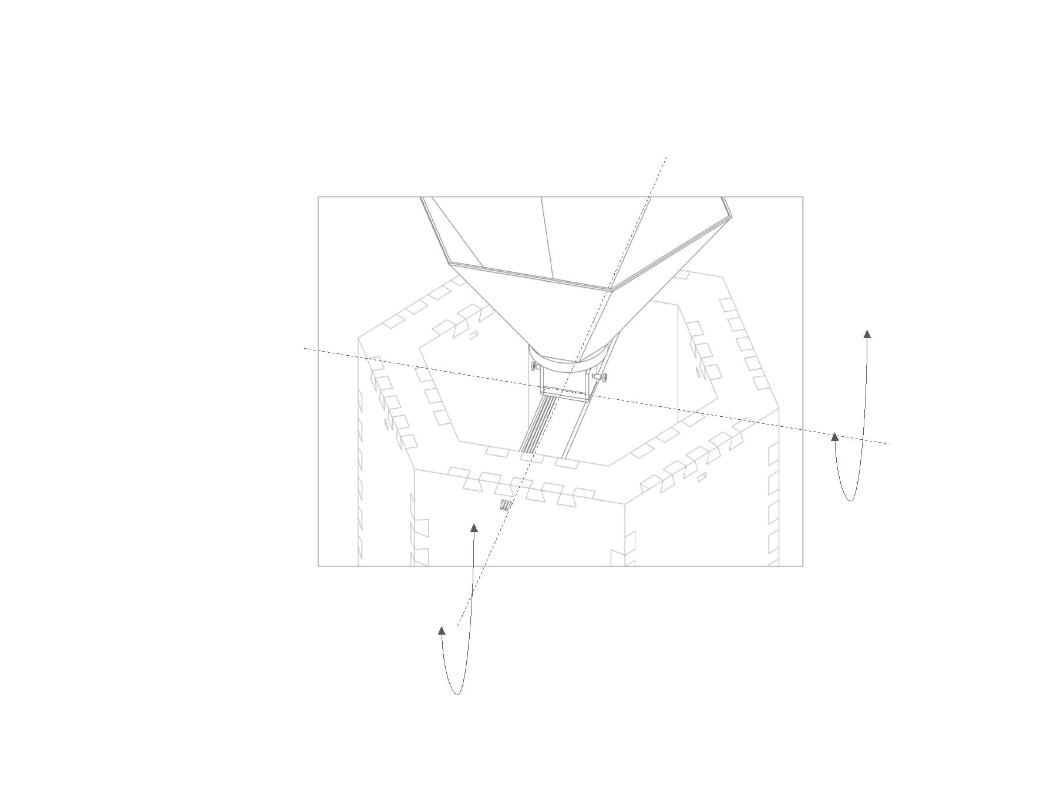

LAGI 2022
8
Kaleidoscopic Dune
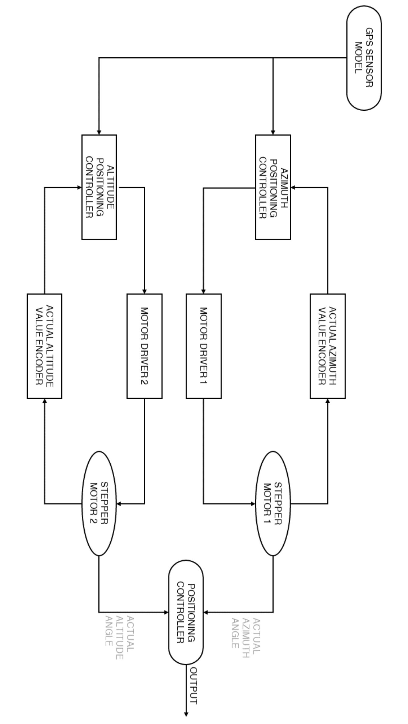

The type of photovoltaic system used is a solar concentrating system with the help of a fresnel lens.
The photovoltaic cell (PV) has an initial contact layer which is placed side by side to anti reﬂective
coating. The top cell comes beneath this and is made of Indium Gallium Phosphide. The wide band
gap tunnel junction is underneath the top cell layer. The middle cell layer is made of Indium Gallium
arsenide. Then comes the tunnel junction beneath it. The region which acts as a buﬀer is then un-
derneath it and it is followed by the nucleation layer. Then the boꢀom cell made of Germanium is
under this, followed by the contact layer.
A multi-junction solar cell has multiple layers of diﬀerent semiconductor materials, each of which
produces electric currents in response to diﬀerent wavelengths of light. This means that, theoreti-
cally, multi-junction solar cells are capable of converting more sunlight that hits them to electricity
when compared to single-junction cells.
They produce electricity through the photovoltaic eﬀect. Light is absorbed by solar cells and elec-
trons in the semiconducting material. Loose electrons ﬂow through the p-n junction between se-
miconductor layers, creating an electrical current. The current is captured and transferred to wires.
Single-junction solar cells have one p-n junction to direct the ﬂow of electricity created when sun-
light hits a semiconducting material. In a multi-junction solar cell, there are multiple p-n junctions
that can induce a ﬂow of electricity.
LAGI 2022
9
Kaleidoscopic Dune
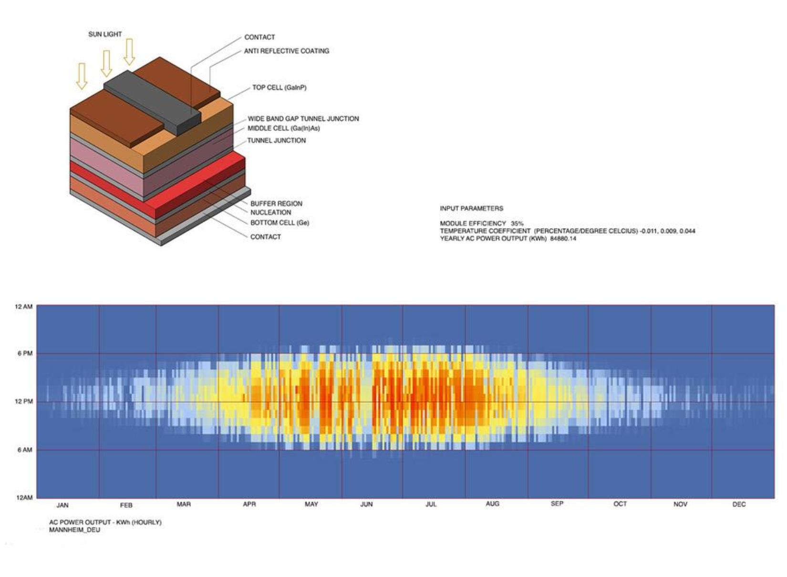

Electrical System Details
Sun’s energy is the main input for our electrical system, each hexagonal module will harvest the sun’s
energy and every electric wire will be connected, and it will be combined into one electric wire. These
energies will be store in the main baꢀery which is located in between the foundation structure and
it will distribute to ﬂoor power outlets located at the 4 corners of the module.
Light bulbs
Charge controller
DC Load
Musical instruments,
electric vehicules,
cell phones
PV Module
Power grid to
Mannheim
city
Baꢀerie
Inverter
_{Switch contro}l
AC Load
Back up
power
V. Cost estimate (main pavilion)
LAGI 2022
10
Kaleidoscopic Dune
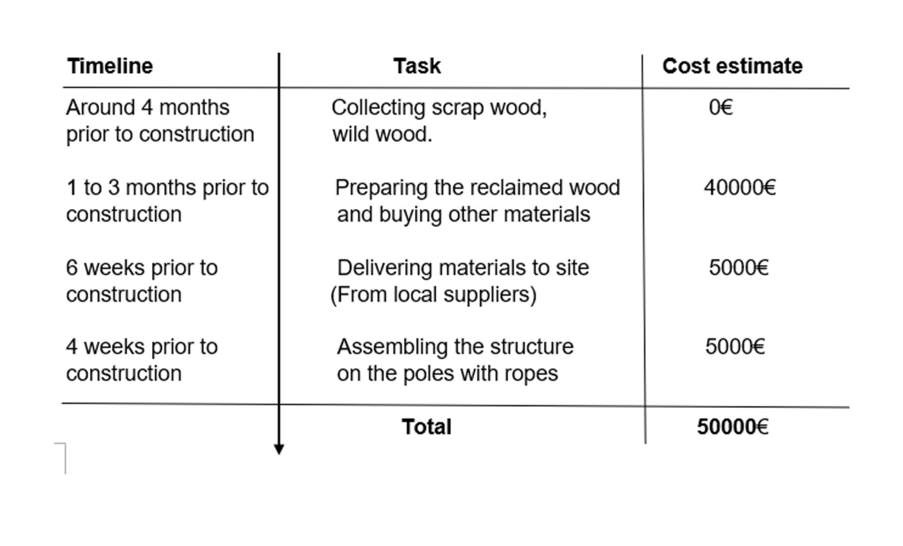

VI. Modular System Details
Top Anchor Point
Kaleidoscope
Solar Cell Module
Bottom Anchor Point
Floor
Galvanized
Hex Bolts
Manila Rope
⌀ 40 mm
Metal Plate
10 mm
Metal Plate
10 mm
Manila Rope
⌀ 40 mm
Hollow Steel Post
⌀ 20 mm
Tension System 2
The second point which need to be connected
by the tension system is the 4 corners of the
structure.
Tension System 1
At the ﬁrst tension system point, at the top
of the post, there are 4 metal plates that are
connected with the Manila rope for creating
tension.
LAGI 2022
11
Kaleidoscopic Dune
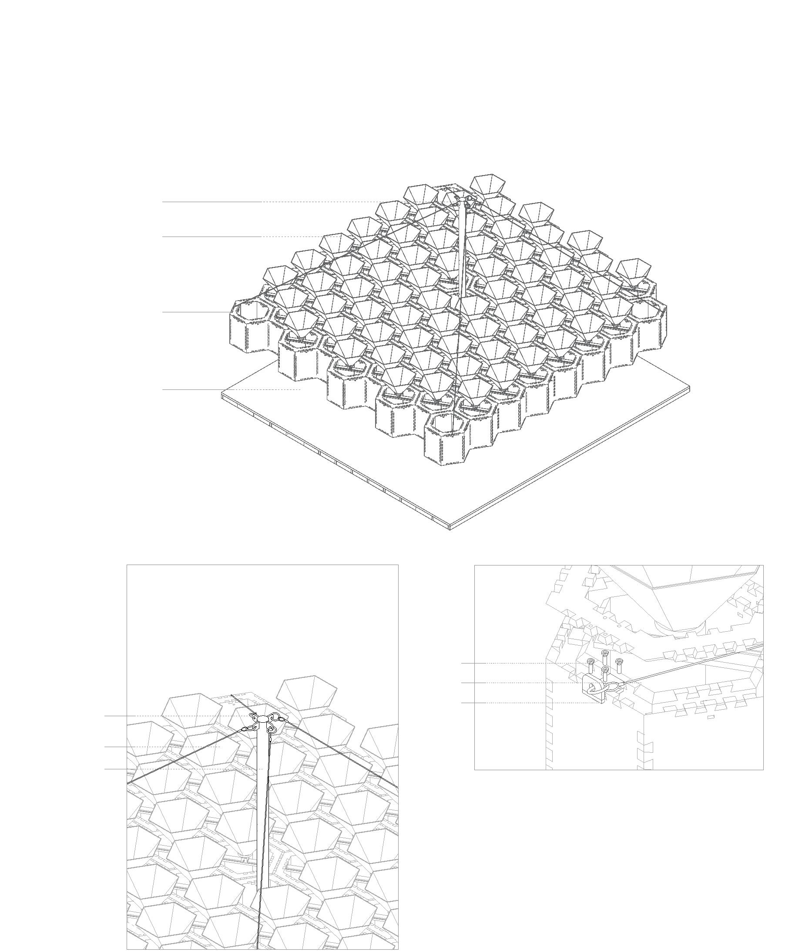

Alternative
Roof Shape
Flat Roof
Alternative Designs
The system that we’ve designed can be
adjusted into many designs by adjusting
the height of each hexagonal module and
they can be connected to each other in or-
der to create a bigger space.
LAGI 2022
12
Kaleidoscopic Dune
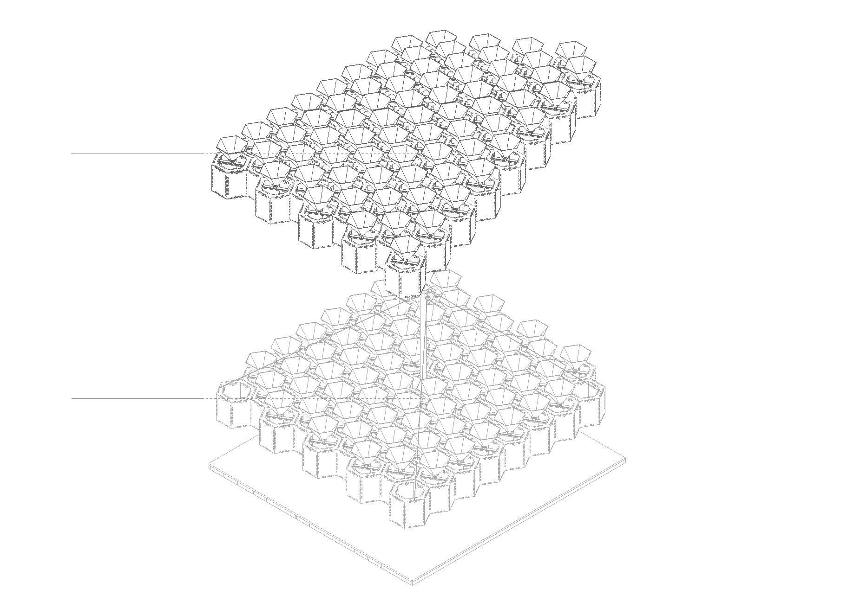

Kaleidoscope Solar Cell Module
Solar cell
Mirror
One Hexagonal Module
In one kaleidoscope module
consisits of the solarcell system
and the kaleidoscope system
Kaleidoscope Module
Coniferous Lumber
60 mm
Joint
The dovetail joint is used for the
joint system in order to reduce
unnecessary materials.
Dovetail Joint
@ 50 mm
LAGI 2022
13
Kaleidoscopic Dune
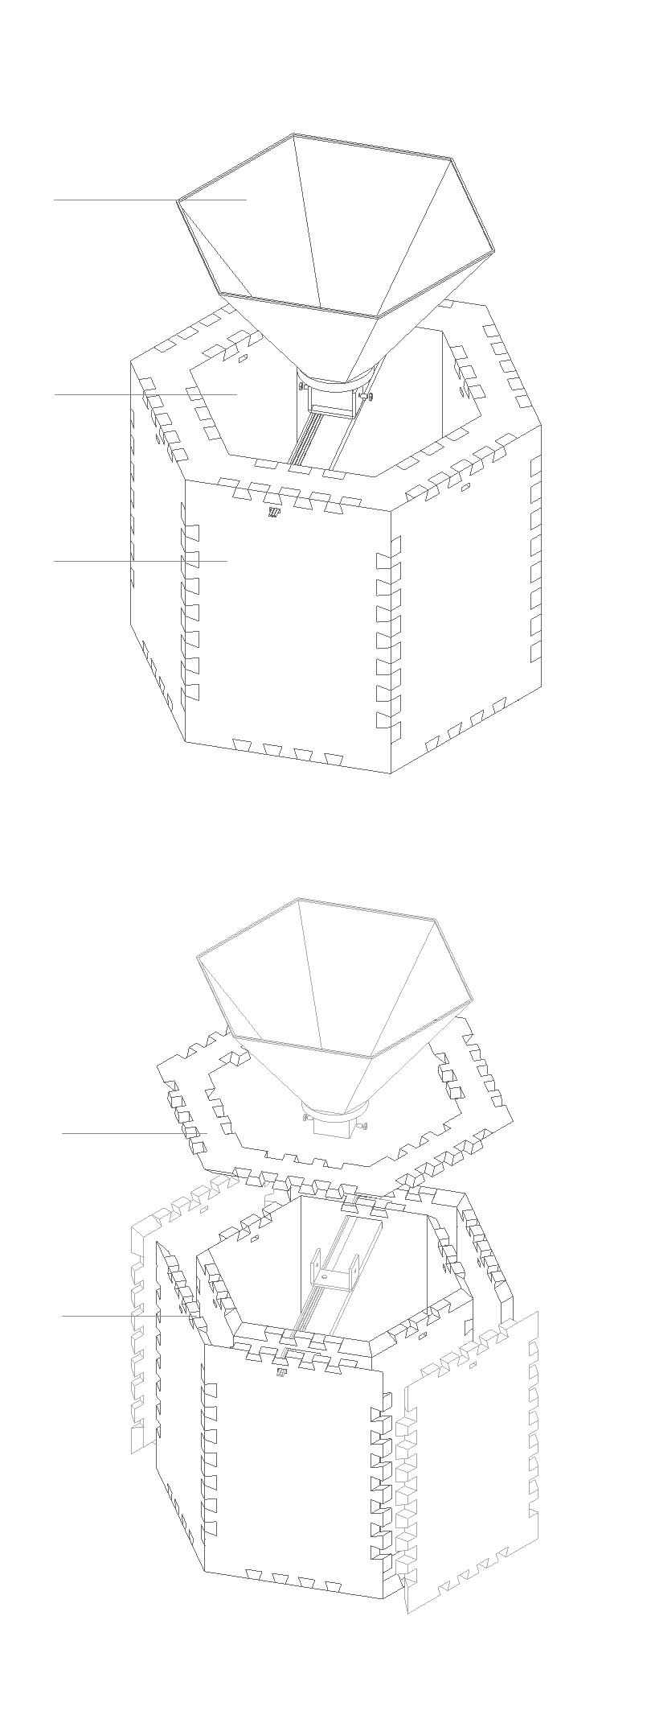

Rotation Joint
10 mm
Galvanized Hex Bolts
Transparent Acrylic
10 mm
Wire Connector
20 x 40 mm
Solar Cell System’s Detail
The solar cell will be connected to
the rotating joint which will make the
solar cell harvest the sun’s energy
from any direction.
LAGI 2022
14
Kaleidoscopic Dune
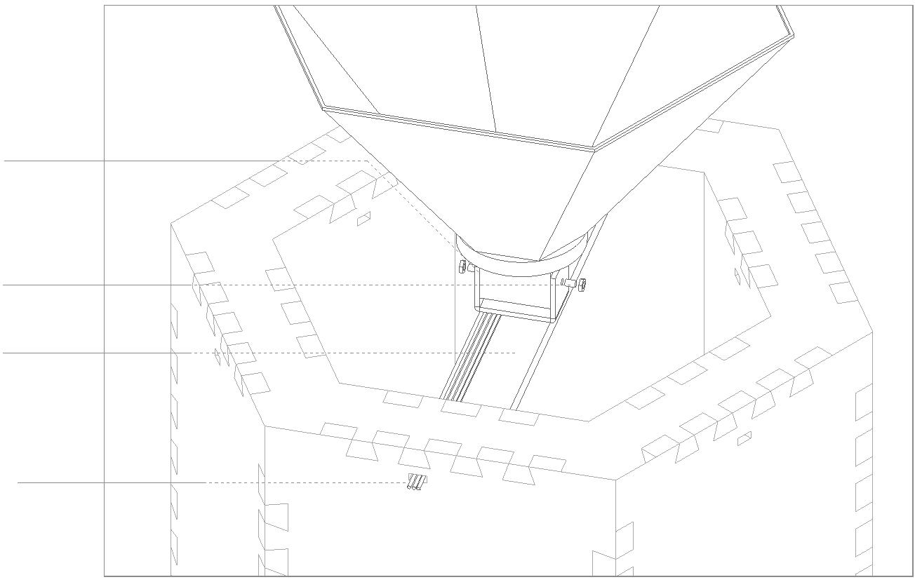

Female Joint
Male Joint
Joint Between Each Modules
This part consists of 2 elements,
male and female joints. They can
be easily connected to each other
with the dovetail joint.
Male Joint
Detail of Joint Between Each Modules
In order to connect between each module, the male and
female joints need to be cut at a
speciﬁc length according to the pavilion’s height.
LAGI 2022
15
Kaleidoscopic Dune
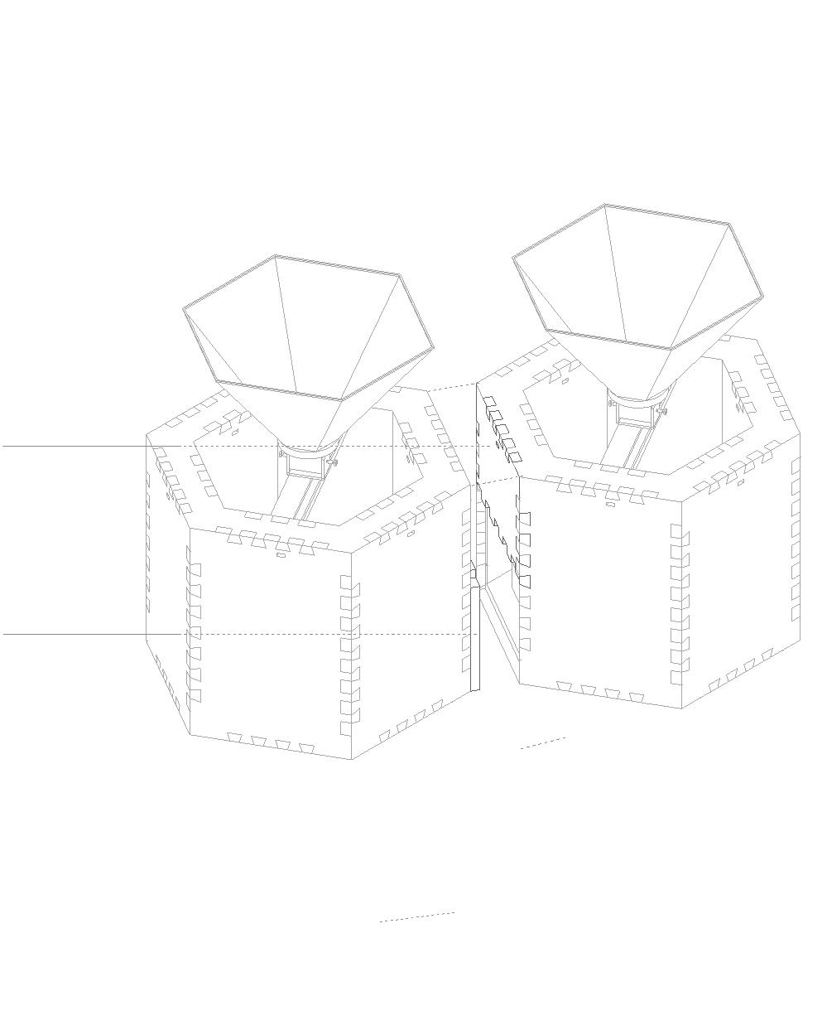
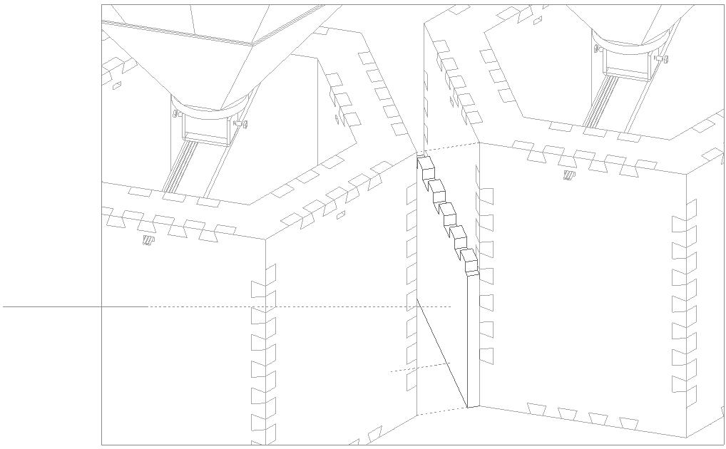

Main Pavilion
Exhibition Space
Semi Outdoor Concert Space
+ 9.00 m
▽
▽
+ 8.00 m
+ 1.00 m
+ 0.00 m
▽
▽
0.50 m
1.00 m
1.00 m
1.00 m
1.00 m
1.00
10.00
A
B
C
D
E
Section
LAGI 2022
16
Kaleidoscopic Dune
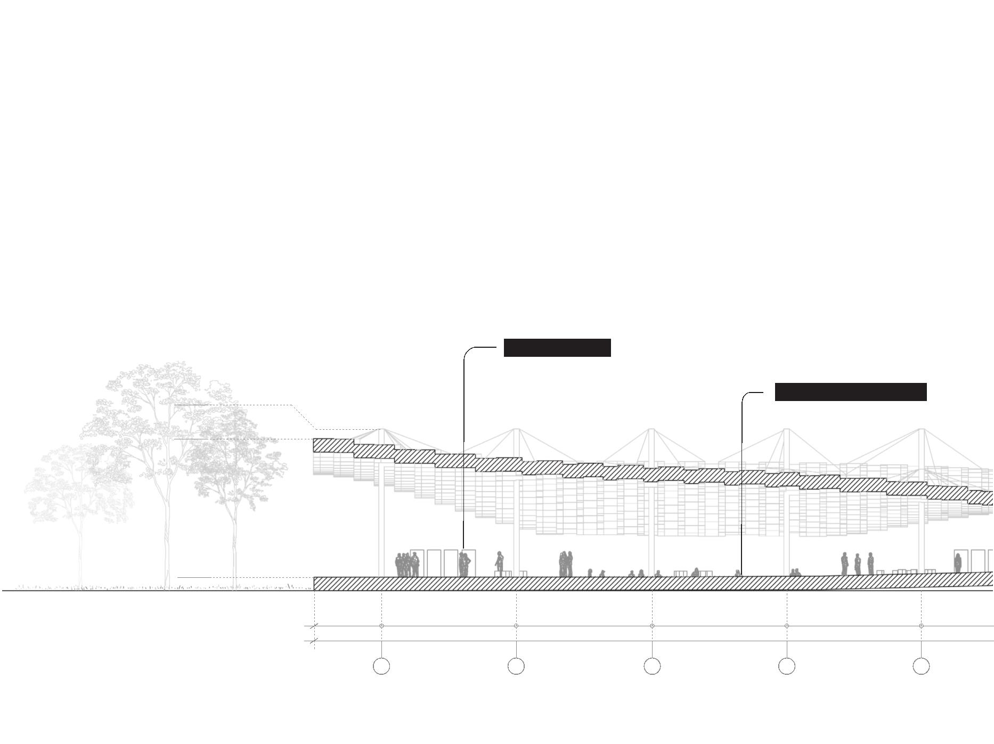

Semi Outdoor Concert Space
Kaleidoscope Modules
Exhibition Space
Relaxing Space
Light Testing Space
Entrance
Kaleidoscope
Solar Cell Module
Light Testing Space
Roof Tension System
Bioluminescent Plants
0 m
0 m
1.00 m
1.00 m
1.00 m
1.00 m
0.50 m
F
G
H
I
J
LAGI 2022
17
Kaleidoscopic Dune
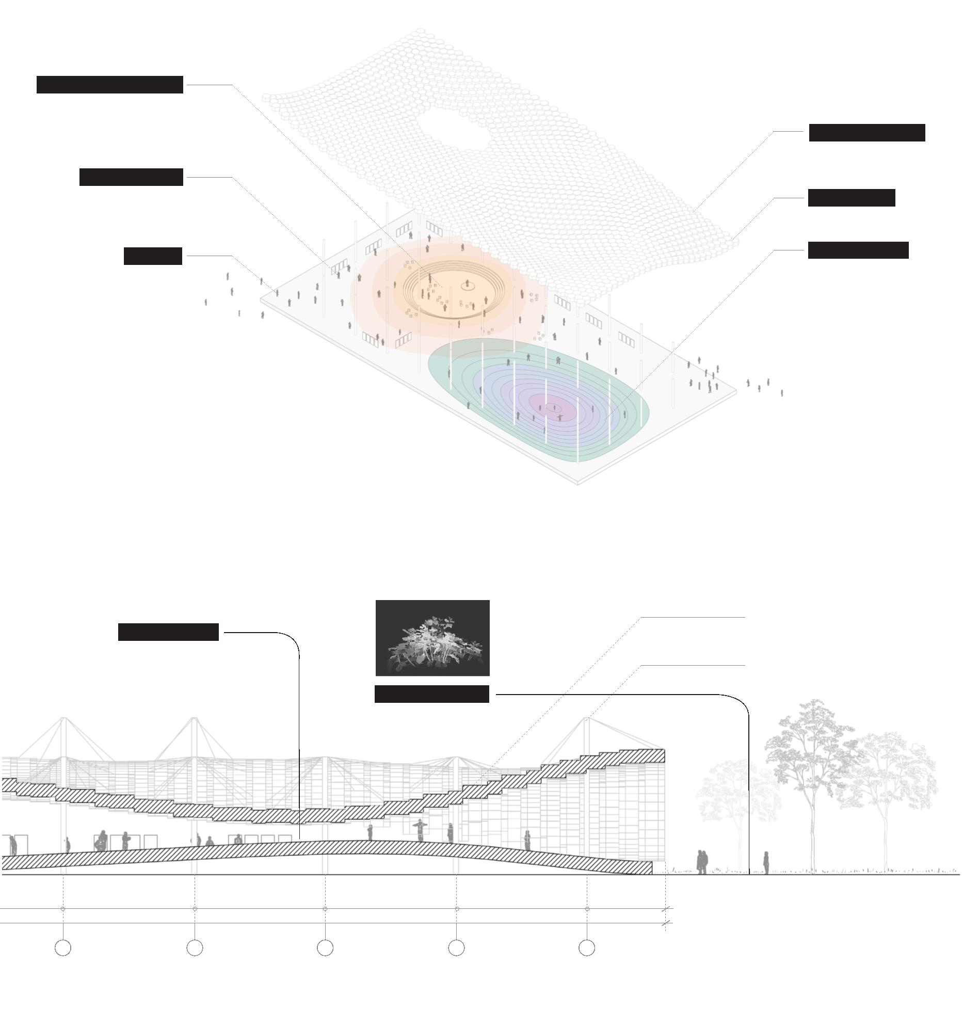

Appendix: prototype model
We wanted to experiment
the kaleidoscope eﬀect by
creating a physical model
that would help us beꢀer
understand. We tried to
combine both color from the
ICFS system as well as addi-
tional colors within the ka-
leidoscope and then tested
out its eﬀect at diﬀerent
times of the day.
LAGI 2022
18
Kaleidoscopic Dune
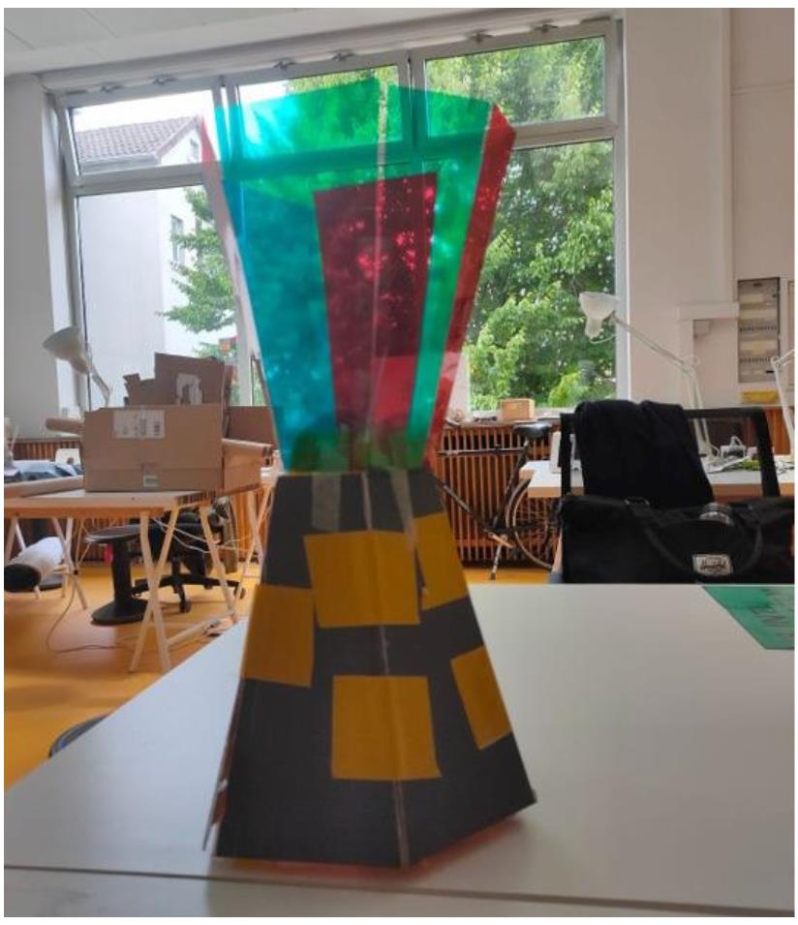
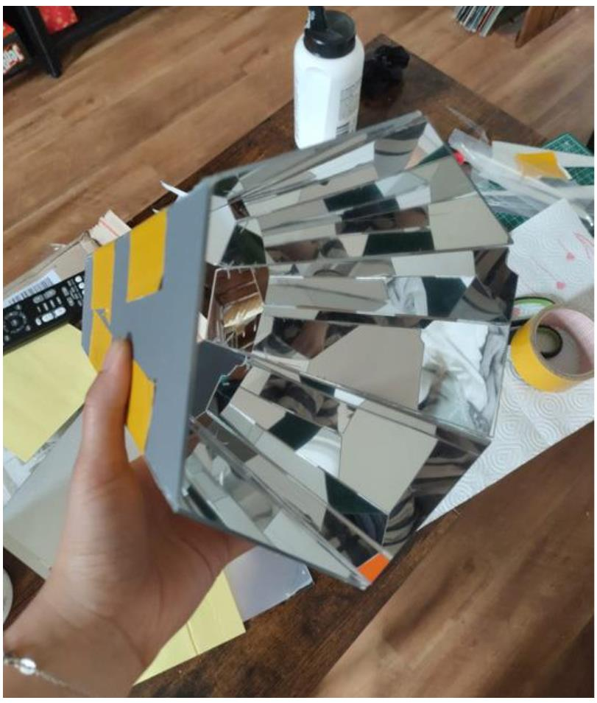
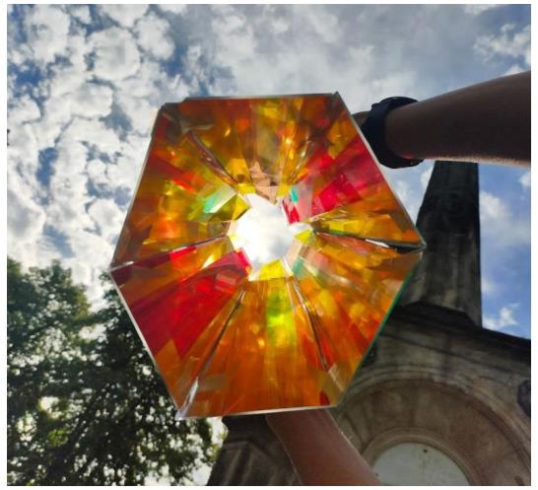
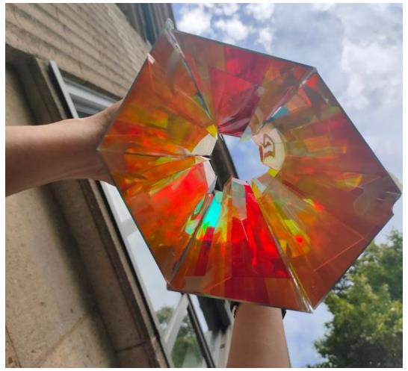
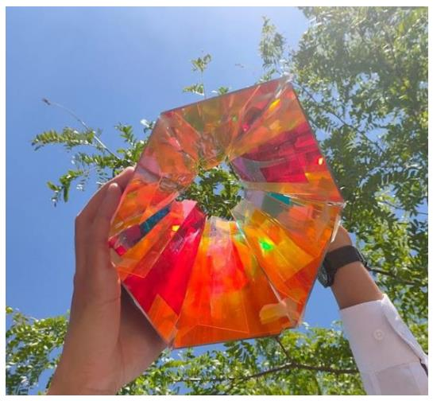
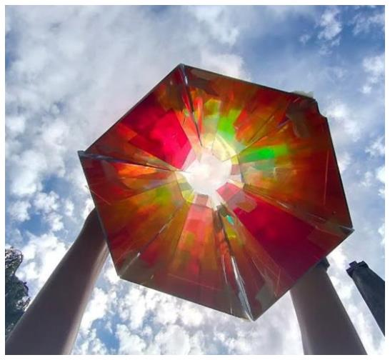
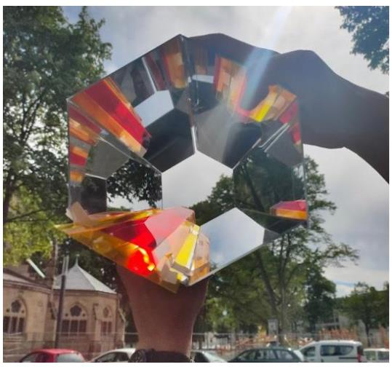

Appendix: prototype model
LAGI 2022
19
Kaleidoscopic Dune
