H.E.A.R.T
Holistic Engine for Adaptative and Restorative Transformation

1_What we TAKE
The love of the life bringers
From the center of the park, we take up the inspiring example of Dominic Spinelli. His love for people and his generosity are the starting point to resume his initiative to keep the local people alive. To strengthen the community.
Spinelli's heart is also Mannheim's heart. We propose a space to celebrate love for our planet. A square that functions as a heart. This "Holistic Engine for Adaptive and Restorative Transformation" (H.E.A.R.T.) recalls the Neckar River, and its ancient channels, as the one that gave life to this part of ​​Europe and part of its current form to the city. In this way, H.E.A.R.T. uses water, to reconnect people in the section of the Völklinger axis that intersects with the train tracks that start from the current U Hall and the projection of the street axis that reaches the churches of St. Hildegard and Philippuskirche.

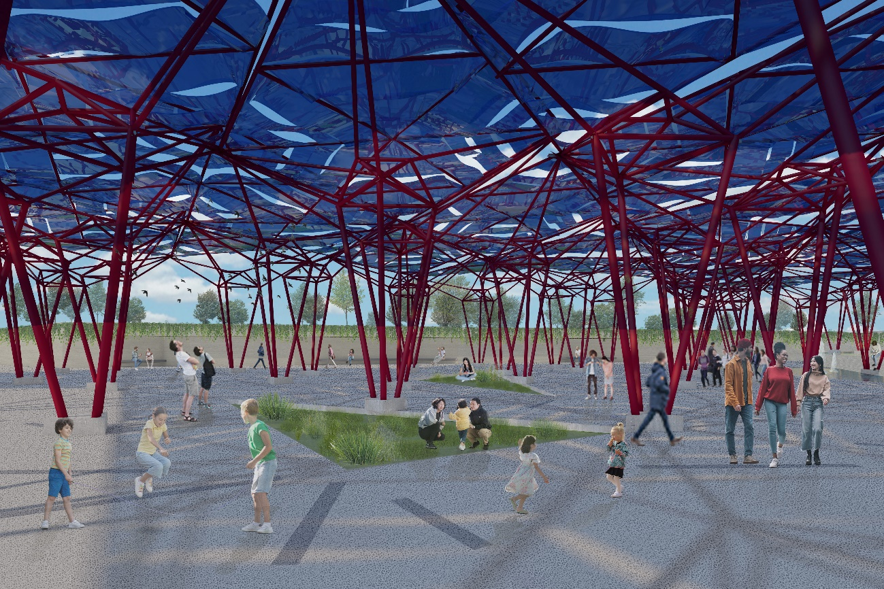
2_What we TRANSFORM
The heartbeat
The land beats and rises slightly a few meters above the ground level, forming a small hill. We use part of the earth and the stones that are excavated to build the new buildings and give them new life, as part of the support of a public nursery garden.

Water, wind and living beings erode this mound, with a network of canals, like veins, that take wastewater from the neighborhood to return it clean and reusable for irrigation of the park and neighborhood. Its force models the stone on the walls and floor in such a way, that forms a fissure containing a new space in Mannheim’s landscape.

Nature breaks through and emerges, in the form of trees and combined with technology, to make new artificial processes of photosynthesis. With the collection of solar energy, it is possible to keep the water pumping and cleaning system in operation, support the lighting of the area and to return some energy to the community.

The core of this gesture in the landscape serves as a public and educational space for children, supporting the Bertha Hirsch School and the Joseph Bauer House Nursing Home, and for adults, as a gathering and productive site.

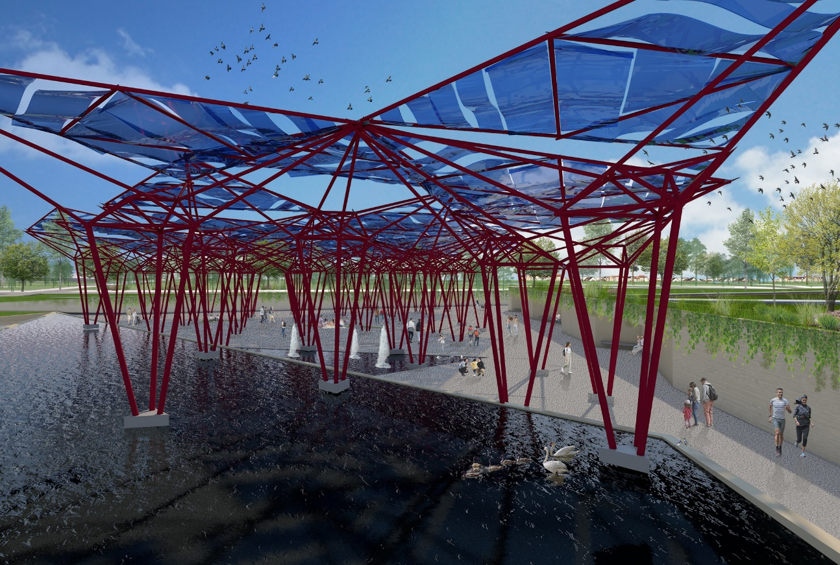

3_What we RETURN
Pumping it up
One of the goals of H.E.A.R.T is to return borrowed resources from the planet.
We recirculate wastewater from the neighborhood and return 3141,40 gallons of clean water to maintain parks or public buildings in the area. The flexible solar panels generates 2197,97m2 of friendly shade and at the same time are used to generate 439,594 mwh of energy (at 20% of efficency) while the wind shakes the surfaces and gives them movement so that, from a distance, it appears to be beating, like a heart.
We promote the responsible use of the soil and self-sustaining crops so that scalability is in how the neighbors start taking care of their crops at home and then be able to keep them growing on the terraces and, later, transplant them where they are needed.
We won a public space where sports can be played in an open space, but with some shade. Where children can play and learn about a posible future.

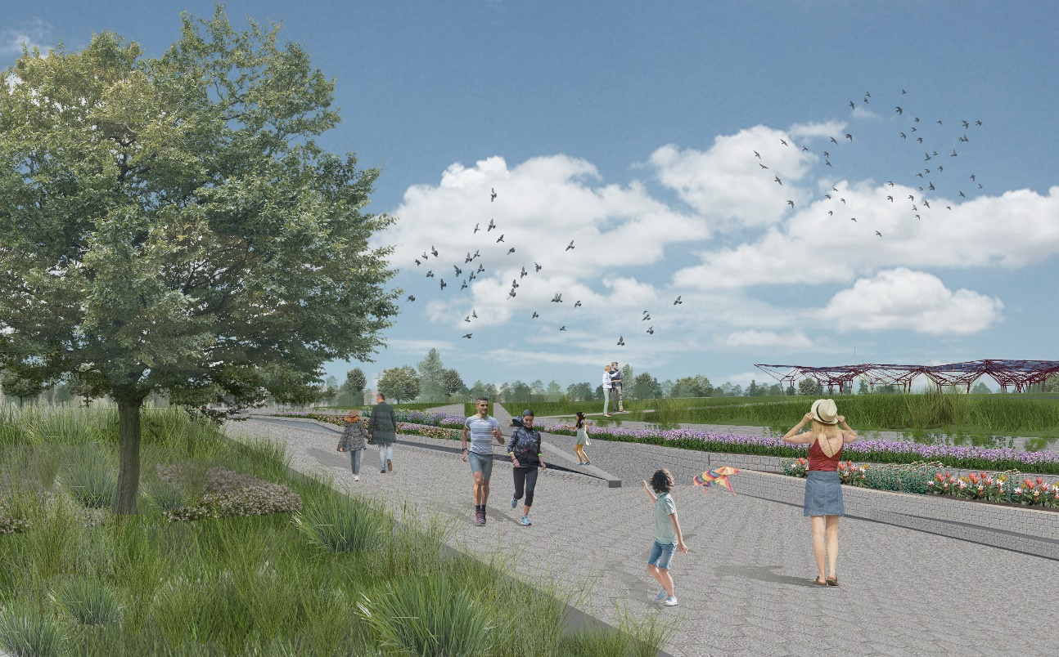
Environmental Impact
H.E.A.R.T. has the initiative to be self-sufficient. Not only generates energy for itself and shares it’s remaining with the community but provides with clean water with its water waste treatment pools. Both resources, solar and water, are essential for human life and being able to generate them helps reduce the environmental impact.
The worldwide generation of electricity and heat by burning fossil fuels such as coal, oil and natural gas causes a large chunk of global emissions. This is why H.E.A.R.T. generates energy with flexible solar panels which also create a plaZyful space to share with family, friends and pets. Having different water ponds also brings together native and migratory species, making a more diverse biodiversity.
This environmental impact can be measure in watts and liters per year, but creating a public space for integration and awareness can create a bigger impact. H.E.A.R.T. promotes love and diversity between people and nature, even though it belongs to a urban space.

