LAGI 2022 – Mannheim

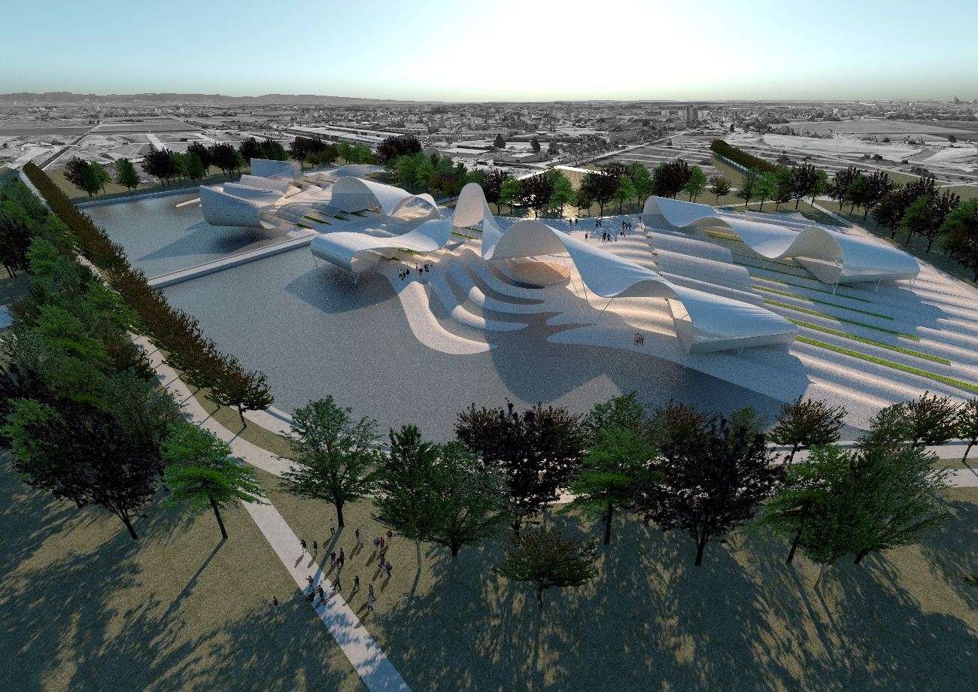

Rebirth:
An ephemeral moment in the movement of a ribbon pushed by the wind. The tape is time, the movement does not stop, the moment is our opportunity. The ephemerality of the balance of life and natural forces sublimated in an urban Land Art for reflection and enjoyment of life

Memory:
The Rebirth project takes place in a 68,168 m2 fraction of Spinelli Park in Mannheim.
It is an agrovoltaic installation that reproduces elements of nature, both in its objectives and in its formal appearance, and aims to minimize the visual irruption in the urban landscape.
It is a land art project that is not designed to stand out in itself, but rather seeks to be part of the geography and daily life of the region's inhabitants. It organically integrates the different aspects that a community requires, from food production, water collection and energy generation, to the recreational, social and cultural life of the community.

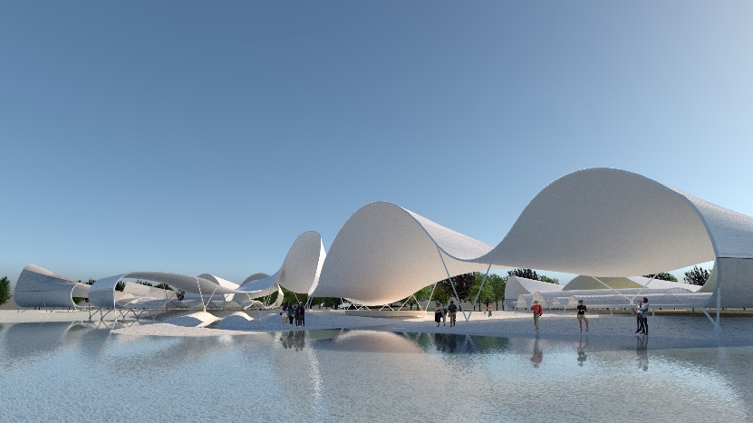

The vision of the project is that the people who interact in the space do so as those peoples who settled in new lands to obtain from them the basic benefits for the development and sustenance of the village.
With this objective, four primary elements are projected that are interrelated and, as in nature, are functional to each other:
-Soil
-Roof
-Water
-Vegetation
------
Soil:
On the surface of the entire fraction, some gentle undulations are reproduced that form channels for the collection of rainwater and contain lines of beds for the cultivation of small orchards, destined for the rotating production of 118.000 kg of food per year.
The construction of the floor is planned with a lining of irregular flat stones, embedded without any specific visual pattern.
The orchards are arranged in a staggered manner in the depressions generated in the terrain and are located in the areas facing south, with the aim of making the most of the incidence of sunlight.
The staggering in the layout of the crops proposes a front of greater efficiency in the use of solar energy in a smaller area. On the other hand, it facilitates accessibility for cultivation work.

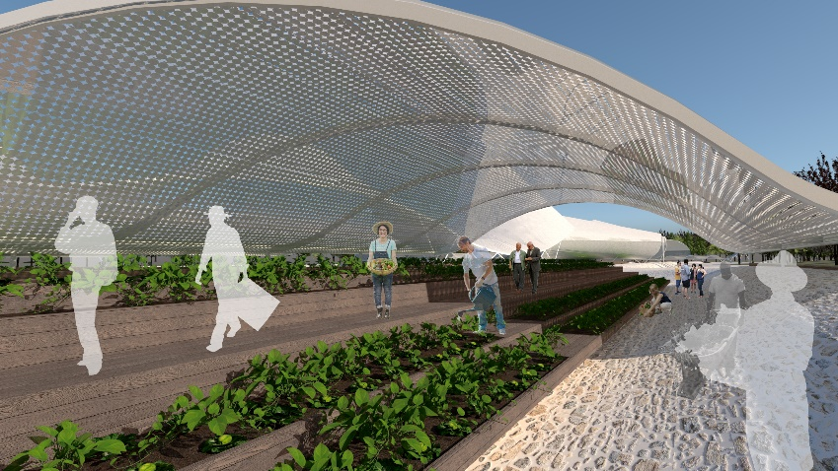

The cultivable 8.000 m2 are distributed between uncovered and covered areas to be exploited according to different types of crops.
The semi-transparent cover of photovoltaic cells reduces, conveniently for certain crops, solar radiation. Allowing to save irrigation water.
Those same covered areas can function as greenhouses for crops in cold times of the year.
---------
Roof:
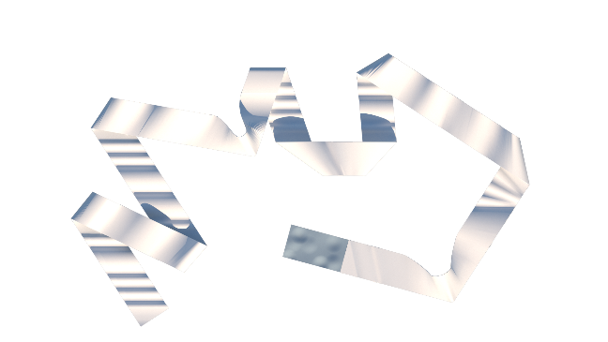
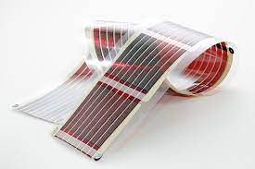
Organic photovoltaic Cell

The iconic piece of the project: an extensive strip of organic photovoltaic cells, built in partially translucent material with undulations and changes of direction, forms a set with the channels in the ground that determines an ordered linear space that is optimally used, both for energy harvesting solar and for agricultural production.
The undulating surface of the great ribbon is projected at different angles of inclination and azimuth, oriented towards the path of the sun, with the aim of maximizing the use of radiation values ​​throughout the year.
60% of this surface has a south orientation and will be exclusively made of photovoltaic material. In the east-west oriented surfaces, the aim is to improve the capture in the morning and afternoon hours, achieving a more uniform generated power curve throughout the day. With a flattened peak in the midday hours.
The energy production that our tape can generate allows us to supply the complete needs of the entire installation and the remaining accumulated energy to be injected into the city's electrical network.
Organic photovoltaic cells are flexible, can be semi-transparent and are also easily recyclable unlike silicon plates.

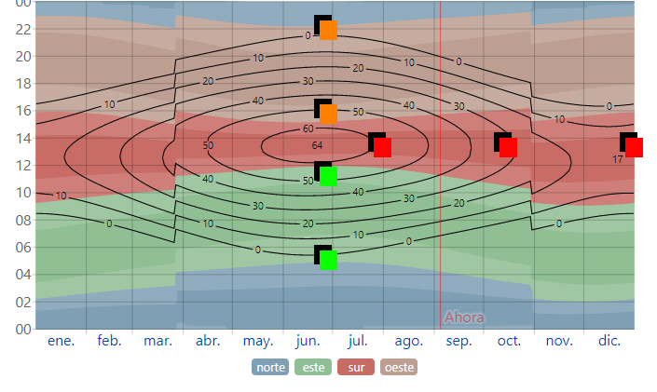
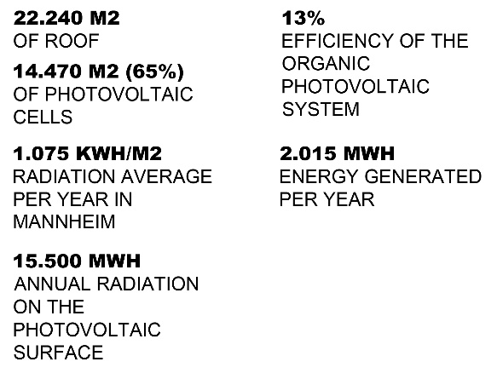

Solar elevation and azimuth in Mannheim

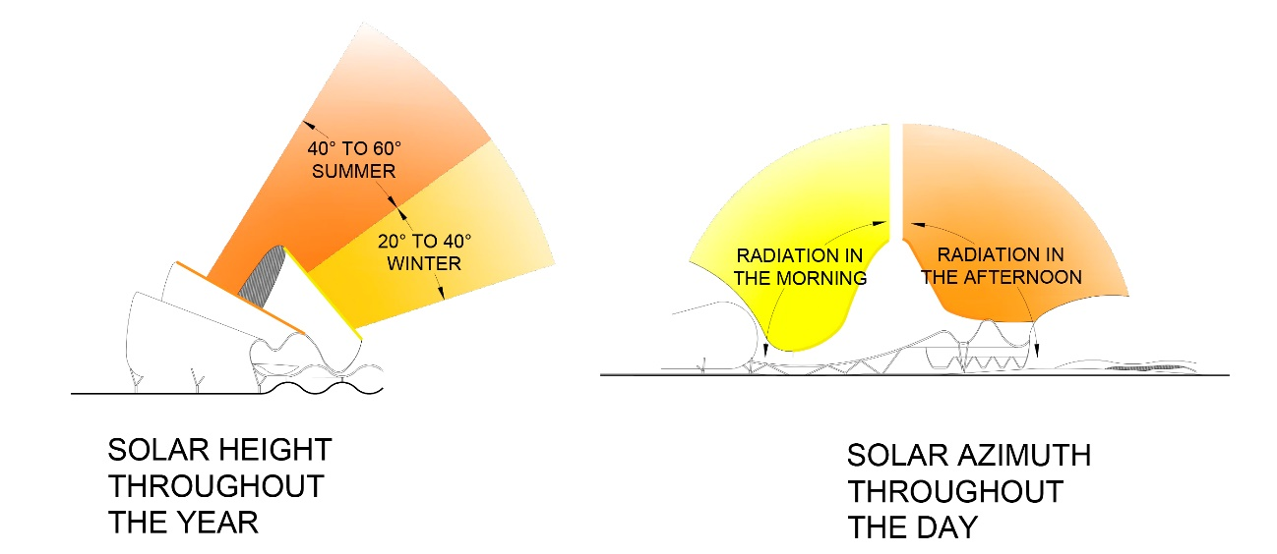
------

Water:
Two large water ponds divided by an access bridge from the city, are the reservoir used for crop irrigation.
The rainwater that falls on the entire lot, including the roofs, is conducted through the surface through the channels that form the undulations of the ground towards the ponds.
By means of a pumping system, the water is conducted from the ponds to the crop lines and to the ring of trees, through underground pipes.
To maintain the minimum levels of water reserves in times of low rainfall, water is extracted from the groundwater with underground pumps to feed the ponds.

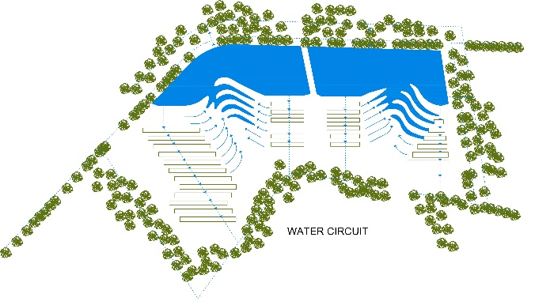

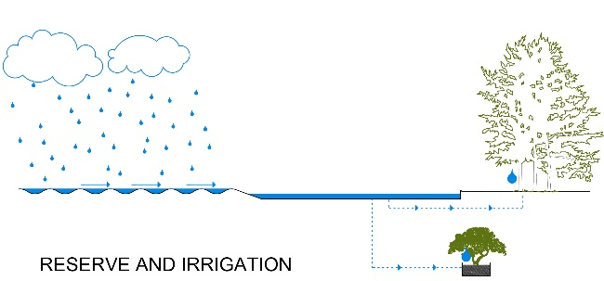

The water mirror is integrated into the concept of reproducing and visualizing a natural habitat. It fulfills an aesthetic and non-disruptive function and allows the use of the resource in a passive and sustainable way, avoiding the demand for water from the urban network to supply the project's requirements.
Another fundamental aspect of having a "lagoon" in the complex is the primary function of air humidification that favors crop production.
In winter, frost transforms the surface of a large mirror of water into a rink suitable for games and ice skating.

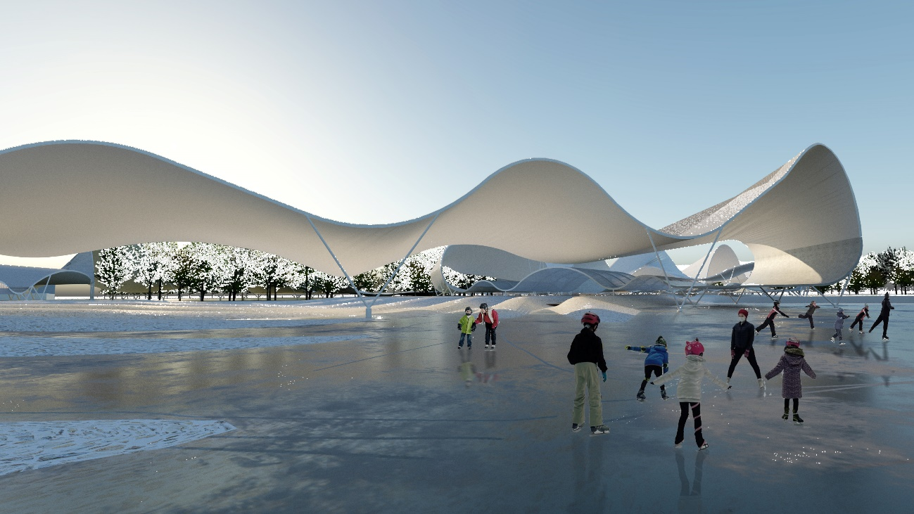

------

The vegetation
A ring of native deciduous trees is distributed along the perimeter of the property with a bio-environmental sense and reproduces the function of any leafy mass in nature:
-Improves climatic conditions in times of high temperatures
-Generates shade throughout the perimeter route that defines the park enclosure, generating social meeting points sheltered from the sun's rays.
-It allows to improve the air flows that cross the entire installation, collaborating with the reduction of the thermal sensation, together with the other elements of the park, placing it at more comfortable levels for users and walkers.
They manage the production of CO2 that can arrive from urban areas.
-In winter, when the foliage disappears, it generates an increase in temperature and improves the sunlight of the entire surface, thanks to the accumulation of heat energy stored in the stone floors.

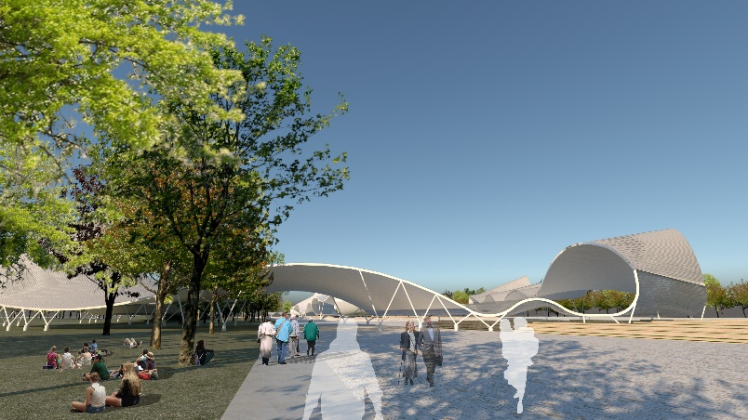

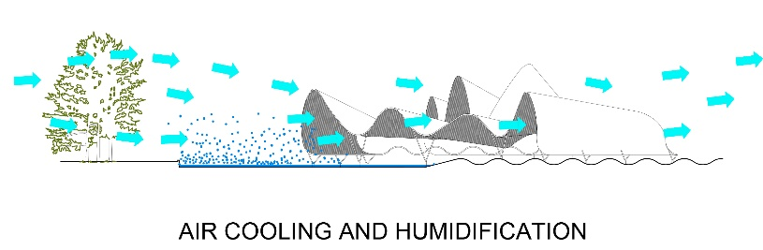

------
Symbolic and conceptual:
Rebirth is also a story from the perspective of the symbolic and conceptual.
In this sense, soil modeling has strong historical links and others related to energy and its forms of visual representation:
In principle, it refers to the furrows of the plowed land, a footprint as old as the one left by the first human settlements.
In counterpoint to the stone surface of the floor, the ceiling has an undulating but light and shiny laminar shape. A sheet that suggests the passage of the human being through life in a vision of the subtle and fragile balance that represents our intervention in the space in which we live to achieve survival.
Ponds are a mirror in which we can look at ourselves. They accentuate that pause in which the evolution of the species has acquired consciousness and, suddenly, it can see itself.
It is the brief and wonderful moment in which we can reflect and understand the risk, the fragility of all the scaffolding on which we build our development as a society.
Rebirth proposes a pause for reflection by emphasizing the idea of ​​the instant of frozen time.
------
Social Environment:
This project seeks to create a social meeting point. The facilities could be a place for development and experimentation in the field of agrovoltaics, giving rise to public, educational and entertainment enterprises or private “kleingartens” for family farming.

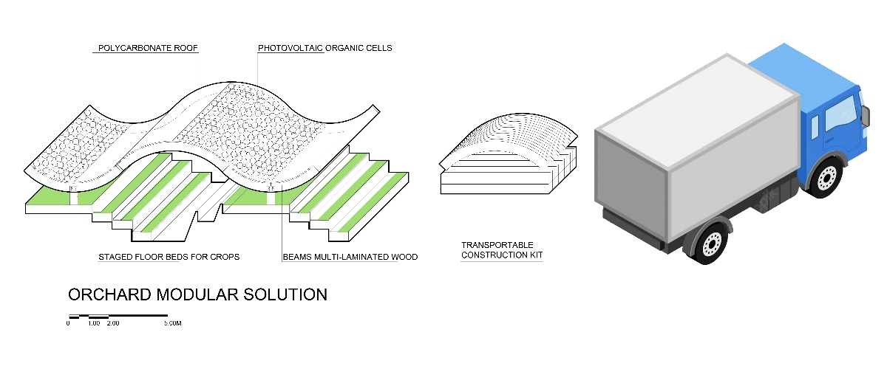
In this sense, the orchard section model is a repeatable unit at different scales for productive developments in other places that could form a network that stimulates cooperation and innovation in the agrovoltaic field.
It is proposed that the installation be an attractive icon of great significance within the city; that constitutes a new centrality within the Spinelli park.
The project appropriates the idea of ​​bringing the generation of resources closer to the city, retracing the path in which cities are only consumers of resources that are foreign to them.
The installation creates a new landscape and a new footprint in the territory in which society can design virtuous links and exchanges with the natural and social environment.
Rebirth is not intended to be immersed in the solemnity of a work of art for contemplation. In addition to the communication and staging of certain sustainable ideas, the aim is to transform the entire property into a stage for social activities on a different scale, some of which we list below, but which will depend on the proposals carried out. community:
-Fairs of agricultural producers,
-Music or performing arts festivals.
-Space for plastic artists with temporary or permanent exhibitions.
-Space for games and entertainment for walkers in the park of all ages.
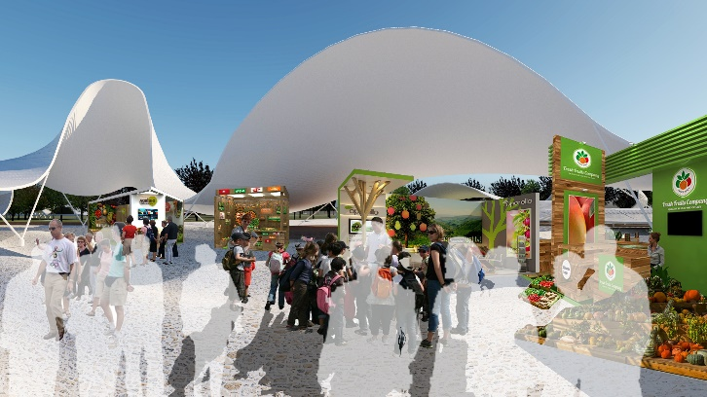
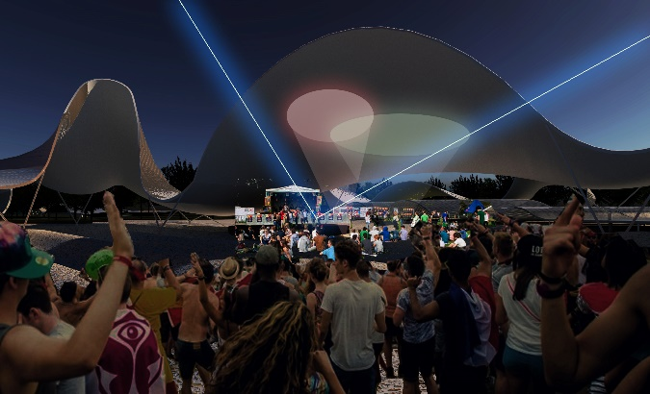

highlights
-The entire Rebirth project generates photovoltaic electricity with zero carbon footprint in its production, avoiding the introduction of CO2 into the atmosphere.
-It contributes to reduce the greenhouse effect that causes climate change on our planet.
-In the season of foliage and greater horticultural production, the installation becomes a CO2 absorber due to plant activity.
-It is a generator of food and
-It is a convening environment for social and cultural activities.

The success of the project lies in the fact that a large number of people visit and enjoy it, experiencing a new urban landscape: that of a Land Art Generator.

