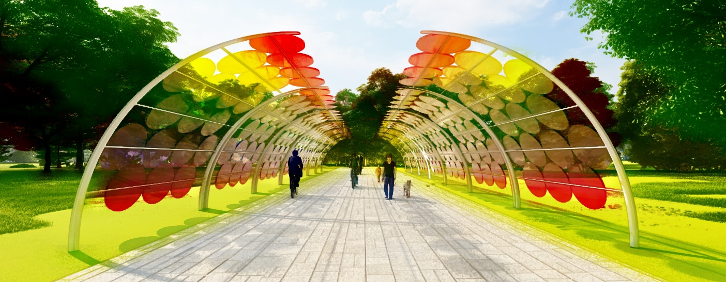
POWER WALK

Introduction
We believe sustainability is not achieved through grand monuments, but through simple solutions that can be implemented by the everyday person. LAGI 2022 is about creating examples of sustainable solutions, so our design focuses on scalability and consumer availability while minimizing the impact of construction on the site itself. The focus on sustainability and open green spaces are critical factors to this project. Power Walk seeks to provide a sculptural pedestrian experience that compliments the innovative nature of Mannheim. The project consists of modular canopies (4.26m wide 3.74m high by 3.8m long) that transform pedestrian and bike pathways within the site into inviting spaces that generate energy from solar radiation. By utilizing the pedestrian and bike pathways, Power Walk will intentionally preserve the maximum amount of green space within the site to allow for versatility of use.

Technology
This concept utilizes solar glass technology to create transparent sunshades that can protect pedestrians from harmful solar radiation while also generating electricity that can be used to power amenities within the park as well as supporting the surrounding neighborhoods with affordable energy. By using glass that utilizes light refraction to change color based on the angle of the sun, we create walkways that would serve not just as a means to get from one destination to another but become a destination in and of themselves. The foundation consists of pilings so as to reduce the disturbance of existing pathways and the electrical wires are run and connected to the existing power grid through underground lines. A section can be as small as one modular unit for residential/consumer use or contain dozens to cover stretches of pathways for civic use. The units can be arranged in several configurations including an arch, half arch, and butterfly design to maximize utility and aesthetic.
The maintenance required would include landscaping, regular cleaning of solar glass panels, waste pickup from waste collection bins, and IT and internet service and maintenance for wireless internet routers. System inputs for street lighting and internet access stations would require 0.60 MWh annually. The cost of materials and labor to build one module is estimated to be $5556 (€5592) per module. To cover all of the pedestrian and bike pathways with 1500 units would cost an estimated $8.34 million (€8.39 million). That cost would be recuperated over time through energy savings and selling excess power. The strategy for on-site prototype development would involve construction of one modular unit to test the efficacy over the course of one year. Subsequent changes to design could be made and the decision to go forward with more units could be made at that time.
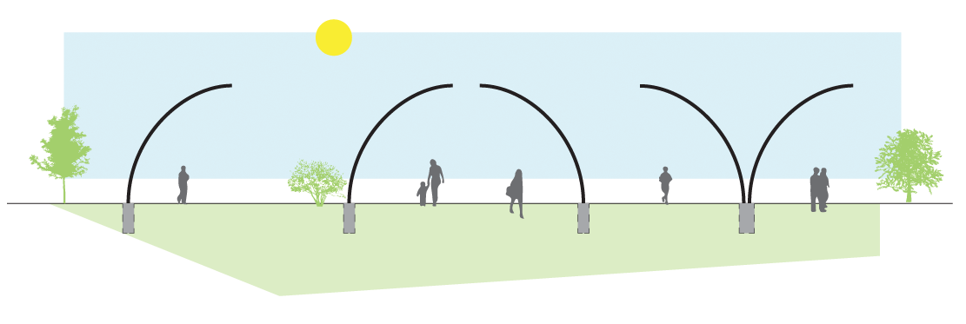

Sustainability
By preserving a majority of the green open space, this project allows for rainwater to penetrate the ground and back into the water table and provide space for wildlife habitats, adding to the sustainable nature of the project. Power Walk utilizes sustainable materials such aluminum that can not only be sourced from recycled materials, but also be recycled at the end of their lifecycle. By utilizing solar glass panels, the structures can generate power while allowing filtered light to penetrate below for landscaping. The plants surrounding the walkways utilize permaculture and regenerative landscaping principles to restore the natural landscape and allow edible plants to provide food for residents. The project presents a pragmatic and scalable solution address to a number of UN Sustainable Development goals.
- End poverty: By increasing the urban resilience of Mannheim and providing internet access to residents who do not currently have access of their own.
- Zero hunger: By providing edible landscaping, this project seeks to provide food for vulnerable populations.
- Good health and well-being: By preserving green space, allowing fresh air to flow into the city and providing an inviting outdoor space for residents to recreate.
- Quality education: By educating and informing residents about the environment, renewable energy, and sustainability.
- Gender equality: By implementing a well-lit street lighting system to connect the city with a space where people of all genders can feel safe.
- Clean water and sanitation: By maximizing green space, this project allows rainwater to penetrate the ground and filter back into the water table.
- Affordable and clean energy: By providing clean, local power to the residents of Mannheim.
- Decent work and economic growth: By connecting the surrounding neighborhoods, this project increases social cohesion as well as the ability to work outdoors using the public wireless network. The project will create economic growth through the manufacturing jobs in the process of its construction.
- Industry, Innovation, and infrastructure: By utilizing innovative technologies like solar glass panels, this project will become an important part of the energy infrastructure of Mannheim.
- Reduced inequalities: By reducing the digital divide, this project will work to reduce inequality within the community. The walkways also provide a space of recreation for people of all ages and abilities.
- Sustainable cities and communities: By reconnecting the cities with safe and inviting pathways, this project will promote the ability of users within Mannheim to walk and bike to various destinations in the surrounding neighborhoods. The project will also be a source of clean, renewable energy.
- Responsible consumption and production: By including edible landscaping as part of Power Walk will increase the amount of food produced locally residents. Additionally, by including native plants, this project will increase biodiversity to restore natural landscapes and habitats for wildlife.
- Climate Action: By providing a source of locally generated renewable energy, this project will reduce the reliance on fossil fuels in the future.
- Life below water: By allowing rainwater to penetrate the site, filter through the ground and back into the water table, this site allows natural processes to clean water and release it back into the environment.
- Life on land: By reducing the reliance on fossil fuels, this project will decrease air and ground pollution related to fossil fuel extraction and consumption.
- Peace, justice, and strong institutions: By providing accessible safe pathways through the city for residents of all ages, abilities, and genders to move about the city.
- Partnerships for the goals: By increasing access to internet, which has become more necessary in a post-pandemic world.

Activities and social benefits
Activities of the site could accommodate large public gatherings and events as well as recreation for residents of the surrounding areas. Integrated into the modules are wireless internet access points allowing users the flexibility to work outside and providing access for folks who otherwise would not have the resources to access it. The project would have an educational component as well and seek to inform residents about sustainability, regenerative design, and renewable energy. At night the structure would provide inviting lighted walkways, connecting the surrounding areas of the city together and providing safe spaces to congregate. In many ways, this project further adds to the urban resilience of Mannheim.
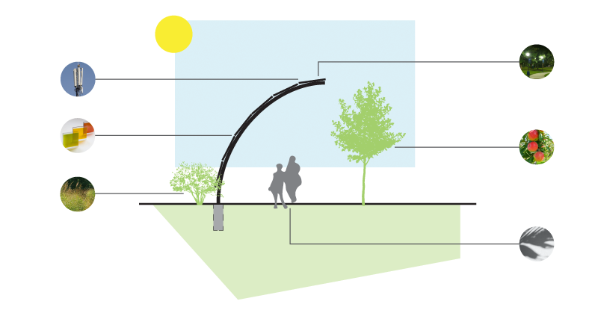
Environmental Impact Summary
The scalable nature of this project means that amount of power generated depends on the application for which it is used. One module can produce 4.38 MWh annually. If the canopies were deployed on the majority of the pedestrian walkways and bike pathways of the site, the project could generate a minimum of 4,000 MWh annually. The materiality of the project would consist of aluminum which is highly recyclable at both the beginning and end of its lifecycle. The installation of the module minimally impacts the site and rests on a small footprint, decreasing the impact on the surrounding areas. The landscaping of the pathways could consist of a mix of native and edible plants providing habitat and food for native species and residents alike.

