Energy Routines

Everyday human activities such as personal hygiene, food preparation, heating, and the use of electronic devices are presented as artistic-technical installations - the "Energy Routines".
The energy consumption of each of these activities is broken down to the personal scale of individual consumers, making it legible and understandable.
The “Shower Tower” illustrates the everyday routine of body care in an impressive, sculptural way using the example of a shower.
Instead of a single large-scale installation, individual, smaller installations can be distributed on the BUGA 23 site, become goals in the landscape, allow physical proximity, and thus set visitors, energy production, and nature in dialogue with each other.

Visualized calculations

The energy and other material requirements of the “Energy Routines” shown are calculated and the components required for each are presented: the water and heat requirements during a shower, the heating of a room with an average floor area, each related to one person, etc.
These components are then clearly and legibly related to one another using and thus becoming installations, the "Energy Routines".
The "Energy Routines" illustrate directly and without detour what otherwise happens hidden in a machine or behind or inside a wall.
The expression of the “Energy Routines” is deliberately chosen to be technical for several reasons: on the one hand, the artificiality of the energy production is to be explicitly represented. On the other hand, the choice of construction and material should emphasize the interplay of energy production and the infrastructure needed for it.
Above all, however, the chosen expression serves to make a change of perspective: if we treat the earth in the same way as we would when settling down on a new planet, we should try to have as little impact as necessary, as minimal, and efficient as possible.
Therefore, the visual design strategy is based on the principles of spacecraft design: just as we should design new devices for alien worlds as ideally as possible, we should explore the implicit potentials of regenerative energy production without prejudice and preconceived design goals.

Small Scale - Human Scale

The "Energy Routines" should enable a change of perspective and a direct relationship with the structural aspects of energy production.
Thus the "Energy Routines" are smaller objects, just as big as they are necessary for the respective activity - small is beautiful.
They are devices with which we can relate, and which make the relationship between energy production and the environment legible: they orientate themselves on the course of the sun, they move in the wind, and they change their position.

The 4 “Energy Routines”
The 4 installations of the Energy Routines deal with all aspects of human existence: physical needs such as preparing food and personal hygiene, generating energy for work, communication, or entertainment, and generating heat in air-conditioned rooms. Here are the 4 “Energy Routines” in detail:

1. Parabolic Heat

The living space available per person in Germany is around 40m². This living space must of course be heated and cooled. Therefore, "Parabolic Heat" is based on the volume formed by this 40m² multiplied by a room height of 2.5m.
A movable solar thermal parabolic mirror is used as the energy source. The volume created from the average base area forms the framework for the frame of the parabolic mirror, in which it can also move.
The volume is broken through by the parabolic mirror and thus establishes a connection between the volume to be air-conditioned and the energy source in the most direct way possible.
The "Parabolic Heat" installation can be used not only to illustrate energy requirements but also as a meeting room and bar.

2. Shower Tower

The “Shower Tower” illustrates the everyday routine of body care in an impressive, sculptural way using the example of a shower.
The interaction of water demand and the generation of the necessary energy for water heating is illustrated by the required components:
- A water reservoir, which, thanks to its funnel shape, provides the amount of water available based on the average amount of rain in Mannheim.
- A solar module that provides the heat-energy required for a warm shower
- A shower tray that is available to BUGA 23 park visitors
These components are grouped vertically in chronological order: water collection and storage, power generation and water heating, and finally the point of consumption. The breakdown and direct sequence of the process into its components make it legible and quantifiable.

3 . Solar Kitchen

The design for the “Solar Kitchen” is based on the average annual power consumption of a kitchen in a typical German household of 2.5 people.
The annual electricity consumption of the end devices can be generated by a roof made of polycrystalline photovoltaic solar cells. Although these polycrystalline solar cells are less efficient than monocrystalline solar cells, they are easier to manufacture and therefore cheaper.
The calculations are based on averaged solar inputs in Mannheim in recent years, plus the technical efficiency of the system.
The solar roof formed in this way is structurally and energetically connected to the kitchen at four suspension points and is aligned orthogonally to the solar radiation/global radiation using adjustment motors in the traverses.

4. Aero Consume

The "Aero Consume" wind turbine generates the electricity consumption of a single home office or office workplace. It provides enough energy for an average 8-hour working day over 300 working days.
On the one hand, all local end devices are included in the calculation, but also the external servers and all provisions of services necessary to
work in a network.
The calculations for the wind turbine are based on the local cold air flow values ​​in Mannheim.
This routine is to be understood both as a pavilion of interaction and as a media installation, which shows the enormous difference in the area of input (energy) and output (computer screen and devices) and thus shows this difference in a creative and explanatory way.

Materiality, Modularity, and Customizability

Each of the "Energy Routines" illuminates its aspect of sustainable energy production: materiality, space, and individual and collective activities.
What they have in common is their simple construction: it is made from standard elements, and can be dismantled, converted, transported, and expanded. The duplication or scaling of the "Energy Routines" on the BUGA 23 site is conceivable. The individual shower becomes the shower facility, the kitchen becomes a restaurant, the living room becomes a hall, and the Aero Consume becomes the Aero Office Park.
Due to the small scale, the applicability in a classic allotment garden is also given, the "Energy Routines" could be used directly in allotment garden colonies, as a single solution, or as interconnected or scaled systems.

System Inputs – System Outputs

Calculations and materials used for each of the “Energy Routines”:

1. Parabolic Heat
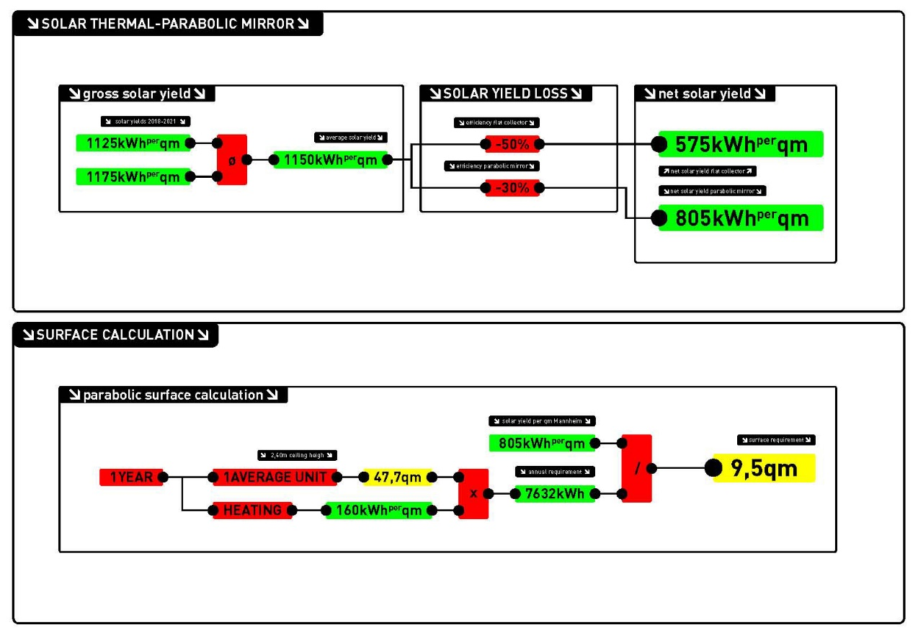

2. Shower Tower
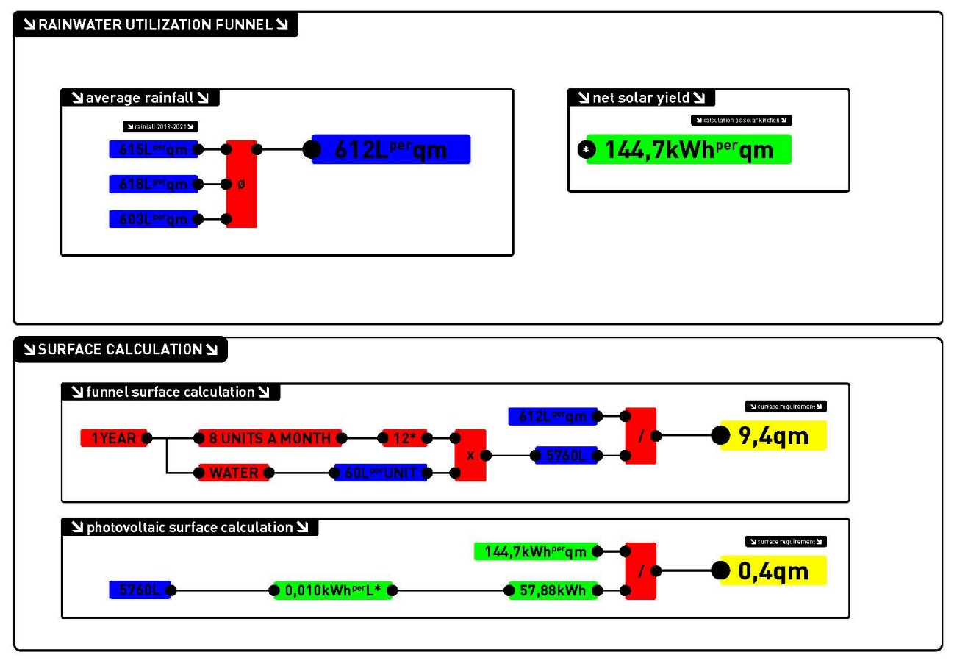

3. Solar Kitchen
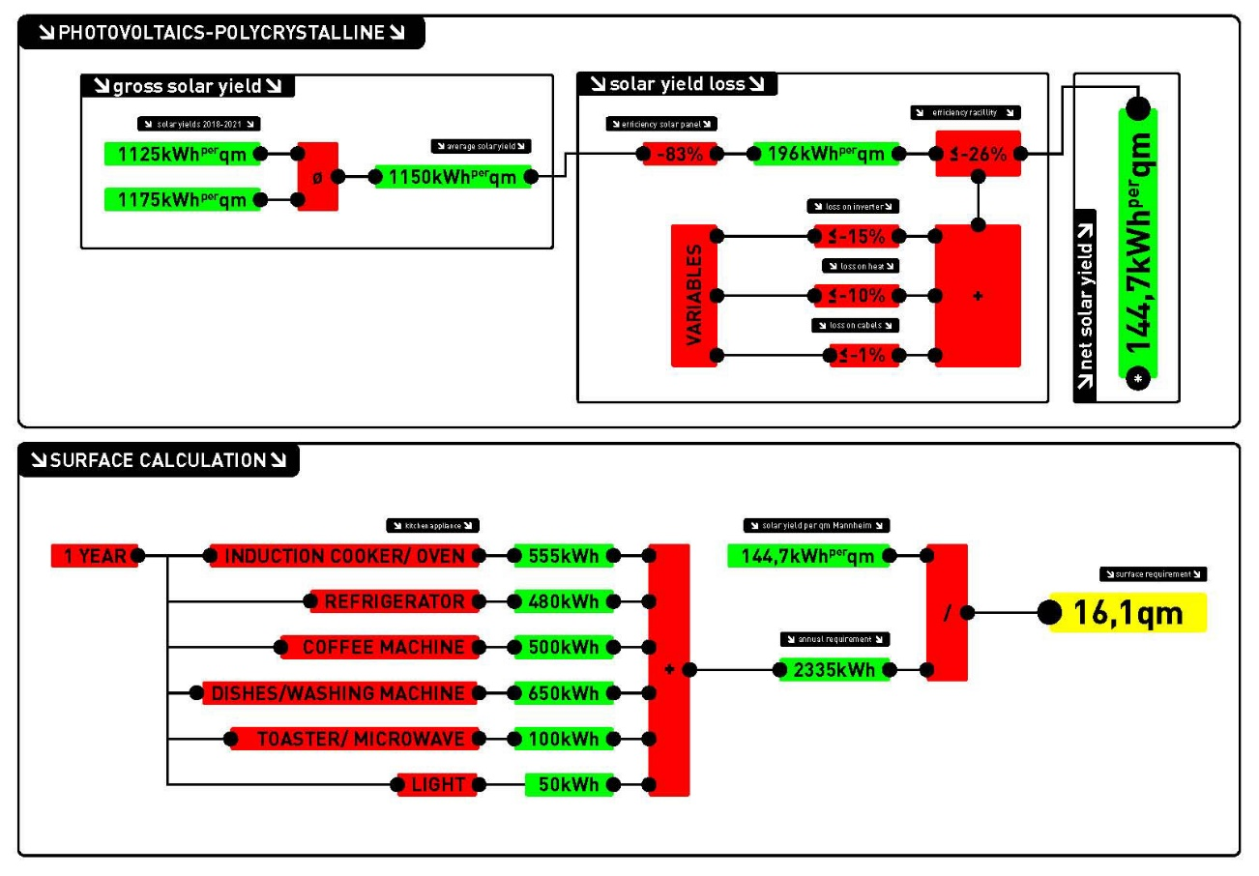

4. Aero Consume
