The FLOW of Neckar
LAGI Competition 2022
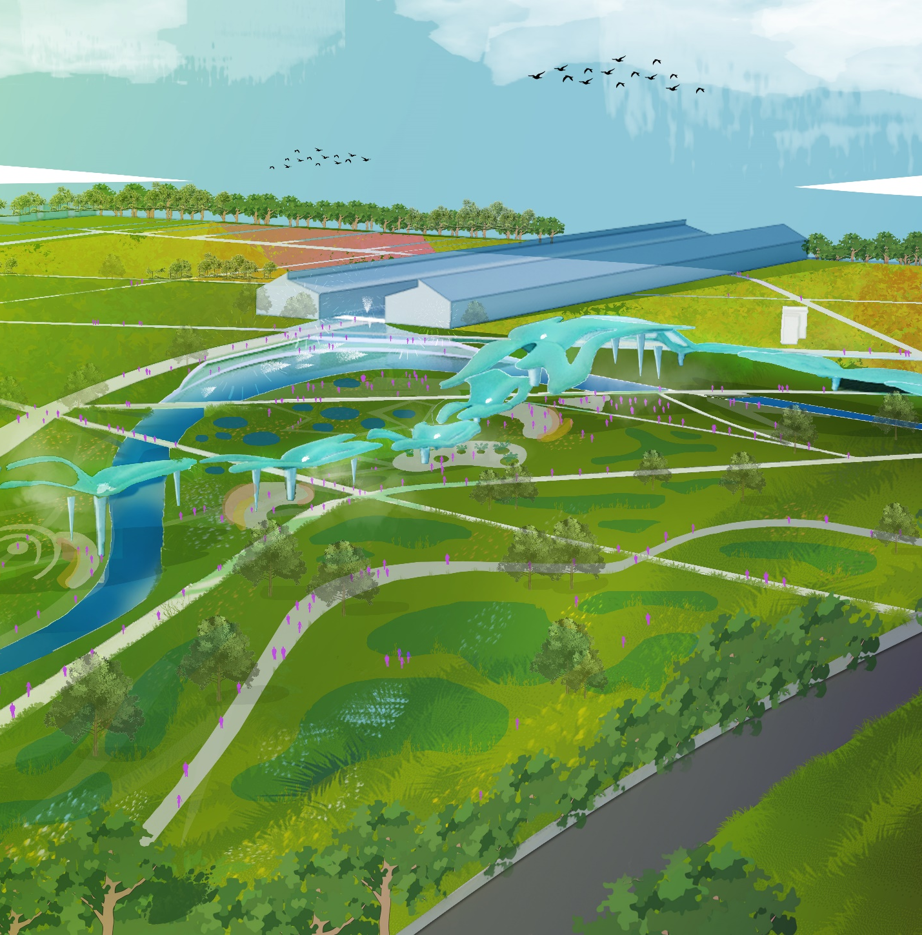

Project Context
Understanding past and future of Mannheim.
The barracks and grid layout of the former Spinelli Barracks site reflected the industrial past of Mannheim city. Now, is Mannheim ready for a new history? Can our design support Mannheim as a vibrant, ecological, and circular city which benefit not only people but biodiversity? Inspired by the historic tributaries of Neckar River in the city of Mannheim, our design ‘FLOW of Neckar’ aims to not only generate energy but also to reconnect the city and the people with its shared water history.
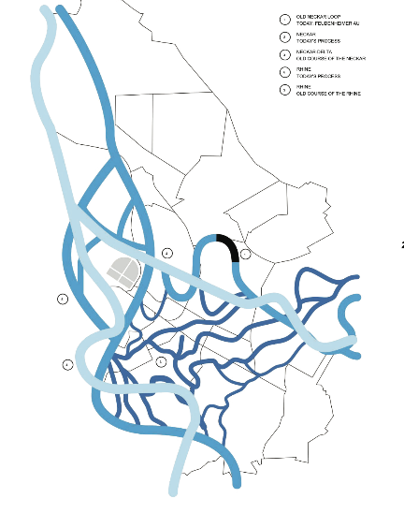
Figure 1 The Historic Tributaries of Neckar River
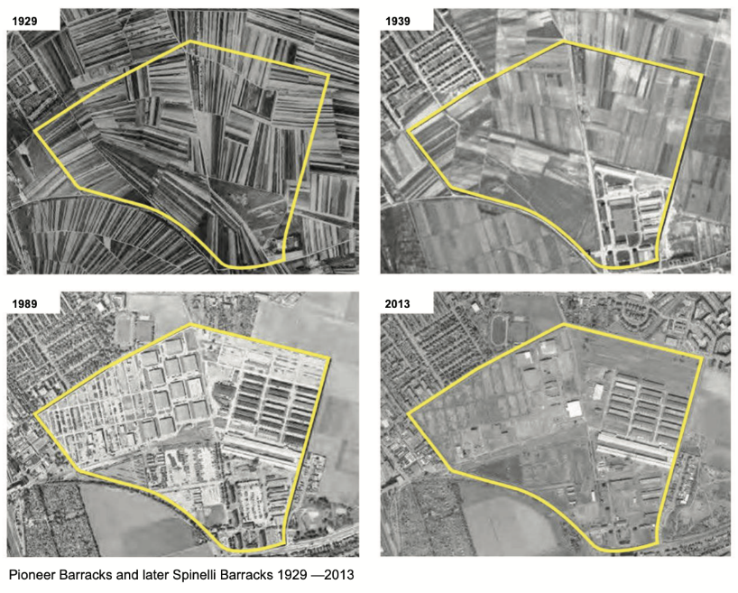
Figure 2 Can we move from the rigidity and bring back the fluidity of the site?
Our vision for the site starts from the Neckar River – its element of water. Figuratively, the overlapping meandering shapes of the river inspires us to thread the flow of people, energy, and ecology. Functionally, water and energy are intricately connected and interdependent. Energy require water during the production process, from powering turbines to cooling for thermal processes. Whilst water resources could only be proceeded using energy, e.g., processing drinkable water to irrigation for crops. Water itself is a finite resource required to serve growing population and city growth. Based on report by UNESCO in 2018, global water demand is projected to increase from 20% to 30% by 2050. Hence, by reducing water consumption – energy consumption could also be saved.
How Can the FLOW Device Save Energy?
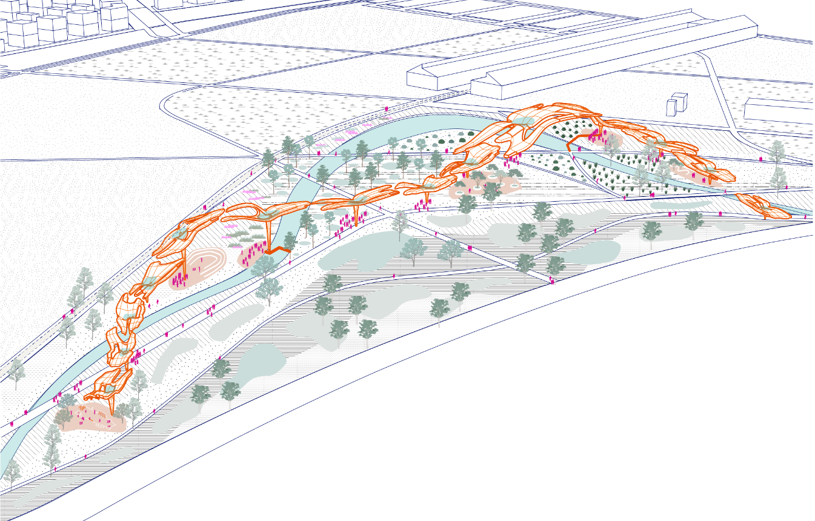
Figure 3 The FLOW of Neckar
As rain falls throughout the year in Mannheim and resulting to surplus of 500-950 litres/sqm each year, harvesting rainwater can contribute to water conservation and further reduce energy resources needed. Taken influence from shape of water lily plants growing in Neckar River, the FLOW (For Life of Water) device is an art sculpture which helps collect and clean rainwater to be reused for misting and irrigation purposes. Rainwater is collected on top of the canopy, circulated through the pipe, bio-filtration and then stored underground or reused. The device could be installed and functions individually or to generate more energy, to be constructed in group.
In context of the site, the devices are arranged together as an art exhibition to support BUGA and laid on constructed sponge wetland areas. The wetland areas are part of the northeast green corridor connecting to Luisenpark and Vogelstangseen. Its landscape is designed to capture stormwater runoff, the cleansing biotopes feature help cleanse the water before conveyed to the meandering channel. The wetland itself consisted of dry ponds which could be overflown (wet) by rainwater during storm events. Collected water absorbed in the sponge wetland area and the FLOW devices are stored together for reuse.
In addition, for energy generating purposes, the FLOW device includes installation of flexible solar panel to in consideration of the 1,500-2,000 hours of sunshine per year in Mannheim. As the water lily leaf absorbs sunlight for photosynthesis process, the big canopy in FLOW device generates solar energy and store it in the battery for lighting and electricity using photovoltaics. During the winter, heat is generated through solar thermal panel on the device.
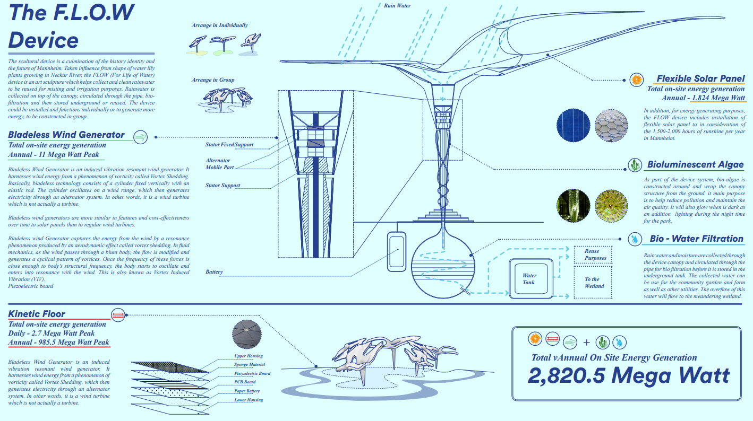
Figure 4 Energy generation within the FLOW device
Attached as a frame for the pillars are bioluminescent-algae pipes. The sunlight during daytime sustains the photosynthesis process and keep the algae alive which helps remove CO2 from air and produce oxygen. In return, the algae emit soft fluorescent glow helpful for zero-energy lighting at night.
Bladeless wind generator is included in the FLOW device to induce vibration resonant wind generator. It harnesses wind energy from a phenomenon of vorticity called Vortex Shedding. It consists of a cylinder fixed vertically with an elastic rod. The cylinder oscillates on a wind range, which then generates electricity through an alternator system. In other words, it is a wind turbine which is not actually a turbine. Bladeless wind generators are more similar in features and cost-effectiveness over time to solar panels than to regular wind turbines.
This generator captures the energy from the wind by a resonance phenomenon produced by an aerodynamic effect called vortex shedding. In fluid mechanics, as the wind passes through a blunt body, the flow is modified and generates a cyclical pattern of vortices. Once the frequency of these forces is close enough to body’s structural frequency, the body starts to oscillate and enters resonance with the wind. This is also known as Vortex Induced Vibration (VIV).

Combining Flow of Energy with People and Ecology
Can we ensure co-benefit of the FLOW device and its environment?
Supporting Mannheim as a vibrant and sustainable city also means to bring energy closer to the people. Unlike typical power plant which are located far away from the community, the FLOW devices stand as part of the park’s landscape and larger green corridor network. In this proposal, the FLOW devices are arranged together, creating a series of meandering public art on the site. The meandering FLOW devices are overlapping with pathways and swale. The confluence of these layers brings people, energy, and ecology together.
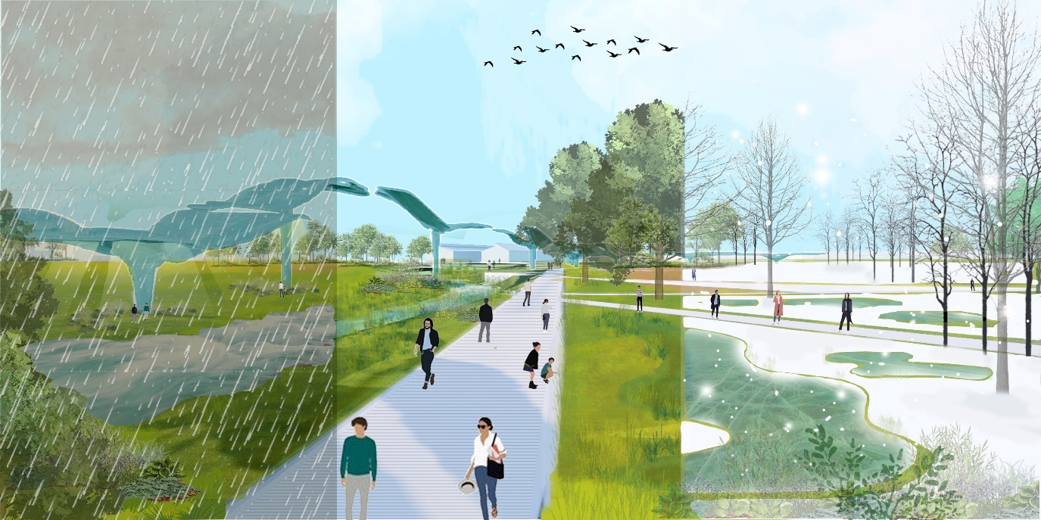
Figure 5 The FLOW of Neckar throughout Different Seasons; (from left to right) Storm Events, Summer, and Winter
Each of the FLOW device is an art sculpture easily combined with community and public use. The all-in battery and water storage made the device flexible to be installed individually or in group. The FLOW device could function as a standalone sculpture and function as a shade during summer, generating energy for lighting at night. Integrated with the FLOW device, kinetic floors could be installed for plaza or pathway to generate electricity from people’s movement whilst giving a fun education about energy saving. The device could also be used to as a mist generator for children playground, hence provide cooling during summertime. When there is a surplus of rainwater, the filtration in the FLOW device could also be used to provide water feature which cools and beautify the space. For the communal use of Schrebergarten, the FLOW device could be installed to provide drip irrigation using recycled rainwater for the community farm.
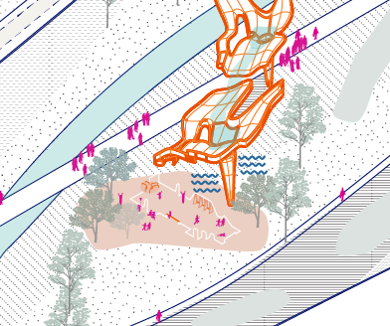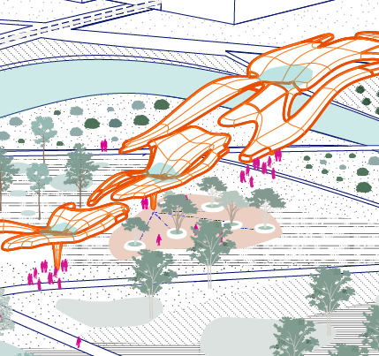
Figure 6 FLOW device integrated with community use, as cooling device and irrigation system
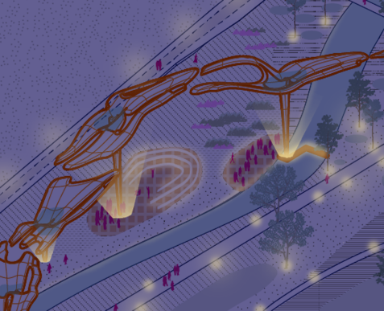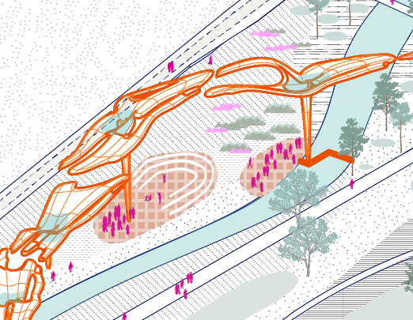
Figure 7 Solar and kinetic energy in FLOW device provides lighting, supporting activity during night-time
We also realized that in this post pandemic era, cities are shifting to be healthier, and park becomes essential in supporting people’s wellness. The proposed sponge wetland landscape is both beneficial for people and ecology. Whilst functioning as a water management tools, the sponge wetland landscape is an ecological tool which provides habitat for diverse ecosystems. The cleansing biotope itself is consisted of various aquatic plants, further enhancing biodiversity.
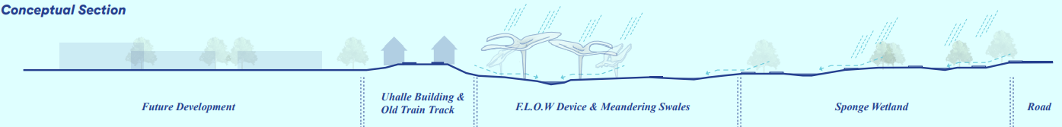
Figure 8 The water management system within the FLOW of Neckar
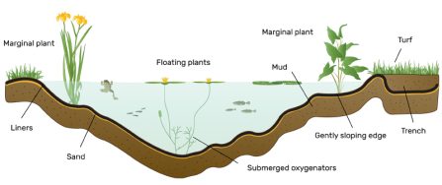
Figure Wildlife Pond Ecosystem

How Does FLOW of Neckar Supports the UN SDGs?
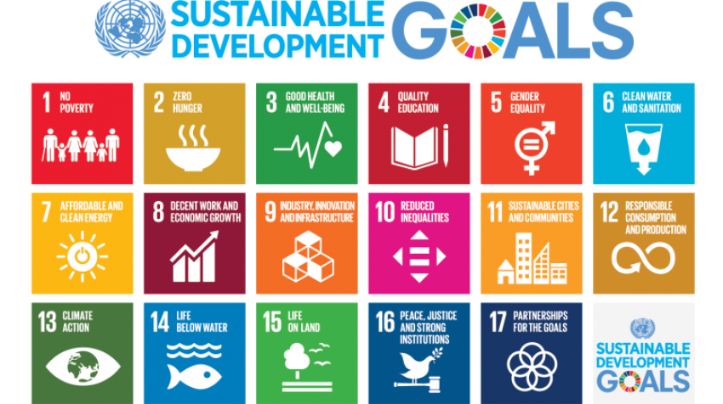
Figure The UN SDGs
The overall FLOW of Neckar proposal supports 8 of the 17 UN Sustainable Development Goals as below:
- No. 3 – Good Health and Well-Being
By designing the device as an outdoor art sculpture and integration to landscape, the FLOW provides space for people to get closer to nature and opportunity for leisure, sport, and socialization. Hence it helps improve both physical and mental health for the surrounding communities.

- No. 4 – Quality Education
These public art sculptures encourage visitor to wonder and sparks curiosity. The educational trail proposed in the FLOW of Neckar provides information for both children and adults on the process of energy saving and water recycling.

- No. 6 – Clean Water and Sanitation
One of the aims of the FLOW device is to recycle rainwater as much as possible. Using filtration inside the device, it generates clean water safe to use by the people.

- No. 7 – Affordable and Clean Energy
The proposal features various use of clean energy sources such as solar, wind, kinetic and bio-luminescent algae to generate electricity and clean water. By actively generating energy, the device reduces emission, carbon and cost required in traditional power plant.

- No. 11 – Sustainable Cities and Communities
In sustainable cities, parks and renewable energy are championed. The FLOW of Neckar promotes the use of renewable energy to reduce consumption of water, generating electricity while hosting various community activities. The proximity of the FLOW device to the public encourage community to see first-hand the process of energy saving and generation, inspire them to be mindful of energy consumption.

- No. 12 – Responsible Consumption and Production
The FLOW of Neckar uses renewable energy and functions as water harvesting and recycling station, therefore reduce consumption and excessive production of energy.

- No. 13 – Climate Action
In the recent years, we all have experienced the extreme climate weather including drought and heavy precipitation. The FLOW device helps store water useful to mitigate drought during dry season and provides landscape to help capture runoff during the storm events – reduce flood risk in the surrounding. Aside, by using renewable energy, the proposal reduces carbon emission and negative environment impact.

- No. 15 – Life on Land
The proposed sponge wetland landscape provides habitat for diverse ecosystems, therefore reduce biodiversity loss, and promotes sustainable terrestrial environment.

Environmental Impact Summary
The FLOW device structure is using renewable and recycled materials, sourced locally in the region. The main structure is consisted of steel with foundation and storage using prefabricated concrete. The prefabricated concrete is highly durable and uses low-water cement ratio. Since the design is modular, it reduces the material waste and could be easily assembled on site hence lowered production cost. The size and height of each device could be adjusted based on site condition. Solar panels, bladeless wind generator and kinetic motors are commonly used and produced in the region hence can be manufactured and transported locally. Each component from end-of-life solar panels could also be recycled; glass recycling is a well-established industry, and its copper wire and aluminium frame are easily recyclable. The pipe used for bio-luminescent algae are produced from recycled plastic – hence also support the material circularity.
Rainwater filtrations use natural materials such as sand, aggregates, and nutrients. The water is conveyed using gravity, require zero energy. The distribution of water for irrigation from the device uses the electricity generated by the solar panel, hence also require zero energy, and leave minimum environmental impact.
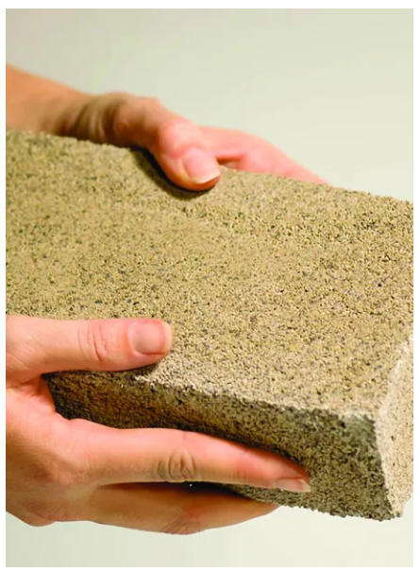
Figure BioBrick / bioMASON
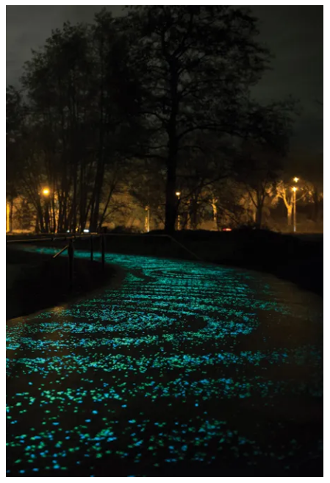
Figure Photo-luminescent strip at Van Gogh Path / Pim Hendriksen
The sponge wetland is constructed following the existing typologies and using cut and fill method. Therefore, minimize cost and quantity of land required to be transported to create the desired levels. Floording for plazas and pathways are designed using low impact materials recommended by The Sustainable SITES Initiative™ (SITES®), such as BioBrick which uses bacteria to generate bricks out of sand or other aggregate. Lightings are generated using bio-luminescent algae from the device and on plaza surfaces, using photo-luminescent strips which absorb daylight and emit light during the night up to eight hours – reducing electricity use.
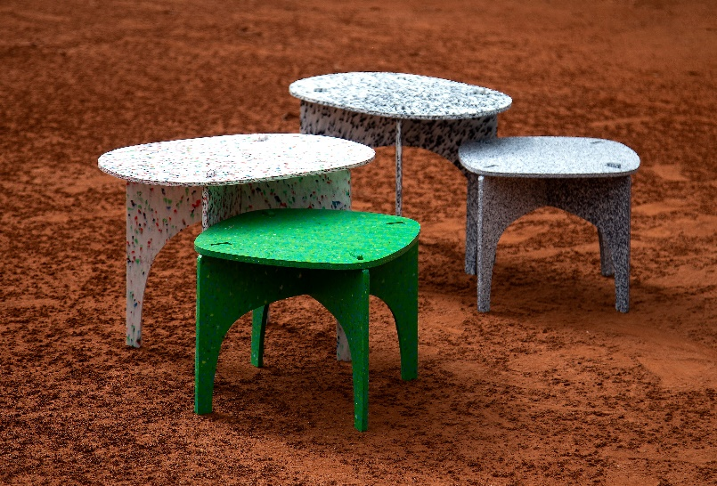
Figure Flatpack furniture using recycled plastic bottle
Public furniture proposed on the plazas such as seating, tables, play elements and sport equipment could utilize material found in the warehouses such as steel panels. Elements such as seating and tables could also be easily made using recycled plastic, as an upscaling for wasted material.

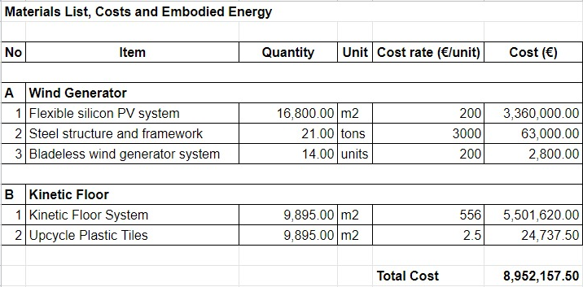
Figure Total cost and embodied energy for The Flow of Neckar

“World Water Development Report 2018 | UN-Water.” UN-Water, 2018, www.unwater.org/publications/world-water-development-report-2018/.
“Wildlife Ponds | Surrey Wildlife Trust.” Www.surreywildlifetrust.org, www.surreywildlifetrust.org/act-wildlife/helping-wildlife/wildlife-ponds. Accessed 2 Sept. 2022.
“Home.” BioMASON, biomason.com/.
Transmaterial Next by Blaine Brownell, © 2017 Princeton Architectural Press
“Flatpack Furniture Made from Recycled Plastic.” MaterialDistrict, materialdistrict.com/article/flatpack-furniture-recycled-plastic/.

