SPEAK UP

PROJECT STATEMENT
The site that was chosen for the project is located to the upper north-west of the Bundesgartenschau 23 exhibition park; and it falls neatly between the crossroads of the main pedestrian walkways. While the established plot is of rather a small size compared to the whole territory, the overall mission of the competition is of creating an authentic art piece that thrives on renewable energy sources and exists across a variety of scales. Eventually, the SPEAK UP project proposal was created with care and fondness and is expected to attract attention of the dwellers to the fact that alternative energy can be both embedded into an everyday life without being distracting while serving its purpose and at same time elegant and charming and welcoming.
According to Brad Gemmel, moon jellyfish might be one of the most energy-efficient living organisms on the planet. While taking this into account and also being quite enraptured by the “Jellyfish Princess” Japanese art piece; this ethereal but rather deadly representative of Medusozoa subphylum ended up being an inspirational foundation for the project. During the concept shaping “Midjourney” artificial intelligence was utilised, later embedding the parametric design through Grasshopper plugin of Rhinoceros. The art installation repeats the smooth forms of the jellyfish and harmonizes with the environment.
The plot having an aura of being enclosed due to the thick greenery encircling it, might as well be a little secret hidden from a public view, the type that you stumble upon and then share it with your closest. It serves as a peaceful area, a common picnic zone, a place to relax, to chat and to have a generally laid-back attitude. Beautiful illumination at night smoothly guides you around as it is inbuilt into pavement.
While Jellyfish art installations serve as a soul of the project, the amphitheatre in the centre is undoubtedly its heart. Created as a symbiosis of a starfish and a seashell, it is the semantic and compositional centre of this little oasis. While the area itself plays the role of a public space, performs an important function of socialization and cultural development; the amphitheatre is the one where cultural and educational events will be held, all the possible causes for you to not be afraid to raise you voice: conferences, master classes, exhibitions, stand-ups, debates, community gatherings, performance shows, etc., all the reasons to raise a topic that surprises you, makes you wonder, bothers or hurts you. Speaking up when you were afraid to do so for a long time is a part of treatment, it feels rather cathartic, it makes you feel better afterwards. Or it might leave you inspired, give you strength to go and make it all happen, all the things you have been craving for.
Both buildings are made energy sustainable by installing rainwater harvesting collectors, wind harvesting micro-turbines, photovoltaic solar panels, piezoelectric sound sensors and piezoelectric walking energy harvesting pavement blocks to generate energy to supply lighting and stereo installations. Through three polygonal shaped speakers installed outside, people can listen to the events that take place in the amphitheatre, while spending time outdoors. When free from public events, the amphitheatre will serve as a recreational area where any city dweller can come in to work quietly or take lessons. All conditions have been created for this: sockets for connecting various gadgets to the power grid, tables for laptops and books, soft pillows and free Wi-Fi.
UN SUSTAINABLE DEVELOPMENT GOALS
The proposal supports some of the UN sustainable development goals as is:
- Good health and well-being, by encouraging people to spend time outside, to communicate and to relax from an everyday stress of a common townsman;
- Clean water and sanitation, by harvesting rain water into a jellyfish art installation, filtering it through a carbon filter for drinking purposes, and distribution it through drinking fountains;
- Affordable and clean energy, by implementing renewable energy means into the project proposal;
- Sustainable cities and communities, by providing all-inclusive, welcoming, accessible and safe public environment;
- Climate action and Reduced inequality, by providing a stage where discussions, disputes and debates can openly take place and be welcomed during it all;
- Life below water, since the project has taken sea inhabitants as its central concept idea, it attracts attention towards those that are silently suffering from climate change, pollution and marine debris and unable to defend themselves.

IMPLEMENTED RENEWABLE ENERGY TECHNOLOGY

PHOTOVOLTAIC SOLAR CELL WORKING PRINCIPLE
The PV cell consists of one or two layers of a semi conducting material, usually silicon. Under the influence of light, the redistribution of electrons in the elements begins due to the photoelectric effect. The distribution of electrons occurs in the direction of the energy state, which at the moment have inhomogeneous semiconductor structures. This converts light energy into electrical energy. The greater the intensity of the light, the greater the flow of electricity.
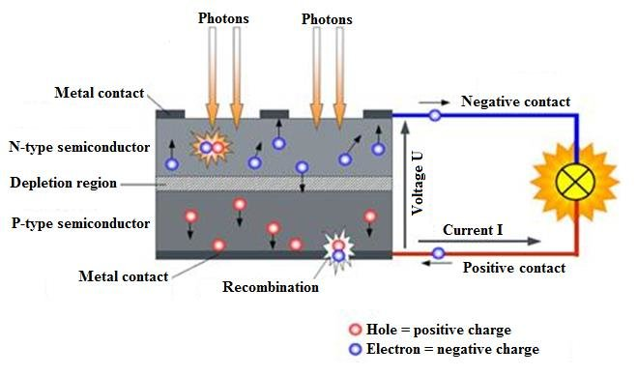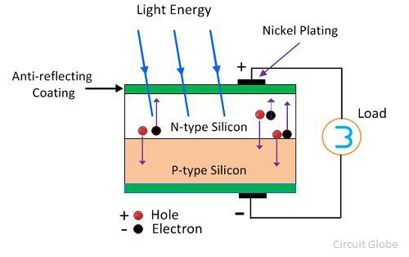

PIEZOELECTRIC MICRO WIND TURBINES
The transduction of a miniaturized piezoelectric turbine with self-regulation for increased air speed range is achieved by magnetic “plucking” of a piezoelectric beam by the passing rotor. The increased speed range is achieved by the self-regulating mechanism which can dynamically adjust the magnetic coupling between the magnets on the turbine rotor and the piezoelectric beam using a micro-spring. The spring is controlled passively by the centrifugal force of the magnet on the rotor. This mechanism automatically changes the relative position of the magnets at different rotational speeds, making the coupling weak at low airflow speeds and strong at high speeds. Hence, the device can start up with a low airflow speed, and the output power can be ensured when the airflow speed is high.
The performance of the harvester was measured in the test section, whose dimension is 100 mm × 85 mm × 85 mm. The maximum peak power output at 3.94 m/s airflow speed is 705 μW.
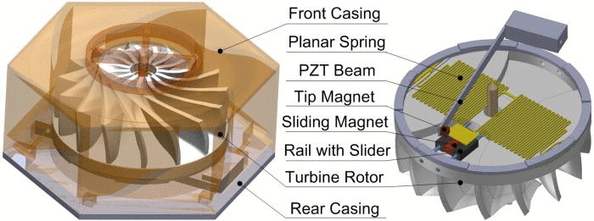
Hailing Fu and Eric M. Yeatman , "A miniaturized piezoelectric turbine with self-regulation for increased air speed range", Appl. Phys. Lett. 107, 243905 (2015) https://doi.org/10.1063/1.4938000

PIEZOELECTRIC SOUND HARVESTING SENSORS
Sound is a form of mechanical energy; therefore, it can be converted to electric energy through many approaches including through using piezoelectric materials. Utilizing noise through using piezoelectric materials as an approach of conversion to produce green sustainable electric energy that can be used to decrease the energy consumption from non-renewable sources and utilizing this energy in street lighting.
The electric energy produced from an area of 1.45 m2 containing 690 piezoelectric QB220-503YB transducers at each of the selected stations was about 0.024 watt per hour.
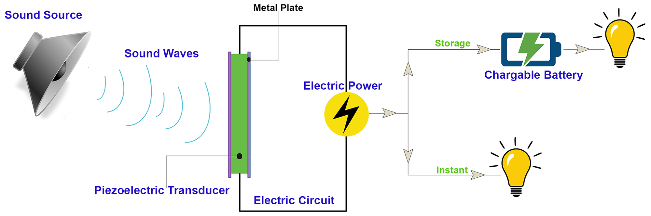
Farghaly YA, Hemeida FAA, Salah S (2019) Noise utilization as an approach for reducing energy consumption in street lighting. PLoS ONE 14(7): e0219373. https://doi.org/10.1371/journal.pone.0219373

PIEZOELECTRIC WALKING ENERGY HARVESTING PAVEMENT
A pavement block piezoelectric energy harvester (PBPEH) can be installed in an actual walkway. A highly integrated module with 24 piezoelectric devices were fixed inside the PBPEH. Under maximum weight condition, that is, in case of a person weighing 100 kg passing over the module, an output voltage of 38.52 Vmax, current of 3.85 mAmax, and power of 148.3 mWmax (3.7 W/m2) were generated at a load resistance of 10 kΩ. Energy storage test as applied to realistic conditions, that is, when a 60 kg person (average weight condition) passes over the module 10 times it charged a capacitor (1000 μF) to 55.6 mJ. As a result, it successfully turned on a delineator installed on an actual walkway after 4.8 s and powered the IoT sensor system without an external energy source.
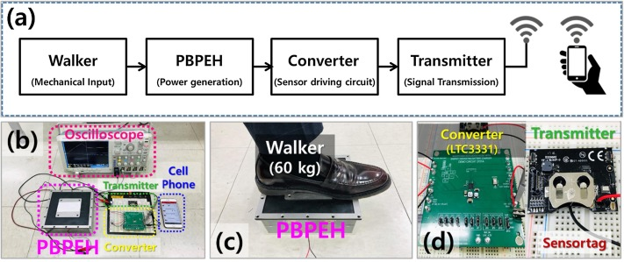
Song, Gyeong & Cho, Jae Yong & Kim, Kyung-Bum & Ahn, Jung & Song, Yewon & Hwang, Wonseop & Hong, Seong & Sung, T.. (2019). Development of a pavement block piezoelectric energy harvester for self-powered walkway applications. Applied Energy. 256. 113916. 10.1016/j.apenergy.2019.113916.

TRIBOELECTRIC RAIN ENERGY HARVESTING GENERATOR
A conventional droplet energy generator based on the triboelectric effect can generate electricity induced by contact electrification and electrostatic induction when a droplet hits a surface. However, the number of charges generated on the surface is limited by the interfacial effect, and as a result, the energy conversion efficiency is quite low.
In order to improve the conversion efficiency, the research team has developed the DEG. Its instantaneous power density can reach up to 50.1 W/m2, thousands of times higher than other similar devices without the use of FET-like design. And the energy conversion efficiency is markedly higher.
The device consists of an aluminium electrode, and an indium tin oxide (ITO) electrode with a film of PTFE deposited on it. The PTFE/ITO electrode is responsible for the charge generation, storage, and induction. When a falling water droplet hits and spreads on the PTFE/ITO surface, it naturally “bridges” the aluminium electrode and the PTFE/ITO electrode, translating the original system into a closed-loop electric circuit.
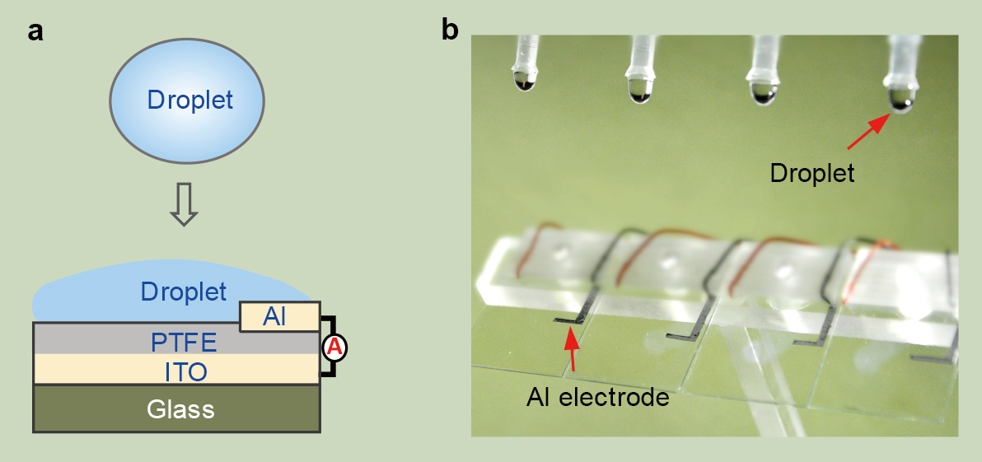
Xu, W., Zheng, H., Liu, Y. et al. A droplet-based electricity generator with high instantaneous power density. Nature 578, 392–396 (2020). https://doi.org/10.1038/s41586-020-1985-6

RAIN WATER FILTRATION
Low-cost rainwater harvesting unit can produce safe drinking water that meets safety guidelines, particularly maintaining Escherichia coli and nitrate levels below the recommended limits.
The system is sustainable, uses locally available materials (such as gravel, sand, charcoal, limestone and stainless-steel wire mesh or even cheesecloth), needs minimal maintenance, and is simple to operate. Communities can be trained to use these water systems regardless of technological skill level.
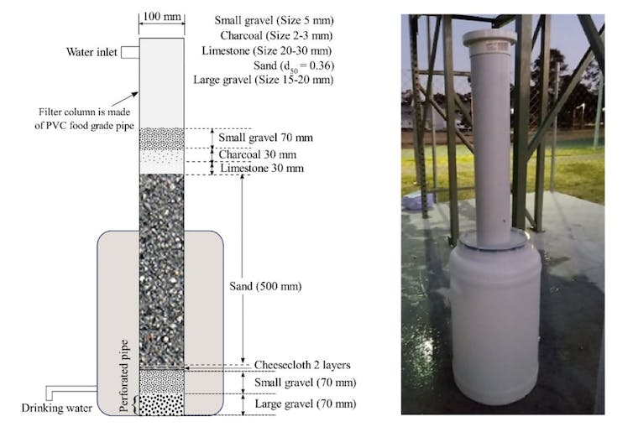
Mohammad A. Alim, A.F.M. Ali Ashraf, Ataur Rahman, Zhong Tao, Reyad Roy, Muhammad M. Khan, Shafiq Shirin, Experimental investigation of an integrated rainwater harvesting unit for drinking water production at the household level, Journal of Water Process Engineering, Volume 44, 2021, 102318, ISSN 2214-7144, https://doi.org/10.1016/j.jwpe.2021.102318.

ENERGY PER YEAR
- A pavement block piezoelectric energy harvester creates: 3.7 W/m² * 8390 m² (walking area of the plot and encircling walkways) * 8760 h = app. 272 MWh annually;
- For better output wind-harvesting micro turbines can be replaced with photovoltaic cells, thus expanding the area: 580 m² (amphitheatre shell area) + 3*73 m² (jellyfish installation tensile area) = app. 800 m². Choosing Silasolar 550W TP solar panel gives 586.95 KWh daily. 586.95 KWh * 365 = app. 214117.99 KWh = 214 MWh annually;
- Triboelectric rain energy generator produces: 50.1 W/m² * 36 m² (area of rain harvesting bowl of three jellyfish art installations) * 8760 h = app. 16 MWh

ENVIRONMENTAL IMPACT SUMMARY
While possibly not overly contributing to climate change on a global scale, this artistic landscape project has a significant impact on local environment and nature of the park. It focuses on its own rather large plot and strives to make it self-sufficient. By reusing rainwater for drinking purposes through carbon filters embedded into art installations, it provides for the area. As for the powering the lighting, it can be partially covered by the electrical generator technologies that harvest the energy from sun rays, wind power, rain drops impact and mechanical energy of the walking people. While these renewable energy-based technologies are of extreme importance to the global community, they are rather complex for the understanding of the general crowd and therefore are distant from people’s minds. By not only implementing them into our everyday lives, but making it breathtakingly beautiful and purposeful and of instant result this can be changed for good.
