Artee
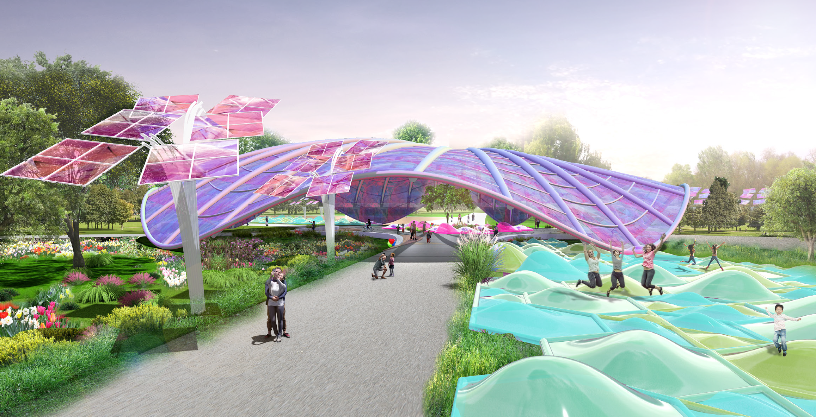

LAGI 2022
MANNHEIM

Artee

TABLE OF CONTENTS

00

Project Appreciation
Competition Framework & Design Response 04
01
Site Analysis & Urban Design Approach
BUGA 75 - Concepts & Technological Framework 05
Urban & Landscape Design Framework 06
02
Artee - BUGA 23 Pavilion
Sustainable Technologies Strategy & Transformable Energy 08
03
Artee - Modular Approach
Modularity Technologies & German Gardens 10
Application & Energy Capture 10
Environmental Performance and Optimization 12
04
Artee - Cost Estimate
Indicative Cost Estimate 14

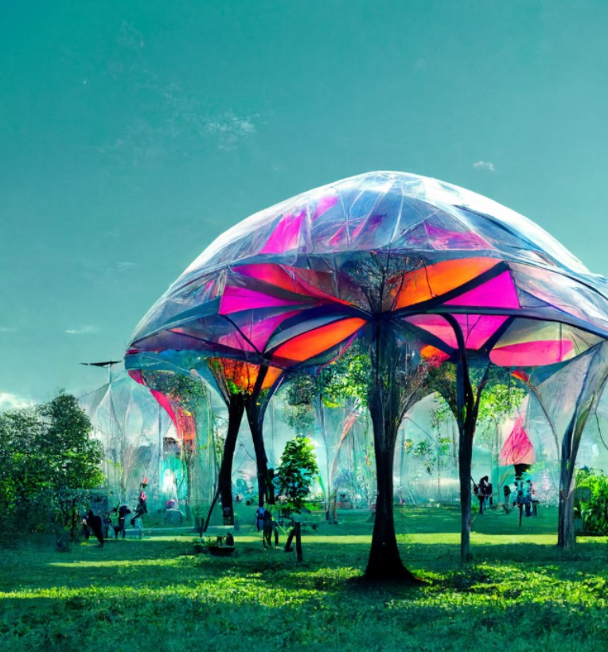
Project Vision/ Created using midjourney

00

Project Appreciation
A holistic design approach incorporating the recognition of piezoelectric and daylight as a “renewable energy source” is crucial for our design proposal since it empowers an ecological perspective, architectural and engineering creativity, and last but not least social interaction. Artee aims to integrate art, design, engineering and technology concepts through architecture as well as to provide a solution that can enhance UN’s sustainable and liveable goals. The primary idea demonstrates a high-performance adaptive kinetic solar pavilion, sun-tracking solar thin- film towers and piezoelectric installations to optimize efficiency and power output and actively engage the community with physical activity and active living in urban environments.

The proposed design concept supports several of the UN sustainability goals. Clearly, “Affordable and Clean Energy” is supported as the energy produced is clean and can be used directly for the surrounding buildings (goal 7). Further, the novel adaptive kinetic solar

pavilion and the sun-tracking solar thin-film towers can be extended to many sectors of the built environment (goal no. 8 – Decent Work and Economic Growth).
The proposed ultra-light structures of the pavilion and the towers have a high grade of prefabrication which supports the decrease of labour-intensive work.

The proposed innovative systems introduce materials and technologies that are used, for example, in robotics or mechanical engineering, advancing scientific research and improving the technological capabilities of industrial sectors (goal no. 9 – Industry, Innovation, and Infrastructure). The design proposal offers a self-sufficient solution that can weave renewable energy into our built environment using existing clean energy technologies - piezoelectric and solar - leading to a paradigm shift in how we design our built environments (goal no. 11 – Sustainable Cities and Communities).

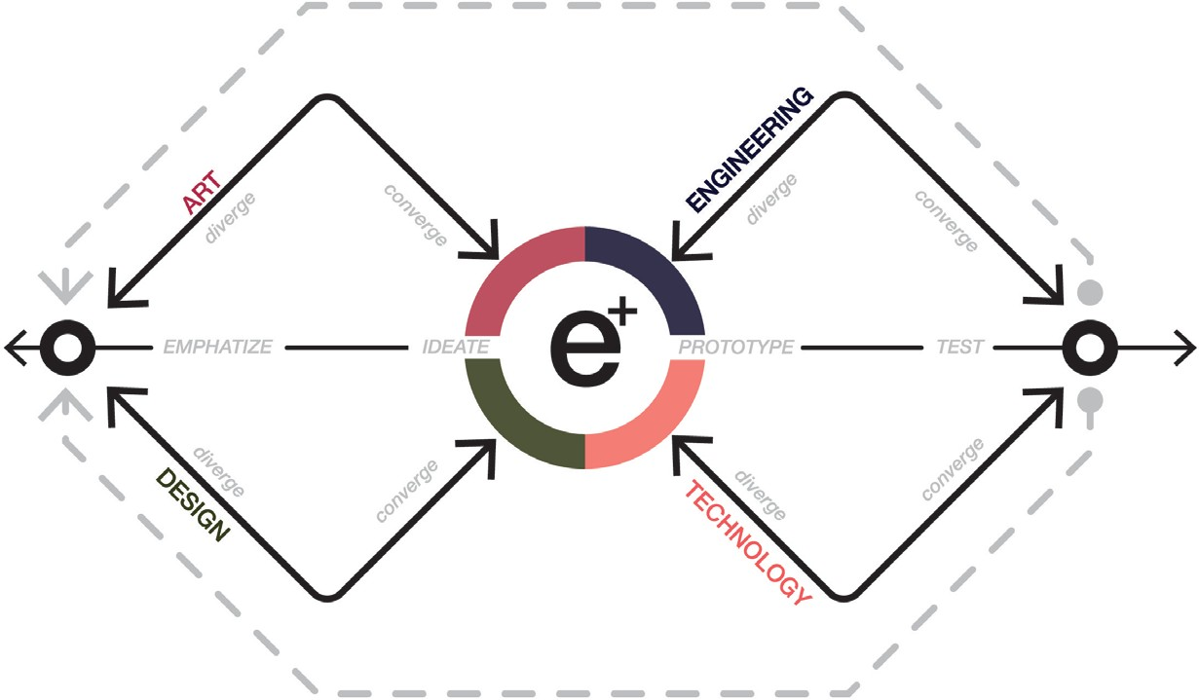
EMPHASIZE

Concept & Competition Framework

01

Site Analysis & Urban Design Approach

BUGA 75 - Concepts & Technological Framework

The design proposal aims to shape green energy production units in aesthetic ways at the intersection of art, design, engineering, and technology. Adaptive ultra-light kinetic structures and piezoelectric installations have been proposed on a residential and public scale to strengthen the relationship between community and green energy while at the same time optimising their energy efficiency according to the sun’s position. Organic solar thin-films were used due to their low environmental impact, flexibility, low production cost, and optimum energy efficiency.

With an adaptive pavilion placed at the crossing of the pathways, an open shelter for people to interact and exchange is set. The pavilion is covered with organic solar thin-film and, due to a pneumatical regulation,

it is able to transform its shape to maximise the solar energy gain over the day and year. Its organic shape and material are remembered in the Multihalle, built for the BUGA 1975 in Mannheim.
Throughout the park, sun-tracking solar thin-film towers are aggregated, as shown. The tower’s pedals track the sun to maximise the solar energy gain, while at the same time, they provide shading for people.
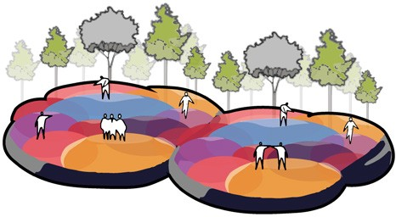
While closing, the pedals covered with organic solar thin-films form a double curved shape that increases the solar gain efficiency due to reflections of the sunbeams in between the surfaces. The kinetic towers are proposed for usage in the German gardens as they work as single elements. They represent an aesthetic way of green energy production in an ultra-light and material-friendly system that can work as a single element on a residential scale as well as be aggregated on a civic scale.

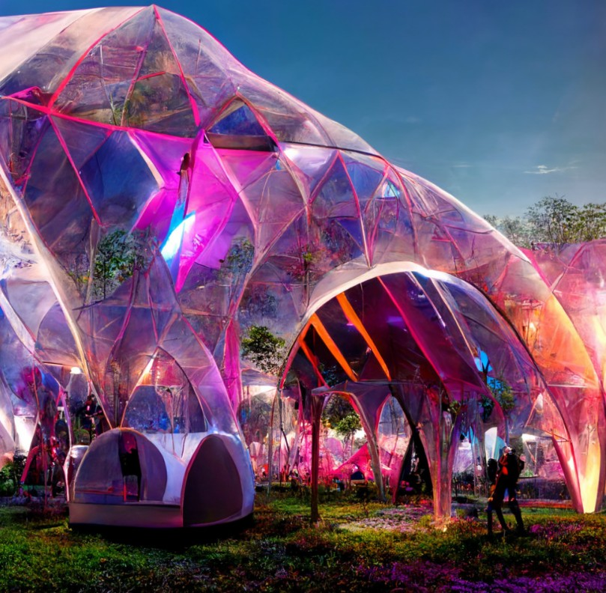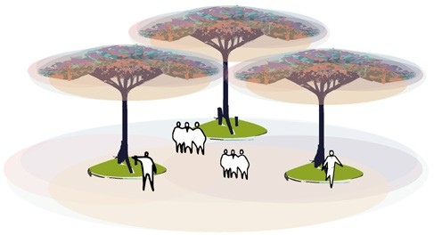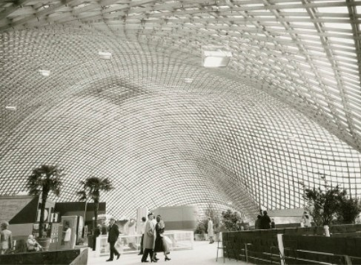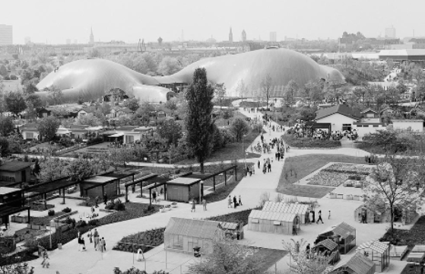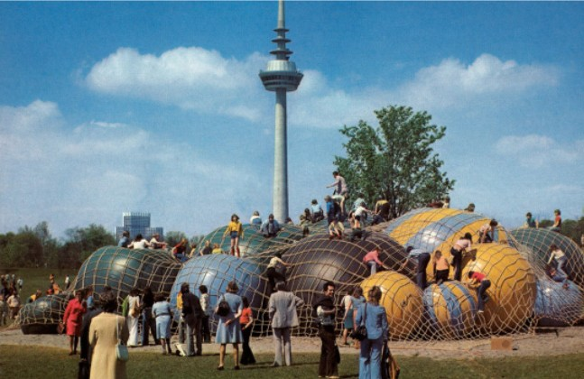
DESIGN
Mannheim BUGA 75
DESIGN
ENGINEERING
TECHNOLOGY
ENGINEERING
Mannheim BUGA 75
ART
Mannheim BUGA 75
ART
“Deep neural networks in conmteporary AI are machines of automaticity that imitate brain plasticity. They are therefore able to ‘receive’, ‘give’ and ‘explode’form, yet are also inscribed with a conceptually similar ‘fallibility’for their capacity to generate forms”
2022, vol 92 - AD Machine Hallucinations, pg 88.
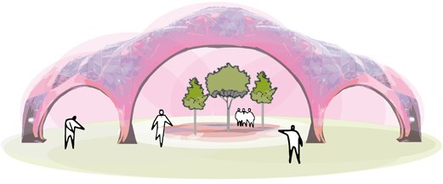
Concept & Competition Framework

01

Urban & Landscape Design Framework

The urban & landscape design response aims to incorporate previous proposals developed on the site. The urban proposal respects the position of the thematic gardens and the U-Hall by connecting them directly and strategically to the new kinetic pavilion and the Climate Park, which becomes a new heart of the park, through a convergence of thematic experiences.
The “Erfinderpark” continues to have a character of inventions and becomes a transitional element
between the new park and the city edge. The Neodine Sand continues to be an important edge that borders and integrates Feudenheimer Street with the dry biotope and rare plant and animal species.

The overall design idea is based on four pillars: Design, Art, Engineering & Technology. These four pillars seek

to develop, integrate and enhance the potential of design into sustainable and resilient strategies that can be applied in a large-scale environment.

The new design for the park is divided into these four pillars that incorporate different technologies such as Tensairity, Flexible Solar Cells and Piezoelectric. These technologies have been developed in the form of single modules that complement the overall design and the main central structure. The main pavilion enables
the park to host more significant events by taking advantage of the rapid assembly and disassembly process applicable to this pneumatic pavilion.

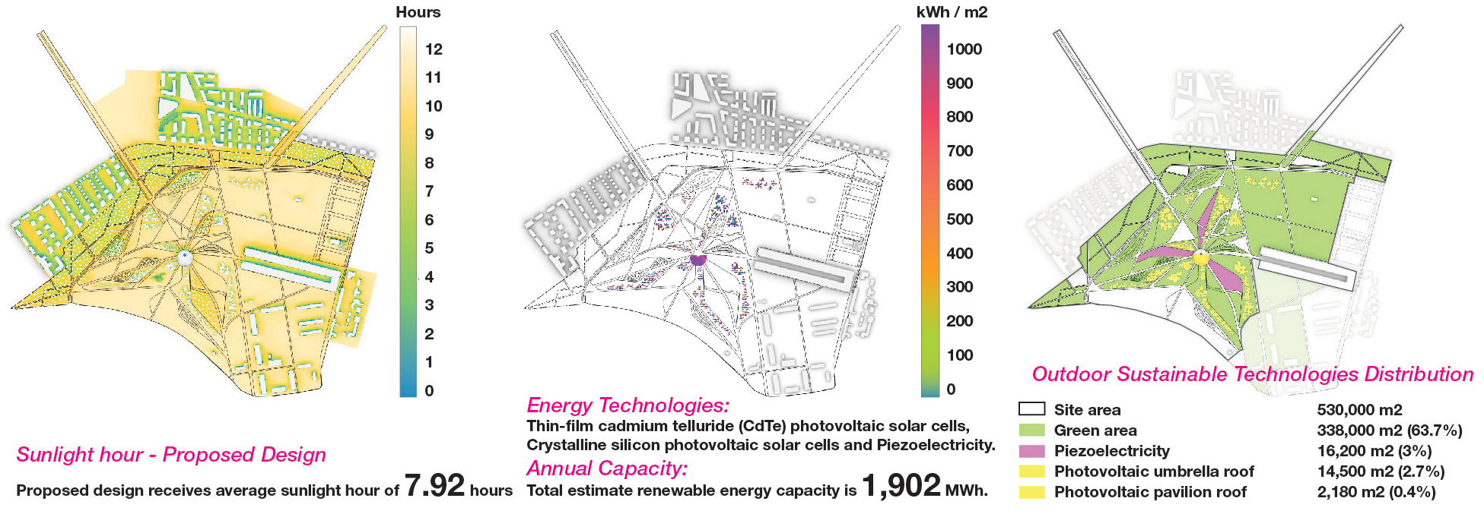
Proposed Site Capacity

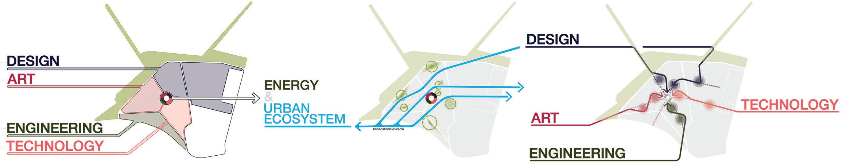

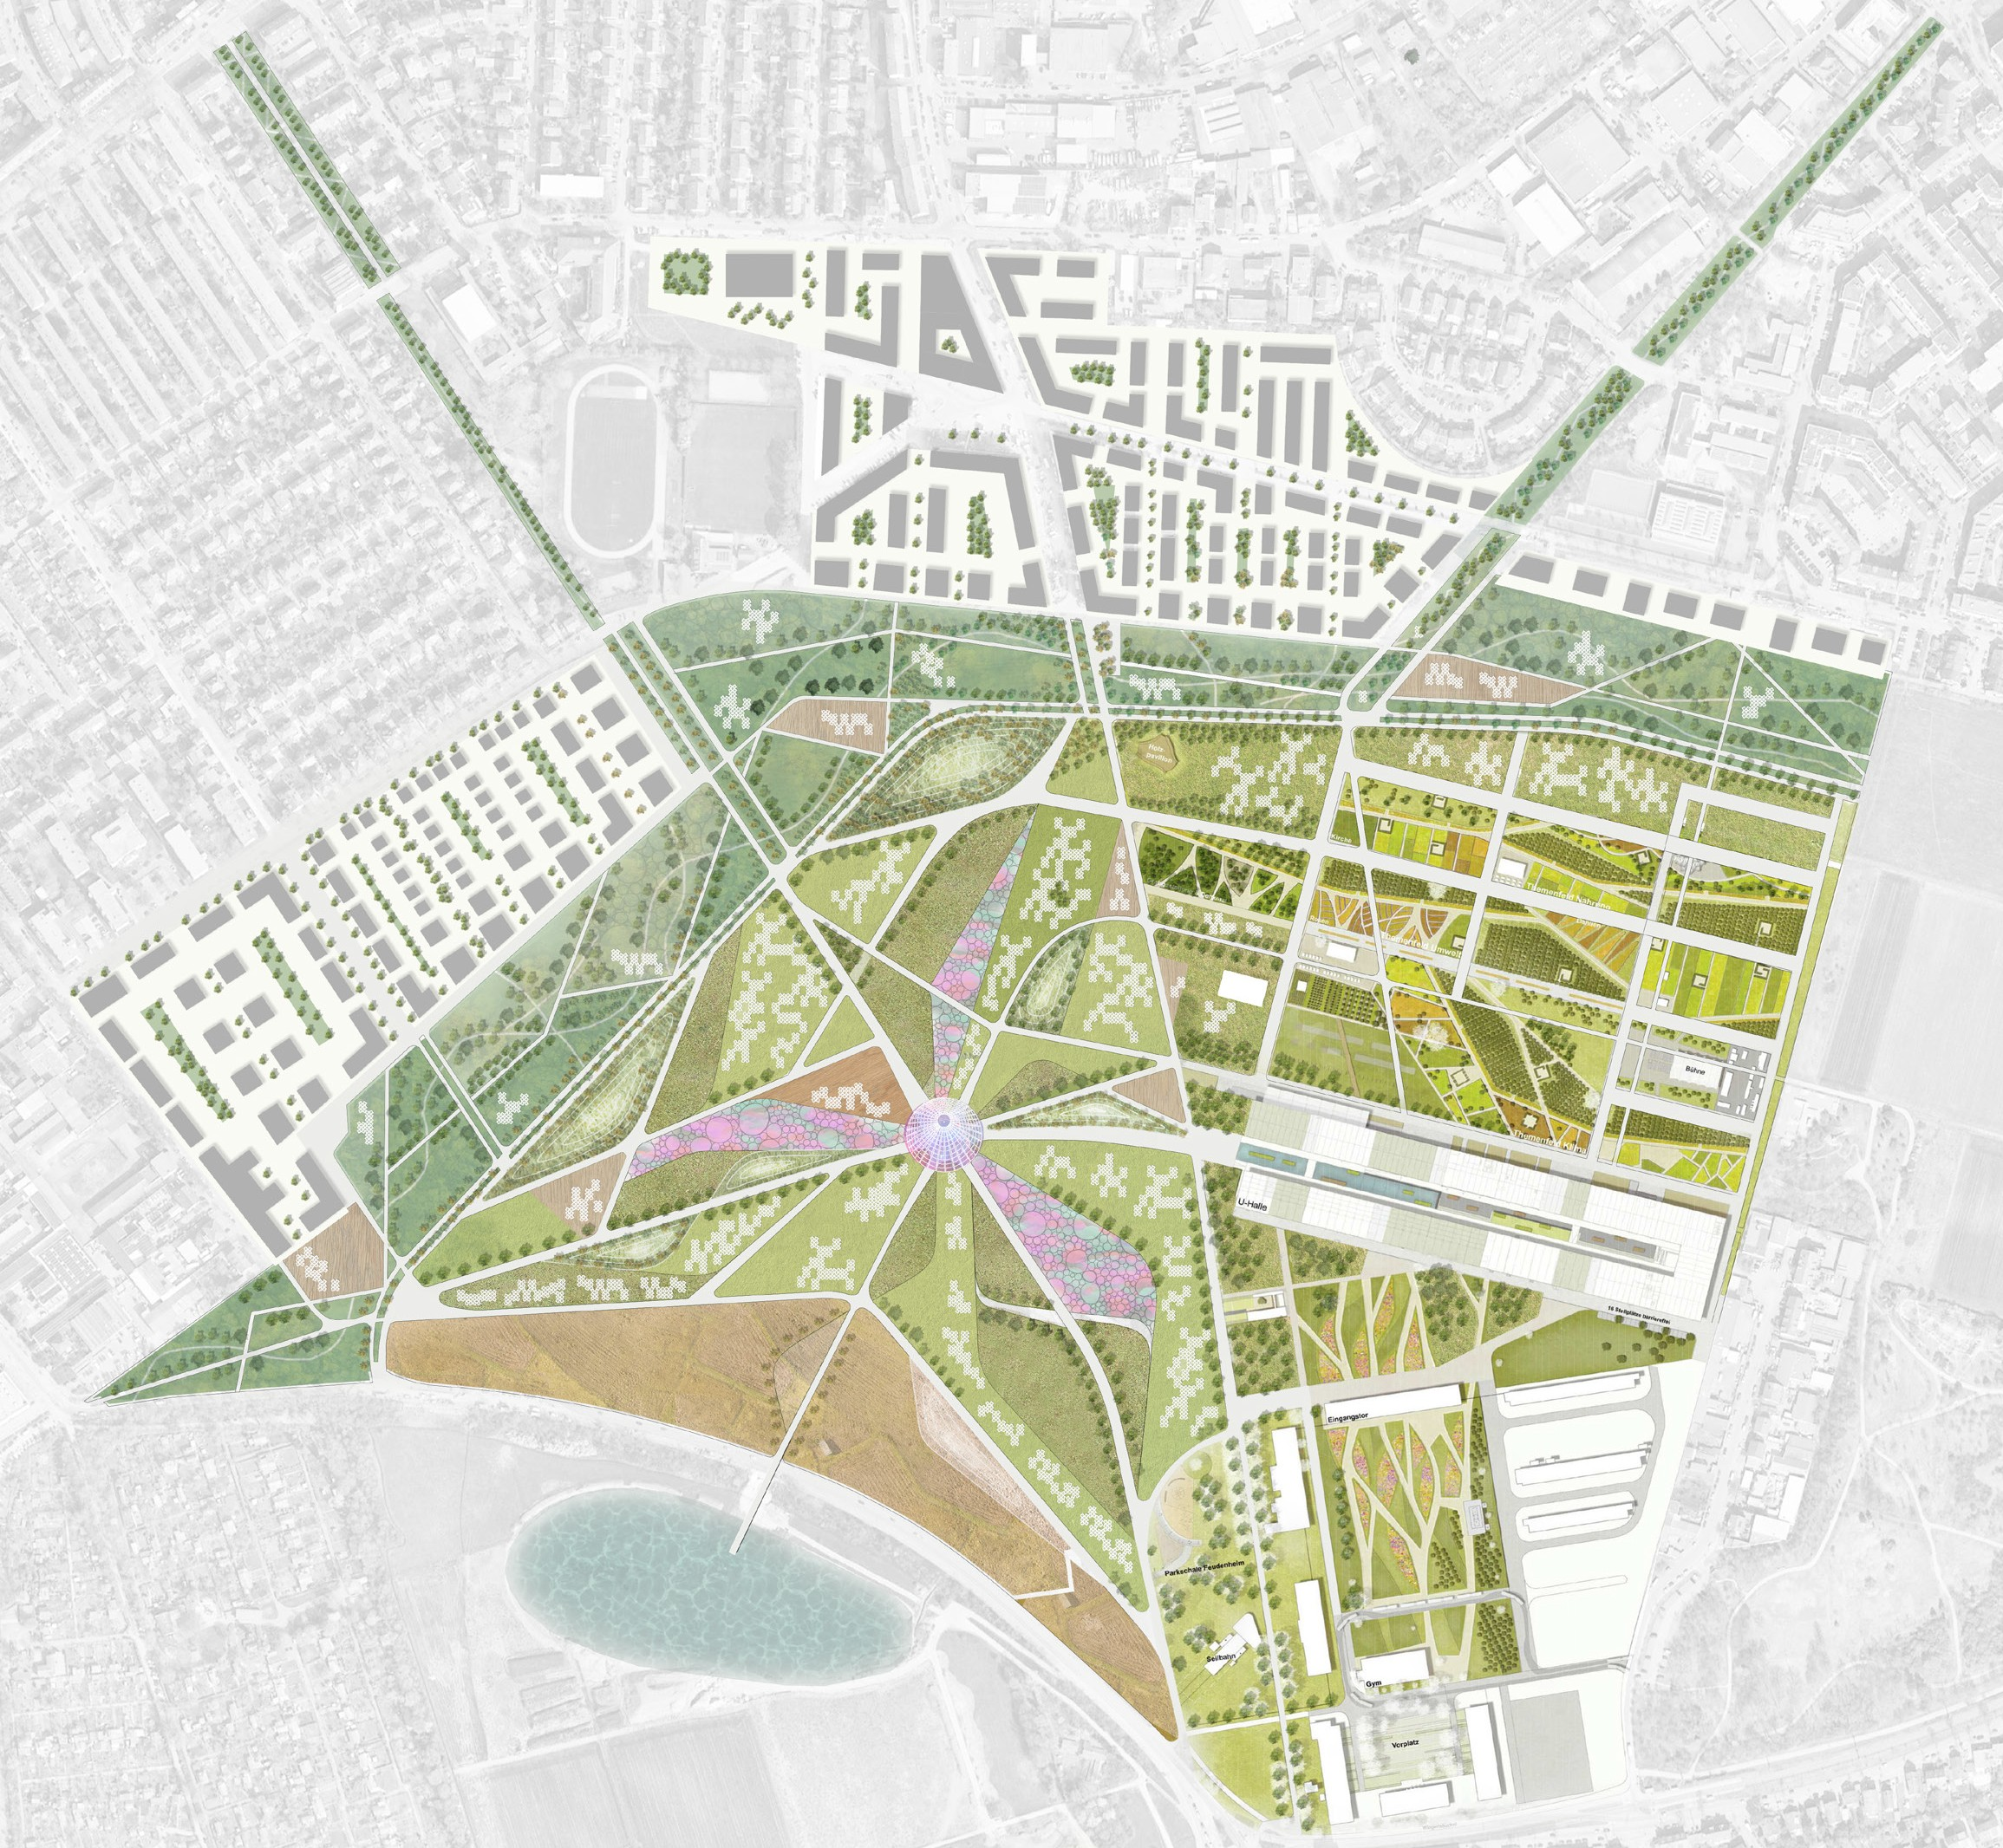4 4

4
5

1
6

2

- Pavilion and climate park
- Neodine
- Panoramic masts and water 3
- Play and activity park
- Themed gardens
- U-Hall

10 50 100 250
Proposed Urban & Landscape Design Framework

02

Artee - BUGA 23 Pavilion

Sustainable Technologies Strategy & Transformable Energy

Understanding each technology’s advantages led to the main pavilion’s design process. The key driver to the design of the central element was
to discover a form that enables the integration of multiple technologies to improve energy performance.
Integrating these technologies fell into the concept of Artee, a mix of design, art and engineering that incorporates flexible solar thin-films, Tensairity & Piezoelectric installations.

The installation’s centrepiece is an adaptive kinetic solar pavilion that can change shape to maximise the surface area facing the sun during the day and the seasons for optimum efficiency and power output.
With a span of 58m and a height of 10m, the covered area of solar thin-film is 2,143m².
Due to an energetic and structural optimisation, the solar thin-films are placed on the eastern, southern, and western areas, whereas the steep northern part of the pavilion is uncovered. The building structure of the adaptive kinetic pavilion consists of inflatable tensairity beams defined as ribs connected with an inner and outer ring. This ultra-light and flexible structure of the pavilion allows changing its shape by adjusting the air

pressure inside the tensairity ribs.
In order to achieve geometrical stiffness, high and low points are generated with the wavy outer ring, as illustrated in the renderings.

The solar pavilion is co-beneficially opened for access by the outer ring. All the structural elements of the inflatable tensairity beams are made out of PVC-coated polyester fabric reinforced by a thin steel wire mesh, and the envelope consists of an Elastan membrane on which the solar thin-films are mounted.

The direct solar radiation in Manheim ranges in between 200 and 1000 kWh/m2 during the year, while summer is the period with high solar irradiation. The solar pavilion optimises its surface faced to the sun during the day and the seasons resulting in a high- energy performance canopy due to its kinetic system. The roof collects solar radiation most efficiently when the sun’s rays are perpendicular to the panel’s surface. Precisely, the pavilion adjusts the inclination of the surface not only at 12:00 but also at 9:00 and 16:30 (highest temperature) in summer.

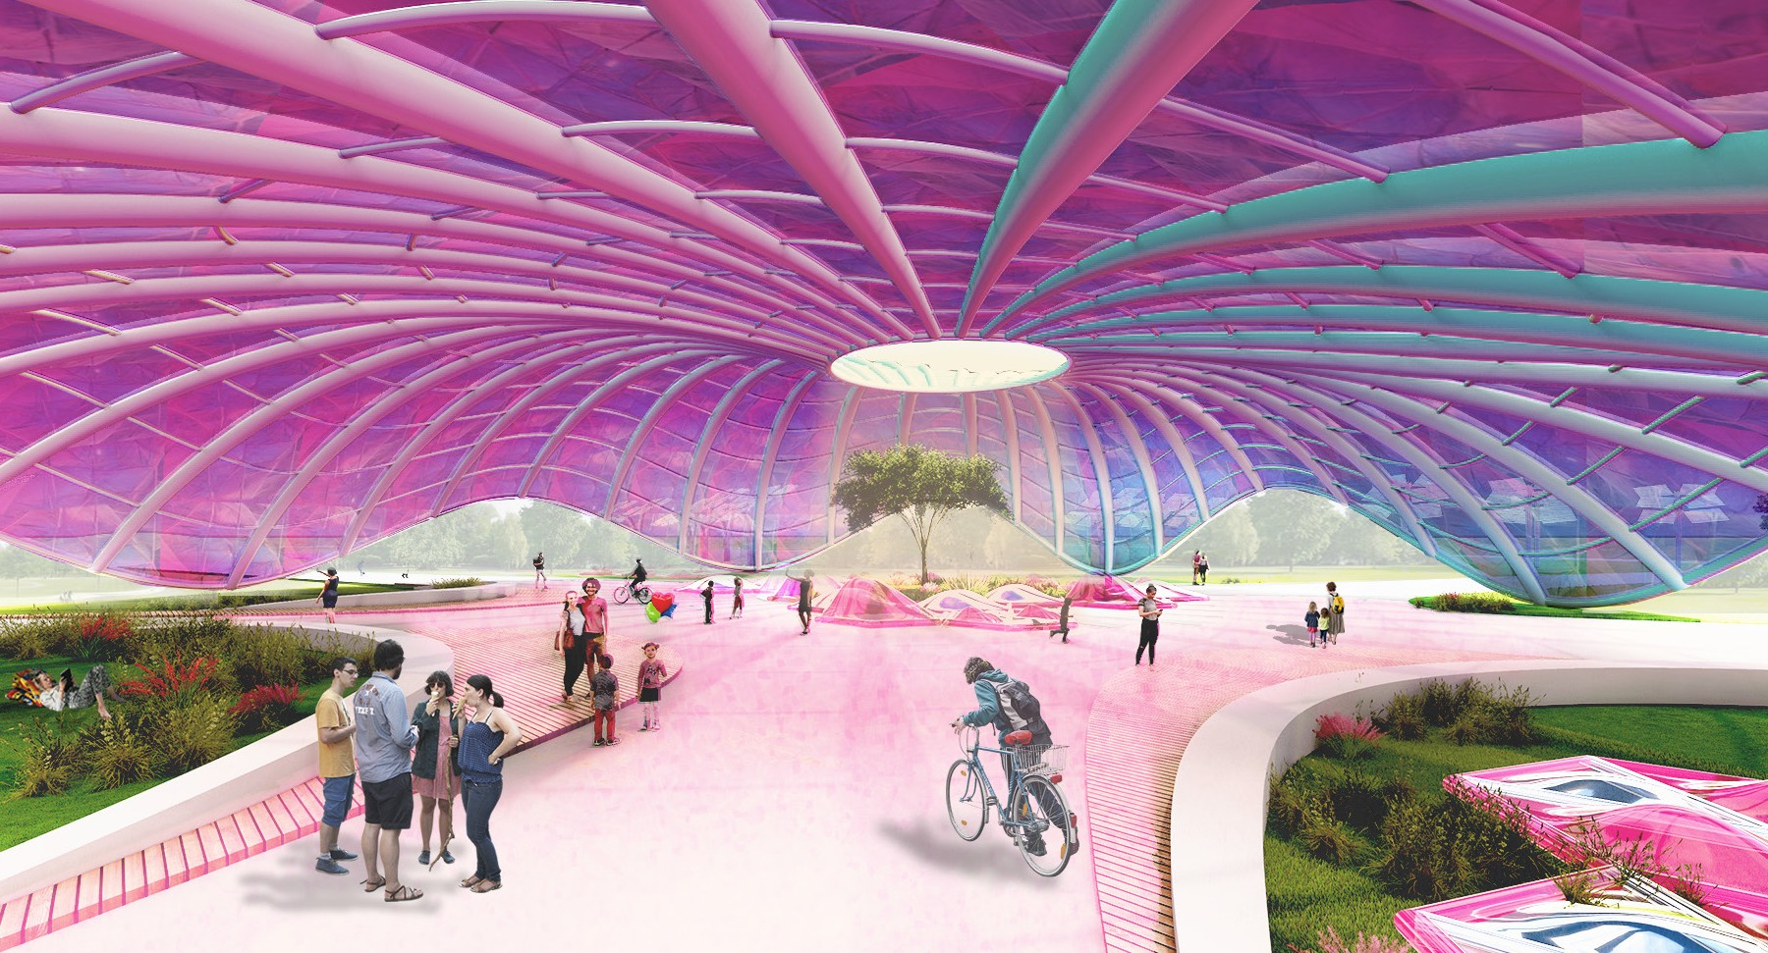

03

Artee - Modular Approach

Modularity Technologies & German Gardens

A novel solar-powered lightweight and adaptive kinetic tower has been proposed to optimise its tilt and direction for optimal efficiency and power output. By reorienting its petals toward the sun throughout the day and the seasons, the sun-tracking solar thin-film tower increases the amount of energy absorbed and, thereby, the solar production by 40% compared to conventional solar panels.

The modularised 6m-tall hybrid tower comprises a combination of air beams made out of ETFE fabric and recycled aluminum recalling the musculoskeletal system of human body (muscles and bones/tension and compression). Air beams hold the solar thin-films and are connected to the tower by a bidirectional soft actuator. The compliant body of soft robots can be rapidly fabricated, achieving different locomotion.
When inflated or deflated, the soft pneu-net actuators (Hao et al., 2017) may bend or rotate inward or outward, reorienting the petals to face the sun. In addition to solar energy systems, kinetic structures are implemented to maximise energy gains and social interaction.

Application & Energy Capture

The sun-tracking solar thin-film towers cover 14,496m2, and the total annual PV energy production is 1.66GWh. A significant impact on energy efficiency is reached by implementing kinetic structures that can track the sun’s position and adjust its orientation or shape to maximise the energy output. The soft actuator optimises the position of the petals at different points of time during the day and the seasons.

According to statics and research assessments, the dual axis of PV provides high-energy performance systems. In our design project, we explore the potential of optimising the position of the petal not only at
12:00 but also at 9:00 and 16:30 (highest temperature) in summer with resilient and ultra-light systems. In addition, the implemented piezoelectric floors generate energy approximately 1W to 7W per bump. Added up, this works as a supplementary kinetic energy for LED street lighting.

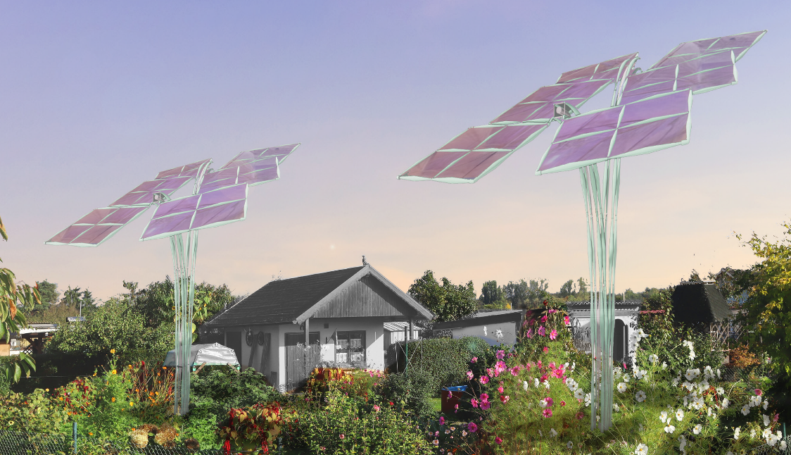

Environmental Performance and Optimization

Regarding material use, the approach was driven by the two factors of using less material and using low-impact material. For that reason, the decision for the PV panels fell to an organic solar thin-films. These solar thin-films use organic polymers to create energy from sunlight. Its light, flexible structure and use of organic material make it the best choice for the proposed concept regarding environmental impact. Moreover, with
a conversion efficiency of up to 16%, it can outperform conventional PV over time due to the light situation.
Using as little material as possible led the design to pneumatic structures fabricated out of membrane material. Using air to stiffen rigid structure components is a highly efficient way of creating large spanning surfaces. This saves the amount of support structure needed to carry the building’s dead weight. An annual energy consumption of 21kWh was calculated, while a production capacity of 93MWh is achieved.

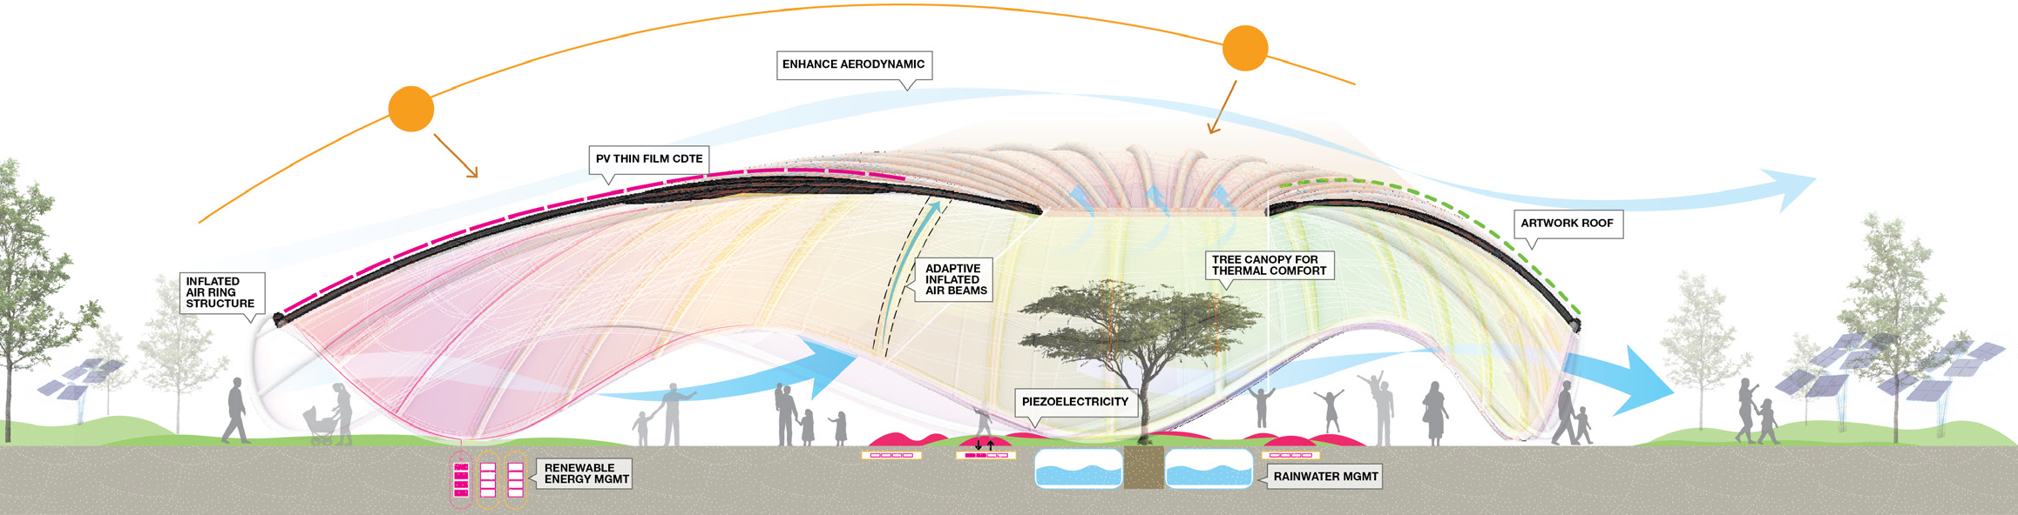

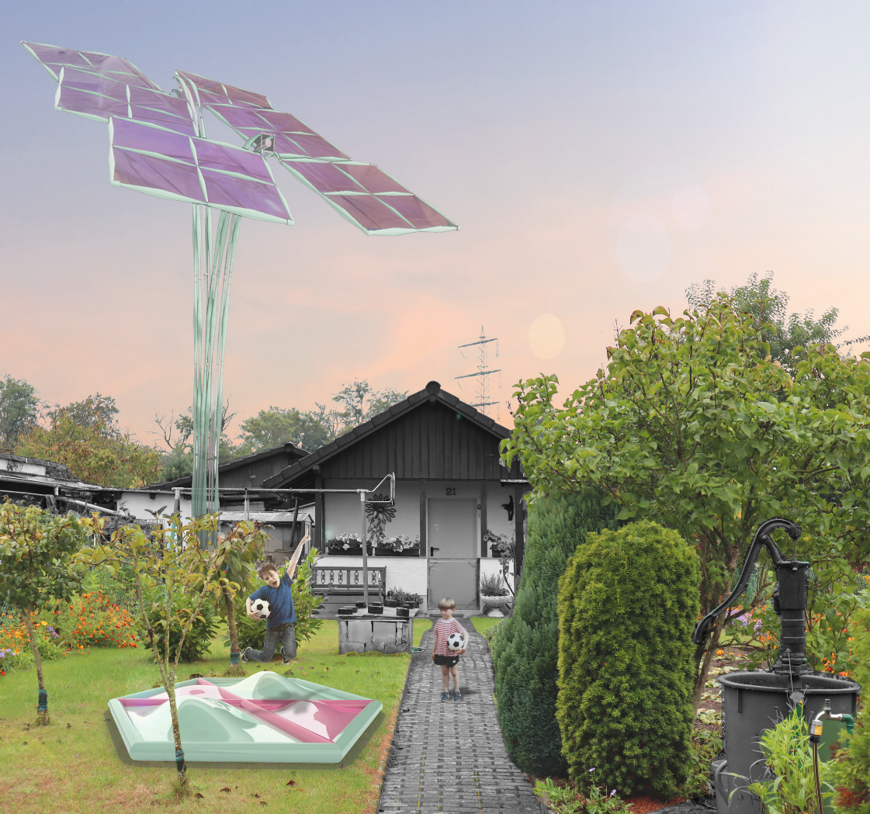

04

Artee - Indicative Cost Estimate
The main pavilion is an adaptive kinetic solar structure that works as an inflatable element, the prototype development is based on a assemble & disassemble process that allows the structure to be installed quickly.

The assembly process is based on the main PVC- coated polyester fabric being fabricated off-site and inflated on-site. Since the components are small and light when deflated, transport and assembly are
advantageous. Due to the geometry of the presented concepts being mainly dependent on the cutting of

the textiles, the size and form of the prototype can be adapted to the circumstances of the event. The tensairity uses air as the main rigid element that can be efficiently pumped into the fabric. Once the pavilion reaches a specific point, constant air will increase pressure in specific parts enabling the pavilion to change and adapt to the sun’s position.
Once the main event is over, the fabric can be reused and reinstalled in a different location.

Artee Pavillion- Indicative Cost
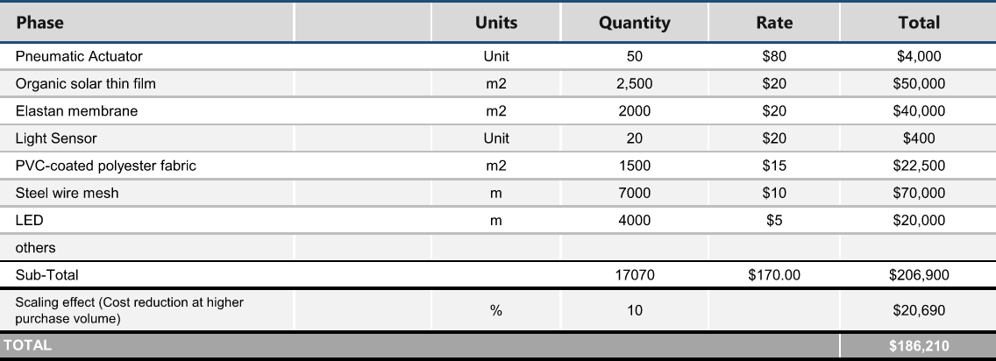

Artee Solar Film - Indicative Cost
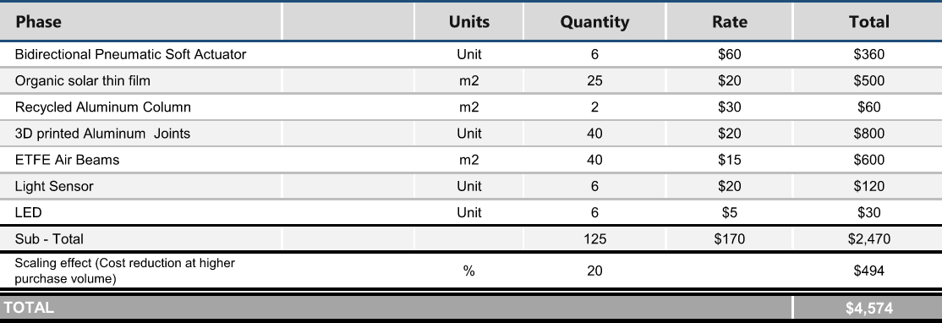

Artee Piezoelectric - Indicative Cost
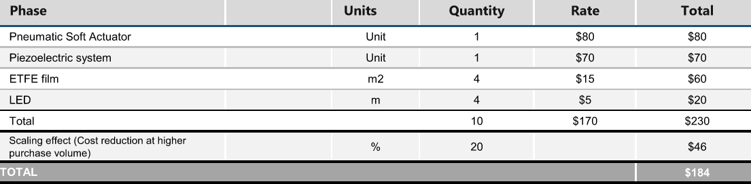

Artee

LAGI 2022
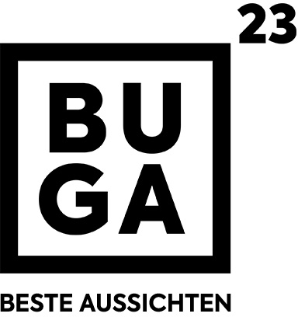
MANNHEIM

