Hope & Legacy

Strategies and expression
After researching the basic information of the site, it is found by comparison that due to the flatness and barrenness of the site, the climate information of the site area has obvious characteristics of high solar light intensity and multiple wind directions. Due to the single volume of the landscape building and the preservation of the original ecological conditions of the site, a sustainable energy source with solar energy as the main design was chosen. When researching the concept of solar energy related forms, I thought of the concept that reflects people's expectations for the future green life picture - SolarPunk. As a sci-fi theme and the meaning of an art movement, solarpunk was born in the 2010s. Like this design, it pays more attention to technology rather than just form concept aesthetics. It includes low-tech sustainable lifestyles, such as gardening, Permaculture, regenerative design, positive psychology and do-it-yourself ethics. Based on such concept, I choose common forms to extracte the basis for a series of structures.
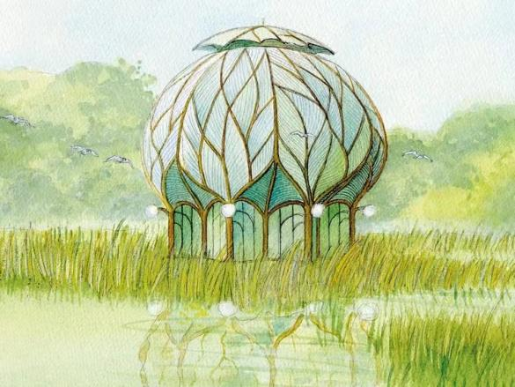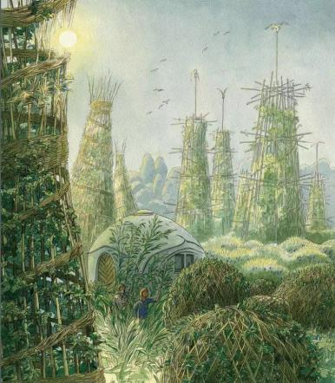
SolarPunk buildings original concept
(ART BY LUC SCHUITEN)

In designing the basic forms of the buildings, in addition to relying on people's fantasy that the future green is a social scene in the concept of sun punk itself, special consideration is given to the main unit located in the main center of the site. While thinking about the accessibility of buildings in a sustainable process, it comes to mind that the transport emissions consumed by the smaller folded building blocks during construction are smaller (compared to the transportation of a large number of building materials), and the small-volume building blocks consume less transport emissions. The volume is reminiscent of origami. The retractable origami can not only reduce the footprint of the unit block, but also conform to the application of the regulated solar panel in the unit, and also conforms to the blade in the concept. The folding of the applied solar panel page was explored by laser printing. Finally, considering the solar light receiving area, the number of unit divisions based on 6 (12) is selected for subsequent design.
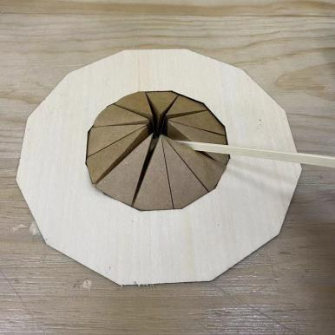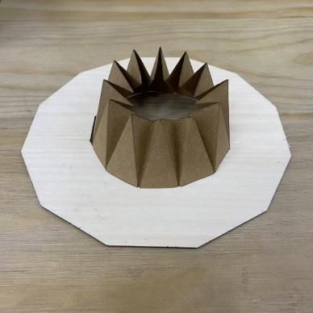
Origami modes exploring

In order to plan the site in response to the natural form, retain the facilities and pipelines of the buildings around the underground space in the overall space, and retain the main roads on the site in the overall design, and use the space syntax tool based on ecological optimization to build on the basis of the original first-class roads and second-class roads. The three-level road system is divided up to minimize the sense of manual intervention of the road on the site and preserve the ecology of the site.

The overall road value is based on the Physarealm slime mold algorithm to achieve autonomy. In this value, setting the central vertical agricultural building , the main entrance and exit of the site as the food attraction point (Food attraction) as well as the launch point (Emitter Point) respectively, while using the life dispersion time of 30s to collect and simulate the shape of the flow of people activities on the site block. Different experimental groups were differentiated by the comparison of Max speed, Possibility of changing direction, offset angle and emission angle (SA & RA) of slime molds. Taking a clear path as an effective image, 11 groups of effective experimental groups were selected.

After analyzing 11 sets of effective path images, choosing to compare them with the original first and second-level roads of the site. By selecting the experimental group with more and clearer corresponding trunk roads as the basic form of the third-level road, I finally select a group of experimental groups as the follow-up design. the road base (Database: Max speed:3 ; Possibility of changing direction:0.1 ; SA=RA=45°).
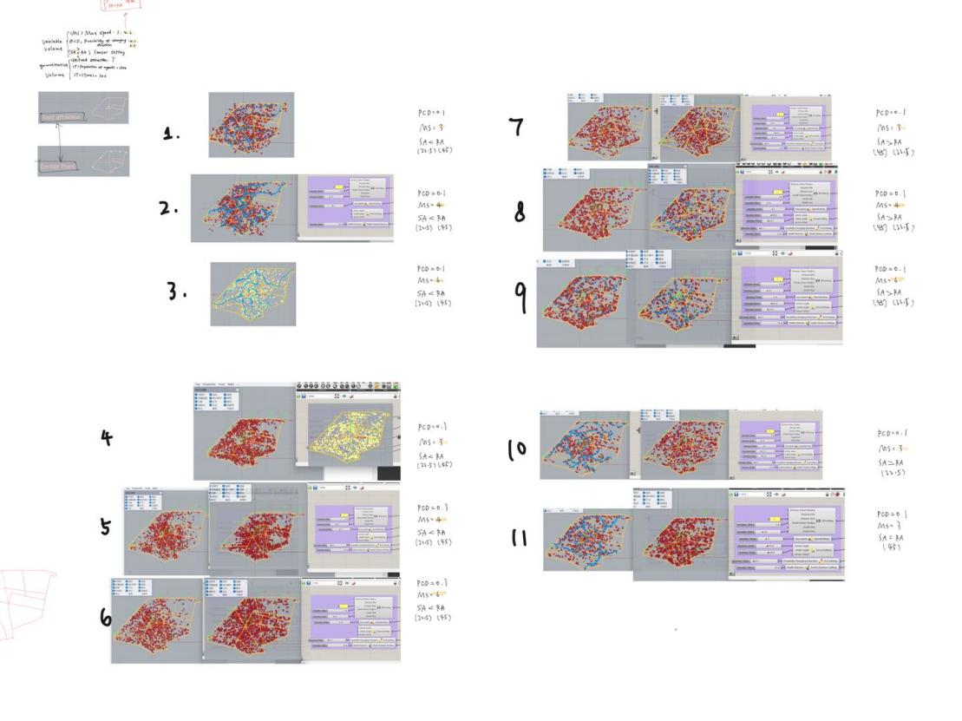
Summary of experimental groups

By analyzing the cultural and historical clues in the site, it can be known that between the three garden festivals (Mannheim Horticultural Exhibition in 1907, the Federal Garden Festival in 1975 and the BUGA Garden Festival in 2023), there were U.S. troops stationed and foreign refugees living in the site respectively. The conflict between the closed, unsettled refugee groups and the aborigines left over after the withdrawal of the US military made the landscape architecture designed to solve these remaining challenges as much as possible, especially to enhance the sense of connection among the people.

For this reason, the main building of the center was designed-- Towers for vertical farming. Retain the unit structure, realize the energy and resource circulation of the single building as much as possible through the folding solar panels and the rainwater collection device in the center, provide a functional space for aboriginals, refugees, tourists and other diverse groups to gather, and at the same time become a new Park themed scenery. The planting area of the main building is designed to be similar to the waterwheel running in the traditional Chinese agricultural mode to ensure the light receiving and maintenance and management functions of crops under a certain floor height. Like the China Pavilion left in Luisen Park, it uses the integration of agricultural form elements with Chinese characteristics. The main building is set up on the site mainly with wood, and the extension components are applied to other functional units. It makes the building itself truly benefit from the historical and cultural elements left over.

Energy inspection

Selection of energy conversion tools
  - PVs
Using semiconductor photovoltaic cells, solar energy can be directly converted into electricity in a solar photovoltaic system. The efficiency of photovoltaic technology (about 15%) is still not enough, but the situation is improving with the increasing development of photovoltaic technology.Within the limited roof area, the most efficient monocrystalline photovoltaics were selected to obtain as much energy as possible.

The estimated value of the effective solar radiation area in the site: 2495.25π≈7835.085㎡, the following calculation value is calculated with 7835 as the area value.

 | Monocrystalline photovoltaic PVs panel
Board mounting area（㎡） | 7835
Energy production value | 1㎡-120kWh Electricity per year
Carbon value reduction | 1㎡-3.84kg CO2 per year
Average annual energy production（kWh/a） | 7835*120KWH/a=940200KWH/a
Average annual carbon reduction（kgCO2/a） | 7835*3.84kg=30086.4kg

  - PV-Ts

Another renewable energy system studied is PV-Ts. This system is a relatively new technology.The system requires additional machinery to absorb heat to prevent overheating, and it typically uses an air source heat pump and a gas tank of at least 250 liters. This is critical for maximizing the efficiency of photovoltaic power generation as well as providing heat. Running a heat pump requires a certain amount of basic electrical energy.

 | PV-T
Board mounting area（㎡） | 7835
Energy production value | 1㎡-120kWh  Electricity per year |  | 1㎡-120kWh  heat energy per year
Carbon value reduction | 1㎡-55kg CO2 per year
Average annual energy production（kWh/a） | 7835*120KWH/a=940200KWH/a | 7835*250KWH/a=  4958750KWH/a |  | Total：2898950KWH/a
Average annual carbon reduction（kgCO2/a） | 7835*55kg=430925kg  But only 30054kg CO2/year electricity + 260443kgCO2/year natural gas = 290497kg CO2/year can be effectively reduced

In comparison, photovoltaics generate only 34% of energy demand. The best option is PV-T, which offers 55% energy reduction and 82% carbon reduction. It has excess energy, but the amount is small so it can be tolerated. From this calculation, PV-T was selected as the main renewable technology.

Mannheim buildings have more energy demand electricity than water.Even if all roofs are covered pv, it only generates 24% of the total energy demand on the other hand if only solar thermal uses the roof, it generates more energy demand. The carbon intensity of the German grid is very low, so the best approach is to reduce gas demand in the first place. PV-T produces more energy than natural gas requires more energy, the energy produced is not constant throughout the year as it relies on solar radiation that varies from month to month.

Summary of new energy production (based on NREL's PVwatts energy estimate)
The NREL standard can be used to estimate energy production and energy costs for grid-connected photovoltaic (PV) energy systems worldwide, and to evaluate the performance of photovoltaic installations in buildings. The estimates below are based on the National Solar Radiation Database (NSRDB) in Mannheim.Table below is the PVWatts data summary .

Solar RESULTS | 7298,573 hWh/Year
Month | Solar Radiation  (kWh / m² / day ) | AC Energy  (kWh)
January | 0.86 | 176,453
February | 1.77 | 327.620
March | 324 | 647,062
April | 4.15 | 784.072
May | 5.14 | 971,834
June | 4.71 | 862.378
July | 5.70 | 1,049,309
August | 523 | 947,455
September | 3J7 | 702.814
October | 2.34 | 459.406
November | 1.05 | 205.945
December | 0.80 | 164,226
Annual | 3.24 | 7,298,574
Location and Station Identification
Requested Location | Mannheim
Weather Data Source | (INTL)MANNHEIM. GERMANY | 4.3 mi
Latitude | 49.52* N
Longitude | 8.55* E
PV System Specifications
DC System Size | 7835 kW
Array Tilt | 22°
Array Azimuth | 180"
Inverter Efficiency | 96%
DC to AC Size Ratio | 1.2
Performance Metrics
Capacity Factor | 10.6%

