SEED
symbiotic coevolution

Climate change, and other man-made disasters driven by rampant consumption, are rapidly destroying the planet and leading to wide-scale desertification and habitat loss. But these trends are reversible, and we think what we build on Fly Ranch can become the seed of a beautiful, symbiotic future that will grow and spread around the world counteracting and reversing current trends and bringing us inline with a natural state of evolution.
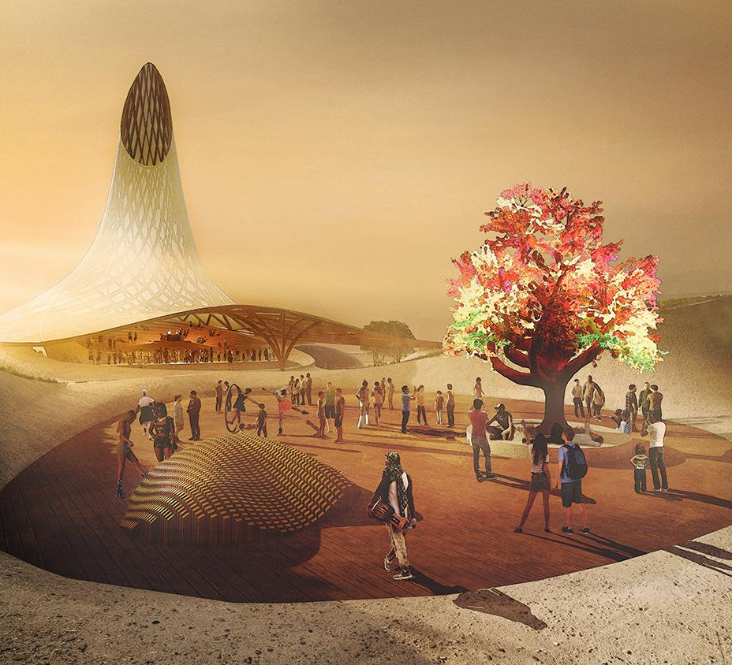
Renewable technology and generative practices are a given. What we need is a spiritual awakening to reframe our values.
Our proposal is not only about the environment: it is about people, and the experiential, emotional, and psychic experience of humans. Our optimistic mission is to demonstrate how human spiritual ambitions can be attuned to restore the ecosphere. This is how we foster conditions for a way of life that cares for the earth, longterm; because it cares for its people, too

How do we do this? We create a thriving community, one where people are healthier, happier, and spiritually transformed into a new global conscience; nurturing a higher quality of life through a social art practice.
This ethos manifests in the development of a knowledge-based city that will become the world's epicenter for research, exchange, investment and advancement of life-centered products, systems, and services. It also serves as a destination spiritual oasis and wellness center. It invites the world to share in this learning and communing, to symbiotically connect with ourselves, each other, and nature.

The premise of our design is deeply organic, taking inspiration and paying respects to the native peoples who have lived on this land for tens of thousands of years: natural materials, food grown and energy produced onsite, using 90% less electricity than average. A series of structures that are adaptable and flexible in order to support an ever-growing community; they scale nimbly and efficiently. The structures are tucked humbly and thoughtfully into the landscape, spawning a collaborative sculpture with the earth itself. They are discrete, graceful, low-impact, and elegant.

Agricultural and energy systems will be completely intertwined with day to day life: imagine riding your solar powered e-bike and picking an apple off a tree on your way to a conference. Our goal is not to be merely sustainable, but wholly generative: we seek not to just maintain and sustain, but to restore and improve, greening the desert as we go. We will in turn create the most beautiful environment for the human experience, centered around community, knowledge and research.

Our designs, systems, and philosophy take inspiration and direction from the Northern Paiute and the native people who have lived in harmony with this land for millenia. From the art found in petroglyphs at Winnemucca Lake, to the convening tribes for celebration, conference, and trade, the delicate relationship with species like Cui-ui, their lightweight nomadic structures, and underlying everything, the belief in Puha, the universal power that flows through all beings and entities - we see our future as much as the past.

We are creating the conditions for a global community to emerge, one in which scientists, artists, renegades, tinkerers, thinkers, makers, talkers and doers symbiotically thrive and care for the land, themselves and each other.
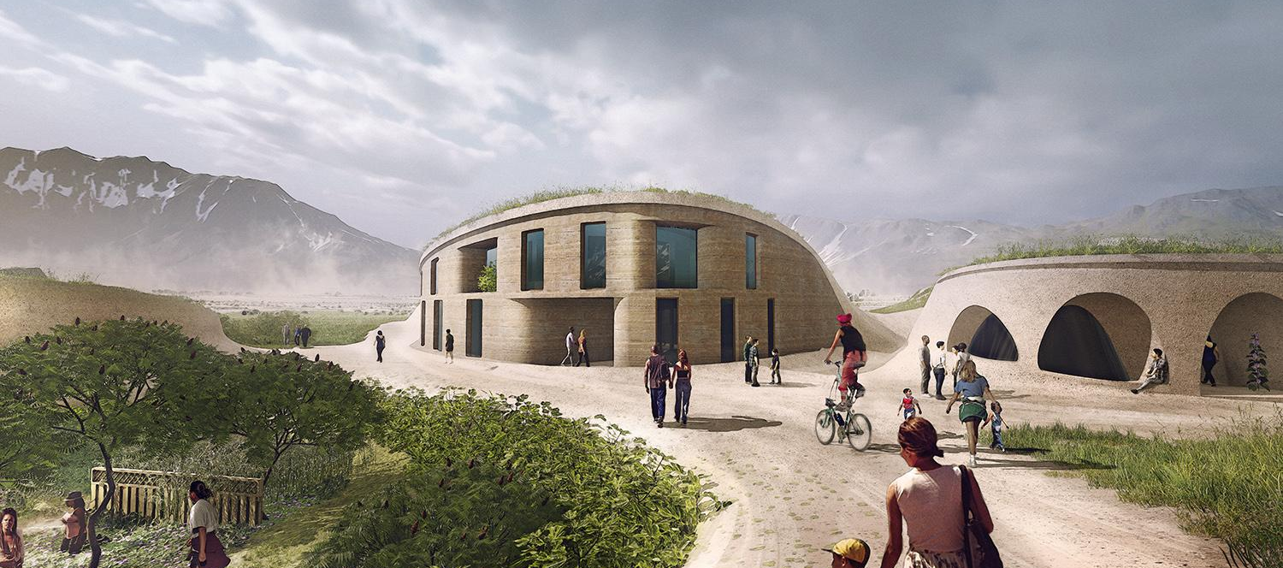
ACTIVITIES

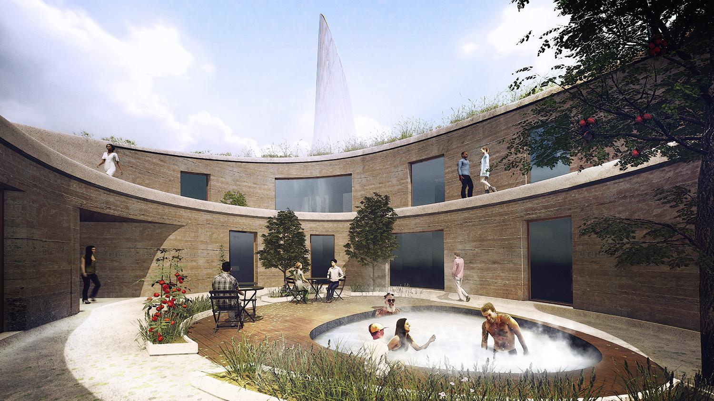
People will come to Seed for conferences, workshops, retreats, and more, partaking in a radically participatory community. Onsite activities will support our KPIs of increased longevity, and lower rates of cancer, depression, and suicide. They will achieve our goals of creating happier, healthier, more lively human beings.

We’ll have weekly farmers markets and a CSA program open to Gerlach residents. Evenings will commence with themed conversations and conceptual menus. We’ll create land art with food waste, turning compost into living sculptures that disintegrate into the earth.

Knowledge-centered experiences will establish the DNA of the community. Lectures, talks, and workshops by experts in various fields while they’re staying onsite. A thriving metropolis that attracts leading thinkers, writers, public intellectuals, researches, scientists, technologists. Vibrant symposiums and avant-garde festivals. Research labs and maker spaces, art studios outdoors. Each resident unified by a relentless desire and openness to the exchange of ideas, perspectives, enthusiasm and expertise.

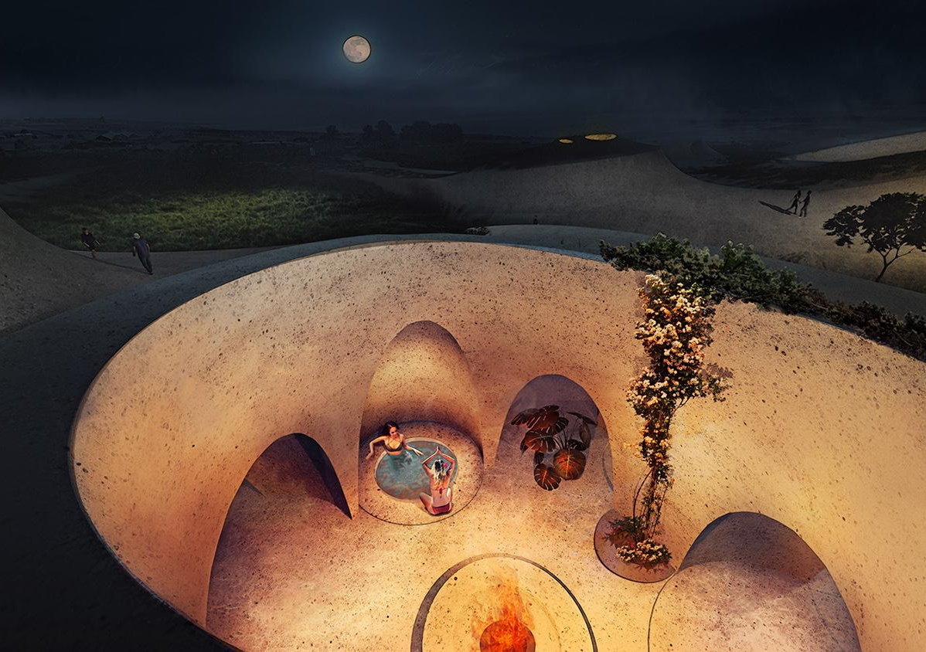
We will work and create together. There will be pop-up exhibits, DIY galleries, science “museums”. There will be a repair shop to fix bikes, software, and broken hearts; marketplaces to exchange goods and services. Through an artisans-in-residence program, we’ll engage university students, artists, and architects, working onsite in exchange for housing.

Pleasure and play will abound. Bathing and body positive parties, concerts, trail running. Sensual haircuts, bikram yoga, and bee venom therapy will delight the senses, rejuvenating the body and mind. Ashrams will create spaces of peace and quiet, encouraging meditation and internal repose.

Our community will empower youth, too. Along with child-care for residents, there will be educational programming for students from local high schools. Through a regular “art + energy” camp, kids will learn about renewable energy by building solar artworks in teams led by a resident counselor, fostering the next generation of global citizens who see the promise of a truly regenerative lifestyle.

All activities, programming, and experiences on-site are made possible only through community buy-in and empowered self governance.

TECHNOLOGY

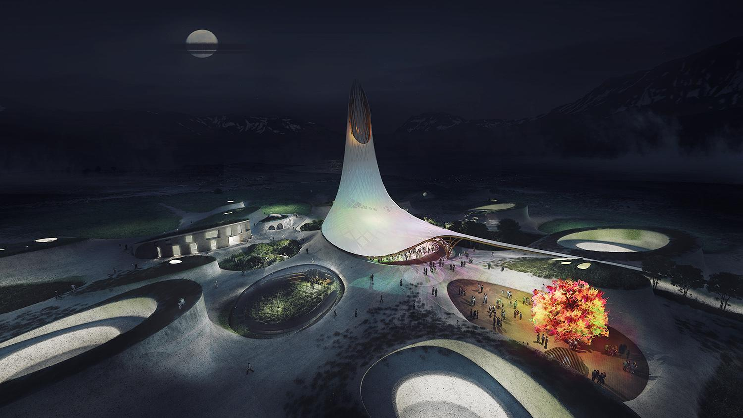
Our design aims to integrate existing technologies in novel ways. We will utilize solar, geothermal heat exchange and radiant floor, cooling tubes, and wind catchers. A micromobility superhighway for transportation will be created on mechanically stabilized earth.

We will take advantage of waste streams by composting food scraps to create highly fertile soil. We will create greenhouses for both plants and people, and implement efficient, high intensity production systems such as aquaponics using the local cut-throat trout species. Community scale biodigesters will generate liquid fertilizer for use in orchard systems, and greywater will irrigate edible landscapes, perennial grains, and food forests. We will use earthworks to extend soil moisture throughout the growing season. We will use high intensity grazing and native nitrogen fixing ground covers to quickly cycle nutrients, generate topsoil, and sequester carbon. Areas for natural ecosystem preservation will be untouched, serving as a valuable asset for natural education.

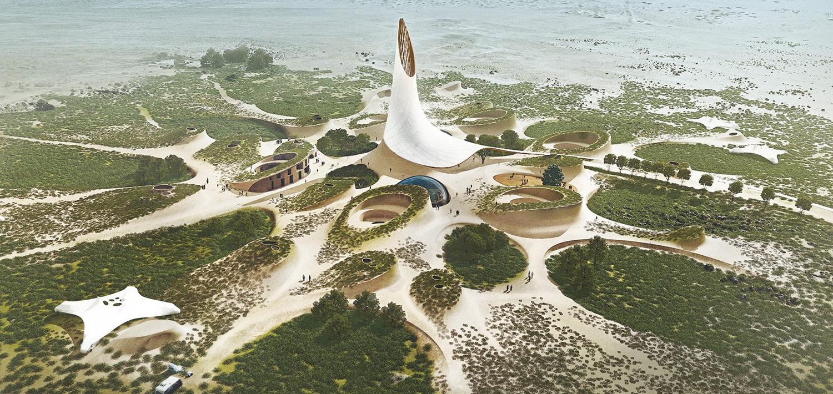

SYSTEM INPUTS & OUTPUTS

City Wide Inputs:

- Solar / Geothermal - Power and heat.
- Well Water - 20 gallons/person/day.
- People / Labor - Construction, maintenance, creation.
- Income - Residences, conferences, workshops, retreats, think tanks.
- Investments - Corporate & venture, sponsoring projects.

City Wide Outputs:

- Knowledge / Innovation - White papers, scholars, applications, tools,
technologies, new philosophies, AI training systems, artists, entrepreneurs,
greentech, fund to help other symbiotic communities get off the ground and
adapt these practices.
- Electricity - Abundance of summer sun ––> export excess renewable electricity.
- Greens - biomass, food.
- Financial Capital – Can invest in other endeavours: grow the system.
- Economic Opportunity – Local citizens, government.

PRIMARY MATERIALS

The city is designed to be biodegradable and natural, without any off-gassing. Over centuries, it will slowly disintegrate back into the landscape without leaving any matter out of place.

We will craft adobe bricks made of earth and clay to build our residences that have a ~30M diameter with an interior courtyard of ~12M. We’ll add artificial reinforcing to soil to construct mechanically stabilized earth. Rammed earth walls and terra cotta, baked onsite using a solar cooker, will provide support along with textile membranes, geofabric, cob, and locally sourced thatch. Upgradeable, recyclable photovoltaic panels and battery storage will be judiciously used.

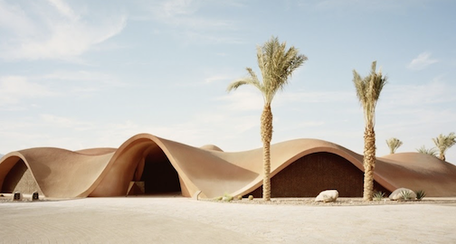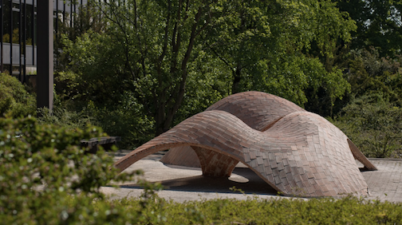
Image Source: Oppenheim Architecture Image Source: BLOCK Architecture
CONCEPTUAL COST ESTIMATE

At all levels, this project will be environmentally and economically positive, producing more than we consume. Pulling brilliant minds and hands in to contribute, teach and share, we will create a generative economy with income through convenings, retreats, classes, co-working, and co-living, sponsorships and partnerships, all with aligned partners, collaborators, visitors, scholars, workers, and artists.

We already have a commitment to fund the prototype grant 10x, up to $150k. We can provide food and shelter at irrefutably low costs and fund an initial community of 200 people - living, working, teaching, for 3-5mm. And using our low cost sustainable practices, we can achieve our vision for epic architecture and amenities supporting a scalable community that can swell from 500-2000 people for 20-120mm capex. All our initial modeling indicates that this is financeable, and cash flow positive with excess revenues to reinvest in the community and to finance new communities around the globe.

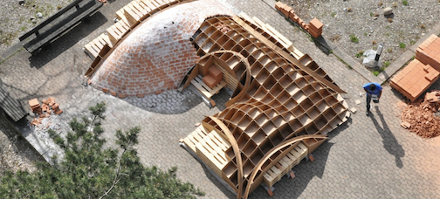
Image Source: BLOCK Architecture
ONSITE PROTOTYPE DEVELOPMENT STRATEGY
Using the honorarium grant plus matching funds, we will build a small, self-sufficient, carbon positive community for ~50 people for 1 year.
This will include at least one “camp” structure with radiant floor heating and earth wall cooling tube to support ~20 people, and a clubhouse + campervan space for ~30 people. For food production, we will set up a caterpillar tunnel to experiment with aquaponics and permaculture. Perennials will be planted in the surrounding areas to begin maturation of a food forest. We will use compost and waste to power a small-scale biodigester to use for cooking. A small, local materials lab will be created to support brick production.

The seeds for a knowledge-centered city will be planted, strengthening Fly Ranch as a living laboratory, a test-bed of innovation on how to live sustainably in a desert environment. Research on materials, systems, and energy will be ongoing, supplemented by small-scale conferences. Informal learning and knowledge exchange between residents will be a constant, through themed conversational dinners, peer-led workshops, and collaborative art making.

There will be a thoughtful emphasis on integrating the Gerlach community from the start. We will sponsor 5 scholars to live and learn in our development, and build on the Fly Ranch Nature Walks program.

We’ll use this prototype to prove out not only the technologies, but the community, business model, and financial feasibility. This will set us up to raise financing to build to the next level and grow our city.

ENVIRONMENTAL IMPACT

We are proposing a city built from local, earthen materials with low embodied energy. We will use proven, sustainable technology to address shelter, food production, energy production and wastewater treatment. Our goal is to define patterns and systems which can allow the city to slowly grow and expand without requiring external inputs, and without exporting any waste.

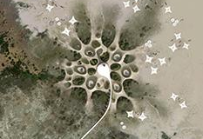
Our proposed structures will make use of earthen elements, consisting of mud brick, adobe, rammed earth, geotextiles and cob. These earthen elements will be paired with light weight textiles for shade and shelter. We plan to source the earth used to construct these shelters from on site. We recognize that by altering the topography, we will alter the way water flows and interacts with the normally level site. We will mitigate this issue by using the excavated areas for food production, planting them with perennial fruiting trees and shrubs, and diverse, hearty, native ground covers. This will minimize erosion, sequester carbon, build topsoil and produce food using the extra water that will accumulate in these excavated areas.

We recognize that by bringing in non-native species for food production, we may alter the ecological composition of the site. We will mitigate the risk of introducing new invasive species by choosing introduced species carefully, and using species which can only thrive in the protected microclimates created by our earthworks. We also plan to designate large areas of the site as “do not disturb” areas, which will be untouched, and can serve as ecological preserves for native species. We hope that these natural areas can also be used for education, and that by creating an ecologically sensitive populous, the citizens of Fly Ranch will steward the land, seeking out and eradicating invasive species such as Tamarisk and preserving ecologically sensitive areas such as natural wetlands.

We will provide power for our structures using solar photovoltaic panels paired with batteries for energy storage. We believe that simple solar photovoltaics will be the least invasive way to produce power on site, since the panels can double as shade structures, and won’t have moving parts, minimizing the need for maintenance and repair. The use of solar panels might increase polarized light on the site. Since Fly Ranch is used by a wide variety of birds and insects, some of which use polarized light to detect water, we will mitigate this issue by creating small engineered wetlands to treat greywater and provide habitat for these native species.

To address organic waste produced by citizens and visitors, we will divert sewage and other organic waste into biodigesters. These will produce biogas which can be used for cooking or water heating, and bioslurry which can be treated in reed beds, then used for fertigation of non-edible plantings.

In general, one of our primary design goals for this project was to minimize the impact of our structures on the landscape and the ecosystem. The undulating, dune-like nature of our buildings will help them blend into the environment, and the natural materials used for their construction will not poison the earth or produce plastic trash. The power, shelter, food and water systems we have chosen all function in symbiosis to turn typical waste streams into valuable resources. We are proposing a city that facilitates environmental stewardship and sustainability by implementing known solutions and proven technologies to create a closed loop, zero-waste, off-grid city.

