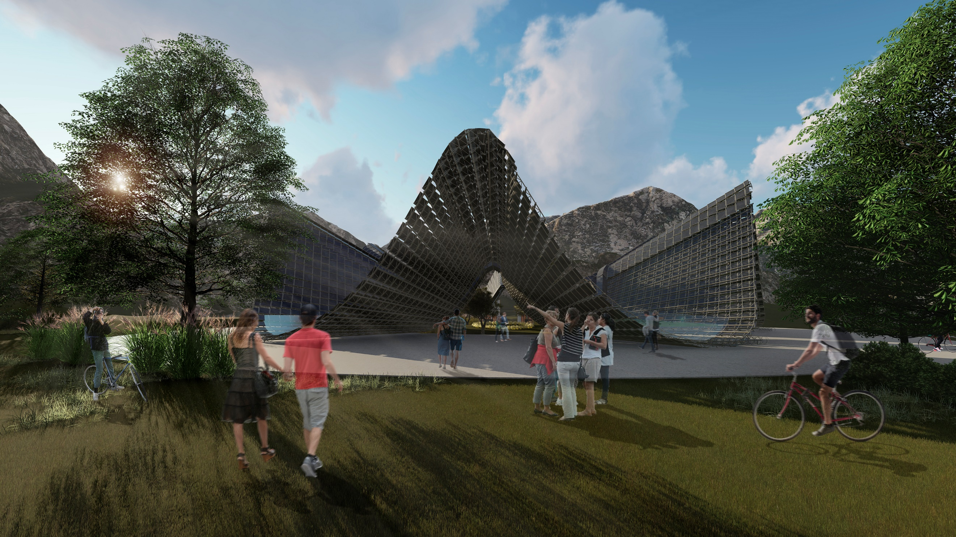
The Wave

To understand the project of the wave, it is necessary to understand the nature and the environment where it is located, it is a reverence for beauty and everything that the earth gives us.
Fly ranch Nevada, can have great variability in its climates and temperatures throughout the year, and it also has various characteristic elements of the area such as the Mountains, Lakes and Geysers.
The Wave project is a fusion that unites the characteristics of these 3 elements to provide sustainable responses to problems not only in the community, but also on a global scale.
As for solutions, with various technologies such as solar panels and atmospheric water generators, it is possible to generate water and energy in a totally ecological way. In addition to providing shelters for all those who need it.
The project is not only capable of self-sustaining, but also produces a large amount of energy and drinking water that can be used in multiple ways, for example being able to support hundreds of houses.
All this also generating a public space where multiple activities take place, ranging from just spending the day in a park and having a drink with family or friends, to taking place in experiences such as cultural events, art exhibitions, etc. marveling at the incredible beauty of nature and all that it gives to us.
The main structure of the work is based on this ring of curves, made of a metal structure and covered with flexible solar panels, which rise like the local mountains, where 3 curves are semi-covered that serve as a passage to the interior of this space, where other events take place, and the other 3 are closed spaces but with large windows that allow an incredible view of the surroundings, which serve as a shelter for all the aforementioned activities, each with a specific program.
As the curves descend, the morphology of the project itself solves the use of rainwater, being able to contain it in its descending part, generating water bodies that are very reminiscent of the lagoons that surround the project.
And finally, in the center of the project is an artifact of just over 2 meters high, which takes advantage of all this reused and sustainably generated water to launch a pleasant drizzle both to water nature and to be reached people who want it and refresh themselves, this not only remembers the characteristic Geysers, but is a symbol of giving back to the earth what it gives us.
The wave is a project that not only seeks to serve man, but also nature, and to enhance its beauty.

"Utopia is on the horizon. I walk two steps; she goes two steps away and the horizon runs ten steps further. So, for what does the utopia works? For that, it is good for walking ».
Eduardo Galeano.
Technical solutions and applied technologies:

Various technologies are used in the project, each one in order to solve one of the aforementioned problems.

Regarding energy production, flexible solar panels (CIGS) are used to cover the entire concrete structure, thus generating an approximate amount of 1,263,411 kW / h per year.
Enough energy to support themselve and power 154 houses per month, or 1.844 houses per year.

(Photo taked from LAGI- Field
Guide Renewbable Energy)

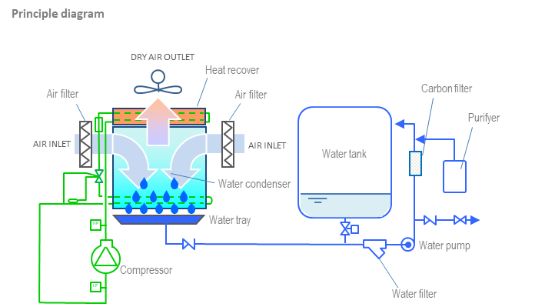
For the production of water in a sustainable way, it is achieved in two ways, the first and simplest is the reuse of rainwater, which according to the average annual rainfall in Reno, Nevada, which is 9 inches, would obtain about 718,033 liters of water per year.
The second technology applied in the project to generate water are the atmospheric water generators, located in height in order to take advantage of a greater airflow.
These take the humidity in the air to produce drinking water.
With a quantity of 50 generators, it would be possible to obtain about 5,703,125 liters of drinking water per year.

Calculations:

Capacity in kWp:

- Surface PV Area of One solar panel: 2.6m² ⁽size of the panel 2598mm x 1000mm) 2.600 watt
- x 20% Efficiency Assumed Based on LAGI Field Guide Document, THIN-FILM NON-SILICON 520 W(p)
- There are 1.385 solar panels in the structure: 660 W(p) x 1.385 = 720.200 W(p)
- After conversion to KW(p) is 720,2 kW(p)

Annual kWh of Energy Expected:

One Day kWh: 3.600 m² (real magnitude by curves) x 0.20 (Efficiency) x 6.41 (Peak Sun Hours) x 0.75 (Effective Output % After Deducting Losses) = 3461,4 kWh/day

Annual kWh = 3451,4 kWh/day x 365 = 1.263.411 kWh/year = 1.263 mWh/year

Water:

Each atmospheric water generator (1790 x 785x 1175mm) produces 500 liters of drinking water per day, under standard climatic conditions: 80% Relative humidity.
50 generators fit in the structure, 500l x 50 = 25,000 liters of water per day
25,000 x 365 days = 9,125,000 liters of water per year.

In Reno Nevada the annual average relative humidity is 50%
So if 80% -------- 9,125,000
50% ------- x = 5,703,125 liters of water per year is what it will generate.

Regarding rainwater, the annual average rainfall in that same area is 9 inches, with an area of ​​3,140 m2, 718,033 liters would be obtained per year.

In total, the water obtained by the project would be 6,421,158 liters per year.
Environmental impact:

The Wave Project is a sustainable project, which seeks to use all the materials and elements in the best way in order to avoid any type of unnecessary waste.
The structure is constructed of recycled steel, which allows us a minimum footprint to the environment avoiding gas emissions and other waste that can be produced with other types of materials.
Once the project is done, it will leave a positive footprint in terms of generating large amounts of energy and water, resources of great need. Not to mention the fact of being able to create shelters for people who need it and provide a pleasant space not only for people but also for nature.

Main costs:

Metal structure (approximately) = $1.500.000
Solar panels: CIGS solar panel (2598x1000x1.4mm): $770 x 1385 = $1.066.450
Water Generators (1790 x 785x 1175mm): $6500 x 50 = $325.000
Total: $ 2.891.450

* All the prices of the products and data pertinent to the climate such as relative humidity and rainfall were taken from the official pages of the producers, as well as from meteorological pages of the area and of the entire country, may vary.

