FLY RANCH BOTANICAL GARDEN
Most people think Fly Ranch is a barren desert, but it is one of the largest water reservoirs in northern Nevada and home to dozens of hot and cold springs, three geysers, and hundreds of wetlands acres. It also has 107 identified different plant species, with quite a few more still unidentified. To make Fly Ranch’s nature and plant diversity known to the public, comes the idea of designing a botanical garden, which also plays a central role in meeting human needs, and providing well-being. There are three distinct area types that define Fly Ranch’s site boundary:

- Primary Site Boundary: Contains Desert Ship and the Cluster Structure buildings. The remaining areas can be used for landscaping, non-native agriculture, and site routes.
- Low-Impact Site Boundary: Contains low-impact landscaping areas, non-native gardens, and car parking areas.
- Conservation Area: Contains natural native plants and springs for Fly Ranch. No construction will take place in this area.

TECHNOLOGY USED
- SOLAR PANEL SYSTEM (POWER): With over 250 sunny days a year in Fly Ranch, a solar panel system becomes a great investment that can provide on-site renewable energy sources for the next 25 years or more.
The solar panels in this system are paired with a hybrid inverter and a battery to save more energy for future use. The hybrid inverter combines two separate components, a solar inverter, and a battery inverter, into a single piece of equipment, so that it can function as both an inverter for electricity from the solar panels and a solar battery. (Fig.1)
Solar panels require very little maintenance to function; the only thing they need is a periodic light cleaning to make sure dirt, leaves, and other debris are not obstructing sunrays.
This system achieves a net-zero energy state annually; the collected energy will be used for all project needs. LED and Laser lights are recommended for the interior and exterior lighting systems to save energy.
The total energy harvested by the solar panel systems used in this project is 2,844,309.1 Kwh per year.

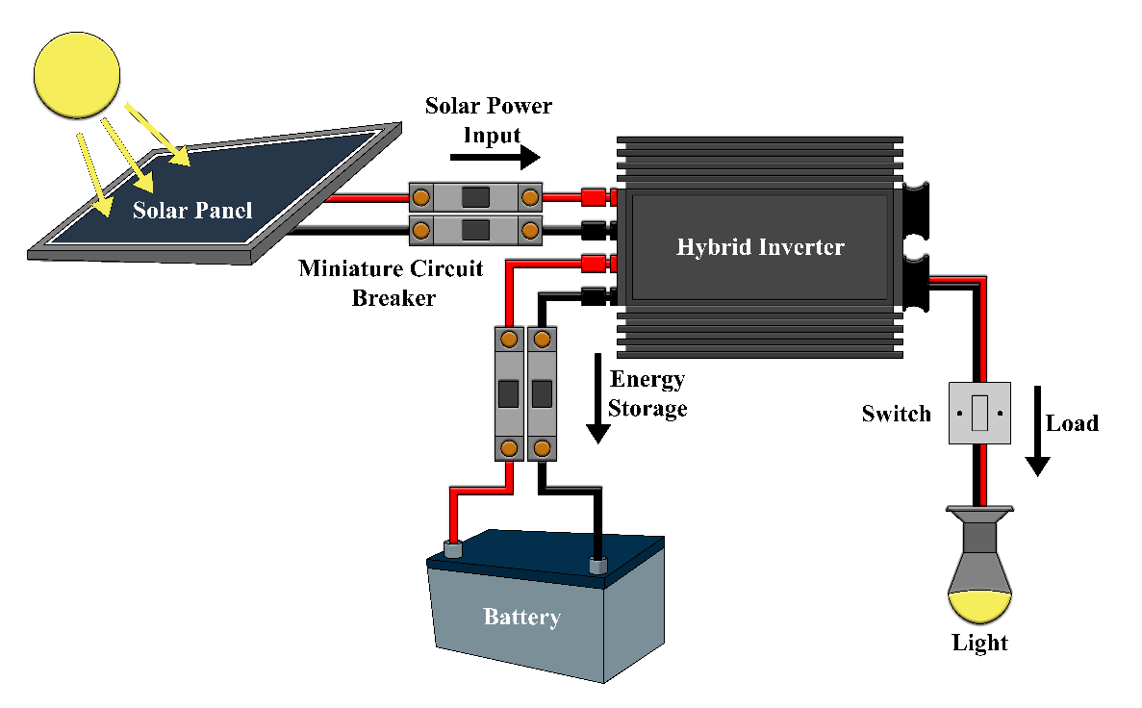

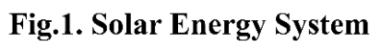
- WATER HARVESTING SYSTEMS (WATER): With several hot and cold springs, many pools, and artesian wells, water is the lifeblood of Fly Ranch. It rains every year in Fly Ranch, but the rains are typically short and dry out quickly, although, in 2014, a full day of rain was observed.
Two water harvesting systems are used in this project, one to collect rainwater and the other is to collect groundwater. Both systems are used to efficiently capture, store, treat, filter, and deliver non-potable water for a variety of end uses, including irrigation, restrooms, and more. The collected rainwater will go through a tube to an underground rainwater storage tank. The groundwater is extracted through a well drilled into the aquifer and brought to an underground groundwater storage tank by a pump. In addition to the collected water, the buildings, gardens, and landscaping can be connected to the site’s existing water line to draw water when needed. (Fig.2)
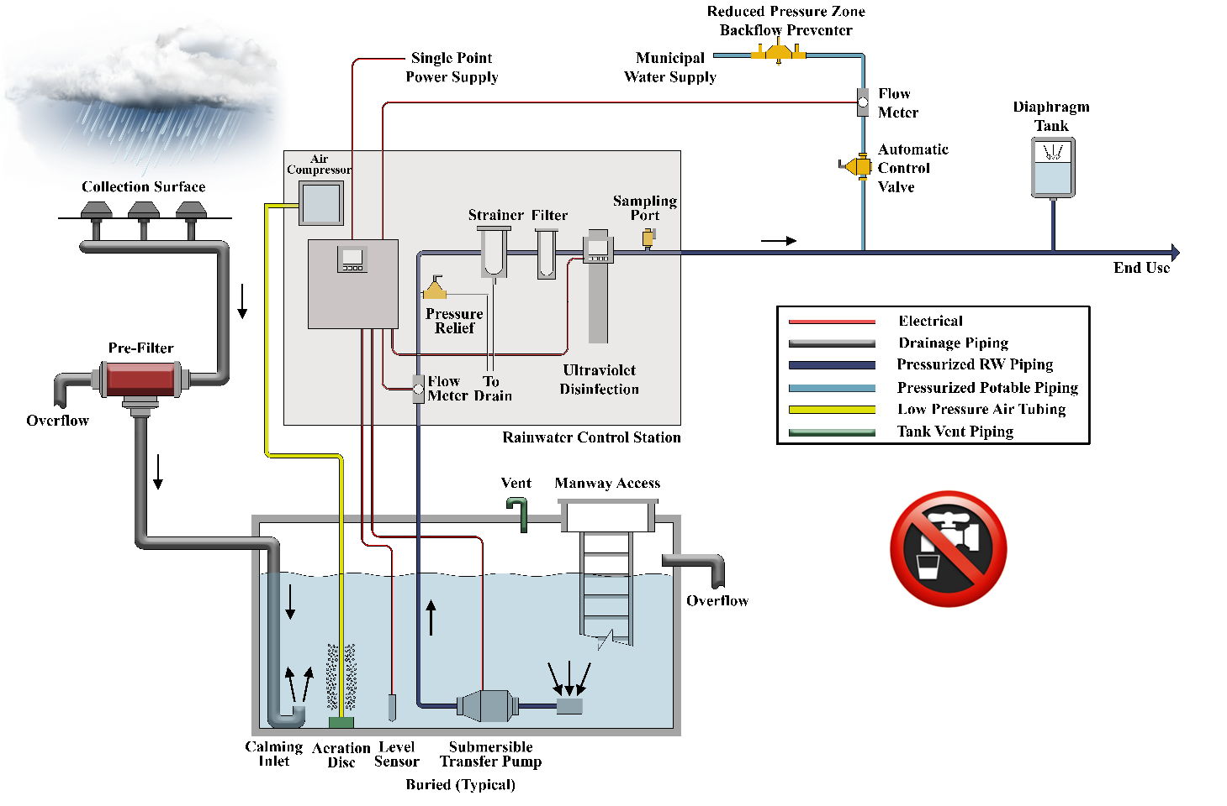
The trucks currently fill up with water to supply Black Rock City from the existing water hoses location. These need to be relocated to prevent trucks from accessing deep into the project.

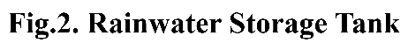
- GLASSHOUSES (FOOD): Glasshouses are high tech production facilities for vegetables, fruits, and flowers, which can be used as a food source. It is made chiefly of transparent glass, which contains plants that require regulated climatic conditions. The interior of a glasshouse becomes significantly warmer than the external temperature when exposed to sunlight, thus protecting its contents in cold weather. These glasshouses are filled with equipment, including screening installations, heating, cooling, and lighting, which are controlled by a computer to optimize conditions for plant growth. Different techniques such as air temperature, relative humidity, and vapor-pressure deficit are then used to evaluate optimality degrees and comfort ratio of glasshouses in order to reduce production risk before cultivating a specific crop.

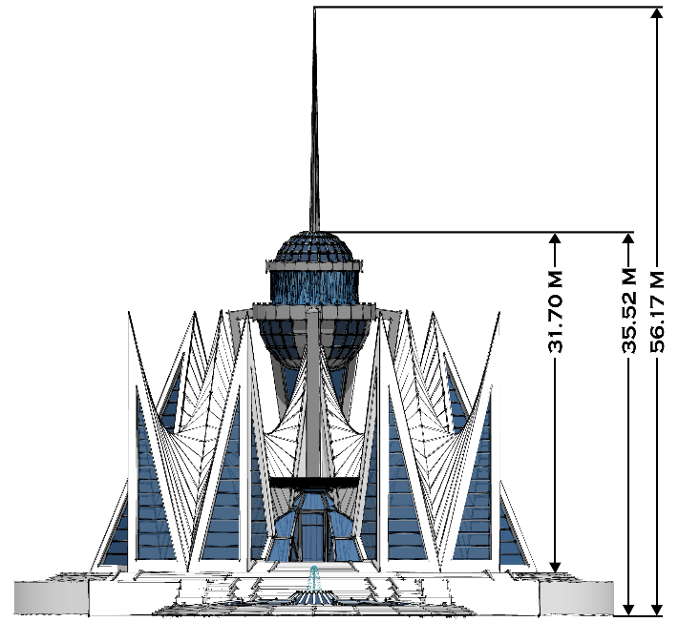
- SUSTAINABLE ARCHITECTURE AND ENTERTAINMENT COVERED SPACES (SHELTER):
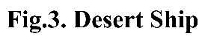
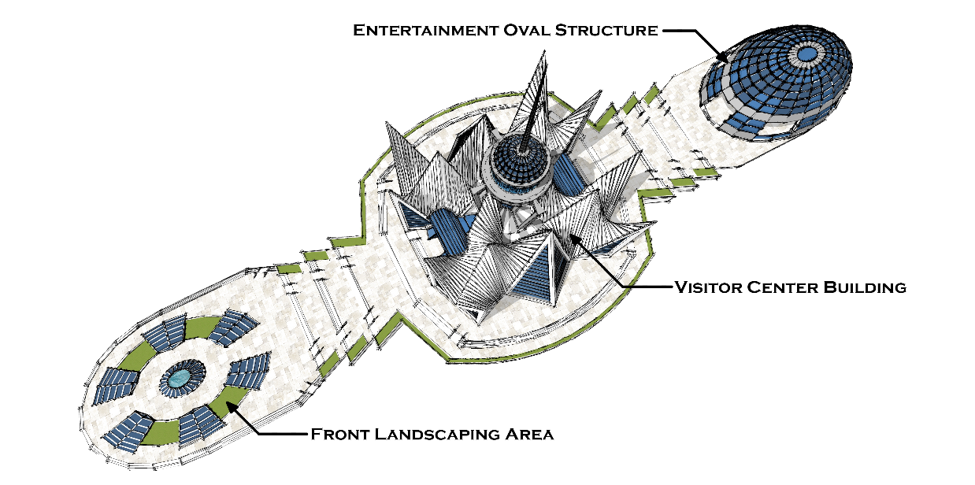
- Desert Ship:
The floating Desert Ship is a landmark structure in Fly Ranch Botanical Garden; it sits on Fly Reservoir lake and the oasis area at parcel 071-331-11, Washoe County. The Design style is futuristic, and the intention of using this style is to create a lasting and magnificent visual impact that will represent Fly Ranch.
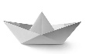
This structure contains the visitor center building, the covered entertainment oval structure, and the front landscaping area. The shape of the visitor center building has been inspired by the shape of four paper ships, , standing on a base, surrounding, and connected to a central divided sphere.
The upper and lower parts of the sphere have a solar panel system and play a role in rainwater harvesting on rainy days. When rain falls on the upper part of the sphere, the water will collect and go through a trench to the lower part of the sphere, creating a waterfall scenery. When the rain stops, water detecting sensors located on the top of the upper part of the sphere activates a motor, which keeps an amount of water flowing like a waterfall. The collected rainwater will go through a large central tube to an underground storage tank.
The metal rod attached to the top of the building is a lightning rod that connects to the ground through a wire. When lightning strikes the rod, the electric charge is conducted harmlessly into the ground.
This building principally consists of two collaborating systems, a concrete structure combined with a space frame system, to enable the construction of a free-form structure in order to achieve a column-free space that allows visitors to experience the beauty of the interior.
Glass Fiber-Reinforced Concrete-(GFRC) and Glass Fiber-Reinforced Polyester-(GFRP) are the ideal cladding materials for the skin. The GFRC acts as a formwork that encases the building in flowing lines of crisp white. To provide additional structural support to the GFRC, lightweight concrete is poured inside the casing with steel rebar. The interior materials are glass, terrazzo flooring, stainless-steel, glass-reinforced gypsum, and gypsum board painted. The colors used for the interior and exterior are white, silver, and blue. The building functions as a community-oriented center for the botanical garden; it has a café, library, offices, visitor halls, and restrooms.
The Entertainment Oval Structure is located behind the visitor center in the Desert Ship. This structure will be used as a covered entertainment area for the visitors, and it contains a bar area and restrooms. This building principally consists of a steel structure; the skin materials are aluminum exterior cladding and insulated glass. A solar panel system is also used in this building, and it is connected to the visitor center building’s solar panel system.
The front landscaping area for the Desert Ship has a solar panel system that is connected to the visitor center building’s solar panel system too.
The structural system used for the base of Desert Ship in the floating area, depends on the depth of Fly Reservoir Lake at the construction location. Concrete floats or/and barrels underneath can be used.
The proposed height for Desert Ship is 35.52m, without the rod. A variance is needed, as the building height exceeds the maximum height limits of Washoe County’s GR Zone. This building should be a grand landmark of the project, and because it is located far enough from the site boundary, the proposed height should not affect other parcels around the project site. This building will provide additional beauty to the area. The area covered by solar panels for Desert Ship is around 872m², and results in 209,692.5Kwh per year. (Fig.3)

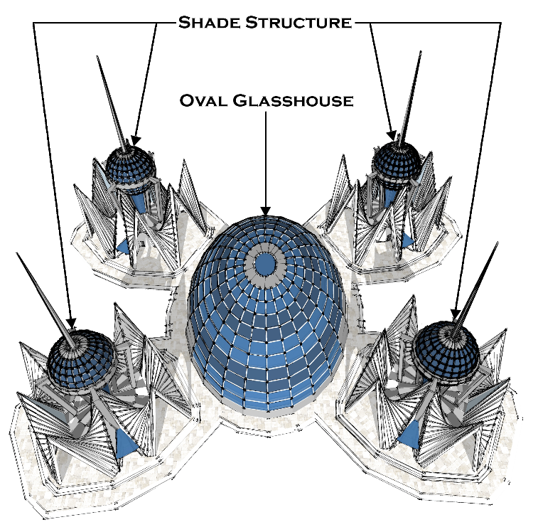
- Cluster Structure:
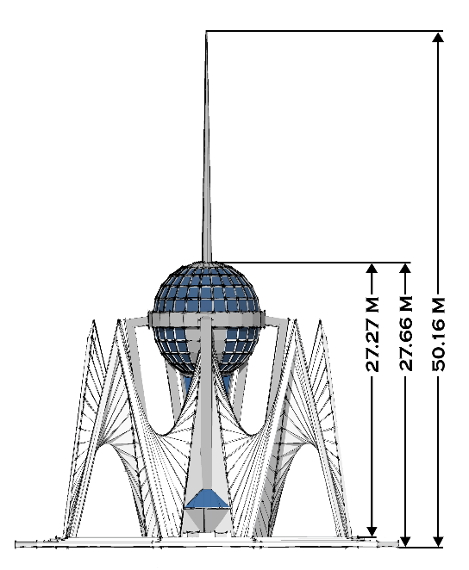

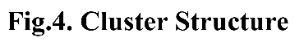

The form of the Cluster Structure has been inspired by Desert Ship’s shape. It represents four shade structures surrounding a central oval glasshouse, to create another futuristic structure style.
The shade structure has a central sphere, which contains the solar panels and the lightning rod.
The shade structure consists of the same structural, skin cladding materials and colors used in the visitor center, and provides protection as well as a nice sitting and restroom zone for the visitors.
The Oval Glasshouse is a home for edible plants, and is used to display them to the visitors. This building consists of a steel structure; the exterior skin materials are aluminum cladding and a greenhouse glazing system. It has a solar panel system that connects to the four shade structures’ solar panel systems.
The proposed height for Cluster Structure is 27.66m, without the rod. A variance is needed, as the building height exceeds the maximum height limits of Washoe County’s GR Zone. This building should be in harmony with the height of Desert Ship, to make a balanced visionary scene. It can also be scaled down to meet the required height.
The area covered by solar panels for the Cluster Structure is around 996m², and results in 239,510.6Kwh per year. (Fig.4)

The conceptual cost estimate for Fly Ranch Botanical Garden, including the Desert Ship and eleven Cluster Structures, is $160-$180 million.

ENVIRONMENTAL IMPACT STATEMENT
- The solar panels provide clean and renewable energy and do not produce air pollution or greenhouse gas emissions. Using solar energy will have a positive, indirect effect on the environment because it replaces or reduces the use of other energy sources that have negative effects on the environment.

- The collected rainwater and groundwater will support plants and provide a sustainable environment for survival. Rainwater collection affects the environment positively in many ways. The rainwater system counteracts stormwater runoff and therefore reduce flooding, erosion, and groundwater contamination.

- Plants will not only enhance the look of the botanical garden and make it a much nicer place, but they are also considered a critical resource because of the many ways they support life on earth and help the environment.
Plants use oxygenic photosynthesis to convert carbon dioxide into oxygen that is returned to the atmosphere. Plants also provide habitat and food for wildlife and humans, as well as play an essential role in regulating the water cycle by preventing soil erosion and increasing groundwater levels. Green plants also release water vapor in the air as a by-product of photosynthesis, thus involving groundwater in the water cycle.

- The design creates a sustainable architecture with a great visual impact due to its shapes and colors. The structures’ white skin will look in harmony with the mountain range in winter. The futuristic design shape for the buildings and the waterfall scenery created for the Desert Ship structure will be contrary to Fly Ranch’s natural look, and they will not reflect and impact the look of Fly Geyser, to keep it as a unique attraction in the area for the visitors and tourists.

