FLY RANCH POO FARM
Wetland Regenerator and Sage Grouse Wonderland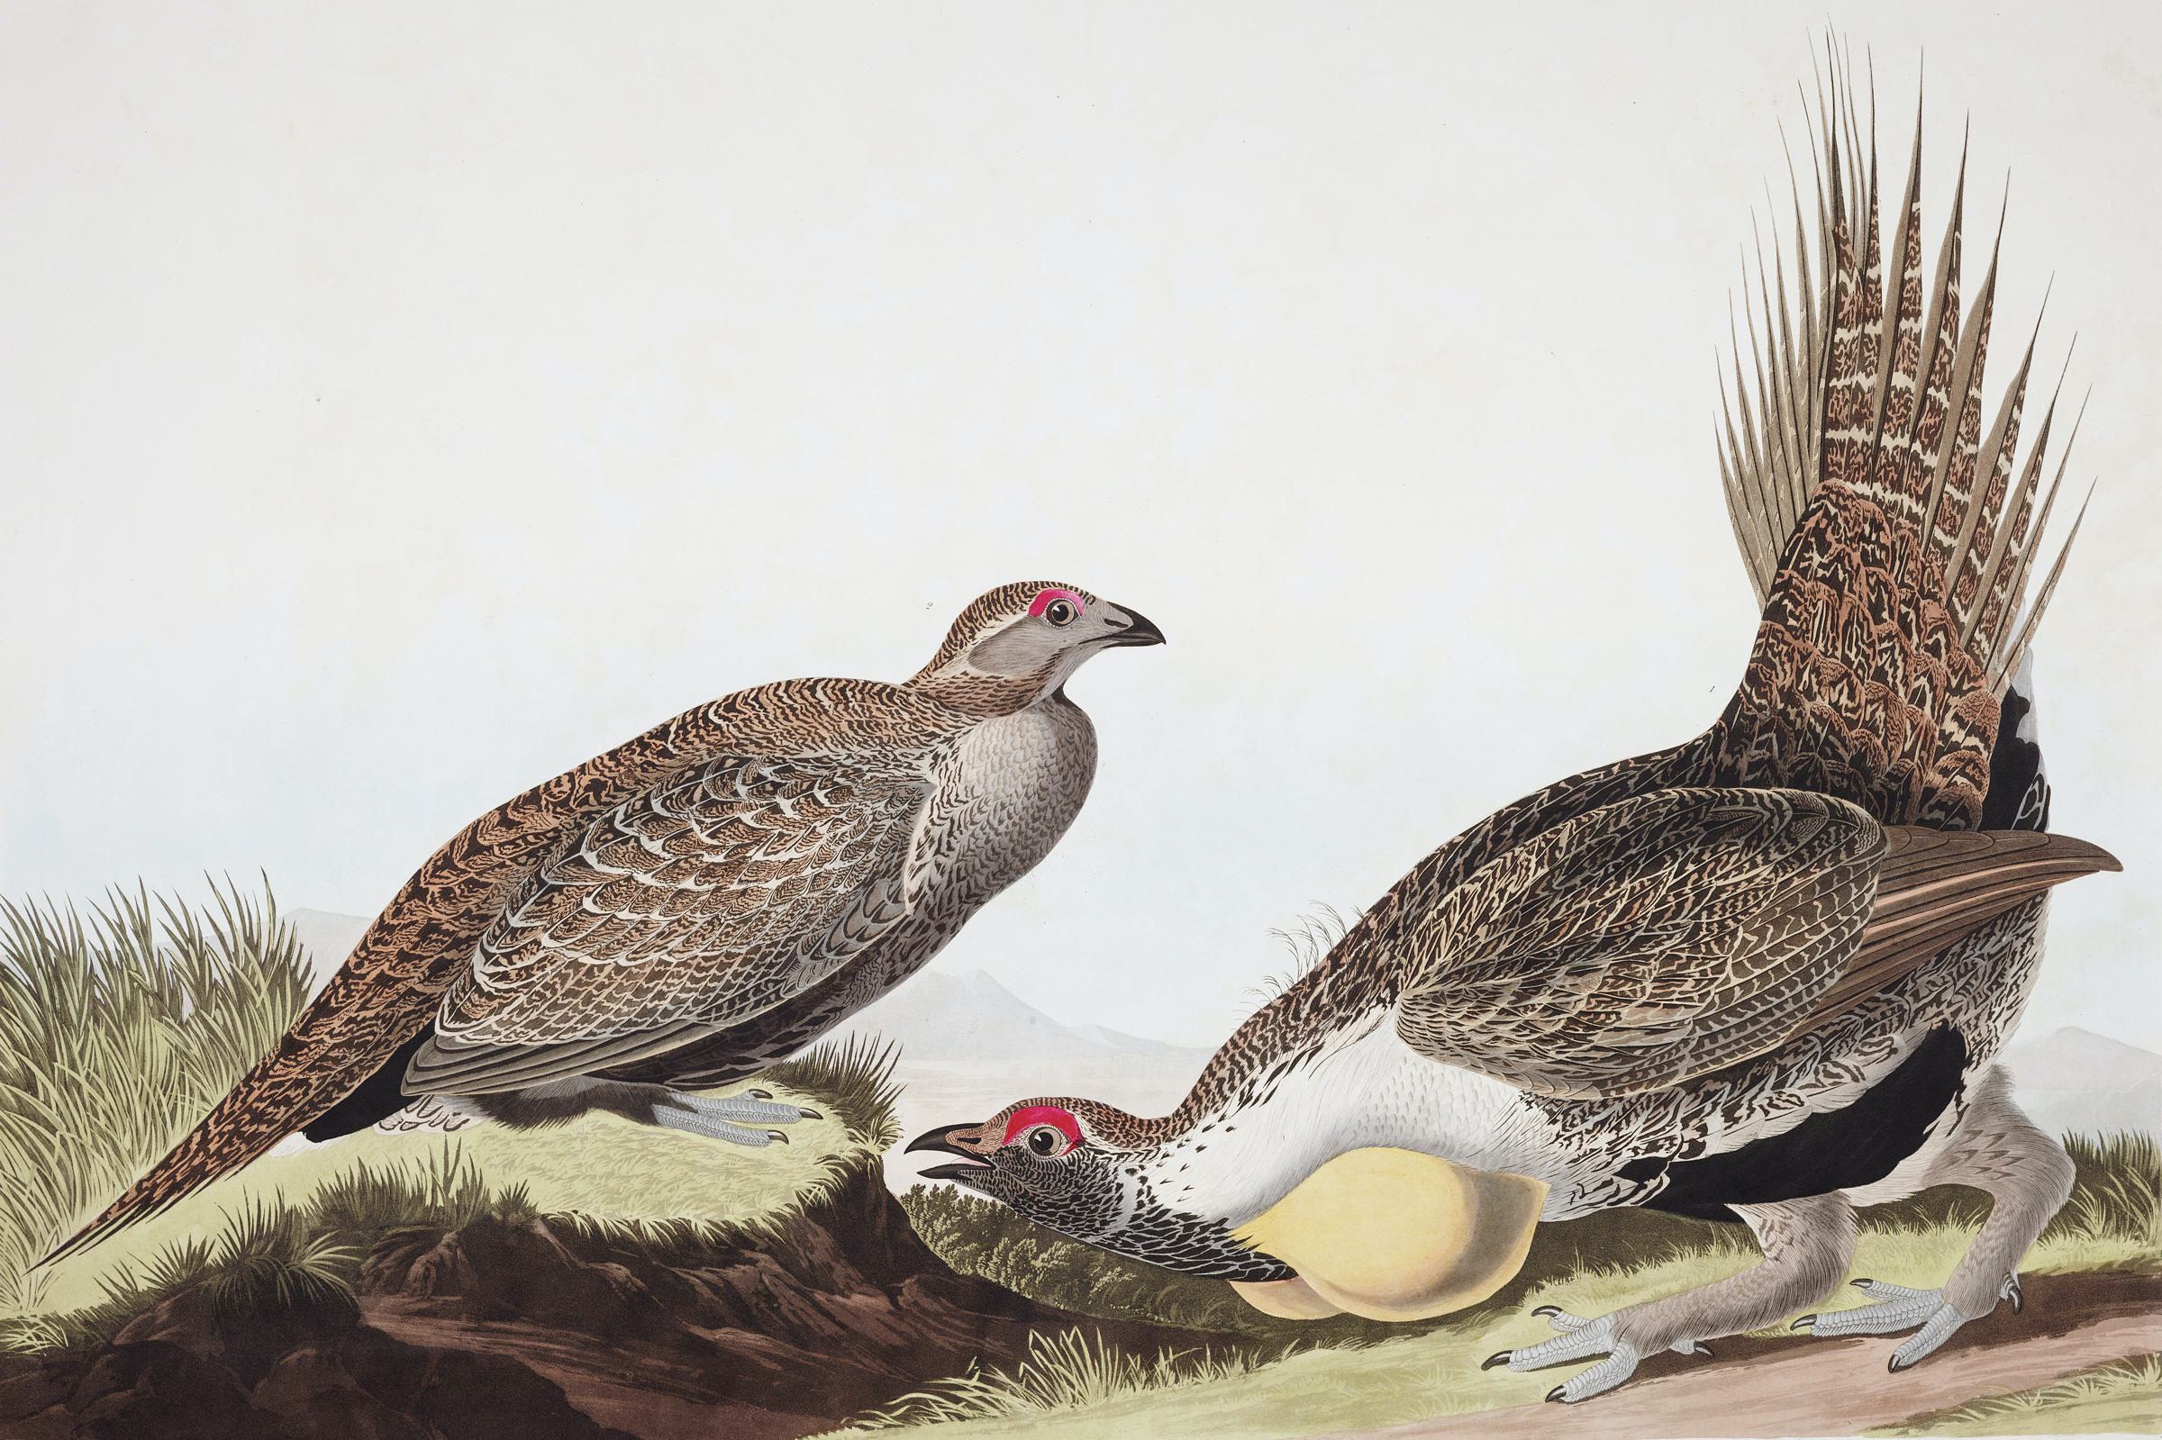
John James Audubon. 1835. Bird’s of America.

THE VISION
Though volunteers spend weeks erasing all physical traces of Burning Man from the playa, the less-visible impacts of gathering tens of thousands of people at an interactive art festival reverberate throughout our compromised ecosystem long after the last RV has headed home. Millions of gallons of water are removed from the Fly Ranch wells to mitigate playa dust, hundreds of thousands of gallons of wastewater are trucked daily from Black Rock City to Reno, and millions of tons of materials permanently enter the waste stream as the ephemeral experience of Burning Man fades into memory. Fly Ranch Poo Farm imagines a future where the festival gives back to its landscape as much as it extracts, where nine days on the playa can support a regenerated ecosystem year-round, and where humans and the land thrive in reciprocity. We propose waste outputs as environmental inputs, and structures and technologies that support both the human and ecological needs of Fly Ranch.

Studies estimate the total CO2 emissions for Burningman 2019 to be over 100,000 tonnes, almost 2.8 times the emissions of the average American (an already high 16.6 tonnes per year). This design for Fly Ranch proposes a resource sharing connection between Black Rock City and Fly Ranch, carefully mapping the resources embedded in Burningman and Black Rock City and reconfiguring current waste streams as resource streams that will be used to construct a new future for Fly Ranch.

THE THING
“There are three preconditions for People’s Architecture — It must be easy to assemble for a layman — It has to be an assembly of inexpensive technical components — And easy to dis-assemble and re-assemble into a different pattern.”
Yona Friedman, Architecture Mobile

Inspired by Yona Freidman’s open-ended architectural proposals and the plight of the sage grouse, the Poo Farm proposes a flexible (and limited) future for Fly Ranch. Fly Ranch is a temporary construction that will transition over a span of 50 years, from resource recovery and conference center for Burningman to Sagebrush research camp and finally, a restored sage grouse habitat.

Fly Ranch is located in the sagebrush steppe of northwestern Nevada. Known as the “Big Empty,”the sagebrush ecosystem crosses 11 western states and two Canadian provinces and covers over 70 million of an original 129 million hectares. Since the late-nineteenth century, the sagebrush ecosystem has been destroyed by grazing, road construction, resource extraction, and wildfire. The ecosystem is home to over 350 critical species of plants and animals and is the only ecosystem where the endangered sage grouse can survive. The sage grouse was once so numerous that naturalist George Grinnell said the ground “was a moving mass of gray,” and birds in flight bumped each other and fell to the ground. Today, less than ten percent of the sage grouse’s original population remains. Climate change threatens the high-desert sagebrush ecosystem, potentially eliminating 94% of the habitat of the sage grouse. Half of the remaining sage grouse habitat is on private lands and restoration of private grazing lands to sagebrush is critical to the survival of the sage grouse.

PROGRAM
- Eco-machine for water cleaning
- Water harvesting structures (storage for Burningman dust abatement and fire suppression).
- Community agriculture
- Nursery to grow plants for wetland and sagebrush ecosystem restoration.
- Conference Center (for 200 people during offseason), which converts to housing for Black Rock City volunteers before Burningman Festival begins.

INPUTS
Structures: Individual building components (or ‘tetra-units’) are constructed from reused (metal) and bicycle rims, which then stack into regular icosahedral forms. The dome structures can connect, intersect, and scale to allow for an infinitely-extendable tempered space for the waste/water regeneration cycle and human program. The tetra-units are quilted with reused flexible ETFE skins, and contain rigid ETFE ‘bubbles’ for water storage. Smaller individual domes are constructed on the site for dwelling or research and a distributed water harvesting program.

Landscape: Built from reused PVC and 55-gallon drums, the waste/water regenerator stores and treats sewage “waste” from the festival using bacteria and native wetland species, which are in turn propagated in order to restore endangered local habitat. The bio-cleansed water is further filtered through the reconstructed wetlands to recharge the aquifers, partly replenishing the water harvested for dust abatement. Sludge byproduct from the regenerator, as well as organic waste composted on site, is used to cultivate a sagebrush and wetland nursery for the replanting and restoration program.

Water: In addition to the water treated and returned to the land through the regenerator, the proposal will harvest water from Fly Ranch’s many natural springs and wells throughout the year in order to reduce the infrastructure required, and lessen the impact of the annual water extraction for dust abatement at the Burningman festival. The design will reduce the water footprint of Black Rock City and Fly Ranch (there is currently a 17 million gallon deficit) through water harvesting and the use of a eco-machine / blackwater wetland treatment system.

Community solar: Initial investment into 40kW solar array on South 260 site. A transmission line runs through the South 360 site allowing the possibility of a build-operate partnership with NV Energy.

Pooh: Resource harvesting from Burningman. Burningman generates over 800,000 of black- and gray-water over the course of the nine-day event. Currently driven 112 miles to Sparks, Nevada for disposal, the water will be transported to Fly Ranch and cleaned in the eco-machine. Transporting black- and gray-water to Fly Ranch for processing cuts vehicles miles from 19,000 to 2,600 miles and provides Fly Ranch with over 800,000 gallons of water that can be utilized for irrigation.

Compostable waste: Burningman generates over 1.3 million pounds of compostable waste, and 1.9 million pounds of solid waste. The compostable waste will be harvested at Fly Ranch.

Sagebrush and wetland plant nursery: The nursery will utilize soil amendments from composted organic waste and sludge harvested from the eco-machine to rebuild the soil layer at Fly Ranch.

OUTPUTS
Water from the Eco-machine: 15,000 gallons per day of treated water (tertiary treatment with UV) for irrigation and gray water. The living machine treats the 800,000+ gallons of waste- and gray-water harvested from Burningman and the output from Fly Ranch estimated at 920,000 gallons annually with a 75-person daily occupancy load.

Sagebrush and wetland plant nursery: The sagebrush ecosystem sequesters over 17 tonnes per hectare more CO2 than a degraded grazing ecosystem. If eighty percent of Fly Ranch is restored to a sagebrush ecosystem, over 20,000 additional tonnes of CO2 will be sequestered.

Reused waste: The compostable waste will produce between 130,000 and 325,000 pounds of compost annually, while the solid waste will be sorted and harvested for building materials.

Solar: (160 acres) 40mW electricity, 100,000 mWh annually (0.291 load factor). About 50 Gerlachs of electricity daily or power for 8500 households.

COST ESTIMATE
- 40mW solar array: $50 million including permits and transmission line hookup. Less if build-operate partnership with NV Energy. Solar array provides an expected annual income of $4 million after provision of subsidized energy to Gerlach, Black Rock City Shop, and Fly Ranch for ROI of approximately 13 years.
- All new structures and infrastructure (conference center and eco-machines): $5 million
- Wetland and Sagebrush Restoration of 1,225 hectares: $5 million
- Site cleanup and final phase abandonment of Fly Ranch: $1 million

PROTOTYPE
- Eco-machine. Some questions, can the water treatment infrastructure utilize and propagate native wetland plants? Will the treated water meet EPA standards? We intend to establish a small-scale regenerator, and potentially partner with UNLV researchers on a longer-term study.
- Tetra-unit. Is the construction of the tetra-units from harvested/salvaged materials feasible? Are the units structurally efficient? How do they assemble?

ADDITIONAL STRATEGIES
BLM mandated dust abatement during Burningman uses over 17 million gallons of water annually. Water use can be reduced through research into more efficient nozzles (the redesign spray patterns and testing of water flow rates) and the use of routing software to optimize spray truck paths and fossil fuel use. Modifications to spray nozzles in mining operations have reduced water use between 20% and 50% while maintaining dust abatement effectiveness. This has the potential of saving between 3.4 and 8.5 million gallons of water, reducing travel miles of the water trucks from almost 90,000 miles to 45,000 miles, and cutting over 520 tonnes of carbon emissions.

Community solar at South 360 site (40mW) to provide subsidized electricity to Gerlach, Black Rock City Shop and Fly Ranch with the excess sold to NV Energy. Subsidized electricity in Gerlach, Black Rock City Shop, and Fly Ranch is contingent on carbon reduction targets like EV vehicles, upgraded appliances and HVAC systems, and reduced water use in Gerlach, Black Rock Station, and Fly Ranch.

MAXIMUM ENVIRONMENTAL IMPACT
- The design uses Burningman as a resource recovery site for materials to construct new structures or repair existing structures over the life of the project. Leftover materials from Burningman will be transported to Fly Ranch and reused and upcycled.

Carbon Footprint
Operation | Current practice | Post-design
Dust abatement | 561.12 tonnes | 280.56 – 448.89 tonnes
Pooh | 123.20 tonnes | 16.50 tonnes
Wastewater treatment (0.6 kWh/m3/0.92 tCO2) | 1671 tonnes | 0
Organic Waste (landfill vs. composted) | 32,602 tonnes | 3622 tonnes
Sagebrush Restoration @ 1225 hectares | –17,750 tonnes | –37,975 tonnes
Solar array (40 mW and 100,000mWh per/year) |  | –53,096 tonnes
 | 17,447 tonnes | –86,984 tonnes

A difference of 69,500 tonnes in carbon emissions, or over two-thirds of the estimated carbon emissions from the 2019 Burningman event.

REFERENCES
EPA (1985) provided some guidelines regarding water application rates for dust suppression in unpaved roads in hazardous waste sites. An application rate of 0.125 gal/yd^ (0.566 L/m^), applied every 20-30 minutes (application depth of 0.057 cm or 0.022 inches) is recommended for a dust control effectiveness of 100% on unpaved roads.

Paul, Shibi. 2004. Spray characterization of water truck nozzles and proposed nozzle modifications to improve spray uniformity. Unpublished dissertation, University of Nevada Las Vegas.

Prostański, Dariusz. 2013. Use of Air-and-Water Spraying Systems for Improving Dust Control in Mines. Journal of Sustainable Mining 12(2): 29–34. https://doi.org/10.7424/jsm130204.

Shrestha, Gyami, and Peter D. Stahl. 2008. Carbon accumulation and storage in semi-arid sagebrush steppe: Effects of long-term grazing exclusion. Agriculture, Ecosystems and Environment 125: 173–181. https://doi:10.1016/j.agee.2007.12.007.

Pyke, D.A., Chambers, J.C., Pellant, M., Knick, S.T., Miller, R,F., Beck, J.L., Doescher, P.S., Schupp, E.W., Roundy, B.A., Brunson, M., and McIver, J.D. 2015. Restoration handbook for sagebrush steppe ecosystems with emphasis on greater sage-grouse habitat—Part 1. Concepts for understanding and applying restoration. U.S. Geological Survey Circular 1416. http://dx.doi.org/10.3133/cir1416.

