A Vessel for Detachment
LAGI 2020 Fly Ranch Proposal

PROJECT BRIEF

LAGI’s 2020 design competition focuses on Fly Ranch, Nevada, a 3,800-acre property recently acquired in 2016 by the Burning Man Project in need of environmentally regenerative, infrastructural art.

PROBLEM

The Burning Man Project is currently taking steps to mitigate and eventually reverse its negative environmental impact. Two immediately apparent issues include high carbon emissions and ineffective waste management.

Based on Black Rock Labs’ estimates, scaling the 2007 Cooling Man model to current population and transportation levels, Burning Man’s annual carbon footprint is projected to be approximately 100K tons. Besides transportation, one of the largest contributing factors is open playa burning conducted at temperatures too low to destroy toxins, thereby releasing 40 times more particulates per pound than high temperature combustion with modern safeguards.

While leaving no trace is a principle strongly upheld by most Burning Man participants, especially through the work of restoration teams in the weeks following the event, in practice this discipline often does not extend beyond the playa, prompting the use of illegal dumping hotlines and contentions with public works and the Bureau of Land Management.

STATEMENT

Regeneratively, the following proposal acts as an intermediate step toward a circular zero-waste economy by directly combating current issues of waste management and emissions while also heightening awareness of participants’ consumption, the resulting waste, and its mutable form.

Experientially, the space acts as an extension of the ritual destruction characteristic of Burning Man and takes precedent from the event in strengthening the immediacy of experience and the cognitive impact of the desert on the mind. These phenomena reinforce the principles participants will take home: decommodification and detachment.

SITE LOCATION

The chosen site is located in the northern portion of Fly Ranch southeast of the central Fly Geyser hub, situated within the primary site boundary. This places the vessel within close proximity to the Hualapai Flat, taking advantage of the vast and horizontal surrounding landscape which is closely connected to the projects conceptual underpinning.

GUIDING CONCEPTS

Destruction & The Presence of Absence

The Burning Man event is concluded each year by three acts of destruction:
The burning of the Temple
The burning of the Man
The dispersal of the City

The absence of familiar surroundings, details and distractions in a place like the Black Rock Desert deprives us of the context with which we normally orient ourselves in reality. It can heighten our awareness of what is left behind, giving a stronger sense of the underlying, barely perceptible presence that exists throughout and imbues the world around us. These ritualistic acts of destruction serve as moving moments of surreal, spiritual intensity that reveal this presence while simultaneously signifying the unimportance of material place. The temple, effigy and city have a psychological impact but are only impermanent structures, not to be deified.

“One can then enter the temple and simmer soulfully in its divine gravity without idolizing its structure. This is not just a matter of heady “spirituality” or theological rumination; it’s about being awake and openhearted amidst all wild and unpredictable possibilities that life unfurls in each moment.”

– Temples on Fire - Sam Berrin Shonkoff
Playa Dust: Collected Stories from Burning Man

PROGRAM SYNOPSIS

The proposal provides a place for mental contemplation and destruction through biomass incineration. This takes precedent from the ritualistic destruction iconic to Burning Man, preserving and reshaping a tradition amidst growing emission concerns being addressed in the organization’s 2030 roadmap.

“Burning altars” designed for individual use are utilized in place of a single burning chamber in order to reduce the auxiliary fuel load and effect intimacy of a solitary ritual. These altars are integrated into pillars, arrayed in a grid throughout the space. Light apertures are cut above each module where it visibly separates itself from the ceiling, allowing for a source of diffused light for each altar.

The heat produced by burning waste, invasive plant species, or other scrap material produces steam which, in turn, generates energy to sustain extended site use and the creative work of visitors to Fly Ranch.

Participants will enter the structure through a low arched opening via broad stairs, with a merged ramp for accessibility, leading up to the main, occupied room. This semi-enclosed space forms an expansive, horizontal plane, leading to an open view of the playa. This space reinforces the “presence” of the desert through manipulation of the interior microclimate in juxtaposition to the hot, arid climate of the flat. Wind is channeled through the wide, horizontal opening over a shallow pool of water covering the surface of the floor. This creates a natural evaporative cooling effect dropping the interior temperature and raising its humidity.

This plane of water is constantly and gradually replenished via atmospheric water harvesting and precipitation collection, both integrated into the exterior shell of the structure. The vessel is defined by an organic, parametrically layered shell, placing emphasis on the visually registered systems within. The vessel emits steam during the day and light during the night.

FORM

The conceptual form is evolved from the conventional incinerator smokestack and articulated as a sweeping parametric profile morphing from horizontal to vertical in juxtaposition to the horizontal nature of the surrounding playa, with a monumental presence prominently visible from a distance.

EXTERIOR STRUCTURE

Structurally, the intervention consists of a permeable assembly allowing for the visible passage of light and steam from the burning modules within. The outermost layer of the shell is constructed of aerated autoclaved concrete tubes, precast and pretensioned before being joined by welded contacts. This provides lightweight but rotationally stiff layers on the exterior that work as individual spanning units and as a system, resisting shear and torsion. On a larger level the shape of the form itself resists lateral forces through the curvature of the shell as well as the rear fold and front ribs forming the underside of the structure. The exterior concrete is pigmented black via iron oxide (magnetite), giving it a stronger visual presence against the lighter landscape.

Approximate primary dimensions of the structure consist of a 30m wide front profile reaching to 44m in height, the occupied space being 4m above the playa surface with a floor to ceiling height of 3m. This space has a depth of 22m with the combined stair and ramp of the entry/exit covering an additional 14m.

SHELL EQUIPMENT

A perforated metal surface mounted to the light steel frame serves as the interior finish for the main occupied space, maintaining the permeability of the assembly and allowing for the mechanical workings of the space to be visible though not distractingly obvious. Integrated into the shell between the interior skin and exterior concrete layers are atmospheric water harvesters, utilizing accessible cartridges of metal organic framework (MOF) for water adsorption and excess heat from incineration for more efficient drainage. A closed water loop runs through each module and the steam turbine housed on ground level.

BURNING MODULES

The burning modules each include a grate and removeable tray for collection of left-over bottom ash which may be repurposed for use in applications such as aggregate and ceramics. Auxiliary burners are required to reach the necessary temperature of combustion needed to destroy toxic byproducts and pollutants in the flue gas. Furthermore, metal organic framework (MOF) cartridges are used for carbon capture, an application of the technology that is enhanced at higher temperatures. A closed water loop is fed through the top of each module allowing water to be converted to steam before it is directed to the turbine below.

GROUND LEVEL EQUIPMENT

Housed on the ground level of the structure is a steam turbine through which the water loop is directed, powering the attached generator. Steam travels from the turbine to a condenser before being pumped through the loop again. Energy generated is stored in an array of lithium ion batteries acting as portable modules to be used on and off site for a variety of sustainable and creative applications. Additionally, two storage tanks are installed, one for collection of CO2 from carbon capture which may be repurposed for use in greenhouse applications, the other containing auxiliary fuel for the burners which, through further development, may be produced on site via alternative digestion modules, generating biofuel/biogas rather than energy.

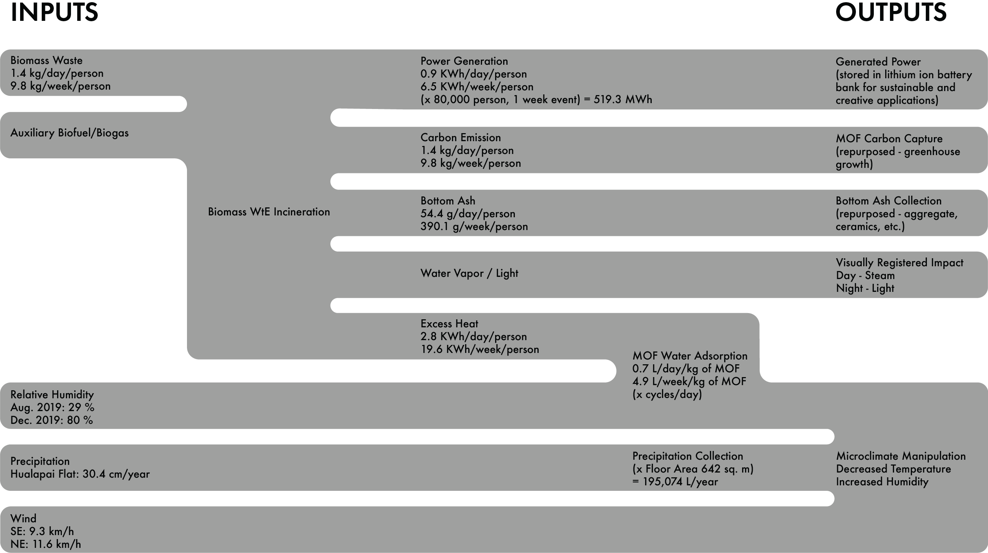

– estimated amounts based on 2017 municipal solid waste statistics provided by EPA.gov and EIA.gov

PROTOTYPE DEVELOPMENT

While technologies such as MOF water/carbon capture are still in early development with limited existing applications, making it difficult to assess the feasibility, in the case of received funding, the proposed program presents different courses of prototype development: developing the structure, using integrated water harvesting and evaporative cooling to create a contemplative, experiential space, or developing and testing the feasibility of the burning module system which could potentially act as precedent for a more efficient and environmentally conscious method of waste disposal, simultaneously reshaping a tradition of the Burning Man event, moving into the future.

ENVIRONMENTAL IMPACT – NET ZERO EMISSIONS

By focusing specifically on incineration of biomass waste, the program supports a net zero emissions impact. Biomass incineration itself is commonly considered carbon neutral as released carbon that was originally absorbed by the organic material will theoretically be reabsorbed by its replacement. Additionally, with the implementation of the MOF carbon capture system, though it is a relatively new technology, absorbing the low levels of CO2 released by the individual altars and storing it for more beneficial uses such as enhancing greenhouse growth, would theoretically be possible.

