FLY RANCH — Narrative

We are Guests on this Land

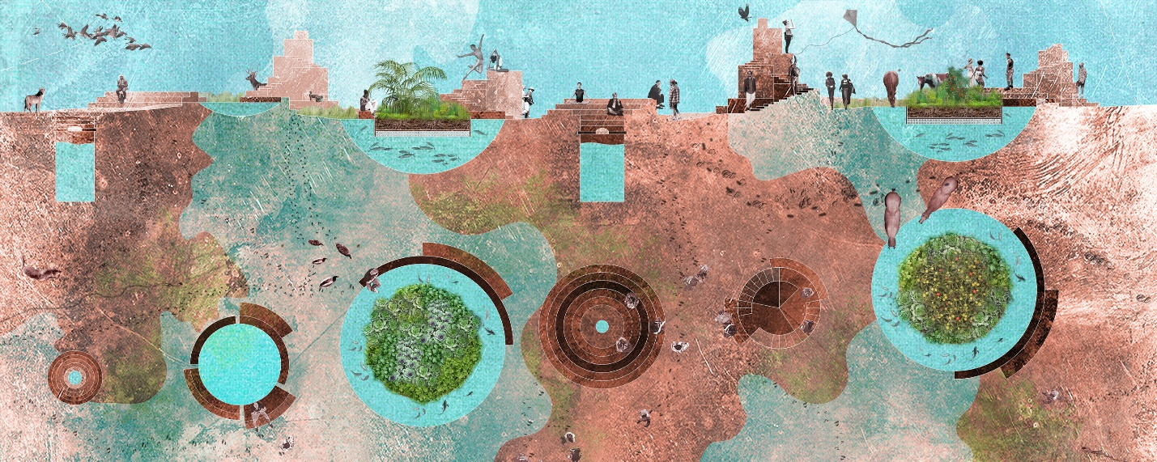

In the spirit of the nomadic Numu (Northern Paiute) and Newe (Western Shoshone) communities, we come as guests to this land. As nomadic human guests, we interact with the existing environment and coexist with its non-human inhabitants. As inheritors of Numu’s and Newe’s ancestral knowledge, we conceive water as the gravitational force in this landscape—water is life—around which human interventions are organized into an open exchange system. Within this exchange system a ‘contagion’ effect takes place, generating spontaneous situations around the interventions as the new human guests and non-human inhabitants move through this unique Fly Ranch Habitat.

Interventions and support systems

The interventions – Sediment, Harvest, Cultivate, Regenerate – work as catalyzers and each of these interventions has a direct relationship to the Food, Water and Zero Waste support systems. The production of food, the enhancement of water cycles and the harvesting and maintenance of water sources, will in turn enhance the endemic ecosystems bringing back local flora and fauna.

Sediment
The excavated earth piles up like an anthill providing a high viewpoint for the celebration of life on the landscape.

Harvest
Water—the source of life—is collected in ponds and wells allowing vegetation and life to foster through dry seasons.

Cultivate
Floating farming islands (chinampas) made from the waste from Burning Man festival and residues of excavated earth produce food throughout the year for the nomadic community.

Regenerate
Applying the knowledge of the Numu’s tribes, water harvested in ponds heals and overflows the land around them during dry seasons.

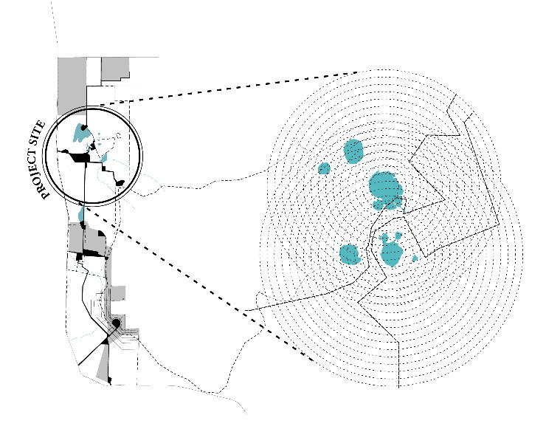
Key plan Project Site

The project site is within the primary site boundary, organized around the existing lakes.

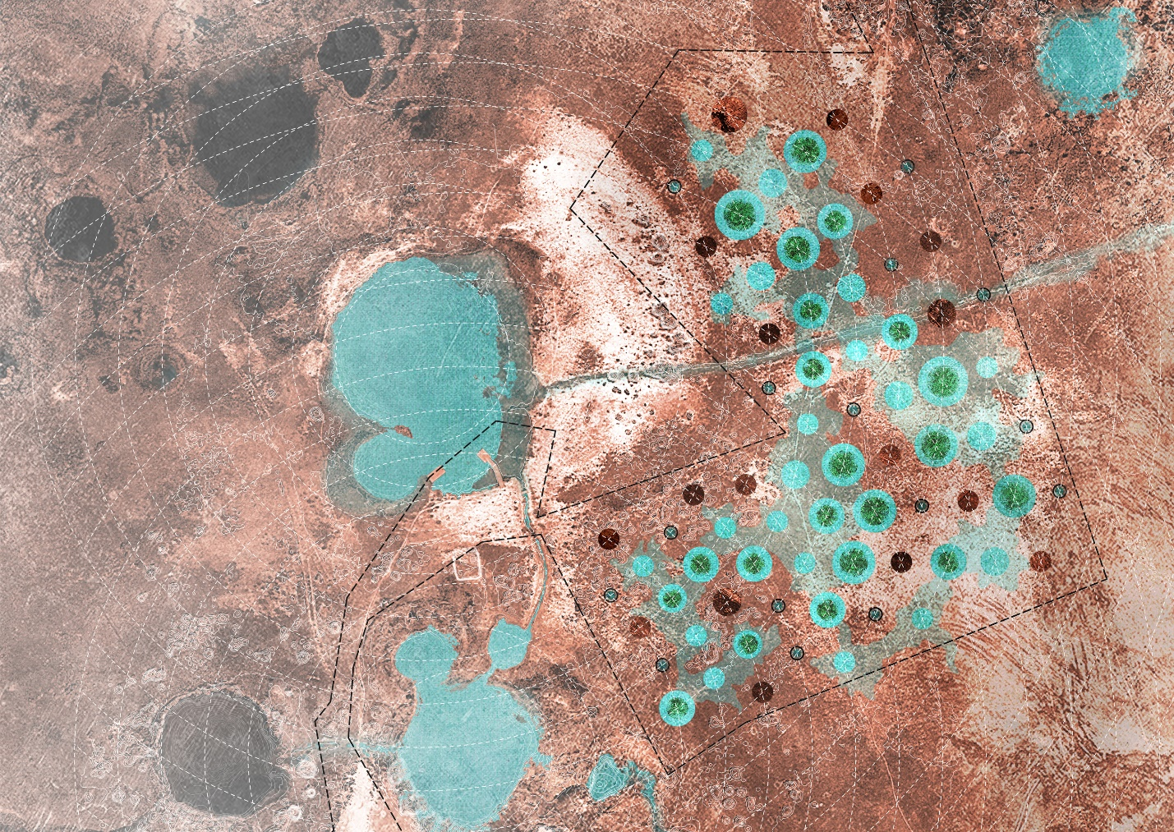

Plan

Healing the Land

The interventions – Sediment, Harvest, Cultivate, Regenerate – are organized in a rhythmic pattern around the existing lakes as Land Art. Following an acupuncture strategy, the interventions act on specific points and penetrate the surface layer to heal the land using natural elements and bringing back ancestral knowledge.

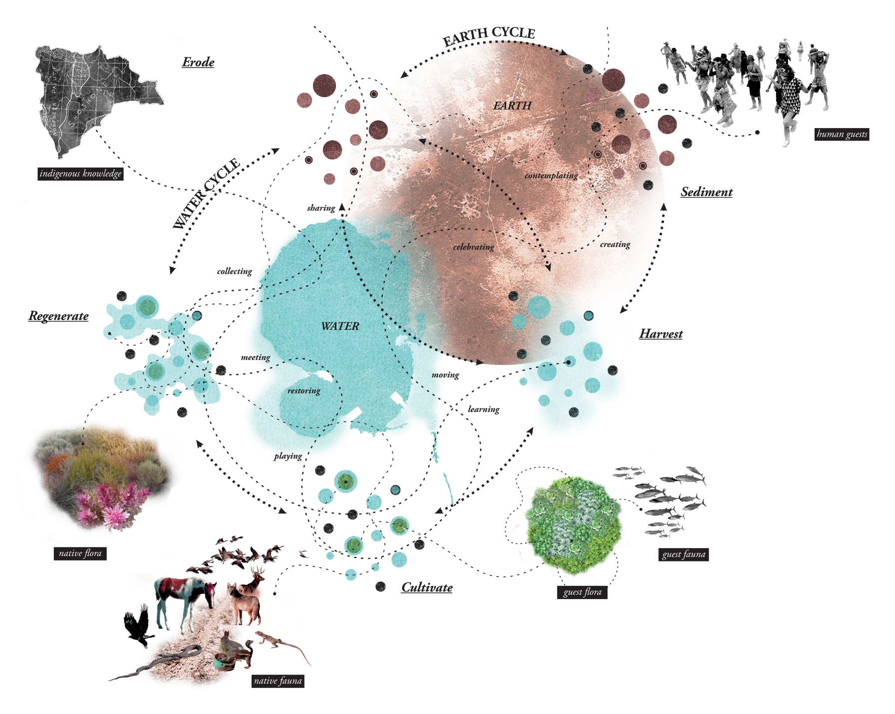

Situations

Spontaneous situations—celebrating, sharing, collecting, creating, contemplating, learning, meeting, playing, restoring and many other living experiences—result from the relationship between food, water and zero waste support systems and from the interaction between interventions and natural elements. These situations allow for a harmonious sense of being with nature, coexisting with non-human agents, and celebrating life.

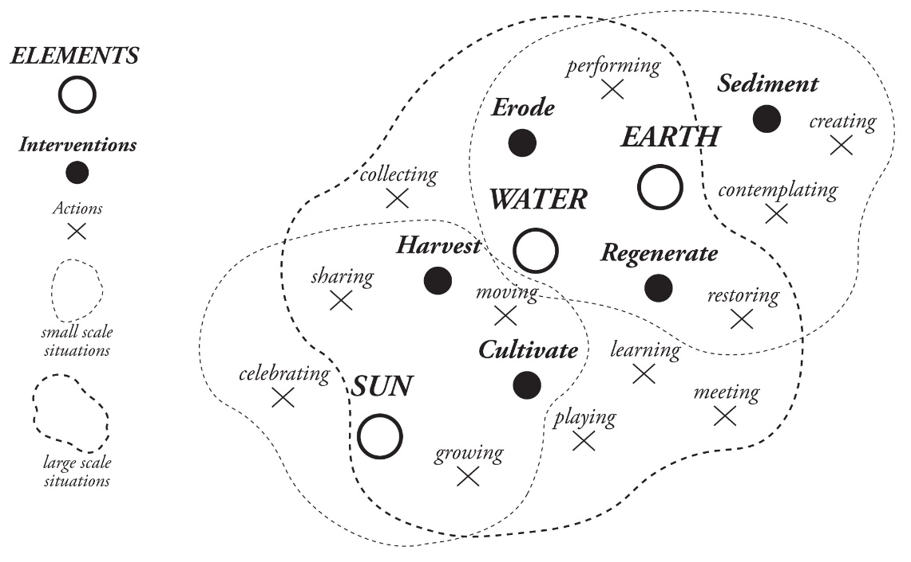

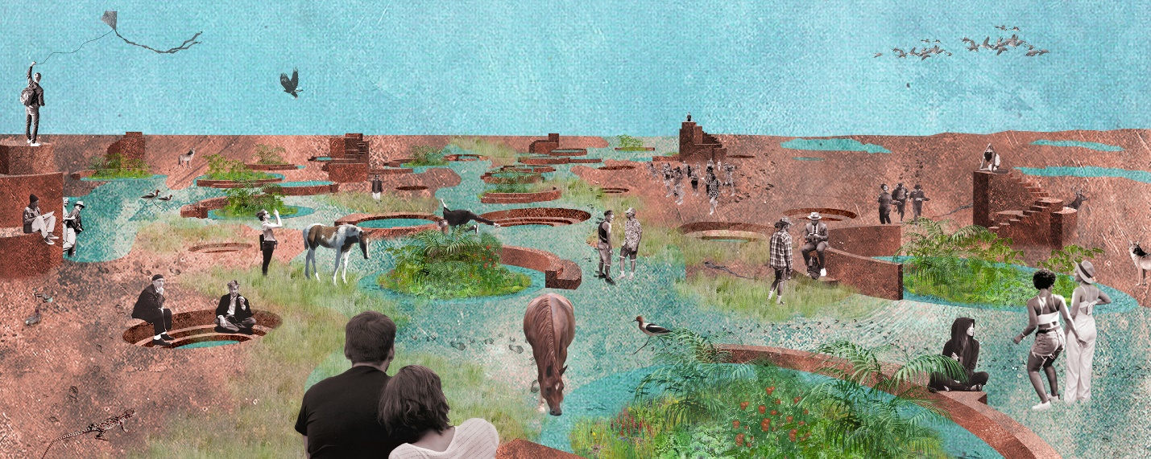

Technical information

Technology, fabrication & maintenance

Our proposal relies on ancestral technologies: The movement of earth from one place to another, and as a result, the harvesting, the channeling and natural movement of water for slow flooding. We are also proposing the use of ‘chinampas’, the floating gardens used by the Aztecs in Tenochtitlan, where fish create nutrients that feed the plants above and the plants provide food for the fish.

Our goal is to minimize input from outside the site and thus minimize generated waste. Therefore, the main construction of this exchange system will solely require movement of earth from one place to another, excavating and sedimenting in equal amounts, eliminating the need for importing or exporting earth to and from the site. The construction can be accomplished with small construction equipment, such as a bobcat.

Meanwhile, the ‘chinampas’ would float inside some of the newly created ponds. The fabrication of these floating islands requires wood members for floating and holding the farming earth. Sized lumber could be collected as leftovers from the Burning Man festival, or branches could be collected from the site if available. Around the ‘chinampas’ and ponds, sedimented and compacted earth will create seating areas for gathering.

The view towers are sculpted over a period of time out of the excavated earth. Depending on the earth’s composition at the site we are considering different options for construction.
One version would be similar to the fabrication of rammed earth structures or walls. Another version could involve the fabrication of blocks from the excavated earth, and piling of these blocks to form the view towers.

Our intervention is about enhancing natural processes, and we expect minimum maintenance will be required. The maintenance involved would be collection of food and upkeep of the floating gardens, and regulation of the water channels and gates from the ponds to flood the land during the dry seasons.

Size, on-site prototype development, and scalability

The project contemplates an area of 1.5 hectares (3.7 acres) with a range of 50 to 75 interventions. The project is scalable to include as few or as many interventions as wanted, adapting to the Fly Ranch community needs over time. However, we think that for the project to be readable and impactful enough, a minimum of 0.4 hectares (1 acre) and 10 to 15 interventions would be optimal, but a smaller intervention could be studied if necessary. As for the cost, we estimate $5,000 per intervention. Thus the preliminary cost of the proposed scope would be: 10 interventions x $5,000 = $50,000

Environmental impact

We estimate minimal environmental impact, limited to the transportation of team members, labor & construction equipment to the site and fuel for construction equipment; the use of items and food necessary for team members; and the excavation of earth to generate the water system—later to be sedimented on the view towers, generating no waste in the process. Our team has a philosophy that goes beyond not leaving waste behind. We will have a materials use plan that includes monitoring input of external materials, and recycling and re-use options for any materials used during fabrications and construction.

We estimate a larger environmental benefit from our project by healing the land. Providing an environment for endemic animals and plants to thrive through the harvesting and management of water cycles.

