FLY HAVEN
DESIGN DOC

Prepared for the LAGI 2020 Fly Ranch Design Competition

In the Nevada heartland, sixty miles north of the Pyramid Lake Paiute reservation, sits Fly Ranch, a vibrant community of artists, dreamers, researchers, makers, and humanists. It is here, nestled between Fox Mountain, Granite Peak, and the Black Rock Desert, in this arid, inhospitable landscape, that solutions to humanity’s most difficult challenges will be tested. The LAGI 2020 Fly Ranch design competition tasks artists and designers to address five pressing, global issues: shelter, food, water, power, and regeneration. Our multidisciplinary team chose to address all but power when giving form to our proposal, using both the latest tools at our disposal and traditional building techniques suited to the punishing terrain of Fly Ranch.
Part land art, part geological formation, Fly Haven emerges gracefully in the landscape between Ranch and Geyser, its vertical stack reaching high to signal shelter in the harsh plains. As you approach the structure, hints to Fly Haven’s main function become apparent. Through a large oculus you spot the canopy of a solitary tree. From a small bridge, you notice a stream hugging the folds and curves that welcome you inside. Amongst the rocks and shrubs and dirt of this barren desert, within a shell made from the ground itself, life grows freely and plentifully, sheltered from the fickle elements, using no energy or water beyond what is readily available. A desert garden, nourishing body and spirit.

Welcome to Fly Haven!
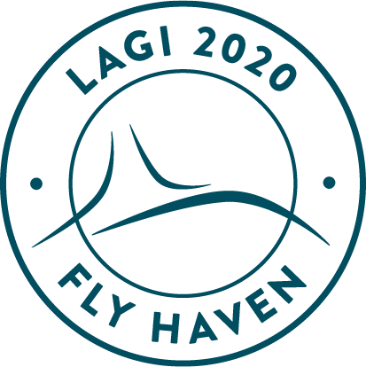

A Space to Commune

The Sanctum is the hearth of the community – a sheltered, multidisciplinary space, secular in nature yet spiritually invigorating. Its purpose is to bring people together and to act as a catalyst for human interaction, exchange, and creative manifestation.
As you descend through the lifted veil of the entrance, you enter a tall, circular space, light pouring in through the smokestack. The terraced forms emerge from the structure’s skin, giving you a place to rest your weary legs, or to enjoy the company of your peers. Here, within the Sanctum, the human spirit thrives, and the collective energy of all life unites to create a better, environmentally conscious, and inclusive world.

A Space to Grow

The Grove feeds the community. By nestling the Grove beneath ground level, we provide a temperate climate sheltered from wind and blaring sun, from extreme temperature swings common to this arid climate. Water basins, replenished by nearby streams and aquifers, are populated with fish to fertilize and irrigate the surrounding plants. These techniques allow this luscious garden to flourish with fruits and vegetable, greens and grains that would otherwise prove impossible to grow.
The Grove is a living laboratory for agricultural experimentation. Whether through ancestral Paiute slow-moving surface irrigation methods, or diverse heights of plantation, the purpose is to test yield ratios and harvest cycles over many years. And should these methods prove effective in the most unforgiving environment, the system can be adapted to other climates and ecosystems.

Between Ranch and Geyser

Fly Haven is conceived as an adaptable system that can propagate organically across the grounds of Fly Ranch – infrastructure and community nodes rising from the earth, changing form and scale as needed. For this first garden, our team chose PRIORITY AREA P-2D, between the ranch settlement and Fly Geyser, the main community hub and visitor attraction.
As you walk from ranch to geyser, you can stop at Fly Haven to grab a snack, rest your feet, or seek shelter from sun, wind, or rain. The microclimate inside is an extension of those already present along the pond and bourn, further tempered by the careful positioning of the oculus to control sun exposure, and the gentle curves which shield from the north-westerly winds.

Earth-bourn: Building Fly Haven

The design of Fly Haven was refined through a cyclical process of hand crafting and digital modeling. Sculpting in clay, the shape was molded, discovered, discarded, remolded, adjusted, over and over. The form was then digitized and optimized for light exposure, wind flows and engineering. To ensure that Fly Haven is respectfully integrated into the landscape, augmented reality headsets can overlay the project on the chosen site. This allows the project team to assess precise environmental impacts, coordinate site preparation, and evaluate potential water sources.
In the ethos of using only site-sourced materials for construction, the formwork for Fly Haven is a carefully constructed mound of compacted earth. Workers equipped with VR headsets can assess the form as it emerges from the earth and adjust accordingly. Approximately 5000 metric tons of soil would need to be excavated from adjacent sites that fall within the primary site boundaries. This can include expansion of ponds and reservoirs with minimal impact on wildlife habitats.
The shell of Fly Haven is also built of the surrounding earth and gravel. By adding cement and water, the mixture can be poured, reinforced, and rammed onto the formwork. This traditional construction method blends seamlessly with the landscape and provides thermal mass to balance out extreme temperature swings. And by using existing on-site materials, we can limit the production, transportation, and insertion of foreign building products on the ranch, greatly reducing the project’s carbon footprint. Roughly 900 m² of rammed earth at 600 mm thickness would be required to create the two spaces proposed. As the walls rise to form the two major openings (the stack in the Sanctum and the Oculus in the Grove), this thickness can reduce to a mere 200 mm.
Once the shell is cured, the earthen formwork is then dug out to reveal the generous space within. This formwork can then be repurposed over and over to create other gardens or community structures. By building out of and only with earth, there is minimal environmental impact should these structures be decommissioned. They can either be ground-up and returned to the land, or be left as relics, reclaimed by nature and wildlife over time.
The final structure measures roughly 20 x 40 meters and reaches 8 meters at its highest point in the Sanctum, and 3.5 meters above ground in the Grove. To ensure stable soil temperatures throughout the unsteady days and seasons, the Grove is excavated 2.5 meters deeper than the surrounding plain. The stepped planters are formed once again using rammed earth, creating variable conditions for different crops, and in places collecting water to irrigate, humidify, and further temper the space.
At the scale proposed, the main project costs emerge from professional fees, cement, reinforcement materials and manual labour. The earth is there, it simply needs to be moved into the correct place and geometry. We evaluate that the construction costs of the full-scale Haven would be between 250 000$ and 500 000$. This rough estimate is dependent of the material donations and labour costs. Due to the simple nature of the construction method, we project that Fly Haven can be community-built in the spirits of barn-raising.

A Passive Garden in the Desert

It is now time to grow. As designed, the Grove should offer a stable microclimate where plants, insects, birds, and fish can grow while nourishing one another as well as the Flyers. The water basins are fed by the nearby stream and allow for slow-moving surface irrigation of the 5000 square feet stepped garden. Fish in the basins fertilize the water used to irrigate the plants, while bee colonies pollinate the flowers and create their sweet Fly Honey. The whole system is passive and requires as much input as your typical community garden – namely, human care and labour. Compost created by the husks of harvested crops can be used to fertilize the next cycle of growth. Fly Haven works with nature and for nature, consuming no energy in its operation, providing its bounty for us to enjoy without sacrificing the surrounding beauty; a completely passive structure born of the earth, bound to it inextricably like us all.

The Prototype

While it is the hope of everyone involved to see this concept emerge from the ground, we understand that many components of this seemingly simple system need to be tested and adapted to truly provide the effects outlined above. Furthermore, it is only at full scale that the system can function as a self-sustaining micro-climate. For a prototype respecting the allocated grants, we propose a small-scale section be built, one that can provide shelter for a few people. This steppingstone would allow us to validate the soil composition, measure the proper ratios needed to form the earth mixture, and analyse data for thermal behavior, climate mitigation and structural stability. Much like our early clay studies, there would be a back-and-forth between the crafted structure and further parametric optimization. As the proposal is for a system more than a form, we feel this research will be invaluable when deploying Fly Haven at scale and across the site of Fly ranch.

We truly hope you enjoyed our proposal, and we would love to further explore this idea for a desert agricultural laboratory and communal heart for Fly Ranch together in 2021.

Be well and stay Fly.

Sincerely,
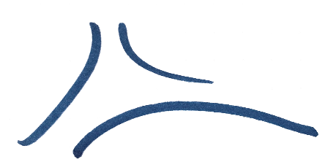

The Fly Haven Design Team

