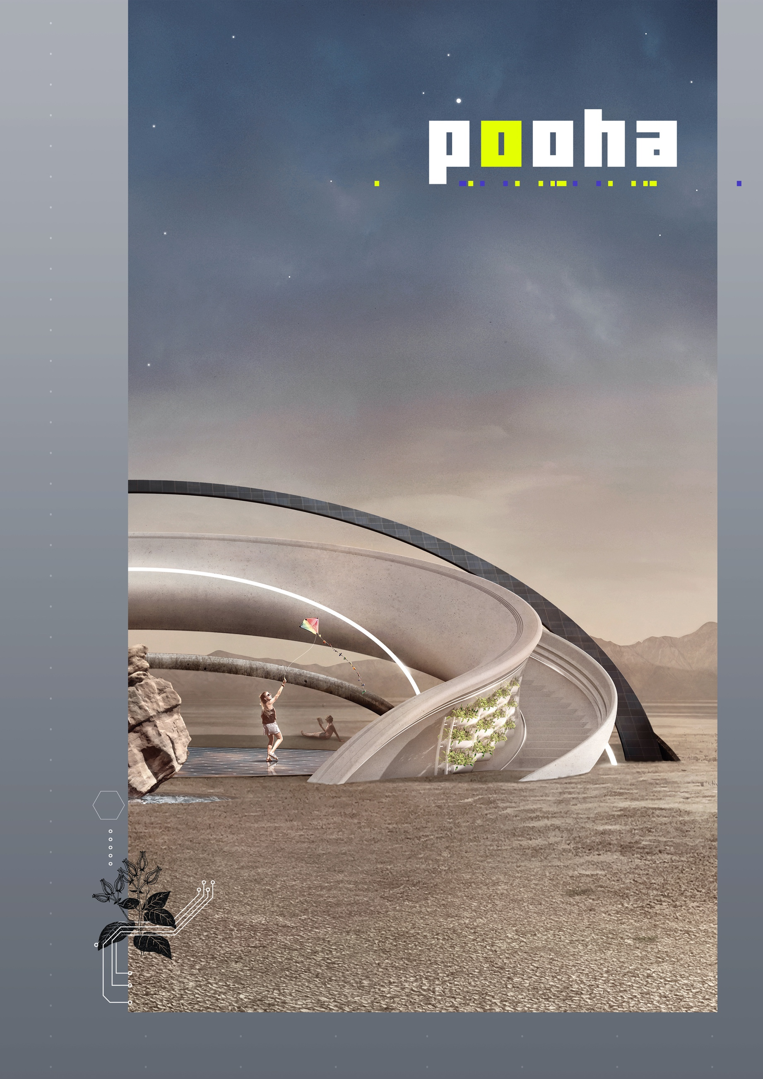

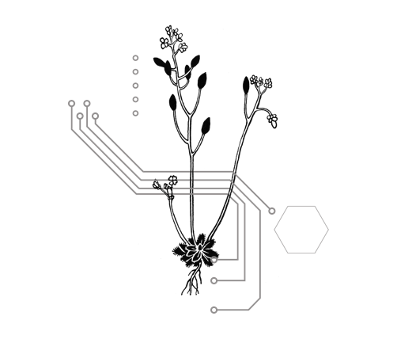

What you are about to read
will likely seem to you as a dream.
And of this dream, we’ve got all
the ingredients to make it real…

10.000 years ago in the Nevada Desert lived Paiute tribes; they were forced into a nomadic lifestyle, imposed by the scarcity of food and water.
Despite adversities and the necessity to roam, the natives’ strong faith and devotion towards nature was the element that gave them life.

They called the supernatural force which made things happen beyond their capacity of comprehension POOHA. And with extreme reverence, they respected its action, almost divine.
POOHA
This project narrates the evolution of a millennial story; It responds to that ancestral life necessity making the impossible possible: thus granting a permanent dwelling in a place with extremely unbalanced resources.
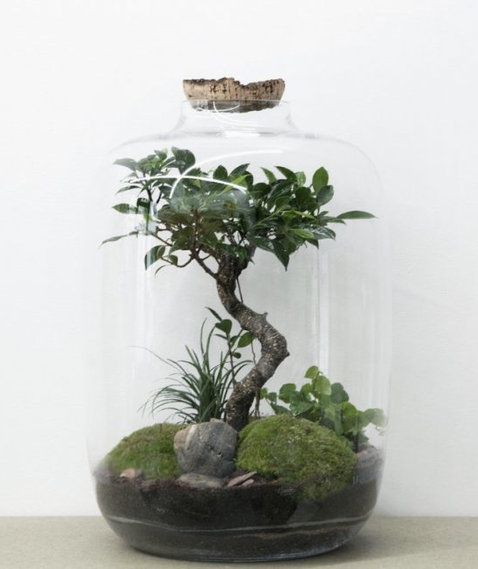
The idea took inspiration from a very simple technique of the 1800s, the Closed Terrarium; used to carry plant species across the oceans. The terrarium technique involves the creation of a circular micro-ecosystem inside a glass container which, when closed, becomes self-sufficient for its survival.

In our modern Terrarium, thanks to technology and a control system, we have been able to eliminate the dividing element between it and the environment in which it is inserted.
We have created a human-friendly machine; you could call it a ‘guest-ecosystem’ installed into a ‘host-ecosystem’, the Nevada desert. Drawing from the latter, resources that are promptly restored and using the existing energy sources without affecting the host-ecosystem.

We have combined existing techniques and technologies to recreate a glassless “terrarium”, designed to provide energy, food, water to support the life of a community of 15/30 people who could live around it.

Our project will create a positive-sustainable environment that will benefit from the energy and natural resources available onsite, remaining below the natural threshold of consumption/restoration; in this way the impact of the settlement will remain sustainable.
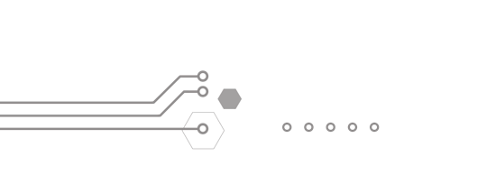
This is POOHA.

POOHA’s FUNCTION
We define POOHA a smart semi permanent architecture conceived as a modular structure.
It has the function of balancing itself in its environment and, in doing so, allows the well-being of the human community.

Its main structure is built around an iconic central element, the balanced stone. This conceptual structure manages and uses the outer existing elements to allow for human dwelling.
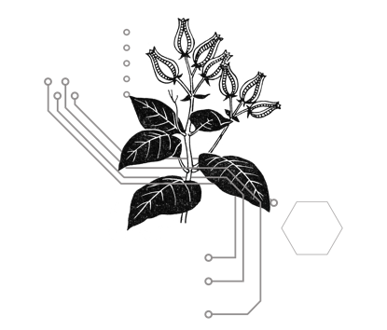
POOHA is a sort of conceptual mediator between nature and humans, acting as the key to sustainability.

Our basic needs can be summed up in two main “actions”:
- production and storage of energy;
- collection and storage of water.

And a result:
- produce food.

From these elements life will originate and everything that stems from it.
THE DESIGN

POOHA’s development uses the golden ratio as a module for the design of all volumes. It uses a circle for defining shapes and a hexagon for modulating the spaces..

The circular shape promotes equality and is based on the old way people used to settle and gather (i.e. fire camp). While the hexagon has been used as a modular pattern motivated by parametric nature (i.e. bee hives).

POOHA redesigns the future concept of settlement. It is the heart of the community that can grow and develop around it and thanks to it.

The main body consists of an inclined halo (16.5%) oriented to the South. It has a diameter of 25m, grafted into the ground with a minimal depth of foundation in order to preserve balance and to have the least impact on the host- ecosystem's terrain.
We have optimized the foundation's counterweight needs by including a 1000lt water basin. This basin is POOHA's water source and storage.
The inclination is chosen for a dual function: the first to recreate a shaded area and a shelter, the second to allow, in its exposed part, an optimal solar radiation throughout the day.
The central part of the structure is a circular square of walkable solar PV, this is POOHA’s primary source of energy.

The main body (halo) is designed to accommodate a multilevel hydroponic glass greenhouse on its entire circumference divided into 5 parts, suitable for hosting 3 different types and cultivation techniques.
Access to the greenhouse is via a gentle staircase that makes the entire structure accessible, offering a panoramic viewpoint at the top (6m high).
The entire architecture is covered by a telescopic structure that makes the greenhouse area fully sheltered thanks to a heat shield made with aerospace technical material, functional to the thermal stabilization of the greenhouse and its protection.

POOHA’s design is ingrained in the 10 principles of Burning Man: anyone can be part of POOHA.
Wheelchair guests can access the halo part by using the snaps at the bottom of its path. A braille indication and blind path are integrated into the whole POOHA to make it accessible for visually impaired visitors.
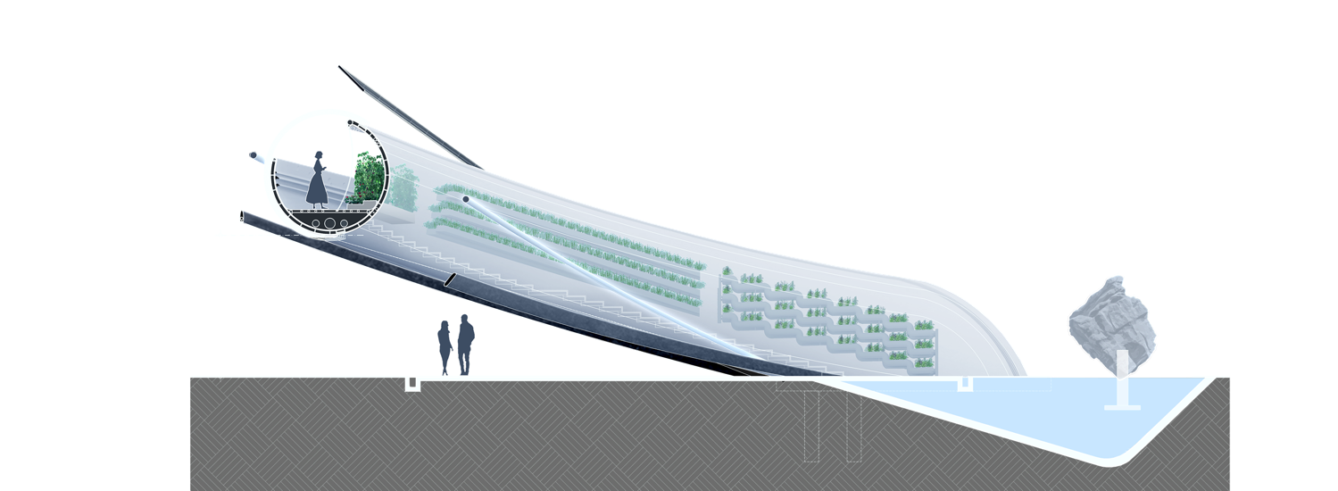
POOHA halo will have an ergonomic handrail designed to suit all ages, and the main body of POOHA has punctured holes for views of the outside in various heights and locations.

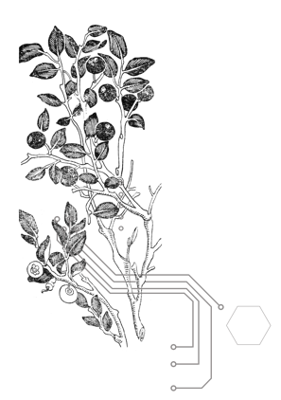
TECHNOLOGY
POOHA has a beautiful shape and also a beautiful mind. We think, technologically speaking, it’s far more important to point at a better efficiency of the existing systems rather than looking for something unstable, experimental, that doesn't let us feel safe. POOHA is fully feasible but also smart and responsive.

What does this mean: it gives heat when it is cold. It gives cooling when it is too hot. It provides water. It provides food. It provides energy. All this for a happy and environmentally friendly way of sustainable living.
When it's dark it gives light. And maybe at a certain point of the day, at sunrise and at sunset it also plays music coming from the natural surroundings.

In order to reach this goal, the structure has been conceived as modular and expandable, thanks to the “RING” system.

THE ARDUINO APPROACH: RINGS
POOHA is a ‘Plug & Play’ dynamic element in nature.

It’s composed of a fixed body, made up of HALO (greenhouse), WATER BASIN, SOLAR-PV GROUND PANEL & STONE and elements which can be plugged in or varied in order to make POOHA suitable to any type of environment. Following the concept of ARDUINO, the fixed body functions as a motherboard efficient in controlling additional elements, called RINGS.
The RINGS allow the POOHA to be suitable for very different environments. In terms of Energy, POOHA takes half of the energy needed for its sustainability from the sun, and the other half using a natural energy source that belongs to the ‘hosting-ecosystem’.

For Example, a POOHA installed: in windy Ireland, will have a WIND RING; in the North Pole a TIDE RING system; in the Amazon River a WATER TURBINE RING.
There are different typologies of Rings which can please energetic needs, techniques, functions, but also entertainment purposes.

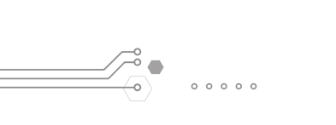
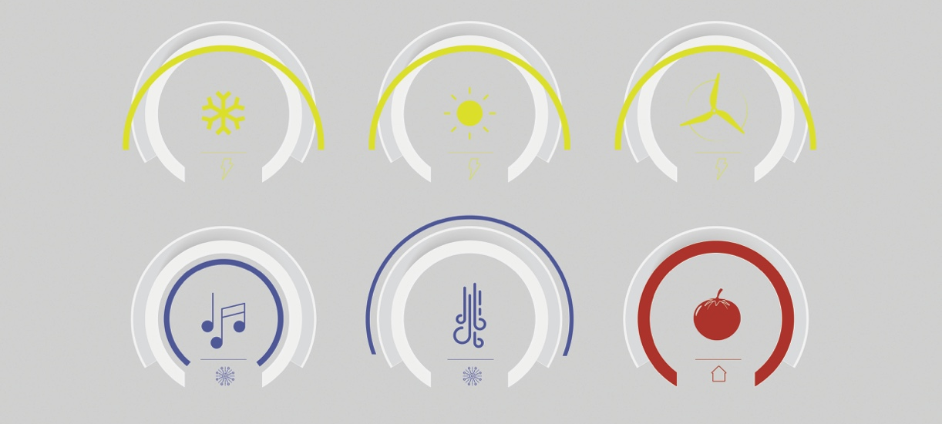
By applying the “ Arduino approach” to the main structure designed for FLY RANCH, we’ve added the following rings:

RING | TYPE | # of RINGS | FUNCTIONS
SOLAR PV | Energy | 1 | increase the solar panel surface and energy production
LIGHT | Illumination | 2 | gives light
MUSIC | Entertainment | 1 | to play background music for the community
MIST | Heat-Cooling | 1 | decreases the temperature in its proximity, waters the neighbouring ground by lowering the dust entrance inside the central square.
HEATPIT | Temperature | 1 | increase the temperature in the center of the structure.

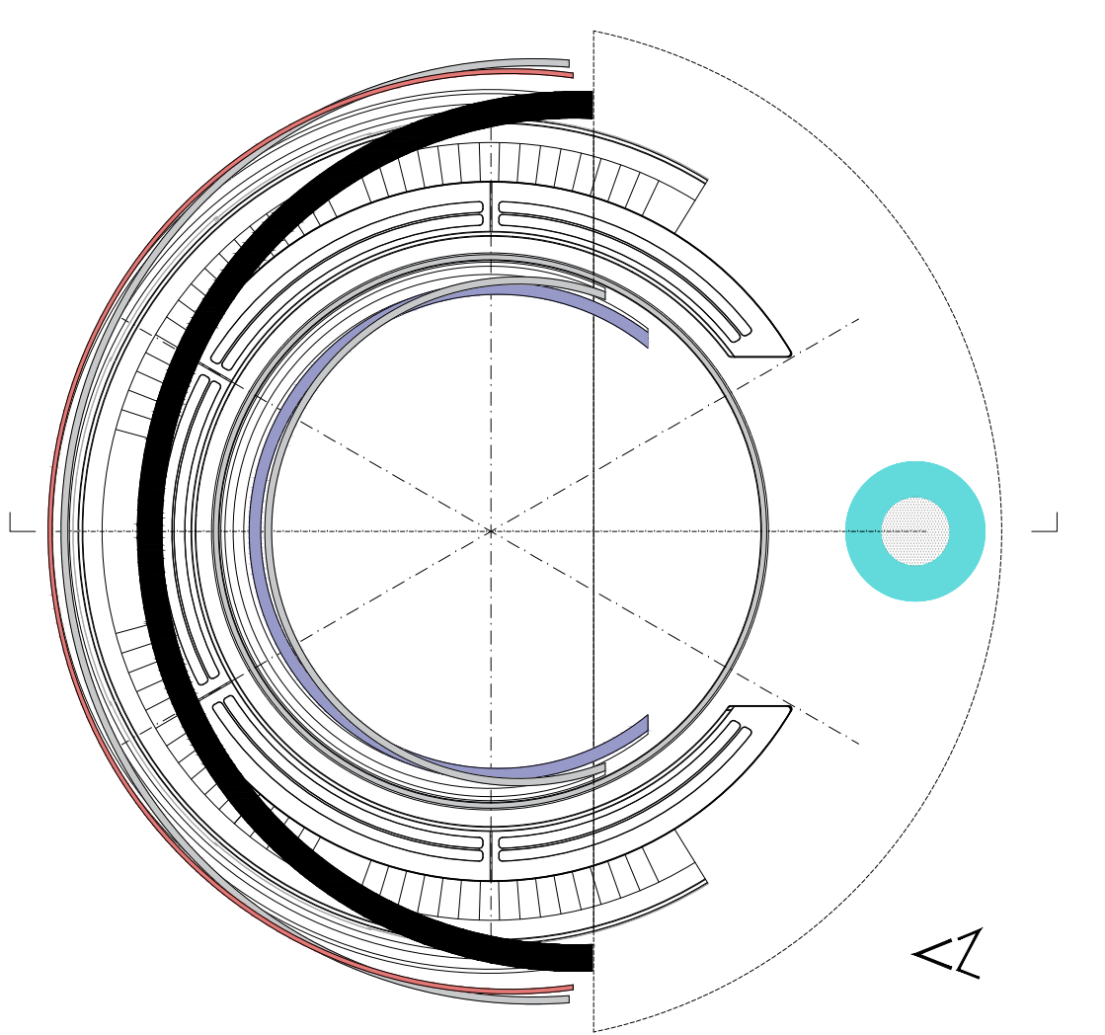
TECHNOLOGY USED - ENERGY/FOOD PRODUCTION & CONSUMES

ENERGY PRODUCTION SOURCES:

- 98% natural resident sources
- 2% human power
TOTAL ENERGY PRODUCTION: ~34.000 kWh/year

ENERGY BREAKDOWN
- ENERGY CONSUMES: ~28.900kWh/year
(details: 70% Hydroponic greenhouse including water-system & water-pumping)
| 22% structure maintenance and services | 8% control system)

- ENERGY SURPLUS: ~6.100 kWh/year (18% of production)

- ENERGY STORAGE CAPACITY: 30% of production

ENERGY SYSTEMS
- 98% natural resident sources
Energy in POOHA is produced by a combination of elements.
- A 200sqm all-black high-efficiency solar-PV-walkable ground: ~18.500 kWh/year.
(standard production: 29884.03 kWh / loss of walkable set to 40%)
- A 50sqm all-black high-efficiency solar-PV-Ring: ~13.500 kWh/year

- 2% human power
A 100sqm Energy floor system: A smart and interactive solution that makes sustainability visible and produces energy by people walking on it.
Energy production: ~2.000 kWh/year

WATER

POOHA water comes from air/rain.

POOHA has an integrated AWA MODULA system that will produce from 800>2,500 litres of water
from air per day + primary fresh air + hot water for the heating circuit + cold water.

The water production can be modulated in order to guarantee the best integration with HVAC systems and ensure great ENERGY SAVINGS.

The system can treat dark water and can produce a very high quality water and guarantee the pureness and the total absence of chemical and bacteriological elements.

STORAGE
- Water basin: 1000lt (500lt storage + 300lt pure/drinkable + 200lt dark_water)
- Greenhouse tanks: 2400lt (4x500lt - 2x200lt) - (pure+dark cycle system)

PRODUCTION (POTENTIAL): ~400.000lt/year

TOTAL CONSUMES: 57.000lt/year (5% drinkable - 68% greenhouse - 16% HCVA - 11% mist+structure)

WATER CYCLE
A controlled system provides water to POOHA combining electronic-pumps and mechanical-pumps, integrated into the halo stairs, working thanks to the inhabitants' walking pressure.
TOTAL ENERGY SAVING BY STEP PUMPING: ~8.000kWh/year

THE FOOD: GREENHOUSE

THE GREENHOUSE
5 sections - 3 different types of crops = 150 monthly rations
(Enough to satisfy the resident community)

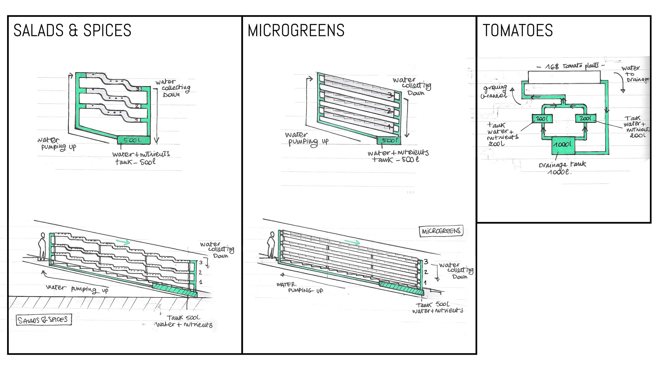

For POOHA's greenhouse we have chosen the Hydroponic System.
Hydroponic systems, compared with soil-based cultivation systems, are cleaner techniques and, thus, they lead to a reduction in pollution. It can also be more sustainable and efficient solutions because the supply of nutrients and the use of water can be more stable than in soil.
Hydroponics, with the support of automation and computerization systems for climate control and crop transpiration in the greenhouse, is a technique that best meets the modern principles of sustainability, allowing an efficient use of resources, like energy, labor and water. Thanks to a computerized system, both vegetables and fruits receive the right amounts of nutrient solution through the water, administered according to the specific needs of the different species.
The POOHA smart farm is both a flat and a vertical farm, designed as a continuous production system that cultivates crops without the human intervention through automatic control in a suitable space for the crop's growth in an environment such as light, temperature, humidity, carbon dioxide levels, and nutrients.

The greenhouse system works in a closed cycle: an amount of nutrient rich water is fed into the greenhouse at every irrigation, the plants consume the water they need and release the water deemed to be in excess and therefore unnecessary. This water is recovered, filtered and sterilized and reused with each subsequent irrigation. There is no waste of water.
Each greenhouse will use a complex LED light temporized system with a thermal control that will allow it to give the proper light and temperature balance to the cultivation.

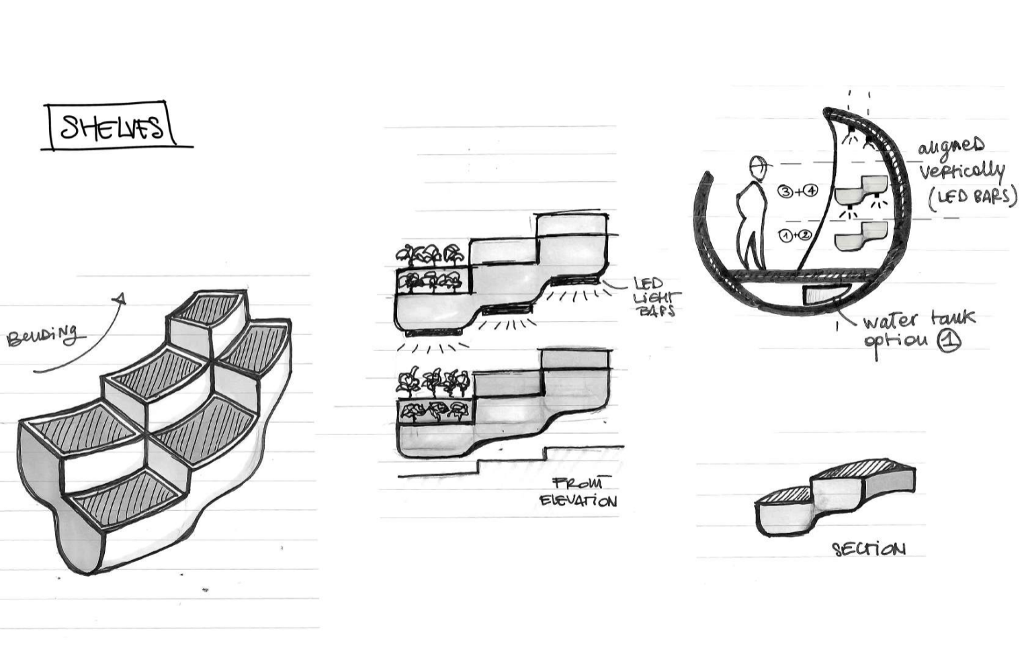
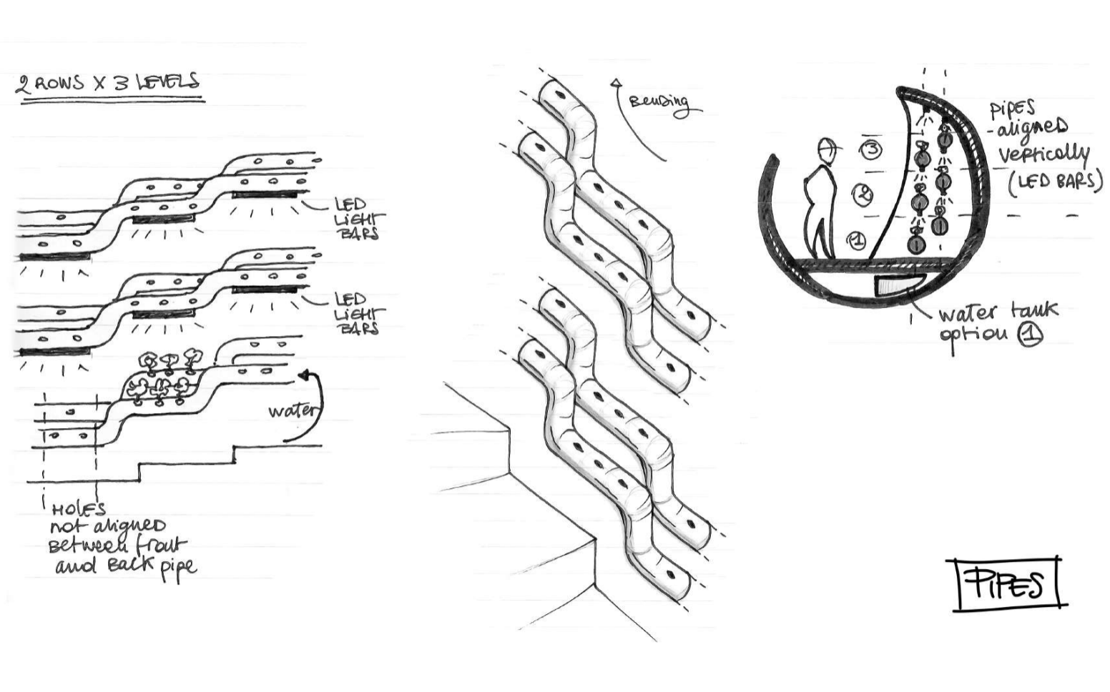

FOOD PRODUCTIONS - FORECASTED YIELD
- CULTIVATION TYPE 1 - (i.e SALADS AND SPICES) - 45 Kg/month
- CULTIVATION TYPE 2 - (i.e MICROGREENS) - 360 Kg/month
- CULTIVATION TYPE 3 - (i.e TOMATOES) - 600 Kg/moth

TOTAL FOOD PRODUCTION
150 rations month - ~20 people need

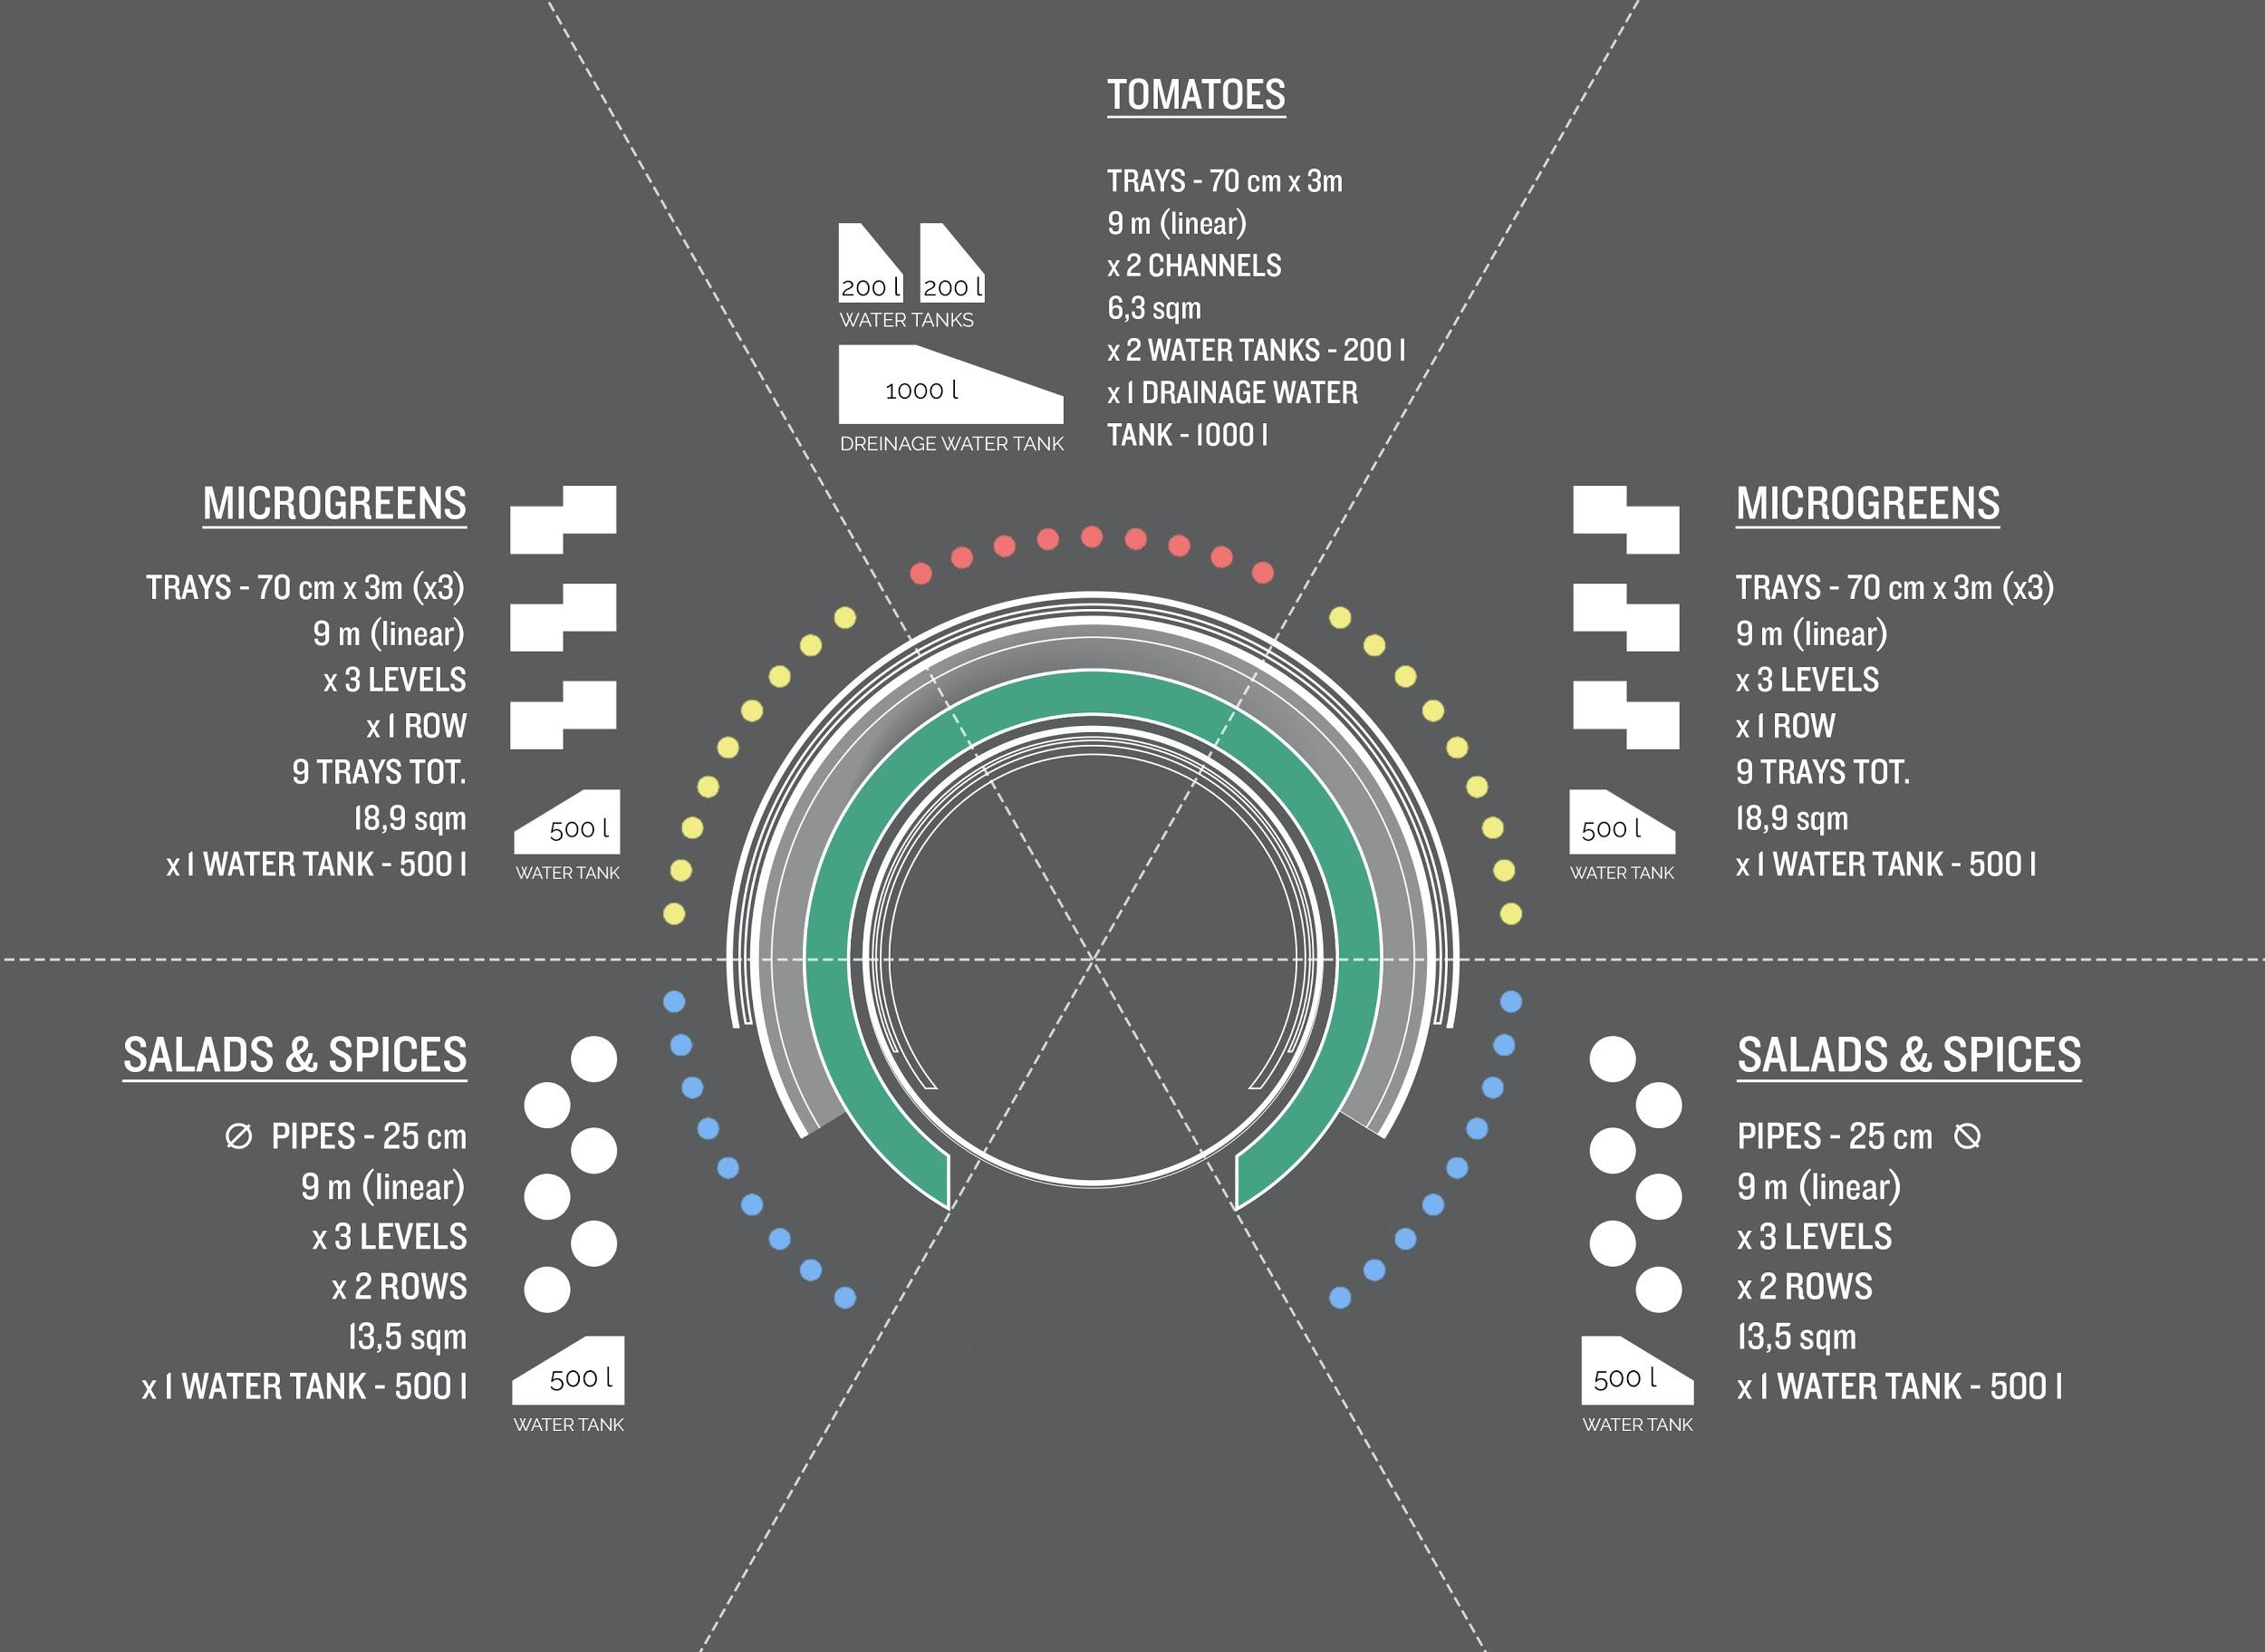

THE STONE: KEY TO SUSTAINABILITY
We are used to consuming the planet's resources without realizing it, thinking that our actions will have no consequences.
At the heart-centre of POOHA we have set a rolling stone that is in balance over a water surface. It's our symbol of sustainability. The stone is linked to the control system, it functions as an indicator of the ratio energy/consumption of the whole of POOHA and of the community it relies on. The stone rotates thanks to a particular mechanism that uses water pressure. When POOHA is at its highest sustainable level (producing and storing energy) the stone rotates. However, If there is a shortage in the energy system the stone will stop rotating.
POOHA's energy model, 98%/2% relates its sustainability to human action, without it the entire structure would find itself in an energy deficit.
Only with everyone's commitment, participation and dedication will POOHA result in being sustainable.

ENVIRONMENTAL IMPACT
AND SUSTAINABILITY:

POOHA always produces a surplus of energy. There will be a single primary energy vector - green electricity, which will be produced by two types of photovoltaic units - the PV ring and the ground main circle. Humans will contribute to the energy cycle by seamlessly pumping the water needed for POOHA’s greenhouse as they are climbing it, as well as produced by their movement across the main ground circle and stone area (energy floor). The instantaneous energy balance will be revealed by the energy stone - as the stone rotates, POOHA is accumulating energy, if it stops that means there is an energy flow error and the demand larger than the production, triggering the extra power required to be delivered by the storage.

To permit the POOHA to be sustainable a proper BMS (Building Management System) will be installed. The BMS will use Bacnet/IP as the main protocol and will deliver setpoints and receive information from and to the local controllers of each subsystem. The main focus of the BMS will be to maintain the required conditions inside the Hydroponic farm applying energy saving control strategies. All the lights will be dimmable and will compensate for the external solar radiations. The water pumping will be variable, the VSD will adapt the pumping RPM to the real requirements of the cultures. The BMS will be storing all the historical data regarding the installed sensors and energy usage monitoring the main KPIs. Finally, the BMS will be the single HMI for the operator and will receive all the alarms and warnings from the technology installed in the POOHA.
A separate but BMS integrated control system is needed to balance energy production, storage and consumption working on site. The control system will dispatch the energy flows between production, high capacity low intensity energy storage, high intensity low capacity energy storage and users in order to maintain the grid frequency and power quality acceptable. Due to the site of the installation, no remote connection from the web is possible, therefore all the control systems will be deployed on-premise and dashboards will be available locally.

THAT’S POOHA

