Project Regenerative Cosmos

Fly Yupa + Fly Drone + Fly Blossom Ritual

The intention of Project Regenerative Cosmos is to be a conscious steward of the ancient future of Fly Ranch. The proposed project integrates land and cosmos, ancient and future, human and robot; guided by the sacred time of the seasons.

A solar powered robot named the Fly Yupa begins the story by seeding annual native blossoms and tracking the movement of stars. The proposed Fly Blossom ritual is a biannual vision quest for the fall seeding and the spring blooming. As the Fly Yupas launch the annual native blossom festival, the long term conservation plan takes to the sky via the fly drone.

The Fly Drones are a pure conservation activity related to supporting the habitat of local flora and fauna. The drone supports the conservation without engaging in any activities that are not allowable in this area.

The seeding of the Fly Yupa creates a biannual vision quest during the fall seeding and the spring blooming. The blossom ritual drives human connection and the creation of a regenerative economic model.

The Fly Yupa exists in multiple dimensions.
It is both a prototype and archetype.

The Fly Yupa is a prototype that frames the only hypothesis that matters, how can humanity create a net positive relationship with the earth to ensure not only our own future but the future of the planet?

The Fly Yupa responds to that same hypothesis through its own embodiment as the ancient connection between man, built form, and cosmos. Its very existence is the ancient future.

Based upon the universal ancient ritual pillar found in all cultures from vedic, mayan, chinese to indigenous cultures, the original function of the universal yupa is to connect man, earth, and cosmos through ritual activity. Through aligning with the universal yupa of ancient times we align with the sacred relationship between human, earth, and cosmos.

STRUCTURE + FUNCTION
The Fly Yupa is a nomadic totem, tracking the movements of the celestial bodies creating a pilgrimage site around its actions, and harmonizing with the flora and fauna of Fly Ranch.

The chambers of the Fly Yupa hold play things and gifts for the local animals, nesting materials for birds, and the seeding of the land with native plants to build a regenerative ecosystem.

List of Activities the Fly Yupa Supports
- Ritual activity
- Seeding
- Harvesting
- Star gazing
- Seasonal pilgrimage
- Playful engagement between human and robot.
- Playful engagement between local animal kingdom and robot.
- Playful engagement between local plant kingdom and robot.

COSMOS
Crowned with a celestial visor that frames the stars, the prototype of the Fly Yupa in motion will be tracking the celestial movements of Venus during the summer solstice. The installation strategy includes an on-site analysis, a cosmographical analysis in collaboration with a recently funded project to learn the Paiute star map constellation from the elders.

Based upon the stories of the local indigenous tribes, the subsequent Fly Yupas can each track one particular constellation or star. As such the design of each Fly Yupa will reflect the story of the celestial phenomena that it tracks.

LOCATION
The Fly Yupa explores the perimeter. When at rest, the Fly Yupa is located at the perimeters between the primary site and the low impact site boundary. When in motion, they move in spiral formations for seeding, and curves and angles when tracking cosmic movements.

The Fly Yupa’s primary navigation stays in regions that are flat enough to not be occluded by nearby objects. Ultimately, as the Fly Yupa move fluidly through and along the perimeter, they explore the psychic space of the transitional zone of the land and help to integrate the whole ecosystem.

PHASES

Phase 1: 2021
The Fly Yupa completes one small seeding in year one. At rest it offers nesting materials to birds and playthings for animals.

March 2021
- identify location of the small annual blossom ritual
- identify the annual that has the highest probability of blossoming
- partner with a local nursery
- use an annual already in the growth cycle
- plant into the Fly Ranch site.

Summer Solstice 2021
- The blossoming will demonstrate the potential of the power of seasonal ritual.
- The planting of annuals native blossoms can be installed separate from the Fly Yupa.

Phase 2: 2022-2026
The goal of the Fly Blossom rituals and retreats are to listen to the desire of the land, ancestors and cosmos.
- Retreatants identify the annuals for the next blossom expression of the land's fertile ground.
- Visitors work with native blossom plants
- Create a regenerative self-sustaining economic system that is aligned with the ethos of Black Rock City.

FAll 2022-26:
- Low impact yupa seeding pending prototype.
- Depending on the results we can expand the Yupas to other sites, and seed a 7 acre radius per yupa in anticipation of the spring bloom season.
- Continue to offer Fall Seeding vision quests.

Summer Solstice 2021-26:
- Blossom Season will create ritual
- project team will have a retreat in celebration of the summer solstice.
- This biannual retreat process will allow the regenerative project to gain momentum.

Phase 3: 2027-2050:
The Fly Drones
- Leverage the award to create rituals that are sustainable for 10 years
- The blossoms create a revenue model that is economically regenerative.
- A pure conservation activity.
- Provide seeding of native plants and trees that supports the habitat of local flora and fauna.
- All drone activity strictly designated for the Conservation Area, which is 70% of the total land area.

Fly Yupa Prototype:
List of system inputs:
Prototype
Solar:
- Resting: harnessing the solar of a max of 1160 W/m2
- In motion: It’s stored max of 1160W/m2 allowing for 4 hours of motion in conversation with the cosmos.
Wind:
- Resting: can withstand max of 11 m/s
- In motion: can withstand max of 7 m/s

Precipitation:
- Resting: harnessing the cleansing of water to a max of 1000mm
- In motion: cleansing of a max of 1200mm

Temperature:
- Resting: of a max of 110F
- In motion: max of 110F

List of system outputs:
200-500kilowatt hours
Waste materials: Yupas have a life cycle of 10years. Most materials involved are regenerative and compostable. The mechanisms that are not compostable will be removed at the end of the life cycle by the project team.

List of primary materials used in design and major dimensions:
- omni wheels
- Solar battery
- solar panels
- space frame
- seed hopper
- seeds
- nesting materials
- 88H” x 36L” x 31W”
- Weight 50kg

Economic Model

The Regenerative economic model allows the seed funding to be leveraged into a fall and summer solstice retreat that creates revenue for the ritual. If selected together the $450k can be leveraged into creating an financial self sustaining economic model that is projected to be a $2M budget that equals 3x the original investment.

The first phase allows for the seeding of the Blossom Ritual, the second phase supports the momentum of the summer solstice ritual. The final phase allows the Fly Drones to enhance the ritual event and increase the support needed for the conservation areas.

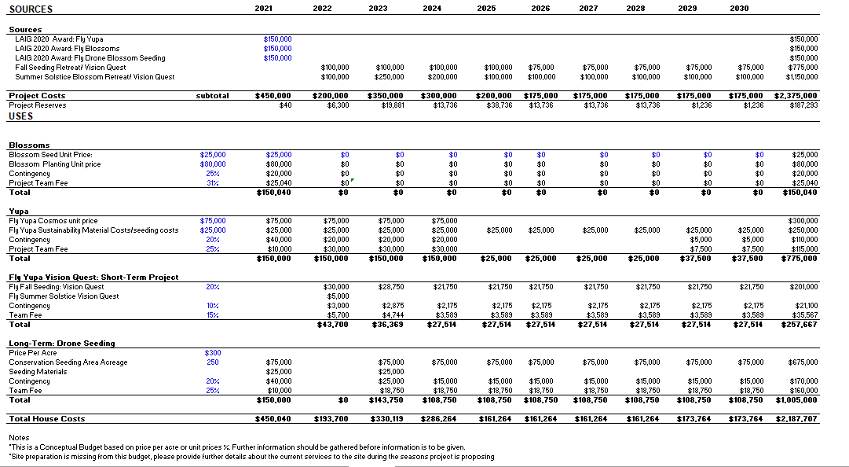

Maximum environmental impact summary:

We will be working with site appropriate species and seeds, so the danger of invasives is low. The robot weighs 50kg, so it’s not likely to drive compaction issues as long as it is not rolling on sensitive land or mud. The actual goal is to have a positive impact on the environment by having the robot help in ecological restoration and habitat support.

