Kiba paa'a
Mountains of water

One time this was all water but just one little island. That is what we are living on now […] In all directions the land was lower than this mountain. It was burning under the earth.

Northern Paiute Tales, Isabel T. Kelly

J Am Folk 1938

Water and fire sculpted the Great Basin. The subduction of the Pacific Plate under North America gave rise to a series of mountain ridges and valleys that form the largest endhoreic watershed in North America. Here, geological activity interplays with water and soil to sculpt a unique landscape of faults, hot springs, salty lakes and vegetation. Snow accumulates at the peaks during winter and meltwater flows down bringing life to the sage-covered valleys during the hot, dry summers.
Access to water is a pillar of human communities. From the 19th century, water management in the Great Basin technfied to meet the needs of human activity and intensive agriculture. The water management strategy put into practice at the Hualapai Flat changed the natural west-to-east water flow from the Granite Range to the Playa. Currently, a rectilinear, north-to-south structure collects runoff water and brings it to the middle Fly Ranch facilities. This construction disturbed the natural water movement and changed the landscape and soil, as is visible on the old aerial photographs. As a result, vegetation disappeared from large areas in the north of the valley, that were exposed to erosion and degradation of the soil.

Coyote walked far without water. He was very thirsty. He dug a hole under the sagebrush and lay down with his mouth wide open. Horned Toad saw him. He climbed on the sagebrush above Coyote and dropped a little water in his mouth. Coyote didn't see him above. He took his bow and shot in the air, but he didn't see Horned Toad at all. Pretty soon Coyote had enough of this water, so he got up and went on.

Northern Paiute Tales, Isabel T. Kelly

J Am Folk 1938

These intrusive strategies contrast with traditionally techniques used by local communities. Myths and stories recount the importance water had for them since early times and even give clues about the methods used to obtain it. Water was closely associated with ground morphology; instead of using external elements like pipes, conduction of water was done through land modifications by digging ditches and raising small promontories. They used materials available on site without using any heavy machinery. This results in structures with low environmental impact that integrate organically the landscape. Paiute testimonials capture the view of the valley as a garden that irrigation ditches make bloom. This «extraordinary aesthetic value» of surface water is also emphasised by current regulations as the Pyramid Lake Paiute Tribe Water Quality Control Plan of 2015.

Thousands of years ago, the Paiute dug irrigation ditches that routed runoff from melting snows into the valley. But unlike modern irrigation practices, the Paiute didn't channel the water onto farms or specific plots of land. «We looked at everything as a garden. The natives had made this place bloom like a rose»

Harry Williams, Bishop Paiute tribe, Owens Valley, CA

Paya, documentary, 2017

In 2005, the Jornada Experimental Range initiative presented a systematic, scientific approach to sustainable water and vegetation management in the Basing and Range geological province (of which the Fly Ranch is part). After a thorough study of the precipitation, soil, physiography, and vegetation, a catchment plan to remediate soil erosion and promote vegetation growth in key areas was developed. The installation of ditches and water spreaders to slow down surface runoff in specific sites enhances water infiltration into soil and vegetation productivity promoting remediation of degraded rangelands and changes of natural vegetation patterns at a landscape scale. They named this idea «Islands of hydrologically enhanced biotic productivity.»¹

Project proposal
Kiba paa’a – Mountains of water proposes revisiting water management at Fly Ranch. Instead of the current high impact, functionalist system, we bring forward a series of conservational, minimally intrusive and reversible interventions to provide sustainable water collection while bringing out the allure of water, soil and vegetation. Based on the concept of islands of hydrologically enhanced biotic productivity, proven to be successful in analogous environmental conditions, we advocate for a thought-out, long-term landscape modelling:
  - Study of precipitation, soil and vegetation at the Hualapai Flat
  - Selection of arid, eroded areas with biodiversity potential
  - Minimally intrusive catchments selectively placed to maximise water collection and slow down runoff water. Computer simulation of runoff allows to identify the intervention zones.
  - Long term landscape modelling: provide the conditions for soil regeneration and conservation of local species.
  - The aspect of the intervention constantly changes and is not fully determined by design.

We propose three sites of intervention:

Northern Fly Ranch: At the Northern Fly Ranch, a water collection infrastructure intercepts runoff water flowing towards the Playa. This affects wetlands, creating dry areas subjected to erosion and vegetation impoverishment. We propose an intervention to reconstruct natural water flows using the faults made by tectonics. Three structures are envisaged:
  - Embankment at the Little Cottonwood Creek to redirect water flows to arid areas
  - Two swells following a fault to create wetlands and conduct water towards the Fly Ranch facilities.

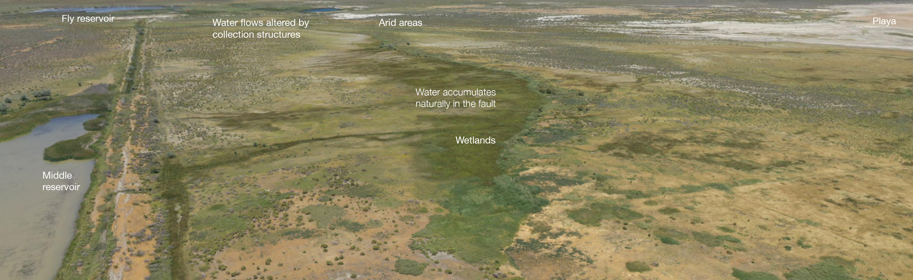

Middle Fly Ranch: At the Middle Fly Ranch there is the stream with the most abundant flow in the Hualapai Flat. This water flow is affected by seasonality and during episodes of heavy rain, it has sufficient power to erode the soil forming gullies. A series of gully plugs (see Techniques below) will slow down these fast water flows, mitigating erosion and promoting sedimentation and soil enrichment.
This intervention will take place in the shape of a yearly social episode based on Paiute traditions^{2,3}:
  - A Tuvaijü^{’u} or head irrigator is elected by popular assembly every spring. During the irrigation season, he will wield the pavodo irrigation tool, a pole of 8 feet long and 4 inches diameter.
  - The Tuvaijü^{’u} announces the time to begin the irrigation, which is approved by the people.
  - People of the community assist in the construction of a dam or gully plug that deviates part of the river flow towards a site of interest, namely rain gardens. The overflow water from irrigation is permitted to take its course and wander on the river bed again.
  - With the arrival of autumn, the dam is destroyed, allowing water to flow once more down its main channel.
Held annually by Paiutes, this rite had the functional value of deviating water towards agriculture sites. Irrigated areas are enriched with sediments and the quality of the soil is improved. We re-interpret this to bring out the dialog between seasons, water and soil. Every year we will assist a new, different process in which water transforms soil and creates new vegetation spaces.

Southern Fly Ranch: Water flows in the south of the Fly Ranch are highly subjected to seasonality. We find intermittent flows of purely runoff water. We propose a series of crescents, small ditch-lie structures that will form islands of hydrologically enhanced biotic productivity. This action will promote sedimentation, improve the quality of the soil and colonisation by local species in a long term (>15 years).

Activities that support | Inputs | Outputs
Water collection | 3 intervention sites | Capacity of collecting 3500 m³ of surface water (added)
Erosion mitigation | 4 catchment techniques | Soil quality improvement
Remediation of degraded soil and rangeland | 1800 m³ of locally available rocks and earth | Irrigation areas for local species

Conservation of local species
Community involvement through construction and maintenance

Techniques
Gully plugging consist on blocking gullies with stones and earth dams to create vegetative barriers to promote deposition of fertile sediments and organic matter during heavy rainfall episodes. Gully plugs accommodate annual crops, fruit trees or grasses. Mitigates expansion of the gully and loss of land.
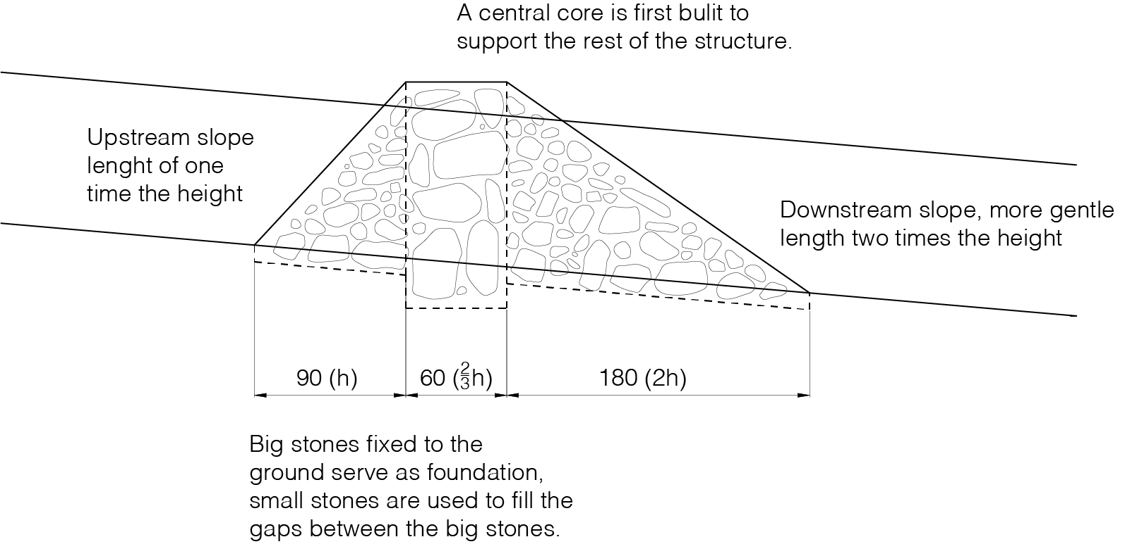
Swales serve to discharge runoff water to a waterway. They act as infiltration and retention ditches. Swales are dug across a slope to intercept surface runoff streams. The same soil that is removed from the trench can be heaped to ridge in the downstream side of the trench, which acts as embankment protection in case of overflowing.
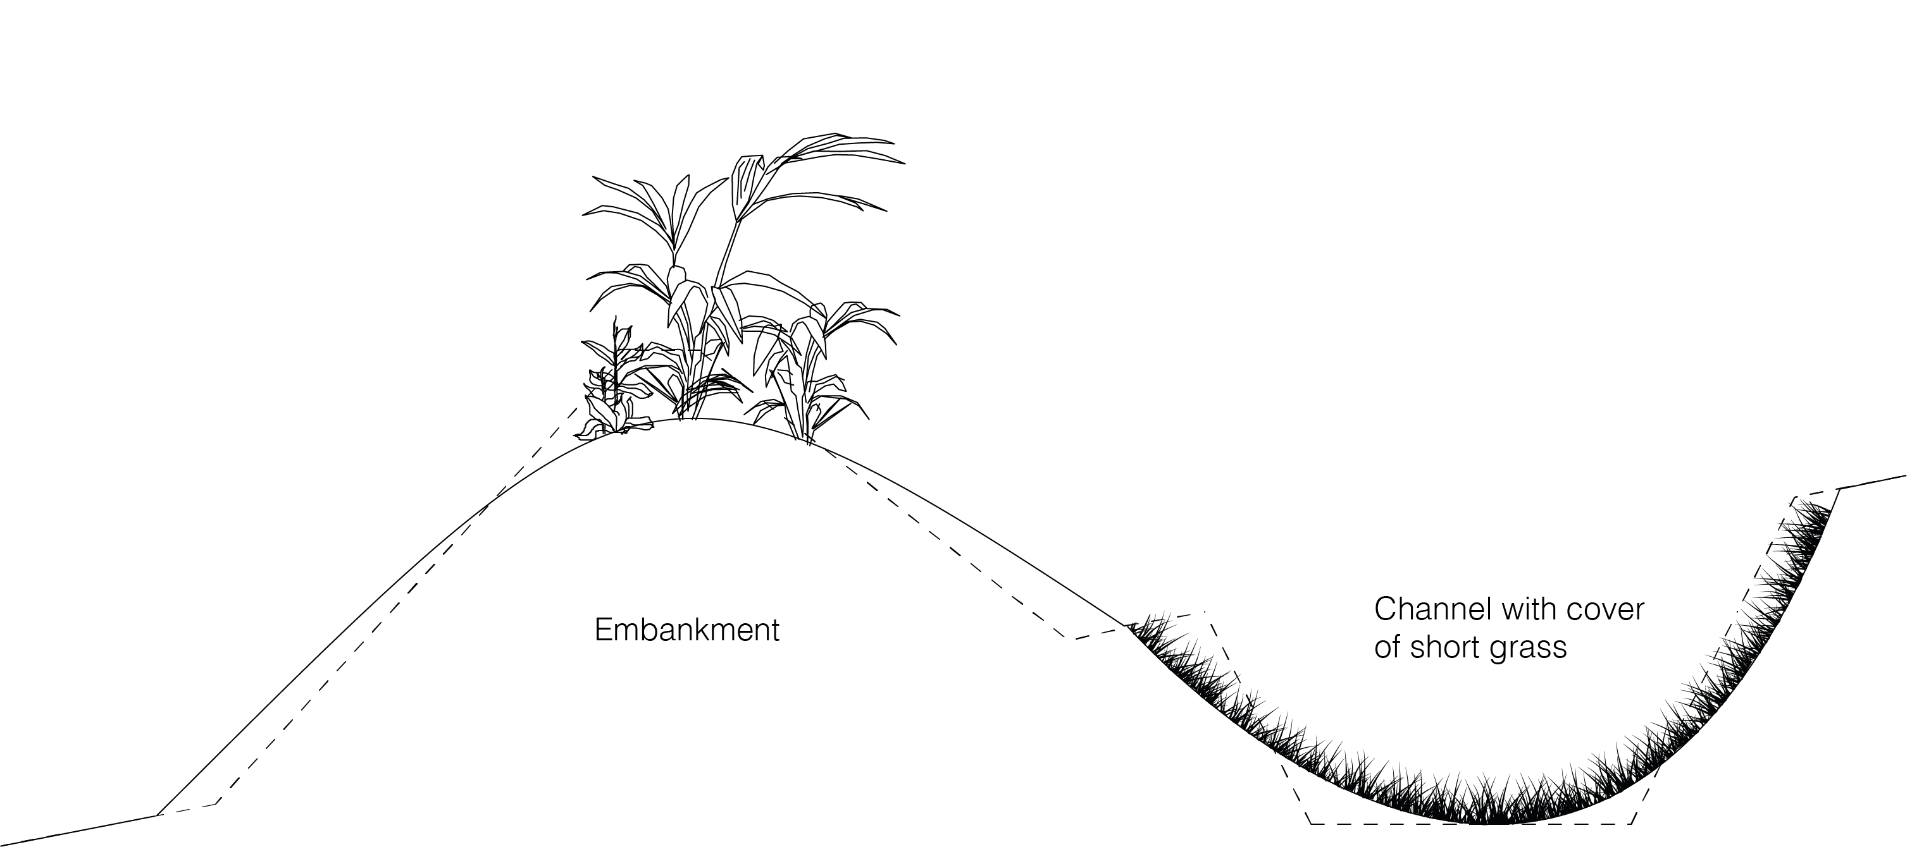

Crescents are small swale-like structures with a crescent shape, instead of rectilinear. They serve to catch water in specific points such as temporary waterbeds and isolated runoff flows.
Rain gardens, also called bioretention facilities are large, swallow excavated areas that capture rain and runoff water. Native species are planted in the rain garden to slow down runoff water and assist percolation into the soil.
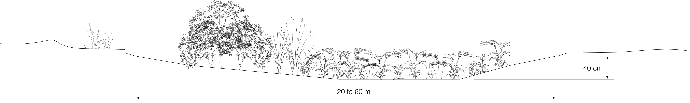

Materials and costs
Materials and costs are based on analogous interventions depicted in the World Overview of Conservation Approaches and Technologies (WOCAT) 2013 report «Water Harvesting - Guidelines to Good Practices²» and are approximate. We adapted them to the Fly Ranch proposal.
Structure | Materials | Tools | Cost of construction | Cost of maintenance
Gully Plugging | Locally available rocks and soil | Masonry tools, light machinery, theodolite, plumb, ropes | 110 USD/ha | 20 USD/ha/year
Swales | Locally available rocks and soil | Masonry tools, light machinery, theodolite, plumb, ropes | 100 USD/ha | 20 USD/ha/year
Crescents | Locally available rocks and soil | Masonry tools, light machinery, theodolite, plumb, ropes | 80 USD/ha | 20 USD/ha/year
Rain gardens | – | Masonry tools, light machinery, theodolite, plumb, ropes | 80 USD/ha | 10 USD/ha/year

Labour requirements:
Number of workers | Number of days per person and per structure | Total number of days per structure
Tuvaijü^{’u} | 50 | 50
4 masons | 50 | 200
15 community workers | 50 | 750

Environmental impact
Kiba paa’a – Mountains of water is founded in three principles:
Principle of low impact: minimal disturbance of landscape, natural water flows, soils and local species. In line with traditional techniques.
Principle of responsible construction: Use of locally available materials. Even if machinery could be used, the structures are designed so they can be constructed with collective human labour solely. They invite the community to participate in its construction and maintenance.
Principle of reversibility: All the interventions are removable with low cost and environmental impact.
During the execution phase, environmental impact is expected from the transportation of machinery (if used) and materials. Transportation and manipulation of materials and tools will cause noise and atmospheric pollution, CO₂ emissions and particle suspension. During the lifetime phase, environmental impact is expected from its maintenance and conservation activities. Al through the life of the interventions certain impacts on water and soil quality can appear, as well as topographic/relief changes. The outcomes are expected to have a positive influence on soil, water and vegetation quality. However, the precise impact is difficult to predict. Therefore future monitoring of water and soil quality will be advised. As preventive measurements, the use of machinery and vehicles during execution and lifetime should be minimised. Soil and water quality should be monitored (chemical, physical and microbiological properties) periodically. If a deleterious alteration on water, soil or vegetation quality is identified, we will invoke the principle of reversibility.

Prototyping
For the prototyping phase, we propose to build one example of each structure: one swale in the north, one gully plug in the middle Fly Ranch and one crescent in the south. In this way, the performance of each technique can be evaluated on site. During the first year, water flows will be observed in situ by the local community to correct the placement of structures if needed, now designed using runoff simulation data. If possible, we encourage the use of community human labour only, and avoid as much as possible the use of machinery.

References
- Rango, A., Tartowski, S. L., Laliberte, A., Wainwright, J., & Parsons, A. (2006). Islands of hydrologically enhanced biotic productivity in natural and managed arid ecosystems. Journal of arid environments, 65(2), 235-252.
- Steward, J. H. (1933). Ethnography of the Owens Palley Paiute (Vol. 33, No. no 3). Berkely: University of California Press.
- Lawton, H. W., Wilke, P. J., DeDecker, M., & Mason, W. M. (1976). Agriculture among the paiute of Owens Valley. The Journal of California Anthropology, 3(1), 13-50.
- Mekdaschi Studer, R. and Liniger, H. (2013). Water Harvesting - Guidelines to Good Practice. World Overview of Conservation Approaches and Technologies (WOCAT)

