A sun, a bubble, a man

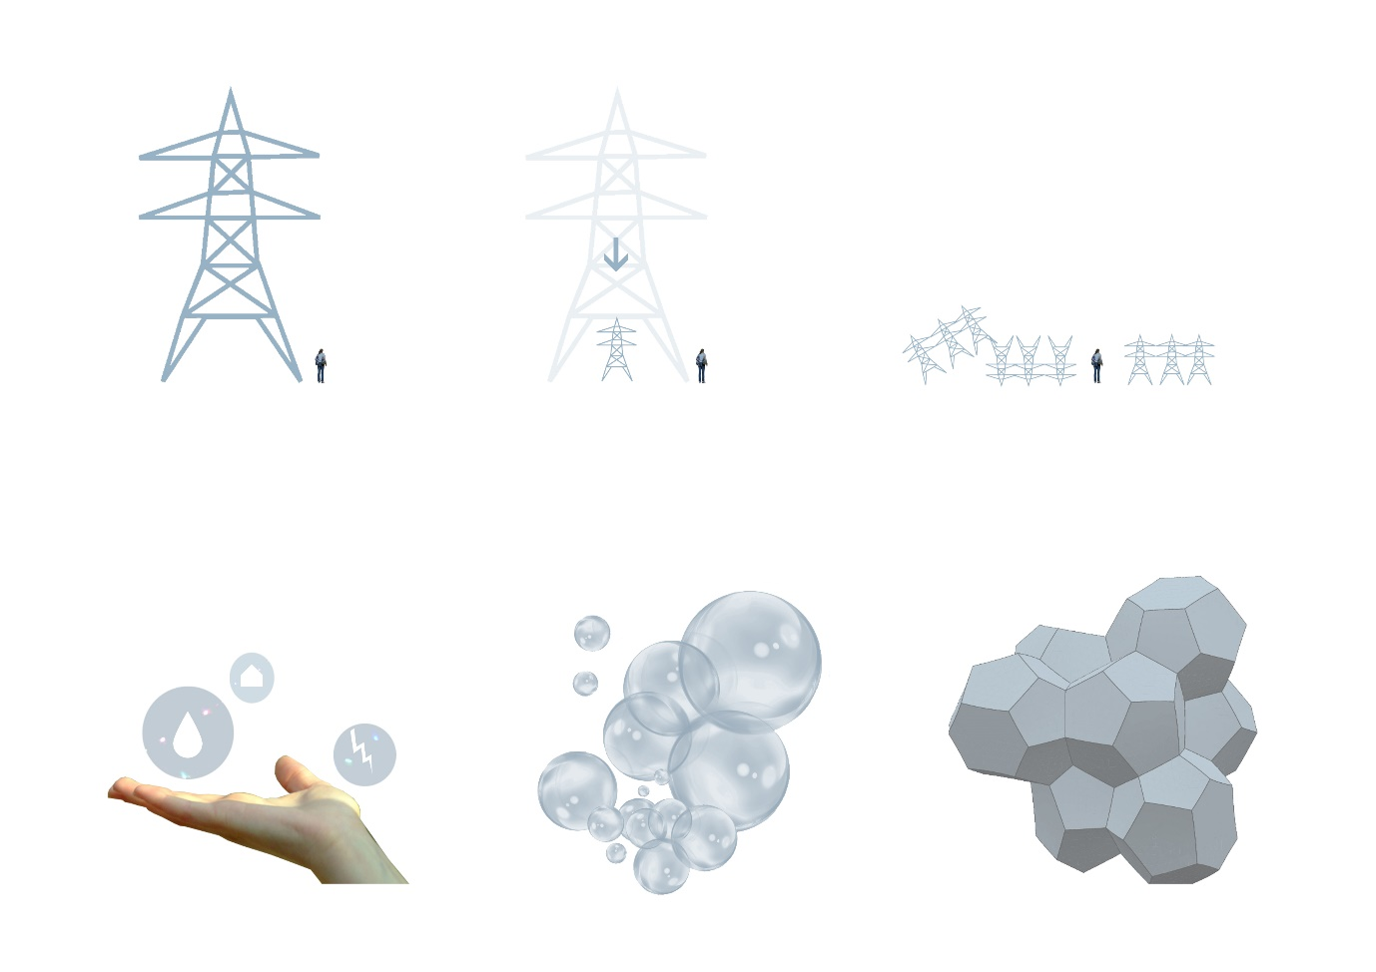

Introduction:
“A sun, a bubble, a man” is a proposal founded on the question: how do we create an understandable, publicly engaging and connective infrastructural/artistic solution that meets future sustainability goals? (LAGI, 2020) Our proposal for this question is the development of a scalable and adaptable infrastructure module – putting the power of energy and water systems back into the hands of the users.
The intervention aims to create transparency around infrastructure, art and sustainable action through public participation, simple but innovative intervention, prototyping and experimentation, self-expression and creating a system that exists with its surrounding natural landscape whilst meeting the needs of its community. This proposal corresponds to Fly Ranch’s Roadmap of creating a space that embodies the principles of Burning Man for more than just a week in a year. “A sun, a bubble, a man” seeks to support Fly ranch for 12 months, before it is torched at the following years Burning man festival – giving way to new proposal, a new artistic experiment in a continuous venture for a resilient future. The proposal utilizes the philosophies of Burning Man – from the approach, to execution. The idea of a temporary structure was influenced by Black Rock City’s process of burning interventions at the end of the festival. The liminality ties back to the natural world and gives visitors a greater appreciation for the project before a new cycle begins. By breaking our project up into smaller, manageable parts allows users to cooperate in the infrastructural process, to individually express themselves, thus become included in the larger identity of the project. “A sun, a bubble, a man” is an expression of life, and of the responsibility we must all have towards preserving our natural environments in support of future generations.
The project’s concept is the manipulation of infrastructural scale: dividing large systems into inclusive modules. Smaller units can be adaptive, easily maintained, moved and duplicated into larger networks, creating holistic schemes with interwoven parts. In lowering the scale, our project removes the elusiveness around infrastructure, and therefore creates a new transparency around sustainable change. Due to the size of Fly ranch, its rich history and conglomeration of different habitats, our group decided to divide our scheme into 3 parts, across 3 sites, relating to 3 chosen systems: Water, Shelter and Energy. All 3 sites are located in Priority level 1 areas of the ranch. While these parts are in no way separate from one another, they did help inform different narratives for each of our chosen sites: 1.) Gateway, located on the Southern most tip of Fly Ranch (parallel to R34), the Gateway offers a point of information, reflection and gathering for new and old visitors of the ranch. 2.) Shelter, built onto or next to the existing dwellings of the ranch to help sustain the immediate needs of Fly Ranch’s residents. 3.) Water, south-west of Fly Geyser (popular tourist destination and crucial water resource), near the water trench, to help filter the water from the reservoir and create a greater sense of place for visitors. Each site was chosen for its importance to Fly Ranch, and the vastly different experiences it would offer visitors.

The program does have systematic overlays but is mostly unique to the site it is supporting. The Gateway site offers visitors a place to rest when travelling with shelter, solar charging stations, maps, information boards, seating, panels for local artists to define, and LED lighting fixtures to create a beacon for when the sun sets. The Shelter collection offers a larger formwork with more solar panels to support the energy needs of the ranch. This is coupled with seating, desks, storage and LED lighting. Lastly, the water scheme, near Fly geyser, creates water transport units to move water from the site to Burning Man, a pvc piping water cooling system, and a constructed wetland module to filter unwanted compounds from the water.

Bubble Form and structure:
Mathematics is a key link between nature and architecture. One doesn’t have to look far to see the translation of human proportions, plant patterns or geometries into concrete space. Based on our concept of the ‘module’ our group was tasked with finding the optimal unit of representation- scalable, adaptable and unique in its possibility to create new collective forms. Our research led us to Bubbles. Bubbles are unique in their lightness,
flexibility and unique form creations. Bubbles relate the Lord Kelvin problem: subdividing three-dimensional space into multiples pieces, all of equal volume. This problem was solved in 1993 with the Weaire-Phelan Surface: a collection of 12 sided dodecahedrons (all polygons) and 14 sided polyhedrons (hexagons and polygons). This was ultimately the best solution for our unit because not only is the Weaire-Phelan surface the most optimal subdivision of three-dimensional space, but it is a pattern that already exists in nature, thus enforcing the interdependencies of our proposal with the landscape of Fly ranch. The form is inherently strong and lightweight. It is also more efficient in terms of cost as it fills a maximum volume with the least amount materials needed. The volume of the scheme relies on the addition of each unit, thus creating a cohesive whole. Similar to a soap bubble foam, one module can exist, but becomes stronger when coupled with other units.
The structure of the module is made up of three parts: Form, frame, panel. The form, as previously discussed, is the 2 multi-faceted geometries. They are constructed using light-weight cross-laminated timber frames. These frames can be flat packed to allow for efficient transport and use of the solar panels (if needed). The design allows for the installation of multiple panel iterations. The panels are clipped on to the steel brackets of the timber frame – enclosing one module. Every unit is made using the same basic structure. Units are attached to one another with steel tension cables and fixing plates. The Weaire-Phelan form is notably stable with forces counteracting one another, therefore maintaining equilibrium for the aggregation.
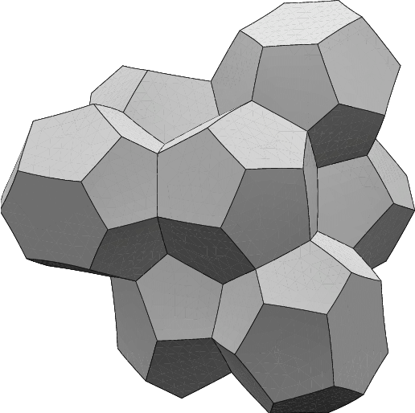
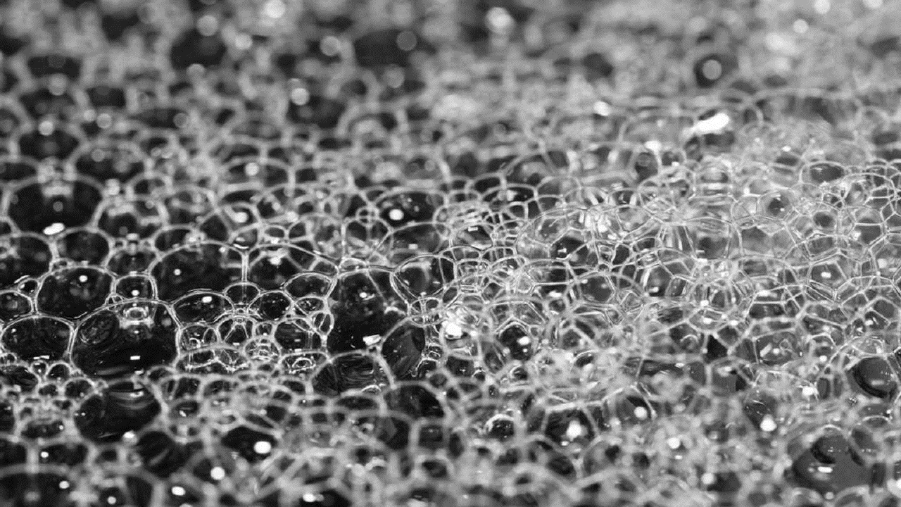

Materials and size: The listed materials were chosen for this scheme due to their low carbon footprint, proximity to the site, accessibility, cost, strength, re-use and recyclability.
- Treated 3 ply cross-laminated timber- strong, re-usable, easy to use, cost effective. Size: 38x76mm per supporting arm
- Steel tension cord- affordable and strong- roughly 2.5m per module
- Steel finger hinges with fixing plates - only custom-made unit (but are incredibly durable and can be recycled for other projects)
- Connecting cleat (allowing the unit to stay in tension) – easy to use and cheap.
- Plywood, Tarpaulin, canvas, recycled PVC flexible piping etc.- for the design of the 0.279m² panel faces, this would vary depending on the site and choice of the builder/user (this adaptability makes no 2 units the same).

Polyhedron
Dodecahedron

Environmental impact summary:

The sustainable methodology for this project follows 4 simple practices: Lean start, loose fit, long life, low energy (first introduced by Alexander John Gordon in 1972 for ‘Characteristics of a good building’). These 4 principles are deployed as a means of curbing the envrionmental impact the scheme might have on the landscape of Fly Ranch. The modules are small, temporary and allow for rapid aggregations. This ‘small’ intervention is what Alexander might refer to as the lean start. Starting smaller allows room for change. Our modules light weight frames and detachable paneling make them loose-fit to one another and their context. By the gateway site there might be more LED panels to help create a beacon for drivers by to see at night, whereas the shelter site would have more charging points and points of storage. As previously discussed, this proposal is only meant to last a year. It is, however, our belief that the project’s finiteness will remain as a narrative within visitors and users. A narrative that might translate into other projects, extending the life of the project beyond its physical existence. The pursuit of a carbon free world will never come about from one project. It is a consistent venture that requries numerous prototypes, and we believe our scheme could assist in that journey. The low energy principle is something our group added onto Aexander’s. By using a light-weight, changeable unit, our scheme limited its carbon footprint, made it easy to understand and maintain. None of the units are static and thus do not rely on ground foundations or excessive site preparations. Materials used in the scheme can be found at most local hardwares,are adaptive to the cold and hot weather conditions and can eventually encompass the local biodiversity (plants, animals and insects making nests in the units). ‘A sun, a bubble, a man’ is meant to be an extension of the landscape it supports.

Capacity and output:
For example: 1 Dodecahedron module= 12 sides
1 pentagon face= 0.279m² , 12x0.279= 3.348m² , however only 8 of these faces will receive full solar exposure under the best conditions, therefore 8 x 0.279=2.232m²

One module solar energy output:

Annual, expected kWh
(1 module)

Annual, expected kWh
(100 modules)

100 modules solar output:

Single module= 0.4kW(p)= 2 kWh per day (after deductions and assuming 6 hours of peak sun time).
The energy of multiple modules will thus be enough to charge the electrical devices of visitors and dwellers, to light LED way-finding units, and to possibly help power other equipment on site.

Water
The constructed wetland water system is made up of roughly 10 modules, each with an internal volume of 0.5m³. Due to the area of growing substrate and plants, only 0.1-025m³ allows for the passage of water. The system is placed on the northern edge of the site to filter the high levels of sulphur, iron and bacteria from the water. The system is not originally intended to filter wastewater from the dwelling units but can be adapted for future use. The system could thus filter roughly 2m³ every 5-10 days (depending on the rate of flow of the reservoir and geysers). This water can then coincide with the existing wells and be used for other cleaning, cooking and recreational activities.
Cost and maintenance
To limit costs and to allow people a greater design flexibility over the proposal, our group aimed at making the modules as financially efficient as possible. We approached this goal by proposing a design made only of locally (hardware) accessible materials, with exception of the solar panels (if applying a full surface panel, otherwise smaller panels can be used) and the custom steel finger hinges. The remaining panels, tension ties and primary timber structure can all be adapted from locally sourced materials and hardware equipment (refer to detail).

It is assumed at 100 units are made, and this calculation is broken down for one module: (calculation does not include other panel designs, only the most basic solar module)
- Timber frame- 28 arms of 3 ply cross-laminated timber, 38x76mm= $140
- Custom made steel hinges- 2 hinges per arm= 48 hinges total= $192
- Steel cables= $20
- Cleats= $20
- Solar panels, cabling, transformers= 0.279m² panel= requires 6 panels per module= $ 180, based on a $3 cost per Watt
- Data transmitter- $80
- Plywood-$7 (single sheet, making 2-3 panels of 0.279m²)
- Charging point (including transformer and wiring)-$20
- Labour- Varies, but is estimated at $50 per unit due to quick construction time
- Transport of materials (divided between the 100 units)- $5
Estimated total cost per unit: $ 714 (excluding additional panelling)
100 units: $ 714 000
Due to the scale, materials used and primitive joinery- the system is incredibly easy to maintain, deconstruct, move and change. The clippable panel faces are also interchangeable and thus the overall design can morph to the needs of its users depending on the season or required program.

Strategy for on-site prototyping and way forward:
Although the team had not physically visited the proposed site, the design was created with the site in mind, based off a detailed research of the site constraints and characteristics. Nevertheless, prototyping will be a necessary step in refining and testing the design in a real-world on-site context, insuring a fully functional and successful result. This project employs the use of an iterative prototyping strategy, as such a strategy will enable design flexibility and adaptation that may occur when visiting and experiencing the site first-hand. This is beneficial as it will allow for the gradual achievement of the realised goal - a fully functionable model/art piece.
Active learning of the design site will enable the creation of iterative prototypes of the proposed form, frame and panel system, using the chosen materials for their low cost and sustainable properties. The team proposes starting off with a relaxed prototype model to reduce costs, as this will allow for exploration (and subsequent success) of the overall form and joinery system early on, allowing for early risk reduction and refining of the overall design. Thereafter, the team will move into an evolutionary stage, aimed at further refinement of the iterative model. Overall, this process will allow for a natural transition from explorative prototype modelling into a fully developed system.

