­­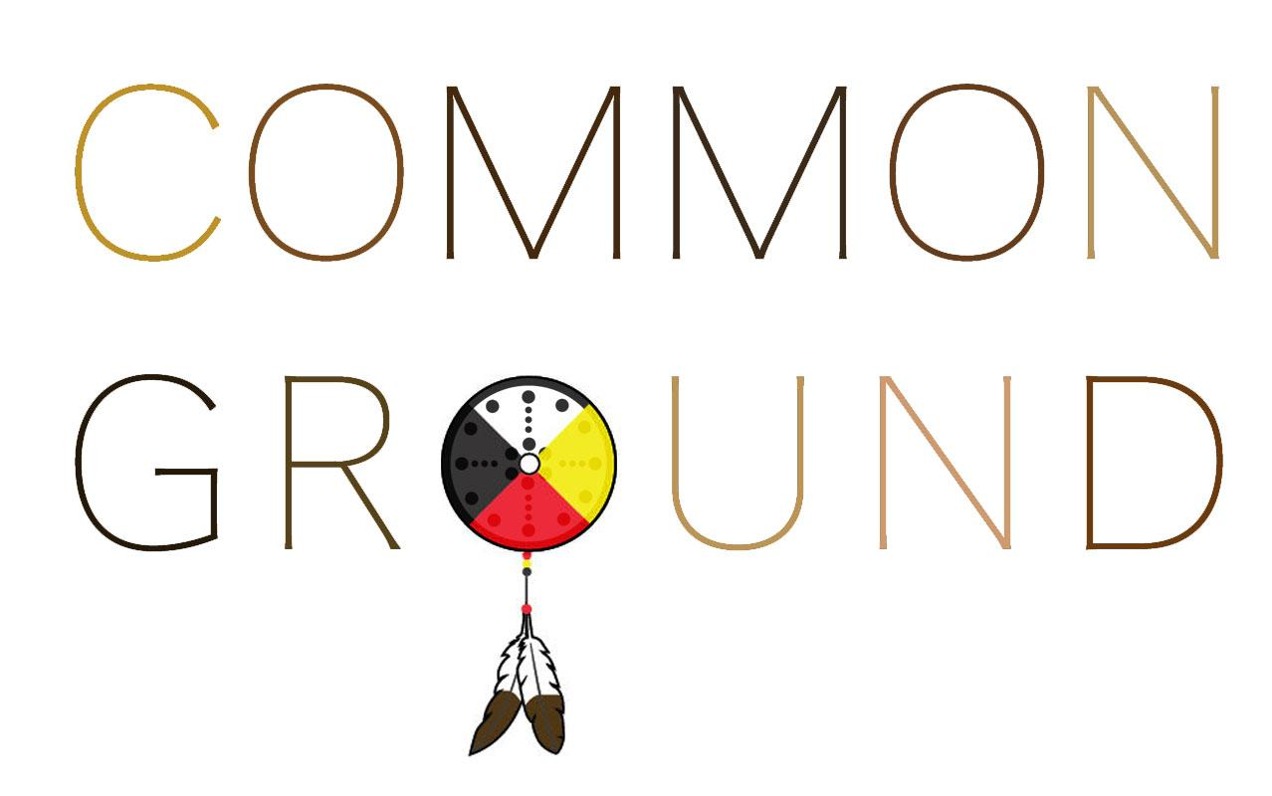

“Treat the earth well: it was not given to you by your parents, it was
loaned to you by your children. We do not inherit the earth from
our ancestors, we borrow it from our children. We are more than the
sum of our knowledge, we are the products of our imagination”
- Ancient Indian Proverb

STORY OF THE ARTWORK

Our world is at a pivotal point in history. Will we choose to face the seemingly insurmountable challenges of our degrading society and our environment? Thus, we are standing at a crossroads, which at face value looks pretty bleak. Yet, we find ourselves amongst a community of doers, thinkers, and creators that are bold enough to address a question fundamental to the survival of our species…..What kind of world do we want to pass along to our children?

Hearing Will Roger ask this question changed my perspective forever. It’s May 2019 and I’m visiting Fly Ranch for the second time. Taking a break from the day's activities, I decide to look for a place to sit and meditate. A short meandering out in the grass leads me to an open patch that looks just comfy enough to sit for a while. Assuming my normal half lotus posture, I begin to drop into myself. After a couple minutes I notice the rough grasses irritating my skin. The sun begins to feel like it’s burning my skin now. Small aches begin to emerge in my back due to the uneven ground. I take a deep breath and lean into the moment. Through the discomfort, a vision emerges in the form of a place where people from all walks of life can come together to have conversations about creating lasting solutions to the global issues facing our species and planet today, let go of the worries of the modern world, and marvel at the beauty at Fly Ranch. These visions were not mine. They came from land.

Then another question arose, can we do all of this while merging with the wisdom of indigenous cultures? This is the curiosity behind the wheel of Common Ground.

PROJECT DESCRIPTION

Let’s start with what Common Ground is not.

● It’s not a tourist attraction
● It’s not an art installation
● It’s not affiliated with any secular tradition or religion
● It’s not a place to bring your sparkle pony
● It’s not a place for hatred or division

Now, what is it?

It’s a place that welcomes all peoples, beliefs, faiths, cultures, races, sexual orientations, and traditions in an effort to combine our knowledge and wisdom in new ways that can address the monumental problems we are facing in the world today. Our intention is to create an honest space that inspires wonder, and welcomes those open to conversation and holistic growth. With interior and exterior spaces where people can gather, Common Ground fosters the future of what Fly Ranch is becoming and strengthens our community to create solutions for a brighter tomorrow.

To do this, we got curious about ways to integrate powerful ancient symbols that represent a tradition deeply intertwined with indigenous cultures across the world, from Australia to the Americas, commonly known as the Four Directions.

Thus, our main building is based on a First Nation’s design called the Medicine Wheel which represents the Four Directions. It is a simple circular shape rich in meaning. Each side represents one of the pillars of the Four Directions; North, South, East, and West. All have significance and carry different energy. In the Paiute tradition they also acknowledge grandfather sky, grandmother earth, past, present, future, and within. We will honor each of these in the design of the structure through symbology.

Surrounding our main structure is a shape known as Metaron’s cube. The name comes from Archangel Metatron, who is known as the Archangel of Empowerment. Whether you believe in angels or not, the meaning of this simple yet intricate design goes to the very core of our universe. He represents all of our abilities to achieve higher spiritual awareness. Additionally, Metatron’s cube contains the shapes of all 5 platonic solids. In other words, all forms of matter within our known universe can be created from this simple form. "Metatron’s Cube helps us realize the harmony and balance of nature," writes VanDen Eynden in Metatron.

The exterior wall will be made from rammed earth, an ancient and effective technique.
Earth is also going to top off the building with a flat “green” roof, allowing it to coexist within the natural ecosystem. It will consist of a multi-layered system that allows us to grow plants native to the area and capture precious rain water. This will also add to the thermal properties and help maintain a temperate climate inside during the hot summers and cold winters.

Our entrances, facing due east and west, will feature Peace Poles sponsored by May Peace Prevail on Earth International, which is “A global network of peacemakers”. Each will feature a custom design and host translations of “May Peace Prevail On Earth” in several different languages. These unique structures will join a family of over 250,000 Peace Poles placed around the world. Incorporated into the design of the poles are wind generators that provide 1-2 kilowatts of power. Combined with solar panels producing 2.3kw, this power will allow the whole building to be self sustained.

With a focus on the location being situated on native Paiute land, there is great opportunity to bridge with the local community in creating this place. It will be important for this project to not only support their culture and traditions, but to honor the land that was originally theirs. A land that was undoubtedly sacred due to all the water access. Through conversations with elders of the Dene, Lakota, and Hopi tribes we have incorporated wisdom from our First Nations tribes into our design and intention. We envision a place where local tribal members can return to the sources of water of their ancestors. Creating a strong and symbiotic relationship with the people who’s land Fly Ranch is on, begins the healing of the wounds of our cultures and fosters the kind of world that our children would be proud to live in.

SUPPORTED ACTIVITIES:
- Small gatherings
- Learn about ecological building
- Large “round table” gatherings of 75-150 people
- Solo meditation, meditation groups, and workshops
- Healing ancestral trauma workshops
- Welcome center
- Meeting place for Fly Ranch nature walks
- Ceremonies and rituals with local Paiute tribe members
- Deep conversations
- Late night dance parties
- Fireside chats
- Retreat center
- Nature talks
- One on one conversations
- Journaling
- Read a book
- Learn about ecological building
- Grow medicinal plants

PROTOTYPE CONSTRUCTION

The overall process should take no more than 4 months to complete by hosting multiple workshops on sustainable building practices, building solar systems, and integrating water capture, etc. We will host workshops in each phase of the project to incorporate community into every aspect of the construction. Our intention is to have this be built by people who have a desire to create a more sustainable and symbiotic relationship with their own living environments. The workshops allow people to come be a part of the build, to learn, to connect and contribute. Ultimately, this is a place built for and by community. Should there be a need to supplement our team with electricians, builders, etc, we will look to the local areas in Gerlach first, then Nixon, and Reno so that any money spent goes directly back to the local community.

Phase 1 - Clearing, foundation excavation
Phase 2 - Peace pole construction, wind generators, solar installation
Phase 3 - Aircrete mixing, pour foundation, make bricks
Phase 4 - Erect main structure, install roof
Phase 5 - Build exterior wall
Phase 6 - Complete interior of courtyard, interior of main building
Phase 7 - Shade Structures
Phase 8 - Celebrate!!!

DIMENSIONS - MATERIALS - TECHNOLOGIES - ESTIMATED POWER

DIMENSIONS
- Main Building - 37’ diameter x 12’ high, 960 sq ft
- Courtyard Area - 135’ length x 117’ width, 9,300 sq ft

ENERGY HARVESTING
- Solar panel watts x average hours of sunlight x 75% = daily watt-hours
  - (2.3kwh) x (10) x (.75) = 17.35 KwH/day
- Wind turbines ~ 1 kw hr/unit x 2 units = 2kwh/day

WATER COLLECTION
- Atmospheric water generator - (Produces more in temperature 65 degrees fahrenheit) approximately 10 gallons per day
- 300 gallon cistern for storage
- Excess rain water is routed into storage. Approximately 500 gallons per year

PRIMARY MATERIALS
- Aircrete - 35% concrete, 65% foam
- Rammed Earth - mixture of dirt & concrete
- Wood - Plywood, wood beams
- Lighting - High Efficiency LED

MAINTENANCE
This system is designed to require minimal maintenance. Occasionally solar panels will need to be wiped / cleaned and batteries replaced. Water filters will need to be checked and replaced 2-3 times per year.

ROUGH ORDER OF MAGNITUDE COST ESTIMATE
- Aircrete - $4/sq ft = $6000
- Adobe interior = $2000
- Atmospheric Water Generator = $900
- Solar - 2.5 kw system = $5,500
- Green Roof = $3,000
- Equipment Costs = $3000
- Misc Building Materials = $2,000
- Labor = $5,000
- LED Lighting = $1,000
- Peace Poles / wind generator = -$2,000 - sponsored
- Shade Structures = $500
- Water pumps = $250
- Water Storage = $800
- Art finishing / painting = $1000
- Doors = $500
- Transportation of Materials = $2,000

TOTAL ESTIMATED COST = $35,350

Please note the numbers are estimated on the high side and we strongly believe that we will be able to do this for approximately $30k. We are also willing to raise any additional money needed to bring this to fruition!

ENVIRONMENTAL IMPACT

Rooted in a desire for the good of all, including Mother Earth, our design is made to have minimal impact on the environment. This place is intended to coexist within the native ecosystem. To do this, we will build with sustainable materials and obtain natural resources through renewable methods. These practices that can be duplicated throughout the world. Aircrete, local wood, and good ole dirt are the primary elements to build this structure. Throw in a dash of solar power, a splash of water pulled from thin air, and a lot of love…..and Voila!

We believe in a future where dwellings have zero emissions. Common Ground does not generate any greenhouse gases or physical waste products. Our structures are composed of primarily renewable, locally sourced materials. Recycled materials will also be used wherever possible and can be found locally with low transit impact. The foundation and walls of the main circular structure is composed of aircrete which has minimal environmental draw. Rammed earth can be sourced locally from the land and/or surrounding areas. Both will be mixed on site and bricks will be made before construction begins. The majority of the materials for the overall construction, wood, plywood, concrete, pvc pipes, electrical wiring, lighting, irrigation systems, can be sourced locally.

Aircrete is a mixture of concrete and foam that is extremely lightweight, weather resistant, unharmed by moisture, durable, insect proof, fireproof, AND has incredible thermal properties. This is what the foundation and walls of the main building as well as some of the seating will be made of. It will not rot or decay. It offers good thermal and sound insulation, and unlike concrete is very easy to shape and work with. Coupled with an earthen roof composed of elements and plants sourced locally, this will help keep the structure cool in the hot days and warm on the cold nights.

Photovoltaic solar panels are one of the most reliable, available, and cost effective ways to generate electricity. Our solar system is designed to run everything in our structure plus a little extra, and it includes room to expand should the power demands of Fly Ranch increase in the future. These panels require minimal maintenance.

Collecting clean drinking water is a necessity for this region due to its desert climate and low access to drinking water. Implementing an atmospheric water generator and rain capture allows us to capture water, filter it, and store. Clean water is increasingly a precious global resource that 1 in 5 people don’t have access to. By implementing systems that allow water to be sourced locally from the air, even in very dry climates we can create a model that people can use throughout the world to improve the quality of life. Mni Wiconi, Water is life.

Our aim is to offset any disturbance of the land from pulling resources by having small gardens for food and using our earthen roof to grow plants native to the area. Ultimately we intend to have a minimal impact on the environment.

.

