THE DESERT TOWER
The “Desert Tower” is a system that can merge four different techniques in a single unique solution able to create synegies between various tecnologies and produce a large amount of sustenable energy and water storage.
The tower could be located almost in every available area of the Fly Ranch.
Through this, to maximize its performance, it is preferable to place it in the windiest part of the region, that could probably be the desert area in the South of the site, due to the lowest wind resistance of its soil; even if a more accurate wind analysis of the area should be considered.
Moreover, the aim of the tower is to provide a large amount of susteinable energy and water to the existing and future activities in this area, such as the most energy-comsuming one: the Burning Man (which is bound to become completely sustainable by 2030). Therefore the two systems must be closely related.
The Tower, acting as a sort of power station, is also designed in the desert area so as to not interfere with the ecological system of the northen part, creating a strong human landmark where the rest of life forms seem not able to inhabit.
Thanks to its size, the Desert Tower can be enhanced for many other functions, for example as a viewpoint, a hub for various activities or a control tower for numerous ultralight aircrafts used in this remote area, especially during the Burnigman festival.
The tower is a modulable and scalable system, its dimension and energy production can range as far as its cost. In order to ensure good efficiency and maximize the energy production, for this project a high scale has been developed. The results can be more or less summarized as follows:
ENERGY PRODUCTION:
Photovoltaic: with around 2000* square meters of well-exposed surface, the tower can be covered by enough pannels to produce more than 250MWh of energy in one year. The pannels can maximize their efficiency due to the inclination and the refreshing action of wind.
Eolic: It is hard to quantify the capacity of the turbine but we can estimate around 1000-3000MWh up to 4000MWh in the periods of highest demand, when the action of the steam is provided. The conformation of the structure allows also to capture the wind from every direction and to protect the turbine from weather events, lightnings and storms.
The Desert Tower can store over 7500 cube meters of water and redistribute them to supply activities like the Burning Man and agricoltural activities.

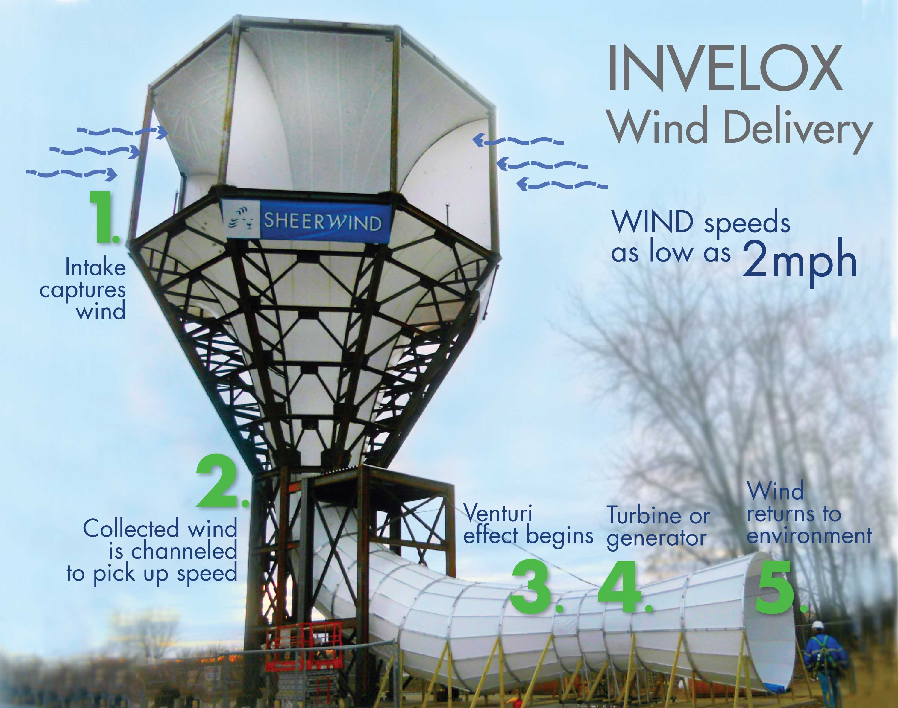
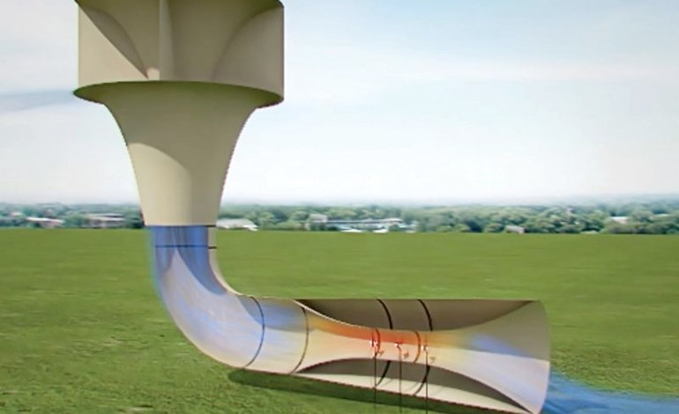
REFERENCE/INSPIRATION

