Leader Fishy
The “Leader’ Fishy name is taken from the type of fish found in the reservoirs, It incorporates all of the leading components of a permaculture design & satisfies most of the five leading design ideals.
placement (N40°51'32.82"; W119°19'56.27"; Altitude: 1224.8 m)
Technology in the design:
Vortex Wins turbine
Tesla Glass tile solar panels
passive rain water catchment
greenhouse
solar heat pump
straw bale infil
Led lighting
water purification system
Composting toilet
hydraulic floor heat
methane collector
passive cooling by induction/solar fans
Support activities
Home
gardening
solar collection
water collection, heat, gardens, and house needs
inputs and Maintenance
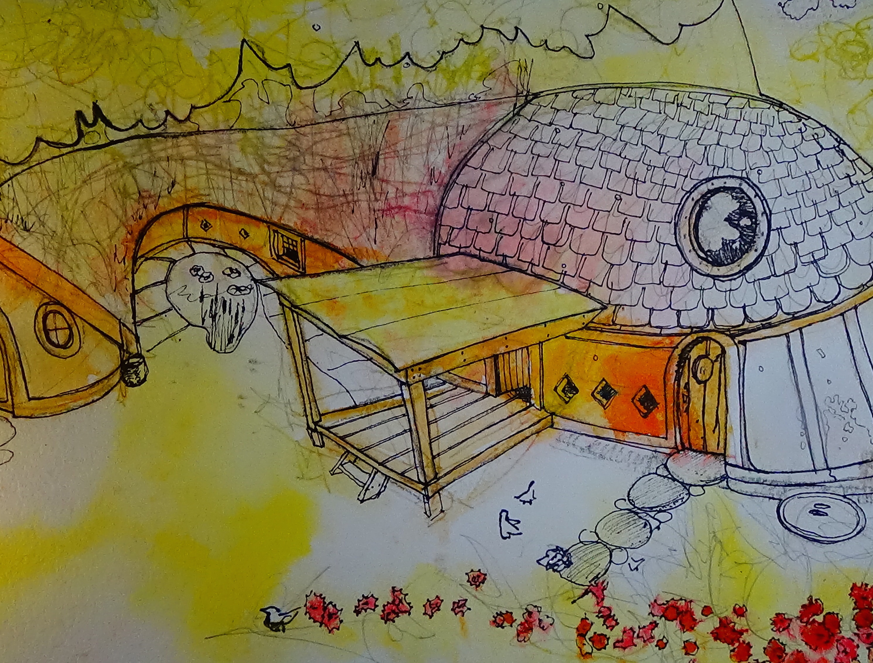
inputs would be on the front end with the materials for constructing the building in the winter there may be times when utilizing the fire place would require acquisition of fire wood, Soil for the green house, maintenance for composting toilet will have to be changed out of 50 gallon barrels when they become full enough to replace. The full ones would be placed in storage until the summer heat when placed on there sides to start decomposing & letting off methane for collection.Once the compost ready it can be used to feed fruit nut trees & bushes Other maintenance would be cleaning solar tiles for maximum solar acquisition
Primary materials solar tiles, straw bales, clay, construction grade lumber, storage building/s, pond liner, water circulation pumps, solar panel electrical system and back up batteries, a cost estimate of 150 sq. ft. Major Dimensions would be 12.192 m x 9.144m x 6.096 m x 3.675m depth of storage buildings

A summary of the environmental impacts that may occur are as follows. Digging deep enough holes to accommodate the storage containers which may or may not need a cement foundation underneath, the acquisition of straw from a local farmer and the construction materials may entail the use of a large semi truck for the delivery of the materials and what ever impacts the burning of fossil fuels would leave. Utilizing local clay may be as simple as utilizing the clay dug out for the storage buildings other wise the clay material would have to be acquired from a local landscape company. Other impacts would be methane production of the nominal sort coming from the composting toilets. Other impacts may be unforeseen such as the digging and design of the ponds and or water tanks .

