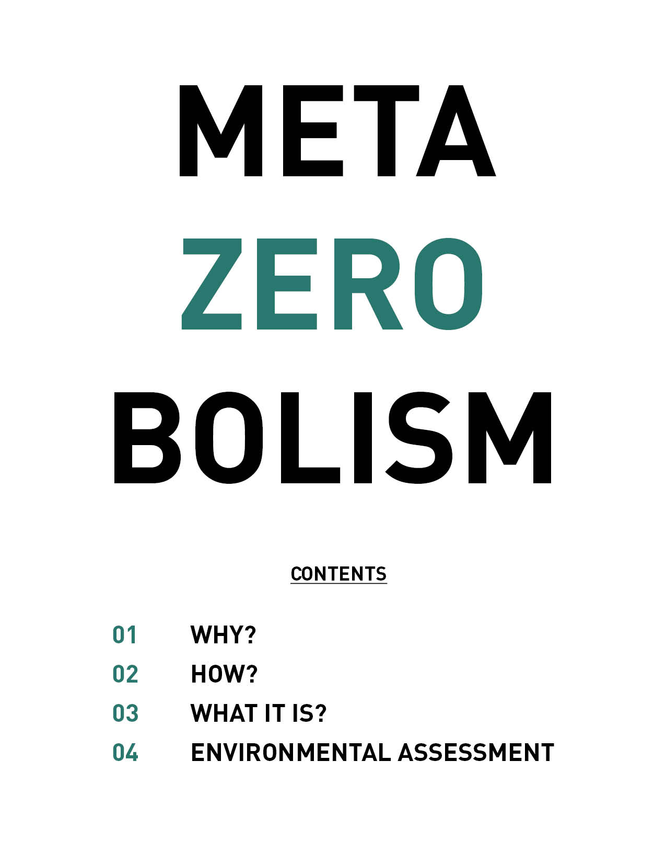

WHY?
Let’s start our journey with a critical mindset. Let’s see where we are and then find solutions with the best of our abilities and awareness with common goals for humanity. The intention is embedded in the word META, a prefix meaning more comprehensive or transcending. Also, META means goal in Spanish. That is precisely the way we can look at Fly Ranch’s life. So it can go beyond the site boundaries with a more comprehensive view of the metabolic process looking forward to a solution with a common goal of carbon ZERO emission.
How do we go beyond regeneration? When we wholeheartedly want to preserve nature but at the same time want to inhabit and experience it without ecological cost. Human activity has huge metabolic pressure on the hinterlands and beyond regional and planetary web moving people, goods, energy, water, solid waste, and wastewater. All of that means outputs of carbon production on the atmosphere; but also nitrogen, fluorine, phosphorus on the water system to mention a few.
The pressure comes not only from the activities within the site boundary that can be carbon neutral or ideally carbon negative but also the pressure of development of neighbor’s private lots, the flux of economic forces, and social impact that the surrounding areas and regions will inevitably experience. Having an event leave no trace city of +80,000 people once a year is a big deal. In which Fly Ranch's existence and re-bird are direct reactions of adjacent areas getting pressure to provide and keep up with this valuable cultural event on a national preservation area.
So, yes we want to have an event every year with minimal impact. For that, the infrastructure has to be reimagined with a unique ecological sensibility. Fly Ranch has the potential to resolve one of the most damaging silent problems of wastewater disposal of large gatherings of people living on the Black Rock Playa.
If we look at the numbers of inputs and outputs more closely of what people in Fly Ranch will produce daily, we realized that energy source is not the main issue. But water waste becomes the main challenge. A staggering amount of 89% of human waste ends on the water system, only 11% is solid trash, recycle, or compost. Outsourcing the dumping due to the volume of water that needs to transport approx. 200 miles about 4 hours round trip by a vacuum truck, or handedly individually to the nearest available waste dump facility for then to get in the system of the standard management plants in Washoe County, Nevada. It is not only a black water toilet issue. Most human waste bulk like detergents, chemicals, and minerals coming from human hygiene, cleaning items and food preparation & cooking ends diluted on the water system as nitrogen, fluorine, phosphorus, etc. All being transport as grey water to traditional facilities vis-à-vis CO2.

But even if the transport of wastewater were to use renewable energy, or be part of an offset program the issue will remain because the local waste treatments and waste disposal facilities are traditional standard infrastructure receiving all the pressure of Burning Man. And not dealing with it or standing for a carbon zero waste disposal, nor either looping it back into the metabolic system to make it regenerative.
The scale is a key factor, if we were to consider small events or just a few people living on fly ranch, the wastewater wouldn’t be a problem. It could be easily self-sufficient with a biomass-compos of the wastewater, it will naturally process it and loop it back own its system. But we are envisioning a 2050 scenario in which the metabolic pressure of large events on the surrounding areas of Burning Man is being addressed directly. For that, Fly Ranch becomes an active responsible key player in solving the metabolic pressure. Becoming a testing ground for technologies where waste, water, shelter energy, and food are looping at multiple scales in a META.ZERO.BOLISM.

ISSUE 1: 89% OF HUMAN WASTE IS BEING DISCHARGED ON WATER
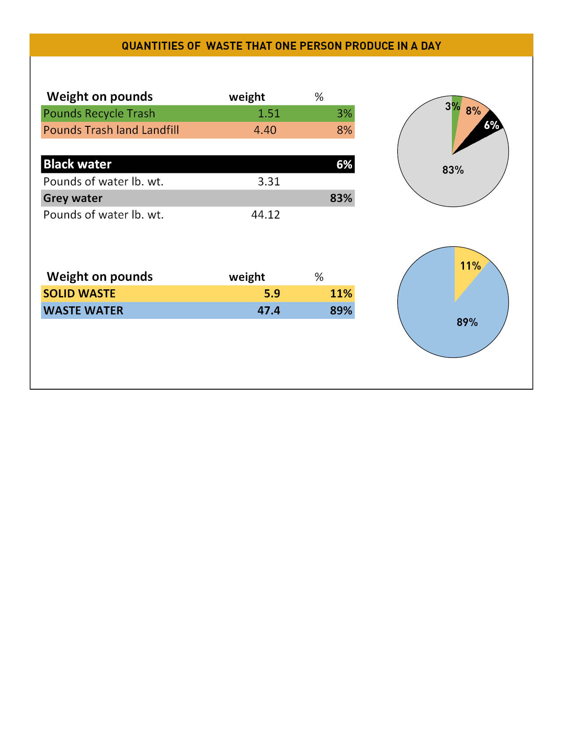

ISSUE 2: SOLID AND WATER WASTE OUTSOURCING
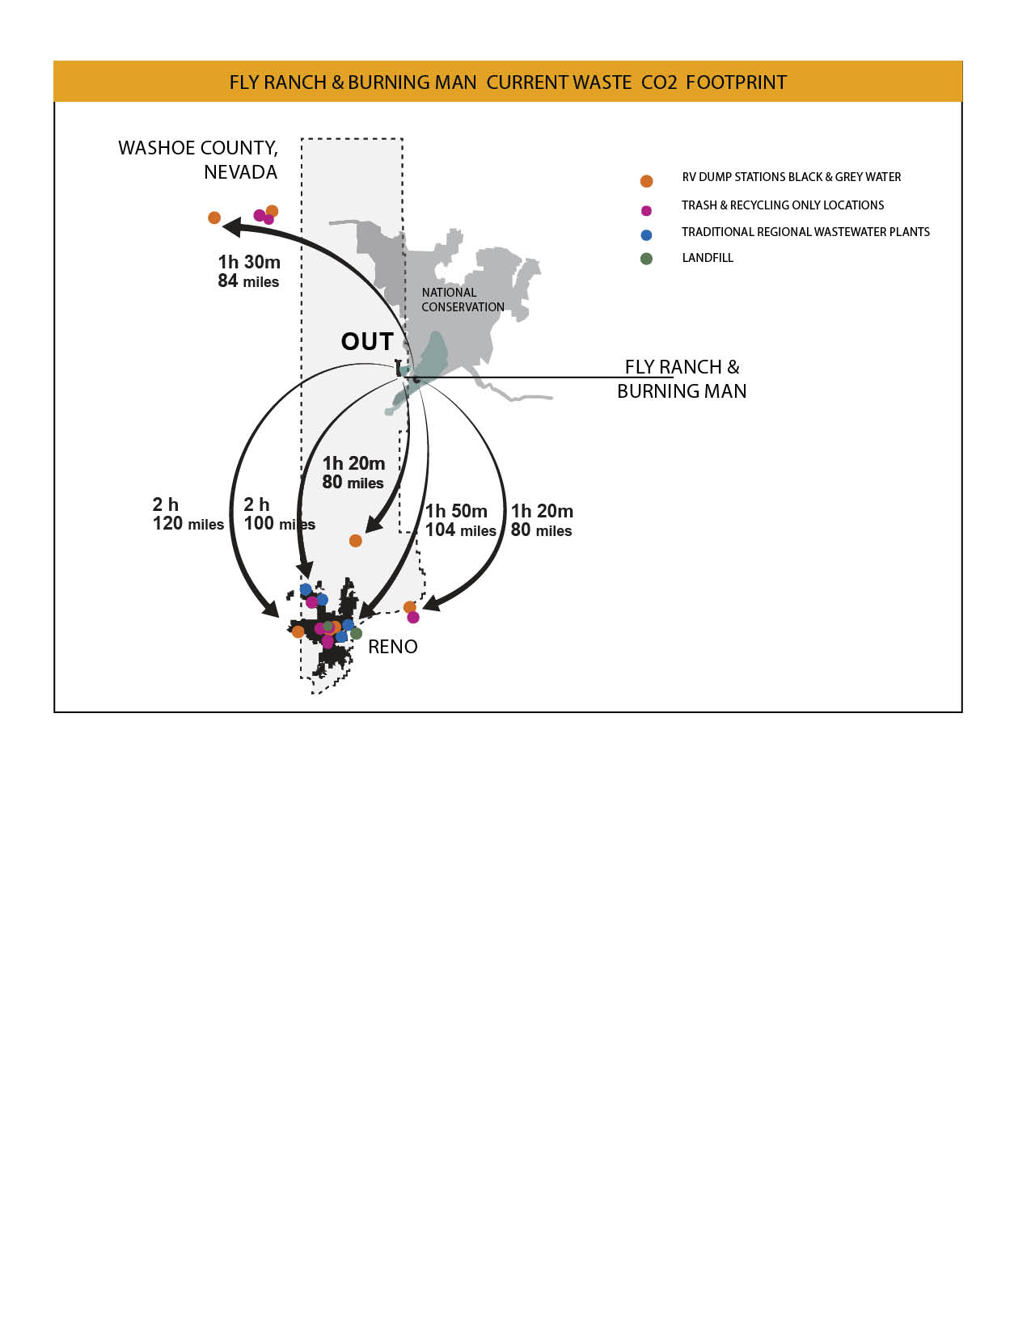

ISSUE 3: AMOUNT OF WASTE WATER TRANSPORT-CO²

ISSUE 4: OUTSOURCING TO STANDARD FACILITIES
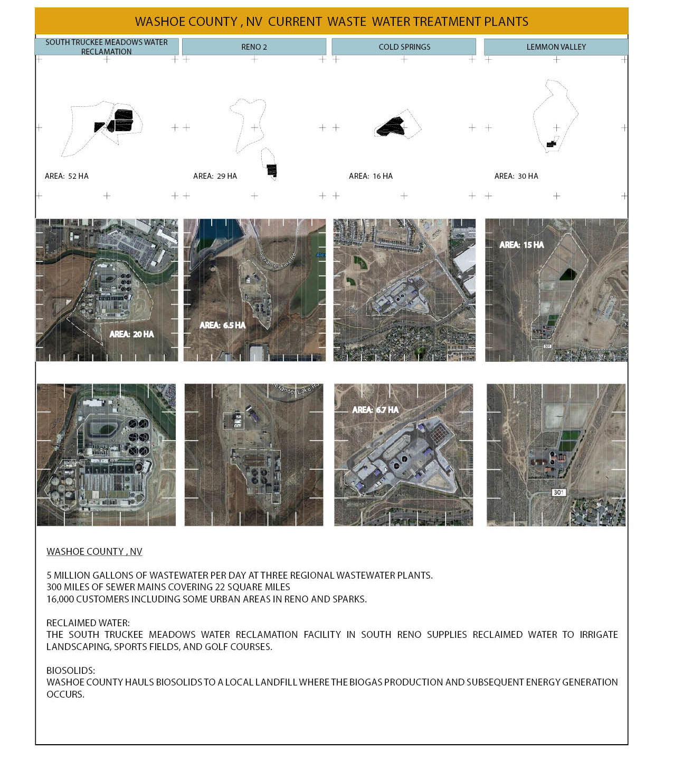

HOW?
By a comprehensive vision of the metabolic water system addressing the symbiotic interactions at the macro and micro scale loops. At the large scale Fly ranch’s hydrologic loop recycle and reuse the wastewater with a minimal compact footprint infrastructure, the nearest possible to the main existing asphalt road. Leaving the rest for strict preservation of the ecosystem. Having the minimum impact at the micro-scale on the site and fostering human interaction and multi-use of the infrastructure.
The metabolic process takes advantage of three pioneering technologies like NEW WATER implemented in Singapore, NERADA implemented in the Netherlands, and a set of different types of filtration for different purpose and scales that overall reduces the footprint, impact, energy consumption, and cost of traditional wastewater treatment plants. As well as incorporating solar energy source to be a self-sufficient system. The novel filtration methods that will convert black-grey water, and exiting groundwater suitable to different needs like black rock playa watering, agriculture, drinking water, and revert the surplus water back to nature. All of them with different requirements of filtration.
Modular growth capacity as needed over time. Working first at the local scales of the site needs for regular small events and share compact shelters with services. In the future, as a key player with a possible capacity of 100.000 people a day for large events like Burning Man or local community who are outside a renewable loop of waste disposal on the regular basis. A pioneering contextual wastewater treatment plant in the region. All of this within a broader interaction of other systems like Food, Energy, Solid Waste, shelter needs of Fly Ranch.
- A community Shelter, as a compress infrastructure with black-grey & drinking water service, plus energy self-sufficient. To host indoor events, performance, or camp-sleep on the ground overnight, or shared eat and prepare food area.
- A Recycle & Solid waste to energy facility dealing with the other 9% from the total human waste: Following a program of End-Use reduction of solid waste, no plastic allows and recycling mindset as a way of life. Small storage and waste to energy process facilities will de be needed. Organic Compost will need a large capacity to hold large events.
- Other facilities like Food lab/hub. An experimental space of best agriculture practices using filtered water when need it. It could hold a facility to convert biomass from the sludge tank into natural fertilizers for broader use and distribution.
- The Wellness Facility. It is mainly a compact service stop with toilets and water plug on existing asphalt road to support the activity happening the preservation area of hot spring, and geyser.
- A solar farm for distribution of energy to the local community and Burning Man event. Could be located also on the Gerlach site.
- Burning Man temporal floating infrastructure link: provide energy, water, black, and grey wastewater through a temporal line connecting it to the primary road line.

COMPREHENSIVE VISION OF THE METABOLIC WATER SYSTEM

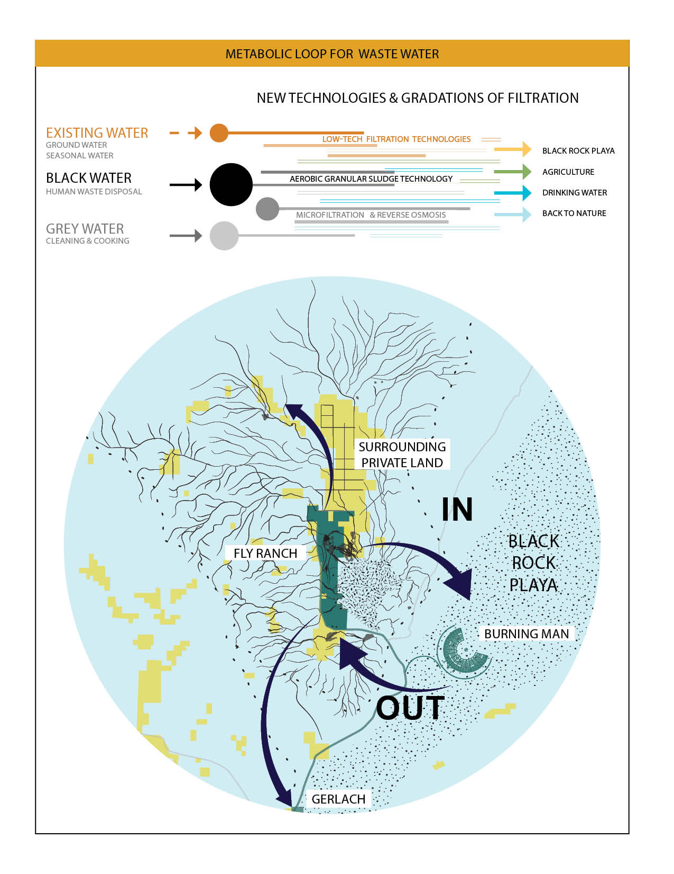

WHAT IT IS?
Focusing on the design of the Metabolic Water System as a contextual sensible artifact by reinterpreting the novel available technology for wastewater treatment, recycle and filtration of use water for human and agriculture use.

- AEROBIC GRANULAR SLUDGE TECHNOLOGY. Patented in the Netherlands by NERADA. It’s an advance one-tank does it all technology for black water, which uses a natural granular separation of biomass and water thereby reduces considerably the foot print of the facility, energy consumption, and cost.

- MICRO FILTRATION AND REVERSE OSMOSIS. Patented in Singapore by NEW WATER. Which can recycle wastewater into extra pure water for industrial use and drinking water.

- FILTERS TYPES: From a low-tech like sand as a high-tech as reverse osmosis. This last step of the water cycle will allow us to process water for different needs not only drinking water but also filtering groundwater for watering the black rock playa or making it suitable for agriculture. This way allowing to configure and reconfigure water filtration as needed.
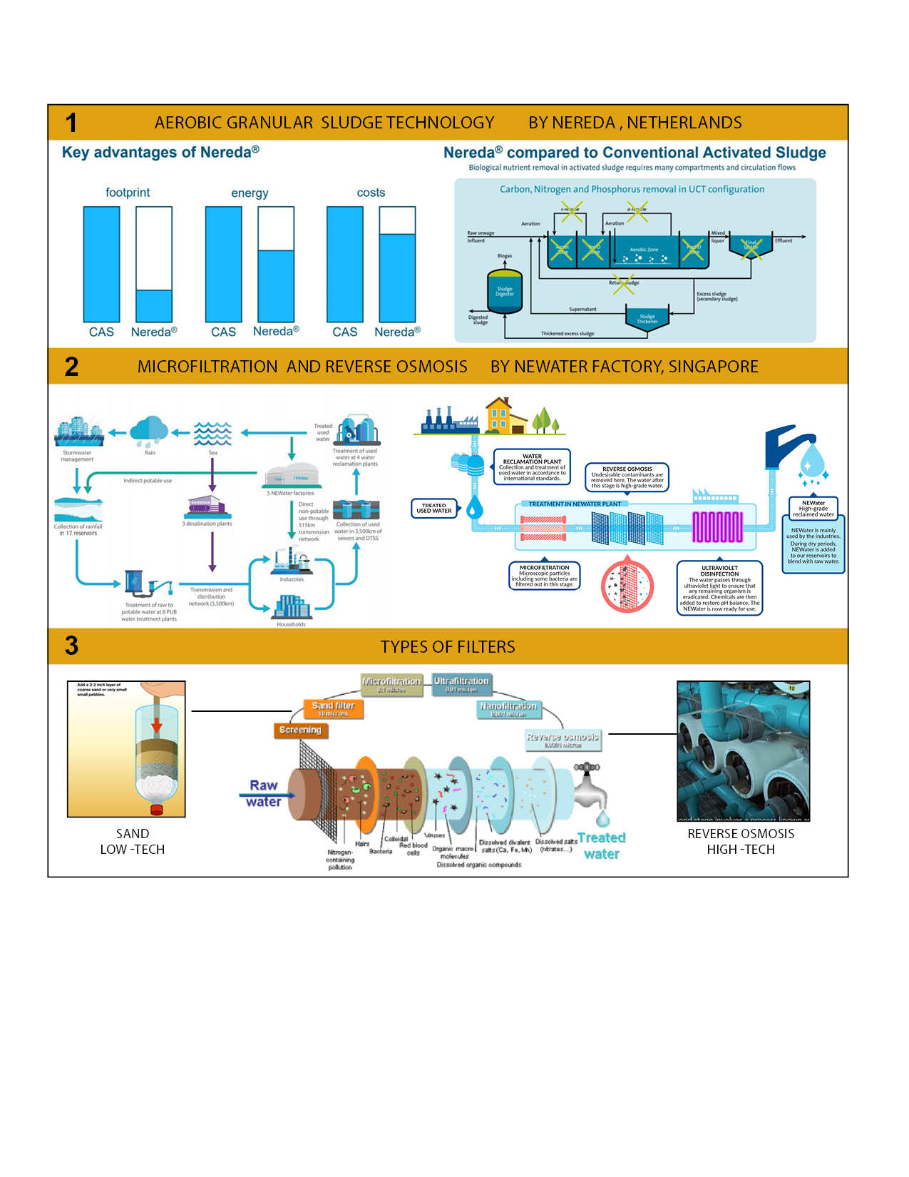

- Self-sufficient Energy will be provided by the roof of some structures as THERMAL SOLAR CONCENTRATED SOLAR POWER (CSP) PARABOLIC TROUGH, used in the shelter. And a THERMAL SOLAR CONCENTRATED (CSP) SOLAR POWER TOWER with mirrors in the canopies of one tank both ensuring energy for the water recycle and shelter services facility.

Activities and Use
The performance of infrastructure is conceived as multi-purpose at the macro-micro scale. It is an Infrastructure that processes water at a large scale but it is also a space at the human scale that allows people interaction and interpretation of the artifact on the landscape.
The tanks can be multifunctional so they can allow the galleries, toilets, services, resting decks, shaded areas the filter network are part of the landscape as an art performance as a tech/art
The shelter, As compress energy self-sufficient space, will be the primary receptor of human pressure, providing share toilet, Showers, water, Kitchen –food prep, Indoors space for either event during day time and share floor deck for indoor camping overnight for those who will stay longer than a day.
On-site prototyping
The first step will be to gather a sample of the technologies to show the community how they work. It has to do more with education purposes and fundraising. The physical interaction is important in order to understand the scale and impact on the land. So it will be more to do with a real small scale model of the artifacts. More technical and Engineer impute will be required to design a more detail this assemble of technologies.

Environmental assessment:
MINIMIZING THE EXTENT OF INTERVENTION:
We can possibly engage and rebrand the existing main asphalt road by integrating it to our new water recycle plan by underground or floating pipes as the mayor move and statement of new era. From there, the minimum connection to the new infrastructure which runs through the existing access dirt road. Water Tanks will only be built on the allowed primary site area. All exterior filtration elements will only be permitted in the in low impact site boundary respecting existing flora.

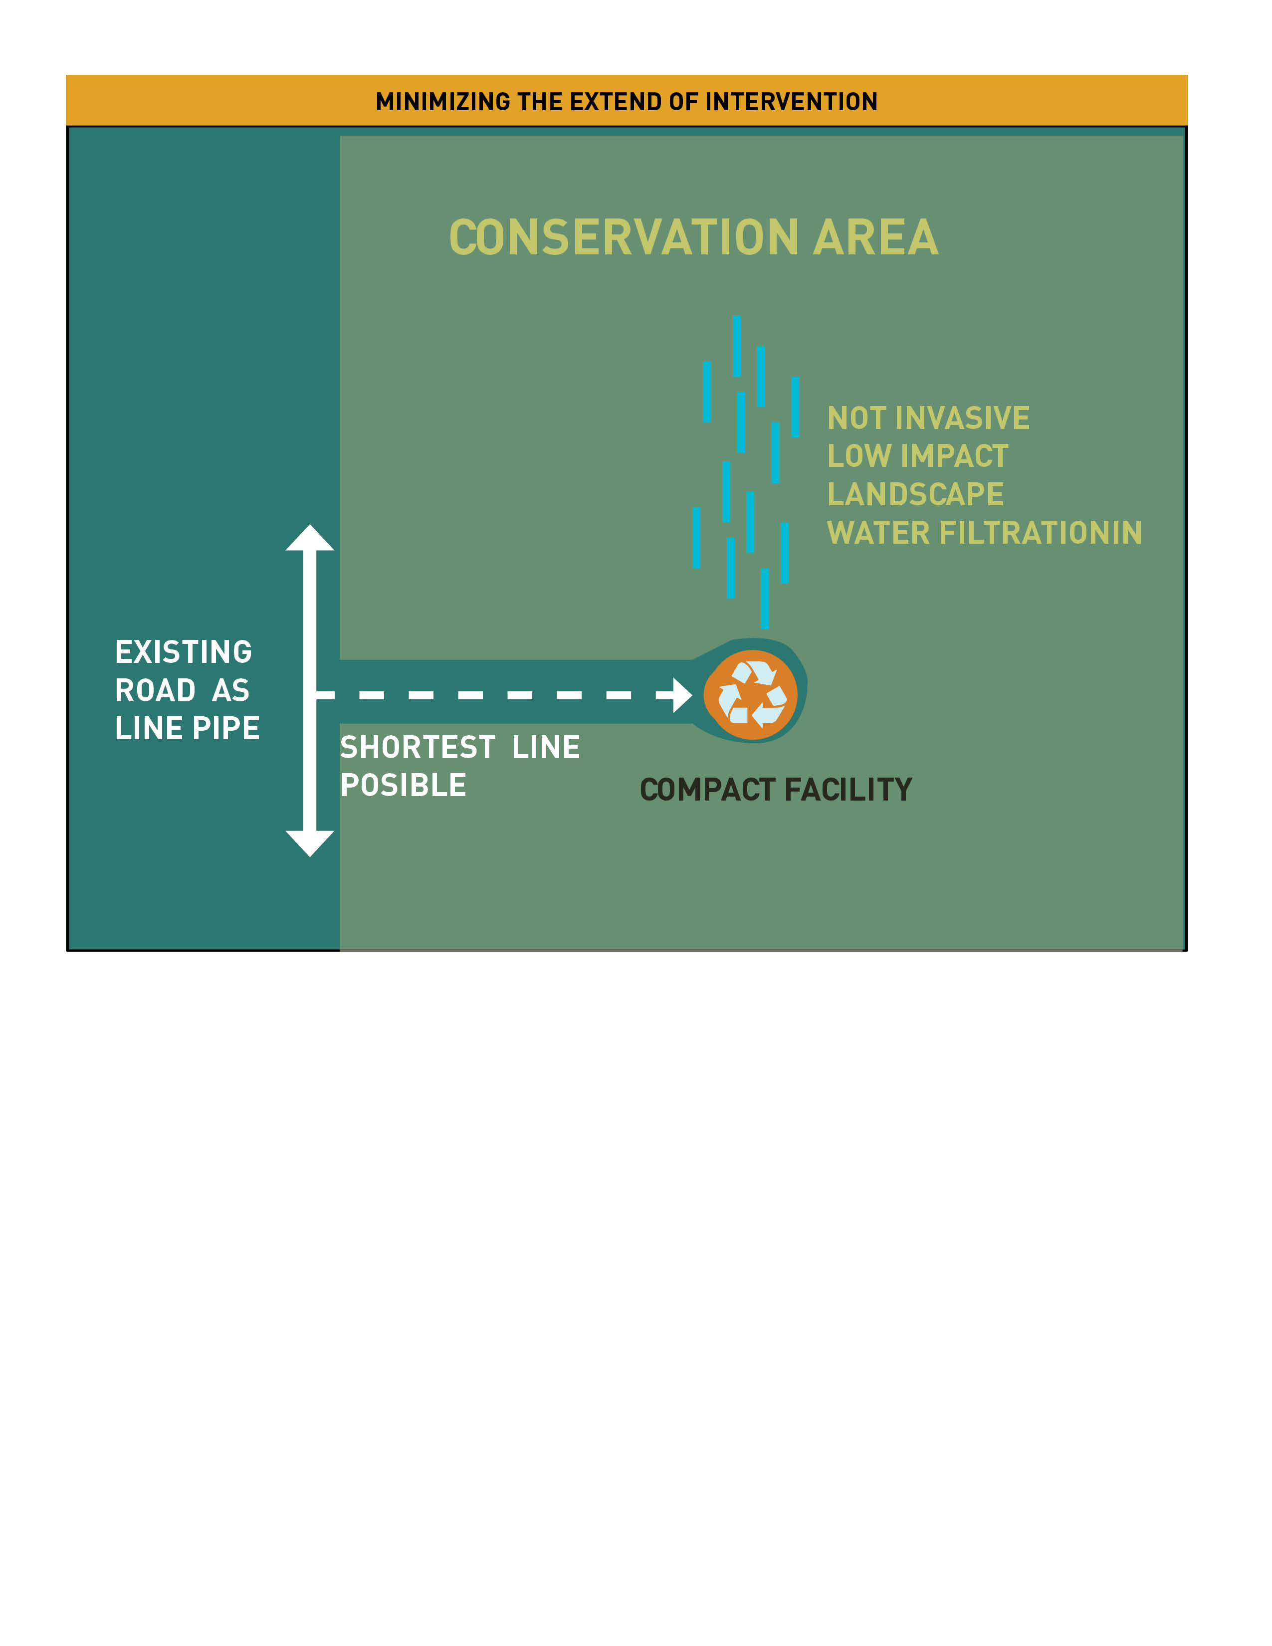

WHEN DECOMMISSION
The main structure can be disassembled into pieces as they are prefab recycled concrete. Leaving only a concrete Amphitheatre/pond when flooded. Or it can be left as remain artifact /art piece in the landscape as a standing ruin pulling some of the wall pieces as dormant stones in the ground.
The remains of the solar tower and filtration system are recyclable disassemble in pieces to have a second life as glass, steel, membranes, tube copper/plastic.
