LE MIRAGE
An art installation that creates a mirage while generating electricity
Deep from the Earth
Written on the Sky
Let the Energy manifest
Through your magic eyes…
Life on the desert can be very difficult for humans. Nature challenges us, bringing our bodies to the limit. The extreme temperatures, lack of vegetation and water, trick our mind. Almost as an act of magic, when we think we are lost in the middle of an arid area, our eyes see water bodies and objects floating from nowhere.
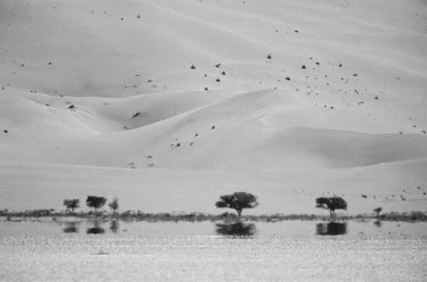
The mirage creates an illusion of a landmark. An apparent reflection. As soon as we see it, it drags us to see something that seems to be there, but when reaching it, disappears. The changing temperatures on masses of air, trick our eyes to see mirrored images from afar. The mirage appears to reminds us of our vulnerability and our dependence on water.

The primary drive of the proposed artwork is to create an ethereal and physical visual landmark. A mirage which is the direct consequence of generating of electricity. It will appear and evidence when the artwork is on generation mode, and will disappear when the energy output is low.
The mirage created will be a product of light reflecting and bending in two masses of air at different temperature. The artwork is inspired on the effect of the upper mirages, also known as Fata Morgana, caused by a mass of hot air static over a mass of colder air, bending the light to reflect what is happening around, creating the illusion of objects appearing as weightlessly floating in the air.

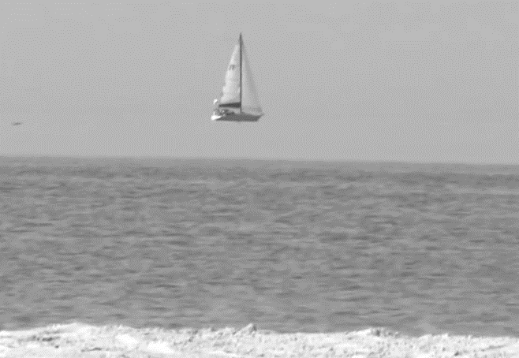
The mass of hotter air will be exhausted by a network of towers which combine reversible Solar Updraft/Downdraft reinforced with Geothermal-sourced heat and Solar PV panels placed on the external fabric. This combination would provide a low-maintenance, steady source of energy throughout the year without water and wind.
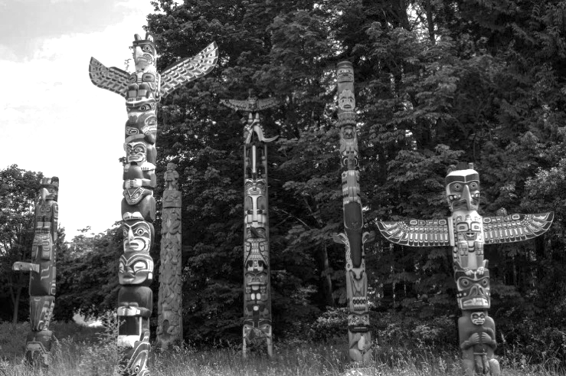
Inspired in the native American tradition, these towers stand as contemporary magic totems arranged in special places of the Fly Ranch, where events happen. Standing approximately 20 meters, this network of elements generates electric energy “from thin air” for local consumption, without transport lines.

These contemporary totems will be mostly made of reclaimed materials. Externally, they will be dark-coloured in a pattern that enhances the updraft effect. Additionally, a series of PV Panels will be arranged externally in the south-facing surfaces, contributing to the total output of the system.
Inspired in the images of the native American totems, arrays of LED lights will be incorporated to specific areas of the modules. These will allow observers to interact with the artwork, projecting geometrical patterns and faces that will be visible from afar.

The electric generation relies on air convection streams, where the air moves due to temperature and pressure differences. On a normal operation, the air will be dragged from the ground area onto a lower chamber. Acting like a geyser chamber, the air will progressively get warmer and accelerate upwards in the tower, travelling through a series of turbines and producing electricity.
During the night time, the process would continue to work until all the heat stored as thermal mass would eventually dissipate. It is then when the flow would be reversed, and cold air would flow downwards in the totem.
The totem will be composed of a series of dark hollow modules, built around a hollow structural core. These will be rooted on a reclaimed tank buried in the desert ground, which acts as foundation and as a geyser-like chamber. Additionally, this chamber would store water from condensation as a result of night-time operation.
The totem modules will incorporate a compression-decompression chamber system inspired in high-efficiency turbines. Heated under the desert sun, the air will progressively accelerate. Using venturi chambers, the air will quickly accelerate, increasing the efficiency of a traditional solar updraft tower.
In the coronation of the totem, a special module will include the exhaust vent grill. This will be carefully designed to funnel the hot air and create the mirage.
Besides contributing to generate the mirage, the solar updraft technology has been selected for other additional reasons. Solar PV panels are effective during daytime and lose efficiency when covered by desert dust, which implies the need of cleaning, using a precious resource in the desert: water. Secondly, the analysis of the wind charts provided shows that the wind strength will not be enough to solely rely on it to generate electricity.
The system will work as a mostly autonomous system, requiring minimum checks, maintenance and replacement. The only moving parts of the solar updraft tower are the turbines and generator – lowering the overall maintenance cost. The lower pieces, including the generation turbines and machinery will be designed to be easily accessible without compromising the structural stability.
The totems will be constructed with modules of approximately 800x800mm. They will be constructed with recycled and reclaimed sheets, tanks or parts made of aluminium and steel from local industrial waste. These are tough materials that will resist weathering, sand abrasion and exposure to UV light. The modules will be created as structurally sound meshes arranged around a central core. Overall, the totem will behave as a flexible structure that gently flexes to the wind forces.
The cost of each totem will depend on the amount of reclaimed materials, their transport, the excavation cost (digger, etc), and the cost of the generator, inverter and batteries. For manufacturing cost, the jointing of the elements will be done with mechanical joints -rivets, screws- and flexible materials, to minimise on-site welding.
The onsite prototyping would aim to help develop the design by making, verifying the following: Optimisation and amplification of the mirage effect and the optimisation of the updraft effect. The correct balance of these two is the ultimate goal of the proposed artwork. The prototyping phase would establish the process of sourcing the reclaimed materials, fine tuning the dimensions depending on the availability of materials and adapting the visuals of the totem. In this phase it would also be key to further study the geothermal and geotechnical characteristics of the land for the election of site, ideally to be integrated with other architectural and artistic proposals. Early research has shown that an estimate of 2MW could be produced with a 20m high tower, however this figure could be up for discussion. Lastly, the prototyping phase would seek to optimise the jointing of the pieces to achieve wind resistance.
In short, this artwork proposes a game of optics, perspective and reflection. Visitors and dwellers will be dragged towards the mirage, which reflects the activities happening around them, and which will progressively disappear as the observer gets closer to it.
Deep from the earth, written on the sky, this artwork offers a true poetic ending, a cadenza, to the life cycle of the energy production, casting the collective images and beautiful moments of the site into people’s the eye.
ENVIRONMENTAL IMPACT SUMMARY
The artwork proposed aims to have a low environmental impact. The totems will be fabricated using reclaimed materials, sourced from local nearby sites, recycled aluminium and steel. The totems will use a foundation system that could be dismantled, aiming to use zero concrete on site.
The proposed solution will not produce any greenhouse emissions, waste nor environmental pollution during its operational life. An effort will be made to minimise the cradle to gate emissions. For example, whilst we suggest that PV panels could be implemented, we are aware of their high environmental cost. As a mitigation, we would first propose to evaluate its contribution to the overall energy production and consider the possibility of using recycled or reclaimed PV panels.
The totems will be strategically located near consumption points, aiming to minimise loses on electric transport and the use of insulating plastic materials on cables.
The lack of movable parts will not disturb the local fauna and the impact on underground animals will be minimal. Grilles will discourage rodents and other small animals to dwell and nest on the lower parts of the artwork. The geometry will discourage birds from perching or nesting. Its lighting features will make them visible and distinguishable at night, avoiding any collision.
The artwork will not create acoustic pollution. Its non-pressurised air streams will not cause vibration nor high-pitched sounds. The shape of the totems will be optimised to not cause wind noise.

